    Joint Video Experts Team (JVET)  of ITU-T SG 16 WP 3 and ISO/IEC JTC 1/SC 29/WG 11  12th Meeting: Macao, CN, 3–12 Oct. 2018 | Document: JVET-L0222-v2

Title: | CE3 6.6.1: A simple 6-MPM list construction with truncated binary coding for non-MPM signalling
Status: | Input document to JVET
Purpose: | Proposal
Author(s) or  Contact(s): | A. M. Kotra, B. Wang, S. Esenlik  H. Gao, J. Chen (Huawei)  M. G. Sarwer, C.-W. Hsu, Y.-W. Huang  S.-M. Lei (MediaTek)  L. Li, J. Heo, J. Choi, S. Yoo, J. Lim, S. Kim (LGE)  A. K. Ramasubramonian  G. Van der Auwera  M. Karczewicz (Qualcomm) | Tel:  Email: | +886-3-5670766  {anand.meher.kotra, biao.wang, semih.esenlik,han.gao,jianle.chen}@huawei.com  {mohammed.sarwer, cw.hsu,  yuwen.huang, shawmin.lei}  @mediatek.com  {l.li, jin78.heo, jungah.choi  sunmi.yoo,jaehyun.lim, seunghwan3.kim} @lge.com  {aramasub, geertv, martak}  @qti.qualcomm.com
Source: | Huawei, MediaTek Inc., LGE, Qualcomm Inc.
_____________________________

Abstract
This contribution proposes a 6 most probable modes (MPM) based intra mode coding method. The MPM list is generated based on the left and top neighboring modes. The truncated binary coding is used to signal the remaining 61 non-MPM modes. It is reported that under All Intra configuration this proposal can achieve −0.32%/−0.26%/−0.24% Y/U/V BD-rate for VTM2.0.

Introduction
In VTM2.0.1, for luma intra mode coding, a list of 3 MPMs is generated from above (A) and left (L) neighboring modes. Figure 1 shows the locations of the neighboring modes used in VTM2.0.1.

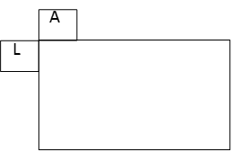
Figure 1: Neighboring modes for MPM generation in VTM2.0

In VTM2.0.1, after extracting the left neighboring mode (leftIntraDir) and above neighboring mode (aboveIntraDir), the MPM list (mpm[]) is constructed as follows:

offset = 62;
mod = offset + 3;
if (leftIntraDir == aboveIntraDir)
{
if (leftIntraDir > DC_IDX) // angular modes
{
mpm[0] = leftIntraDir;
mpm[1] = ((leftIntraDir + offset) % mod) + 2; // -1 mode of left mode
mpm[2] = ((leftIntraDir - 1) % mod) + 2; // +1 mode of left mode
}
else // non-angular
{
mpm[0] = PLANAR_IDX;
mpm[1] = DC_IDX;
mpm[2] = VER_IDX;
}
}
else
{

mpm[0] = leftIntraDir;
mpm[1] = aboveIntraDir;

if (leftIntraDir && aboveIntraDir) // both modes are non-planar
{
mpm[2] = PLANAR_IDX;
}
else
{
mpm[2] = (leftIntraDir + aboveIntraDir) < 2 ? VER_IDX : DC_IDX;
}
}
For the remaining 64 modes, a 6-bit fixed-length-code (FLC) is used to send the remaining mode indices.

Proposed method

MPM list generation
As in VTM2.0.1, this proposal uses two neighbors to derive the MPM list, however, the locations of neighbors are different than in VTM2.0.1. Figure 2 shows the location of the neighbors of the proposed method. If any of the neighboring modes is unavailable, that mode is replaced by the planar mode.

A
L

Figure 2: Neighboring modes for MPM generation

In the proposed method, the MPM generation part is categorized into 3 cases. Cases are defined based on the number of available angular modes (N_{ang}) in left (L) and above (A) neighbors.

Case 0: if none of the neighboring modes are angular (N_{ang} = = 0)
In this case, the 6 MPM list is generated as follows:

mpm[0] = PLANAR_IDX;
mpm[1] = DC_IDX;
mpm[2] = VER_IDX;
mpm[3] = HOR_IDX;
mpm[4] = VER_IDX - 4;
mpm[5] = VER_IDX + 4;

Case 1: if only one angular mode is found in the neighboring modes (N_{ang} = = 1)
In this case, the insertion order of the modes in the MPM list is given below:
{left mode, above mode, planar, DC, left mode - 1, left mode + 1, vertical mode, horizontal mode}
It is worth noting that a special case occurs when the left and above mode are the same angular mode. In such case, the above mode will be skipped in the insertion order.
Assume:
- leftIntraDir = left mode
- aboveIntraDir = above mode
- AngMode is the available angular mode after checking left and above modes.
- availNonAngMode is the available non-angular mode after checking left and above modes. If any non-angular mode is unavailable, availNonAngMode = -1.

offset = 62;
mod = offset + 3;

if (both top and left modes are available and they are different)
{
mpm[0] = leftIntraDir;
mpm[1] = aboveIntraDir;
mpm[2] = (availNonAngMode == PLANAR_IDX) ? DC_IDX : PLANAR_IDX;
}
else
{
mpm[0] = AngMode;
mpm[1] = PLANAR_IDX;
mpm[2] = DC_IDX;
}

mpm[3] = ((AngMode + offset) % mod) + 2; // -1 mode of angular mode
mpm[4] = ((AngMode - 1) % mod) + 2; // +1 mode of the angular mode
mpm[5] = (AngMode > 48 && AngMode < 52) ? HOR_IDX: VER_IDX;

Case 2: if two different angular modes are found in neighboring modes (N_{ang} = = 2)
According to the definition, both the top and left modes in this case are angular modes and they are different. The insertion order of the modes in the MPM list is given below:
{left mode, above mode, planar, DC, left mode - 1, left mode + 1, above mode - 1, above mode + 1}
It is worth noting that a special case occurs when “left mode - 1” equals the above mode. In such case, the candidate “above mode – 1” is inserted before “left mode + 1”.
Assume:
- leftIntraDir = left mode
- aboveIntraDir = above mode

mode = leftIntraDir;
angMinus = ((mode + offset) % mod) + 2; // angular -1 ;
angPlus = ((mode - 1) % mod) + 2; // angular +1 ;

mpm[0] = leftIntraDir;
mpm[1] = aboveIntraDir;
mpm[2] = PLANAR_IDX;
mpm[3] = DC_IDX;
if (angMinus == aboveIntraDir)
{
mpm[4] = ((aboveIntraDir + offset) % mod) + 2; // above; angular -1 ;
mpm[5] = angPlus;
}
else
{
mpm[4] = angMinus;
if (aboveIntraDir == angPlus) mpm[5] = ((aboveIntraDir - 1) % mod) + 2;
else mpm[5] = angPlus;
}

Signalling MPM and non-MPM indices
In the proposed method, truncated unary coding is used to signal the MPM index. All of the bins of the MPM index are coded with bypass coding, and there is no context coding used for signalling the MPM index. The remaining 61 (67 total modes – 6 MPM modes) non-MPM modes are truncated binary coded with a pre-processing step, where the intra mode to be encoded deducts an offset based on its value and the intra modes in the MPM lists. This pre-processing step ensures the intra mode value range between 0 to 60.

Simulation results
The proposed method is implemented in BMS2.0.1 with VTM configuration. Table 1 shows the simulation results of the proposed method.

- VTM simulations:
  - Anchor: VTM2.0.1
  - Test: VTM2.0.1 + proposed method

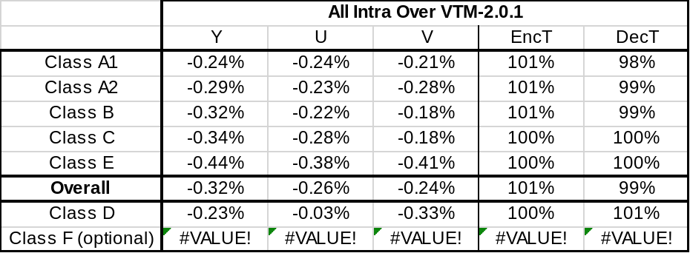
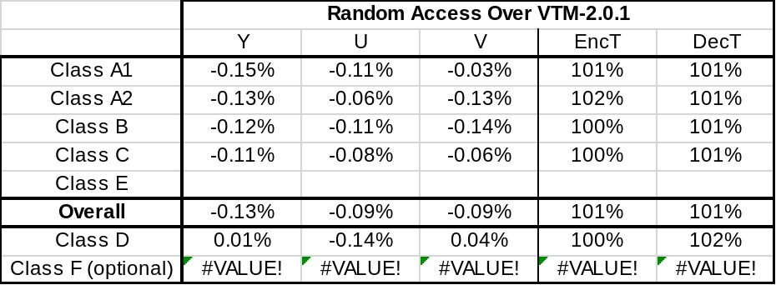

Table 1. Simulation results of the proposed methods compared to VTM2.0.1

Conclusions
Compared to VTM2.0.1, this proposal reportedly achieves BD-rates of -0.32%/-0.26%/-0.24% for Y/U/V, respectively, in All Intra configuration.

Patent rights declarations
Huawei Technologies Co.,Ltd. may have current or pending patent rights relating to the technology described in this contribution and, conditioned on reciprocity, is prepared to grant licenses under reasonable and non-discriminatory terms as necessary for implementation of the resulting ITU-T Recommendation | ISO/IEC International Standard (per box 2 of the ITU-T/ITU-R/ISO/IEC patent statement and licensing declaration form).

MediaTek Inc. may have current or pending patent rights relating to the technology described in this contribution and, conditioned on reciprocity, is prepared to grant licenses under reasonable and non-discriminatory terms as necessary for implementation of the resulting ITU-T Recommendation | ISO/IEC International Standard (per box 2 of the ITU-T/ITU-R/ISO/IEC patent statement and licensing declaration form).

LG Electronics Inc. may have current or pending patent rights relating to the technology described in this contribution and, conditioned on reciprocity, is prepared to grant licenses under reasonable and non-discriminatory terms as necessary for implementation of the resulting ITU-T Recommendation | ISO/IEC International Standard (per box 2 of the ITU-T/ITU-R/ISO/IEC patent statement and licensing declaration form).

Qualcomm Inc. may have current or pending patent rights relating to the technology described in this contribution and, conditioned on reciprocity, is prepared to grant licenses under reasonable and non-discriminatory terms as necessary for implementation of the resulting ITU-T Recommendation | ISO/IEC International Standard (per box 2 of the ITU-T/ITU-R/ISO/IEC patent statement and licensing declaration form).

References
[1] B. Bross, J. Chen, S. Liu, “Versatile Video Coding (Draft 2),” Document of Joint Video Experts Team, JVET-K1001-v4, Ljubljana, SI, 10–18 July 2018.
[2] F. Bossen, J. Boyce, K. Suehring, X. Li, V. Seregin, “JVET common test conditions and software reference configurations,” Document of Joint Video Experts Team, JVET-K1010.

