    Joint Video Experts Team (JVET)  of ITU-T SG 16 WP 3 and ISO/IEC JTC 1/SC 29/WG 11  12th Meeting: Macau SAR, CN, 3–12 Oct. 2018 | Document: JVET-L0221

Title: | CE3 6.5.1: 6-MPM list with Intra mode independent CABAC context
Status: | Input document to JVET
Purpose: | Proposal
Author(s) or  Contact(s): | B. Wang, A. M. Kotra, S. Esenlik  H. Gao, J. Chen (Huawei)  M. G. Sarwer, C.-W. Hsu, Y.-W. Huang  S.M. Lei (MediaTek)  L. Li, J. Heo, J. Choi, S. Yoo  J. Lim, S. Kim (LGE)  A.K. Ramasubramonian, G. Van der Auwera, V. Seregin, M. Karczewicz (Qualcomm) | Tel:  Email: | {biao.wang,anand.meher.kotra, semih.esenlik,han.gao,jianle.chen}@huawei.com  {mohammed.sarwer, cw.hsu,  yuwen.huang, shawmin.lei}  @mediatek.com  {l.li, jin78.heo, jungah.choi  sunmi.yoo, jaehyun.lim, seunghwan3.kim}@lge.com  {aramasub, geertv, vseregin, martak}@qti.qualcomm.com
Source: | Huawei, MediaTek Inc., LGE, Qualcomm Inc
_____________________________

Abstract
This contribution use the conventional strategy to build a 6-MPM list using five spatial neighboring blocks. However, the CABAC decoding and MPM list construction is decoupled in this contribution, thus a higher throughput CABAC decoder can be achieved. Furthermore, a macro is defined to switch on/off the alignment of RD checks with VTM 2.0.1. Experimental results of the proposed solution are as follows:
Over VTM2.0.1 Anchor with RD alignment on (AI, RA): − 0.35%, − 0.13% Luma BD rate saving with 103% and 101% encoding time and with 99% and 99% decoding time.
Over VTM2.0.1 Anchor with RD alignment off (AI, RA): − 0.59%, − 0.23% Luma BD rate saving with 112% and 103% encoding time and with 102% and 101% decoding time.

Introduction and Proposed Method
In BMS 1.0, conventional 6-MPM list construction is used where MPM list is built based on the five neighboring blocks, as shown in Fig. 1. Furthermore, CABAC decoding and MPM list construction is coupled, as CABAC context is dependent on the first three entries of the MPM list, compromising the throughput of CABAC decoding. In this report, the CABAC context and MPM list are decoupled. The CABAC context use fixed pre-defined context mode and therefore no CABAC decoding needs to wait for the completion of MPM list.
Furthermore, to compare with the latest VTM 2.0.1 reference mode, two variations of this approach are used. The first variation’s RD check is aligned with VTM 2.0.1, where up to two candidates in the MPM list are used in the RD check. The other one use the same RD check approach in BMS 1.0, where up to three candidates in the MPM list are used in the RD check.
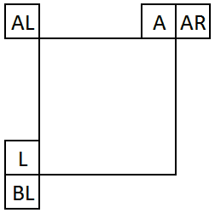
Fig. 1 Neighbour intra modes

Experimental Results
The table below shows the coding gain and processing time impact of the proposed solutions.
- VTM simulations
  - Anchor: VTM2.0.1
  - Test: VTM2.0.1 + Proposal
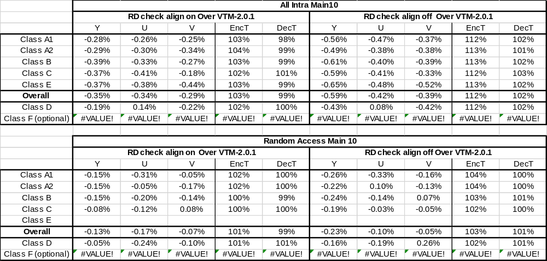

Conclusion
The proposal reports the results for the conventional 6-MPM construction method with CABAC decoding decoupled using fixed context models. The proposal with RD check alignment “ON” achieves a Luma coding gain of − 0.35% and − 0.13% on top of VTM 2.0.1 for AI and RA configurations, respectively.

Reference
[1]“Description of SDR, HDR and 360° video coding technology proposal by Samsung, Huawei, GoPro, and HiSilicon – mobile application scenario”, A. Alshin et. al., doc. JVET-J0024, April 2018.
[2] “Versatile Video Coding (Draft 2)”, B. Bross, J. Chen, S. Liu doc. JVET-K1001, April 2018
[3] “Description of Core Experiment 3 (CE3): Intra prediction and mode coding”, G. Van der Auwera, J. Heo, A. Filippov, doc. JVET-K1023, September 2018

Patent rights declaration(s)
Huawei Technologies Co.,Ltd. may have current or pending patent rights relating to the technology described in this contribution and, conditioned on reciprocity, is prepared to grant licenses under reasonable and non-discriminatory terms as necessary for implementation of the resulting ITU-T Recommendation | ISO/IEC International Standard (per box 2 of the ITU-T/ITU-R/ISO/IEC patent statement and licensing declaration form).

MediaTek Inc. may have current or pending patent rights relating to the technology described in this contribution and, conditioned on reciprocity, is prepared to grant licenses under reasonable and non-discriminatory terms as necessary for implementation of the resulting ITU-T Recommendation | ISO/IEC International Standard (per box 2 of the ITU-T/ITU-R/ISO/IEC patent statement and licensing declaration form).

LG Electronics Inc. may have current or pending patent rights relating to the technology described in this contribution and, conditioned on reciprocity, is prepared to grant licenses under reasonable and non-discriminatory terms as necessary for implementation of the resulting ITU-T Recommendation | ISO/IEC International Standard (per box 2 of the ITU-T/ITU-R/ISO/IEC patent statement and licensing declaration form).

Qualcomm Inc. may have current or pending patent rights relating to the technology described in this contribution and, conditioned on reciprocity, is prepared to grant licenses under reasonable and non-discriminatory terms as necessary for implementation of the resulting ITU-T Recommendation | ISO/IEC International Standard (per box 2 of the ITU-T/ITU-R/ISO/IEC patent statement and licensing declaration form).

