    Joint Video Experts Team (JVET)  of ITU-T SG 16 WP 3 and ISO/IEC JTC 1/SC 29/WG 11  12th Meeting: Macao, CN, 3–12 Oct. 2018 | Document: JVET-L0198_r2

Title: | CE4-related: Simplification of ATMVP candidate derivation
Status: | Input document to JVET
Purpose: | Proposal
Author(s) or  Contact(s): | Suhong Wang¹, Xiaozhen Zheng², Xiang Zhang¹, Shanshe Wang¹, Siwei Ma¹  Peking University¹, DJI² | Emails: | suhong.wang@pku.edu.cn  xiaozhen.zheng@dji.com
Source: | SZ DJI Technology Co., Ltd., Peking University
_____________________________

Abstract
At the 11th JVET meeting, alternative temporal motion vector prediction(ATMVP) was adopted to VTM-2.0 reference software. In order to reduce both the average and worst-case complexity, this contribution reports the experimental results on three cases of the ATMVP as follows.
- Test (a): Restrict the number of neighboring block scanning to one time
- Test (b): Fix size of ATMVP sub-block to 8x8
- Test (c): Test (a) plus Test (b)
Simulation results for Test(a), Test (b) and Test (c) show no performance change compared to VTM 2.0.1 and observe minor encoding and decoding time decrease.

Introduction
ATMVP derives multiple motion for sub-blocks of one coding unit (CU) based on the motion information of the collocated blocks from temporal reference picture. Although it has improved the coding efficiency of inter prediction, the following complexity issues still exist:
- The derivation of collocated block for ATMVP is derived by scanning the neighboring blocks in the spatial merge candidates, which means up to four scanning and checks needed be processed in the worst case.
- The motion information of each ATMVP CU is adaptively set to 4x4 or 8x8, while the motion filed are now compressed at 8x8 granularity. This means 4x4 sub-CU size is unnecessary in some cases.

Proposed Method
To simplify ATMVP candidate derivation process, two simplification methods have been proposed to ATMVP current design.

Simplified derivation of the collocated block
In current design, ATMVP predicts the motion vectors of the sub-CUs within a CU in two steps. The first step is to identify the corresponding block in the collocated picture, which is signaled at the slice header. The second step is to split the current CU into sub-CUs and obtain the motion information of each sub-CU from the block corresponding to each sub-CU in the collocated picture.
In the first step, the collocated block is identified by always scanning the MVs of the spatial merge candidates twice (once for each list). The construction of merge candidates list is performed by checking $A_{1}→B_{1}→B_{0}→A_{0}→ATMVP→B_{2}→TMVP$, as shown in Fig 1. Therefore, the number of MVP candidates in the merge list is up to 4 before ATMVP, which means that in the worst case, the scanning process in the first step needs to check all the 4 candidate blocks for each list.
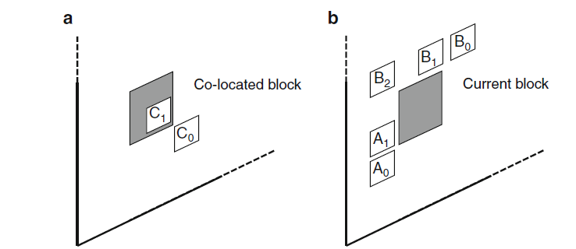
Fig.1 Temporal(a) and spatial(b) motion vector prediction candidates in merge mode
To simplify the neighboring blocks’ scanning process, the proposed method restricts the number of scanning process for deriving the collocated block to one time, which means that only the first candidate in the merge list will be checked. If the candidate doesn’t satisfy the condition of ATMVP neighboring blocks scanning in current VVC working draft, zero motion vector will be used to derive the collocated block in the collocated picture. In this method, the checking process will be performed up to 1 time.

Fixed size for ATMVP sub-block
At the 11th JVET meeting, ATMVP was adopted into VTM-2.0 with compressing motion field at 8x8 granularity. While, in the current ATMVP design, the sub-block size is adaptively set to 4x4 or 8x8, based on the average size of the ATMVP CUs from the last coded picture in the same temporal layer. Therefore, in some cases, the motion information derived by sub-CUs in one CU might be the same (if all from one 8x8 motion storage area), resulting in useless operation of splitting the current CU into several 4x4 blocks, as shown in Fig.2.
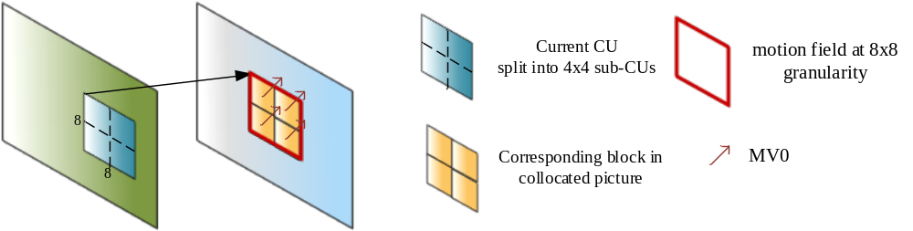
Fig.2 Example of useless operation of splitting the current CU into 4x4 sub-blocks
Therefore, the proposed method suggests fixing the sub-CU size for ATMVP to 8x8. Compared to the adaptive ATMVP sub-block size design, in this method, no side information needs to be specified in the bitstream to certain which size is chosen. Moreover, when the sub-CU size for ATMVP is set to 8x8, the sub-CUs’ motion vector can be stored and used at deblocking, whose basic unit is also 8x8, for the sub-CUs’ boundary that can reduce blocking noise and artifacts.

Experimental Results
The experiments were performed under JVET common test conditions.
BD-Rate results of the three tests on top of the VTM-2.0.1 compared to the anchor with RA and LDB configurations are shown in following tables. The full results are provided in the attached excel sheets.

Coding performance and complexity of Test (a) (restrict the number of scanning process to one time):
 | Random Access Main 10
 | Over vtm2.0.1
 | Y | U | V | EncT | DecT
Class A1 | 0.00% | 0.06% | 0.04% | 100% | 101%
Class A2 | 0.01% | 0.05% | 0.01% | 100% | 100%
Class B | 0.02% | 0.01% | 0.01% | 100% | 101%
Class C | 0.02% | 0.11% | 0.11% | 100% | 97%
Class E
Overall | 0.01% | 0.06% | 0.04% | 100% | 100%
Class D | 0.03% | 0.07% | 0.01% | 100% | 100%
Class F (optional) | #VALUE! | #VALUE! | #VALUE! | #DIV/0! | #DIV/0!
 | Low delay B Main10
 | Over vtm2.0.1
 | Y | U | V | EncT | DecT
Class A1
Class A2
Class B | 0.04% | -0.11% | -0.14% | 100% | 100%
Class C | 0.01% | -0.07% | -0.11% | 100% | 100%
Class E | -0.04% | -0.07% | -0.34% | 100% | 100%
Overall | 0.01% | -0.09% | -0.18% | 100% | 100%
Class D | 0.04% | 0.41% | -0.27% | 101% | 101%
Class F (optional) | #VALUE! | #VALUE! | #VALUE! | #DIV/0! | #DIV/0!

Coding performance and complexity of Test (b) (fix the sub-block size for ATMVP to 8x8):
 | Random Access Main 10
 | Over vtm2.0.1
 | Y | U | V | EncT | DecT
Class A1 | -0.01% | 0.03% | -0.03% | 100% | 100%
Class A2 | 0.01% | -0.02% | -0.07% | 99% | 99%
Class B | 0.00% | 0.05% | 0.00% | 99% | 101%
Class C | 0.00% | 0.12% | 0.03% | 100% | 96%
Class E
Overall | 0.00% | 0.05% | -0.01% | 100% | 99%
Class D | 0.00% | 0.02% | -0.02% | 100% | 100%
Class F (optional) | #VALUE! | #VALUE! | #VALUE! | #DIV/0! | #DIV/0!
 | Low delay B Main10
 | Over vtm2.0.1
 | Y | U | V | EncT | DecT
Class A1
Class A2
Class B | 0.01% | -0.22% | -0.04% | 99% | 100%
Class C | 0.06% | 0.08% | -0.13% | 99% | 96%
Class E | -0.09% | -0.03% | -0.38% | 100% | 98%
Overall | 0.00% | -0.07% | -0.16% | 99% | 98%
Class D | 0.00% | 0.14% | -0.38% | 100% | 99%
Class F (optional) | #VALUE! | #VALUE! | #VALUE! | #DIV/0! | #DIV/0!

Coding performance and complexity of Test (c) (Test (a) plus Test(b)):
 | Random Access Main 10
 | Over vtm2.0.1
 | Y | U | V | EncT | DecT
Class A1 | 0.00% | 0.04% | -0.01% | 100% | 100%
Class A2 | 0.02% | -0.03% | -0.08% | 100% | 100%
Class B | 0.00% | -0.02% | -0.03% | 99% | 101%
Class C | 0.01% | 0.15% | 0.07% | 100% | 96%
Class E
Overall | 0.01% | 0.03% | -0.01% | 100% | 99%
Class D | 0.00% | -0.03% | 0.03% | 100% | 98%
Class F (optional) | #VALUE! | #VALUE! | #VALUE! | #DIV/0! | #DIV/0!
 | Low delay B Main10
 | Over vtm2.0.1
 | Y | U | V | EncT | DecT
Class A1
Class A2
Class B | 0.02% | -0.09% | -0.11% | 99% | 99%
Class C | 0.04% | -0.01% | -0.31% | 99% | 98%
Class E | -0.12% | 0.41% | -0.13% | 99% | 97%
Overall | -0.01% | 0.06% | -0.18% | 99% | 98%
Class D | -0.05% | 0.45% | 0.52% | 100% | 99%
Class F (optional) | #VALUE! | #VALUE! | #VALUE! | #DIV/0! | #DIV/0!

Conclusion
This contribution proposed simplifications on ATMVP candidate derivation, which makes restriction on the scanning process for deriving the collocated block and fix the sub-block size to 8x8.
Simulation results for all tests shows no performance change on average compared to VTM 2.0.1 anchor, while minor encoding and decoding time decrease are observed. Therefore, it is recommended to adopt the proposed ATMVP simplification methods to the next version of VVC wording draft.

Patent rights declaration(s)
SZ DJI Technology Co., Ltd. may have current or pending patent rights relating to the technology described in this contribution and, conditioned on reciprocity, is prepared to grant licenses under reasonable and non-discriminatory terms as necessary for implementation of the resulting ITU-T Recommendation | ISO/IEC International Standard (per box 2 of the ITU-T/ITU-R/ISO/IEC patent statement and licensing declaration form).

Peking University may have current or pending patent rights relating to the technology described in this contribution and, conditioned on reciprocity, is prepared to grant licenses under reasonable and non-discriminatory terms as necessary for implementation of the resulting ITU-T Recommendation | ISO/IEC International Standard (per box 2 of the ITU-T/ITU-R/ISO/IEC patent statement and licensing declaration form).

