    Joint Video Experts Team (JVET)  of ITU-T SG 16 WP 3 and ISO/IEC JTC 1/SC 29/WG 11  12th Meeting: Macao, CN, 3–12 Oct. 2018 | Document: JVET-L0191

Title: | CE3-5.1: On cross-component linear model simplification
Status: | Input document to JVET
Purpose: | Proposal
Author(s) or  Contact(s): | Guillaume Laroche  Jonathan Taquet  Christophe Gisquet  Patrice Onno  Canon Research Centre France  Rue de la Touche Lambert  35510 CESSON-SEVIGNE, FRANCE | Tel:  Email: | +33 299876800  guillaume.laroche@crf.canon.fr
Source: | Canon
_____________________________

Abstract
This contribution reports the results of CE3 test 5.1. This CE3 replaces the LMS algorithm by a straight-line equation for CCLM mode Luma to Chroma prediction. More precisely, this CE3 is related to a modification of the determination of the linear model parameters $α$ and $β$. In the current VTM2.0 implementation, these parameters are derived by minimizing the regression error between the neighbouring Luma and Chroma samples. In this CE3, 2 Luma samples and their corresponding Chroma samples are used to obtain the linear model parameters $α$ and $β$ in order to avoid the regression error minimization algorithm where all Luma and Chroma samples from the border are considered.
An average Luma BDR is reported compared to VTM2.0 of 0.11% and 0.08%, for respectively AI and RA configurations.
In addition, the proposed modification removes about 80 lines of the current VTM2.0 source code.

Introduction / Problem Statement / …
The current VTM2.0 implementation includes the cross-component linear model (CCLM) method. This method obtains the linear model parameters $α$ and $β$ based on a least means square algorithm given by the following formula:
$α= \frac{N·∑\left(L\left(n\right)·C\left(n\right)\right)-∑L\left(n\right)·∑C\left(n\right)}{N·∑\left(L\left(n\right)·L\left(n\right)\right)-∑L\left(n\right)·∑L\left(n\right)}$
$$β= \frac{∑C\left(n\right)-α·∑L\left(n\right)}{N}$$
where $L\left(n\right)$ represents the down-sampled top and left neighbouring reconstructed luma samples, $C\left(n\right)$ represents the top and left neighbouring reconstructed Chroma samples.
By considering that the division operation is replaced by a multiplication, the complexity related to the least means square algorithm inside the VTM is given by the following table:

Table 1 Number of operations for the current LMS of Cross-component prediction.
Operations | Number of operations LMS
Multiplications | 2N+2+2
Sums | 7N+3
“Divisions” | 2
Where N is the number of Chroma samples in the border. Please note that the division is of course implemented thanks to a table, a multiplication and a shift.

Proposed method
In this CE3 test, we propose to replace the LMS algorithm of the linear model parameters $α$ and $β$ by a straight line equation. The 2 points (couple of Luma and Chroma) (A, B) are the minimum and maximum values inside the set of neighboring Luma samples as depicted in Figure 1.
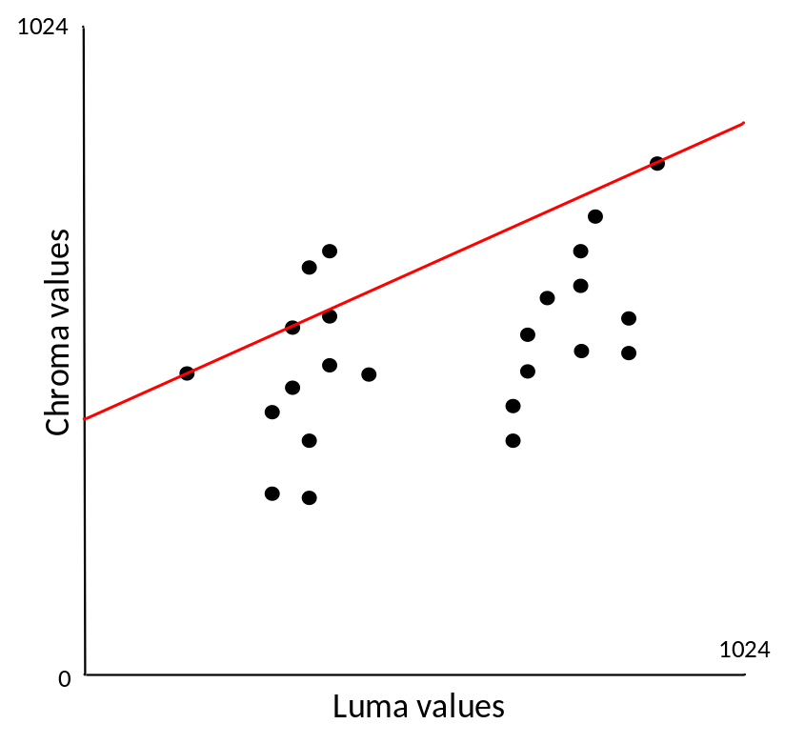
$$Y=αx+β$$
A
B
Figure 1 Illustration of the straight line between minimum and maximum Luma value
Where the linear model parameters $α$ and $β$ are obtained according to the following equation:$β= \frac{∑C\left(n\right)-α·∑L\left(n\right)}{N}$
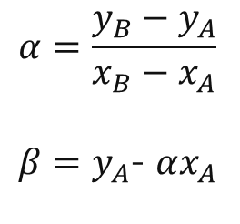
Of course the division is avoided and replaced by a multiplication and a shift.
To derive the Chroma predictor, as for the current VTM implementation, the multiplication is replaced by an integer operation as the following:
${pred}_{C}\left(i, j\right)=\left(A·{rec}_{L}^{'\left(i, j\right)}\right)≫S+ β$
Yet the implementation is also simpler than the current VTM implementation because shift S always has the same value.
In term of complexity, the proposed algorithm reduces the number of operations as depicted in the following table:
Operations | Number of operations LMS | Number of operations proposed
Multiplications | 2N+2+2 | 1
Sums | 7N+3 | 3
“Divisions” | 2 | 1
Comparisons |  | 2N
The number of operations is reduced but the proposed method needs several comparisons to obtain the minimum and maximum Luma values of the neighboring sample.

Comment on Implementation
As the proposed method is simpler than the LMS algorithm, the proposed algorithm reduces the number of active lines of source code of 81 lines as depicted in the following table:

 | Number of lines
lines Active | 136
lines inactive | 217
Difference | 81

Experimental results
The proposed method is implemented on top of the BMS2.0.1 with VTM configuration and replaces the linear model for CCLM method. The proposed method gives an average BDR loss of 0.11% for AI configuration and 0.8% for RA configuration for Luma component. For LD configuration, the proposed method gives -0.02% BDR gain.
Table 2 Results of CE3-5.1 test.
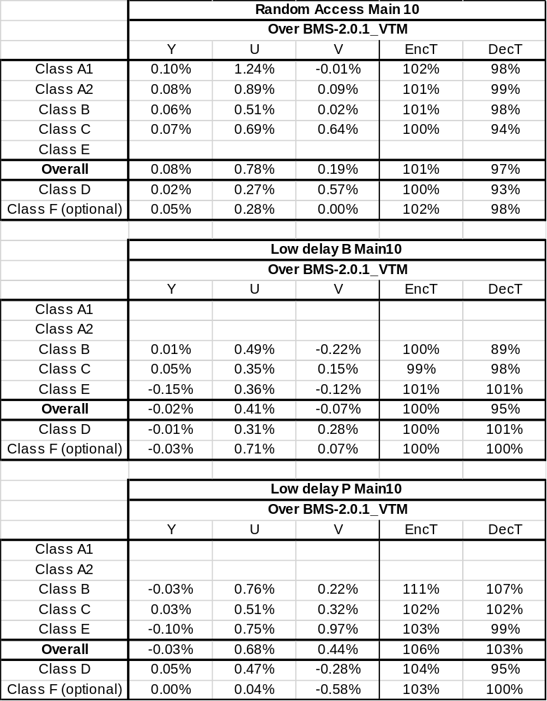

Conclusion
In this CE3-5.1 test, the least means square algorithm is replaced by a straight line equation between the maximum and minimum reference samples in order to reduce the worst case decoding and complexity. The proposed method has a small impact on the coding efficiency. According to these results and the complexity reduction obtained with this method, we recommend to consider the modification for its integration into the next VTM software.

Patent rights declaration(s)
Canon Research Centre France may have current or pending patent rights relating to the technology described in this contribution and, conditioned on reciprocity, is prepared to grant licenses under reasonable and non-discriminatory terms as necessary for implementation of the resulting ITU-T Recommendation | ISO/IEC International Standard (per box 2 of the ITU-T/ITU-R/ISO/IEC patent statement and licensing declaration form).

