    Joint Video Experts Team (JVET)  of ITU-T SG 16 WP 3 and ISO/IEC JTC 1/SC 29/WG 11  12th Meeting: Macau, CN, 08–12 Oct. 2018 | Document: JVET-L0158

Title: | CE4-related: History-Based Motion Vector Prediction considering parallel processing
Status: | Input document to JVET
Purpose: | Proposal
Author(s) or  Contact(s): | Naeri Park  Hyeongmun Jang  Junghak Nam  Jaeho Lee  Jaehyun Lim  Seung Hwan Kim  19 Yangjaedaero-11gil  Seocho-gu, Seoul 06772  South Korea | Tel:  Email: | +82-2-6912-6561  {naeri.park, hm.jang, junghak.nam, jhlee.lee, jaehyun.lim,  seunghwan3.kim }@lge.com
Source: | LG Electronics Inc.
_____________________________

Abstract
In JVET-K0104 [1], History-based Motion Vector Prediction (HMVP) method was introduced. Since history table including previous motion information is initialized on slice basis, it could cause problem with implementation of parallel processing. Therefore, this contribution proposes two initialization methods for the HMVP buffer to support parallel processing as follows;
Test #1: Initialization on CTU Row basis
Test #2: Initialization on CTU basis
The experimental results for Test #1 reportedly show -0.01% and 0.01% BD-rate savings without any noticeable encoding or decoding run-time change compared to CE4.4.7 with default setting as anchor in RA and LB configurations, respectively. The experimental results on Test #2 reportedly show -0.09% and -0.02% BD-rate savings without any noticeable encoding and decoding run-time change compared to CE4.4.7 with default setting as anchor in RA and LB configurations, respectively.

Introduction
In MERGE/AMVP mode, multiple motion vectors of the Spatial/Temporal neighboring are constructed as MVP candidates. But, some candidates in non-adjacent region have not been considered because of hardware implementation issues like as line buffers.
HMVP scheme described in [1] makes motion vectors of the non-adjacent blocks as MVP for current block by adding to a buffer motion vectors of previous coded blocks. Here, the buffer for HMVP is initialized on slice bases, and it could cause motion vector dependency. It means that parallel processing on CTU Row or CTU basis may not be compatible with current HMVP design. This contribution proposes methods to resolve the dependency issues without noticeable coding loss.

Technical description
In order to reduce encoding/decoding time, paralleling process of the CTU Rows is commonly used in the field. As depicted in Figure 1, a CTU has data dependency with its neighboring CTUs (i.e., left, above-left, above, and above-right CTU), and there is a delay as one CTU to launch a thread for a CTU Row.

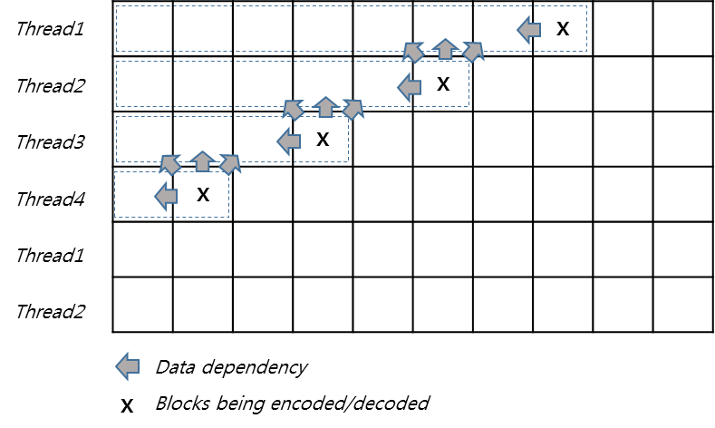
Figure 1 Data dependency on parallel processing

In the conventional HMVP scheme, resetting the HMVP buffer based on slice make parallel processing for each CTU Row impossible because candidates in the MVP buffer are unknown that these candidates belong to which CTU. For example, a CTU in Nth CTU Row could have dependency with last CTU in (N-1)th CTU Row if there are candidates from the last CTU in the HMVP buffer as described in Figure 2.

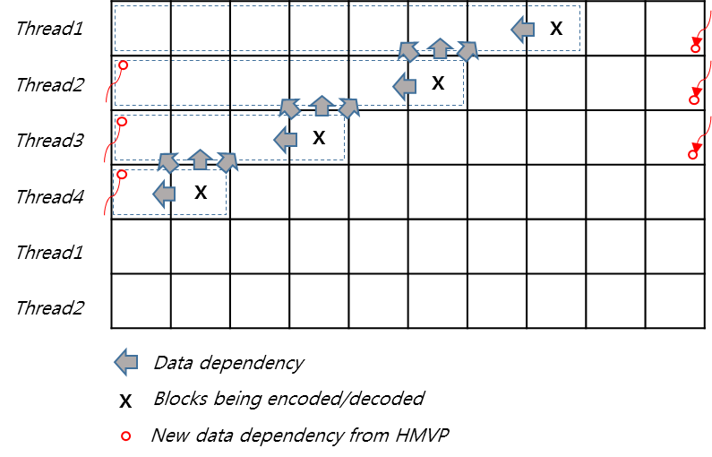
Figure 2 New data dependency from HMVP on parallel processing

In this proposal, it is suggested two methods to resolve data dependency added from HMVP. First one is to initialize the HMVP buffer on CTU Row basis. Second one is to initialize the buffer on CTU basis. Both of two schemes are remove the additional dependency and it makes parallel processing possible.

Experimental results
The proposed method has been implemented on top of the CE4.4.7[2] with default setting and tested using JVET SDR common test condition[3].

CE4.4.7 default setting is as follows. It means that HMVP buffer size is 6 and HMVP is only applied to MERGE mode with pruning check. Table 1 show the CE4.4.7 test results on VTM2.0.1 RA and VTM2.0.1 LB condition.
#define NUMBER_LUTMERGE 1
#define ALLOWED_CHECKED_NUM 6
#define APPLIED_AMVP 0
#define NO_AFFINE_UPDATE 1
#define MRG_IDX_CODING 1
#define ADD_PRUNING_4TABLE_UPDATE 1
#if ADD_PRUNING_4TABLE_UPDATE
#define PRUN_FOR_MRG_MODE_ONLY 0
#endif
Table 1 CE4.4.7 experimental results on VTM2.0.1 RA & LB
 | Rancom Access Main 10 |  |  |  |  | Low delay B Main 10
 | Over VTM-2.0.1 |  |  |  |  | Over VTM-2.0.1
 | Y | U | V | EncT | DecT | Y | U | V | EncT | DecT
Class A1 | -0.33% | -0.29% | -0.51% | 100% | 100%
Class A2 | -0.40% | -0.64% | -0.69% | 100% | 100%
Class B | -0.58% | -0.64% | -0.75% | 99% | 100% | -0.39% | -0.46% | -0.37% | 100% | 104%
Class C | -0.32% | -0.35% | -0.54% | 100% | 102% | -0.10% | -0.12% | -0.40% | 100% | 107%
Class E |  |  |  |  |  | 0.07% | -0.16% | -0.24% | 101% | 104%
Overall | -0.43% | -0.49% | -0.63% | 100% | 100% | -0.18% | -0.27% | -0.35% | 100% | 105%
Class D | -0.13% | -0.45% | -0.37% | 100% | 100% | 0.01% | 0.41% | -0.21% | 101% | 108%
Class F (optional) | #VALUE! | #VALUE! | #VALUE! | #REF! | #REF! | #VALUE! | #VALUE! | #VALUE! | #REF! | #REF!

Test #1: Initialization on CTU Row basis
The initialization on CTU Row basis is tested. The experimental results for Test #1 reportedly show -0.01% (0.01%) BD-rate savings with 100%(100%) encoding complexity and 100%(98%) decoding complexity compared to CE4.4.7 in RA(LB), respectively.

Table 2 CE4.4.7 Default setting and proposed test #1 experimental results on VTM2.0.1 and CE4.4.7.
 | Random Access Main 10
 | Over VTM-2.0.1 |  |  |  |  | Over CE4.4.7
 | Y | U | V | EncT | DecT | Y | U | V | EncT | DecT
Class A1 | -0.31% | -0.29% | -0.52% | 99% | 100% | 0.01% | 0.00% | -0.01% | 100% | 100%
Class A2 | -0.37% | -0.69% | -0.69% | 99% | 100% | 0.03% | -0.05% | 0.00% | 99% | 100%
Class B | -0.56% | -0.63% | -0.76% | 99% | 100% | 0.02% | 0.01% | -0.01% | 100% | 100%
Class C | -0.34% | -0.30% | -0.43% | 100% | 103% | -0.02% | 0.05% | 0.11% | 100% | 101%
Class E
Overall | -0.42% | -0.49% | -0.61% | 99% | 101% | 0.01% | 0.00% | 0.02% | 100% | 100%
Class D | -0.12% | -0.27% | -0.22% | 100% | 101% | 0.00% | 0.18% | 0.15% | 100% | 101%
Class F (optional) | #VALUE! | #VALUE! | #VALUE! | #REF! | #REF! | #VALUE! | #VALUE! | #VALUE! | #REF! | #REF!

 | Low delay B Main10
 | Over VTM-2.0.1 |  |  |  |  | Over CE4.4.7
 | Y | U | V | EncT | DecT | Y | U | V | EncT | DecT
Class A1
Class A2
Class B | -0.36% | -0.35% | -0.66% | 100% | 104% | 0.02% | 0.12% | -0.29% | 100% | 100%
Class C | -0.11% | -0.30% | -0.38% | 100% | 102% | -0.01% | -0.18% | 0.03% | 100% | 96%
Class E | 0.01% | 0.23% | -0.10% | 100% | 100% | -0.06% | 0.39% | 0.15% | 100% | 97%
Overall | -0.19% | -0.19% | -0.42% | 100% | 103% | -0.01% | 0.08% | -0.07% | 100% | 98%
Class D | 0.02% | 0.56% | 0.05% | 100% | 105% | 0.00% | 0.15% | 0.30% | 100% | 97%
Class F (optional) | #VALUE! | #VALUE! | #VALUE! | #REF! | #REF! | #VALUE! | #VALUE! | #VALUE! | #REF! | #REF!

Test #2: Initialization on CTU basis
The initialization on CTU basis is tested. The experimental results for Test #2 reportedly show -0.09% (-0.02%) BD-rate savings with 100% (100%) encoding complexity and 100% (100%) decoding complexity compared to CE4.4.7 in RA(LB), respectively.

Table 3 CE4.4.7 Default setting and proposed test #2 experimental results on VTM2.0.1 and CE4.4.7.
 | Random Access Main 10
 | Over VTM-2.0.1 |  |  |  |  | Over CE4.4.7
 | Y | U | V | EncT | DecT | Y | U | V | EncT | DecT
Class A1 | -0.17% | -0.14% | -0.32% | 100% | 100% | 0.15% | 0.15% | 0.19% | 100% | 100%
Class A2 | -0.33% | -0.53% | -0.54% | 100% | 100% | 0.07% | 0.10% | 0.16% | 100% | 100%
Class B | -0.46% | -0.57% | -0.68% | 100% | 100% | 0.12% | 0.07% | 0.07% | 100% | 100%
Class C | -0.31% | -0.33% | -0.50% | 100% | 103% | 0.01% | 0.02% | 0.04% | 100% | 101%
Class E
Overall | -0.34% | -0.41% | -0.53% | 100% | 101% | 0.09% | 0.08% | 0.10% | 100% | 100%
Class D | -0.13% | -0.29% | -0.32% | 100% | 101% | 0.00% | 0.16% | 0.04% | 100% | 101%
Class F (optional) | #VALUE! | #VALUE! | #VALUE! | #REF! | #REF! | #VALUE! | #VALUE! | #VALUE! | #REF! | #REF!

 | Low delay B Main10
 | Over VTM-2.0.1 |  |  |  |  | Over CE4.4.7
 | Y | U | V | EncT | DecT | Y | U | V | EncT | DecT
Class A1
Class A2
Class B | -0.29% | -0.34% | -0.55% | 100% | 104% | 0.10% | 0.12% | -0.17% | 100% | 100%
Class C | -0.07% | -0.20% | -0.38% | 101% | 107% | 0.03% | -0.09% | 0.02% | 100% | 100%
Class E | -0.05% | -0.09% | -0.44% | 101% | 104% | -0.12% | 0.07% | -0.20% | 100% | 100%
Overall | -0.15% | -0.23% | -0.46% | 101% | 105% | 0.02% | 0.04% | -0.11% | 100% | 100%
Class D | -0.01% | 0.62% | -0.23% | 100% | 107% | -0.03% | 0.20% | 0.02% | 100% | 99%
Class F (optional) | #VALUE! | #VALUE! | #VALUE! | #REF! | #REF! | #VALUE! | #VALUE! | #VALUE! | #REF! | #REF!

Conclusion
This contribution proposes two initialization methods for HMVP to support compatibility with parallel processing implementation algorithms. First method is to initialize the HMVP buffer on CTU Row basis. Second method is to initialize the buffer on CTU basis. The simulation results show the marginal coding loss when it is compared with CE4.4.7. It is recommended to consider this method when HMVP method is adopted in next VTM.

Reference
- Li Zhang, et al., “CE4-related: History-based Motion Vector Prediction”, Joint Video Exploration Team (JVET) of ITU-T SG 16 WP 3 and ISO/IEC JTC1/SC 29/WG 11 JVET-K0104, 11th meeting, Ljubljana, SI, 10-18 July 2018.
- H. Yang, “Description of Core Experiment 4 (CE4): Inter prediction and motion vector coding”, Joint Video Exploration Team (JVET) of ITU-T SG 16 WP 3 and ISO/IEC JTC1/SC 29/WG 11 JVET-K1024, 11th meeting, Ljubljana, SI, 10-18 July 2018.
- J. Boyce, et al., “JVET common test conditions and software reference configurations”, Joint Video Exploration Team (JVET) of ITU-T SG 16 WP 3 and ISO/IEC JTC1/SC 29/WG 11 JVET-K1010, 11th meeting, Ljubljana, SI, 10-18 July 2018.

Patent rights declaration(s)
LG Electronics Inc. may have current or pending patent rights relating to the technology described in this contribution and, conditioned on reciprocity, is prepared to grant licenses under reasonable and non-discriminatory terms as necessary for implementation of the resulting ITU-T Recommendation | ISO/IEC International Standard (per box 2 of the ITU-T/ITU-R/ISO/IEC patent statement and licensing declaration form).

