    Joint Video Experts Team (JVET)  of ITU-T SG 16 WP 3 and ISO/IEC JTC 1/SC 29/WG 11  12th Meeting: Macao, CN, 3–12 Oct. 2018 | Document: JVET-L0154

Title: | CE3-related: MPM Modifications for Intra Mode Coding
Status: | Input document to JVET
Purpose: | Proposal
Author(s) or  Contact(s): | Yong-Uk Yoon  Do-Hyeon Park  Jae-Gon Kim  Jinho Lee  Jungwon Kang | Tel:  Email: | +82-2-300-0414  yuyoon@kau.kr  dhpark@kau.kr  jgkim@kau.ac.kr  jinosoul@etri.re.kr  jungwon@etri.re.kr
Source: | Korea Aerospace University (KAU), ETRI
_____________________________

Abstract
This contribution proposes two modifications of most probable mode (MPM) for intra mode coding. The first is modification of positions deriving MPM candidates and the second is modification of context models for MPM index. First, in the current VTM software, the 3 MPM candidates are derived from neighbors which are adjacent to above-left corner of the current block. In this contribution, the positions deriving MPM candidates are modified to be the same as the positions deriving MERGE candidates. Second, 3 MPMs are signalled by MPM_FLAG and MPM_IDX. The first bin of MPM_IDX is using the bypass coding. In this contribution, the first bin of MPM_IDX is coded by two context models according to predefined condition. This contribution reports the performances on the four tests below:
- Test 1: modified positions deriving MPM candidates
- Test 2: modified context model of MPM_IDX with two context models
- Test 3: modified context model of MPM_IDX with a context model and bypass
- Test 4: Test 2 with Test 1
Under VTM configuration, the experiment results reportedly show 0.07%, 0.08%, 0.10% and 0.15% bitrate savings without increase of the encoding/decoding running time for Test 1, Test 2, Test 3, and Test 4, respectively.

Introduction
At the last meeting, 3 MPM is adopted in VTM-2.0.1 software [1], [2]. There are some differences between 3 MPM and 6 MPM. First, in current VTM software, the 3 MPM candidates are derived from neighboring blocks which are adjacent to above-left corner of current block as shown in Figure 1 (left) while 6 MPM candidates are derived from neighbors of three corners as shown in Figure 1 (right) [3]. Secondly, 3 MPMs are signalled with MPM_FLAG and MPM_IDX. For 3 MPM, MPM_FLAG is encoded using the regular coding mode and MPM_IDX encoded in the bypass coding mode while the first three bins of MPM_IDX are coded by regular coding in the case of 6 MPM.
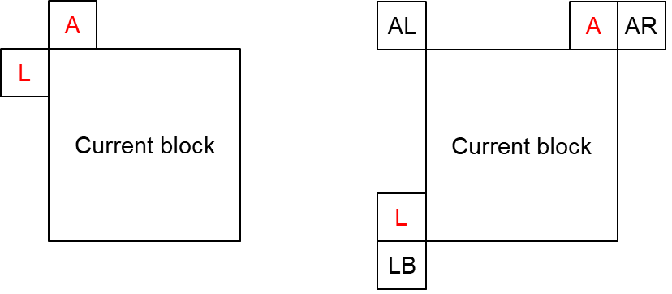
Figure 1. The derivation positions of MPM candidates (left: 3 MPM, right: 6 MPM)

Proposed modifications

Modification of positions deriving MPM candidates
The MPM candidates to be derived from the current positions shown in Figure 1 (left) are likely to be the same intra mode since both positions are close to each other. In this case, the MPM candidates may be configured in the default intra mode. In the proposed modification, as shown in Figure 2, the positions for MPM candidates derivation are changed from neighbors of the above-left corner to neighbors of two corners of the current block. This modification of derivation positions may allow more diverse MPM candidates to be derived and match with the MERGE candidates derivation position.
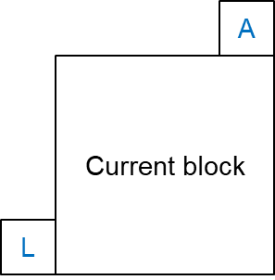
Figure 2. Proposed modified positions for MPM candidates derivation

Modification of context model for MPM_IDX
The 3 MPMs are signalled with 1-bin of MPM_FLAG and 2-bins of MPM_IDX which are binarized with truncated unary and coded using bypass coding mode. Since the intra mode of the current block tends to be similar to neighboring modes, if the neighboring intra modes are the same, the bypass coding mode may not be efficient for the encoding of the first bin. In this contribution, considering this tendency, the regular coding mode for the first bin of MPM_IDX is used instead of the bypass coding mode. The proposed modification adaptively uses one or two context models for the first bin according to the intra mode condition as shown in Table 1:
Table 1. assignments of ctxInc to mpm_idx syntax with context coded bin
Test | Syntax element | Bin Idx
Test | Syntax element | 0 | 1
Test 2 | mpm_idx[][] | (left intra mode == above intra mode) ? 0:1 | bypass
Test 3 | mpm_idx[][] | (left intra mode == above intra mode) ? 0:bypass | bypass

Experimental results
The proposed modifications are implemented on top of BMS-2.0.1 [4] and evaluated with VTM configuration according to the common test conditions [5]. This contribution reports on the performance on the four tests below:
- Test 1: Modified positions deriving MPM candidates
- Test 2: Modified context model of MPM_IDX with two context models
- Test 3: Modified context model of MPM_IDX with a single context model and bypass coding mode
- Test 4: Test 2 with Test 1

Table 2. Experiment results of Test 1 over All Intra
 | All Intra Main10
 | Over BMS-2.0.1 (VTM cfg)
 | Y | U | V | EncT | DecT
Class A1 | -0.03% | -0.04% | -0.05% | 100% | 103%
Class A2 | -0.05% | -0.08% | -0.11% | 98% | 99%
Class B | -0.09% | -0.11% | -0.03% | 99% | 100%
Class C | -0.09% | -0.11% | 0.08% | 100% | 100%
Class E | -0.07% | -0.16% | -0.18% | 100% | 96%
Overall | -0.07% | -0.10% | -0.05% | 99% | 100%
Class D | -0.06% | -0.03% | -0.18% | 101% | 96%
Class F (optional) | -0.09% | -0.27% | -0.13% | 101% | 99%

Table 3. Experiment results of Test 2 over All Intra
 | All Intra Main10
 | Over BMS-2.0.1 (VTM cfg)
 | Y | U | V | EncT | DecT
Class A1 | -0.13% | -0.26% | -0.14% | 98% | 105%
Class A2 | -0.04% | -0.05% | -0.10% | 97% | 102%
Class B | -0.08% | -0.13% | -0.08% | 98% | 101%
Class C | -0.04% | -0.12% | 0.03% | 99% | 99%
Class E | -0.12% | -0.16% | -0.12% | 99% | 97%
Overall | -0.08% | -0.14% | -0.08% | 98% | 101%
Class D | -0.05% | 0.12% | -0.09% | 100% | 95%
Class F (optional) | -0.36% | -0.48% | -0.27% | 99% | 99%

Table 4. Experiment results of Test 3 over All Intra
 | All Intra Main10
 | Over BMS-2.0.1 (VTM cfg)
 | Y | U | V | EncT | DecT
Class A1 | -0.14% | -0.14% | -0.16% | 98% | 103%
Class A2 | -0.04% | -0.09% | -0.11% | 98% | 99%
Class B | -0.10% | -0.13% | -0.08% | 98% | 99%
Class C | -0.06% | -0.07% | -0.01% | 99% | 99%
Class E | -0.14% | -0.12% | -0.29% | 99% | 95%
Overall | -0.10% | -0.11% | -0.12% | 98% | 99%
Class D | -0.06% | 0.09% | -0.13% | 107% | 97%
Class F (optional) | -0.25% | -0.26% | -0.12% | 99% | 100%

Table 5. Experiment result for Test 4 over All Intra
 | All Intra Main10
 | Over BMS-2.0.1 (VTM cfg)
 | Y | U | V | EncT | DecT
Class A1 | -0.17% | -0.20% | -0.19% | 98% | 103%
Class A2 | -0.11% | -0.17% | -0.13% | 98% | 100%
Class B | -0.18% | -0.19% | -0.15% | 98% | 99%
Class C | -0.12% | -0.15% | -0.07% | 98% | 99%
Class E | -0.18% | -0.19% | -0.25% | 99% | 95%
Overall | -0.15% | -0.18% | -0.15% | 98% | 99%
Class D | -0.08% | 0.20% | -0.23% | 100% | 95%
Class F (optional) | -0.53% | -0.61% | -0.48% | 100% | 100%

Table 6. Experiment results for Test 1 over Random Access
 | Random Access Main10
 | Over BMS-2.0.1 (VTM cfg)
 | Y | U | V | EncT | DecT
Class A1 | -0.03% | 0.03% | 0.09% | 101% | 100%
Class A2 | -0.01% | -0.03% | -0.03% | 100% | 100%
Class B | -0.02% | 0.02% | 0.07% | 99% | 97%
Class C | -0.01% | -0.01% | 0.17% | 99% | 95%
Class E
Overall | -0.02% | 0.01% | 0.08% | 100% | 98%
Class D | 0.00% | -0.51% | 0.11% | 98% | 90%
Class F (optional) | #VALUE! | #VALUE! | #VALUE! | #DIV/0! | #DIV/0!

Conclusions
This contribution presents two modifications of the MPM for intra mode coding. First, the positions deriving MPM candidates are modified to be the same as the positions deriving MERGE candidates. Next, the first bin of MPM_IDX is coded by one or two context models according to predefined condition. The four tests are performed in this contribution. The experimental results report 0.07%, 0.08%, 0.10% and 0.15% bitrate savings without increase of the encoding/decoding running time for Test 1, Test 2, Test 3, and Test 4, respectively.

References
- J. Chen, Y. Ye, and S. Kim, “Algorithm description for Versatile Video Coding and Test Model 2,” JVET document, JVET-K1002, July 2018.
- VVC Test Model (VTM), https://vcgit.hhi.fraunhofer.de/jvet/VVCSoftware_VTM/tags
- J. Chen, E. Alshina, G. J. Sullivan, J.-R. Ohm, and J. Boyce, “Algorithm description of Joint Exploration Test Model 7 (JEM7),” JVET document, JVET-G1001, July 2018.
- Benchmark Set (BMS), https://vcgit.hhi.fraunhofer.de/jvet/VVCSoftware_BMS/tags
- F. Bossen, J. Boyce, X. Li, V. Seregin, and K. Suhring, “JVET common test conditions and software reference configurations for SDR video,” JVET document, JVET-K1010, July 2018.

Patent rights declaration(s)
KAU and ETRI Inc. may have current or pending patent rights relating to the technology described in this contribution and, conditioned on reciprocity, is prepared to grant licenses under reasonable and non-discriminatory terms as necessary for implementation of the resulting ITU-T Recommendation | ISO/IEC International Standard (per box 2 of the ITU-T/ITU-R/ISO/IEC patent statement and licensing declaration form).

