    Joint Video Experts Team (JVET)  of ITU-T SG 16 WP 3 and ISO/IEC JTC 1/SC 29/WG 11  12th Meeting: Macao, CN, 3–12 Oct. 2018 | Document: JVET-L0152-v3

Title: | CE3-related: Simplification of PDPC
Status: | Input document to JVET
Purpose: | Proposal
Author(s) or  Contact(s): | Jinho Lee  Hahyun Lee  Sung-Chang Lim  Jungwon Kang  Hui Yong Kim  218 Gajeong-ro, Yuseong-gu, Daejeon, 34129, KOREA | Tel:  Email: | +82-42-860-5656  jinosoul@etri.re.kr  hanilee@etri.re.kr  sclim@etri.re.kr  jungwon@etri.re.kr  hykim5@etri.re.kr
Source: | ETRI (Electronics and Telecommunications Research Institute)
_____________________________

Abstract
This contribution presents modification of position dependent intra prediction combination (PDPC). It includes three modifications which are block size restriction, removal of interpolation, and restriction on wide angle intra prediction modes. It is reported that the average luma BD-rate gain of all the modifications for AI case is -0.03% compared to VTM 2.0.1.

Algorithm description
The position dependent intra prediction combination (PDPC)[1] is applied to intra predicted samples for all block sizes when an intra prediction mode is one of DC, Planar, horizontal/vertical, angular mode less than mode 11, and angular mode greater than mode 57.
In this contribution, three simplifications of PDPC such as block size restriction, removal of interpolation, and restriction on wide angle intra prediction modes are proposed to reduce complexity.

Block size restriction
The PDPC applies filters to intra predicted samples using reference samples with weights. Therefore, each predicted sample is refined by applying higher weight to closer reference sample. However, the PDPC may not perform efficiently for large blocks since the predicted samples are similar to the reference samples. It could reduce complexity without loss by restricting PDPC on large blocks, so the proposed method restricts PDPC when block width or height is 64. As a result, the maximum block size for PDPC is 32x32.
In addition, when a predicted sample is far from reference samples, weights for the reference samples are set to zero. As a result, the PDPC is applied to some prediction lines adjacent to the reference sample. The number of prediction lines are decided by scale value which is affecting the weights. In VTM 2.0, the scale value is set to ( Log2(Width) + Log2(Height) − 2 ) >> 2. Therefore, when the scale value is 2, 1, and 0, the PDPC is applied to up to 12, 6, and 3 prediction lines, respectively. In this contribution, the number of prediction lines are reduced by setting the scale value to ( Log2(Width) + Log2(Height) ) > 6 ? 1 : 0, and the PDPC is restricted when the width of height is 64. Table 1 represents the number of prediction lines used for PDPC based on block size in VTM 2.0 and proposed method, respectively.

Table 1. Number of prediction lines used for PDPC based on block size
S = Width + Height | VTM 2.0 | Proposed
S > 64 | 12 | -
S = 64 | 12 | 6
16 < S < 64 | 6 | 6
S = 16 | 6 | 3
S < 16 | 3 | 3

Removal of interpolation
For angular prediction, bilinear interpolation filter is applied to reference samples to generated prediction samples. For example, above two reference samples are interpolated for prediction when a vertical angular prediction mode is used as depicted in Fig. 1. In addition, left two reference samples are also interpolated in PDPC. To reduce computational complexity, an integer reference sample is used for PDPC rather than applying the interpolation in this simplification.
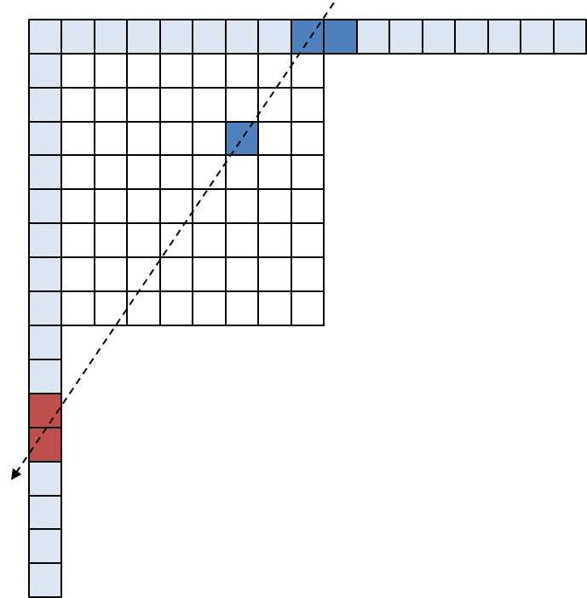
Figure 1. Interpolation for intra prediction and PDPC in VTM 2.0

Restriction on wide angle intra prediction modes
In VTM 2.0, wide angle intra prediction (WAIP) modes are used when a ratio of non-square block and an intra prediction mode are satisfied with a certain condition. By harmonizing PDPC with WAIP, the PDPC is also applied to the WAIP modes. However, the PDPC reflecting higher weight to closer reference sample may not be efficient since the references samples for prediction are already replaced with closer reference sample by the WAIP. In this modification, the PDPC is simply disabled for the WAIP modes.

Experimental results
The experiments were performed based on BMS 2.0.1 software [2] with VTM 2.0.1 configuration file under JVET common test condition [3].
Below Tables show experimental results of the each proposed method compared to VTM 2.0.1. The average luma BD-rate gain for AI case of all the proposed methods is -0.03% as represented in Table 5.

Table 2: T1. Block size restriction
Table 3: T2. Removal of interpolation
Table 4: T3. Restriction on WAIP modes
Table 5: T4. T1 + T2 + T3

Table 2. Results of T1 over VTM 2.0.1
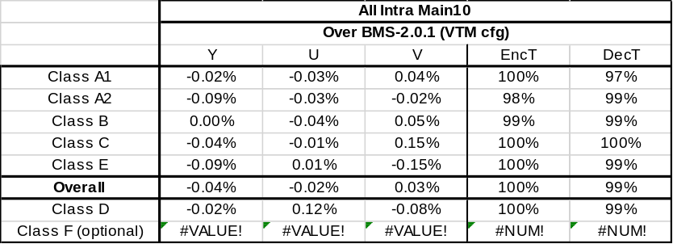

Table 3. Results of T2 over VTM 2.0.1
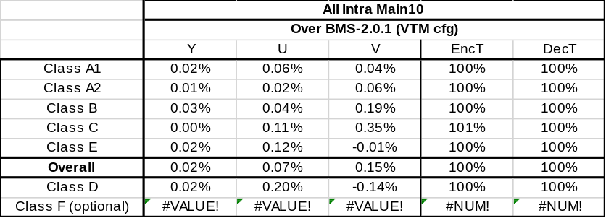

Table 4. Results of T3 over VTM 2.0.1
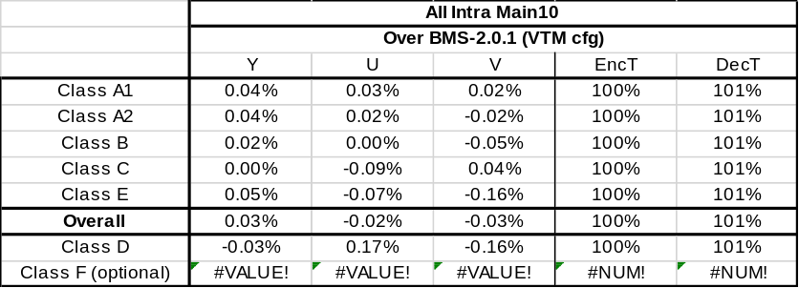

Table 5. Results of T4 over VTM 2.0.1
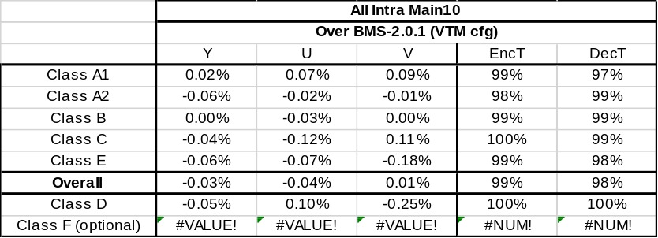

Conclusions
This contribution reports three simplifications of PDPC to reduce complexity. The average luma BD-rates is almost same when all the proposed methods are applied, and encoding/decoding time is slightly decreased. We suggest the proposed methods to be adopted into VTM 3.0.

Reference
- G. Van der Auwera, V. Seregin, A. Said, A. K. Ramasubramonian, and M. Karczewicz, “CE3: Simplified PDPC (Test 2.4.1),” JVET-K0063, July. 2018
- https://vcgit.hhi.fraunhofer.de/jvet/VVCSoftware_BMS/tags/BMS-2.0.1
- F. Bossen, J. Boyce, X. Li, V. Seregin, and K. Sühring, “JVET common test conditions and software reference configurations for SDR video,” JVET-K1010, July 2018.

Patent rights declaration(s)
ETRI may have current or pending patent rights relating to the technology described in this contribution and, conditioned on reciprocity, is prepared to grant licenses under reasonable and non-discriminatory terms as necessary for implementation of the resulting ITU-T Recommendation | ISO/IEC International Standard (per box 2 of the ITU-T/ITU-R/ISO/IEC patent statement and licensing declaration form).

Annex - Decoding process (Based on JVET-K1001-v5)

Block size restriction
8.2.4.2.1 General intra sample prediction
…
When nTbW is less than MaxTbSizeY, nTbH is less than MaxTbSizeY, and one of the following conditions is true, the position-dependent prediction sample filtering process specified in clause 8.2.4.2.9 is invoked with the intra prediction mode predModeIntra, the transform block width nTbW, the transform block height nTbH, the predicted samples predSamples[ x ][ y ], with x = 0..nTbW − 1, y = 0..nTbH − 1, the reference sample width refW, the reference sample height refH, the reference samples p[ x ][ y ], with x = −1, y = −1..refH − 1 and x = 0..refW − 1, y = −1, and the colour component index cIdx as inputs, and the output is the modified predicted sample array predSamples:
- predModeIntra is equal to INTRA_PLANAR
- predModeIntra is equal to INTRA_DC
- predModeIntra is equal to INTRA_ANGULAR18
- predModeIntra is equal to INTRA_ANGULAR50
- predModeIntra is less than or equal to INTRA_ANGULAR10
- predModeIntra is greater than or equal to INTRA_ANGULAR58

8.2.4.2.9 Position-dependent intra prediction sample filtering process
Inputs to this process are:
- the intra prediction mode predModeIntra,
- a variable nTbW specifying the transform block width,
- a variable nTbH specifying the transform block height,
- a variable refW specifying the reference samples width,
- a variable refH specifying the reference samples height,
- the predicted samples predSamples[ x ][ y ], with x = 0..nTbW − 1, y = 0..nTbH − 1,
- the neighbouring samples p[ x ][ y ], with x = −1, y = −1..refH − 1 and x = 0..refW − 1, y = −1,
- a variable cIdx specifying the colour component of the current block.
Outputs of this process are the modified predicted samples predSamples[ x ][ y ] with x = 0..nTbW − 1, y = 0..nTbH − 1.
Depending on the value of cIdx, the function clip1Cmp is set as follows:
- If cIdx is equal to 0, clip1Cmp is set equal to Clip1_{Y}.
- Otherwise, clip1Cmp is set equal to Clip1_{C}.
The variable nScale = ( Log2( nTbW ) + Log2( nTbH ) ) > 6 ? 1 : 0
is set to ( ( Log2( nTbW ) + Log2( nTbH ) − 2 ) >> 2 ).

Removal of interpolation
8.2.4.2.9 Position-dependent intra prediction sample filtering process
Inputs to this process are:
…
- Otherwise, if predModeIntra is less than or equal to INTRA_ANGULAR10, the following ordered steps apply:
- The variables dXPos[ y ], dXFrac[ y ], dXInt[ y ] and dX[ x ][ y ] are derived as follows using invAngle as specified in clause 8.2.4.2.7 depending on intraPredMode:
dXPos[ y ] = ( ( y + 1 ) * invAngle + 2 ) >> 2
dXFrac[ y ] = dXPos[ y ] & 63 (8-86)
dXInt[ y ] = dXPos [ y ] >> 6
dX[ x ][ y ] = x + dXInt[ y ]
- The variables refL[ x ][ y ], refT[ x ][ y ], wT[ y ], wL[ x ] and wTL[ x ][ y ] are derived as follows:
refL[ x ][ y ] = 0 (8-87)
refT[ x ][ y ] = ( dX[ x ][ y ] < refW − 1 ) ? mainRef[ dX[ x ][ y ] ] : 0 (8-88)
( ( 64 − dXFrac[ y ] ) * mainRef[ dX[ x ][ y ] ] +
dXFrac[ y ] * mainRef[ dX[ x ][ y ] + 1 ] + 32 ) >> 6 (8-88)
: 0
wT[ y ] = ( dX[ x ][ y ] < refW − 1 ) ? 32 >> ( ( y << 1 ) >> nScale ) : 0 (8-89)
wL[ x ] = 0 (8-90)
wTL[ x ][ y ] = 0 (8-91)
- Otherwise, if predModeIntra is greater than or equal to INTRA_ANGULAR58, the following ordered steps apply:
- The variables dYPos[ x ], dYFrac[ x ], dYInt[ x ] and dY[ x ][ y ] are derived as follows using invAngle as specified in clause 8.2.4.2.7 depending on intraPredMode:
dYPos[ x ] = ( ( x + 1 ) * invAngle + 2 ) >> 2
dYFrac[ x ] = dYPos[ x ] & 63 (8-92)
dYInt[ x ] = dYPos[ x ] >> 6
dY[ x ][ y ] = y + dYInt[ x ]
- The variables refL[ x ][ y ], refT[ x ][ y ], wT[ y ], wL[ x ] and wTL[ x ][ y ] are derived as follows:
refL[ x ][ y ] = ( dY[ x ][ y ] < refH − 1 ) ? sideRef[ dY[ x ][ y ] ] : 0 (8-93)
( ( 64 − dYFrac[ x ] ) * sideRef[ dY[ x ][ y ] ] +
dYFrac[ x ] * sideRef[ dY[ x ][ y ] + 1 ] + 32 ) >> 6 (8-93)
: 0
refT[ x ][ y ] = 0 (8-94)
wT[ y ] = 0 (8-95)
wL[ x ] = ( dY[ x ][ y ] < refH − 1 ) ? 32 >> ( ( x << 1 ) >> nScale ) : 0 (8-96)
wTL[ x ][ y ] = 0 (8-97)
…

Restriction on wide angle intra prediction modes
8.2.4.2.1 General intra sample prediction
…
- Otherwise, the corresponding intra prediction mode process specified in clause 8.2.4.2.7 is invoked with the intra prediction mode predModeIntra, the transform block width nTbW, the transform block height nTbH, the reference sample width refW, the reference sample height refH, and the reference sample array p as inputs, and the modified intra prediction mode predModeIntra and the predicted sample array predSamples as outputs.

8.2.4.2.7 Specification of INTRA_ANGULAR2..INTRA_ANGULAR66 intra prediction modes
Inputs to this process are:
- the intra prediction mode predModeIntra,
- a variable nTbW specifying the transform block width,
- a variable nTbH specifying the transform block height,
- a variable refW specifying the reference samples width,
- a variable refH specifying the reference samples height,
- the neighbouring samples p[ x ][ y ], with x = −1, y = −1..refH − 1 and x = 0..refW − 1, y = −1
Outputs of this process are the modified intra prediction mode predModeIntra and the predicted samples predSamples[ x ][ y ], with x = 0..nTbW − 1, y = 0..nTbH − 1.

