    Joint Video Experts Team (JVET)  of ITU-T SG 16 WP 3 and ISO/IEC JTC 1/SC 29/WG 11  12th Meeting: Macau, CN, 08–12 Oct. 2018 | Document: JVET-L0142

Title: | CE4: Simplification of the common base for affine merge (Test 4.2.2)
Status: | Input document to JVET
Purpose: | Proposal
Author(s) or  Contact(s): | Jaeho Lee  Junghak Nam  Naeri Park  Hyeongmun Jang  Jaeho Lee  Jaehyun Lim  Seung Hwan Kim  19 Yangjaedaero-11gil  Seocho-gu, Seoul 06772  South Korea | Tel:  Email: | +82-2-6912-6561  {jhlee.lee, junghak.nam, naeri.park, hm.jang, jaehyun.lim, seunghwan3.kim}@lge.com
Source: | LG Electronics Inc.
_____________________________

Abstract
This document reports the results of Simplification of the common base for affine merge as follows;
- Test 4.2.6.a: Simplified inherited candidate
- Test 4.2.6.b: Simplified constructed candidate
- Test 4.2.6.c: a) + b)
- Test 4.2.6.d: c) + reduced candidate number of candidate
- Test 4.2.6.e: d) + line buffer restriction
- Test 4.2.6.f: d) + Test 4.1.2.d
- Test 4.2.6.g: e) + Test 4.1.2.e
Test results are reported the negligible coding loss with complexity reduction in terms of the pruning check and the scaling of motion vector.

Introduction

Simplified inherited candidate
In this method, the maximum two inherited affine candidates are derived from affine motion model of the neighboring blocks and inserted into the candidate list. For the left predictor, the scan order is: {A, D, E} and for the above predictor, the scan order is: {B, C} as shown in Figure 1. Each predictor selects the only one inherited candidate. No pruning check in performed between two inherited candidates.
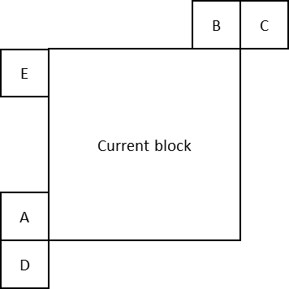
Figure 1: Spatial positions for inherited candidate

Simplified constructed candidate
In the common base for affine merge, the available combination of motion information of CPs is only considered when the CPs have the same reference index.

Reduced candidate number of candidate
In the available constructed candidates, the following candidates are not considered:
{CP2, CP3}, {CP1, CP4}, {CP2, CP4}, {CP3, CP4}

Line buffer restriction
In this method, to avoid the line buffer storage increase, inherited candidate is restricted to derive from the above block with CTU boundary.

Technical description
The proposed methods have been implemented on the top of VTM-2.0.1 with the common based for affine merge, and tested based on JVET SDR common test condition.
Seven tests have been performed as listed in Table 1 and results are summarized in Table 2 ~ Table 7.
Table 1: Test specification of Test 4.1.4
Test # | Test Description
4.2.4.a | Simplified inherited candidate
4.2.4.b | Simplified constructed candidate
4.2.4.c | a) + b)
4.2.4.d | c) + reduced candidate number of candidate
4.2.4.e | d) + line buffer restriction
4.2.4.f | d) + Test 4.1.2.d
4.2.4.g | e) + Test 4.1.2.e
Table 2: Test results of 4.2.4.a.
Table 2: Test results of 4.2.4.a.
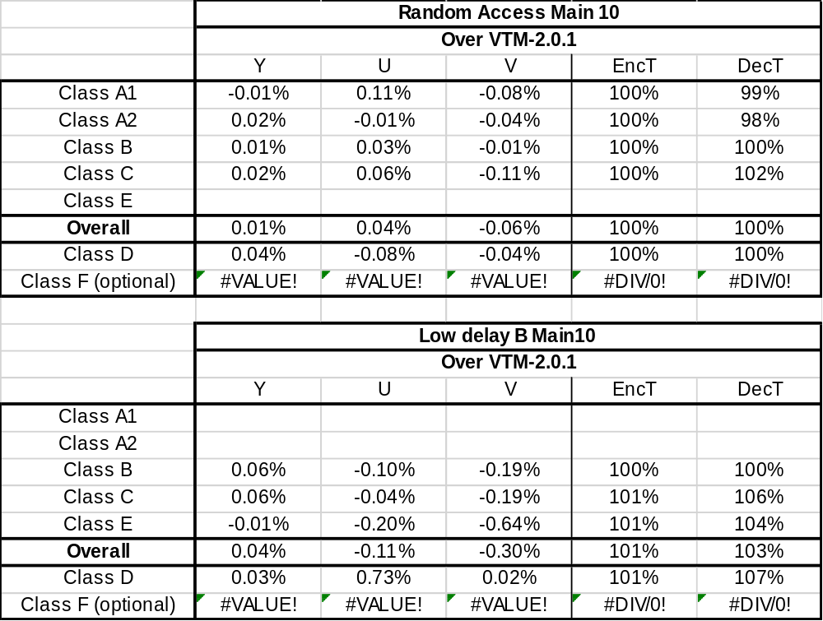
Table 3: Test results of 4.2.4.b.
Table 4: Test results of 4.2.4.c.
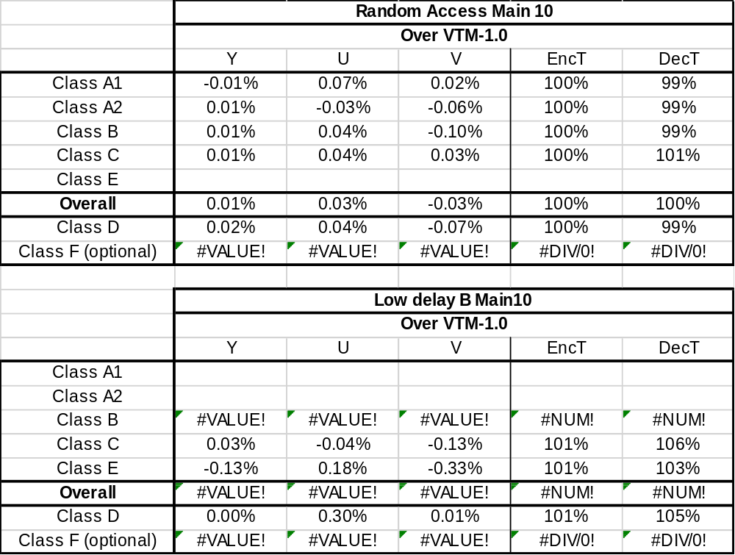
Table 5: Test results of 4.2.4.d.
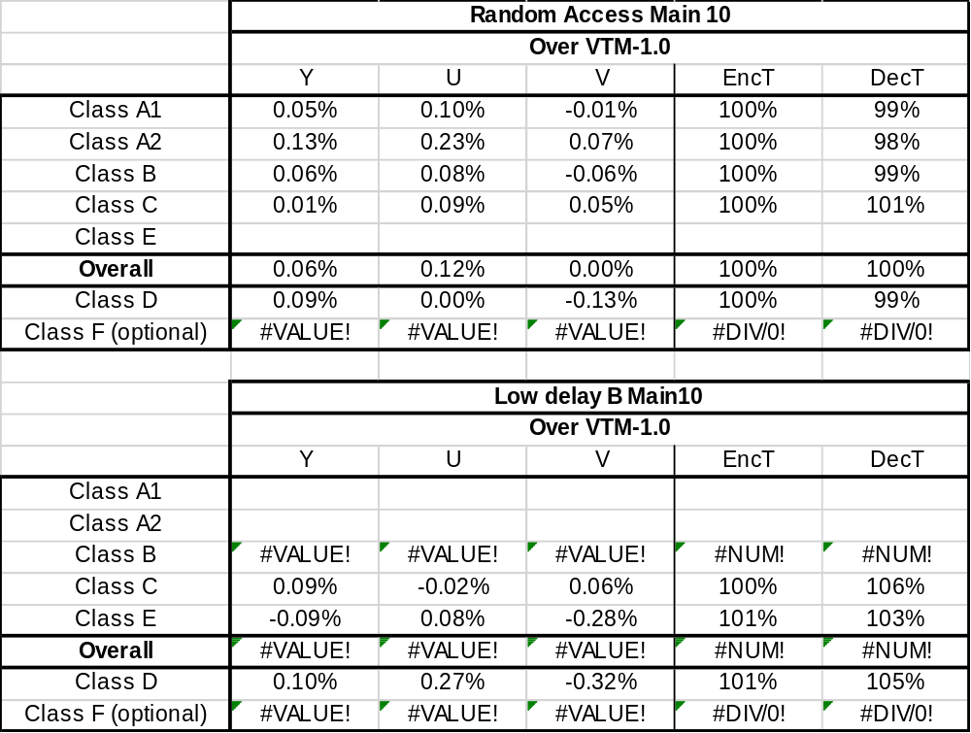
Table 6: Test results of 4.2.4.e.
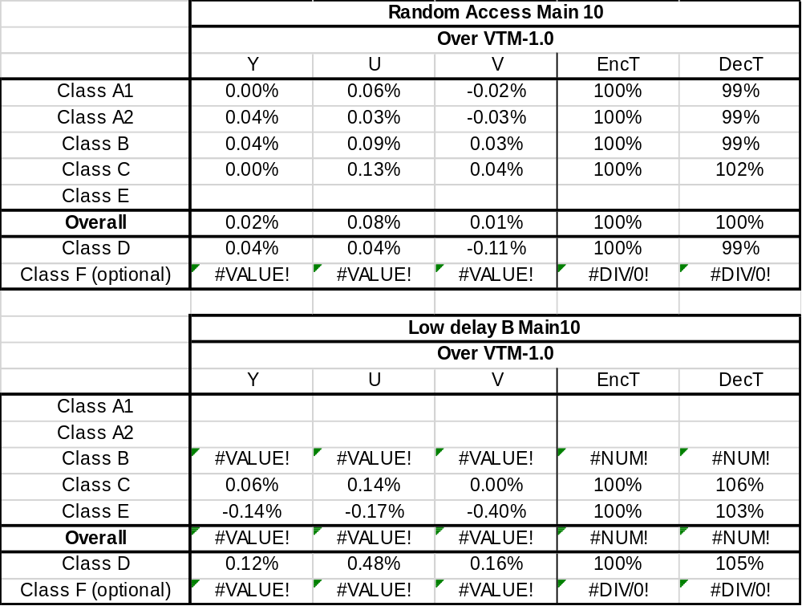
Table 7: Test results of 4.2.4.f.

Patent rights declaration(s)
LG Electronics Inc. may have current or pending patent rights relating to the technology described in this contribution and, conditioned on reciprocity, is prepared to grant licenses under reasonable and non-discriminatory terms as necessary for implementation of the resulting ITU-T Recommendation | ISO/IEC International Standard (per box 2 of the ITU-T/ITU-R/ISO/IEC patent statement and licensing declaration form).

