    Joint Video Experts Team (JVET)  of ITU-T SG 16 WP 3 and ISO/IEC JTC 1/SC 29/WG 11  12th Meeting: Macao, CN, 3-12 Oct. 2018 | Document: JVET-L0139-v5

Title: | CE3-related : Simplified MDMS
Status: | Input document to JVET
Purpose: | Proposal
Author(s) or  Contact(s): | Jangwon Choi, Jin Heo, Sunmi Yoo, Ling Li, Jungah Choi, Jaehyun Lim  19 Yangjaedaero-11gil  Seocho-gu, Seoul 06772  South Korea | Tel:  Email: | +82-2-6912-6561  { jangwon84.choi, jin78.heo, sunmi.yoo, l.li, jungah.choi, jaehyun.lim }@lge.com
Source: | LG Electronics Inc.
_____________________________

Abstract
This contribution proposes a simplified MDMS. In this method, chroma intra candidate modes are derived from the simplified DM point searching and the reduced number of context models is used in the binarization of chroma intra modes, compared to the JEM MDMS.
Experimental results with 5 chroma modes show -0.09%, -0.97%, and -1.00% BD-rates on Y, Cb, and Cr components, respectively, compared to VTM2.0.1 in All Intra configuration, and -0.00%, -0.83%, and -0.77% BD-rates, compared to VTM2.0.1 in Random Access configuration.
Experimental results with 3 chroma modes show -0.09%, -0.30%, and -0.31% BD-rates on Y, Cb, and Cr components, respectively, compared to VTM2.0.1 in All Intra configuration, and 0.03%, -0.30%, and -0.31% BD-rates, compared to VTM2.0.1 in Random Access configuration.

Introduction
The MDMS (multiple DM modes signaling) method was proposed in JVET-D0111 [1]. In the MDMS, the list generation of chroma mode candidates except CCLM mode is composed of the following two parts:

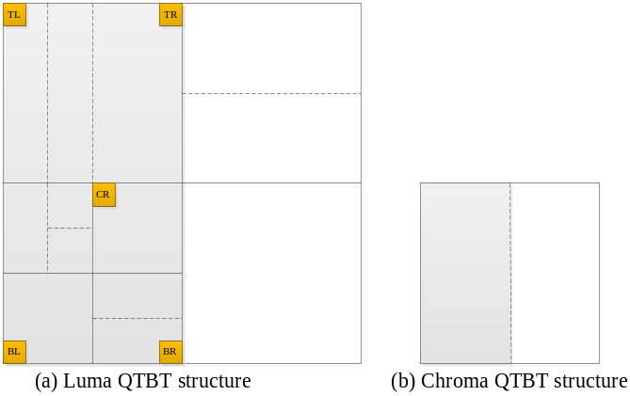
Figure 1 Example of corresponding sub-blocks for a chroma CB in I slice.

- intra prediction modes derived from luma CBs covering the co-located five positions of the current chroma block: the five positions to be checked in order are defined as: center (CR), top-left (TL), top-right (TR), bottom-left (BL) and bottom-right (BR) 4x4 block within the corresponding luma block of current chroma block for I slices. For P and B slices, only one of these five sub-blocks is checked since they have the same mode index. An example of five co-located luma positions is shown in Figure 1.
- chroma prediction modes from spatial neighboring blocks to unify the luma and chroma mode derivation process as follows:
  - 5 chroma prediction modes from left, above, below-left, above-right, and above-left spatial neighboring blocks of merge mode
  - Planar and DC modes
  - derived modes are added, those intra modes are obtained by adding -1 or +1 to the angular modes which are already included into the list
  - default modes are added in the order of: Vertical (Mode 18), Horizontal (Mode 50), Mode 2, Mode 34, Mode 66, Mode 10, Mode 26
  - if any of the four default modes (Planar, Horizontal, Vertical and DC modes) is not included in the list, the missing default modes are used to replace the last one or more candidates
Pruning process is applied whenever a new chroma intra mode is added to the candidate list.

In the VTM2, the chroma intra candidate modes are constructed as the same way of HEVC[2], which constructed with the one DM mode and the four default modes (i.e. Planar, Vertical, Horizontal, DC, and Mode 66).
Table 1 shows the complexity comparison of the number of pruning check, point access, and context models in the worst case between VTM2 and MDMS.

Table 1 Complexity analysis of VTM2 and MDMS
 | VTM2 | MDMS
Number of pruning check | 4 | 40
Number of luma DM point access | 1 | 5
Number of chroma neighbor spatial access | 0 | 5
Number of context models | 1 | 5

Proposed method
This contribution proposes a simplified MDMS method, which uses the reduced number of both point accesses and context models. In the proposed method, five chroma intra candidate modes are constructed with the two DM points (BL, and TR as shown in Figure 1). The chroma intra candidate mode list is generated as follows:

- If BL = TR and BL is either Planar or DC : BL, !BL, Vertical, Horizontal, and Mode 66
- If BL = TR and BL is neither Planar nor DC : BL, BL-1, BL+1, Planar, DC
- If BL != TR and BL+TR < 2 : BL, TR, Vertical, Horizontal, and Mode 66
- If BL != TR and both BL and TR are not Planar and DC : BL, TR, Planar, DC, BL-1
- Else : BL, TR, Planar or DC, max(BL,TR)-1, max(BL,TR)+1

Figure 2 shows the flow chart of the proposed method.

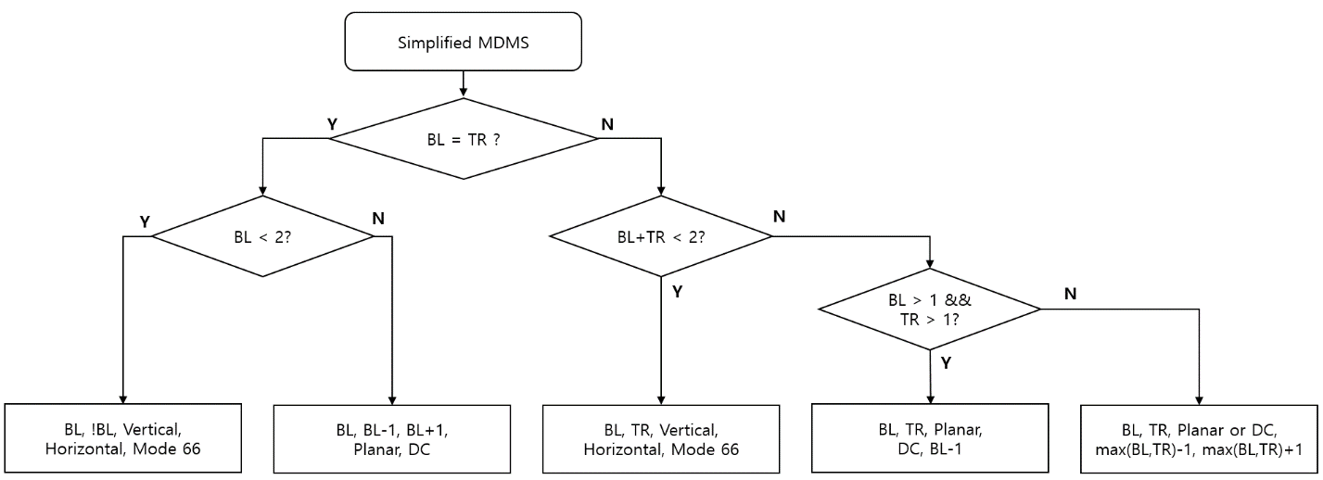
Figure 2 Flow chart of the proposed method.

In order to reduce the complexity, this proposal reduces the number of context models which are used in the binarization of the chroma intra mode is set to 1 (i.e., reduced 5 to 1, compared to the JEM MDMS). More precisely, the first chroma candidate mode is binarized with 1 bit which is encoded using 1 context model, and the remained four chroma modes are binarized with 1 bit plus 2 bins from fixed length binarization without context models, as shown in Table 2.

Table 2 Comparison of the chroma intra mode binarization with the JEM MDMS and the proposed method
 | Binarization |  | Number of context model
 | JEM MDMS | Proposed method | JEM MDMS | Proposed method
Chroma candidate mode 1 | 0 | 0 | 1 | 1
Chroma candidate mode 2 | 10 | 100 | 1 | 0
Chroma candidate mode 3 | 110 | 101 | 1 | 0
Chroma candidate mode 4 | 1110 | 110 | 1 | 0
Chroma candidate mode 5 | 11110 | 111 | 1 | 0
Total number of context models |  |  | 5 | 1

Table 3 shows the complexity comparison of the number of pruning (or condition) processes, point accesses, and context models in the worst case of VTM2, MDMS, and proposed method.

Table 3 Complexity analysis of VTM2, MDMS, and proposed method
 | VTM2 | MDMS | Proposed method
Number of pruning (or condition) processes | 4 | 40 | 5
Number of luma DM point accesses | 1 | 5 | 2
Number of chroma neighbor spatial accesses | 0 | 5 | 0
Number of context models | 1 | 5 | 1

As shown in Table 3, the proposed algorithm has similar complexity with the VTM2 chroma intra mode generation.

We also propose the simplified MDMS with three chroma candidate modes to reduce the complexity of VVC encoder. The intra prediction of current VVC has a problem that the complexity of intra prediction is so high. To reduce the complexity of intra prediction without coding loss, we apply the proposed method with the three chroma candidate modes. With this approach, we can reduce the RD process in the chroma intra prediction to 3, without the coding loss in All Intra configuration.
The three chroma intra candidate mode list is generated as exactly same as 3 intra luma MPM modes of VTM2, as follows:
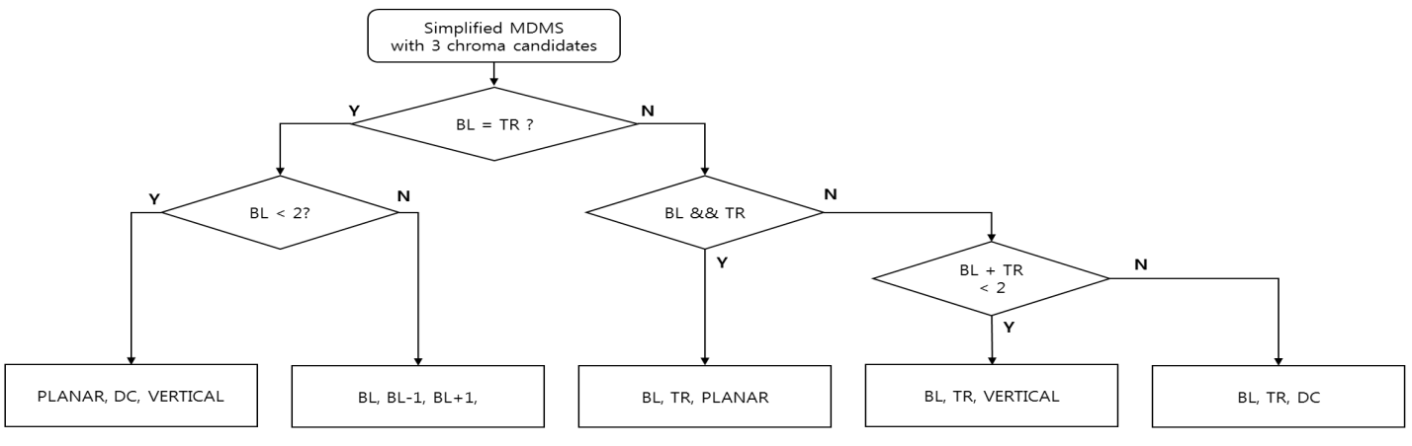
Figure 3 Flow chart of the proposed method.

Table 4 shows the binarization of the proposed method with the three chroma candidate modes.
Table 4 The three chroma intra mode binarization with the proposed method
 | binarization | Number of context model
Chroma candidate mode 1 | 0 | 1
Chroma candidate mode 2 | 10 | 0
Chroma candidate mode 3 | 11 | 0

Table 5 shows the detailed complexity comparison in the worst case of VTM2, MDMS, and proposed two method.

Table 5 Complexity analysis of VTM2, MDMS, and proposed two method
 |  | Max number of Luma DM point to access | Max number of neighbors to access | Max layers of if conditions | Max number of comparison operator | Max number of logical operators | Max number of assignment operators
VTM2 |  | 1 | 0 | 1 | 4 | 0 | 9
MD MS |  | 5 | 5 | 4 | 39 | 28 | 80
JVET-L0139 | 5 mode | 2 | 0 | 3 | 5 | 1 | 18
JVET-L0139 | 3 mode | 2 | 0 | 2 | 3 | 1 | 13

 |  | Max number of increments | Max number of bit operation | Number of Context modeling for MPM coding | number of full RDO checks | Has LUT? | LUT size
VTM2 |  | 0 | 0 | 2 | 6 | N | 0
MD MS |  | 5 | 2 | 6 | 6 | Y | 68
JVET-L0139 | 5 mode | 2 | 2 | 2 | 6 | N | 0
JVET-L0139 | 3 mode | 2 | 2 | 2 | 4 | N | 0

Experimental results
The proposed method has been implemented using BMS-2.0.1 as software base and experimentally evaluated for VTM test according to the common test conditions defined in JVET-K1010 [3] and Core Experiment description in JVET-K1023 [4]. For the VTM based test, the VTM configuration was enabled.
Table 6 and Table 7 show the test1 results of proposed method in AI and RA configurations.

Table 6 Experimental results of Test1 for all-intra (AI) test condition; anchor is VTM2.0.1
 | All Intra Main10
 | Over VTM-2.0.1
 | Y | U | V | EncT | DecT
Class A1 | -0.07% | -0.61% | -0.66% | 99% | 99%
Class A2 | -0.09% | -0.86% | -0.82% | 100% | 99%
Class B | -0.07% | -0.92% | -1.04% | 99% | 99%
Class C | -0.07% | -0.98% | -0.89% | 99% | 99%
Class E | -0.18% | -1.52% | -1.63% | 99% | 99%
Overall | -0.09% | -0.97% | -1.00% | 99% | 99%
Class D | -0.06% | -0.53% | -0.95% | 99% | 95%

Table 7 Experimental results of Test1 for random-access (RA) test condition; anchor is VTM2.0.1
 | Random Access Main 10
 | Over VTM-2.0.1
 | Y | U | V | EncT | DecT
Class A1 | -0.06% | -0.39% | -0.41% | 100% | 101%
Class A2 | -0.02% | -0.71% | -0.56% | 99% | 100%
Class B | 0.03% | -1.08% | -1.18% | 100% | 100%
Class C | 0.03% | -0.92% | -0.68% | 100% | 100%
Class E
Overall | 0.00% | -0.83% | -0.77% | 100% | 100%
Class D | 0.00% | -1.06% | -0.61% | 99% | 94%
Also, Table 8 and 9 show the test2 results of proposed method with 3 chroma candidate modes in AI and RA configurations.

Table 8 Experimental results of Test2 for all-intra (AI) test condition; anchor is VTM2.0.1
 | All Intra Main10
 | Over VTM-2.0.1
 | Y | U | V | EncT | DecT
Class A1 | -0.06% | -0.11% | -0.35% | 97% | 98%
Class A2 | -0.07% | -0.27% | -0.34% | 96% | 98%
Class B | -0.07% | -0.41% | -0.43% | 98% | 98%
Class C | -0.08% | -0.29% | -0.06% | 97% | 101%
Class E | -0.16% | -0.77% | -0.68% | 98% | 98%
Overall | -0.09% | -0.37% | -0.36% | 97% | 99%
Class D | -0.08% | 0.05% | -0.26% | 96% | 94%

Table 9 Experimental results of Test2 for random-access (RA) test condition; anchor is VTM2.0.1
 | Random Access Main 10
 | Over VTM-2.0.1
 | Y | U | V | EncT | DecT
Class A1 | -0.03% | 0.01% | -0.21% | 98% | 99%
Class A2 | 0.02% | -0.12% | -0.25% | 97% | 98%
Class B | 0.04% | -0.51% | -0.46% | 98% | 99%
Class C | 0.08% | -0.41% | -0.24% | 98% | 99%
Class E
Overall | 0.03% | -0.30% | -0.31% | 98% | 99%
Class D | 0.06% | -0.48% | -0.17% | 98% | 94%

Conclusions
To reduce the complexity of the MDMS, simplified MDMS is proposed. In this method, two positions are utilized in the corresponding luma CB and only one context model is used in the chroma mode coding. This method reduces the operation complexity of the MDMS similar to the current VTM2 with 0.09%, 0.97%, and 1.00% bit rate savings on Y, Cb, and Cr components respectively, compared to VTM2.0.1 in All Intra configuration.

Reference
- Y. Chen, et al., “Description of SDR, HDR and 360° video coding technology proposal by Qualcomm and Technicolor – low and high complexity versions”, Joint Video Exploration Team (JVET) of ITU-T SG 16 WP 3 and ISO/IEC JTC 1/SC 29/WG 11 JVET-J0021, 10th Meeting, San Diego, CA, 10-20 April 2017.
- B. Bross, et al., “Versatile Video Coding (Draft 2)” Joint Video Exploration Team (JVET) of ITU-T SG 16 WP 3 and ISO/IEC JTC1/SC 29/WG 11 JVET-K1001, 11th meeting, Ljubljana, SI, 10-18 July 2018.
- F. Bossen, et al., “JVET common test conditions and software reference configurations for SDR video” Joint Video Exploration Team (JVET) of ITU-T SG 16 WP 3 and ISO/IEC JTC1/SC 29/WG 11 JVET-K1010, 11th meeting, Ljubljana, SI, 10-18 July 2018.
- G. Van der Auwera, et al., “Description of Core Experiment 3 (CE3): Intra Prediction and Mode Coding” Joint Video Exploration Team (JVET) of ITU-T SG 16 WP 3 and ISO/IEC JTC1/SC 29/WG 11 JVET-K1021, 11th meeting, Ljubljana, SI, 10-18 July 2018.

Patent rights declaration
LG Electronics Inc. may have current or pending patent rights relating to the technology described in this contribution and, conditioned on reciprocity, is prepared to grant licenses under reasonable and non-discriminatory terms as necessary for implementation of the resulting ITU-T Recommendation | ISO/IEC International Standard (per box 2 of the ITU-T/ITU-R/ISO/IEC patent statement and licensing declaration form).

