    Joint Video Experts Team (JVET)  of ITU-T SG 16 WP 3 and ISO/IEC JTC 1/SC 29/WG 11  12th Meeting: Macao, CN, 3–12 Oct. 2018 | Document: JVET-L0099-v2

Title: | CE9-related: BIO simplification
Status: | Input document to JVET
Purpose: | Proposal
Author(s) or  Contact(s): | Chen-Yen Lai, Yu-Chi Su,  Tzu-Der Chuang, Ching-Yeh Chen,  Yu-Wen Huang, Shaw-Min Lei  No. 1, Dusing 1st Rd.,  Hsinchu City 30078, Taiwan | Tel:  Email: | +886-3-5670766  {jenny.lai, yu-chi.su, peter.chuang, chingyeh.chen, yuwen.huang, shawmin.lei}  @mediatek.com
Source: | MediaTek Inc.
_____________________________

Abstract
This contribution proposes four simplifications on bi-prediction optical flow (BIO). The first simplification is to reduce operation bit depth by applying bit depth constraints. The second simplification is to reduce the worst case number of extra 8-tap interpolation filtering by disabling BIO for small CUs. The third simplification is to reduce data dependency by applying one fixed filter to intermediate results after horizontal interpolation in MC process for gradient calculation. The four simplification is to reduce the required MC samples. Simulation results are shown as follows, where the anchor disables BIO.
BIO:
VTM2.0.1-RA: {Y-BD-rate = -1.41%, EncT=105%, DecT=119%}
BIO with simplification 1: Apply bit depth constraints
VTM2.0.1-RA: {Y-BD-rate = -1.38%, EncT=105%, DecT=119%}
BIO with simplification 2: Disable BIO for small CUs
VTM2.0.1-RA: {Y-BD-rate = -1.36%, EncT=104%, DecT=117%}
BIO with simplification 3: Apply one fixed filter to intermediate results after horizontal interpolation in MC process for gradient calculation
VTM2.0.1-RA: {Y-BD-rate = -1.13%, EncT=106%, DecT=123%}
BIO with simplification 1 and simplification 2
VTM2.0.1-RA: {Y-BD-rate = -1.35%, EncT=104%, DecT=117%}
BIO with simplification 1, simplification 2, and simplification 3
VTM2.0.1-RA: {Y-BD-rate = -1.10%, EncT=104%, DecT=122%}
BIO with simplification 1, simplification 2, and simplification 4.1: Reduce the required MC samples from (W+4)x(H+4) to (W+2)x(H+2)
VTM2.0.1-RA: {Y-BD-rate = -1.31%}
BIO with simplification 1, simplification 2, and simplification 4.2: Reduce the required MC samples from (W+4)x(H+4) to WxH
VTM2.0.1-RA: {Y-BD-rate = -1.22%}

Introduction
BIO is proposed in VCEG-AZ07 and adopted in JEM. The concept of BIO is to utilize the assumption of optical flow and steady motion to further refine the final predictor in bi-prediction. In this contribution, simplifications to BIO are tested.

Proposed methods

Apply bit depth constraints (simplification 1)
In the current design of BIO, operations with bit depth higher than 32 are needed. For example, in BIO displacement derivation, several sums of products (s1, s2, …, s6) between “per sample difference between predictor of list 0 (L0) and predictor of list 1 (L1) (predDiff),” “per sample sum of the horizontal gradients of L0 and L1 (gradXSum),” and “per sample sum of vertical gradient of L0 and L1 (gradYSum)” are accumulated in one 6x6 window, as shown in the following equations, where $I_{x}^{\left(0\right)}\left[i^{'},j^{'}\right]$ and $I_{x}^{\left(1\right)}\left[i^{'},j^{'}\right]$represent horizontal gradient values in L0 and L1, $I_{y}^{\left(0\right)}\left[i^{'},j^{'}\right]$ and $I_{y}^{\left(1\right)}\left[i^{'},j^{'}\right]$represent vertical gradient values in L0 and L1, and $p^{\left(0\right)}\left[i^{'},j^{'}\right]$ and $p^{\left(1\right)}\left[i^{'},j^{'}\right]$represent sample values after MC interpolation in L0 and L1 before right shift to be consistent with input sample bit depth, i.e., 10 bits in common test conditions (CTC). In these equations, the bit depth of predDiff is 17; the bit depths of gradXSum and gradYSum are 14. Therefore, the bit depths of the products are up to 30, and the bit depths of the sums of the products in one 6x6 window are up to 36 or 42 if additional 6 bits in S6 for high precision operations is also counted. To allow 32-bit operations for BIO, it is proposed to right shift 4 bits for three intermediate values in BIO process, including predDiff, gradXSum, and gradYSum. The additional 6 bits in S6 and additional 5 bits in S5 for high precision operations is also moved to the derivation process of displacement to further reduce the required bit depth of intermediate data.

$$predDiff\left[i^{'},j^{'}\right]= p^{(0)}\left[i^{'},j^{'}\right]-p^{\left(1\right)}\left[i^{'},j^{'}\right],$$
$$gradXSum\left[i^{'},j^{'}\right]=I_{x}^{\left(0\right)}\left[i^{'},j^{'}\right]+I_{x}^{\left(1\right)}\left[i^{'},j^{'}\right]$$
$$gradYSum\left[i^{'},j^{'}\right]=I_{y}^{(0)}\left[i^{'},j^{'}\right]+I_{y}^{(1)}[i^{'},j^{'}]$$
$$s1=-\sum_{Ω}{{\left(gradXSum[i^{'}, j']\right)}^{2}}$$
$$s2=s4=\sum_{Ω}{\left(gradXSum[i^{'}, j']\right)\left(gradYSum[i^{'}, j']\right)}$$
$s3=-\sum_{Ω}{\left(predDiff\left[i^{'},j^{'}\right]\right)\left(gradXSum[i^{'}, j']\right)}$*2⁵
$s5=\sum_{Ω}{{(gradYSum[i^{'}, j'])}^{2}}$*2
$s6=-\sum_{Ω}{\left(predDiff\left[i^{'},j^{'}\right]\right)\left(gradYSum[i^{'}, j']\right)}$*2⁶
$$Ω:a 6x6 window$$

Disable BIO for small CUs (simplification 2)
In the current design of BIO, the worst case number of interpolated samples per 4x4 block is increased from 4x4 to 8x8 when BIO is enabled. The worst case happens when the current CU is 4x4. In order to reduce the worst case number of extra 8-tap interpolation filtering, it is proposed to disable BIO when the CU height or width is smaller than or equal to 4. With this CU size constraint, the worst case number of interpolated samples per 4x4 block becomes 6x6 (derived from (12x12) / (2x2)), and the worst case happens when the current CU is 8x8. In the original 4x4 bi-prediction block, the number of required 8-tap interpolation filtering is ( (4+7) x4 + 4x4 ) x2 = 120; when BIO is enabled, it becomes ( (8+7) x8 + 8x8 ) x2 = 368. After applying CU size constraint, the worst case becomes ( (12+7) x12 + 12x12 ) x2 / (2x2) = 186. The worst case number of extra 8-tap interpolation filtering per 4x4 block is reduced from 207% to 55%.

Apply one fixed filter to intermediate results in MC process for gradient calculation (simplification 3)
JVET-K0255 proposed to calculate gradients directly on interpolated samples. In this way, the additional filter sets in JEM7.0 for gradient calculation can be saved, but data dependency between sample interpolation and gradient calculation is introduced. In order to remove this data dependency, it is proposed to apply one fixed filter to intermediate results after horizontal interpolation in MC process.

Reduce the required MC samples (simplifications 4.1 & 4.2)
In BIO, for one CU with size of WxH, we have to generate (2+W+2)x(2+H+2) MC samples, because (1+W+1)x(1+H+1) gradients are required and derived by one 3-tap filter with coefficients equal to [-1, 0, 1]. However, this induces lots of computation, especially when CU size is small. In order to reduce the overhead of extra MC samples, we propose to reduce the required MC samples. Simplification 4.1 is to reduce the required MC samples from (2+W+2)x(2+H+2) to (1+W+1)x(1+H+1). However, this induces that the gradients at block boundaries cannot be derived by the 3-tap filter. For these samples, padding from the gradients of neighboring samples is used to generate the corresponding gradients instead of really applying one 3-tap filter. Combining CU size constraint, the worst case of 8-tap interpolation filtering becomes ( (10+7) x10 + 10x10 ) x2 / (2x2) = 135. The worst case number of extra 8-tap interpolation filtering per 4x4 block is reduced to 12.5%. In simplification 4.2, we reduce the required MC samples from (2+W+2)x(2+H+2) to WxH and use one 2-tap filter with coefficients equal to [-1, 1] to calculate the gradients of samples at CU boundaries. Padding technology is also used to generate the corresponding MC results and gradients of samples out of the original MC region (WxH). By using this setting, no extra 8-tap interpolation filtering is required.

Experimental results
The proposed methods have been integrated into BMS2.1 [1]. All the tests were conducted according to the RA common test conditions [2], where the anchor disables BIO. Table 1 shows the results of the current BIO. Table 2 shows the results of BIO with simplification 1 (applying bit depth constraints). Table 3 shows the results of BIO with simplification 2 (disabling BIO for small CUs). Table 4 shows the results of BIO with simplification 3 (applying one fixed filter to intermediate results after horizontal interpolation in MC process for gradient calculation). Table 5 shows the results of BIO with simplification 1 and simplification 2. Table 6 shows the results of BIO with simplification 1, simplification 2, and simplification 3. Table 7 shows the results of BIO with simplification 1, simplification 2, and simplification 4.1. Table 8 shows the results of BIO with simplification 1, simplification 2, and simplification 4.2. The run time comparisons in Table 7 and Table 8 are not accurate.

Table 1. Results of BIO
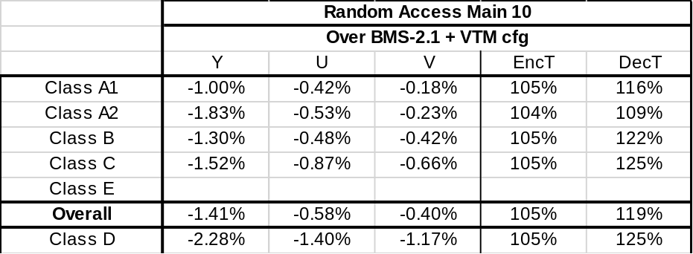

Table 2. Results of BIO with simplification 1
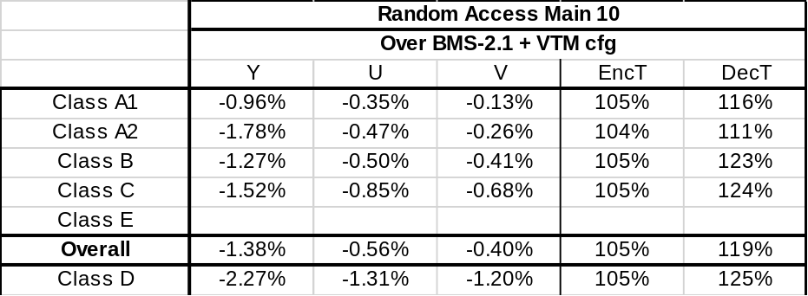

Table 3. Results of BIO with simplification 2

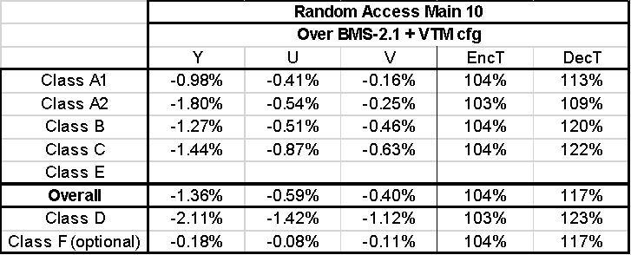

Table 4. Results of BIO with simplification 3
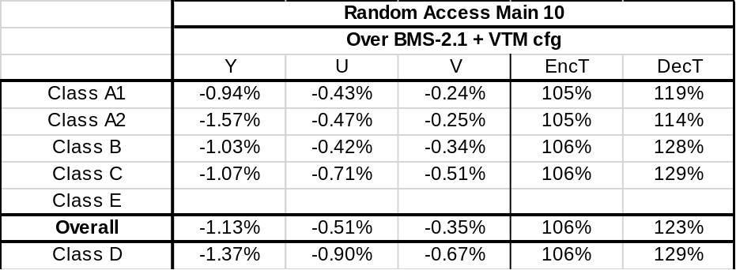

Table 5. Results of BIO with simplifications 1 and 2

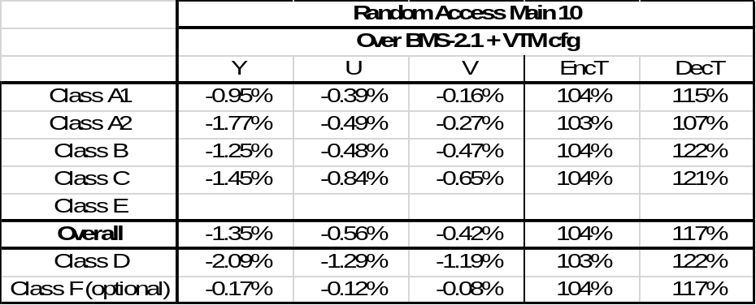

Table 6. Results of BIO with simplifications 1, 2, and 3

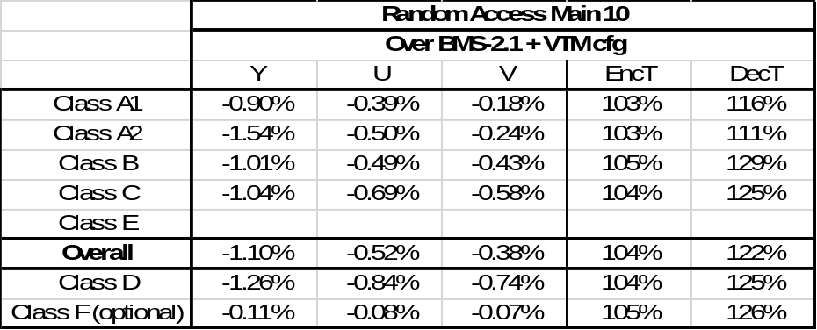

Table 7. Results of BIO with simplifications 1, 2, and 4.1; inaccurate runtime data
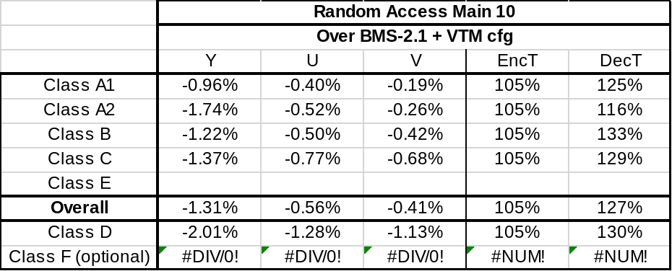

Table 8. Results of BIO with simplifications 1, 2, and 4.2; inaccurate runtime data
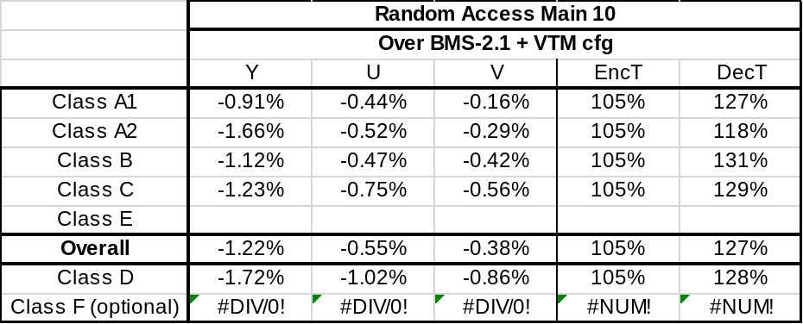

Conclusions
Four BIO simplifications are proposed. Applying bit depth constraints, disabling BIO for small CUs, applying one fixed filter to intermediate results after horizontal interpolation in MC process for gradient calculation, and reducing the required MC samples are tested and reported.

References
- BMS2.1: https://jvet.hhi.fraunhofer.de/svn/svn_VVCSoftware_BMS/tags/BMS-2.1
- J. Boyce, K. Suehring, X. Li, V. Seregin, “JVET common test conditions and software reference configurations,” Document of Joint Video Experts Team, JVET-K1010.

Patent rights declaration(s)
MediaTek may have current or pending patent rights relating to the technology described in this contribution and, conditioned on reciprocity, is prepared to grant licenses under reasonable and non-discriminatory terms as necessary for implementation of the resulting ITU-T Recommendation | ISO/IEC International Standard (per box 2 of the ITU-T/ITU-R/ISO/IEC patent statement and licensing declaration form).

