    Joint Video Experts Team (JVET)  of ITU-T SG 16 WP 3 and ISO/IEC JTC 1/SC 29/WG 11  12th Meeting: Macao, CN, 3–12 Oct. 2018 | Document: JVET-L0083-v2

Title: | CE2-related: Reduction of bits for ALF coefficient fractional part
Status: | Input document to JVET
Purpose: | Proposal
Author(s) or  Contact(s): | Yu-Chi Su, Ching-Yeh Chen,  Yu-Wen Huang, Shaw-Min Lei  No. 1, Dusing 1st Rd,  Hsinchu City 30078, Taiwan | Tel:  Email: | +886-3-5670766  {yu-chi.su, chingyeh.chen, yuwen.huang, shawmin.lei}  @mediatek.com
Source: | MediaTek Inc.
_____________________________

Abstract
In the contribution, it is proposed to reduce bits for adaptive loop filter (ALF) coefficient fractional part. In VTM2.0.1, the fractional part of each ALF coefficient is represented in nine bits. It is reported that, compared with VTM2.0.1, 6-bit fractional part results in 0.10%, 0.09%, and -0.04% luma BD-rates for AI, RA, and LB, respectively, and 7-bit fractional part results in -0.01%, -0.03%, and -0.09% luma BD-rates for AI, RA, and LB, respectively. The reduction of bits for ALF coefficient fractional part is also tested on top of CE2.2.2 from JVET-L0082. The real value range of the center ALF coefficient is within [0.0, 2.0), the real value range of non-center ALF coefficients is within [-1.0, 1.0), and the number of bits for ALF coefficient fractional part is six or seven. It is shown that compared to VTM2.0.1, 6-bit fractional part with the reduced ranges results in 0.10%, 0.08%, and -0.03% luma BD-rates for AI, RA, and LB, respectively, and 7-bit fractional part with the reduced ranges results in -0.01%, -0.04%, and -0.11% luma BD-rates for AI, RA, and LB, respectively. With the 7-bit fractional part with the reduced ranges for ALF coefficients, the numbers of required bits to represent a non-center coefficient and a center coefficient are reduced from 11 to 8 and 15 to 8, respectively, when compared to VTM2.0.1. There are almost no run time changes in all the above tests.

Proposed methods
In VTM2.0.1, the number of bits for ALF coefficient fractional part is nine. In this contribution, four tests related to ALF coefficient fractional part bit number reduction are presented. In the first and second tests, ALF coefficients with 6-bit and 7-bit fractional parts are evaluated. In the third and fourth tests, based on CE2.2.2 from JVET-L0082 [1], wherein the real value ranges of a non-center coefficient and a center coefficient are [-1,1) and [0,2), respectively, ALF coefficients with 6-bit and 7-bit fractional parts are evaluated. Table 1 shows comparison between different tests.

Table 1. Summary of different tests
 | Number of bits for fractional part | Number of bits for a non-center coefficient | Number of bits for a center coefficient | Others
VTM2.0.1 | 9 | 11 | 15
CE2.2.2 | 9 | 10 | 10 | Reduced range
Test1 | 6 | 8 | 12
Test2 | 7 | 9 | 13
Test3 | 6 | 7 | 7 | Reduced range
Test4 | 7 | 8 | 8 | Reduced range

Experimental results
The proposed methods have been implemented on top of VTM2.0.1 [2]. Table 2 and Table 3 show the results of 6-bit and 7-bit fractional parts, respectively. Table 4 and Table 5 present the results of 6-bit and 7-bit fractional parts with reduced ranges, respectively.

Conclusions
In this contribution, reducing ALF coefficient fractional part to seven bits, constraining center ALF coefficient real value range within [0.0, 2.0), and constraining non-center ALF coefficient real value range within [-1.0, 1.0) together achieve -0.01%, -0.04%, and -0.11% luma BD-rates for AI, RA, and LB, respectively, with very minor runtime changes, when compared to VTM2.0.1. The number of required bits is reduced from 11 to 8 for representing a non-center ALF coefficient, and from 15 to 8 for representing a center ALF coefficient.

Patent rights declaration
MediaTek, Inc. may have current or pending patent rights relating to the technology described in this contribution and, conditioned on reciprocity, is prepared to grant licenses under reasonable and non-discriminatory terms as necessary for implementation of the resulting ITU-T Recommendation | ISO/IEC International Standard (per box 2 of the ITU-T/ITU-R/ISO/IEC patent statement and licensing declaration form).

References
[1] Y.-C, Su, C.-Y. Chen, Y.-W. Huang, S.-M. Lei, “CE2.2.1 and CE2.2.2: ALF coefficient coding and range constraints,” Document of Joint Video Experts Team, JVET-L0082.
[2] VTM2.0.1 reference software, https://vcgit.hhi.fraunhofer.de/jvet/VVCSoftware_VTM/tags/VTM-2.0.1

Table 2. Results of Test1: 6-bit fractional part for ALF coefficients
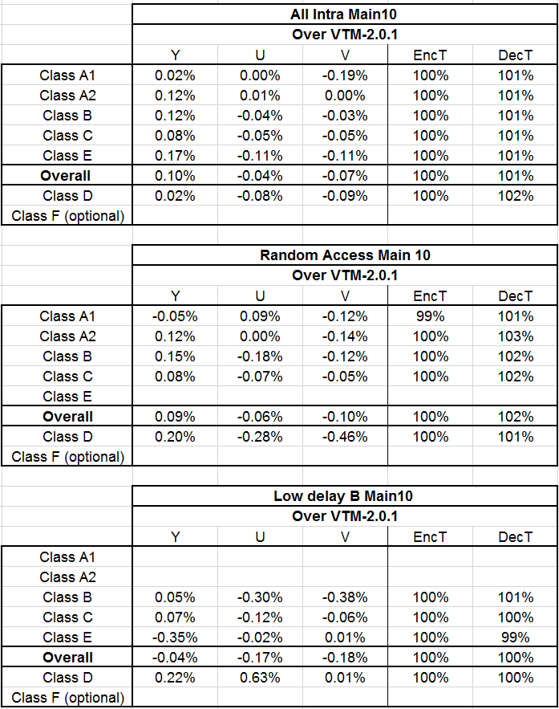

Table 3. Results of Test2: 7-bit fractional part for ALF coefficients
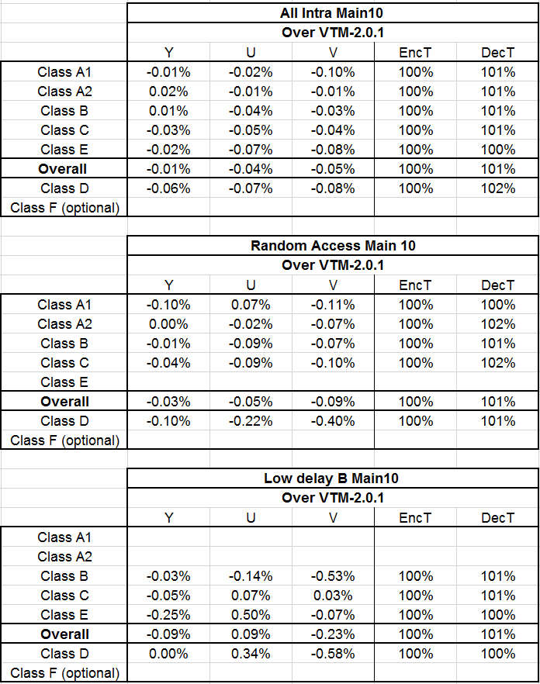

Table 4. Results of Test3: 6-bit fractional part with reduced ranges for ALF coefficients
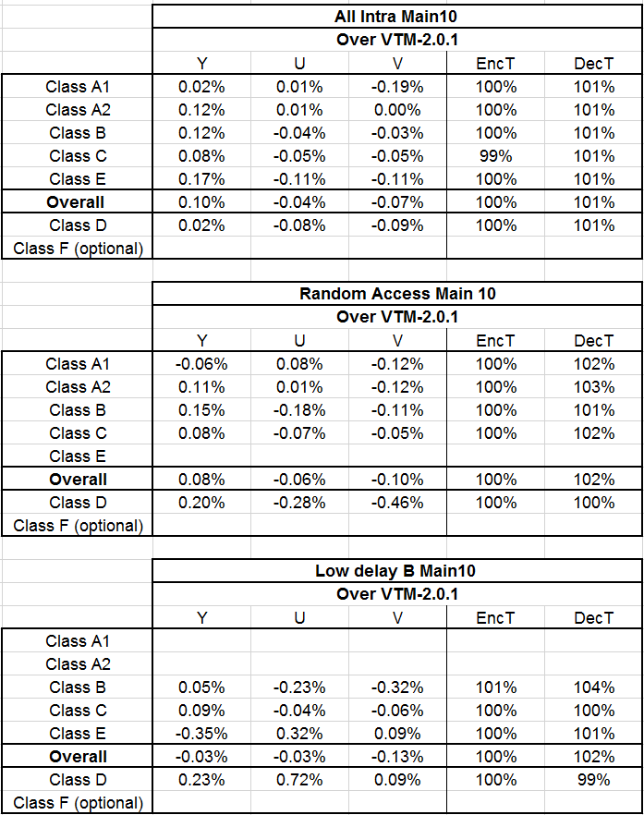

Table 5. Results of Test4: 7-bit fractional part with reduced ranges for ALF coefficients
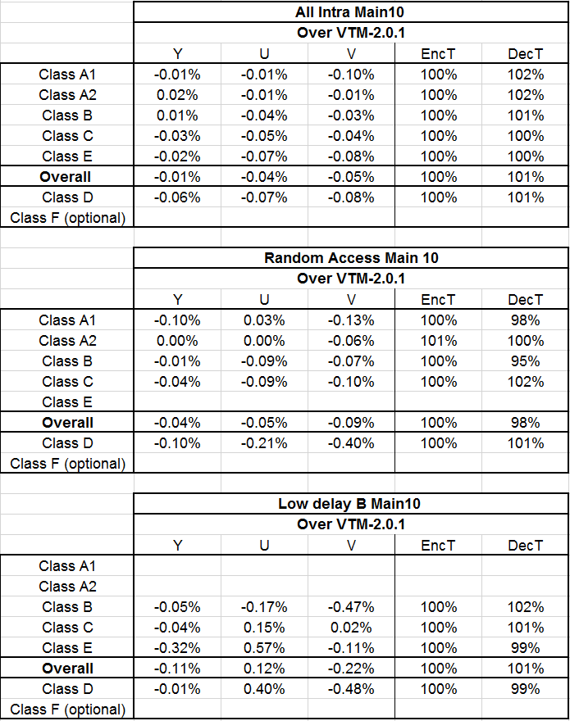

Working Draft of Proposed Method + CE2.2.2
The following text is modified based on JVET-K1007-v7.
The modified part is highlighted in yellow.

Adaptive loop filter data semantics
alf_luma_coeff_delta_abs[ sigFiltIdx ][ j ] specifies the absolute value of the j-th coefficient delta of the signalled luma filter indicated by sigFiltIdx. When alf_luma_coeff_delta_abs[ sigFiltIdx ][ j ] is not present, it is inferred to be equal 0. It is a requirement of bitstream conformance that the values of alf_luma_coeff_delta_abs[ sigFiltIdx ][ j ] shall be in the range of 0 to 2¹¹ − 1, inclusive.
alf_chroma_coeff_abs[ j ] specifies the absolute value of the j-th chroma filter coefficient. When alf_chroma_coeff_abs[ j ] is not present, it is inferred to be equal 0. It is a requirement of bitstream conformance that the values of alf_chroma_coeff_abs[ j ] shall be in the range of 0 to 2⁷ − 1, inclusive.

Derivation process for ALF luma coefficients
Outputs of this process is a luma filter coefficient array c_{L}.
The variable filterCoefficients[ sigFiltIdx ][ j ] with sigFiltIdx = 0..alf_luma_num_filters_signalled_minus1, j = 0..11 is initialized as follows:
filterCoefficients[ sigFiltIdx ][ j ] = alf_luma_coeff_delta_abs[ sigFiltIdx ][ j ] * (8-418)
( 1 − 2 * alf_luma_coeff_delta_sign[ sigFiltIdx ][ j ] )
When alf_luma_coeff_delta_prediction_flag is equal 1, filterCoefficients[ sigFiltIdx ][ j ] with sigFiltIdx = 1..alf_luma_num_filters_signalled_minus1 and j = 0..11 are modified as follows:
filterCoefficients[ sigFiltIdx ][ j ] += filterCoefficients[ sigFiltIdx − 1 ][ j ] (8-419)
It is a requirement of bitstream conformance that the values of filterCoefficients[ sigFiltIdx ][ j ] shall be in the range of -2⁷ to 2⁷ − 1, inclusive.
The binary array filter_pattern[ j ] with j=0..11 determines which coefficients are available based on 7x7 filter pattern and is defined as follows:
filterPattern[ ] = { 0, 0, 1, 0, 0, 1, 1, 1, 0, 0, 1, 1 } (8-420)
The variable k is set equal to 0, and the luma filter coefficients c_{L} with elements c_{L}[ filtIdx ][ j ], with filtIdx = 0..NumAlfFilters − 1 and j = 0..11 are derived as follows
  - If filterPattern[ j ] is equal 1 or alf_luma_type_flag is equal 0, the following applies:
c_{L}[ filtIdx ][ j ] = filterCoefficients[ alf_luma_coeff_delta_idx[ filtIdx ] ][ k ] (8-421)
k++
  - Otherwise, the following applies:
c_{L}[ filtIdx ][ j ] = 0 (8-422)
The last filter coefficients c_{L}[ filtIdx ][ j ] for j = 12 and filtIdx = 0..NumAlfFilters − 1 are derived as follows:
c_{L}[ filtIdx ][ 12 ] = 128 − Σ_{k} ( c_{L}[ filtIdx ][ k ] << 1 ), with k = 0..11 (8-423)
It is a requirement of bitstream conformance that the values of c_{L}[ filtIdx ][ 12 ] shall be in the range of 0 to 2⁸ − 1, inclusive.

Derivation process for ALF chroma coefficients
Outputs of this process are the 7 chroma filter coefficients c_{c}.
The chroma filter coefficients c_{C} with elements c_{C}[ j ], j = 0..5 are derived as follows:
c_{C}[ j ] = alf_chroma_coeff_abs[ j ] * ( 1 − 2 * alf_chroma_coeff_sign[ j ] ) (8-424)
It is a requirement of bitstream conformance that the values of c_{C}[ j ] shall be in the range of -2⁷ to 2⁷ − 1, inclusive.
The last filter coefficient for j = 6 is derived as follows:
c_{C}[ 6 ] = 128 − Σ_{k} ( c_{C}[ k ] << 1 ), with k = 0..5
It is a requirement of bitstream conformance that the values of c_{C}[ 6 ] shall be in the range of 0 to 2⁸ − 1, inclusive.

Coding tree block filtering process for luma samples
Inputs of this process are:
- a reconstructed luma picture sample array recPicture_{L} prior to the adaptive loop filtering process,
- a filtered reconstructed luma picture sample array alfPicture_{L},
- a luma location ( xCtb, yCtb ) specifying the top-left sample of the current luma coding tree block relative to the top left sample of the current picture,
- an array of luma filter coefficients c_{L}[ filtIdx ][ j ] with filtIdx = 0..NumAlfFilters − 1 and j = 0..12.
...
…
  - The variable sum is set to 0 and modifed using the following ordered steps:
- When filterType is equal 0, the following applies:
sum = filterCoeff[ 0 ] * ( recPicture_{L}[ h_{x}, v_{y + 3} ] + recPicture_{L}[ h_{x}, v_{y − 3} ] ) +
filterCoeff[ 1 ] * ( recPicture_{L}[ h_{x + 1}, v_{y + 2} ] + recPicture_{L}[ h_{x − 1}, v_{y − 2} ] ) +
filterCoeff[ 3 ] * ( recPicture_{L}[ h_{x − 1}, v_{y + 2} ] + recPicture_{L}[ h_{x + 1}, v_{y − 2} ] ) + (8-433)
filterCoeff[ 4 ] * ( recPicture_{L}[ h_{x + 2}, v_{y + 1} ] + recPicture_{L}[ h_{x − 2}, v_{y − 1} ] ) +
filterCoeff[ 8 ] * ( recPicture_{L}[ h_{x − 2}, v_{y + 1} ] + recPicture_{L}[ h_{x + 2}, v_{y − 1} ] ) +
filterCoeff[ 9 ] * ( recPicture_{L}[ h_{x + 3}, v_{y} ] + recPicture_{L}[ h_{x − 3}, v_{y} ] )
- The following operations apply:
sum += filterCoeff[ 2 ] * ( recPicture_{L}[ h_{x}, v_{y + 2} ] + recPicture_{L}[ h_{x}, v_{y − 2} ] ) +
filterCoeff[ 5 ] * ( recPicture_{L}[ h_{x + 1}, v_{y + 1} ] + recPicture_{L}[ h_{x − 1}, v_{y − 1} ] ) +
filterCoeff[ 6 ] * ( recPicture_{L}[ h_{x}, v_{y + 1} ] + recPicture_{L}[ h_{x}, v_{y − 1} ] ) + (8-434)
filterCoeff[ 7 ] * ( recPicture_{L}[ h_{x − 1}, v_{y + 1} ] + recPicture_{L}[ h_{x + 1}, v_{y − 1} ] ) +
filterCoeff[ 10 ] * ( recPicture_{L}[ h_{x + 2}, v_{y} ] + recPicture_{L}[ h_{x − 2}, v_{y} ] ) +
filterCoeff[ 11 ] * ( recPicture_{L}[ h_{x + 1}, v_{y} ] + recPicture_{L}[ h_{x − 1}, v_{y} ] ) +
filterCoeff[ 12 ] * recPicture_{L}[ h_{x}, v_{y} ]
sum = ( sum + 64 ) >> 7 (8-435)
  - The modified filtered reconstructed luma picture sample alfPicture_{L}[ xCtb + x ][ yCtb + y ] is derived as follows:
alfPicture_{L}[ xCtb + x ][ yCtb + y ] = Clip3( 0, ( 1 << BitDepth_{Y} ) − 1, sum ) (8-436)

Coding tree block filtering process for chroma samples
Inputs of this process are:
- a reconstructed chroma picture sample array recPicture prior to the adaptive loop filtering process,
- a filtered reconstructed chroma picture sample array alfPicture,
- a chroma location ( xCtbC, yCtbC ) specifying the top-left sample of the current chroma coding tree block relative to the top left sample of the current picture,
- an array of chroma filter coefficients c_{C}[ j ] with j = 0..6.
…
…
  - The variable sum is derived as follows:
sum = c_{C}[ 0 ] * ( recPicture[ h_{x}, v_{y + 2} ] + recPicture[ h_{x}, v_{y − 2} ] ) +
c_{C}[ 1 ] * ( recPicture[ h_{x + 1}, v_{y + 1} ] + recPicture[ h_{x − 1}, v_{y − 1} ] ) +
c_{C}[ 2 ] * ( recPicture[ h_{x}, v_{y + 1} ] + recPicture[ h_{x}, v_{y − 1} ] ) + (8-471)
c_{C}[ 3 ] * ( recPicture[ h_{x − 1}, v_{y + 1} ] + recPicture[ h_{x + 1}, v_{y − 1} ] ) +
c_{C}[ 4 ] * ( recPicture[ h_{x + 2}, v_{y} ] + recPicture[ h_{x − 2}, v_{y} ] ) +
c_{C}[ 5 ] * ( recPicture[ h_{x + 1}, v_{y} ] + recPicture[ h_{x − 1}, v_{y} ] ) +
c_{C}[ 6 ] * recPicture_{C}[ h_{x}, v_{y} ]
sum = ( sum + 64 ) >> 7 (8-472)
  - The modified filtered reconstructed chroma picture sample alfPicture[ xCtbC + x ][ yCtbC + y ] is derived as follows:
alfPicture[ xCtbC + x ][ yCtbC + y ] = Clip3( 0, ( 1 << BitDepth_{C} ) − 1, sum ) (8-473)

