    Joint Video Experts Team (JVET)  of ITU-T SG 16 WP 3 and ISO/IEC JTC 1/SC 29/WG 11  12th Meeting: Macao, MO, 03–12 Oct. 2018 | Document: JVET-L0065-v1

Title: | CE3-related: One-line CCLM for reduction of reference sample lines
Status: | Input document to JVET
Purpose: | Proposal
Author(s) or  Contact(s): | Name(s)  Jongseok Lee  Joohyung Byeon  Seane Park  Donggyu Sim | Email: | suk2080@kw.ac.kr,  quswngud3@kw.ac.kr,  psea1118@kw.ac.kr  dgsim@kw.ac.kr
Source: | Kwangwoon University (KWU)
_____________________________

Abstract
This contribution presents a modified Cross Component Linear Model (CCLM) methods with one-line luminance sample line for down-sampling process. In the CCLM mode in VTM2.0.1, two upper neighboring reconstructed luminance lines are required in the down-sampling process. The proposed method uses one reconstructed luminance sample line, that is upper adjacent to the current PU in order to reduce a luminance line buffer. Experimental results show that the proposed method yields BD-rate loss of 0.1%, 0.23%, and 0.22% for three color components on average over VTM2.0.1 with CCLM, respectively.

Introduction
In VTM-2.0.1, CCLM (Cross Component Linear Model) mode include a down-sampling process to compute linear model parameters between neighboring reconstructed luminance and chrominance samples. The CCLM requires two upper neighboring luminance sample lines and one chrominance samples line. This contribution proposes one-line CCLM that uses one upper reconstructed luminance sample line and one chrominance sample line in computing the model parameters. In designing a decoder, one upper line buffer is enough to support CCLM.

One-line Cross Component Linear Model
In VTM-2.0.1, the down-sampled luminance sample value (${Rec}_{L}^{'}$) for neighboring reconstructed sample line and prediction signal is computed as
${Rec}_{L}^{'}\left[x,y\right]=(\left(2∙{Rec}_{L}\left[2x, 2y \right]+{Rec}_{L}\left[2x-1, 2y \right]+ {Rec}_{L}\left[2x+1, 2y \right]\right) + \left(2∙{Rec}_{L}\left[2x,2y+1\right]+{Rec}_{L}\left[2x-1, 2y+1\right]+ {Rec}_{L}\left[2x+1, 2y+1\right]\right)+4)≫3$,
$W>x>0, x=-1, H>y>-1$.
If the left PU of the current PU is not available, the down-sampled luminance sample value at the point
[0, y] is computed as
${Rec}_{L}^{'}\left[x,y\right]=\left({Rec}_{L}\left[2x, 2y\right]+ {Rec}_{L}\left[2x, 2y+1\right]+2\right)≫2$, $x=0 , H>y>-1$.
where ${Rec}_{L}\left[x,y\right]$ denotes reconstructed luminance sample value. x and y are the coordinate of chrominance samples in 4:2:0 sub-sampling condition and a coordinate [0, 0] is the left top point of a current chroma prediction unit. W and H are width and height of the chroma prediction unit, respectively. The down-sampling always has a filter stride value as 2.
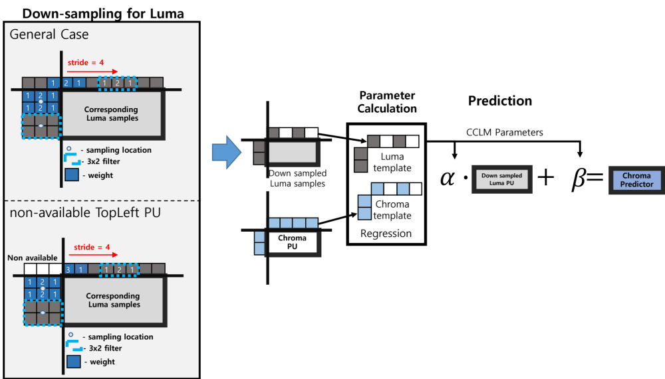
Figure 1. Diagram of the proposed one-line CCLM method

In the proposed method, the down-sampled luminance samples for above reconstructed sample line are computed by
${Rec}_{L}^{'}\left[x,-1\right]=\left(2∙{Rec}_{L}\left[2x, -1 \right]+{Rec}_{L}\left[2x-1, -1\right]+ {Rec}_{L}\left[2x+1, -1\right]+2\right)≫2$,
$W>x> 0$, $x=-1$,
If the left PU of the current PU is not available, the down-sampled luminance sample value computed as
${Rec}_{L}^{'}\left[0,-1\right]=\left(3∙{Rec}_{L}\left[2x, -1\right]+{Rec}_{L}\left[2x+1, -1\right]+2\right)≫2$.
In the proposed CCLM, if current PU is rectangular, the filter stride is changed as ‘2$×$W/minDim’ in the down-sampling process to reduce the redundant calculation. Where, minDim is the smaller of the W and H.
Three left reconstructed lines are also used in computing the CCLM parameters, as the CCLM of VTM 2.0.1. For chroma sample prediction, the same algorithm to CCLM of VTM 2.0.1 is used, as shown in Fig. 1.

Results
The proposed one-line CCLM is implemented within VTM-2.0.1 software. The following tables show coding performance of BD-rate compared to VTM2.0.1 in All Intra configuration. Table 1 shows RD performance of VTM2.0.1 without CCLM. 2.15%, 16.75%, and 15.49% BD losses are found without CCLM for all the color components, respectively. Table 2 show RD performance and computation time of the proposed one-line CCLM over VMT-2.0.1. It is suggested to consider the proposed CCLM for the potential adoption into VTM.

Table 1. RD performance of VTM-2.0.1 without CCLM
 | All Intra Main10
Reference: VTM-2.01 | Over VTM-2.0.1
Tested: VTM-2.01 w/o CCLM | Y | U | V | EncT | DecT
Class A1 | 5.93% | 42.77% | 32.62% | 100% | 102%
Class A2 | 2.20% | 15.19% | 7.72% | 96% | 99%
Class B | 1.10% | 10.89% | 15.71% | 98% | 100%
Class C | 1.92% | 14.40% | 15.80% | 99% | 100%
Class E | 0.40% | 5.18% | 5.32% | 100% | 97%
Overall | 2.15% | 16.75% | 15.49% | 99% | 100%
Class D | 1.23% | 11.14% | 10.76% | 100% | 99%
Class F (optional) | 3.44% | 15.50% | 15.98% | 97% | 99%

Table 2. RD performance of one-line CCLM on the top of VTM-2.0.1
 | All Intra Main10
Reference: VTM-2.01 | Over VTM-2.0.1
Tested: Oneline-CCLM | Y | U | V | EncT | DecT
Class A1 | 0.03% | 0.60% | 0.36% | 98% | 100%
Class A2 | 0.03% | 0.16% | 0.06% | 96% | 100%
Class B | 0.02% | 0.12% | 0.29% | 101% | 100%
Class C | 0.03% | 0.28% | 0.32% | 100% | 100%
Class E | -0.01% | 0.05% | -0.02% | 100% | 97%
Overall | 0.02% | 0.23% | 0.22% | 99% | 100%
Class D | 0.02% | 0.26% | -0.02% | 101% | 93%
Class F (optional) | 0.11% | 0.71% | 0.56% | 97% | 99%

Patent rights declaration(s)
Kwangwoon university may have current or pending patent rights relating to the technology described in this contribution and, conditioned on reciprocity, is prepared to grant licenses under reasonable and non-discriminatory terms as necessary for implementation of the resulting ITU-T Recommendation | ISO/IEC International Standard (per box 2 of the ITU-T/ITU-R/ISO/IEC patent statement and licensing declaration form).

