    Joint Video Experts Team (JVET)  of ITU-T SG 16 WP 3 and ISO/IEC JTC 1/SC 29/WG 11  12th Meeting: Macao, CN, 3–12 Oct. 2018 | Document: JVET-L0045-v1

Title: | CE4: Test results of CE4.1.11 on line buffer reduction for affine mode
Status: | Input document to JVET
Purpose: | Proposal
Author(s) or  Contact(s): | Minhua Zhou  16340 West Bernardo DR  San Diego,  CA-92127, USA | Tel:  Email: | +1 858 521 5838  minhua.zhou@broadcom.com
Source: | Broadcom Inc.
_____________________________

Abstract
This contribution reports test results of CE4.1.11. To avoid the need of a separate line buffer for buffering the control point motion vectors (CPMVs) for affine mode, it was advocated to use the 4-parameter affine motion model, the bottom-left and bottom-right control point motion vectors (CPMVs) to do affine motion data inheritance from a neighboring PU located at the top CTU boundary, regardless whether it uses the 4- or 6-parameter affine motion model. Two tests were carried out. In the first test the vertical position of the bottom-left and bottom-right CPMVs is on the top CTU boundary (test 1); in the second the vertical position of the bottom-left and bottom-right CPMVs is two lines above the top CTU boundary (test 2). Compared to the VTM2.0.1 anchor, the BD-rate differences are 0.09% in RA, 0.00% in LD_B and 0.02% in LD_P for test 1, and 0.12% in RA, 0.01% in LD_B and 0.04% in LD_P for test 2, respectively. For 4K video for example, the proposed changes reduce the line buffer requirement for the affine mode from 9,216 bytes to 256 bytes.

Introduction
This document reports the test results of CE4.1.11 on line buffer reduction for affine mode.

Algorithm description
As described in [2] and [3], the basic idea is to use the 4-parameter affine motion model, the bottom-left and bottom-right control point motion vectors (CPMVs) to do affine motion data inheritance for the current PU, if the (source) neighboring PU is located at the top CTU boundary regardless whether it uses the 4- or 6-parameter model. Compared to the current VTM2.0.1 design, no other change is introduced if the source neighboring PU is not located along the top CTU boundary.
The bottom-left and bottom-right CPMVs are stored in the regular motion data line buffer and are shared for the merge/skip and AMVP list derivations, to avoid the need of a separate line buffer to store the control point motion vectors. The stored the control point motion vectors may or may not be same motion vectors used for motion compensation and/or stored for temporal motion vectors (TMVPs).
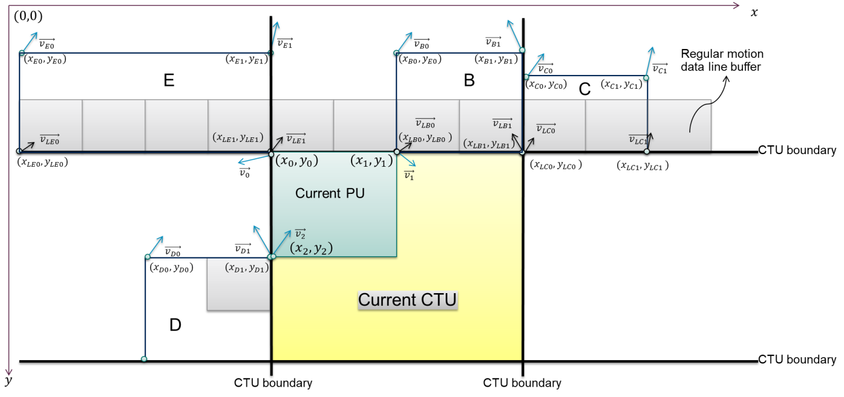

Figure 1: Shared motion data line buffer for the affine mode, the merge/skip mode and the AMVP mode (location 1)

As shown in Figure 1, if the current PU inherits the affine motion data from the neighboring PU E which is located along the top CTU boundary, the control point vectors $\vec{v_{0}}$ and $\vec{v_{1}}$ of the current PU are derived by using the 4-parameter model, and by
$\left\{\begin{matrix}v_{0x}=\frac{\left(v_{LE1x}-v_{LE0x}\right)}{(x_{LE1}-x_{LE0})}(x_{0}-x_{LE0})-\frac{\left(v_{LE1y}-v_{LE0y}\right)}{(x_{LE1}-x_{LE0})}(y_{0}-y_{LE0})+v_{LE0x} \\ v_{0y}=\frac{\left(v_{LE1y}-v_{LE0y}\right)}{(x_{LE1}-x_{LE0})}(x_{0}-x_{LE0})+\frac{\left(v_{LE1x}-v_{LE0x}\right)}{(x_{LE1}-x_{LE0})}(y_{0}-y_{LE0})+v_{LE0y}\end{matrix}\right.$ Equation 1
$\left\{\begin{matrix}v_{1x}=\frac{\left(v_{LE1x}-v_{LE0x}\right)}{(x_{LE1}-x_{LE0})}(x_{1}-x_{LE0})-\frac{\left(v_{LE1y}-v_{LE0y}\right)}{(x_{LE1}-x_{LE0})}(y_{1}-y_{LE0})+v_{LE0x} \\ v_{1y}=\frac{\left(v_{LE1y}-v_{LE0y}\right)}{(x_{LE1}-x_{LE0})}(x_{1}-x_{LE0})+\frac{\left(v_{LE1x}-v_{LE0x}\right)}{(x_{LE1}-x_{LE0})}(y_{1}-y_{LE0})+v_{LE0y}\end{matrix}\right.$ Equation 2
And if the current PU uses the 6-parameter affine motion model, the control point vectors $\vec{v_{2}}$ is derived by
$\left\{\begin{matrix}v_{2x}=\frac{\left(v_{LE1x}-v_{LE0x}\right)}{(x_{LE1}-x_{LE0})}(x_{2}-x_{LE0})-\frac{\left(v_{LE1y}-v_{LE0y}\right)}{(x_{LE1}-x_{LE0})}(y_{2}-y_{LE0})+v_{LE0x} \\ v_{2y}=\frac{\left(v_{LE1y}-v_{LE0y}\right)}{(x_{LE1}-x_{LE0})}(x_{2}-x_{LE0})+\frac{\left(v_{LE1x}-v_{LE0x}\right)}{(x_{LE1}-x_{LE0})}(y_{2}-y_{LE0})+v_{LE0y}\end{matrix}\right.$ Equation 3
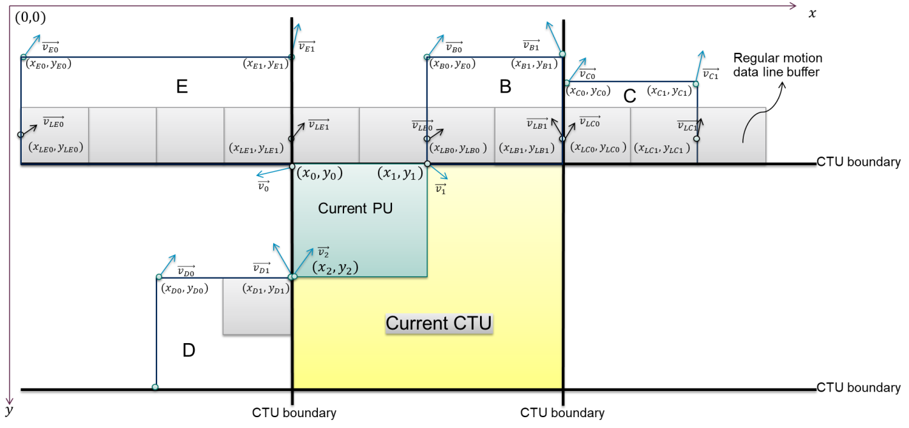

Figure 2: Shared motion data line buffer for the affine mode, the merge/skip mode and the AMVP mode (location 2)
Two control point motion vector locations were tested in the CE. As shown in Figure 1, if the current PU inherits the affine motion data from PU E, the coordinates of the bottom-left and bottom-right CPMVs satisfy the following conditions for location 1:
$\left\{\begin{matrix}\begin{matrix}x_{LE0}=x_{E0} \\ x_{LE1}=x_{E1}\end{matrix} \\ \begin{matrix}y_{LE0}=y0 \\ y_{LE1}=y1\end{matrix}\end{matrix}\right.$ Equation 4
In location 2 depicted in Figure 2, the following conditions apply:
$\left\{\begin{matrix}\begin{matrix}x_{LE0}=x_{E0} \\ x_{LE1}=x_{E1}\end{matrix} \\ \begin{matrix}y_{LE0}=y0-2 \\ y_{LE1}=y1-2\end{matrix}\end{matrix}\right.$ Equation 5

Note that equations 1, 2 and 3 are for algorithm description purpose. In actual implementation, the divisions are replaced with multiplies and shifts.

Experimental results
Tests were carried out by using the VTM2.0.1 software, and the common test conditions defined in [1] were followed.
As shown in Table 1 and Table 2, the average BD-rate differences for test 1 are 0.09% in RA, 0.00% in LD_B and 0.02% in LD_P for test 1, and 0.12% in RA, 0.01% in LD_B and 0.04% in LD_P for test 2, respectively.
The detailed results can be found in the attached spreadsheets. Note that the run time may not be accurate due to the heterogeneous nature of the LSF farm.

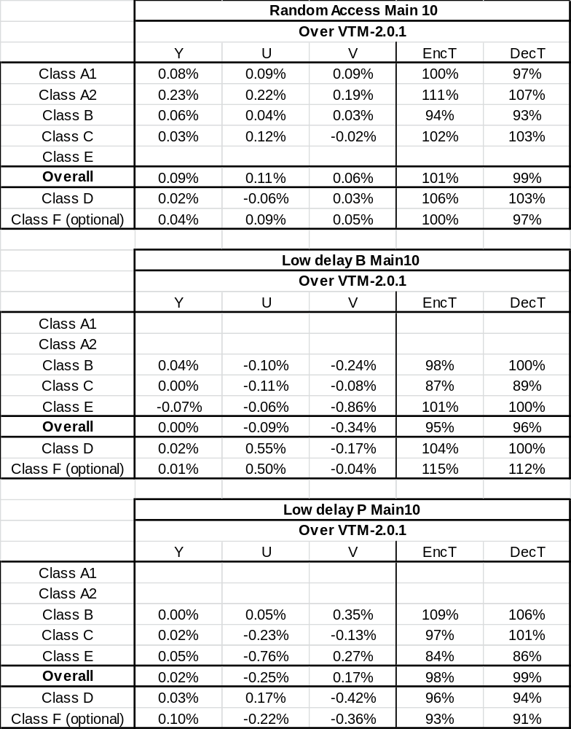
Table 1: Summary results of Test 1 (location 1)
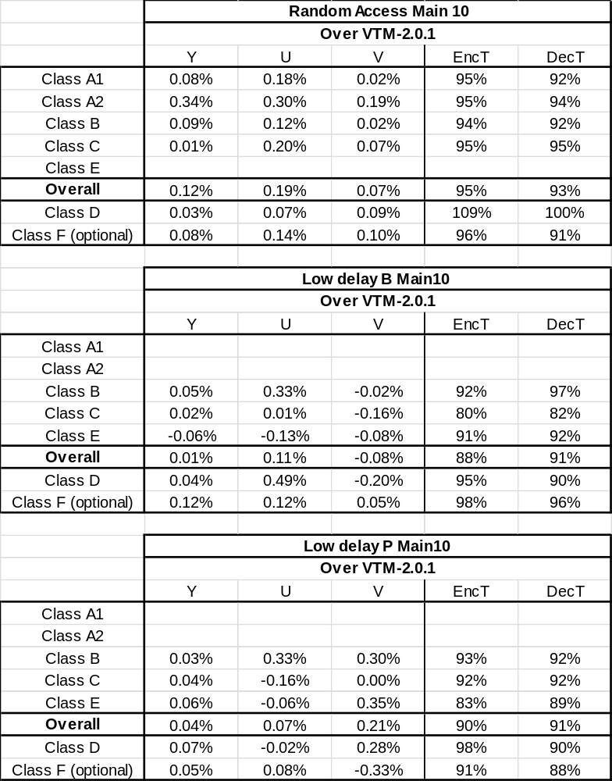
Table 2: Summary results of Test 2 (Location 2)

Line buffer size analysis
The line buffer size reduction was analyzed for 4K video as example. As shown in Table 3, the line buffer size for the affine mode can be reduced from 9216 bytes to 256 bytes for 4K video by using the proposed simplifications.
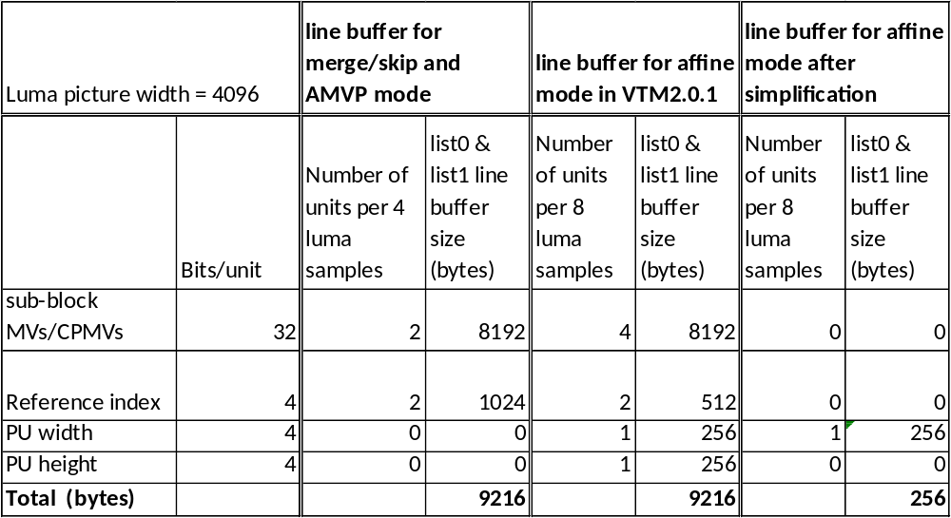

Table 3: Line buffer size for 4K video

References
[1] J. Boyce, K. Suehring, X. Li and V. Seregin, “JVET common test conditions and software reference configurations for SDR video”, JVET-K1010, the 11th JVET meeting, July 2018, Ljubljana, SI.
[2] H. Yang, S. Liu and K. Zhang, “Description of Core Experiment 4 (CE4): Inter prediction and motion vector coding”, JVET-K1024, the 11th JVET meeting, July 2018, Ljubljana, SI.
[3] M. Zhou and B. Heng, “Non-CE4: A study on the affine merge mode”, JVET-K0052, the 11th JVET meeting, July 2018, Ljubljana, SI.
[4] Y. Han, H. Huang, Y. Zhang, C. Hung, C. Chen, W. Chien and M. Karczewicz, “CE4.1.3: Affine motion compensation prediction”, JVET-K0337, the 11th JVET meeting, July 2018, Ljubljana, SI.
[5] B. Bross, J. Chen and S. Liu, “Versatile Video Coding (Draft 2)”, JVET-K1001-v6, the 11th JVET meeting, July 2018, Ljubljana, SI.

Patent rights declaration(s)
Broadcom Inc. may have current or pending patent rights relating to the technology described in this contribution and, conditioned on reciprocity, is prepared to grant licenses under reasonable and non-discriminatory terms as necessary for implementation of the resulting ITU-T Recommendation | ISO/IEC International Standard (per box 2 of the ITU-T/ITU-R/ISO/IEC patent statement and licensing declaration form).

Spec Text Changes relative to JVET-K1001-v6

Text for test 1

Replace

Section 8.3.3.3 Derivation process for luma affine control point motion vectors from a neighbouring block
(Note to Ed: changes are also need for sections where 8.3.3.3 is invoked, i.e. adding numNCpMv, cpNMvLX[ cpIdx ] to the input list)
with
Inputs to this process are:
- a luma location ( xCb, yCb ) specifying the top-left sample of the current luma coding block relative to the top-left luma sample of the current picture,
- two variables cbWidth and cbHeight specifying the width and the height of the current luma coding block,
- a luma location ( xNb, yNb ) specifying the top-left sample of the neighbouring luma coding block relative to the top-left luma sample of the current picture,
- two variables nNbW and nNbH specifying the width and the height of the neighbouring luma coding block,
- the number of control point motion vectors numNCpMv of the neighbouring luma coding block,
- the luma affine control point vectors of the neighbouring luma coding block cpNMvLX[ cpIdx ] with cpIdx = 0 .. 3 and X being 0 or 1,
- the number of control point motion vectors numCpMv.
Output of this process are the luma affine control point vectors cpMvLX[ cpIdx ] with cpIdx = 0 .. numCpMv − 1 and X being 0 or 1.
The variables log2NbW and log2NbH are derived as follows:
log2NbW = Log2( nNbW ) (8-265)
log2NbH = Log2( nNbH ) (8-266)
The variable isCTUboundaryPU set equal to 1 if all the following consitions are true. Otherwise, it is set to 0.
- ((yNb + nNbH) % CtbSizeY) is equal to 0
- And yNb + nNbH is equal to yCb
The variables mvScaleHor and mvScaleVer are derived as follows:
- If isCTUboundaryPU is equal to 1, the following applies:
mvScaleHor = cpNMvLX[ 2 ][ 0 ] << 7 (8-267)
mvScaleVer = cpNMvLX[ 2 ] [ 1 ] << 7 (8-268)

- Otherwise, the following applies:
mvScaleHor = cpNMvLX[ 0 ][ 0 ] << 7 (8-267)
mvScaleVer = cpNMvLX[ 0 ] [ 1 ] << 7 (8-268)

The variables dHorX and dVerX are derived as follows:
- If isCTUboundaryPU is equal to 1, the following applies:
dHorX = ( cpNMvLX[ 3 ][ 0 ] − cpNMvLX[ 2 ][ 0 ] ) << ( 7 − log2NbW ) (8-269)
dVerX = ( cpNMvLX[ 3][ 1 ] − cpNMvLX[ 2 ][ 1 ] ) << ( 7 − log2NbW ) (8-270)
- Otherwise, the following applies:
dHorX = ( cpNMvLX[ 1 ][ 0 ] − cpNMvLX[ 0 ][ 0 ] ) << ( 7 − log2NbW ) (8-269)
dVerX = ( cpNMvLX[ 1 ][ 1 ] − cpNMvLX[ 0 ][ 1 ] ) << ( 7 − log2NbW ) (8-270)

The variables dHorY and dVerY are derived as follows:
- If isCTUboundaryPU is equal to 0 and numNCpMv is equal to 3, the following applies:
dHorY = ( cpNMvLX[ 2 ][ 0 ]− cpNMvLX[ 0 ][ 0 ]) << ( 7 − log2NbH ) (8-271)
dVerY = ( cpNMvLX[ 2 ][ 0 ]− cpNMvLX[ 0 ][ 1 ] ) << ( 7 − log2NbH ) (8-272)

- Ohterwise (numNCpMv is equal to 2, or isCTUboundaryPU is equal to 1), the following applies:
dHorY = − dVerX (8-273)
dVerY = dHorX (8-274)
If isCTUboundaryPU is equal to 1, yNb is set equal to yCb.
The luma affine control point motion vectors cpMvLX[ cpIdx ] with cpIdx = 0 .. numCpMv − 1 and X being 0 or 1 are derived as follows:
- The first two control point motion vectors cpMvLX[ 0 ] and cpMvLX[ 1 ] are derived as follows:
cpMvLX[ 0 ][ 0 ] = ( mvScaleHor + dHorX * ( xCb − xNb ) + dHorY * ( yCb − yNb ) ) (8-275)
cpMvLX[ 0 ][ 1 ] = ( mvScaleVer + dVerX * ( xCb − xNb ) + dVerY * ( yCb − yNb ) ) 8-276)
cpMvLX[ 1 ][ 0 ] = ( mvScaleHor + dHorX * ( xCb + cbWidth − xNb ) + dHorY * ( yCb − yNb ) ) (8-277)
cpMvLX[ 1 ][ 1 ] = ( mvScaleVer + dVerX * ( xCb + cbWidth − xNb ) + dVerY * ( yCb − yNb ) ) (8-278)
- If numCpMv is equal to 3 or ((yNb + nNbH) % CtbSizeY) is equal to 0, the third control point vector cpMvLX[ 2 ] is derived as follows:
cpMvLX[ 2 ][ 0 ] = ( mvScaleHor + dHorX * ( xCb − xNb ) + dHorY * ( yCb + cbHeight − yNb ) ) (8-279)
cpMvLX[ 2 ][ 1 ] = ( mvScaleVer + dVerX * ( xCb − xNb ) + dVerY * ( yCb + cbHeight − yNb ) ) (8-280)
- If ((yNb + nNbH) % CtbSizeY) is equal to 0, the fourth control point vector cpMvLX[ 3 ] is derived as follows:
cpMvLX[ 3 ][ 0 ] = ( mvScaleHor + dHorX * ( ( xCb + cbWidth − xNb ) + dHorY * ( yCb + cbHeight − yNb ) ) (8-279)
cpMvLX[ 3 ][ 1 ] = ( mvScaleVer + dVerX * ( ( xCb + cbWidth − xNb ) + dVerY * ( yCb + cbHeight − yNb ) ) (8-280)

- The rounding process for motion vectors as specified in clause 8.3.2.14 is invoked the with mvX set equal to cpMvLX[ cpIdx ], rightShift set equal to 7, and leftShift set equal to 0 as inputs and the rounded cpMvLX[ cpIdx ] as output, with X being 0 or 1 and cpIdx = 0 .. numCpMv − 1.

