    Joint Video Experts Team (JVET)  of ITU-T SG 16 WP 3 and ISO/IEC JTC 1/SC 29/WG 11  12th Meeting: Macao, CN, 3–12 Oct. 2018 | Document: JVET-L0035

Title: | CE15: Summary report of Core Experiment on palette mode
Status: | Input document to JVET
Purpose: | Report
Author(s) or  Contact(s): | Yu-Chen Sun  Yung-Hsuan Chao  Xiaozhong Xu | Tel:  Email: | yuchen.s@alibaba-inc.com  yunghsua@qti.qualcomm.com  xiaozhongxu@tencent.com
Source: | CE coordinators
_____________________________

Abstract
A summary of Core Experiment 15 (CE15) on palette mode is reported. Two tests are evaluated based on the common test conditions defined in JVET-K1035. All tests and crosscheck results are integrated in this report.

Introduction
The following tests in table 1 are performed in CE15.

Table 1: tests that are evaluated and studied in this CE.
Test | Tester | Document | Tool description | Cross checker
15.1 | Yu-Chen Sun (Alibaba)  Yung-Hsuan Chao (Qualcomm) | JVET-K0411 | Palette mode in JVET-K0411 | J. Ye (Tencent)
15.2 | Yung-Hsuan Chao (Qualcomm)  Yu-Chen Sun (Alibaba) | HEVC-SCC | Palette mode in HEVC-SCC | Jianqing Zhu (Fujitsu)

The detailed description of each tools is provided in the next section.

Description of CE tools

CE15.1: Palette mode
The palette mode in n JVET-K0411 [1].

CE15.2 Palette mode in HEVC-SCC
The palette mode in HEVC-SCC [2].

Difference between CE15.1 and CE15.2
CE15.1 and CE15.2 share the same software code base and can be switched by macro setting. The difference between two tests are summarized in table 2.

 | CE15.1 | CE15.2
Index map coding | - Raster scan  - Escape mode is coded in INDEX mode  - Palette Index is signaled (TBC)  - PLT index(bypass), run type(CABAC), run length(CABAC), and escape sample (bypass) are coded in interleaved manner  - Escape sample is coded using TBC (QP dependent)  - Escape sample: encode Y/ Cb / Cr together for each escape sample | - Horizontal / Vertical traverse scan (flag)  - Escape mode is coded in INDEX/COPY_ABOVE mode  - Redundancy removal before signaling index (TBC) :  if previous pixel is INDEX: curIDX $≠$prevIDX  if previous pixel is COPY_ABOVE: curIDX $≠$aboveIDX  - Encode PLT index (bypass) for whole CU  -> run type (CABAC) and run length (CABAC) interleaved  -> escape samples for whole CU (bypass)  - Escape sample is coded with Exponential-Golomb coding  - Encode Y for whole CU -> Cb for whole CU -> Cr for whole CU.
Syntax inference | - Signal palette info regardless of palette table size | - If palette table size <= 1:  PLT index = 0  run type = INDEX  scanning: horizontal  run length = number of pixels in the CU  if palette table size > 1:  signaling palette info
Bug fix |  | - Bug fix in escape sample coding: fix the issue in division (only affect low QP)

Experimental Conditions
Experimental condition follows CE15 description [3].

Software
One software code base is used which is the BMS software. The BMS subversion repository can be found at https://jvet.hhi.fraunhofer.de/svn/svn_VVCSoftware_BMS. The 2.0.1 release version of the software is used.

Anchors
- The BMS version 2.0.1 software is used with ‘vtm’ configuration files to produce the VTM anchor.

Summary of results
The results of the CE15.1 and CE15.2 software released Sep. 17 are denoted as “15.1” and “15.2”. Later, the proponents provided an encoding-only update, and the results are denoted as “15.1*” and “15.2*. The software with encoding only change is updated roughly 12 hours after the deadline (PST).
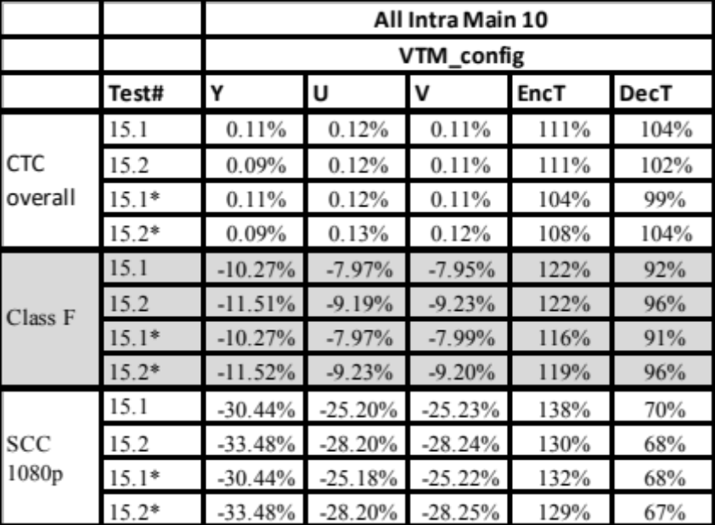
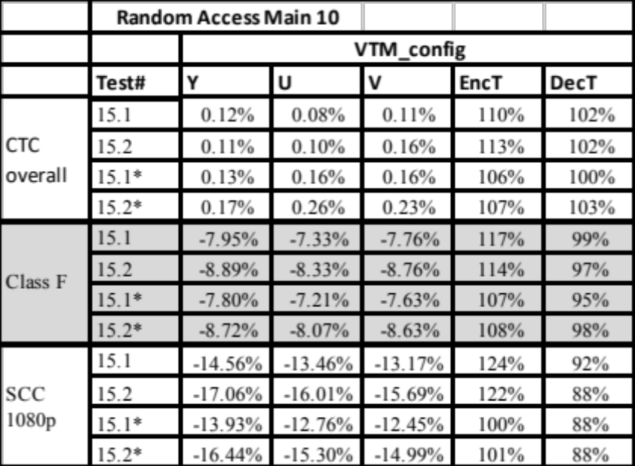
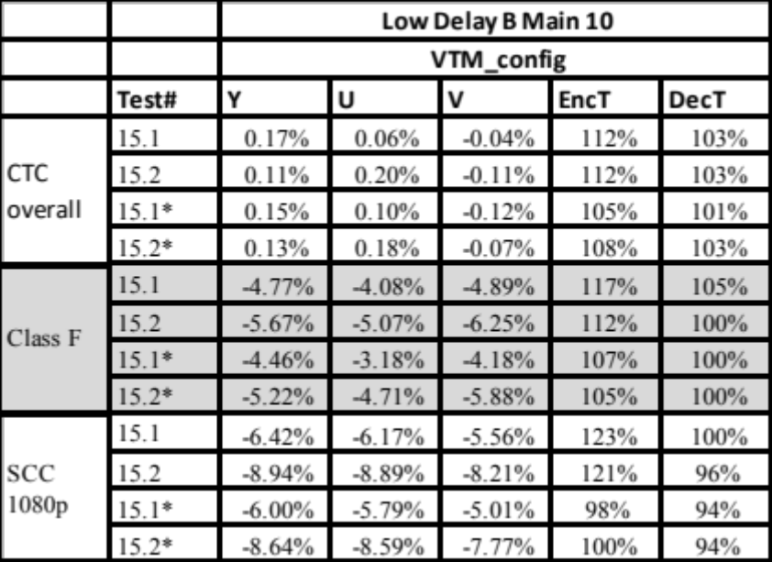
The simulation data have been crosschecked and crosscheck results are summarized as follows,

# | Tester | Cross-checker | Software review/studied? (Y/N) | Any significant inconsistencies between the description and the provided software? | Results available (Full/Partial) | Results matched? (Y/N) | Runtime behavior matched? (Y/N) | Additional comments
15.1 | Yu-Chen Sun (Alibaba) | J. Ye | Ｙ | N | FULL | Y | Y
15.1 | Yung-Hsuan Chao (Qualcomm) | (Tencent) | Ｙ | N |  | Y
15.1* | Yu-Chen Sun (Alibaba) | J. Ye | Ｙ | N | FULL | Y | Y
15.1* | Yung-Hsuan Chao (Qualcomm) | (Tencent) | Ｙ | N |  | Y
15.2 | Yung-Hsuan Chao (Qualcomm) | Jianqing Zhu
15.2 | Yu-Chen Sun (Alibaba) | (Fujitsu)
15.2* | Yung-Hsuan Chao (Qualcomm) | Jianqing Zhu
15.2* | Yu-Chen Sun (Alibaba) | (Fujitsu)

Reference
- Y.-C. Sun, J. An, J. Lou, "AHG11: Palette mode ", JVET-K0411, 11th JVET meeting, July 2018.
- R. Joshi, S. Liu, G. J. Sullivan, Y.-K. Wang, J. Xu, Y. Ye, “HEVC Screen Content Coding Draft Text 6,” JCTVC-W1005, 11th JCTVC meeting, July 2018.
- Y.-C. Sun, Y.-H. Chao, X. Xu, " Description of Core Experiment 15 (CE15): Palette mode, JCTVC-K1035", 11th JVET meeting, July 2018.

