    Joint Video Experts Team (JVET)  of ITU-T SG 16 WP 3 and ISO/IEC JTC 1/SC 29/WG 11  11th Meeting: Ljubljana, SI, 10–18 July 2018 | Document: JVET-K1024-v4

Title: | Description of Core Experiment 4 (CE4): Inter prediction and motion vector coding
Status: | Output document
Purpose: | Core Experiment description
Author(s) or  Contact(s): | Haitao Yang  Shan Liu  Kai Zhang | Email: | haitao.yang@huawei.com  shanl@tencent.com  zhangkai.video@bytedance.com
Source: | CE coordinators
_____________________________

Abstract
The goal of Core Experiment 4 (CE4) is to investigate various inter prediction and motion vector coding techniques on top of VTM2.0. It comprises 8 categories,
- Affine motion compensation
- Affine merge mode
- Planar motion vector prediction
- Merge mode enhancement
- Motion vector coding
- Reference picture boundary padding
- Local illumination compensation
- Motion data storage

CE4.1: Affine motion compensation

Test specification
Test # | Description | Source | Tester | Crosschecker
4.1.1 | Cross-model inheritance for affine candidate derivation | K0185 | H. Chen  (Huawei) | Y. He  (InterDigital)
4.1.2 | Adaptive affine AMVP inheritance (withdraw) | K0337 | H. Huang  (Qualcomm)
4.1.3 | Simplification of affine AMVP list construction  a) Simplify the construction of inherited affine candidates  b) Simplify the construction of constructed affine candidates  c) a)+b) | K0185 | H. Chen  (Huawei) | J. Lee  (LGE)
4.1.4 | Simplified affine MVP list construction  a) Simplified inherited affine candidate with scanning order  b) Simplified inherited affine candidate with the reduced number of candidate  c) Simplified constructed affine candidate  d) a) + c)  e) b) + c)  f) with line buffer reduction | K0094 | J. Lee  (LGE) | H. Chen  (Huawei)
4.1.5 | Spatial & temporal affine AMVP candidate derivation (withdraw)  a) Additional spatial candidates {a2, b3} for predicting the affine motion model of current CU in AMVP affine only  b) Additional virtual temporal candidate to predict the Affine motion model of current CU in AMVP affine only  c) a) + b) | K0218 K0267 | A. Robert  (Technicolor)
4.1.6 | a) Simplification on AMVP candidate list construction  b) Line buffer reduction (withdraw)  c) a) + b) (withdraw) | K0337 | H. Huang  (Qualcomm) | J. An (Alibaba)
4.1.7 | Shape dependent control points selection for affine MVP  a) Apply to explicit affine mode, affine merge, affine MV prediction  b) Apply to explicit affine mode only | K0335 | Y. He  (InterDigital) | H. Chen  (Huawei)
4.1.8 | Slice-level 4/6 parameters affine model switching | K0095 | J. Lee  (LGE)
4.1.9 | Slice-level 4/6 parameters affine model switching (withdraw) | J1024 | A. Robert  (Technicolor)
4.1.10 | Slice level 4/6 parameters affine model switching | K0337 | H. Huang  (Qualcomm) | J. Lee  (LGE)
4.1.11 | 1) Line buffer reduction for affine inherited candidates, location 1  2) Line buffer reduction for affine inherited candidates, location 2 | K0052 | M. Zhou  (Broadcom) | G. Li  (Tencent)
4.1.12 | Simplification of affine AMVP list construction combined with line buffer reduction | K0185 | H. Chen  (Huawei) | K. Zhang  (Bytedance)
4.1.13 | CTU restriction on affine inherited candidates for line buffer reduction | K0339 | H. Huang  (Qualcomm) | J. An (Alibaba)
4.1.14 | Bypass coding of 4/6 parameter indication flag | K0095 | J. Lee  (LGE) | H. Huang  (Qualcomm)
4.1.15 | a) Conditional signaling of 6-param model at block level (withdraw)  b) a) + slice-level 4/6 parameters affine model switching (withdraw) | K0095 | J. Lee  (LGE)
4.1.16 | The sub-block size for chroma components is expanded from 2×2 to 4×4. | K0103 | K. Zhang  (Bytedance)
4.1.17 | a) 3(scaling)/3(rotation)/4 model switching  b) 3(scaling)/3(rotation)/6 model switching  c) 3(scaling)/3(rotation)/4/6 model switching | K0124 | K. Kondo  (Sony) | H. Chen  (Huawei)

Test condition and evaluation criteria
For tests modify affine MVP list construction, the complexity analysis of list construction should be provided and crosschecked. Generally speaking, the complexity should not be higher than that of VTM affine MVP list construction if no distinguishable coding gain is observed.

Number of | Max number of |  |  | Operations |  |  |  | Buffer
candidates in the final list | inherited affine candidate | constructed affine candidate | candidate comparison | add | sht. | cmp. | scal. | additional buffers

Technical description

Cross-model inheritance for MERGE/AMVP candidate derivation (JVET-K0185)
In JVET-K0185, six-parameter motion model represented by three control points is proposed. The 4-parameter and 6-parameter motion models are selected at the CU level by using an additional affine motion type flag.
The cross-model inheritance for affine candidate derivation is further studied in this test. For example, 4-parameter motion model can be converted to 6-parameter affine model by using 4-parameter model formula to generate the motion vector of bottom-left control point. In such case, during MC and motion vector derivation for sub-blocks, unified 6-parameter affine model is used.

Test # | Description | Tester | Crosschecker
4.1.1 | Cross-model inheritance for affine candidate derivation | H. Chen  (Huawei)

Simplification of affine AMVP list construction (JVET-K0185)
In JVET-K0185, the affine AMVP candidate list is constructed as follow:
- Inherited affine candidates
Up to two candidates derived from the affine motion models of neighboring affine coded blocks are inserted into the candidate list. The scan order for this category of candidates is same as AMVP in HEVC. For the left predictor, the scan order is: {A0, A1}. For the above scan predictor, the order is: {B0, B1, B2}.
- Constructed affine candidates
If the number of inherited affine candidates is less than two, different combinations of the motion vector of neighbor coded block of control points are inserted into the candidate list until the number of candidate is two.

The affine AMVP list construction will be simplified and tested as follow:
- Simplify the construction of inherited affine candidates in terms of scanning order and pruning process
- Simplify the construction of constructed affine candidates

Test # | Description | Tester | Crosschecker
4.1.3 | Simplification of affine AMVP list construction  a) Simplify the construction of inherited affine candidates  b) Simplify the construction of constructed affine candidates  c) a)+b) | H. Chen  (Huawei) | J. Lee  (LGE)

Motion vector prediction in Affine AMVP (JVET-K0218, JVET-K0219, JVET-K0267, JVET-K0268)

Affine candidate derivation
The addition of spatial candidates into the list of affine motion models used to predict the affine motion model of current CU has been tested in JVET-K0218, JVET-K0267 and JVET-K0268. It will be tested in this SubCE in the scope of Affine AMVP. As an example, candidate positions {a2, b3} will be tested.
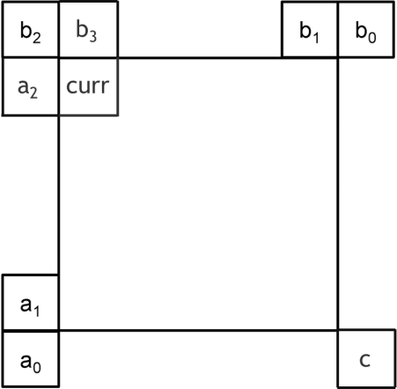

Figure 1. Positions of spatial and temporal candidates of motion information.
The use of additional temporal candidates to predict the affine motion model of current CU has been proposed in JVET-K0219, JVET-K0267 and JVET-K0268. This takes the form of either temporal inheritance of affine motion seeds (which involves the storage of affine seeds in the temporal picture buffer), or the construction of candidate affine seeds based on temporal motion vector predictors.
In the latter case, positions {a0, b0, c0} for temporal vector predictors will be tested, as in contribution JVET-K0267. Alternative positions may be tested.
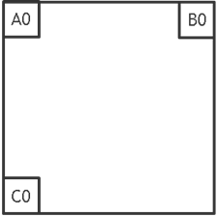
Figure 2: Position of virtual temporal candidates for affine model construction

Slice-level 4-parameters/6-parameters switching
The technique described in previous section will be tested with and without the slice-level switching between 4-parameters and 6-parameters that was proposed in test 4.1.3.d of JVET-J01024.

Test # | Description | Tester | Crosschecker
4.1.5 | Spatial & temporal affine AMVP candidate derivation  a) Additional spatial candidates {a2, b3} for predicting the affine motion model of current CU in AMVP affine only  b) Additional virtual temporal candidate to predict the Affine motion model of current CU in AMVP affine only  c) a)+b) | A. Robert  (Technicolor)
4.1.9 | Slice-level 4/6 parameters affine model switching | A. Robert  (Technicolor)

Line buffer reduction for affine model inheritance (JVET-K0052)
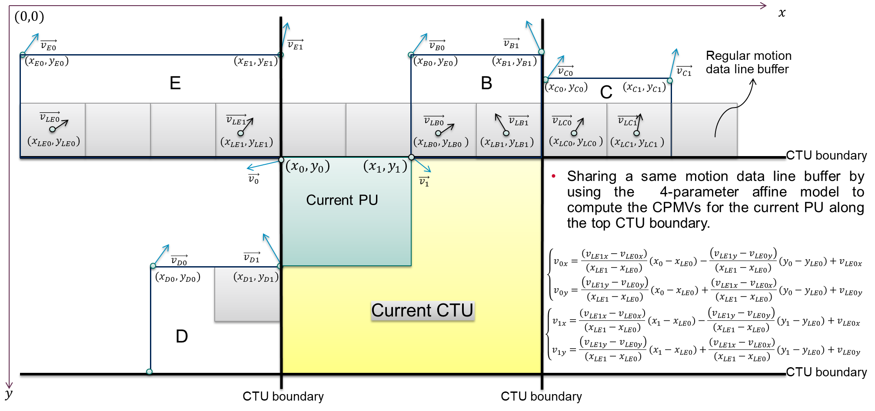
Figure 3: shared motion data line buffer for affine merge and regular merge/skip mode (e.g. 4-parameter affine motion model)
As shown in Figure 3, if the selected neighboring PU is located at the top CTU boundary, the motion vectors stored in the regular motion data line buffer rather than the control point motion vectors of the selected PU are used for derivation of the seed motion vectors of the current PU of the affine merge mode. For example in Figure 3, if the current PU uses the affine merge mode and inherits the affine motion data from the neighboring PU E located at top CTU boundary, then motion vectors in the regular motion data line buffer, i.e. $\vec{v_{LE0}}=\left(v_{LE0x},v_{LE0y}\right)$ at sample position $\left(x_{LE0},y_{LE0}\right)$ and $\vec{v_{LE1}}=(v_{LE1x},v_{LE1y})$ at the sample position $\left(x_{LE1},y_{LE1}\right)$ with $y_{LE1}=y_{LE0}$, instead of affine seed motion vectors of the neighboring PU E, i.e. $\vec{v_{E0}}=\left(v_{E0x},v_{E0y}\right)$ at the top-left sample position $\left(x_{E0},y_{E0}\right)$ and$\vec{v_{E1}}=(v_{E1x},v_{E1y})$ at the top-right sample position $\left(x_{E1},y_{E1}\right)$, are used for the derivation of control point vectors $\vec{v_{0}}$ and $\vec{v_{1}}$ of the current PU.
Motion vectors $\vec{v_{LE0}}$ and $\vec{v_{LE1}}$ used for motion compensation of the bottom-left and bottom-right sub-blocks of PU E is calculated by using the 4-parameter or 6-parameter affine motion model, depending on the affine motion model used by the neighboring PU E.
The control point motion vectors $\vec{v_{0}}$ and $\vec{v_{1}}$ of the current PU coded in affine merge mode are derived by the 4-parameter affine motion mode regardless of whether the neighboring PU E uses the 4-parameter or 6-parameter affine motion model.
$\left\{\begin{matrix}v_{0x}=\frac{\left(v_{LE1x}-v_{LE0x}\right)}{(x_{LE1}-x_{LE0})}(x_{0}-x_{LE0})-\frac{\left(v_{LE1y}-v_{LE0y}\right)}{(x_{LE1}-x_{LE0})}(y_{0}-y_{LE0})+v_{LE0x} \\ v_{0y}=\frac{\left(v_{LE1y}-v_{LE0y}\right)}{(x_{LE1}-x_{LE0})}(x_{0}-x_{LE0})+\frac{\left(v_{LE1x}-v_{LE0x}\right)}{(x_{LE1}-x_{LE0})}(y_{0}-y_{LE0})+v_{LE0y}\end{matrix}\right.$
$\left\{\begin{matrix}v_{1x}=\frac{\left(v_{LE1x}-v_{LE0x}\right)}{(x_{LE1}-x_{LE0})}(x_{1}-x_{LE0})-\frac{\left(v_{LE1y}-v_{LE0y}\right)}{(x_{LE1}-x_{LE0})}(y_{1}-y_{LE0})+v_{LE0x} \\ v_{1y}=\frac{\left(v_{LE1y}-v_{LE0y}\right)}{(x_{LE1}-x_{LE0})}(x_{1}-x_{LE0})+\frac{\left(v_{LE1x}-v_{LE0x}\right)}{(x_{LE1}-x_{LE0})}(y_{1}-y_{LE0})+v_{LE0y}\end{matrix}\right.$
The same method is applied to the inherited affine motion candidate derivation if the current PU is located along the top CTU boundary.
No change is introduced if the current PU is not located along the top CTU boundary.
Refer to the example depicted in Figure 3, in the tests $x_{LE0}$ is set to $x_{E0}$ and $x_{LE1}$ is set to $x_{E1}$ to avoid non-power of 2 computation in equations above. Two tests will be conducted:
- $y_{LE1}=y_{LE0}=y0$ - 0
- $y_{LE1}=y_{LE0}=y0$ - 2

Test # | Description | Tester | Crosschecker
4.1.11 | 1) Line buffer reduction for affine inherited candidates, location 1  2) Line buffer reduction for affine inherited candidates, location 2 | M. Zhou  (Broadcom) | G. Li  (Tencent)

Alternative scaling and rotation model (JVET-K0124)
It’s tested to combine 3-parameter model with Affine model. The 3-parameter models predicts scaling or rotation. It makes a chance to reduce an overhead of motion information.
An encoder can choose a mode in five modes which are a conventional translate, scaling, rotation and Affine. A number of parameters are 2 (one motion vector), 3, 3, 4 (two MVs) and 6 (three MVs) for translate mode, scaling mode, rotation mode and two Affine modes.
The motion model index is defined and it is sent to the decoder to indicate a motion model.

When the scaling mode is chosen, three parameters are used to predict as shown in the below figure. It is one motion vector ($v_{0x}, v_{0y}$) and one element ($v_{1x}$). For the prediction process, the frame work is used the same as for Affine transform in JEM software. The parameter ($v_{1y}$) is implicitly assumed as the same as ($v_{0y}$).
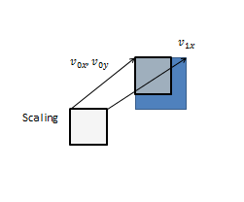
As mentioned above, a rotation mode is added in this technique. If the motion in a test sequence has rotation, the inter prediction can use a rotational translate. This rotation mode can predict the rotation and it can reduce the number of parameters than affine mode.
When the rotation mode is chosen, three parameters are used to predict as shown in the below figure. It is one motion vector ($v_{0x}, v_{0y}$) and one element ($v_{1y}$). For the prediction process, the frame work is used the same as for Affine transform in JEM software. The parameter ($v_{1x}$) is implicitly calculated by below equation. Here, $W$ is width in CU size.
$$v_{1x}=v_{0x}-\frac{{\left(v_{1y}-v_{0y}\right)}^{2}}{2W}$$
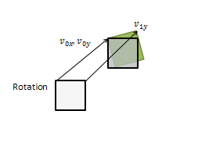

A framework that switching between 3(scaling)/3(rotation)/4(simplified Affine)/6(Affine) is tested. In Ljubljana meeting, 4/6 parameter model was adopted. In this test, to further study to combine with 3-parameter model, it’s implemented on the 4/6 parameter model. And it is divided three tests to check a trade-off in the combination.

Test # | Description | Tester | Crosschecker
4.1.17 | a) 3(scaling)/3(rotation)/4 model switching  b) 3(scaling)/3(rotation)/6 model switching  c) 3(scaling)/3(rotation)/4/6 model switching | K. Kondo  (Sony)

4/6-param model switching (JVET-K0095)
The following three approaches are proposed and tested in CE4. The flag for 4/6-param model switching at block is by-pass coded to reduce the CABAC throughput. 6-param affine model is allowed at block-level only when a neighboring block is in affine mode. Slice-level 4/6-param model switching is proposed.
The following 3 methods are tested:
- by-pass coding of the flag for 4/6-param model switching at block level;
- conditional signaling of 6-param model at block level;
- slice level switching of 4/6-param affine model.

Test # | Description | Tester | Crosschecker
4.1.8 | Slice-level 4/6 parameters affine model switching | J. Lee  (LGE)
4.1.14 | Bypass coding of 4/6 parameter indication flag | J. Lee  (LGE)
4.1.15 | a) Conditional signaling of 6-param model at block level (withdraw)  b) a) + slice-level 4/6 parameters affine model switching (withdraw) | J. Lee  (LGE)

Block size restriction on affine MC for chroma component (JVET-K0103)
In this contribution, the sub-block size for chroma components is expanded from 2×2 to 4×4.
Test # | Description | Tester | Crosschecker
4.1.16 | The sub-block size for chroma components is expanded from 2×2 to 4×4 | K. Zhang  (Bytedance)

Shape dependent control point selection for affine mode (JVET-K0335)
To solve the MV interpolation accuracy problem of affine mode, control points are selected based on coding block shape for the affine coding mode. If coding block width is greater than or equal to coding block height, the control points are defined by top-left corner (P₀) and top-right corner (P₁) as shown in the following figure (a); if coding block width is smaller than coding block height, the control points are defined by top-left corner (P₀) and bottom-left (P₂) corner as shown in following figure (b).
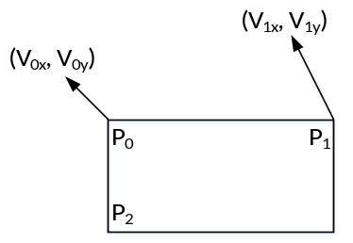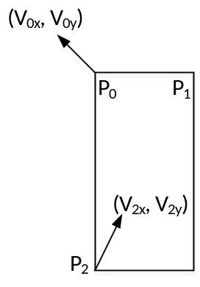
(a) (b)

Test # | Description | Tester | Crosschecker
4.1.7 | Shape dependent control points selection for affine MVP | Y. He  (InterDigital) | H. Chen  (Huawei)

Simplification on affine AMVP candidate list construction (JVET-K0337)
In JVET-K0337, the affine candidate list is appended sequentially by extending affine motion from spatial neighboring blocks (extrapolated affine candidates), the combination of motion vectors from spatial neighboring blocks (virtual affine candidates) and HEVC motion vector prediction (MVP) candidates until there are two affine MVPs in the candidate list. The candidate sets are constructed as follows:
- Up to two different affine MV predictor sets are derived from affine motion of the neighboring blocks. Neighboring blocks A0, A1, B0, B1, and B2 as shown in Figure a) are checked. If the neighboring block is coded using affine motion model and its reference frame is same as the reference frame of the current block, MVs at two (for 4-parameter affine model) or three (for 6-parameter affine model) control points of the current block are derived from the affine model of this neighbor.
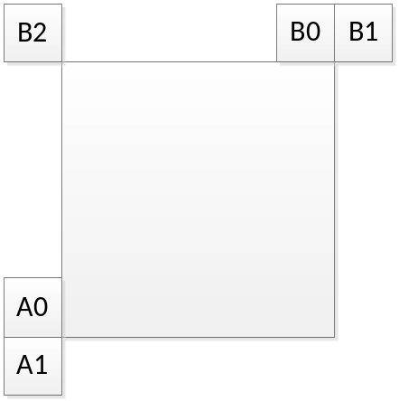
Figure a): Affine motion predictors derivation from affine motion of neighboring blocks.
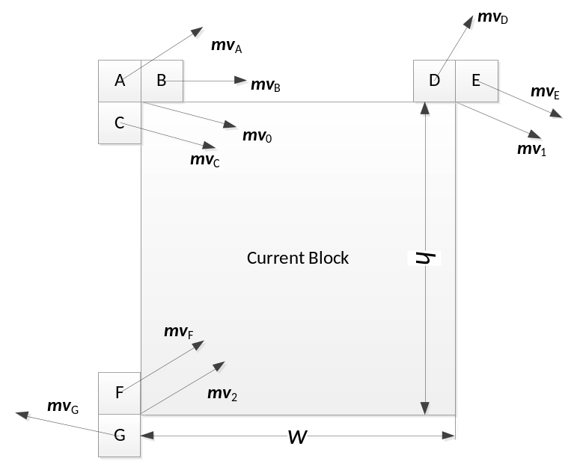
Figure b): Affine motion predictors derivation from motion vectors of neighboring blocks.

- Virtual affine candidates. Figure b) shows the neighboring blocks used to generate the virtual affine candidate set. The neighboring MVs are divided into three groups: $S_{0}=\left\{{mv}_{A},{mv}_{B},{mv}_{C} \right\}$, $S_{1}=\left\{{mv}_{D},{mv}_{E}\right\}$ and $S_{2}=\left\{{mv}_{F},{mv}_{G}\right\}$. ${\overline{mv}}_{0}$ is the first MV in S₀ that refers to the same reference picture as the current block; ${\overline{mv}}_{1}$ is the first MV in S₁ that refers to the same reference picture of the current block; and ${\overline{mv}}_{2}$ is the first in S₂ that refers to the same reference picture of the current block.
- If only ${\overline{mv}}_{0}$ and ${\overline{mv}}_{1}$ can be found, ${\overline{mv}}_{2}$ is derived as:
${\overline{mv}}_{2}^{x}={\overline{mv}}_{0}^{x}-h\frac{\left({\overline{mv}}_{1}^{y}-{\overline{mv}}_{0}^{y}\right)}{w}, {\overline{mv}}_{2}^{y}={\overline{mv}}_{0}^{y}+h\frac{\left({\overline{mv}}_{1}^{x}-{\overline{mv}}_{0}^{x}\right)}{w},$
where the current block size is W×H.
- If only ${\overline{mv}}_{0}$ and ${\overline{mv}}_{2}$ can be found, ${\overline{mv}}_{1}$ is derived as:
${\overline{mv}}_{1}^{x}={\overline{mv}}_{0}^{x}+h\frac{\left({\overline{mv}}_{2}^{y}-{\overline{mv}}_{0}^{y}\right)}{w}, {\overline{mv}}_{1}^{y}={\overline{mv}}_{0}^{y}-h\frac{\left({\overline{mv}}_{2}^{x}-{\overline{mv}}_{0}^{x}\right)}{w}.$

The simplification of the affine AMVP list construction process is tested.
Test # | Description | Tester | Crosschecker
4.1.6 | a) Simplification of affine AMVP list construction  b) Line buffer reduction (withdraw)  c) a) + b) (withdraw) | H. Huang  (Qualcomm) | J. An (Alibaba)

Slice level adaptive affine model selection (JVET-K0337)
The affine models are adaptively selected at slice level as in JVET-K0337.
Slice header flags affine4_flag and affine6_flag indicate whether the 4-parameter affine and 6-parameter affine model are applied. If one of them is equal to 1, affine_flag signaled at block level indicates whether the allowed affine model is used for this block. If both are equal to 1, there is an affine_type flag signaled at block level. If affine_type is equal to 1, the 6-parameter affine model is used, otherwise the 4-parameter affine model is applied. To determine the affine4_flag and affine6_flag for the current slice the statistics from the previous slice are used.

Test # | Description | Tester | Crosschecker
4.1.10 | Slice level 4/6 parameters affine model switching | H. Huang  (Qualcomm) | J. Lee  (LGE)

Simplified affine MVP list construction (JVET-K0094)
The affine MVP candidate list construction is simplified and tested in CE4 as follows.

Test # | Description | Tester | Crosschecker
4.1.4 | Simplified affine MVP list construction  a) Simplified inherited affine candidate with scanning order  b) Simplified inherited affine candidate with the reduced number of candidate  c) Simplified constructed affine candidate  d) a) + c)  e) b) + c) | J. Lee (LGE)

CE4.2: Affine merge mode

Test specification
Test # | Description | Source | Tester | Crosschecker
4.2.1 | Common base for affine merge mode | K0186 | H. Chen  (Huawei) | F. Galpin (Technicolor)
4.2.2 | Simplification of the common base  a) Simplify affine merge list construction by reducing pruning operation  b) Simplify affine merge list construction by reducing MV scaling operation  c) Simplify affine merge list construction by reducing maximum number of candidates  d) Reduce line buffer in affine merge mode  e) a)+b)+c)  f) a)+b)+c)+d)  g) f) + test 4.1.3.c  h) test 4.2.2.e + test 4.4.7.a (History-based Motion Vector Prediction) | K0186 | H. Chen  (Huawei) | J. Lee  (LGE)
4.2.3 | Modified affine merge candidates  a) adding spatial inherit affine merge candidate  b) adding corner derived affine merge candidate  c) adding both spatial inherit affine merge candidate and corner derived affine merge candidate ( a + b)  d) c + reducing line buffer | K0245 | Z.-Y. Lin  (MediaTek)
4.2.4 | Spatial & temporal merge candidate derivation  a) Additional spatial candidates {a2, b3} for predicting the affine motion model of current CU in merge affine only (withdraw)  b) Additional virtual temporal candidate to predict the Affine motion model of current CU in merge affine only  c) a) + b) | K0219 K0267 | F. Galpin  (Technicolor) | H. Huang  (Qualcomm)
4.2.5 | a) Simplification of  affine merge list construction  b  ) a  ) + move ATMVP to affine merge list | K0339 | H. Huang  (Qualcomm) | F. Galpin  (Technicolor)
4.2.6 | Affine merge list construction improvements  a) Simplified inherited affine candidate  b) Simplified constructed affine candidate  c) a) + b)  d) c) + reduced candidate number for affine candidate  e) d) + line buffer reduction  f) d) + CE4.1.4 d)  g) e) + CE4.1.4 f) | K0094 | J. Lee  (LGE) | H. Chen  (Huawei)
4.2.7 | a) Shape dependent control points selection for affine merge (withdraw)  b) a) + Shape dependent control points selection for affine MPV (test 4.1.7) (withdraw) | K0335 | Y. He  (InterDigital) | H. Chen  (Huawei)
4.2.8 | Separate list for sub-block merge candidates  a) 4.2.1 + move ATMVP to affine merge list  b) 4.2.2.e + move ATMVP to affine merge list  c) 4.2.2.e + 4.1.6.a (Simplification on AMVP candidate list construction)  d) 4.2.8.b + 4.1.6.a (Simplification on AMVP candidate list construction) | K0364 | H. Chen  (Huawei) | Z.-Y. Lin  (MediaTek)

Test condition and evaluation criteria
The common base (test 4.2.1): separate list for affine merge candidates, 5 candidates, both inherited and constructed candidates.
Each test should be implemented on top of the common base. And the common base will be used as a second anchor against which each test will be compared. The software of the common base will be provided within 5 days after the release of VTM2.0.
Modifications of each single piece of the common base is suggested to be tested separately, including modified or additional inherited affine candidates, modified or additional constructed affine candidates, additional motion models, the number of candidates in the list, the level of encoder and RD optimizations.
For example, in case of testing modified or additional inherited affine candidate, the constructed affine candidates in the common base should be kept unchanged; in case of testing modified or additional constructed affine candidate, the inherited affine candidates in the common base should be kept unchanged.
Generally, RD optimization in the separate affine merge list should not be changed. And the candidate number should be aligned among all tests. Any change on RD optimization should be reported.
The complexity analysis of list construction should be provided and crosschecked. Generally speaking, the complexity should not be higher than that of VTM affine MVP list construction if no distinguishable coding gain is observed.

Number of | Max number of |  |  | Operations |  |  |  | Buffer
candidates in the final list | inherited affine candidate | constructed affine candidate | candidate comparison | add | sht. | cmp. | scal. | additional buffers

Technical description

Common base for affine merge mode (JVET-K0186)
The common base is based on JVET-K0186. In the common base for affine merge enhancement, the affine merge candidate list is constructed as following steps:
- Insert inherited affine candidates into candidate list
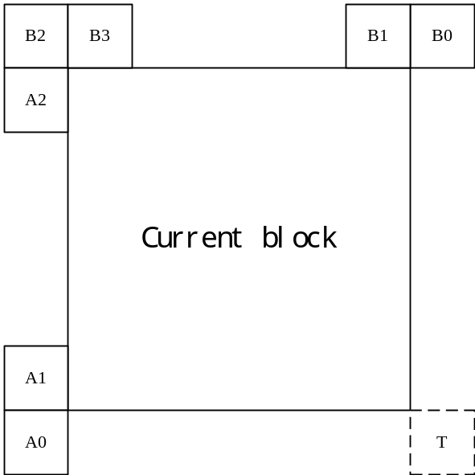
Figure 1 Candidates position for affine merge mode
Inherited affine candidate means that the candidate is derived from the valid neighbor reconstructed block coded with affine mode.
In the common base, as shown in Figure 1, the scan order for the candidate block is A₁, B₁, B₀, A₀ and B₂.
- Insert constructed affine candidates
If the number of candidates in affine merge candidate list is less than MaxNumAffineCand, constructed affine candidates are insert into the candidate list.
Constructed affine candidate means the candidate is constructed by combining the neighbor motion information of each control point.
The motion information for the control points is derived firstly from the specified spatial neighbors and temporal neighbor shown in Figure 2. CPk (k=1, 2, 3, 4) represents the k-th control point. A₀, A₁, A₂, B₀, B₁, B₂ and B₃ are spatial positions for predicting CPk (k=1, 2, 3); T is temporal position for predicting CP4.
The coordinates of CP1, CP2, CP3 and CP4 is (0, 0), (W, 0), (H, 0) and (W, H), respectively, where W and H are the width and height of current block.
The motion information of each control point is obtained according to the following priority order:
- For CP1, the checking priority is B₂->B₃->A₂. B₂ is used if it is available. Otherwise, if B₂ is available, B₃ is used. If both B₂ and B₃ are unavailable, A₂ is used. If all the three candidates are unavailable, the motion information of CP1 cannot be obtained.
- For CP2, the checking priority is B1->B0;
- For CP3, the checking priority is A1->A0;
- For CP4, T is used.
Secondly, the combinations of controls points are used to construct the motion model.
Motion vectors of three control points are needed to compute the transform parameters in 6-parameter affine model. The three control points can be selected from one of the following four combinations ({CP1, CP2, CP4}, {CP1, CP2, CP3}, {CP2, CP3, CP4}, {CP1, CP3, CP4}). For example, use CP1, CP2 and CP3 control points to construct 6-parameter affine motion model, denoted as Affine (CP1, CP2, CP3).
Motion vectors of two control points are needed to compute the transform parameters in 4-parameter affine model. The two control points can be selected from one of the following six combinations ({CP1, CP4}, {CP2, CP3}, {CP1, CP2}, {CP2, CP4}, {CP1, CP3}, {CP3, CP4}). For example, use the CP1 and CP2 control points to construct 4-parameter affine motion model, denoted as Affine (CP1, CP2).
The combinations of constructed affine candidates are inserted into to candidate list as following order:
{CP1, CP2, CP3}, {CP1, CP2, CP4}, {CP1, CP3, CP4}, {CP2, CP3, CP4}, {CP1, CP2}, {CP1, CP3}, {CP2, CP3}, {CP1, CP4}, {CP2, CP4}, {CP3, CP4}
- Insert zero motion vectors
If the number of candidates in affine merge candidate list is less than MaxNumAffineCand, zero motion vectors are insert into the candidate list, until the list is full.

Test # | Description | Tester | Crosschecker
4.2.1 | Common base of affine merge enhancement | H. Chen  (Huawei) | F. Galpin (Technicolor)

Affine merge enhancement (JVET-K0186)
Various simplification of the common base are tested.

Test # | Description | Tester | Crosschecker
4.2.2 | Simplification of the common base  a) Simplify affine merge list construction by reducing pruning operation  b) Simplify affine merge list construction by reducing MV scaling operation  c) Simplify affine merge list construction by reducing maximum number of candidates  d) Reduce line buffer in affine merge mode  e) a)+b)+c)  f) a)+b)+c)+d) | H. Chen  (Huawei)

Motion vector prediction in Merge Affine (JVET-K0245)
In this test, the combined candidate list in proposed. The affine candidates are added to merge candidate list. There are two kinds of affine candidates. The first one is spatial inherited affine candidate. The second one is corner derived affine candidates. Spatial inherited affine candidates use affine model from one of neighboring coding units (CUs) located at A1, B1, B0, A0, and B2 to derive current CU’s affine model as shown in Figure 1. In this proposal, spatial inherited affine candidates only use 6-parameter affine model. For each spatial location, if the spatial inherited affine candidate is available, then its original spatial inherited candidates will not be added to the merge candidate list. The spatial affine candidates searching order goes as A1 B1 B0 A0 B2.
Corner derived affine candidates simply set three spatial candidates as control points. For example, the motion vector (MV) sets of block {(B2, A1, B1), (B2, A0, B1), (B2, A1, B0), (B2, A0, B0)} as shown in Figure 1. Available motion triplets of spatial neighbors with the same reference picture are inserted. The constructed affine candidate (CP2, CP3, CP4) in common base is added as well. For each inserted affine candidate, no pruning and partial pruning will be tested. For example, each affine candidate only check the redundancy with the first available affine candidate. The complexity analysis of how many add/shift/comparison/mult are used will be provided.

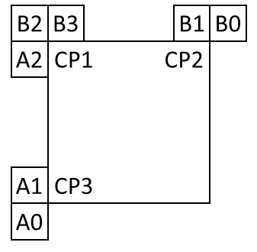
Figure 1. Position for spatial inherited affine and corner derived affine candidates.

Test # | Description | Tester | Crosschecker
4.2.3 | Modified affine merge candidates  a) adding spatial inherit affine merge candidate  b) adding corner derived affine merge candidate  c) adding both spatial inherit affine merge candidate and corner derived affine merge candidate ( a + b)  d) c + reducing line buffer | Z.-Y. Lin  (MediaTek)

Motion vector prediction in Merge Affine (JVET-K0218, JVET-K0219, JVET-K0267, JVET-K0268)
The tests driven in this section will be performed on top of the common base for affine merge mode by using the concepts described in 1.3.3.1 adapted to the affine merge mode.
Test # | Description | Tester | Crosschecker
4.2.4 | Additional spatial & temporal affine merge candidate derivation of the common base  a) Additional spatial candidates {a2, b3} for predicting the affine motion model of current CU in merge affine only  b) Additional virtual temporal candidate to predict the Affine motion model of current CU in merge affine only  c) a) + b) | F. Galpin  (Technicolor)

Affine merge candidate list construction (JVET-K0339)
In JVET-K0339, two categories of affine merge candidates are considered and pruned before inserted into the affine merge candidate list which is constructed separately from the normal merge candidate list.
The first category of affine merge candidate is inherited affine merge candidate and could be further divided into two sub-categories depending the position of the merge candidates. In Figure 2, index 1-5 indicates the adjacent spatial affine merge candidate positions while index 6-49 represent the non-adjacent affine merge candidate positions. Those affine merge candidates are checked in ascending index order. If the block is coded using affine mode and the motion information is different from other affine merge candidates in the affine merge candidate list, the motion information will be inserted into the affine merge candidate list.
The second category of affine merge candidate is called virtual affine merge candidates where affine merge candidate constructed as a combination of motion vectors from spatial neighboring blocks. The neighboring MVs are divided into three groups: $S_{0}=\left\{{mv}_{A},{mv}_{B},{mv}_{C} \right\}$, $S_{1}=\left\{{mv}_{D},{mv}_{E}\right\}$ and $S_{2}=\left\{{mv}_{F},{mv}_{G}\right\}$. The motion vector in each group is scanned in a given order and the first available motion vectors is selected as the corresponding control point motion vector. A total number of 12 possible combinations could be produced from this category.
The target reference picture is determined as follows. If there is a reference picture that is simultaneously referred to by motion vectors in S0, S1 and S2, then such a reference picture with the smallest reference index is selected as the target one; if there is a reference picture that is simultaneously referred to by motion vectors in S0 and in S1, then such a reference picture with the smallest reference index is selected as the target one; if there is a reference picture that is simultaneously referred to by motion vectors in S0 and in S2, then such a reference picture with the smallest reference index is selected as the target one; otherwise, the virtual affine merge candidate is unavailable.
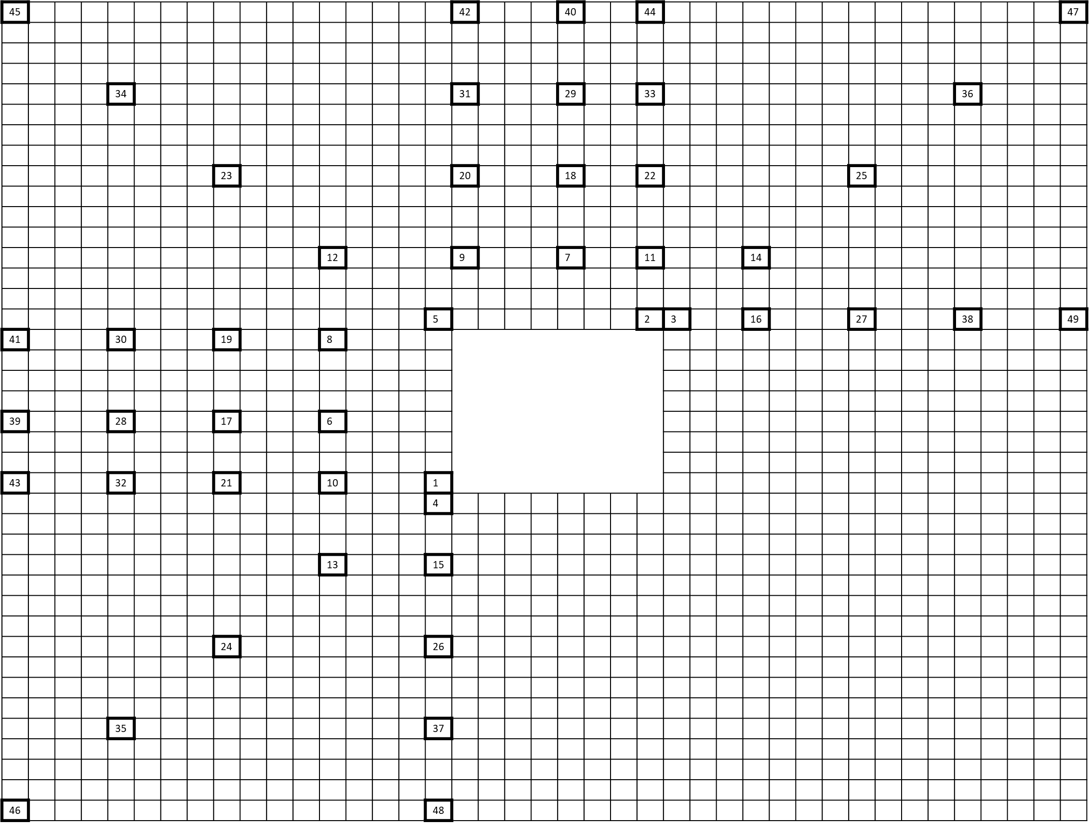
Figure 2: Spatial neighboring blocks used to derive the spatial merge candidates.

Figure 3: Virtual affine merge candidate derivation from motion vectors of neighboring blocks.

Test # | Description | Tester | Crosschecker
4.2.5 | a) Simplification of  affine merge list construction  b  ) a  ) + move ATMVP to affine merge list | H. Huang  (Qualcomm) | F. Galpin  (Technicolor)

Affine merge improvement (JVET-K0094)
Up to two inherited affine merge candidate can be considered on the top of the common base. Simplification and unification approached are considered. And the common base is considered with the proposed inherited candidate in terms of the optimization and simplification.

Test # | Description | Tester | Crosschecker
4.x.x | Affine merge list construction improvements  a) Simplified inherited affine candidate  b) Simplified constructed affine candidate  c) a) + b)  d) c) + reduced candidate number for affine candidate  e) c) + line buffer reduction | J. Lee (LGE)

Separate merge candidate list for sub-block modes (JVET-K0364)
Currently, several sub-block based motion vector prediction (MVP) methods has been proposed, e.g., ATMVP, STMVP, Affine Merge enhancement in JVET-J0024 and Planar MVP in JVET-J0061. All of these methods generate fine granularity motion fields for CUs. Because of the commonality among these methods, this contribution presents a separate merge candidate list for sub-block based MVPs. The candidate list is constructed by integrating two or more sub-block based MVPs into a separate merge candidate list.

Test # | Description | Tester | Crosschecker
4.x.x | Separate list for sub-block merge candidates  a) 4.2.1 + move ATMVP to affine merge list  b) 4.2.2.f + move ATMVP to affine merge list | H. Chen  (Huawei) | Z.-Y. Lin  (MediaTek)

CE4.3: Planar motion vector prediction

Planar Motion Vector Prediction (K0135)
To generate a smooth fine granularity motion field, Figure 1 gives a brief description of the planar motion vector prediction process.
Planar motion vector prediction is achieved by averaging a horizontal and a vertical linear interpolation on 4x4 block basis as follows.
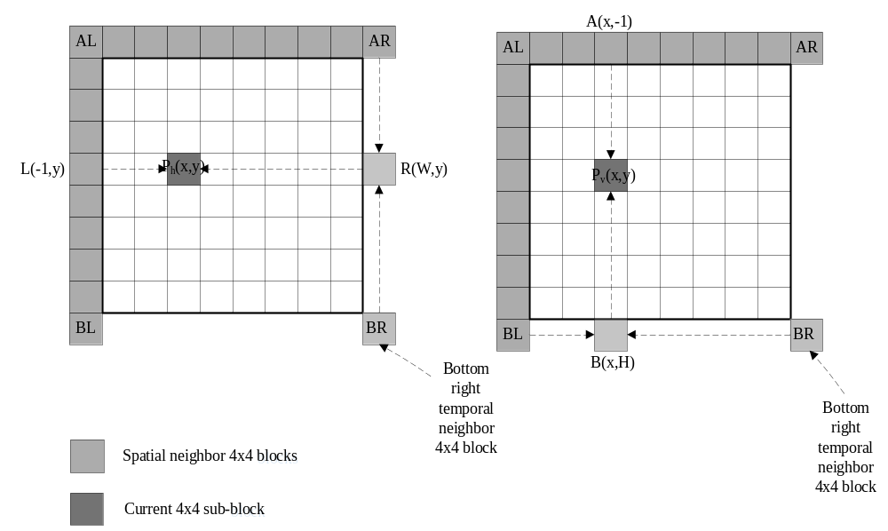
Figure 1. Planar motion vector prediction process
• Extrapolate motion vectors of each sub-block inside a coding block similarly as intra prediction planar mode.
• Motion in the L-shaped area is padded in the same manner as intra reference pixel padding, separately for L0 and L1.
• Bi-directional or uni-directional: decided based on the prediction direction of the motion in the L-shaped area. Once there are two or more L0 or L1 MVs, L0 or L1 direction is activated.
• Ref_idx in L0 and L1 is set to 0.
• Use the bottom-right corner temporal motion vectors for planar prediction.
• It is a merge mode.

Test # | Description | Tester | Crosschecker
4.3.1 | Planar Motion Vector Prediction | N. Zhang  (HiSilicon)
4.3.2 | Separate list for sub-block merge candidates  a) Separate list for 4.3.1 candidates and 4.2.8.b candidates (used as anchor)  b) Unified list for 4.3.1 candidates and 4.2.8.b candidates | H. Chen  (Huawei) | A. Tamse  (Samsung)

MVPlanar (K0349)
MVPlanar prediction introduces subblock-level motion vector derivation. The proposed scheme generates motion vector field by interpolating motion vectors by weighted average of motion vectors of the above, above-right, left, and bottom-left neighboring blocks same as intra planar prediction. If neighboring block is not available or an intra-coded CU, substitution process is carried out in the same way as intra reference sample substation.
For MVPlanar mode, additional syntax mv_planar_flag is signaled at CU level. If mv_planar_flag is set equal to 1, inter_pred_idc and ref_idx are additionally signaled.
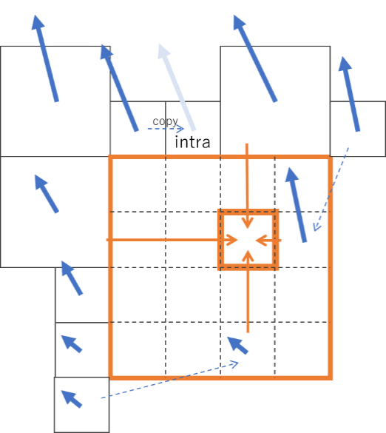

Test # | Description | Tester | Crosschecker
4.3.3 | a) MV Planar prediction  b) a) with temporal bottom-right mv (withdraw) | S. Iwamura (NHK) | K. Kazui (Fujitsu)

CE4.4: Merge mode enhancement

Test specification
Test # | Description | Source | Tester | Crosschecker
4.4.1 | Spatial-temporal merge mode (non sub-block STMVP) | K0532 | T. Zhou  (Sharp) | Y.-W. Chen  (Kwai)
4.4.2 | Long distance merge candidates  a) Search round 1 and 2 with virtual block size (width + i * grid_width, height + i * grid_height)  b) Search round 1 and 2 with virtual block size (width + i * grid_width * 2, height + i * grid_height * 2) | K0286/  K0297 | J. Ye  M. Gao  (Tencent) | T. Solovyev  (Huawei)
4.4.3 | Non-adjacent spatial candidates  a) Line buffer reduction  b) Reduced number of non-adjacent spatial merge | K0198 | X. Chen  (Hisilicon) | Y. Hsiao  (MediaTek)
4.4.4 | Non-adjacent merge candidates with buffer size reduction  a) 4.4.2.a+ Line buffer reduction  b) a) + reference MV position rounding | K0245/  K0246 | Y. Hsiao  (MediaTek)
4.4.5 | Merge mode modification  a) Non-adjacent spatial merge candidates, merge candidate list size equal to 6/8/10  b) a + TMVP candidates, merge candidate list size equal to 6/8/  10 (withdraw)  - a) with 10 checked positions in pattern | K0056 | T. Solovyev  (Huawei) | J. Ye  (Tencent)
4.4.6 | a) Non-adjacent spatial merge with no additional line buffer  b) a + Enlarge merge candidate list size to 10  c) a + Non-sub-block STMVP + Enlarge merge candidate list size to 10 | K0339 | H. Yu  (Qualcomm) | T. Solovyev  (Huawei)
4.4.7 | History-based Motion Vector Prediction  a) Applied to merge list  b) a) + applied to AMVP list as well | K0104 | L. Zhang  (ByteDance) | T. Solovyev  (Huawei)  J. Ye  (Tencent)
4.4.8 | Merge offset extension  a) Applied to merge list with 4 or 8 offset  b) MV offset with different signaling way | K0198 | X. Chen  (Hisilicon) | T. Zhou  (Sharp)
4.4.9 | Middle spatial and multiple temporal candidates (withdraw)  a) Add middle spatial candidates  b) Add multiple temporal candidates  c) a) + b) | K0245 | Y. Hsiao  (MediaTek) | F. Le Léannec (Technicolor)
4.4.10 | Extension of merge and AMVP candidates for inter prediction  a) Add merge candidates at middle position for inter merge  b) Add new AMVP predictor candidates from middle position  c) a) + b)  d) Test 4.4.10.c + 4.4.2.a (withdraw)  e) Test 4.4.10.c + 4.4.2.b | K0301 | G. Li  (Tencent) | T. Zhou  (Sharp)
4.4.11 | Combined Average Merge Candidates | K0198 | N. Zhang  (Hisilicon)
4.4.12 | Pairwise average candidates (list size 6 and 8)  a) Pairwise average candidates without HEVC combine candidate (list size 6, 8, and 10)  b) Pairwise average candidates with HEVC combine candidate (list size 6, 8, and 10) | K0245 | Y. Hsiao  (MediaTek) | F. Le Léannec (Technicolor)
4.4.13 | Block shape based candidate list reordering for spatial candidates  a) Applied to merge list  (withdraw original b))  (withdraw original c))  Evaluate interaction with UMVE (K0115).  b) a) + Test 4.5.4.b  Evaluate interaction with HMVP (K0104).  c) a) + Test 4.4.7.a  (withdraw original f))  d  ) a) + Test 4.4.7.c | K0065 | L. Xu  (Hikvision) | Jie Chen  (Samsung)
4.4.14 | Ranking based spatial merge candidate list for inter prediction  a) Ranking based spatial merge list  b) Evaluate reduced candidate search range to M = H/4+1, N = W/4+1 (withdraw)  c) Evaluate full ranking and put candidates with counts > threshold at the top of candidate list (withdraw) | K0304 | G. Li  (Tencent) | Y. Hsiao  (MediaTek)

Test condition and evaluation criteria
Generally, RD optimization during merge list construction should not be changed. Any change on RD optimization should be reported.
The complexity analysis of list construction for all tests should be provided and crosschecked
Merge list size | Max number of potential candidates | Max number of candidate comparison | Max number of MV scaling | Max number of temporal candidates | Additional local buffer | Max number of memory access | Others
All tests should follow the constraints below
- No additional line buffer
- Max number of potential additional candidates should not exceed 20
- Max merge list size should not exceed 15
Results when merge list size is set being equal to 6, 8, and 10 are mandatory for simulation, if applicable to a proposed method, for the purpose of easier comparison among different tests. Results for other merge list size can also be reported, if the merge list size is a part of the design.

Technical description

Spatial-temporal merge mode (non subblock STMVP) in K0532 (Sharp)
In this proposal, no subblock STMVP is proposed as a spatial-temporal merge mode. This proposed method refers motion vectors of a collocated block and two spatial positions and derive the spatial temporal merge candidate by an average of motion vectors of above block, left block and a temporal block.
As for spatial block, at most following two spatial positions are checked for above side. Same apply for the left side.
Afar: (nPbW * 2, -1), A1 (nPbW -1, -1)
Lfar: (-1, nPbH * 2), B1 (-1, nPbH -1)

Note: Small changes can be applied on the above reference position in accordance with VTM 2.0.
Max candidate number (MaxNumMergeCand) is 7 in this test. Additionally other Max candidate numbers can be tested.
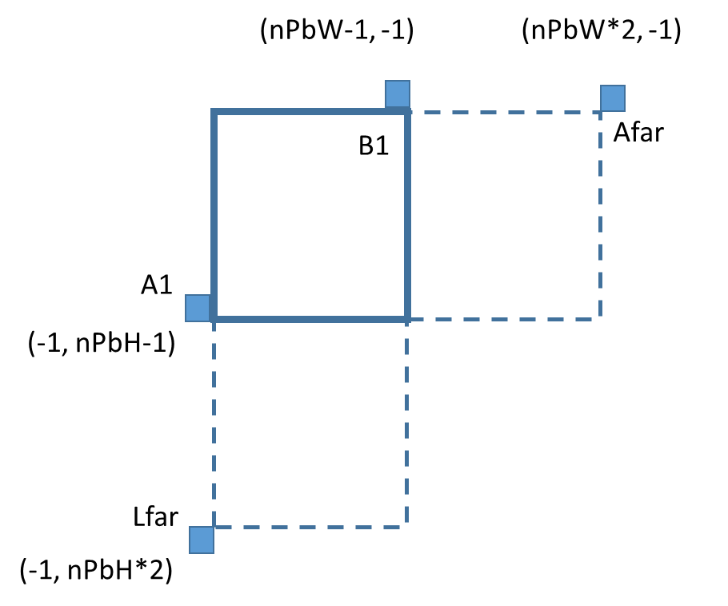

Note: VVC/HEVC default position of spatial candidate is shown below.

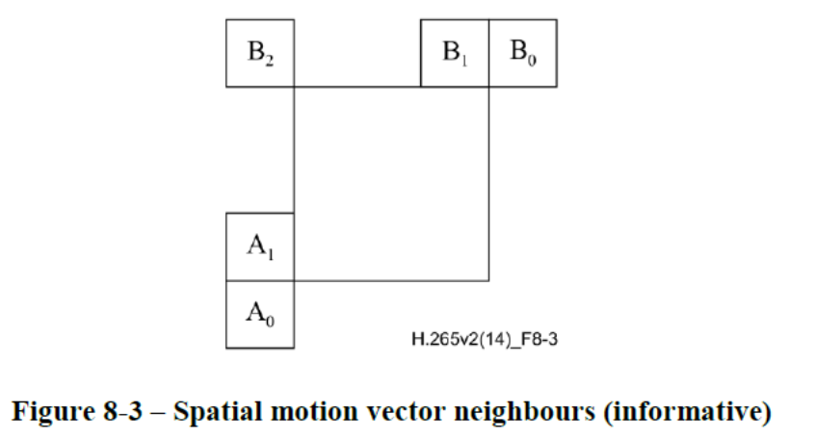

Test # | Description | Tester | Crosschecker
4.4.1 | Spatial-temporal merge mode | T. Zhou  (Sharp) | Y.-W. Chen  (Kwai)

Long distance merge candidates in K0286 and K0297 (Tencent)
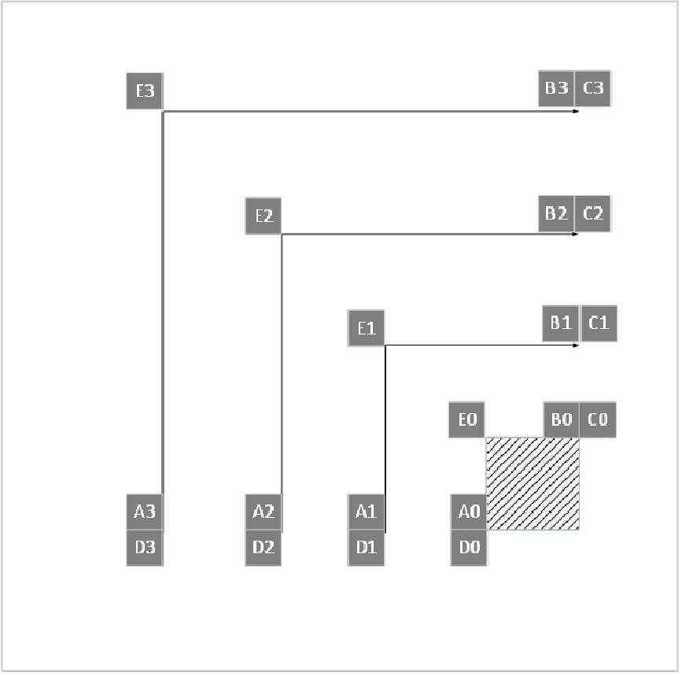
Figure 1 additional merge candidates
The contribution proposes to derive additional spatial merge candidates from positions in an outer reference area which has an offset of (-96, -96) to the current block without any line buffer increasing.
As shown in Figure 1, the positions are marked as Ai, Bi, Ci, Di and Ei. The candidates are checked from inside to the outside. And the order of the candidates is Ai, Bi, Ci, Di, and Ei. For a better description of the positions of Ai, Bi, Ci, Di, and Ei, a virtual block is defined with the top-left position as the (X₀ – i * grid_width, Y₀ – i * grid_height) and block size (width + i * grid_width, height + i * grid_height), where (X₀, Y₀) is the top-left position of the current block, i is the search round index. When i = 0 (first round), HEVC adjacent merge candidates are used as the virtual block is the same as the current block. For i > 0, Ai, Bi, Ci, Di, and Ei may be regarded as the HEVC adjacent merge candidates of the virtual block. For the tests, the maximum searching rounds (maximum i) will be tested. Different pruning methods will be tested. Different virtual block size may also be tested. The memory access to the left side of current CU with different constrain will be tested.

Test # | Description | Tester | Crosschecker
4.4.2 | Long distance merge candidates  a) Search round 1 and 2 with virtual block size (width + i * grid_width, height + i * grid_height)  b) Search round 1 and 2 with virtual block size (width + i * grid_width * 2, height + i * grid_height * 2) | J. Ye  M. Gao  (Tencent) | T. Solovyev  (Huawei)

Merge mode enhancement JVET-K0198 (HiSilicon)
Part A: Non-adjacent spatial candidates
More spatial positions are checked as shown in Figure. The extended spatial positions from 6 to 27 are checked according to their numerical order after the temporal candidate. In order to save the MV line buffer, all the spatial candidates are restricted within two CTU lines. That is, the spatial candidates beyond the CTU line above the current CTU line are excluded.
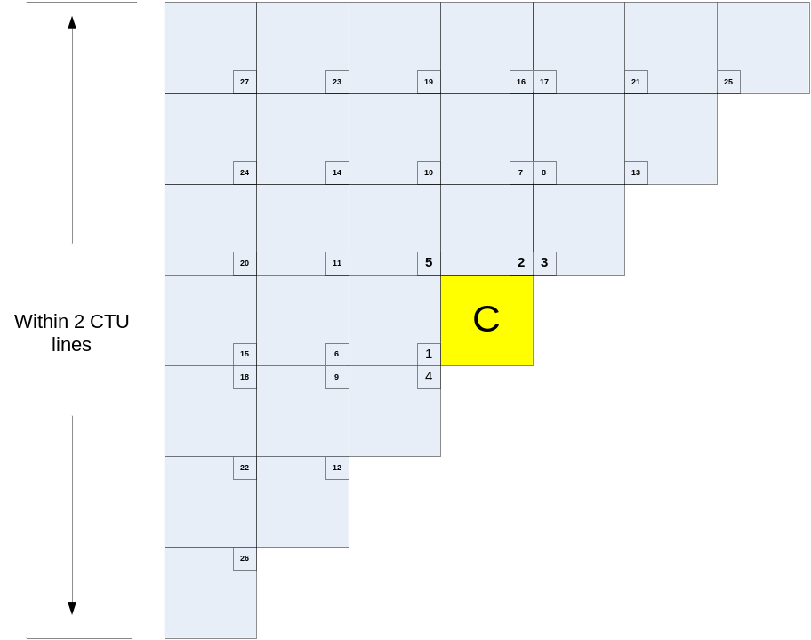

Key points for Part A
Additional 6 merge candidates are added
New candidates are appended to the end of the current merge list
Redundancy checking is performed for the added merge candidates

Test Specifications
Test with appropriate additional merge candidates number.
Take line buffer restriction into consideration for additional merge candidates.
Check the performance based on VTM and BMS.
--------------------------------------------------------------------------
Part B: Merge offset extension
In Merge offset extension, more candidates are checked based on existed candidate. New candidates has mv offset to the mv of existed candidate. New extended mv offset candidates are constructed only based on the first candidate of merge candidate list.
Key points for Part B
- Additional 8 merge candidates are added.
- Cross direction offset is checked firstly, and then X direction offsets.
- New candidates are appended to the end of the current merge list.

Test Specifications
Test how much gain come from symmetric coding.
Test with fewer additional merge candidates.
Check the performance based on VTM and BMS.
--------------------------------------------------------------------------
Part C: Combined Average Merge Candidates
- The first 4 candidates in the merge list is used for deriving the new candidates
- The reference picture in L0 and L1 is decided by voting, separately
- Combination of the 4 candidates is performed to derive 6 pair candidates
- For each pair of candidates, L0 and L1 motion vectors are averaged separately

Test # | Description | Tester | Crosschecker
4.4.3 | Non-adjacent spatial candidates  a) Line buffer reduction  b) Reduced number of non-adjacent spatial merge | X. Chen  (Hisilicon) | Y. Hsiao  (MediaTek)
4.4.8 | Merge offset extension  a) Applied to merge list with 4 or 8 offset  b) MV offset with different signaling way | X. Chen  (Hisilicon) | T. Zhou  (Sharp)
4.4.11 | Combined Average Merge Candidates | N. Zhang  (Hisilicon)

Extension of merge and AMVP candidates for inter prediction JVET-K0301 (Tencent)
It is proposed to add two spatial neighboring positions, which are from the middle position at the left and top edge of the current block, into motion vector predictor candidate list. The new candidates are put at the beginning of the merge candidate list and the AMVP candidate list, if available. The number of allowed merge candidates or AMVP candidates is kept unchanged.
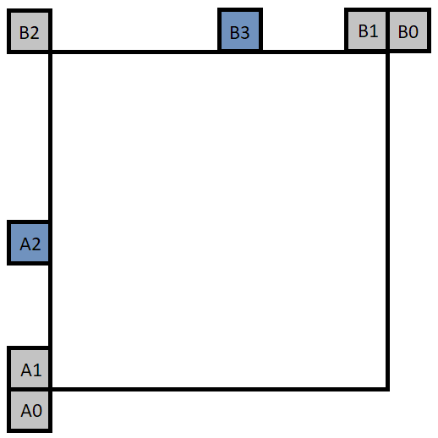

Test # | Description | Tester | Crosschecker
4.4.10 | Extension of merge and AMVP candidates for inter prediction  a) Add merge candidates at middle position for inter merge  b) Add new AMVP predictor candidates from middle position  c) a) + b)  d) Test 4.4.10.c + 4.4.2.a (withdraw)  e) Test 4.4.10.c + 4.4.2.b | G. Li  (Tencent) | T. Zhou  (Sharp)

Ranking based spatial merge candidate list for inter prediction JVET-K0304 (Tencent)
It is proposed to replace the original spatial merge candidate list construction method with a ranking based method and the positions of merge candidates are extended to include more potential candidates. It is proposed to sort spatial candidates in descending order of occurrence. The spatial candidates can be fetched from an L-shaped area around the current block. The proposed spatial candidates are derived and put at the beginning of the merge candidate list. The number of maximum merge candidates is kept unchanged. Other non-spatial merge candidates are added afterwards until the merge list is full.
In proposed method, each scanned spatial candidate block is in minimum block size (4x4 luma samples in VTM), such block will be referred to as min-block in this document. As depicted in Figure 3, the scanning range of spatial candidates includes min-blocks which are immediately adjacent to the current block (including top-left position), M min-blocks from the bottom-left neighboring block downwards, and N min-blocks from the above-right neighboring block to the right.
The value of M is related to the current block height H (in luma pixels). Where M = 2*H/4.
The value of N is determined by the current block width W (in luma pixels). Where N = 2*W/4.

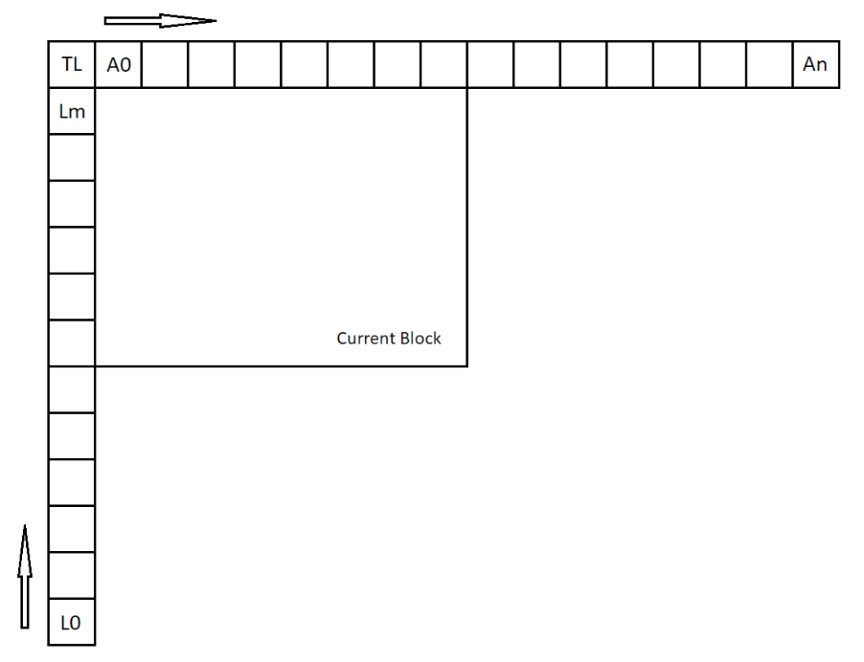

Test # | Description | Tester | Crosschecker
4.4.14 | Ranking based spatial merge candidate list for inter prediction  a) Ranking based spatial merge list  b) Evaluate reduced candidate search range to M = H/4+1, N = W/4+1 (withdraw)  c) Evaluate full ranking and put candidates with counts > threshold at the top of candidate list (withdraw) | G. Li  (Tencent) | Y. Hsiao  (MediaTek)

General Merge Mode JVET-K0244/JVET-K0245/JVET-K0246 MediaTek

Pairwise average candidates as replacement of HEVC combined candidates
Pairwise average candidates are generated by averaging predefined pairs of candidates in the current merge candidate list. The averaged motion vectors are calculated separately for each reference list; if both MVs are available in one list, the MV with the larger merge index is scaled to the reference picture of the merge candidate with the smaller merge index if the reference pictures are different, and the maximum scaling count constraint are applied, and then calculate averaged MV; if only one MV is available, use the MV directly; if no MV is available, keep this list invalid. The pairwise average candidates replace the combined candidates from HEVC. There are 6 potential additional candidates, and the constraint for pruning are applied to lower max number of operations/comparisons/conditions, and the max merge candidates is increased. The max number of 6 and 8 will be tested.

Test # | Description | Tester | Crosschecker
4.4.12 | Pairwise average candidates (list size 6 and 8) | T.-D. Chuang  (MediaTek) | F. Le Léannec (Technicolor)

Middle spatial and multiple temporal candidates
In additional to the spatial candidates located at A1, B1, B0, A0 and B2 in HEVC, two middle spatial candidates located at ML and MT are added as shown in following Figure. The middle spatial candidates at the middle positions of left and top edges are added by following the order {ML, MT}. In contrast to temporal candidates in HEVC (RB or CT if RB is not available), four temporal candidates from colocated blocks are added by following the order {RB, CT, LB, RT} as shown in following Figure. There are 5 potential additional candidates (middle spatial candidates: 2, multiple temporal candidates: 3), and the constraint for pruning are applied to lower max number of operations/comparisons/conditions, and the max merge candidates is increased.
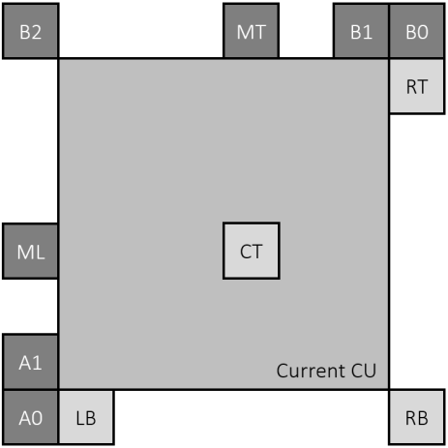

Figure. Positions for spatial (darkest blocks) and temporal (brightest blocks) candidates.

Test # | Description | Tester | Crosschecker
4.4.9 | Middle spatial and multiple temporal candidates  a) Add middle spatial candidates  b) Add multiple temporal candidates  c) a) + b) | Y. Hsiao  (MediaTek) | F. Le Léannec (Technicolor)

Non-adjacent merge candidates with buffer size reduction
This test proposes two motion vector (MV) buffer reduction methods for non-adjacent spatial merge candidates. The first method is to apply a coding tree unit (CTU) row constraint, where candidates belonging to above CTU rows and non-adjacent to the top boundary of the current CTU row are replaced with candidates belonging to above CTU rows and adjacent to the top boundary of the current CTU row. The second method is to round position of the referenced the non-adjacent MV candidate to the center 4x4 of a 16x16 block. The proposed method will be implemented on top of K0297.

Test # | Description | Tester | Crosschecker
4.4.4 | Non-adjacent merge candidates with buffer size reduction  a) 4.4.2.a + Line buffer reduction  b) a) + reference MV position rounding | Y. Hsiao  (MediaTek)

Block shape based candidate list reordering JVET-K0065 (Hikvision)
The proposed method is motivated by that motion information of the neighboring blocks that have more adjacent area with current block would be more convinced to be utilized to predict current one. Therefore, aimed at Merge mode and AMVP mode, the proposed method reorders the candidate list of merge mode and AMVP mode according to the block shape rather than adopting an identical candidate list construction method for all blocks.
Table 1 the proposed candidate order for Merge mode
Width>height | B1A1A0B0
Width=height | B1A1B0A0
Width<height | A1B1B0A0
Table 2 the proposed candidate order for AMVP mode

Description of the combined test technique:
UMVE
Test4.5.4 b) UMVE ( 2 Base candidates from VVC merge list )Test4.5.4
HMVP
Test 4.4.7 a) Applied to merge list
Test 4.4.7 b) Applied to AMVP list
Test 4.4.7 c) a) + b)

Test # | Description | Tester | Crosschecker
4.4.13 | Block shape based candidate list reordering for spatial candidates  a) Applied to merge list  (withdraw original b))  (withdraw original c))  Evaluate interaction with UMVE (K0115).  b) a) + Test 4.5.4.b  Evaluate interaction with HMVP (K0104).  c) a) + Test 4.4.7.a  (withdraw original f))  d  ) a) + Test 4.4.7.c | Liying Xu | Jie Chen  (Samsung)

Merge mode modification K0056 (Huawei)

Long-distance motion vector prediction (LDMVP)
In this method, more spatial positions are checked as shown in Figure 1. The candidates are checked from inside to the outside. And the order of the candidates is A_{i}, B_{i}, C_{i}, D_{i}, E_{i}. These candidates are added after TMVP candidates and before the combined Bi-predictive candidates.

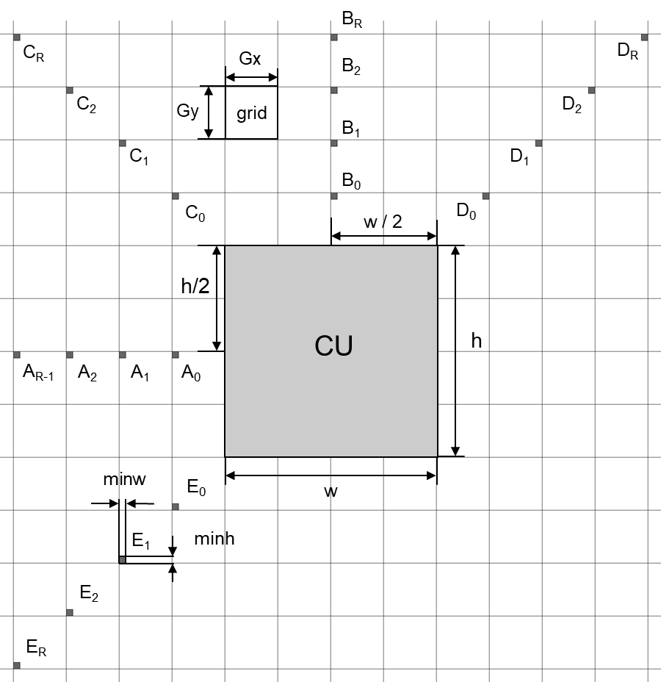
Figure 1. Additional spatial candidates

Additional temporal candidates
In this method more TMVP candidates are added to the merge list. Only the TMVP candidates of the positions that are located within the same CTU row in the collocated reference picture are used.

Test specification
Test # | Description | Tester | Crosschecker
4.4.5 | Merge mode modification  a) Non-adjacent spatial merge candidates, merge candidate list size equal to 6/8/10  b) a + TMVP candidates, merge candidate list size equal to 6/8/  10 | T. Solovyev  (Huawei) | J. Ye  (Tencent)

History-based Motion Vector Prediction (JVET-K0104)
This contribution presents a History-based Motion Vector Prediction (HMVP) method for inter coding. In HMVP, a table of HMVP candidates is maintained and updated on-the-fly. After decoding a non-affine inter-coded block, the table is updated by adding the associated motion information as a new HMVP candidate to the last entry of the table. A First-In-First-Out (FIFO) or constraint FIFO rule is applied to remove and add entries to the table. The HMVP candidates could be applied to either merge candidate list or AMVP candidate list.

Test # | Description | Tester | Crosschecker
4.4.7 | History-based Motion Vector Prediction  a) Applied to merge list  b) Applied to AMVP list  c) a) + b) | L. Zhang  (ByteDance) | T. Solovyev  (Huawei)  J. Ye  (Tencent)

Modified merge candidate list (JVET-K0339)
In VTM and BMS, a merge candidate list is constructed by inserting the motion vectors and reference indices of the spatial neighboring and temporal neighboring blocks into the candidate list with redundancy checking until the number of the available candidates reaches the maximum candidate signaled in slice header. The merge candidate list for the merge/skip mode is constructed in the following order with additionally adding non-adjacent merge/skip candidates as shown in Figure 2:
- Spatial candidates for blocks 1-4.
- ATMVP.
- Non-sub-block STMVP.
- Spatial candidate (block 5) (used only when the number of the available candidates is smaller than 6).
- Temporal candidate (derived as in HEVC).
- Non-adjacent spatial candidate (blocks 6 to 49).
- Combined candidates.
- Zero candidates.

Figure: Spatial neighboring blocks used to derive the spatial merge candidates.
The selected merge candidate is signalled to the decoder.
Some restrictions are performed on the test:
- No additional line buffer involved
The following test will be conducted:
Test # | Description | Tester | Crosschecker
4.4.6 | Non-adjacent spatial merge with no additional line buffer  a) check 18 potential candidates  b) a + simplified pruning  c) check 8 potential candidates  d) c + simplified pruning  e) a + non-sub-block STMVP  f) b + non-sub-block STMVP  g) c + non-sub-block STMVP  h) d + non-sub-block STMVP | H. Yu  (Qualcomm) | T. Solovyev  (Huawei)

CE4.5: Motion vector coding

Symmetrical mode for bi-prediction (K0188)
In this contribution, a mode is proposed for motion information coding in bi-prediction. A symmetrical mode flag indicating whether symmetrical mode is used or not is explicitly signaled if the prediction direction is bi-prediction. When the flag is true, the reference index and MVD for list 0 are derived from motion information of list 1. Moreover, the reference index of list 1 is inferred as 0 for this mode.
As shown in Figure 1, the ref_idx_l0 is decided by searching a reference picture in list 0, which is mirrored with the reference picture for list 1. Since the distance between current picture and the backward reference picture is same as the distance between current picture and the forward reference picture, MVD0 is just set to –MVD1. The final motion vectors are shown in below formula.
$$\left\{\begin{aligned}{\left({mvx}_{0}, {mvy}_{0}\right)=(mvpx}_{0}-{mvdx}_{1},{mvpy}_{0}-{mvdy}_{1}) \\ {\left({mvx}_{1}, {mvy}_{1}\right)=(mvpx}_{1}+{mvdx}_{1},{mvpy}_{1}+{mvdy}_{1})\end{aligned}\right.$$
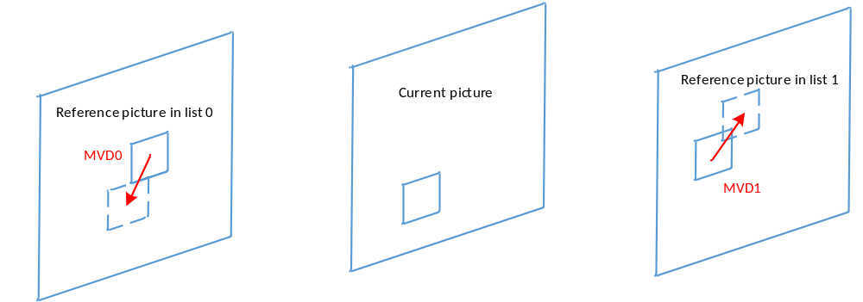
Figure 1 Illustration for symmetrical mode

Test # | Description | Tester | Crosschecker
4.5.1 | a) Symmetrical MVD mode  b) Symmetrical MVD combined with MVD representation in K0115 | H. Chen  (Huawei) | S. Jeong  (Samsung)

Bilateral Motion Vector Prediction (K0302)
The proposed BiMVP mode is another type of AMVP. Keeping the existing AMVP mode, a flag (bilateral_mode_flag) is employed to activate the BiMVP. bilateral_mode_flag equal to 1 indicates the BiMVP is applied for the current CU, while bilateral_mode_flag equal to 0 indicates the existing AMVP mode is done. When activated, BiMVP mode does not signal ref_idx and ref_pred_idc. Instead, the first reference pictures whose ref_idx values are equal to 0 for both list0 and list are used for bi-prediction. Uni-prediction is not allowed. When bilateral_mode_flag is equal to 1, an additional flag (symmetric_flag) is signalled to indicate whether the BiMVP for the current CU is the Symmetric BiMVP mode or the Asymmetric BiMVP mode.

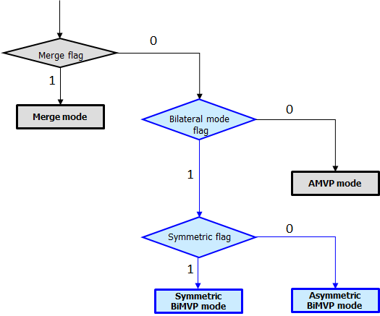

In the symmetric BiMVP mode, only mvp_flag and coded MVD for list0 are signaled. Then, both MV predictor (V1x, V1y) and MV difference (offset_x, offset_y) for list1 are derived from MVP = (V0x, V1y) and MVD = (offset_x, offset_y) for list0 by mirroring values. For example, when the forward MV is equal to (Vx + offset_x, Vy + offset_y), its paired backward MV is derived as equal to (-Vx - offset_x, -Vy - offset_y). Since the derived MV for list1 is exactly symmetric with MV for list1, it is called Symmetric BiMVP mode.
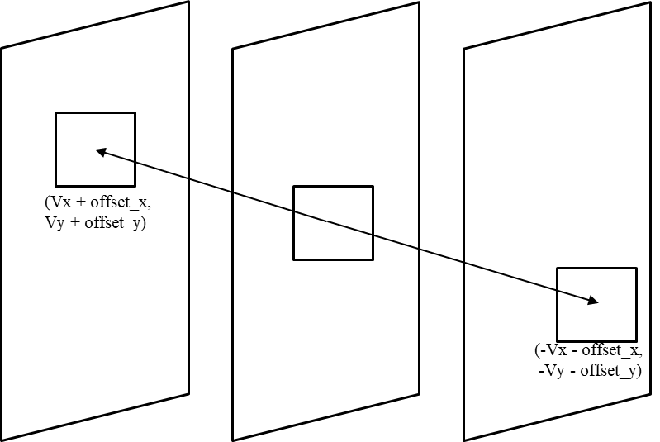

In the asymmetric BiMVP mode, mvp_flag, coded MVD for list0 and mvp_flag for list1 are signaled. It means that the MVP for list1 is not derived from MVP for list0 and explicitly indicated by signaling. For example, where the MV for list0 is equal to (V0x + offset_x, V0y + offset_y), its paired MV for list1 set equal to (V1x - offset_x, V1y - offset_y). Note that both (V0x, V0y) and (V1x, V1y) are determined by the values of mvp_flag. Even though it is called Asymmetric BiMVP mode in this contribution, its MVD values are symmetric.
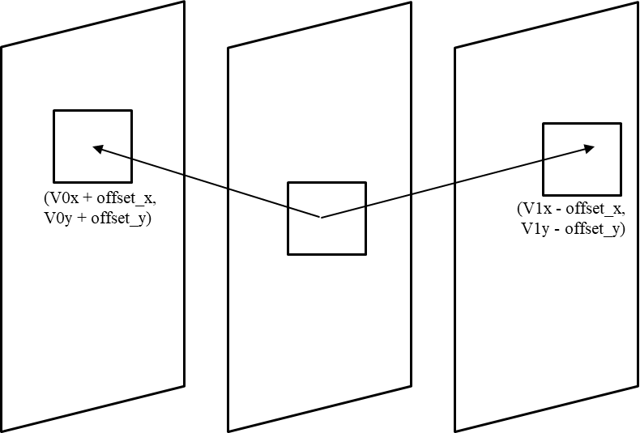

BiMVP can have only a MVD value among a set of predefined MVD values in integer-pel resolution. It employs motion vector compression and reconstruction process, which are intended to reduce the MVD bits and the encoding complexity.

Test # | Description | Tester | Crosschecker
4.5.2 | - Asymmetric BiMVP mode  - Symmeetric BiMVP mode (withdraw)  - a)+b) | Byeongdoo Choi  (Sharp) | Naeri Park  (LG)
4.5.3 | - MVD compression + reconstruction (withdraw)  - Combination of a) and 4.5.2.a  - Combination of a) and 4.5.2.c | Byeongdoo Choi  (Sharp) | Jing Ye (Tencent)

Ultimate motion vector expression (K0115)
Ultimate motion vector expression (UMVE) in J0024 can be either skip or direct (or merge) modes, which use proposed motion vector expression method with neighboring motion information. As the skip and the merge modes in HEVC, UMVE also makes a candidate list from neighboring motion information. Among those candidates in the list, an MV candidate is selected, and is further expanded by new motion vector expression method.
UMVE provides a new motion vector expression with simplified signaling. The expression method includes starting point, motion magnitude, and motion direction.

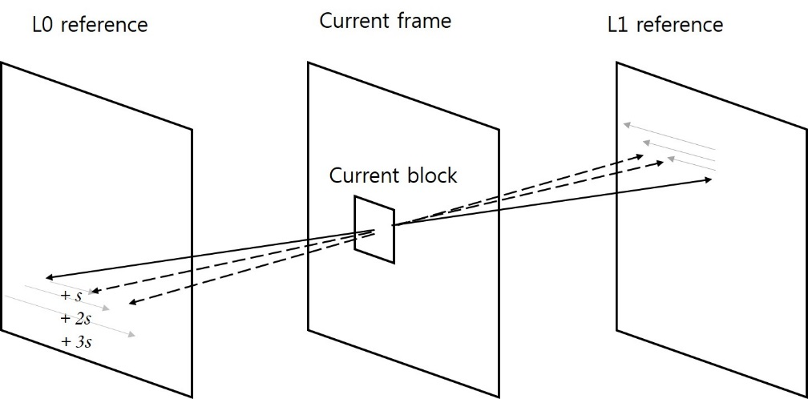
UMVE search process

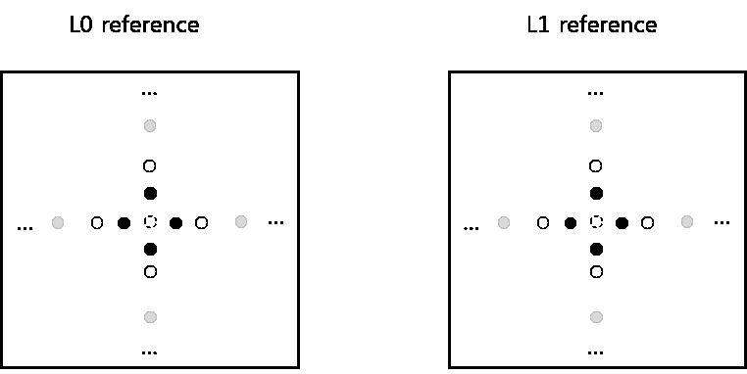
UMVE search point

Base candidate index defines the starting point. Base candidate index indicates the best candidate among candidates in the list as follows.

Base candidate IDX | 0 | 1 | 2 | 3
N^{th} MVP | 1st MVP | 2nd MVP | 3rd MVP | 4th MVP

Distance index is motion magnitude information. Distance index indicates the pre-defined distance from the starting point information. Pre-defined distance is as follows:

Distance IDX | 0 | 1 | 2 | 3 | 4 | 5 | 6 | 7
Pixel distance | 1/4-pel | 1/2-pel | 1-pel | 2-pel | 4-pel | 8-pel | 16-pel | 32-pel

Direction index represents the direction of the MVD relative to the starting point. The direction index can represent of the four directions as shown below.

Direction IDX | 00 | 01 | 10 | 11
x-axis | + | – | N/A | N/A
y-axis | N/A | N/A | + | –
The UMVE method can be implemented on the test model or the Benchmark Set (BMS) as independent UMVE candidates with additional information signaled.

Test # | Description | Tester | Crosschecker
4.5.4 | a) UMVE ( 1 Base candidate from VVC merge list )  b) UMVE ( 2 Base candidates from VVC merge list )  c) UMVE ( 4 Base candidates from VVC merge list )  d) UMVE ( 1 Base candidates from new UMVE candidate list )  e) UMVE ( 2 Base candidates from new UMVE candidate list )  f) UMVE ( 4 Base candidates from new UMVE candidate list ) | Seungsoo Jeong  (Samsung) | J. Li  (Panasonic)

CE4.6: Reference picture boundary padding

Reference Picture Boundary Padding (K0117)
This contribution proposes a padding method for padding outside areas of a picture with motion compensation with motion information of edge pixel of the picture.
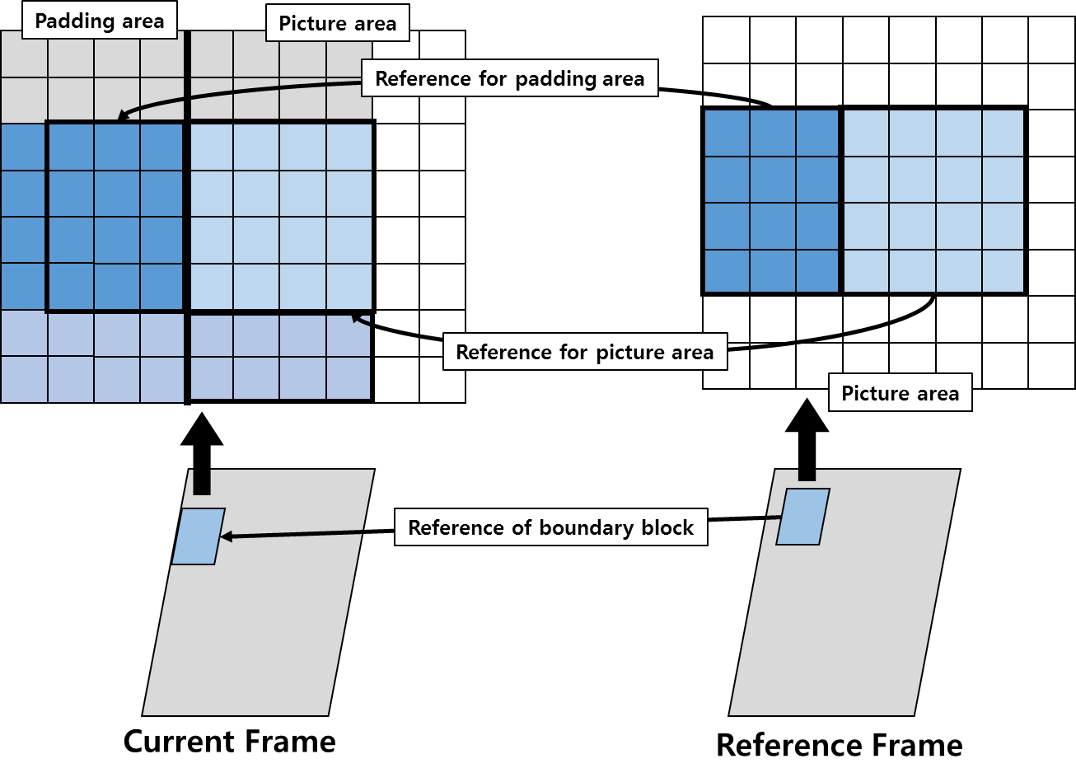
Key points
- If the area padded by MC is shorter than the size of the padding area, the rest of the area is filled with extrapolated edge pixels of the external picture.
- A conventional padding method is performed when an adjacent area is unavailable or there is no information about a motion in a boundary block.
- In case of bi-directional motion in a boundary 4x4 block, bi-directional MC is used for padding.
- The last pixel of each position is extrapolated to induce a left upper portion, a right upper portion, a left lower portion, and a right padding area.

Proponents are encouraged to provide data on the impact on DPB memory, on possible complications of on-the-fly processing and on subjective quality of affected areas.

Test # | Description | Tester | Crosschecker
4.6.1 | Inter boundary padding (withdraw) | M. Park

Multi-directional boundary padding (J0014)
Multi-directional boundary padding (MDBP) uses angular intra prediction to extend the reference frame border, whenever the referenced pixel area is partially or entirely outside the area of the reconstructed reference frame.
The best intra mode is estimated in both encoder and decoder by using template areas that are located inside the reconstructed reference frame as shown below. The template area is filled by using all available intra modes revered and deriving sample values of the template area by intra prediction from the outer-most pixel line. The best intra mode leads to minimal SAD with respect to the original reconstructed sample values.

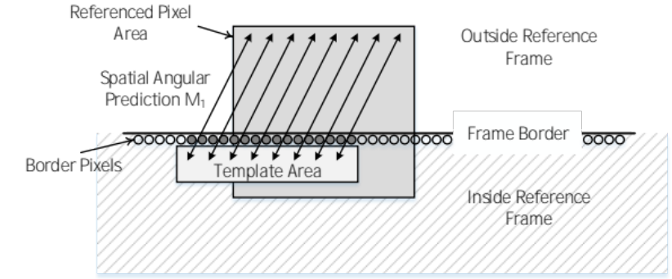
Figure 8: Template area used for estimating the MDBP angular mode
Proponents are encouraged to provide data on the impact on DPB memory, on possible complications of on-the-fly processing and on subjective quality of affected areas.

Test # | Description | Tester | Crosschecker
4.6.2 | Intra boundary padding | J. Brandenburg  (HHI) | Y. Zhang  (Qualcomm)

Inter/Intra Boundary Padding (K0195)
When the decoder performs motion compensation, if the motion vector points to a block outside the frame boundary, a part of the reference block is not available. For each region with size of 4xM or Mx4 along the boundary of the reference picture to be padded, M being the desired frame boundary extension, a motion vector is derived from the nearest 4x4 block inside the frame. If the nearest 4x4 block is intra coded, a zero motion vector is used. If the nearest 4x4 block is coded with bi-directional inter prediction, only the motion vector, which points to the pixel farther away from the frame boundary, is used in motion compensation for padding. After the motion vector derivation, motion compensation is then performed to obtain the pixels in the padding region with the consideration of average pixel value offset between the nearest 4x4 block and its corresponding block in its reference picture. Boundary padding areas for which no motion compensation can be performed, are filled using perpendicular boundary padding as in HEVC. For each reference block that contains boundary padding pixel, when the amount of pixels stemming from perpendicular boundary padding exceeds 50%, intra-prediction based padding as in JVET-J0014 (MDBP) is carried out.
Proponents are encouraged to provide data on the impact on DPB memory, on possible complications of on-the-fly processing and on subjective quality of affected areas.

Test # | Description | Tester | Crosschecker
4.6.3 | Combined inter/intra boundary padding | J. Brandenburg  (HHI) | Y. Zhang  (Qualcomm)

CE4.7: Local illumination compensation

Non-Temporal IC (K0118)
At the end of processing of each CU, linear models (Ax + B = y) are computed by comparing the prediction pixels (x) and the reconstructed pixels (y). The models are computed using linear regression. The lower edge pixels are used for model computation. Two sets of models are computed, one for each colour component. Each set contains models for the two directions (if available). These parameters (sets of A and B) are then stored in the motion information buffer for later access.
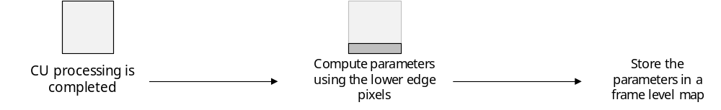
The conditions under which non-temporal IC is applicable is kept same as that of JEM LIC. These conditions depend on the size of the current CU, type of prediction mode and whether the CU uses merge mode or not. If applicable, a flag is signaled to indicate whether non-temporal IC is to be applied to a given inter coded CU or not. If the tool is to be applied, the motion compensation pixels (x) are refined using the application of the linear model (Ax + B) to obtain the new set of prediction pixels. The model used is derived from the current CU’s neighbors. Top and top left and left neighbours are considered for borrowing the parameter. Since multiple neighbors may be available, pruning is performed to obtain a single model. Intra coded neighbours are discarded in the pruning process. Next, the neighbours which have trivial model [x = y] are discarded in the pruning process. If no model is remaining, a trivial model is used. If model(s) still remain, the neighbours with the same reference index as the current CU are given higher priority. If multiple neighbours have the same reference index, the top neighbour is given higher priority compared to the top-left neighbour.
Additionally, when performing RDO check for determining whether non-temporal IC will be used or not, mean-removed SAD (Sum of Absolute Difference) is used instead of the regular SAD for the ME (Motion Estimation) process.
The linear regression method used is same as that in JEM. Also, using two sides for parameter derivation improves the gain.
Key points
- LIC model pre-computation and storage after processing a CU
- LIC model pruning to get the only one model applied to a CU

Test # | Description | Tester | Crosschecker
4.7.1 | Non-temporal IC using above neighbour CU | Anish Tamse  (Samsung) | H. Chen  (Huawei)
4.7.2 | Non-temporal IC using left and above neighbour CU | Anish Tamse  (Samsung) | H. Chen  (Huawei)

CE4.8: Motion data storage

Temporal motion data storage reduction (K0086)
The motion information is achieved from different spatial candidates compared with HEVC for motion vector compression.
Suggested motion data storage reduction could be refer alternative spatial candidate as below example figure:
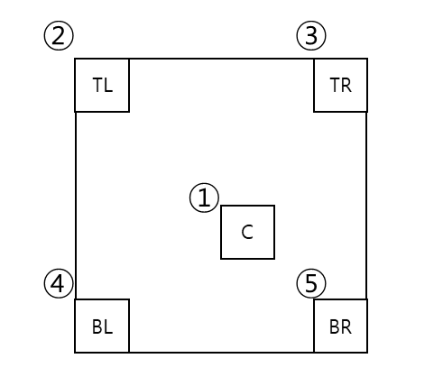
And It is reported that BD-rate and various storage reduction ratio based on various motion vector storage unit granularity

Test # | Description | Tester | Crosschecker
4.8.1 | Motion information storage with alternative spatial candidates for each 8x8 region | H. Jang  (LGE)
4.8.2 | Motion information storage for each 16x16 region | H. Jang  (LGE)
4.8.3 | Motion information storage with alternative spatial candidates for each 16x16 region | H. Jang  (LGE)

Test condition and evaluation criteria
In general, each testing item is required to be compared against VTM. Test against BMS is optional. Each testing item will be evaluated using BD rates, encoding time, decoding time according to Common Test Conditions (CTC) in JVET-K1010. Simulation with RA and LDB configurations are mandatory.
Sub-CE specific test condition and evaluation criteria may be defined for a sub-CE if considered informational for tool evaluation. Please refer to the section of test condition and evaluation criteria in each sub-CE for information.
For getting encoding and decoding time ratio of each test, the same SIMD setting, either SSE or AVX2, must be used for generating both anchor and a test. For easy comparison of encoding and decoding time of different techniques, it is suggested to use SSE as the default SIMD setting by encoder configuration.
It is recommended to have complexity analysis for all tests in this CE.

SW integration guideline
All tests are required to be implemented on top of VTM2.0.

Timeline
T1 | Aug. 8, 2018 | Finalize CE description
T2 | Sept. 3, 2018 | Deliver software packages and begin cross-checking
T3 | Sept. 17, 2018 | Software frozen, testers provide full results, and final crosschecking begins

Participant list
Company/  Organization | Participant Name | Email Address
Technicolor | Antoine Robert  Philippe Bordes  Tangi Poirier  Fabrice Le Léannec  Franck Galpin  Ya Chen | antoine.robert@technicolor.com  philippe.bordes@technicolor.com  tangi.poirier@technicolor.com  fabrice.leleannec@technicolor.com  franck.galpin@technicolor.com  Ya.CHEN@technicolor.com
HHI | Martin Winken  Robert Skupin  Jens Brandenburg  Anastasia Henkel | martin.winken@hhi.fraunhofer.de  robert.skupin@hhi.fraunhofer.de  jens.brandenburg@hhi.fraunhofer.de  anastasia.henkel@hhi-extern.fraunhofer.de
Huawei | Huanbang Chen  Haitao Yang  Jianle Chen  Sychev Maxim  Solovyev Timofey  Alexey Filippov  Vasily Rufitskiy | chenhuanbang@huawei.com  haitao.yang@huawei.com  jianle.chen@huawei.com  Sychev.Maxim@huawei.com  solovyev.timofey@huawei.com  alexey.filippov@huawei.com  vasily.rufitskiy@huawei.com
LGE | Seung Hwan Kim  Jaehyun Lim  Jaeho Lee  Hyeongmun Jang  Jie Zhao  Seethal Paluri | seunghwan3.kim@lge.com  Jaehyun.lim@lge.com  jhlee.lee@lge.com  hm.jang@lge.com  jie.zhao@lge.com  seethal.paluri@lge.com
Tencent | Xiaozhong Xu  Jing Ye  Guichun Li  Shan Liu  Meng Xu  Xiang Li | xiaozhongxu@tencent.com  jingye@tencent.com  guichunli@tencent.com  shanl@tencent.com  mengxxu@tencent.com  xlxiangli@tencent.com
USTC | Yue Li  Li Li | lytt@mail.ustc.edu.cn  lili90th@gmail.com
HiSilicon | Na Zhang  Xu Chen  Jianhua Zhang | zhangna25@huawei.com  anderson.chen@hisilicon.com  zhengjianhua@hisilicon.com
BBC | Saverio Blasi | saverio.blasi@bbc.co.uk
ETRI | Jungwon Kang  Sung-Chang Lim  Hahyun Lee | jungwon@etri.re.kr  sclim@etri.re.kr  hanilee@etri.re.kr
Panasonic | Kiyofumi Abe  Jingya Li | abe.kiyo@jp.panasonic.com  jingya.li@sg.panasonic.com
Fujitsu | Jianqing Zhu  Kimihiko Kazui | zhujianqing@cn.fujitsu.com  kazui.kimihiko@jp.fujitsu.com
Sony | Kenji Kondo | kenji.kondo@sony.com
Qualcomm | Wei-Jung Chien  Vadim Seregin  Chun-Chi Chen  Yan Zhang  Yu Han  Han Huang  Chao-Hsiung Hung | wchien@qti.qualcomm.com  vseregin@qti.qualcomm.com  chunchic@qti.qualcomm.com  yzh@qti.qualcomm.com  yuhan@qti.qualcomm.com  hanhuang@qti.qualcomm.com  chaohsiu@qti.qualcomm.com
Alibaba | Yu-Chen Sun | yuchen.s@alibaba-inc.com
Hikvision | Fangdong Chen | chenfangdong@hikvision.com
Sharp | Weijia Zhu  Byeongdoo Choi  Tomonori Hashimoto  Takeshi Chujoh  Tomohiro Ikai  Kiran Misra  Eiichi Sasaki  Tianyang Zhou | zhuw@sharplabs.com  choib@sharplabs.com  tomonori.hashimoto@sharp.co.jp  chujoh.takeshi@sharp.co.jp  ikai.tomohiro@sharp.co.jp  misrak@sharplabs.com  eiichi.sasaki@sharp.co.jp  zhou.tianyang@sharp.co.jp
Ericsson | Ruoyang Yu  Julien Le Tanou | ruoyang.yu@ericsson.com  julien.le.tanou@ericsson.com
Samsung Electronics | Min Woo Park  Seungsoo Jeong  Anish Tamse  Kiho Choi  Jie Chen  Minsoo Park | m.w.park@samsung.com  ss00.jeong@samsung.com  tamse.anish@samsung.com  kiho14.choi@samsung.com  jie1222.chen@samsung.com  mss.park@samsung.com
Nokia | Jani Lainema  Alireza Aminlou  Ramin Ghaznavi-Youvalari | jani.lainema@nokia.com  alireza.aminlou@nokia.com  ramin.ghaznavi-youvalari@nokia.com
InterDigital | Yuwen He  Xiaoyu Xiu  Daniel Luo  Yan Ye | Yuwen.He@interdigital.com  Xiaoyu.Xiu@interdigital.com  Daniel.Luo@InterDigital.com  Yan.Ye@interdigital.com
Arris | Krit Panusopone  Yue Yu  David Baylon  Seungwook Hong  Limin Wang | Krit.panusopone@arris.com  Yue.yu@arris.com  David.baylone@arris.com  Seungwook.hong@arris.com  Limin.wang@arris.com
MediaTek | Yu-Wen Huang  Chih-Wei Hsu  Ching-Yeh Chen  Tzu-Der Chuang  Shih-Ta Hsiang  Yuling Hsiao  Jenny Lai  Yu-Chi Su  Zhi-Yi Lin | yuwen.huang@mediatek.com  cw.hsu@mediatek.com  chingyeh.chen@mediatek.com  Peter.Chuang@mediatek.com  shih-ta.hsiang@mediatek.com  Yuling.Hsiao@mediatek.com  Jenny.Lai@mediatek.com  Yu-Chi.Su@mediatek.com  Zhi-Yi.Lin@mediatek.com
NHK | Shunsuke Iwamura | iwamura.s-gc@nhk.or.jp
Netflix | Andrey Norkin | anorkin@netflix.com
Orange | Gordon Clare | gordon.clare@orange.com
Broadcom | Minhua Zhou  Pensong Chen  Wade Wan | minhua.zhou@broadcom.com  peisong.chen@broadcom.com  wade.wan@broadcom.com
Canon | Jonathan Taquet | Jonathan.TAQUET@crf.canon.fr
PKU | Zhao Wang | zhaowang@pku.edu.cn
Chips&Media | Wook Je Jeong | nick.jeong@chipsnmedia.com
Aachen University | Johannes Sauer | sauer@ient.rwth-aachen.de
HIT | Yang Wang  Xiaopeng Fan | wangyang.cs@hit.edu.cn  fxp@hit.edu.cn
WILUS | Greg Ko | greg.ko@wilusgroup.com
ITRI | Ching-Chieh Lin | JackLin@itri.com
Bytedance | Kai Zhang  Li Zhang | zhangkai.video@bytedance.com  lizhang.idm@bytedance.com
Kwai | Yi-Wen Chen  Xianglin Wang | yiwenchen@kwai.com  xianglinwang@kwai.com
HNU | Haechul Choi  Heeji Han  Daehyeok Gwon  jaeryun Choe | choihc@hanbat.ac.kr  sarhakor@naver.com  skyeye0530@naver.com  tjswo9395@naver.com
Dolby | Peng Yin | pyin@dolby.com

