    Joint Video Experts Team (JVET)  of ITU-T SG 16 WP 3 and ISO/IEC JTC 1/SC 29/WG 11  11th Meeting: Ljubljana, SI, 10–18 July 2018 | Document: JVET-K0500_r3

Title: | CE3-related: Wide-angle intra prediction for non-square blocks
Status: | Input document to JVET
Purpose: | Proposal
Author(s) or  Contact(s): | Fabien Racapé, Gagan Rath, Fabrice Urban  Liang Zhao, Shan Liu, Xin Zhao, Xiang Li  Alexey Filippov, Vasily Rufitskiy, Jianle Chen, | Email: | {fabien.racape, gagan.rath, fabrice.urban, }@technicolor.com  {leolzhao, shanl, xinzzhao, xlxiangli} @tencent.com  {alexey.filippov, vasily.rufitskiy, jianle.chen} @huawei.com
Source: | Technicolor, Tencent, Huawei Technologies Co., Ltd
_____________________________

Abstract
In this contribution, it is proposed to adaptively replace several conventional angular intra prediction modes with wide-angle intra prediction modes for non-square blocks. The total number of angular directions for any block remains the same as in VTM/BMS. For directions with wide angles, reference sample smoothing is performed. On top of VTM, the simulation results reportedly show luma BD-rate variation of -0.32% and -0.17% on average in All Intra (AI) and Random Access (RA) configuration.

Introduction
VTM/BMS specifies 33/65 angular intra prediction modes in addition to the planar and DC modes. These prediction directions are defined from 45 degrees to -135 degrees in clockwise direction. For a target block of size W×H pixels, the top reference samples array and the left reference samples array are each of size (W+H+1), which is required to cover the afore-mentioned angle range for all target pixels. This definition of the set of angles in VTM/BMS was done for compatibility with HEVC specified directions, without considering the QTBT structure.

For instance, when the block is flat (i.e, W > H), it is placed closer to the top reference array, but asymmetrically. Similarly, when the block is tall (i.e., W < H), it is placed closer to the left reference array, but asymmetrically. This asymmetry is shown in Figure 1.
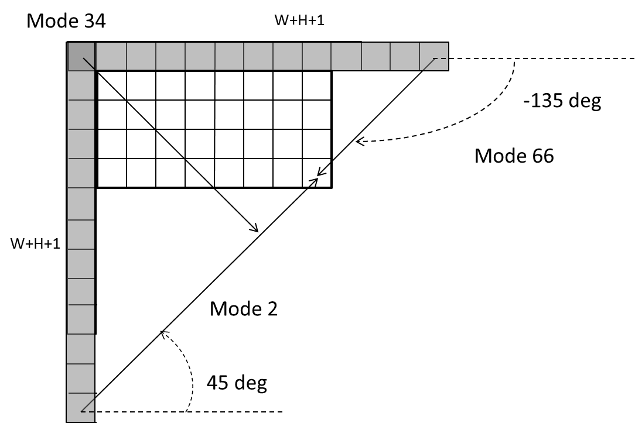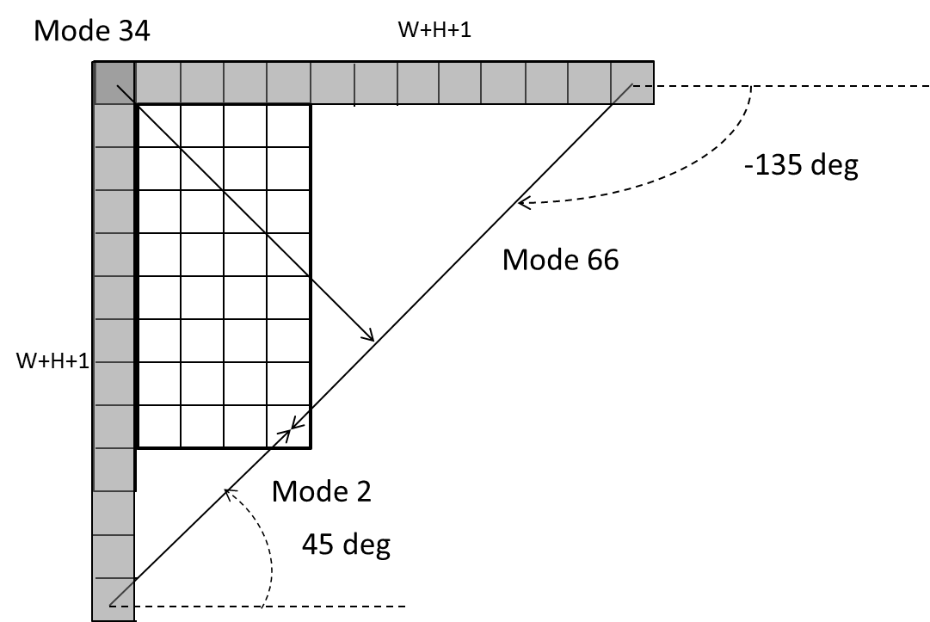
Figure 1: Rectangular target blocks (flat block on the left, tall block on the right) with their top and left reference arrays. The target blocks are asymmetrically placed w.r.t. the two reference arrays.
The result of this asymmetry is that for some prediction modes, the target pixel will be predicted from a farther reference array, whereas the nearer reference array will be excluded because of the defined angles. This is shown in Figure 2.
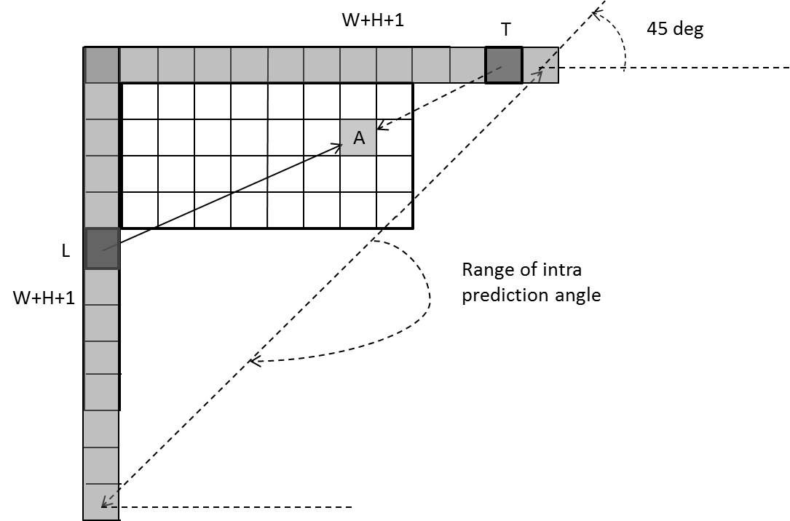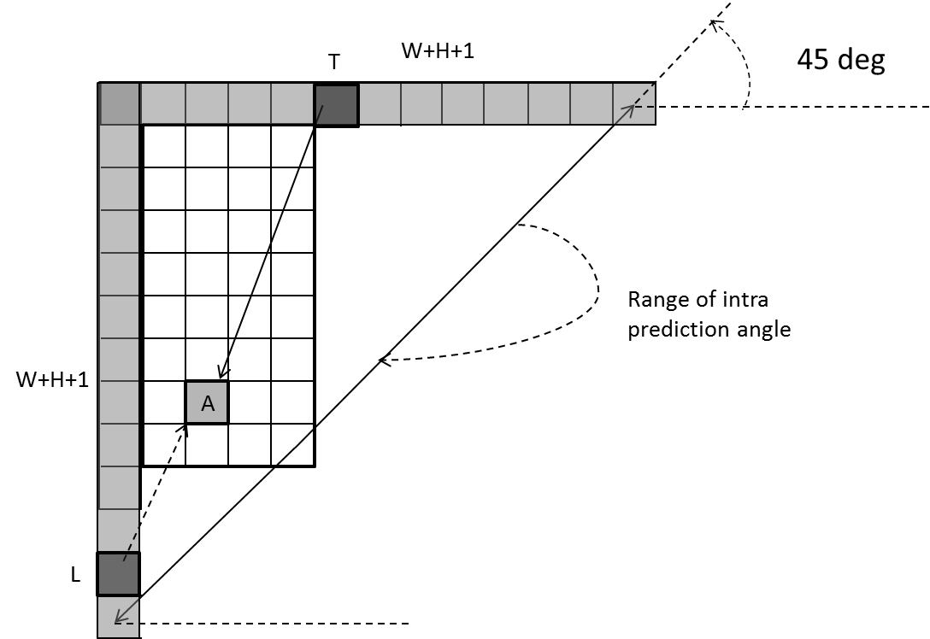
Figure 2: Rectangular target blocks (flat block on the left, tall block on the right) with their top and left reference arrays. On the left, the target pixel A has the predictor sample L on the left reference array with a horizontal prediction direction; Though the sample T on the top reference array is nearer, the vertical prediction direction, so that T could be the predictor sample for A, is not allowed in VTM/BMS. The right figure shows the analogous case for a target pixel in a tall block.
In JVET-J0012 [1], wide angles beyond the range of prediction directions covered by conventional intra prediction modes are proposed, which are called wide angular intra prediction modes. And these wide angles are only applied for non-square blocks as follows:
• Angles going beyond 45 degree in top-right direction if block width is larger than block height
• Angles going beyond 45 degree in bottom-left direction if block height is larger than block width
Each wide-angular intra prediction direction is associated with one conventional intra prediction direction, which captures the same prediction direction, but using opposite side of reference samples (left column or top row). For example, in Figure 1, wide-angular modes 35 and 36 are associated with conventional intra prediction mode 3 and 4, respectively.
Signaling for wide angles is implemented by sending a 1-bin identifier for those directions that have an available wide-angle “flip mode”. The actual sample prediction process follows the one in VTM-1, but the effective prediction direction for the wide angular modes is calculated by inverting the signaled prediction direction and switching the reference arrays (using top instead of left or left instead of top).

Proposed wide angular intra prediction for non-square blocks
For non-square blocks, it is proposed to replace several conventional angular intra prediction modes with wide angular modes. The replaced modes are signaled using the original method and remapped to the indexes of wide angular modes after parsing. The total number of intra prediction modes is unchanged, i.e., 35 as in VTM-1.0, or 67 as in BMS-1.0, and the intra mode coding is unchanged.
To support these prediction directions, it is proposed to define the top reference with length 2W+1, and the left reference with length 2H+1, as shown in Figure 3.
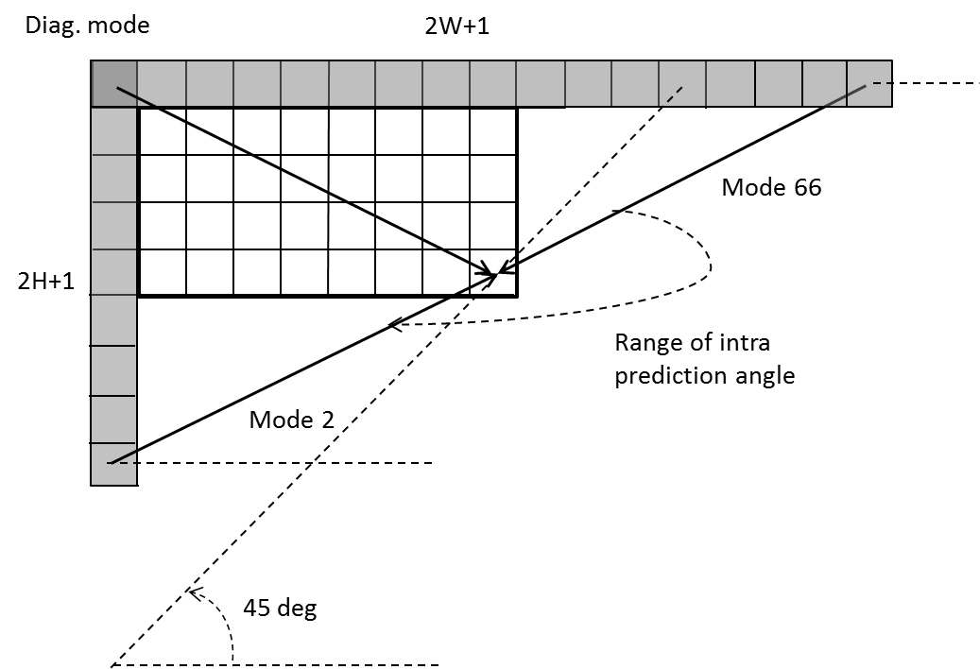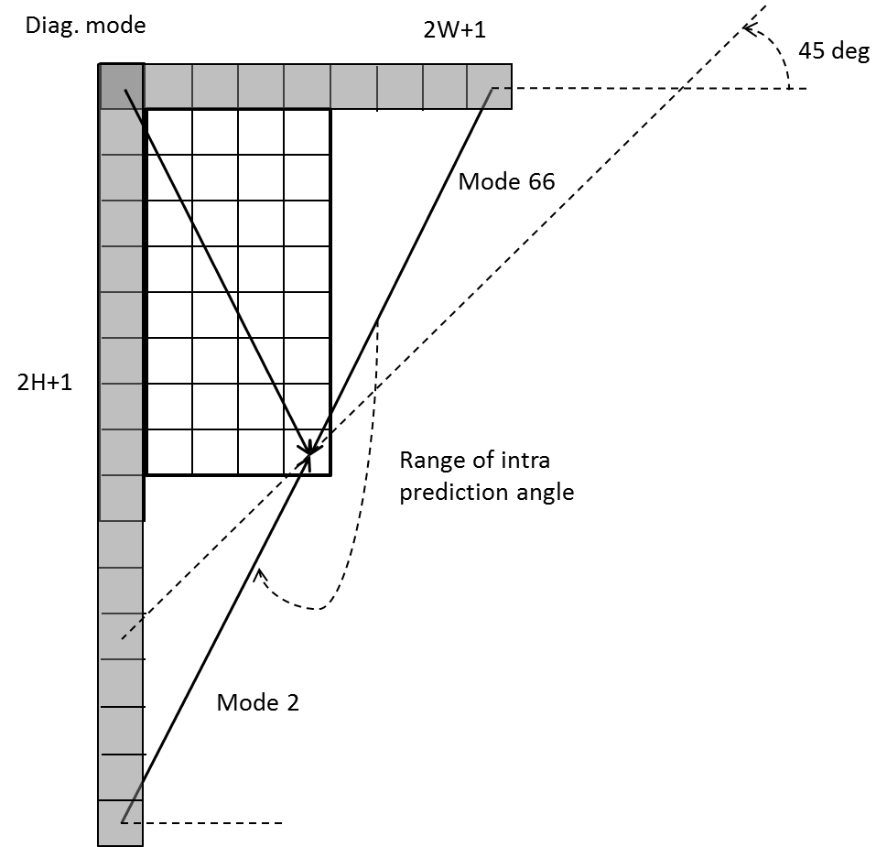
Figure 3: Top reference array has length 2W+1, left reference array has length 2H+1.In the case of a square block, the directions and the lengths of the reference arrays are identical to those in VTM/BMS.

In case of 35 intra prediction modes, the replaced intra prediction modes are illustrated in below Table 1.

Table 1: Intra prediction modes replaced by wide-angular modes when 35 intra prediction modes are used.
Condition | Replaced intra prediction modes
W / H == 2 | Modes 2, 3, 4
W / H > 2 | Modes 2, 3, 4, 5, 6
W / H == 1 | None
H / W == 1/2 | Modes 32, 33, 34
H / W < 1/2 | Modes 30, 31, 32, 33, 34

In case of 67 intra prediction modes, the replaced intra prediction modes are illustrated in below Table 2.

Table 2: Intra prediction modes replaced by wide-angular modes when 67 intra prediction modes are used.
Condition | Replaced intra prediction modes
W / H == 2 | Modes 2,3,4,5,6,7
W / H > 2 | Modes 2,3,4,5,6,7,8,9,10,11
W / H == 1 | None
H / W == 1/2 | Modes 61,62,63,64,65,66
H / W < 1/2 | Mode 57,58,59,60,61,62,63,64,65,66
Figure 4 shows an example of how angular intra modes are replaced with wide angular modes for non-square blocks. In this example, mode 2 and mode 3 are replaced with wide angle mode 35 and mode 36, where the direction of mode 35 is pointing to the opposite direction of mode 3, and the direction of mode 36 is pointing to the opposite direction of mode 4.
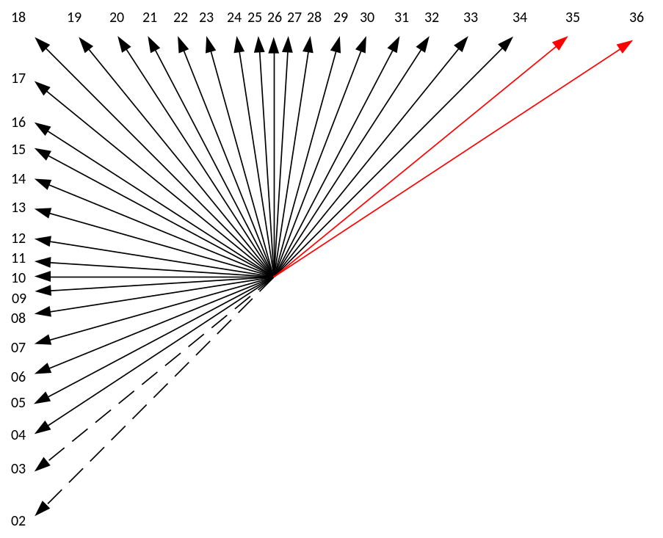
Figure 4: Illustration of the replaced angular modes and added wide angular modes

This new definition of modes requires to adapt the MPM-based prediction mode coding. Since the neighbor blocks of a target block can have different shapes from the target block, their prediction modes need to be mapped to the prediction modes of the target block. A simple solution is to use the original mode indexing with respective directions. In this case, the mode indices corresponding to the removed directions for a target block are mapped to the closest opposite direction which are newly included. If the direction of prediction associated with a mode is still valid for a target block, there is no mapping required.

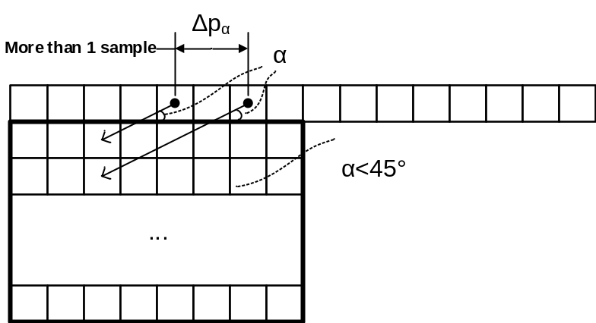
Figure 5: Problem of discontinuity in case of directions beyond 45 deg.
Finally, as can be noticed in Figure 5, two vertically-adjacent predicted samples may use two non-adjacent reference samples in the case of wide-angle intra prediction. Hence, low-pass reference samples filter and side smoothing are applied to wide-angle prediction to reduce the negative effect of the increased gap ∆p_{α}.

Results
The adaptation of intra directions is implemented within the BMS-1.0 software (JEM_TOOLS macros deactivated to emulate VTM). This section reports the BD-rate performance compared to VTM and BMS in AI and RA configuration, as defined in the Common Test Conditions.

VTM

 | All Intra Main10
 | Over VTM-1.0
 | Y | U | V | EncT | DecT
Class A1 | -0.20% | -0.15% | -0.25% | 99% | 96%
Class A2 | -0.25% | -0.23% | -0.28% | 97% | 96%
Class B | -0.28% | -0.35% | -0.37% | 101% | 96%
Class C | -0.44% | -0.69% | -0.83% | 104% | 103%
Class E | -0.44% | -0.35% | -0.25% | 102% | 100%
Overall | -0.32% | -0.37% | -0.42% | 101% | 98%
Class D | -0.34% | -0.59% | -0.47% | 100% | 103%

 | Random Access Main 10
 | Over VTM-1.0
 | Y | U | V | EncT | DecT
Class A1 | -0.17% | -0.20% | -0.20% | 97% | 95%
Class A2 | -0.16% | -0.27% | -0.21% | 96% | 94%
Class B | -0.15% | -0.22% | -0.41% | 100% | 97%
Class C | -0.22% | -0.36% | -0.47% | 102% | 100%
Class E
Overall | -0.17% | -0.26% | -0.34% | 99% | 97%
Class D | -0.14% | -0.21% | -0.45% | 102% | 100%

BMS
 | All Intra Main10
 | Over BMS-1.0
 | Y | U | V | EncT | DecT
Class A1 | -0.14% | -0.02% | -0.16% | 100% | 105%
Class A2
Class B | -0.23% | -0.26% | -0.27% | 99% | 102%
Class C | -0.35% | -0.32% | -0.42% | 100% | 101%
Class E | -0.37% | -0.20% | -0.43% | 96% | 93%
Overall
Class D | -0.21% | -0.17% | -0.36% | 97% | 95%

 | Random Access Main 10
 | Over BMS-1.0
 | Y | U | V | EncT | DecT
Class A1 | -0.10% | -0.08% | -0.19% | 98% | 107%
Class A2 | -0.12% | -0.24% | -0.03% | 98% | 103%
Class B | -0.15% | -0.09% | -0.12% | 94% | 96%
Class C | -0.13% | -0.02% | -0.39% | 97% | 97%
Class E
Overall | -0.13% | -0.10% | -0.19% | 96% | 100%
Class D | -0.09% | 0.03% | -0.28% | 100% | 102%

Spec text
The following text describes the proposed method. It is based on HEVC spec [2] section 8.4.4.2. Modifications with regard to this proposal are highlighted in yellow. Modifications with regard to VTM are highlighted in gray.

8.4.4.2.2 Reference sample substitution process for intra sample prediction
Inputs to this process are:
- reference samples p[ x ][ y ] with x = −1, y = −1.. nTbSHeight * 2 −1 and x = 0.. nTbSWidth * 2 −1, y = −1, for intra sample prediction,
- a transform block size nTbS,
- variables nWidth and nHeight specifying the transform block width and height
- a variable cIdx specifying the colour component of the current block.
Outputs of this process are the modified reference samples p[ x ][ y ] with x = −1, y = −1.. nTbSHeight * 2 −1 and x = 0.. nTbSWidth * 2 −1, y = −1 for intra sample prediction.
The variable bitDepth is derived as follows:
– If cIdx is equal to 0, bitDepth is set equal to BitDepth_{Y}.
– Otherwise, bitDepth is set equal to BitDepth_{C}.
The values of the samples p[ x ][ y ] with x = −1, y = −1.. nTbSHeight * 2 −1 and x = 0.. nTbSWidth * 2 −1, y = −1 are modified as follows:
- If all samples p[ x ][ y ] with x = −1, y = −1.. nTbSHeight * 2 −1 and x = 0.. nTbSWidth * 2 −1, y = −1 are marked as "not available for intra prediction", the value 1 << ( bitDepth − 1 ) is substituted for the values of all samples p[ x ][ y ].
- Otherwise (at least one but not all samples p[ x ][ y ] are marked as "not available for intra prediction"), the following ordered steps are performed:
- When p[ −1 ][ nTbSHeight * 2 −1 ] is marked as "not available for intra prediction", search sequentially starting from x = −1, y = nTbSHeight * 2 −1 to x = −1, y = −1, then from x = 0, y = −1 to x = nTbSWidth * 2 −1, y = −1. Once a sample p[ x ][ y ] marked as "available for intra prediction" is found, the search is terminated and the value of p[ x ][ y ] is assigned to p[ −1 ][ nTbSWidth * 2 −1 ].
- Search sequentially starting from x = −1, y = nTbSHeight * 2 −1 to x = −1, y = −1, when p[ x ][ y ] is marked as "not available for intra prediction", the value of p[ x ][ y + 1 ] is substituted for the value of p[ x ][ y ].
- For x = 0..nTbSWidth * 2 −1, y = −1, when p[ x ][ y ] is marked as "not available for intra prediction", the value of p[ x − 1 ][ y ] is substituted for the value of p[ x ][ y ].
All samples p[ x ][ y ] with x = −1, y = −1..nTbSHeight * 2 - 1 and x = 0..nTbSWidth * 2 −1, y = −1 are marked as "available for intra prediction".

8.4.4.2.3 Filtering process of neighbouring samples
Inputs to this process are:
– the neighbouring samples p[ x ][ y ], with x = −1, y = −1..nTbSHeight * 2 −1 and x = 0..nTbSWidth * 2 −1, y = −1,
- a transform block size nTbS,
- variables nWidth and nHeight specifying the transform block width and height
Outputs of this process are the filtered samples pF[ x ][ y ], with x = −1, y = −1..nTbSHeight * 2 −1 and x = 0.. nTbS Width * 2 −1, y = −1.
The variable nTbS is set to ( nWidth + nHeight ) /2.
The variable filterFlag is derived as follows:
– If one or more of the following conditions are true, filterFlag is set equal to 0:
- predModeIntra is equal to INTRA_DC.
- nTbS is equal 4.
– Otherwise, the following applies:
- The variable minDistVerHor is set equal to Min( Abs( predModeIntra – 26 ), Abs( predModeIntra − 10 ) ).
- The variable intraHorVerDistThres[ nTbS ] is specified in Table 8-3.
- The variable filterFlag is derived as follows:
- If minDistVerHor is greater than intraHorVerDistThres[ nTbS ], filterFlag is set equal to 1.
- Otherwise, filterFlag is set equal to 0.

Table 8-3 – Specification of intraHorVerDistThres[ nTbS ] for various transform block sizes
 | nTbS = 8 | nTbS = 16 | nTbS = 32 | nTbS = 64
intraHorVerDistThres[ nTbS ] | 7 | 1 | 0 | 10

When filterFlag is equal to 1, the following applies:
– The variable biIntFlag is derived as follows:
– If all of the following conditions are true, biIntFlag is set equal to 1:
- strong_intra_smoothing_enabled_flag is equal to 1
- nTbS is equal to 32
- Abs( p[ −1 ][ −1 ] + p[ nTbS * 2 −1 ][ −1 ] – 2 * p[ nTbS −1 ][ −1 ] ) < ( 1 << ( BitDepth_{Y} − 5 ) )
- Abs( p[ −1 ][ −1 ] + p[ −1 ][ nTbS * 2 −1 ] – 2 * p[ −1 ][ nTbS −1 ] ) < ( 1 << ( BitDepth_{Y} − 5 ) )
– Otherwise, biIntFlag is set equal to 0.
– The filtering is performed as follows:
– If biIntFlag is equal to 1, the filtered sample values pF[ x ][ y ] with x = −1, y = −1..63 and x = 0..63, y = −1 are derived as follows:
pF[ −1 ][ −1 ] = p[ −1 ][ −1 ] (8-30)
pF[ −1 ][ y ] = ( ( 63 − y ) * p[ −1 ][ −1 ] + ( y + 1 ) * p[ −1 ][ 63 ] + 32 ) >> 6 for y = 0..62 (8-31)
pF[ −1 ][ 63 ] = p[ −1 ][ 63 ] (8-32)
pF[ x ][ −1 ] = ( ( 63 − x ) * p[ −1 ][ −1 ] + ( x + 1 ) * p[ 63 ][ −1 ] + 32 ) >> 6 for x = 0..62 (8-33)
pF[ 63 ][ −1 ] = p[ 63 ][ −1 ] (8-34)
– Otherwise (biIntFlag is equal to 0), the filtered sample values pF[ x ][ y ] with x = −1, y = −1..nTbSHeight * 2 −1 and x = 0..nTbSWidth * 2 −1, y = −1 are derived as follows:
pF[ −1 ][ −1 ] = ( p[ −1 ][ 0 ] + 2 * p[ −1 ][ −1 ] + p[ 0 ][ −1 ] + 2 ) >> 2 (8-35)
pF[ −1 ][ y ] = ( p[ −1 ][ y + 1 ] + 2 * p[ −1 ][ y ] + p[ −1 ][ y − 1 ] + 2 ) >> 2 for y = 0.. nTbSHeight * 2 − 2 (8-36)
pF[ −1 ][ nTbSHeight * 2 −1 ] = p[ −1 ][ nTbSHeight * 2 −1 ] (8-37)
pF[ x ][ −1 ] = ( p[ x − 1 ][ −1 ] + 2 * p[ x ][ −1 ] + p[ x + 1 ][ −1 ] + 2 ) >> 2 for x = 0.. nTbSWidth * 2 − 2 (8-38)
pF[nTbSWidth * 2 −1 ][ −1 ] = p[ nTbSWidth * 2 −1 ][ −1 ] (8-39)

8.4.4.2.6 Specification of intra prediction mode in the range of INTRA_ANGULAR2.. INTRA_ANGULAR34
Inputs to this process are:
– the intra prediction mode predModeIntra,
– the neighbouring samples p[ x ][ y ], with x = −1, y = −1.. nTbSHeight * 2 −1 and x = 0.. nTbSWidth * 2 −1, y = −1,
a transform block size nTbS,
variables nWidth and nHeight specifying the transform block width and height
– a variable cIdx specifying the colour component of the current block.
Outputs of this process are the predicted samples predSamples[ x ][ y ], with x, y = 0..nTbS − 1.
Figure 8-2 illustrates the total 33 43 intra angles and Table 8-4 specifies the mapping table between predModeIntra and the angle parameter intraPredAngle.
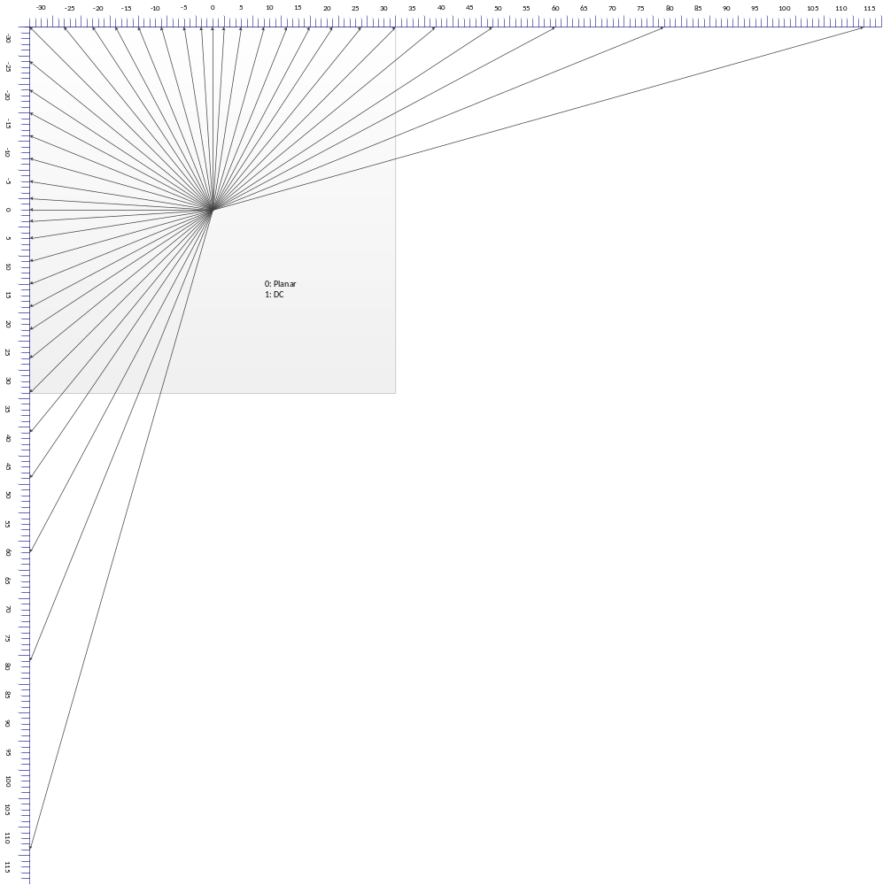
Figure 8-2 – Intra prediction angle definition (informative)

Table 8-4 – Specification of intraPredAngle
predModeIntra | -5 | -4 | -3 | -2 | -1 | 0 | 1 | 2 | 3 | 4 | 5 | 6 | 7 | 8 | 9 | 10 | 11
intraPredAngle | 114 | 79 | 60 | 49 | 39 |  | - | 32 | 26 | 21 | 17 | 13 | 9 | 5 | 2 | 0 | −2
predModeIntra | 12 | 13 | 14 | 15 | 16 | 17 | 18 | 19 | 20 | 21 | 22 | 23 | 24 | 25 | 26 | 27 | 28
intraPredAngle | −5 | −9 | −13 | −17 | −21 | −26 | −32 | −26 | −21 | −17 | −13 | −9 | −5 | −2 | 0 | 2 | 5
predModeIntra | 29 | 30 | 31 | 32 | 33 | 34 | 35 | 36 | 37 | 38 | 39
intraPredAngle | 9 | 13 | 17 | 21 | 26 | 32 | 39 | 49 | 60 | 79 | 114

Table 8-5 further specifies the mapping table between predModeIntra and the inverse angle parameter invAngle.

Table 8-5 – Specification of invAngle
predModeIntra | 11 | 12 | 13 | 14 | 15 | 16 | 17 | 18
invAngle | −4096 | −1638 | −910 | −630 | −482 | −390 | −315 | −256
predModeIntra | 19 | 20 | 21 | 22 | 23 | 24 | 25 | 26
invAngle | −315 | −390 | −482 | −630 | −910 | −1638 | −4096 | -

When nWidth is not equal to nHeight, predModeIntra is mapped as follows:
- if nWidth/nHeight <= 2 and 2 <= predModeIntra <= 4, predModeIntra = predModeIntra + 33
- if nWidth/nHeight > 2 and 2 <= predModeIntra <= 6, predModeIntra = predModeIntra + 33
- if nHeight/nWidth <= 2 and 32 <= predModeIntra <= 34, predModeIntra = predModeIntra – 35
- if nHeight/nWidth > 2 and 30 <= predModeIntra <= 34, predModeIntra = predModeIntra – 35
The values of the prediction samples predSamples[ x ][ y ], with x = 0.. nTbSWidth − 1, y = 0.. nTbSHeight − 1 are derived as follows:
– If predModeIntra is equal or greater than 18, the following ordered steps apply:
- The reference sample array ref[ x ] is specified as follows:
- The following applies:
ref[ x ] = p[ −1 + x ][ −1 ], with x = 0.. nTbSWidth (8-47)
- If intraPredAngle is less than 0, the main reference sample array is extended as follows:
- When ( nTbSHeight * intraPredAngle ) >> 5 is less than −1,
ref[ x ] = p[ −1 ][ −1 + ( ( x * invAngle + 128 ) >> 8 ) ],
with x = −1..( nTbSHeight * intraPredAngle ) >> 5 (8-48)
- Otherwise,
ref[ x ] = p[ −1 + x ][ −1 ], with x = nTbSWidth + 1..2 * nTbSWidth (8-49)
- The values of the prediction samples predSamples[ x ][ y ], with x = 0..nTbSWidth − 1, y = 0..nTbSHeight − 1 are derived as follows:
  - The index variable iIdx and the multiplication factor iFact are derived as follows:
iIdx = ( ( y + 1 ) * intraPredAngle ) >> (8-50)
iFact = ( ( y + 1 ) * intraPredAngle ) & 31 (8-51)
  - Depending on the value of iFact, the following applies:
- If iFact is not equal to 0, the value of the prediction samples predSamples[ x ][ y ] is derived as follows:
predSamples[ x ][ y ] =
( ( 32 − iFact ) * ref[ x + iIdx + 1 ] + iFact * ref[ x + iIdx + 2 ] + 16 ) >> 5 (8-52)
- Otherwise, the value of the prediction samples predSamples[ x ][ y ] is derived as follows:
predSamples[ x ][ y ] = ref[ x + iIdx + 1 ] (8-53)
  - When predModeIntra is equal to 26 (vertical), cIdx is equal to 0 and nTbS is less than 32, the following filtering applies with x = 0, y = 0..nTbS − 1:
predSamples[ x ][ y ] = Clip1_{Y}( p[ x ][ −1 ] + ( ( p[ −1 ][ y ] − p[ −1 ][ −1 ] ) >> 1 ) ) (8-54)
– Otherwise (predModeIntra is less than 18), the following ordered steps apply:
- The reference sample array ref[ x ] is specified as follows:
- The following applies:
ref[ x ] = p[ −1 ][ −1 + x ], with x = 0.. nTbSHeight (8-55)
- If intraPredAngle is less than 0, the main reference sample array is extended as follows:
- When ( nTbSWidth * intraPredAngle ) >> 5 is less than −1,
ref[ x ] = p[ −1 + ( ( x * invAngle + 128 ) >> 8 ) ][ −1 ],
with x = −1..( nTbSWidth * intraPredAngle ) >> 5 (8-56)
- Otherwise,
ref[ x ] = p[ −1 ][ −1 + x ], with x = nTbSHeight + 1..2 * nTbSHeight (8-57)
- The values of the prediction samples predSamples[ x ][ y ], with x = 0..nTbSWidth − 1, y = 0..nTbSHeight − 1 are derived as follows:
- The index variable iIdx and the multiplication factor iFact are derived as follows:
iIdx = ( ( x + 1 ) * intraPredAngle ) >> 5 (8-58)
iFact = ( ( x + 1 ) * intraPredAngle ) & 31 (8-59)
- Depending on the value of iFact, the following applies:
- If iFact is not equal to 0, the value of the prediction samples predSamples[ x ][ y ] is derived as follows:
predSamples[ x ][ y ] =
( ( 32 − iFact ) * ref[ y + iIdx + 1 ] + iFact * ref[ y + iIdx + 2 ] + 16 ) >> 5 (8-60)
- Otherwise, the value of the prediction samples predSamples[ x ][ y ] is derived as follows:
predSamples[ x ][ y ] = ref[ y + iIdx + 1 ] (8-61)
- When predModeIntra is equal to 10 (horizontal), cIdx is equal to 0 and nTbS is less than 32, the following filtering applies with x = 0..nTbS − 1, y = 0:
predSamples[ x ][ y ] = Clip1_{Y}( p[ −1 ][ y ] + ( ( p[ x ][ −1 ] − p[ −1 ][ −1 ] ) >> 1 ) ) (8-62)

References
- Rickard Sjöberg et. al, “Description of SDR and HDR video coding technology proposal by Ericsson and Nokia,” Joint Video Exploration Team (JVET) of ITU-T SG 16 WP 3 and ISO/IEC JTC 1/SC 29/WG 11, JVET-J0012, San Diego, CA, USA, 10–20 April 2018.
- High Efficiency Video Coding, December 2016.

Patent rights declaration(s)
Technicolor may have current or pending patent rights relating to the technology described in this contribution and, conditioned on reciprocity, is prepared to grant licenses under reasonable and non-discriminatory terms as necessary for implementation of the resulting ITU-T Recommendation | ISO/IEC International Standard (per box 2 of the ITU-T/ITU-R/ISO/IEC patent statement and licensing declaration form).

Tencent may have current or pending patent rights relating to the technology described in this contribution and, conditioned on reciprocity, is prepared to grant licenses under reasonable and non-discriminatory terms as necessary for implementation of the resulting ITU-T Recommendation | ISO/IEC International Standard (per box 2 of the ITU-T/ITU-R/ISO/IEC patent statement and licensing declaration form).

Huawei Technologies Co., Ltd may have current or pending patent rights relating to the technology described in this contribution and, conditioned on reciprocity, is prepared to grant licenses under reasonable and non-discriminatory terms as necessary for implementation of the resulting ITU-T Recommendation | ISO/IEC International Standard (per box 2 of the ITU-T/ITU-R/ISO/IEC patent statement and licensing declaration form).

