    Joint Video Experts Team (JVET)  of ITU-T SG 16 WP 3 and ISO/IEC JTC 1/SC 29/WG 11  11th Meeting: Ljubljana, SI, 10–18 July 2018 | Document: JVET-K0409-v3

Title: | On copyright of HLG test sequences
Status: | Input document to JVET
Purpose: | Proposal
Author(s) or  Contact(s): | T. Suzuki  A. Ichigaya | Tel:  Email: | +81-50-3750-2740  Teruhiko.s@sony.com  +81-3-5494-3318  ichigaya.a-go@nhk.or.jp
Source: | NHK and Sony Corporation
_____________________________

Abstract
The test sequences for 4K HLG test sequences were proposed by JVET-E0086 and G0063, and SunsetBeach, DayStreet and PeopleInShoppingCenter are used in CTC. The copyright information is attached to the test sequences at the ftp site. However, it is found that those sequences were used for other purposes. The proponents would like to change the copyright information as described in the section 2. It is also asked to JVET/MPEG/VCEG to notify the copyright and the usage of test sequences to members. It is also ask to continue to manage test sequences appropriately.

Test sequences
The test sequences for 4K HLG test sequences were proposed by JVET- E0086 and G0063, and SunsetBeach, DayStreet and PeopleInShoppingCenter are used in CTC. The sequences proposed by JVET-E0086 and G0063 are as in Table 1, 2. The copyright information is attached to the test sequences at the ftp site.
However, it is found that those sequences were used for other purposes. In this situation,
- NHK/Sony would like to change the copyright information as described in the section 2
I would like to ask JVET/MPEG/VCEG to notify the copyright and the usage of test sequences to members, and would like to ask to continue to manage test sequences appropriately.

Table 1. Proposed test sequences in E0086 (contributed by NHK)
Title | Thumbnail | Brief description
HLG-1 | 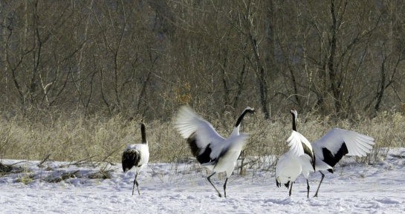 | Moving crane (Slightly panning)
HLG-2 | 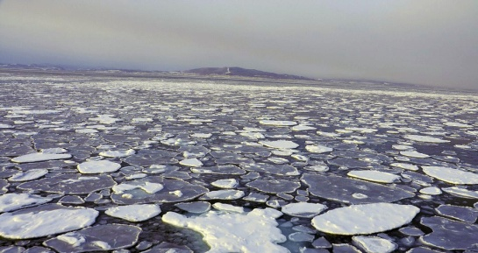 | Drift ice from moving ship (Track up)
HLG-3 | 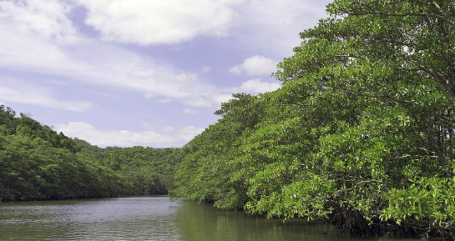 | Trees and river from a boat (Track up)
HLG-4 | 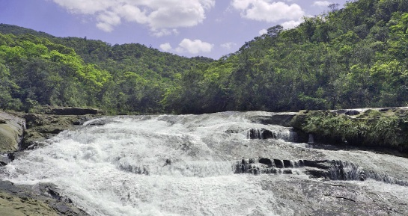 | Waterfall and mountains(Fixed)
HLG-5 | 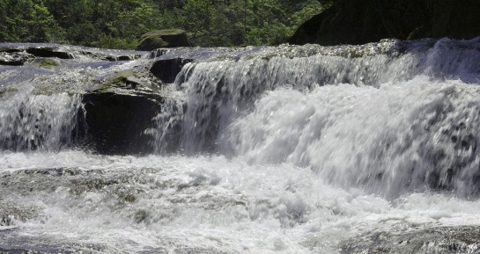 | Waterfall (Fixed)
HLG-6 | 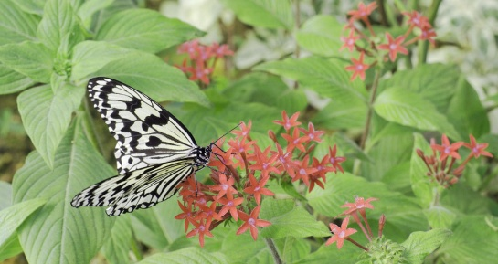 | Butterfly and colorful flowers (Fixed)
HLG-7 | 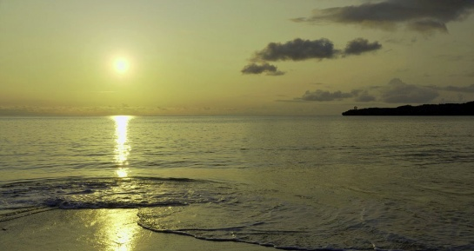 | Sunset beach (Fixed)

Table-2 Proposed HLG test sequences in G0063 (contributed by Sony)
Thumbnail | Sequence name | Brief description
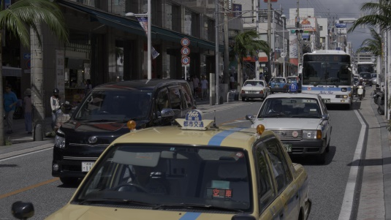 | HLG_DayStreet  _3840x2160_420_10bit_60fps | Reflection on the glass of the cars and heat haze (fixed)
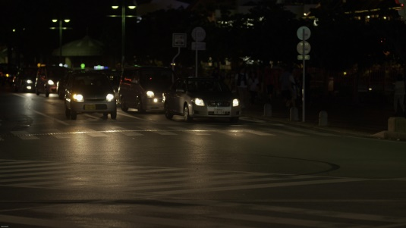 | HLG_NightStreet  _3840x2160_420_10bit_60fps | Reflection on the glass and the body of the cars (fixed)
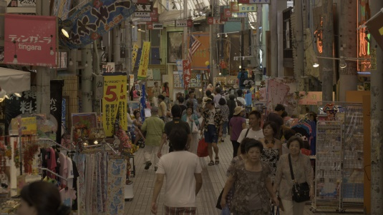 | HLG_PeopleInShoppingCenter  _3840x2160_420_10bit_60fps | People walking in shopping center (fixed)
 | HLG_SeaSurface  _3840x2160_420_10bit_60fps | Birds flying around on the sea (fixed)
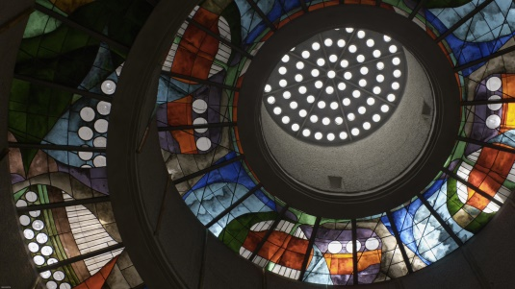 | HLG_StainedGlass  _3840x2160_420_10bit_60fps | StainedGlass (tilting)

Copyright information
The sequences of E0086 and G0063 provided in this contribution are owned by NHK and Sony Corporation, respectively. The copyright and disclaimer are attached with the test sequences. The test sequences shall be copied together with the copyright and disclaimer which is not subject to be encoded.

- Revised copyright for E0086
The sequence has been generated by Japan Broadcasting Corporation (NHK), and all intellectual property rights remain with NHK. The material shall only be used for developing future video coding standards, for evaluating performance of test models in JVET and the subsequent standardization project, and for the relational parent body activities. The sequence should be processed in the original 4K resolution. It is not allowed to modify the characteristics of test materials including transfer characteristics and colorimetric characteristics.
This copyright and permission notice shall be duplicated whenever the data are copied or distributed. The material cannot be distributed with charge. NHK makes no warranties with respect to the material and expressly disclaims any warranties regarding its fitness for any purpose. Unless the above conditions are agreed to by the recipient, no permission is granted for any use, copying, and distribution of the data. By using the sequence, the user agrees to the conditions of this copyright and disclaimer.

- Revised copyright for G0063
The sequence has been generated by Sony Corporation, and all intellectual property rights remain with Sony Corporation. The material shall only be used for ISO/IEC JTC1 SC29 | ITU-T SG16. The sequences should be processed in the original 4K resolution. It is not allowed to modify the test materials to damage creator’s intention, e.g. not allowed to change EOTF (only allowed to use as HLG), color space, etc.This copyright and permission notice shall be duplicated together whenever the data are copied or distributed. The material cannot be charged for any copy or distribution. Sony Corporation makes no warranty with respect to the material and expressly disclaims any warranty regarding any use. If you do not agree to the above polity, no permission is granted for any use of the data. We will regard that you have agreed to the policy of the copyright and disclaimer if you use the data.

The following uses are NOT allowed for the proposed sequences:
    - Do not publish snapshots in product brochures.
    - Do not use video for marketing purposes
    - Do not redistribute video with a commercial product.
    - Do not use in television shows, commercials, or movies.

Conclusions
In this contribution,
- NHK would like to modify the copyright information of 4K HLG test sequences proposed by JVET-E0086
- Sony would like to modify the copyright information of 4K HLG test sequences proposed by JVET-G0063
- It is also asked to JVET/MPEG/VCEG to notify the copyright and the usage of test sequences to members.
- It is also asked to continue to manage test sequences appropriately.

Patent rights declaration(s)
NHK and Sony Corporation does not have any current or pending patent rights relating to the technology described in this contribution.

