Joint Video Experts Team (JVET)  of ITU-T SG 16 WP 3 and ISO/IEC JTC 1/SC 29/WG 11  11th Meeting: Ljubljana, SI, 10–18 July 2018 | Document: JVET-K0331

Title: | CE13: Adaptive frame packing (Tests 4.3 and 4.4)
Status: | Input document to JVET
Purpose: | Proposal
Author(s) or  Contact(s): | Philippe Hanhart, Yuwen He, Yan Ye  9276 Scranton Rd, #300  San Diego, CA 92121, USA | Tel:  Email: | Philippe.Hanhart@interdigital.com  Yuwen.He@interdigital.com  Yan.Ye@interdigital.com
Source: | InterDigital Communications, Inc.
_____________________________

Abstract
This contribution reports simulation results of CE13 tests 4.3 and 4.4. The adaptive frame packing (AFP) periodically modifies the location of discontinuous face boundaries in the frame packed pictures to improve coding efficiency and reduce the visibility of face seam artifacts. Results based on end-to-end WS-PSNR show that AFP provides luma BD-rate savings of about 0.3% on top of EAC and HAC for VTM and BMS configurations. There is no significant encoding or decoding complexity increase due to AFP.

Introduction
Projection formats are used to map 360° video to a normal 2D video such that it can be encoded with existing video codecs. A fixed frame packing arrangement is typically used for projection formats composed of a plurality of faces. It is reported that periodically modifying the location of discontinuous face boundaries in the frame packed pictures can provide better coding efficiency and reduce the visibility of face seam artifacts. AFP is studied in CE13 tests 4.3 and 4.4 [1] and this contribution reports the coding performance of AFP.

Technical description

Adaptive frame packing
To reduce the visibility of face seam artifacts, adaptive frame packing is proposed to periodically modify the location of discontinuous face boundaries in the frame packed pictures. The advantage of changing frame packing parameters at regular time intervals is that, for a discontinuous face boundary in the current picture, if there is a reference picture which uses a different frame packing where that same face boundary is continuous, then better prediction may be achieved for the areas located near the discontinuous face boundary in the current picture. For example, if the reference and current pictures are packed using different frame packing configurations as depicted in Figure 1(a) and Figure 1(b), respectively, then the face boundary between face #1 and face #4 in 3D geometry, marked by the red dashed lines, can be better predicted from the corresponding areas in the reference picture. This is because the areas near that face boundary in the reference picture, marked by the green line in Figure 1(a), are continuous and therefore generally easier to be coded at a higher quality; thus, better prediction may be provided for the current picture around these areas, reducing the visibility of the seam artifact in the current picture. Additionally, by changing frame packing parameters at regular intervals, locations of the discontinuous face boundaries in the frame packed pictures will change periodically. As a result, though face seams may still appear at some point in time, the duration of a face seam at the same location will be reduced. The result is visually more pleasant compared to having a face seam artifact always at the same location, which could catch the viewer’s attention and degrade perceived video quality when watching the viewport video.
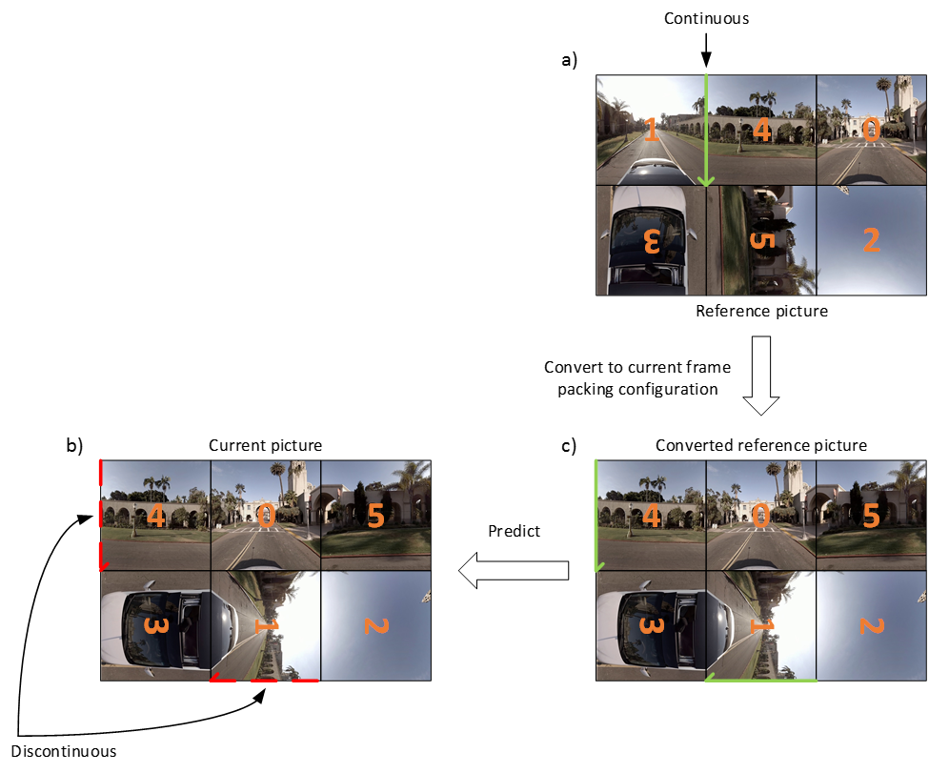
Figure 1. Inter frame prediction in the case of different frame packing configurations between the reference (a) and current (b) pictures. The converted reference picture used to predict the current picture is shown in (c).
As depicted in Figure 1, when the frame packing configuration of the reference picture is different from that of the current picture, the reference picture needs to be first converted into the frame packing configuration of the current picture. This conversion is straightforward and only involves “reshuffling” of the faces within the frame packed pictures. An example of the converted reference picture is shown in Figure 1(c).
The adaptive frame packing parameters are determined at the encoder side at every IRAP and signaled in the PPS.

Adaptive frame packing determination at the encoder
Considering a 3×2 layout of a cubemap-like projection format, there are six different combinations to select two face groups of three faces each. Using the face definitions from the 360Lib, these combinations are listed in Table 1. Considering that the top and bottom parts of the spherical video are typically less interesting and/or easier to encode, only the combinations where three faces along the equators are grouped together. This reduces the problem to four different combinations (combinations 1-4 in Table 1).
Table 1. Combinations to select two face groups of three faces
Combination | Group #1 | Group #2
1 | PX, PZ, NX | PY, NZ, NY
2 | PX, NZ, NX | PY, PZ, NY
3 | PZ, PX, NZ | PY, NX, NY
4 | PZ, NX, NZ | PY, PX, NY
5 | PX, PY, NX | PZ, NY, NZ
6 | PZ, PY, NZ | PX, NY, NX
For any of these four combinations, the three equatorial faces in group #1 are placed horizontally, whereas the remaining three face in group #2 may be rotated in the frame packed picture. However, rotations of ±90° may impact coding efficiency, especially for intra coding. Indeed, a better prediction can be achieved for a pattern composed of diagonal lines, i.e., from upper left to lower right, than for a pattern composed of anti-diagonal lines, i.e., from upper right to lower left, because some intra prediction directions (e.g., those close to the intra mode 2) require reference samples located below left and above right of the current block, respectively, which are more likely to be unavailable.
To determine which rotation is optimal for a face, the horizontal, vertical, diagonal, and anti-diagonal gradients are computed on the luma component using 1-D Laplacian. Then, gradient classification is applied on an 8×8 block basis to determine the dominant gradient in each block. The gradient values are accumulated over all samples within a block. The accumulated horizontal, vertical, diagonal, and anti-diagonal gradient values, denoted g_{h}, g_{v}, g_{d}, and g_{a}, respectively, are compared to each other’s to determine the block’s dominant gradient following the flowchart depicted in Figure 2, where α is a parameter used to classify between active and inactive gradients and is set to 2.
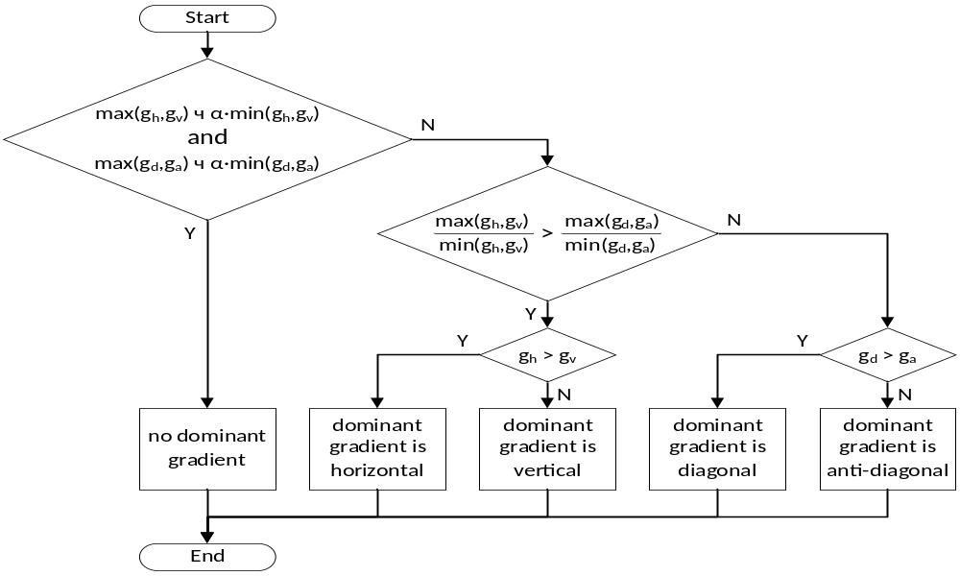
Figure 2. Flowchart for determining the dominant gradient for an 8×8 block
For each face, a cost function is built as
(1)
Where is the face index, , , , and are the weights assigned to the horizontal, vertical, diagonal, and anti-diagonal dominant gradient counts , , , and , respectively. Considering that intra prediction for patterns composed of anti-diagonal lines may be less efficient than for other directions, the following set of weights are used: 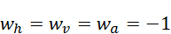, 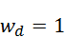. Then, the overall cost for each combination (see Table 1) is computed as the sum of the individual cost of each face, considering the orientation of each face.
A subset of the first four adaptive frame packing combinations shown in Table 1 is used in a rotating manner at the beginning of each IRAP. Among the four combinations, the cost of each combination is calculated using the first picture of the input video sequence. If the cost of any combination is significantly higher than that of the best combination, then that combination is not used in coding the input video sequence to avoid reducing coding efficiency. Since only the first picture in the sequence is used in the determination, this solution can be used together with parallel encoding. Without loss of generality, after analyzing the first picture, assume that all four combinations are determined to be viable, and they are ranked based on their cost as C1, C2, C3, C4. For the first picture, the best combination, i.e., C1, is used. For the subsequent IRAP pictures, two sets of combinations are formed, i.e., {C1,C2} and {C3,C4}, and the optimal combination is selected as
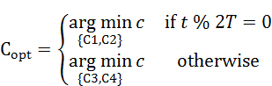 | (2)
where is the IRAP period, % is the modulo operator, and is the cost function computed for the given IRAP picture. Adaptive frame packing parameters are selected by the encoder using the first picture of each IRAP and signaled once per IRAP.

Simulation results
The software is implemented based on BMS-1.0 and 360Lib-6.0. The encoding was done under 360° video CTC [4]. The following tables only report the end-to-end WS-PSNR results. Results for the other metrics can be found in the accompanied Excel spreadsheets.

Test 4.3: EAC + adaptive frame packing
Results for EAC with AFP over EAC without AFP are reported in Table 2.
Table 2. BD-rate for AFP on top of EAC.
 |  | VTM |  |  | BMS
 |  | BD-rate(Y) | BD-rate(U) | BD-rate(V) | BD-rate(Y) | BD-rate(U) | BD-rate(V)
Class S1 | SkateboardInLot | -0.06% | -0.25% | -0.03% | -0.15% | -0.31% | 0.64%
Class S1 | ChairLift | -0.11% | 0.06% | -0.60% | -0.28% | -1.60% | -0.88%
Class S1 | KiteFlite | -0.15% | -1.21% | -1.53% | -0.21% | -1.24% | -1.36%
Class S1 | Harbor | -0.49% | -2.56% | -2.87% | -0.53% | -2.84% | -2.91%
Class S1 | Trolley | -0.64% | -2.09% | -2.28% | -0.74% | -2.90% | -2.49%
Class S1 | GasLamp | -0.95% | -2.29% | -2.21% | -0.83% | -2.47% | -2.67%
Class S2 | Balboa | -0.43% | -0.99% | -0.62% | -0.39% | -1.22% | -0.69%
Class S2 | Broadway | -0.17% | -0.95% | -0.44% | -0.08% | -0.51% | -0.55%
Class S2 | Landing2 | -0.01% | -0.51% | -0.63% | 0.05% | -0.35% | 0.02%
Class S2 | BranCastle2 | -0.08% | -0.07% | -0.15% | -0.09% | 0.61% | 0.26%
Class S1 |  | -0.40% | -1.39% | -1.59% | -0.46% | -1.89% | -1.61%
Class S2 |  | -0.17% | -0.63% | -0.46% | -0.13% | -0.37% | -0.24%
Overall |  | -0.31% | -1.09% | -1.14% | -0.32% | -1.28% | -1.06%
Enc Time[%] |  | 101% |  |  | 100%
Dec Time[%] |  | 103% |  |  | 100%
Simulation results show overall coding performance of EAC with AFP is consistent between VTM and BMS configurations. BD-rate saving for AFP on top of EAC is around 0.3%. The encoding and decoding complexity of EAC with AFP is similar to that of EAC without AFP.

Test 4.4: HAC + adaptive frame packing
Results for HAC, 3 parameters configuration [3], with AFP over HAC, 3 parameters configuration, without AFP are reported in Table 3.
Table 3. BD-rate for AFP on top of HAC.
 |  | VTM |  |  | BMS
 |  | BD-rate(Y) | BD-rate(U) | BD-rate(V) | BD-rate(Y) | BD-rate(U) | BD-rate(V)
Class S1 | SkateboardInLot | -0.15% | -0.33% | 0.26% | -0.22% | -0.45% | 0.38%
Class S1 | ChairLift | -0.09% | -0.37% | -0.94% | -0.25% | -2.00% | -1.11%
Class S1 | KiteFlite | -0.16% | -1.14% | -1.44% | -0.19% | -1.18% | -1.28%
Class S1 | Harbor | -0.49% | -2.59% | -2.87% | -0.47% | -2.79% | -2.72%
Class S1 | Trolley | -0.67% | -2.24% | -2.27% | -0.71% | -2.90% | -2.37%
Class S1 | GasLamp | -0.90% | -2.51% | -2.19% | -0.74% | -2.62% | -2.34%
Class S2 | Balboa | -0.40% | -1.13% | -0.83% | -0.40% | -1.37% | -0.77%
Class S2 | Broadway | -0.19% | -0.51% | -0.72% | -0.07% | -0.60% | -0.68%
Class S2 | Landing2 | -0.01% | -0.45% | -0.36% | 0.04% | -0.54% | 0.13%
Class S2 | BranCastle2 | -0.08% | -0.04% | -0.32% | -0.10% | 0.64% | -0.03%
Class S1 |  | -0.41% | -1.53% | -1.57% | -0.43% | -1.99% | -1.57%
Class S2 |  | -0.17% | -0.53% | -0.56% | -0.13% | -0.47% | -0.34%
Overall |  | -0.31% | -1.13% | -1.17% | -0.31% | -1.38% | -1.08%
Enc Time[%] |  | 100% |  |  | 100%
Dec Time[%] |  | 101% |  |  | 100%
Simulation results show overall coding performance of HAC with AFP is consistent between VTM and BMS configurations. BD-rate saving for AFP on top of HAC is around 0.3%. The encoding and decoding complexity of EAC with AFP is similar to that of HAC without AFP.

Conclusion
This contribution reports simulation result of CE13 tests 4.3 and 4.4, which evaluates AFP on top of EAC and HAC, respectively. AFP periodically modifies the location of discontinuous face boundaries in the frame packed pictures to improve coding efficiency and reduce the visibility of face seam artifacts. The results show BD-rate savings of about 0.3% on top of EAC and HAC for VTM and BMS configurations. There is no significant encoding or decoding complexity increase due to AFP.

References
- P. Hanhart, J.-L. Lin, “Description of Core Experiment 13 (CE13): Projection formats”, JVET-J1033, Apr. 2018, San Diego, USA.
- P. Hanhart, J. Boyce, K. Choi, “JVET common test conditions and evaluation procedures for 360° video”, JVET-J1012, Apr. 2018, San Diego, USA.
- P. Hanhart, Y. He, Y. Ye, “CE13: Hybrid angular cubemap projection (Tests 4.1 and 4.2)”, JVET-K0330, July 2018, Ljubljana, SI.

Patent rights declaration(s)
InterDigital Communications, Inc. may have current or pending patent rights relating to the technology described in this contribution and, conditioned on reciprocity, is prepared to grant licenses under reasonable and non-discriminatory terms as necessary for implementation of the resulting ITU-T Recommendation | ISO/IEC International Standard (per box 2 of the ITU-T/ITU-R/ISO/IEC patent statement and licensing declaration form).

