Joint Video Experts Team (JVET)  of ITU-T SG 16 WP 3 and ISO/IEC JTC 1/SC 29/WG 11  11th Meeting: Ljubljana, SI, 10–18 July 2018 | Document: JVET-K0319-v4

Title: | CE7-Related: TCQ with High Throughput Coefficient Coding
Status: | Input document to JVET
Purpose: | Proposal
Author(s) or  Contact(s): | Jie Dong, Muhammed Coban,  Marta Karczewicz | Tel:  Email: | +1-408-533-9515  jiedong@qti.qualcomm.com
Source: | Qualcomm Inc.
_____________________________

Abstract
Trellis coded quantization (TCQ) together with a coupled coefficient coding scheme was proposed in [1]. It may degrade CABAC throughput compared with the coefficient coding in HEVC or the current JEM design. To improve the throughput and maintain most of the gain reported in CE7 [2], this contribution proposes a modified TCQ with a coupled coefficient coding scheme. The simulation results show -3.98% AI, -2.58% RA, and -1.80% LDB BD-rate reduction compared with VTM-1.0 anchor, and -1.99% AI, -1.37% RA, and -0.98% LDB BD-rate reduction compared with BMS-1.0.

Introduction
Trellis coded quantization (TCQ) was proposed in [1], where two scalar quantizers are switchably used for quantization. The scalar quantizer used for quantizing a current transform coefficient is determined by the parity (the least significant bit) of the quantized coefficient that precedes the current transform coefficient in the scanning order.
A coefficient coding scheme coupled with TCQ was also proposed in [1], by which the context modeling for a quantized coefficient depends on the quantizer it used. Specifically, each of the significance flag (SIG) and the greater than one flag (gt1) has two sets of context models, and the set selected for a particular SIG or gt1 depends on the quantizer used for the associated coefficient. Therefore, the coefficient coding proposed in [1] requires full reconstruction of the absolution level (absLevel) of the quantized coefficient before moving to the next scanning position, in order to know the parity, which is used to determine the quantizer and thus the context sets for the next coefficient. This is one of the main differences from HM/JEM coefficient coding.
The other main difference is that the bins of SIG and greater than x flags (gtx, x = 1, 2, 3, and 4) are regular coded and the sets of context models include two sets for SIG, two sets for gt1, and a separate set shared by gt2, gt3, and gt4.

Problem Statement
The new design of the coefficient coding in [1] may degrade the throughput compared with the design in HEVC or JEM, analyzed as below.
- Regular coded bins are increased. Regular coded bins are processed much slower than bypass coded bins, due to context selection and interval subdivision calculation. With the coefficient coding in [1], the number of regular coded bins in a CG is up to 80, compared with 25 in JEM (16 for SIG, 8 for gt1, and 1 for gt2).
- Bypass coded bins are not grouped. Grouping bypass bins together into longer chains increases the number of bins processed per cycle and thus reduces the number of cycles required to process a single bypass bin. However, with the coefficient coding in [1], all the bypass coded bins in a CG are not grouped (see Fig. 1); instead, they are interleaved with regular coded bins per coefficient.
- Regular coded bins with different sets of contexts are interleaved. When bins that use the same logic for context selection are grouped together, fewer speculative calculations are needed to process multiple bins per cycle. With the coefficient coding in [1], SIG, gt1, and gtx (x=2, 3, 4), which use different sets of contexts, are interleaved per coefficient (as illustrated in Fig. 1).
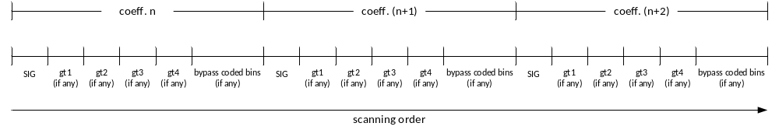
Fig. 1 Order of coefficient bins in a CG, as proposed in [1]
Besides the impact on throughput, memory requirement for storing contexts is increased. Totally 156 contexts (60 for SIG, 64 for gt1, and 32 for gt2/gt3/gt4) are used in [1], compared with 74 contexts (44 for SIG, 24 for gt1, and 6 for gt2) in HEVC.

Proposed TCQ and Coefficient Coding
The goal of this contribution is to achieve the same level of throughput as the coefficient coding design in HM and JEM, while maintaining most of the gain provided by TCQ [2].

TCQ with SIG-based state transition
The parity-based state transition as proposed in [1] is replaced by SIG-based state transition in this contribution, as shown in Fig. 2, while other TCQ design in [1] remains unchanged. By doing this, the scalar quantizer used for quantizing a current transform coefficient is determined by the SIG of the quantized coefficient that precedes the current transform coefficient in the scanning order.
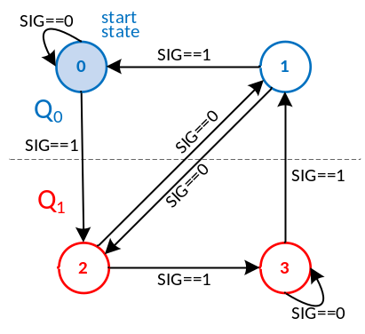
  current state | next state for …
  current state | sig == 0 | sig==1
  0 | 0 | 2
  1 | 2 | 0
  2 | 1 | 3
  3 | 3 | 1
Fig. 2 SIG-based state transition

Coefficient coding
The coefficient coding in this contribution is basically JEM coefficient coding. The difference is that each of the SIG and gt1 has two sets of context models, and the entropy coder selects the context set for a particular SIG or gt1, according to the quantizer the associated coefficient used. Since the entropy coder knows the previous SIG and thus the current quantizer, the right context set can be selected without reconstructing the previous absLevel. Therefore, changing the state transition of TCQ from parity-based to SIG-based enables the similar high throughput design to JEM coefficient coding. The proposed order of coefficient bins in a CG is shown in Fig. 3.
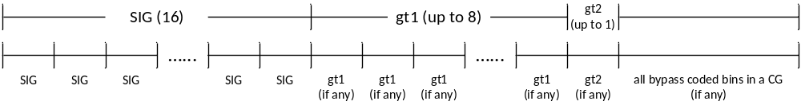Fig. 3 Proposed order of coefficient bins in a CG
Other minor changes include (1) gt2, which shares the same set of context models with gt1 in JEM, also shares the two sets of context models of gt1 in this contribution and switches the set in the same way as gt1 does; (2) the context modeling for SIG does not consider the TU size, and therefore the number of contexts per set is reduced from 54 to 18; (3) the context of cbf_cr is determined by cbf_cb; (4) sign data hiding (SDH) is not used.
In short, with the proposed coefficient coding, the regular coded bins are up to 25 per CG, which remains the same as HM and JEM coefficient coding; all the bypass coded bins in a CG are grouped together; the regular coded bins with the same set of contexts are grouped together. Regarding the memory requirement, totally 104 contexts (60 for SIG and 44 for gt1/gt2) are used, which are 2/3 of the contexts used in [1].

Experimental Results
The proposed scheme was implemented on top of CE 7.2.1 software[3], and the simulation was carried out under the JVET common test conditions [4]. The summary of the results is shown in Tables 1 and 2. More details can be found in the attached spreadsheets.
Table 1 BD-rate reduction compared with VTM-1.0
- All Intra over VTM-1.0
 | Y | U | V | EncT | DecT
Class A1 | -3.87% | -2.29% | -1.73% | 123% | 106%
Class A2 | -4.24% | -0.63% | -1.77% | 136% | 109%
Class B | -3.80% | -0.50% | 0.22% | 134% | 108%
Class C | -4.02% | 0.60% | 0.39% | 179% | 134%
Class E | -4.09% | -0.88% | -0.83% | 155% | 131%
Overall | -3.98% | -0.64% | -0.57% | 145% | 117%
Class D | -4.18% | 1.43% | 1.13% | 185% | 137%
- Random Access over VTM-1.0
 | Y | U | V | EncT | DecT
Class A1 | -2.45% | -1.47% | -0.58% | 112% | 106%
Class A2 | -2.14% | -0.30% | -2.09% | 118% | 106%
Class B | -2.85% | -0.94% | 0.10% | 117% | 106%
Class C | -2.65% | -0.86% | -0.82% | 162% | 131%
Overall | -2.58% | -0.90% | -0.72% | 127% | 112%
Class D | -2.56% | 0.95% | -0.14% | 172% | 136%
- Low Delay B over VTM-1.0
 | Y | U | V | EncT | DecT
Class B | -2.12% | -2.75% | -0.19% | 122% | 109%
Class C | -1.89% | -3.29% | -1.91% | 163% | 137%
Class E | -1.16% | 1.01% | 1.50% | 146% | 140%
Overall | -1.80% | -1.99% | -0.34% | 141% | 125%
Class D | -1.68% | -2.65% | -2.78% | 164% | 135%

Table 2 BD-rate reduction compared with BMS-1.0
- All Intra over BMS-1.0
 | Y | U | V | EncT | DecT
Class A1 | -2.41% | -1.72% | -1.83% | 125% | 96%
Class A2 | -2.39% | -0.29% | -0.67% | 136% | 94%
Class B | -1.94% | -0.96% | 1.30% | 136% | 95%
Class C | -1.74% | -0.50% | 2.18% | 178% | 119%
Class E | -1.60% | -1.02% | 1.55% | 159% | 115%
Overall | -1.99% | -0.88% | 0.68% | 146% | 103%
Class D | -1.72% | 0.50% | 2.55% | 182% | 121%
- Random Access over BMS-1.0
 | Y | U | V | EncT | DecT
Class A1 | -1.63% | -0.57% | 0.02% | 118% | 91%
Class A2 | -1.22% | -0.06% | -0.95% | 129% | 92%
Class B | -1.60% | -0.79% | 1.75% | 128% | 93%
Class C | -1.01% | -1.05% | 1.18% | 170% | 118%
Overall | -1.37% | -0.67% | 0.71% | 136% | 99%
Class D | -1.00% | 0.28% | 2.34% | 173% | 119%
- Low Delay B over BMS-1.0
 | Y | U | V | EncT | DecT
Class B | -1.34% | -2.54% | 0.82% | 125% | 93%
Class C | -0.96% | -2.97% | -1.03% | 166% | 116%
Class E | -0.42% | 0.63% | 2.86% | 147% | 123%
Overall | -0.98% | -1.89% | 0.71% | 143% | 107%
Class D | -0.73% | -1.52% | -1.27% | 168% | 122%

Conclusion
This contribution proposes a modified TCQ coupled with a high-throughput coefficient coding scheme. The simulation results show -3.98% AI, -2.58% RA, and -1.80% LDB BD-rate reduction compared with VTM-1.0 anchor, and -1.99% AI, -1.37% RA, and -0.98% LDB BD-rate reduction compared with BMS-1.0 anchor. It provides a trade-off between CABAC throughput and coding efficiency, and we suggest putting this contribution in CE for further study.

Reference
- “Description of SDR, HDR and 360° video coding technology proposal by Fraunhofer HHI”, JVET-J0014, San Diego, USA, Apr. 10-20, 2018.
- “CE7 summary report on quantization and coefficient coding”, JVET-K0027, Ljubljana, SI, Jul. 10-18, 2018.
- https://jvet.hhi.fraunhofer.de/svn/svn_VVCSoftware_BMS/branches/CE/J_SanDiego/CE7/CE7-2.1-0
- “JVET common test conditions and software reference configuration”, JVET-J1010, San Diego, USA, Apr. 10-20, 2018.

Patent rights declaration(s)
Qualcomm Inc. may have current or pending patent rights relating to the technology described in this contribution and, conditioned on reciprocity, is prepared to grant licenses under reasonable and non-discriminatory terms as necessary for implementation of the resulting ITU-T Recommendation | ISO/IEC International Standard (per box 2 of the ITU-T/ITU-R/ISO/IEC patent statement and licensing declaration form).

