    Joint Video Experts Team (JVET)  of ITU-T SG 16 WP 3 and ISO/IEC JTC 1/SC 29/WG 11  11th Meeting: Ljubljana, SI, 10–18 July 2018 | Document: JVET-K0314-v1

Title: | CE1: Partition Signalling Context Reduction (Test 1.0.11)
Status: | Input document to JVET
Purpose: | Proposal
Author(s) or  Contact(s): | Jie Zhao  Weijia Zhu  Kiran Misra  Andrew Segall | Tel:  Email: | +1-360-834-8054  jzhao@sharplabs.com  zhuw@sharplabs.com  misrak@sharplabs.com  asegall@sharplabs.com
Source: | Sharp
_____________________________

Abstract
In this proposal, it is proposed to share the same set of contexts for the BT/TT split flag for both horizontal and vertical directions. As a result, the number of contexts used for signaling the binary and triple trees is reduced from 12 context to 9 contexts. Calculation of cxIdBT and btSCtxId is unchanged, and it is asserted that the experimental results show that its impact to coding performance is negligible. Specifically:
For the VTM configuration, the average BD rate impact is 0.00%, -0.01%, -0.02% for Y, U, V respectively in the case of AI, 0.01%, 0.05% and -0.01% for Y, U, V respectively in of RA, and 0.00%, 0.03% and 0.3% for Y, U, V respectively in LDB, and -0.01%, 0.12%, 0.05% for Y, U, V respectively in LDP.
For BMS configuration, the average BD rate impact is -0.01%, 0.03%, 0.01% for Y, U, V respectively in the case of AI, 0.03%, 0.10% and 0.02% for Y, U, V respectively in RA, and -0.08%, 0.01% and -0.14% for Y, U, V respectively in LDB, and 0.00%, 0.20%, -0.46% for Y, U, V respectively in LDP.

Introduction
In the VTM (and BMS), 12 contexts are used for signaling the binary and triple tree partition information. The context indices are determined as follows:

BT/TT split mode | Context group start index | Context Index
BT/TT split/no split | 0 | cxIdBT
Hor/Vert Split | 3 | 3+btSCtxId
Hor BT/TT | 6 | 6+btSCtxId
Vert BT/TT | 9 | 9+btSCtxId

Where ctxIdBT is calculated by
ctxIdBT = 0
currDepth = currQtDepth * 2 + currBtDepth
if( cuLeft ) ctxIdBT += ( ( 2 * cuLeft->qtDepth + cuLeft->btDepth ) > currDepth ? 1 : 0 );
if( cuAbove ) ctxIdBT += ( ( 2 * cuAbove->qtDepth + cuAbove->btDepth ) > currDepth ? 1 : 0 );

and
btSCtxId is calculated by
Width==height btSCtxId = 0;
Width > height btSCtxId =1;
Width < height btSCtxId =2;

Proposed Scheme
In this proposal, it is proposed to share the same set of contexts for the BT/TT split flag for both horizontal and vertical directions. As a result, the number of contexts used for signaling the binary and triple trees is reduced from 12 context to 9 contexts. Calculation of cxIdBT and btSCtxId is unchanged. The proposed context indices are assigned as:

BT/TT split mode | Context group start index | Context index
BT/TT split/no split | 0 | cxIdBT
Hor/Vert Split | 3 | 3+btSCtxId
Hor BT/TT | 6 | 6+btSCtxId
Vert BT/TT | 6 | 6+btSCtxId

Experimental Results
The proposed context reduction has been tested following CTC test condition [3]. Tests were done on a heterogenous cluster, so the timing info is not very reliable. For such small modification of context reduction, no impact to coding time is expected.

Table 1. CE1.0.11 VTM result
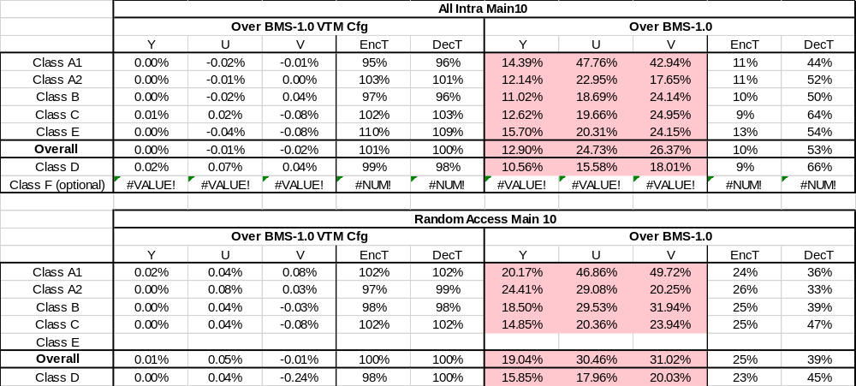
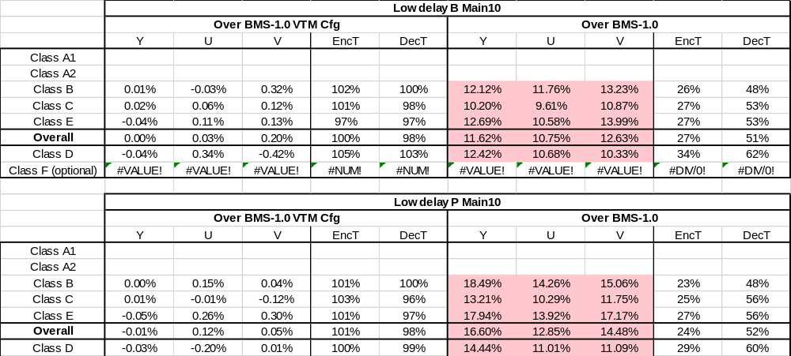

Table 2. CE1.0.11 BMS result

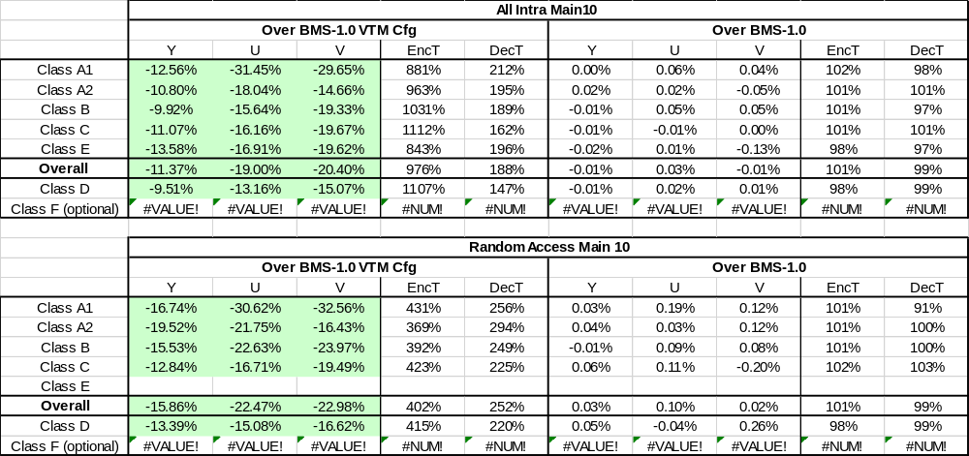
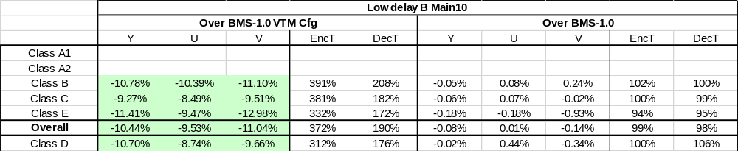

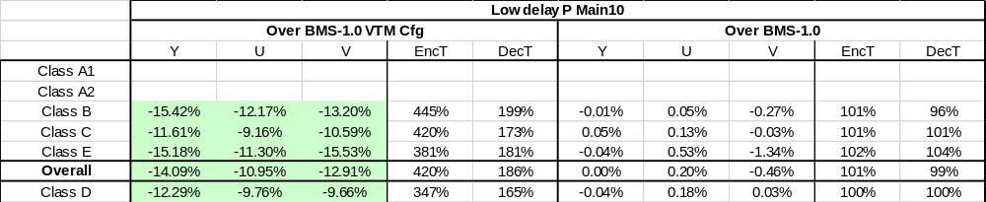
Simulation results validate that the impact to BD rate using the proposed modifications is negligible.
For VTM configuration, the average BD rate impact is 0.00%, -0.01%, -0.02% for Y, U, V respectively in the case of AI, 0.01%, 0.05% and -0.01% for Y, U, V respectively in of RA, and 0.00%, 0.03% and 0.3% for Y, U, V respectively in LDB, and -0.01%, 0.12%, 0.05% for Y, U, V respectively in LDP.
For BMS configuration, the average BD rate impact is -0.01%, 0.03%, 0.01% for Y, U, V respectively in the case of AI, 0.03%, 0.10% and 0.02% for Y, U, V respectively in RA, and -0.08%, 0.01% and -0.14% for Y, U, V respectively in LDB, and 0.00%, 0.20%, -0.46% for Y, U, V respectively in LDP.

Conclusion
It is proposed to share the same set of contexts for the BT/TT split flag for both horizontal and vertical directions. As a result, the number of contexts used for signaling the binary and triple trees is reduced from 12 context to 9 contexts. Experimental results show that the impact of this context reduction on coding performance is negligible. We propose to adopt this method into the versatile video coding working draft and test model.

Reference
- J. Ma, F. Le Léannec and M. W. Park, “Description of Core Experiment 1 (CE1): Partitioning,” JVET-J1021, Apr. 2018, San Diego, US.
- K. Misra, J. Zhao, A. Segall, W. Zhu, B. Choi, F. Bossen, Et al. “Description of SDR and HDR video coding technology proposal by Sharp and Foxconn,” JVET-J0026, Apr. 2018, San Diego, US.
- J. Boyce, K. Suehring, X. Li, V. Seregin “JVET common test conditions and software reference configurations,” JVET-J1010, Apr. 2018, San Diego, US.

Patent rights declaration(s)
Sharp Labs of America may have current or pending patent rights relating to the technology described in this contribution and, conditioned on reciprocity, is prepared to grant licenses under reasonable and non-discriminatory terms as necessary for implementation of the resulting ITU-T Recommendation | ISO/IEC International Standard (per box 2 of the ITU-T/ITU-R/ISO/IEC patent statement and licensing declaration form).

