    Joint Video Experts Team (JVET)  of ITU-T SG 16 WP 3 and ISO/IEC JTC 1/SC 29/WG 11  11th Meeting: Ljubljana, SI, 10–18 July 2018 | Document: JVET-K0251-v2

Title: | CE7.3.2: Extension of quantization parameter value range
Status: | Input document to JVET
Purpose: | Proposal
Author(s) or  Contact(s): | Shih-Ta Hsiang, Shawmin Lei  No. 1, Dusing 1st Rd.,  Hsinchu City 30078, Taiwan | Tel:  Email: | +886-3-5670766  {shih-ta.hsiang, shawmin.lei}  @mediatek.com
Source: | MediaTek Inc.
_____________________________

Abstract
This contribution reports the results of Core Experiment 7.3.2 (CE7.3.2). In the proposed method, the quantization parameter value range is further extended to the maximum value equal to 57 from 51. It is motivated by the observation that the quantization parameter (QP) values for some higher temporal layers are all set to the max QP values 51 for generating anchor results of some Call for Proposls (CfP) test points in the RA setting. CE7.3.2 reportedly achieves average BD rate reductions of 0.67%, 2.24%, and 1.88% for luma, cb, and cr components, respectively, for the RA configuration setting under the VTM-1.0 CTCs (with all BMS tools off) using QPs 32, 37, 42, and 47.
In version 2, the spec text is provided with the maximum quantization parameter value equal to 63.

Introduction
In the reference software VTM-1.0 for VVC Test Model 1 (VTM1) [1], a hierarchical group of pictures (GOP) structure is employed for coding test sequences in the random access or low delay settings. The QP value for quantization of transform coefficients in a temporal layer is derived from a base-layer QP plus a QP offset value corresponding to the current temporal layer index. The QP offset value generally increases with the temporal layer index. When a video sequence is coded with a relatively large base QP value over a low bitrate range, the derived QP value for the higher temporal layers may exceed the maximum QP value 51 in [1]. As a result, the slice QP parameter values for some highest temporal layers are all set to 51 after clipping, leading to inefficient compression. Such scenario is observed from the anchor results of some CfP test points in the RA setting [2].

Proposed method
In the proposed method [3], the QP value range is further extended to the maximum value equal to 57 from 51. The control parameters corresponding to QP values larger than 51 for de-block filtering are extrapolated from the original parameter values.

Experimental results
The proposed method was integrated into the BMS-1.0 reference software [4]. The coding results generated by the proposed method were evaluated against the anchor results generated by the unmodified BMS-1.0 reference software in the RA setting. All the coding experiments were conducted according to the CE7 test conditions specified in [5, 6] except for using a set of large QP values. Please note that the proposed modification only affects the results generated with a base QP value larger than 42 for the RA setting using BMS-1.0.
Table 1 summarizes the simulation results of CE7.3.2 under the VTM-1.0 configurations (with all BMS tools off) and the BMS-1.0 configurations (with all BMS tools on), respectively, using QPs 32, 37, 42, and 47. It is shown that the proposed modification can reduce average BD rates substantially although it only impacts the results corresponding to a base QP value 47.
The detailed simulation results can be found in the attached spreadsheets.

Table 1: Summary of the average BD bitrate and run time for CE7.3.2 using QPs 32, 37, 42, and 47.
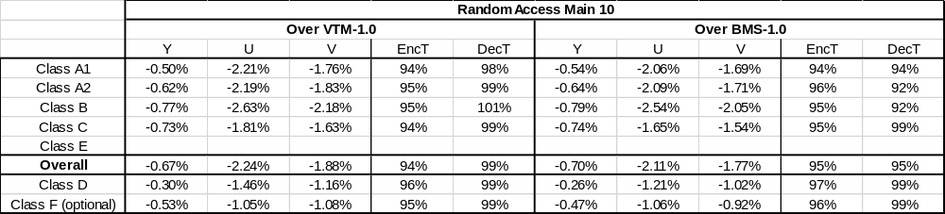

Conclusions
This contribution proposes to extend the QP value range to the maximum value equal to 57 from 51. Experimental results show the proposed modification can improve compression efficiency for coding video sequences in the RA setting using a hierarchical GOP structure.

Patent rights declaration(s)
MediaTek Inc. may have current or pending patent rights relating to the technology described in this contribution and, conditioned on reciprocity, is prepared to grant licenses under reasonable and non-discriminatory terms as necessary for implementation of the resulting ITU-T Recommendation | ISO/IEC International Standard (per box 2 of the ITU-T/ITU-R/ISO/IEC patent statement and licensing declaration form).

References
- The software VTM-1.0: https://jvet.hhi.fraunhofer.de/svn/svn_VVCSoftware_VTM/tags/VTM-1.0/.
- A. Segall, V. Baroncini, J. Boyce, J. Chen, T. Suzuki (editors) “Joint Call for Proposals on Video Compression with Capability beyond HEVC,” Document of Joint Video Experts Team of ITU-T SG16 WP3 and ISO/IEC JTC1/SC29/WG11, JVET-H1002, 8th Meeting: Macao, CN, 18–24 Oct.2017.
- C.-W. Hsu, et al, “Description of SDR video coding technology proposal by MediaTek,” Document of Joint Video Experts Team of ITU-T SG16 WP3 and ISO/IEC JTC1/SC29/WG11, JVET-J0018, 10th Meeting: San Diego, US, 10–20 Apr. 2018.
- The software BMS-1.0: https://jvet.hhi.fraunhofer.de/svn/svn_VVCSoftware_BMS/tags/BMS-1.0/.
- J. Boyce, K. Suehring, X. Li, and V. Seregin, “JVET common test conditions and software reference configurations,” Document of Joint Video Experts Team of ITU-T SG16 WP3 and ISO/IEC JTC1/SC29/WG11, JVET-J1010, 10th Meeting: San Diego, US, 10–20 Apr. 2018.
- H. Schwarz, M. Coban, “Description of Core Experiment 7 (CE7): Quantization and coefficient coding,” Document of Joint Video Experts Team of ITU-T SG16 WP3 and ISO/IEC JTC1/SC29/WG11, JVET-J1027, 10th Meeting: San Diego, US, 10–20 Apr. 2018.

