    Joint Video Experts Team (JVET)  of ITU-T SG 16 WP 3 and ISO/IEC JTC 1/SC 29/WG 11  11th Meeting: Ljubljana, SI, 10–18 July 2018 | Document: JVET-K0237-v1

Title: | CE2-related: Bugfix for deblocking at maximum transform block boundaries
Status: | Input Documents to JVET
Purpose: | Proposal
Author(s) or  Contact(s): | Chia-Ming Tsai, Chih-Wei Hsu,  Yu-Wen Huang, Shaw-Min Lei  No. 1, Dusing 1st Rd.,  Hsinchu City 30078, Taiwan | Tel:  Email: | +886-3-5670766  {chia-ming.tsai, cw.hsu, yuwen.huang, shawmin.lei}  @mediatek.com
Source: | MediaTek Inc.
_____________________________

Abstract
In this contribution, a bugfix is proposed for deblocking at transform block (TB) boundaries. In VTM-1.0 and BMS-1.0, each coding blocks (CB) larger than maximum TB is inferred to be further partitioned into multiple TBs by tiling with the maximum TBs, while each CB smaller than or equal to maximum TB has only one TB. However, deblocking is only performed at CB boundaries and always skipped at maximum TB boundaries that do not coincide with any CB boundaries. It is proposed to apply deblocking to maximum TB boundaries that do not coincide with any CB boundaries.

Introduction
Figure 1 shows an example. Blocky artifacts are visible at maximum TB boundaries that do not coincide with any CB boundaries, where in this case the maximum TB is 64x64.

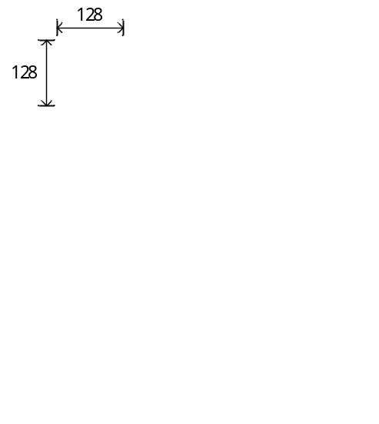
Figure 1. The 3rd decoded picture of FoodMarket4 sequence, BMS-1.0-RA, QP=37

Proposed method
We propose to apply deblocking to maximum TB boundaries that do not coincide with any CB boundaries, as a bugfix to the current deblocking design.

Experimental results

Objective results
The proposed deblocking bugfix has been implemented on BMS-1.0 [1]. The simulations were performed following the JVET common test conditions [2]. Objective results are shown in Table 1. There are almost no impacts on BD-rate, encoding time, and decoding time.

Table 1. Objective results of the proposed deblocking bugfix
 | All Intra Main10
 | Over VTM-1.0 |  |  |  |  | Over BMS-1.0
 | Y | U | V | EncT | DecT | Y | U | V | EncT | DecT
Class A1 | 0.00% | 0.00% | 0.00% | 100% | 100% | 0.00% | 0.00% | 0.00% | 100% | 99%
Class A2 | 0.00% | 0.00% | 0.00% | 101% | 100% | 0.00% | 0.00% | 0.00% | 100% | 104%
Class B | 0.00% | 0.00% | 0.00% | 100% | 100% | 0.00% | 0.00% | 0.00% | 100% | 100%
Class C | 0.00% | 0.00% | 0.00% | 100% | 101% | 0.00% | 0.00% | 0.00% | 99% | 100%
Class E | 0.00% | 0.00% | 0.00% | 100% | 100% | 0.00% | 0.00% | 0.00% | 100% | 100%
Overall | 0.00% | 0.00% | 0.00% | 100% | 100% | 0.00% | 0.00% | 0.00% | 100% | 101%
Class D | 0.00% | 0.00% | 0.00% | 101% | 100% | 0.00% | 0.00% | 0.00% | 100% | 101%
Class F (optional) | 0.00% | 0.00% | 0.00% | 101% | 100% | 0.00% | 0.00% | 0.00% | 100% | 100%
 | Random Access Main 10
 | Over VTM-1.0 |  |  |  |  | Over BMS-1.0
 | Y | U | V | EncT | DecT | Y | U | V | EncT | DecT
Class A1 | -0.10% | -0.04% | -0.01% | 100% | 100% | -0.06% | -0.09% | 0.02% | 99% | 99%
Class A2 | -0.02% | 0.00% | -0.02% | 100% | 100% | 0.01% | -0.01% | 0.01% | 100% | 100%
Class B | 0.01% | 0.02% | 0.00% | 100% | 100% | -0.01% | -0.03% | -0.04% | 100% | 100%
Class C | 0.00% | -0.04% | -0.01% | 100% | 101% | 0.02% | -0.06% | -0.07% | 100% | 99%
Class E
Overall | -0.02% | -0.01% | -0.01% | 100% | 100% | -0.01% | -0.04% | -0.03% | 100% | 100%
Class D | 0.00% | 0.00% | 0.00% | 101% | 100% | 0.00% | 0.00% | 0.00% | 100% | 100%
Class F (optional) | 0.00% | -0.01% | 0.01% | 100% | 100% | 0.01% | 0.02% | -0.01% | 100% | 100%
 | Low delay B Main10
 | Over VTM-1.0 |  |  |  |  | Over BMS-1.0
 | Y | U | V | EncT | DecT | Y | U | V | EncT | DecT
Class A1
Class A2
Class B | -0.01% | 0.05% | 0.02% | 100% | 100% | -0.02% | -0.29% | 0.08% | 100% | 99%
Class C | 0.01% | 0.12% | 0.14% | 100% | 99% | 0.00% | 0.04% | 0.05% | 100% | 100%
Class E | -0.01% | 0.00% | 0.01% | 100% | 99% | -0.15% | -0.25% | -0.64% | 100% | 100%
Overall | 0.00% | 0.06% | 0.06% | 100% | 100% | -0.04% | -0.17% | -0.11% | 100% | 100%
Class D | 0.01% | 0.01% | 0.43% | 101% | 99% | -0.01% | 0.07% | -0.11% | 101% | 100%
Class F (optional) | -0.02% | -0.15% | 0.04% | 100% | 100% | -0.01% | -0.11% | 0.22% | 100% | 100%

Subjective results
Figure 2 shows an example of subjective comparison. It is observed that the proposed deblocking bugfix can reduce blocky artifacts at maximum TB boundaries that do not coincide with any CB boundaries.

Conclusion
This contribution proposes to apply deblocking to maximum TB boundaries that do not coincide with any CB boundaries, as a bugfix to the current deblocking design. The BD-rate, encoding time, and decoding time changes are negligible. The blocky artifacts at maximum TB boundaries that do not coincide with any CB boundaries are reduced.

References
- BMS-1.0: https://jvet.hhi.fraunhofer.de/svn/svn_VVCSoftware_BMS/tags/BMS-1.0
- J. Boyce, K. Suehring, X. Li, V. Seregin, “JVET common test conditions and software reference configurations,” Document of Joint Experts Team, JVET-J1010.

Patent rights declaration(s)
MediaTek Inc. does not have any current or pending patent rights relating to the technology described in this contribution.


(a)

(b)
Figure 2. The 3rd decoded picture of FoodMarket4, RA, QP=37; (a) BMS-1.0 (b) BMS-1.0 with the proposed deblocking bugfix

