    Joint Video Experts Team (JVET)  of ITU-T SG 16 WP 3 and ISO/IEC JTC 1/SC 29/WG 11  11th Meeting: Ljubljana, SI, 10–18 July 2018 | Document: JVET-K0215-v1

Title: | CE2: Alf with Multiplication Replaced by Bit-Shifting (Test 4.1.3)
Status: | Input document to JVET
Purpose: | Proposal
Author(s) or  Contact(s): | Semih Esenlik, Zhijie Zhao, Jianle Chen | Tel:  Email: | semih.esenlik@huawei.com  Jianle.chen@huawei.com
Source: | Huawei Technologies Co.,Ltd.

Abstract
Two modifications have been proposed with respect to the GALF in the BMS. First one is disabling predefined fixed filter predictors, and second one is using logarithmic quantization (in base 2) to represent the outlying filter coefficients in such a way that multiplication operation is replaced by bit-shifting. The proposed method reportedly allows simplified hardware implementations due to the fact that 14 of the 21 multiplication operations in the filtering operation of a pixel sample is replaced by simple bit-shift operations. Experimental results of the combined method are as follows:
Over VTM Anchor (AI, RA, LDB): -3.04%, -5.15%, -4.52% luma coding gain with 102%, 107%, 112% encoding time and 149%, 176%, 154% decoding time.
Over BMS Anchor (AI, RA, LDB): 0.25%, 0.24%, -0.06% luma coding gain with 100%, 100%, 100% encoding time and 100%, 101%, 100% decoding time.

Introduction
The proposed method was first introduced in the Huawei’s CfP response [1], and is evaluated as part of the CE2. The method addresses simplification of the GALF in the BMS, which is considered to be complicated with respect to software and hardware implementations.

Background
In current BMS the GALF employs 400 9x9 predefined fixed filters in order to reduce the signaling overhead of the filter coefficients. It is reported that disabling the usage of predefined fixed filters in the BMS results in 0.19% and 0.18% luma coding loss in AI and RA configurations respectively with -0.08% luma coding gain in LDB configuration.
The 400 predefined fixed filters require considerable amount of ROM space and additional filter estimation processes are necessary in the encoder in order to utilize them.
Secondly GALF in the current BMS1.0 supports multiple filter kernels with a support region of 9x9. The number of multiplication operations in order to filter one pixel sample is 21, which is also considered an important hardware design restriction.

Proposed Method
The proposed method consist of 2 aspects. Firstly the predefined fixed filter predictors are disabled completely, as it is believed that the provided benefit does not justify the necessary implementation costs. It should be further noted that description of the 400 predefined filters, each of which having 21 filter coefficients, would result in 8 pages of text in the draft specification.
According to the proposed method, the predefined fixed filter predictors are disabled completely as a first step.
Secondly the filter coefficients used in filtering of the luma component are divided into 2 groups. The first group contains that coefficients {C1, C2, C3, C4, C5, C6, C8, C9, C10, C11, C15, C16, C17, C18}, and the second group contains the rest of the coefficients {C7, C12, C13, C14, C19, C20, C21}. The first group coefficients are normatively restricted to use only the following set of values: {–64, –32, –16, –8, –4, 0, 4, 8, 16, 32, 64}, which corresponds to logarithmic (in base 2) quantization of filter coefficients. Hence multiplication with those coefficients can be implemented as a single bit shit operation. The allowed filter coefficient values are mapped to {–5, –4, –3, –2, –1, 0, 1, 2, 3, 4, 5} respectively before binarization in order to reduce the signaling overhead.
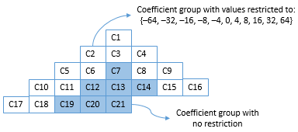
Figure x: Filter coefficients of 9x9 filter kernel according to proposal
It is reported that the proposed logarithmic quantization of the filter coefficients allow for hardware implementations that require much less logic gates, as 10-bit multiplication operation is replaced by simple bit-shifting.

Experimental Results
The table below shows the coding gain and processing time impact of proposal, which is the combination of (1) disabling fixed filter predictors and (2) replacing multiplication replaced by bit shifting.
- VTM simulations
  - Anchor: VTM
  - Test: Anchor with Proposal
- BMS simulations
  - Anchor: BMS
  - Test: Anchor with Proposal

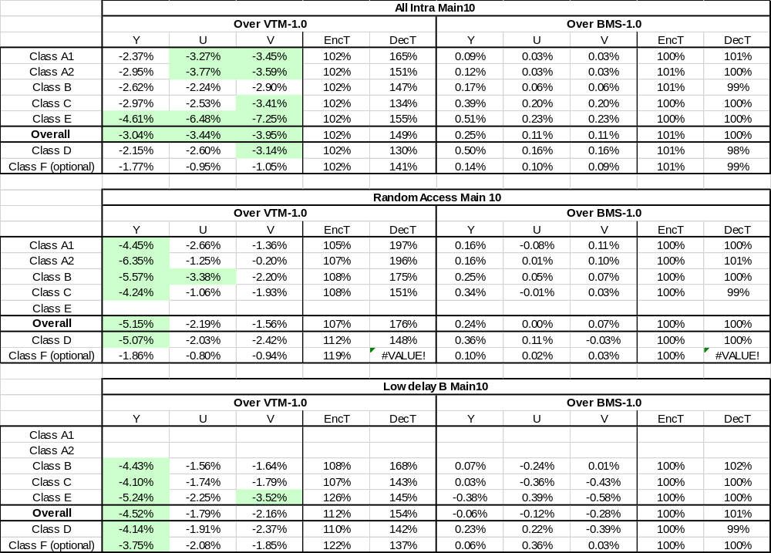

Additional Results for Disabling Fixed Filter Predictors
The table below shows the coding gain impact of disabling the fixed filter predictors of GALF completely.
- VTM simulations
  - Anchor: VTM + GALF
  - Test: Anchor with fixed filter predictors disabled.
- BMS simulations
  - Anchor: BMS
  - Test: Anchor with fixed filter predictors disabled.

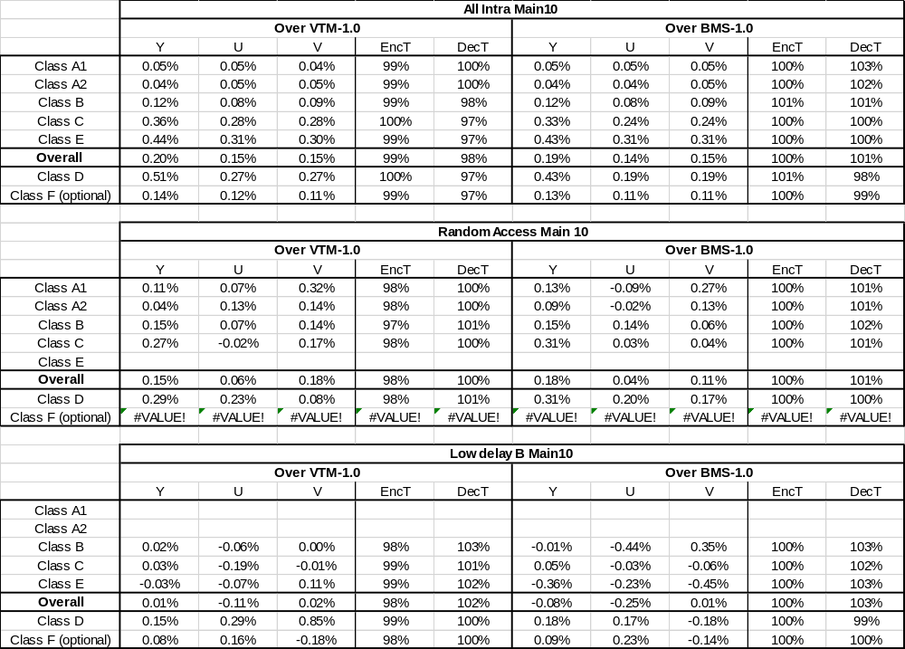
Table x: The coding loss associated with disabling fixed filter predictors completely.

Additional Results for Replacing Multiplication with Bit-Shifting
The table below shows the coding gain impact of replacing multiplication with bit-shifting.
- VTM simulations
  - Anchor: VTM+GALF with fixed filter predictors disabled.
  - Test: Anchor + Multiplication replaced by bit-shifting
- BMS simulations
  - Anchor: BMS with fixed filter predictors disabled.
  - Test: Anchor + Multiplication replaced by bit-shifting

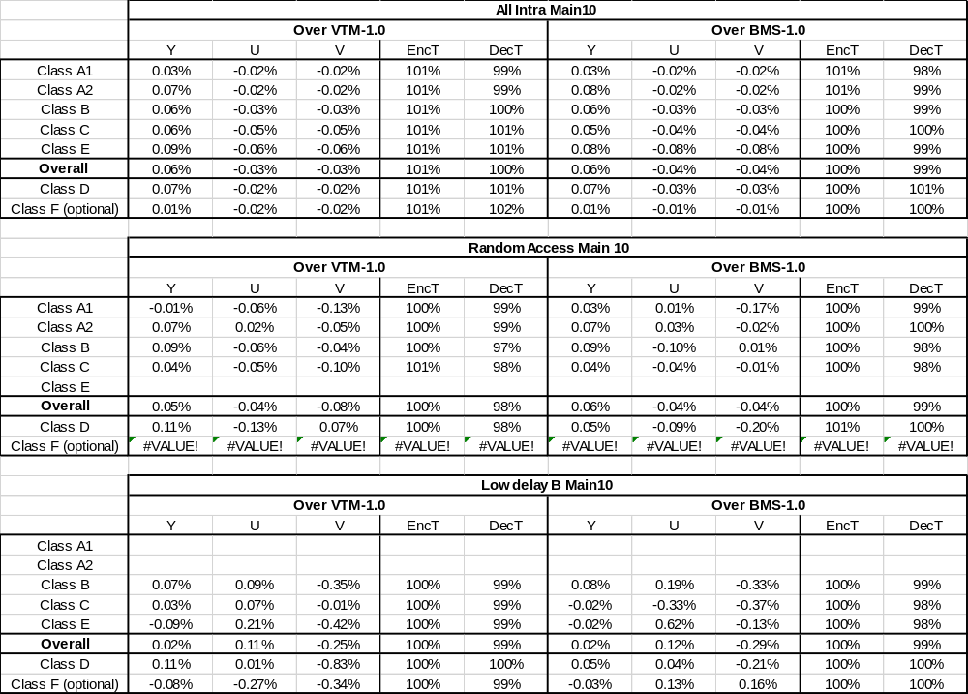
Table x: The coding loss associated with replacing multiplication with bit-shifting.
The detailed simulation results are uploaded in the svn repository under:
https://jvet.hhi.fraunhofer.de/svn/svn_VVCSoftware_BMS/branches/CE/J_SanDiego/CE2/CE2-4.1.3/results/

Conclusion
Two modifications have been proposed with respect to the GALF in the BMS. (1) Disabling prediction from fixed filters, and (2) using logarithmic quantization to represent the outlying filter coefficients in such a way that multiplication operation is replaced by bit-shifting. Reportedly the hardware implementations are simplified due to the fact that 14 of the 21 multiplication operations in the filtering is replaced by simple bit-shift operations. Over BMS Anchor 0.25% and 0.24% coding loss is observed in AI and RA configurations, whereas -0.06% coding gain is observed for LDB case. The combined method is proposed to be adopted in BMS.

Reference
[1] “Description of SDR, HDR and 360° video coding technology proposal by Samsung, Huawei, GoPro, and HiSilicon – mobile application scenario”, A. Alshin et. al., doc. JVET-J0024, April2018.
[2] “Versatile Video Coding (Draft 1)”, B. Bross, doc. JVET-J1001, April 2018
[3] “Description of Core Experiment 2 (CE2): In-Loop Filters”, L. Zhang, K. Andersson, C.-Y. Chen, doc. JVET-J1022, April 2018

Patent rights declaration(s)
Huawei Technologies Co.,Ltd. may have current or pending patent rights relating to the technology described in this contribution and, conditioned on reciprocity, is prepared to grant licenses under reasonable and non-discriminatory terms as necessary for implementation of the resulting ITU-T Recommendation | ISO/IEC International Standard (per box 2 of the ITU-T/ITU-R/ISO/IEC patent statement and licensing declaration form).

