    Joint Video Experts Team (JVET)  of ITU-T SG 16 WP 3 and ISO/IEC JTC 1/SC 29/WG 11  11th Meeting: Ljubljana, SI, 10–18 July 2018 | Document: JVET-K0174-v1

Title: | CE6: NSST with modified NSST sets and signaling (Test2.3)
Status: | Input document to JVET
Purpose: | Proposal
Author(s) or  Contact(s): | Kiho Choi,  Minsoo Park,  Chanyul Kim  Seongchon-gil 34, Seocho-gu, Seoul, 06765 Korea | Tel:  Email: | kiho14.choi@samsung.com  mss.park@samsung.com  dionism@samsung.com
Source: | Samsung Electronics Ltd.
_____________________________

Abstract
This contribution presents a technology described in CE 6.2.3 that is NSST with modified sets and signaling. The proposed method uses the following four parts: 1) reduced angle sets in total as half of that in NSST, 2) new angles sets considering four modes, 3) additional on/off flag to indicate NSST usage, and 4) enabling NSST 8x8 in BMS. Testing results on the proposed method show 5.4%, 2.6%, and 1.0% BD rate savings on average for All Intra (AI), Random Access (RA), and Low Delayed B (LDB) configurations, respectively, compared to VTM1.1, and 1.2%, 0.6%, and 0.3% BD rate savings on average for AI, RA, and LDB configurations, respectively, compared to BMS1.1.

Introduction

Non-separable secondary transform in JEM

Non-separable secondary transforms
In the JEM, a mode-dependent non-separable secondary transform (MDNSST) is applied between the forward core transform and quantization (at the encoder) and between the de-quantization and inverse core transform (at the decoder)[1]. To keep low complexity, MDNSST is only applied to the low frequency coefficients after the primary transform. If both width (W) and height (H) of a transform coefficient block is larger than or equal to 8, then 8×8 non-separable secondary transform is applied to the top-left 8×8 region of the transform coefficients block. Otherwise, if either W or H of a transform coefficient block is equal to 4, a 4×4 non-separable secondary transform is applied and the 4×4 non-separable transform is performed on the top-left min(8,W)×min(8,H) region of the transform coefficient block. The above transform selection rule is applied for both luma and chroma components.
Matrix multiplication implementation of a non-separable transform is described as follows using a 4×4 input block as an example. To apply the non-separable transform, the 4×4 input block X
$X=\left[\begin{matrix}\begin{matrix}X_{00} & X_{01} \\ X_{10} & X_{11}\end{matrix} & \begin{matrix}X_{02} & X_{03} \\ X_{12} & X_{13}\end{matrix} \\ \begin{matrix}X_{20} & X_{21} \\ X_{30} & X_{31}\end{matrix} & \begin{matrix}X_{22} & X_{23} \\ X_{32} & X_{33}\end{matrix}\end{matrix}\right]$ (1)
is represented as a vector :
(2)
The non-separable transform is calculated as , where indicates the transform coefficient vector, and T is a 16×16 transform matrix. The 16×1 coefficient vector is subsequently re-organized as 4×4 block using the scanning order for that block (horizontal, vertical or diagonal). The coefficients with smaller index will be placed with the smaller scanning index in the 4×4 coefficient block. In the JEM, a Hypercube-Givens Transform (HyGT) with butterfly implementation is used instead of matrix multiplication to reduce the complexity of non-separable transform.

Mode dependent transform core selection
There are totally 35×3 non-separable secondary transforms for both 4×4 and 8×8 block size, where 35 is the number of transform sets specified by the intra prediction mode, denoted as set, and 3 is the number of NSST candidate for each intra prediction mode. The mapping from the intra prediction mode to the transform set is defined in Table 1. The transform set applied to luma/chroma transform coefficients is specified by the corresponding luma/chroma intra prediction modes, according to Table 1. For intra prediction modes larger than 34 (diagonal prediction direction), the transform coefficient block is transposed before/after the secondary transform at the encoder/decoder.

Table 1: Mapping from intra prediction mode to transform set index
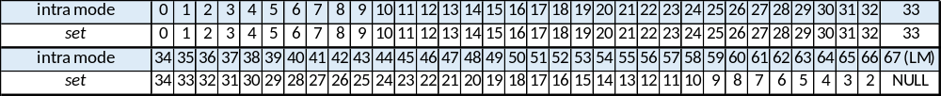

For each transform set, the selected non-separable secondary transform candidate is further specified by the explicitly signalled CU-level NSST index. The index is signalled in a bitstream once per intra CU after transform coefficients and truncated unary binarization is used. The truncated value is 2 in case of planar or DC mode, and 3 for angular intra prediction mode. This NSST index is signalled only when there is more than one non-zero coefficient in a CU. The default value is zero when it is not signalled. Zero value of this syntax element indicates secondary transform is not applied to the current CU, values 1-3 indicates which secondary transform from the set should be applied.

Non-separable transform based on HyGT
A Hypercube-Givens Transform (HyGT) is used in the computation of the non-separable secondary transform. The basic elements of this orthogonal transform are Givens rotations, which are defined by orthogonal matrices G(m, n, θ), which have elements defined by
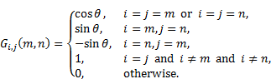 (3)
These transformations can be graphically represented as in Figure 1.
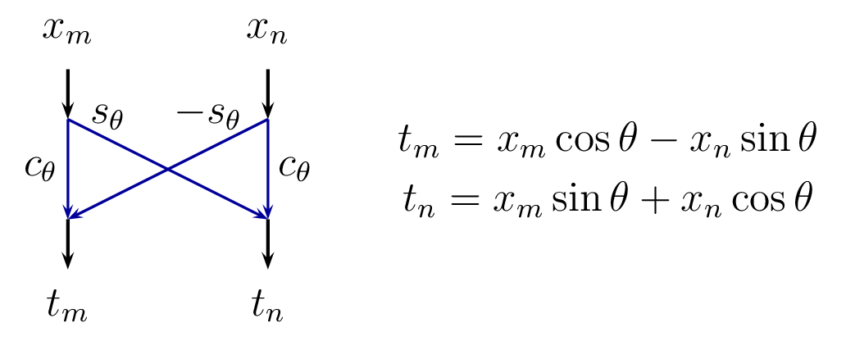
Figure 1: Graphical representation of Givens rotations
HyGT is implemented by combining sets of Givens rotations in a hypercube arrangement. Figure 2 shows the the “butterfly” shape flowchart of HyGT for 16 elements (4×4 non-separable transform). Assuming that N is a power of two, a HyGT round is defined as a sequence of log2(N) passes, where in each pass, the indexes in vectors m and n are defined by edges of a hypercube with dimension log2(N), sequentially in each direction.

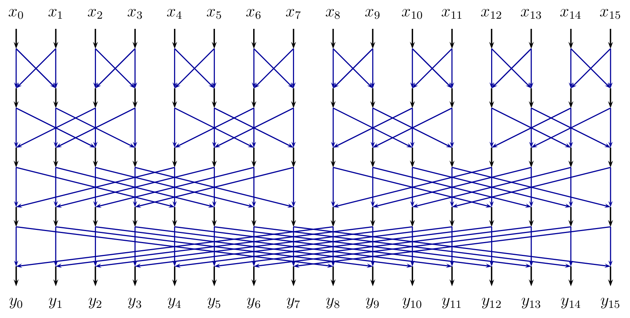
Figure 2: HyGT is defined by combinations of Givens rotations in a hypercube arrangement
To obtain good compression, more than one HyGT round are used. As shown in Figure 3, a full non-separable secondary transform is composed of R rounds HyGT, and may include an optional permutation pass, to sort transform coefficients according to their variance. In the JEM, 2-round HyGT is applied for 4×4 secondary transform and 4-round HyGT is applied for 8×8 secondary transform.
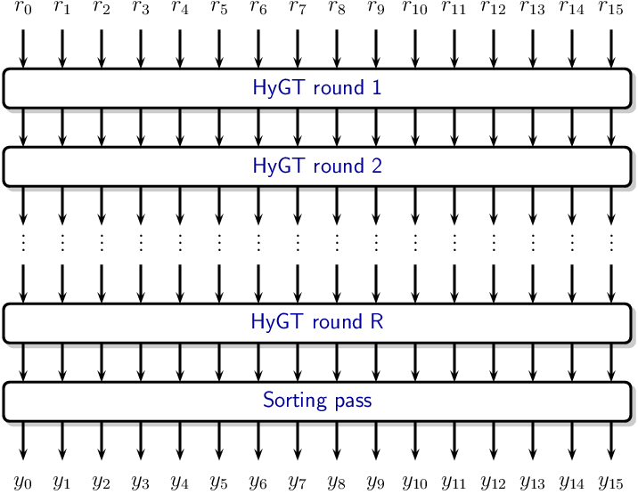
Figure 3: HyGT is defined by combinations of Givens rotations in a hypercube arrangement

NSST in BMS
NSST is only applied to the low frequency coefficients in the areas of upper 4x4 pixels after the primary transform in BMS [2]. Except the fact that BMS is not to use an 8x8 NSST, the others are same to that in JEM.

Proposed method
The proposed method in this contribution was introduced in CfP response of JVET-J0024 [3]. Main difference between NSST in BMS and the proposed method is the following four parts: 1) reduced angle sets in total as half of that in NSST, 2) new angles sets considering four modes, 3) additional on/off flag to indicate NSST usage, and 4) enabling NSST 8x8 in BMS.
NSST in BMS is using totally 35×3 non-separable secondary transforms for 4×4block size, where 35 is the number of transform sets specified by the intra prediction mode, denoted as set, and 3 is the number of NSST candidate for each intra prediction mode.
In the proposed method, NSST is using totally 12x4 non-separable secondary transforms. The total number of non-separable secondary transforms and modes to be evaluated in a block are different from those in BMS. Candidates to be tested in a block are four where 12 is the number of transform sets specified by the intra prediction mode, denoted as set, and 4 is the number of NSST candidate for each intra prediction mode. Table 2 shows grouping of intra prediction for candidates of NSST where intra65 is en/disabled.

Table 2: Mapping from intra prediction mode to transform set index in the proposed method
Grouped id | Intra prediction index  where intra65 enabled | Intra prediction index  where intra65 disabled
0 | 0, 1 | 0, 1
1 | 2, 4, 6, 62, 64, 66 | 2, 3, 33, 34
2 | 3, 5, 7, 61, 63, 65 | 4, 5, 31, 32
3 | 8, 10, 12, 56, 58, 60 | 6, 30
4 | 9, 11, 13, 55, 57, 59 | 7, 29
5 | 14, 15, 16, 52, 53, 54 | 8, 9, 27, 28
6 | 17, 18, 19, 49, 50, 51 | 10, 26
7 | 20, 21, 22, 46, 47, 48 | 11, 12, 24, 25
8 | 23, 25, 27, 41, 43, 45 | 13, 23
9 | 24, 26, 28, 40, 42, 44 | 14, 22
10 | 29, 31, 33, 35, 37, 39 | 15, 16, 20, 21
11 | 30, 32, 34, 36, 38 | 17, 18, 19

In order to support four modes in the proposed NSST, a flag for on/off is added and mode flag are used to indicate which mode should be applied. The mode flag is represented with two bits, then those bits are encoded with CABAC coding.
Compared to BMS in NSST, the proposed method uses reduced look-up table for NSST sets about half of NSST storage. But, to evaluate additional mode in the given sets, one RDO loop is additionally needed.

Test result
Test conditions follows the description in CE6 document [4]. BMS SW was used for these experiments, as specified in JVET-J1010 [5].

Test result compared to anchor
Table 3 shows test results on CE 6.2.3 compared to anchors of VTM and BMS.
Table 3: Test results on CE 6.2.3
 | All Intra Main10
 | Over VTM-1.1 |  |  |  |  | Over BMS-1.1
 | Y | U | V | EncT | DecT | Y | U | V | EncT | DecT
Class A1 | -5.9% | -6.8% | -7.9% | 320% | 113% | -1.7% | -0.7% | -0.6% | 126% | 101%
Class A2 | -4.3% | -4.6% | -4.7% | 337% | 115% | -0.9% | 0.0% | 0.3% | 126% | 101%
Class B | -4.8% | -4.9% | -4.4% | 336% | 111% | -0.9% | -0.3% | -0.2% | 128% | 101%
Class C | -5.9% | -4.3% | -4.9% | 358% | 107% | -1.2% | -0.6% | -0.4% | 132% | 101%
Class E | -6.5% | -4.8% | -4.8% | 298% | 106% | -1.2% | -0.5% | -0.1% | 125% | 100%
Overall | -5.4% | -5.0% | -5.2% | 331% | 110% | -1.2% | -0.4% | -0.2% | 128% | 101%
Class D | -5.3% | -3.7% | -3.9% | 386% | 110% | -0.8% | -0.5% | -0.2% | 134% | 102%
Class F (optional) | -3.8% | -2.8% | -3.1% | 308% | 105% | -0.8% | -0.6% | -0.7% | 130% | 103%
 | Random Access Main 10
 | Over VTM-1.1 |  |  |  |  | Over BMS-1.1
 | Y | U | V | EncT | DecT | Y | U | V | EncT | DecT
Class A1 | -3.0% | -5.6% | -6.7% | 150% | 106% | -0.7% | -0.5% | -0.7% | 119% | 101%
Class A2 | -1.8% | -2.4% | -2.6% | 137% | 103% | -0.4% | 0.2% | 0.1% | 117% | 101%
Class B | -2.7% | -4.3% | -3.9% | 145% | 103% | -0.6% | -0.3% | -0.2% | 120% | 101%
Class C | -3.0% | -2.9% | -3.2% | 151% | 103% | -0.7% | -0.5% | -0.4% | 121% | 101%
Overall | -2.6% | -3.8% | -4.0% | 146% | 104% | -0.6% | -0.3% | -0.3% | 119% | 101%
Class D | -2.3% | -2.1% | -2.8% | 157% | 103% | -0.4% | -0.4% | -0.7% | 122% | 100%
Class F (optional) | -2.4% | -1.9% | -1.9% | 169% | 102% | -0.4% | -0.3% | -0.2% | 123% | 101%
 | Low delay B Main10
 | Over VTM-1.1 |  |  |  |  | Over BMS-1.1
 | Y | U | V | EncT | DecT | Y | U | V | EncT | DecT
Class B | -0.9% | -1.7% | -1.3% | 127% | 102% | -0.2% | -0.3% | -0.2% | 111% | 101%
Class C | -0.9% | -1.3% | -1.5% | 124% | 100% | -0.3% | -0.4% | -0.4% | 111% | 100%
Class E | -1.4% | -1.1% | -1.7% | 109% | 101% | -0.4% | -0.5% | 0.4% | 104% | 101%
Overall | -1.0% | -1.4% | -1.5% | 121% | 101% | -0.3% | -0.4% | -0.1% | 109% | 101%
Class D | -0.6% | -1.0% | -1.0% | 118% | 100% | -0.1% | -0.6% | -0.3% | 109% | 101%
Class F (optional) | -0.9% | -1.3% | -1.3% | 132% | 106% | -0.3% | 0.0% | -0.7% | 113% | 101%

VTM test result
For testing proposed method on VTM, VTM configuration files were used with BMS 1.1 software, and results are shown in Table 3. The average BD-rate gains for AI, RA, and LDB are 5.4%, 2.6%, and 1.0%, respectively.

BMS test result
For testing proposed method on BMS, BMS configuration files were used with BMS 1.1 software, and results are shown in Table 3. The average BD-rate gains for AI, RA, and LDB are 1.2%, 0.6%, and 0.3%, respectively.

Additional test result with AMT enabled
According to recommendation of CE6, results using AMT enabled are provided as supplemental information.
Table 5. Test results on CE 6.2.3 where NSST enabled
 |  | All Intra Main10
 |  | Over VTM-1.1 with AMT
 |  | Y | U | V | EncT | DecT
Class A1 |  | -3.8% | -6.2% | -7.3% | 385% | 95%
Class A2 |  | -2.7% | -3.8% | -3.8% | 397% | 102%
Class B |  | -3.0% | -4.2% | -4.2% | 438% | 100%
Class C |  | -4.2% | -3.7% | -4.3% | 482% | 102%
Class E |  | -4.0% | -3.8% | -3.8% | 423% | 98%
Overall |  | -3.5% | -4.3% | -4.6% | 428% | 100%
Class D |  | -3.8% | -3.2% | -3.4% | 437% | 103%
Class F (optional) |  | -2.9% | -2.5% | -2.7% | 425% | 99%
 |  | Random Access Main 10
 |  | Over VTM-1.1 with AMT
 |  | Y | U | V | EncT | DecT
Class A1 |  | -2.0% | -5.7% | -6.5% | 213% | 95%
Class A2 |  | -1.2% | -2.7% | -2.5% | 200% | 97%
Class B |  | -1.7% | -4.2% | -3.7% | 199% | 95%
Class C |  | -2.2% | -2.7% | -3.1% | 171% | 92%
Overall |  | -1.8% | -3.8% | -3.9% | 194% | 95%
Class D |  | -1.6% | -2.6% | -2.7% | 169% | 89%
Class F (optional) |  | -1.7% | -1.6% | -1.5% | 169% | 88%

Experimental results with AMT enabled (VTM configuration, NSST enabled)
For testing proposed method on VTM with AMT enabled, VTM configuration files were used with BMS 1.1 software, and results are shown in Table 5. The average BD-rate gains for AI and RA are 3.5% and 1.8%, respectively.

Conclusion
This contribution presents a technology described in CE 6.2.3 that is NSST with modified sets and signaling. Main difference between NSST in BMS and the proposed method is the following four parts: 1) reduced angle sets in total as half of that in NSST, 2) new angles sets considering four modes, 3) additional on/off flag to indicate NSST usage, and 4) enabling NSST 8x8 in BMS. Testing results described in the CE documents are provided in this contribution. The benefit of using the proposed method comparing to NSST in BMS is that the proposed method uses only half of NSST sets while preserving coding performance. It is recommend to adopt the proposed method into the next version of test model of VVC.

Reference
[1] J. Chen, E. Alshina, G. J. Sullivan, J.-R. Ohm, J. Boyce, “Algorithm description of Joint Exploration Test Model 7 (JEM7)”, JVET-G1001, Torino, IT, 13–21 July 2017
[2] J. Boyce, “BoG report on Benchmark Set tool selection”, JVET-J0096, San Diego, US, 10–20 Apr. 2018
[3] A. Alshin et al, “Description of SDR, HDR and 360° video coding technology proposal by Samsung, Huawei, GoPro, and HiSilicon – mobile application scenario”, JVET-J0024, San Diego, US, 10–20 Apr. 2018
[4] A. Said, X. Zhao, “Description of Core Experiment 6 (CE6): Transforms and transform signalling”, JVET-1026, San Diego, US, 10–20 Apr. 2018
[5] J. Boyce, K. Suehring, X. Li, V. Seregin, “JVET common test conditions and software reference configurations”, JVET-1010, San Diego, US, 10–20 Apr. 2018

Patent rights declaration(s)
Samsung Electronics Co., Ltd. may have current or pending patent rights relating to the technology described in this contribution and, conditioned on reciprocity, is prepared to grant licenses under reasonable and non-discriminatory terms as necessary for implementation of the resulting ITU-T Recommendation | ISO/IEC International Standard.

