Joint Video Experts Team (JVET)  of ITU-T SG 16 WP 3 and ISO/IEC JTC 1/SC 29/WG 11  11th Meeting: Ljubljana, SI, 10–18 July 2018 | Document: JVET-K0153-v1

Title: | CE2.3.5 CTU adaptive sample adaptive offset
Status: | Input document to JVET
Purpose: | Proposal
Author(s) or  Contact(s): | Tomohiro Ikai | Tel:  Email: | ikai.tomohiro@sharp.co.jp
Source: | Sharp Corporation
_____________________________

Abstract
The contribution proposes a CTU band offset technique, which extends HEVC SAO band offset. The proposed method reportedly show 0.06 %, 0.92 %, and 0.95 % bd-rate gain on Y, Cb, and Cr on average in VTM RA configuration and 0.15 %, 1.52 %, and 2.03 % bd-rate gain on Y, Cb, and Cr on average in VTM LB configuration respectively. It is recommended to adopt this technique in the next VTM software.

Introduction
The range of image value is limited in many areas, which especially is the case in U, V component. However the band offset in HEVC doesn’t care about that range varieties and divides whole target image by constant 32 bands, which result in two problems.
- band granularity is too coarse
- many band position can be not used
The proposal address the above problems by introducing CTU level adaptivity which utilizes min value and max value of each CTU in each component.

 | HEVC | Proposal
Number of signaled position  (signaled bits for that position) | 32  (5 bits) | 16  (4 bits)
min value of band range | 0 | min value of CTU
max value of band range | (1<< bitDepth) – 1 | max value of CTU (roughly)
band interval | 32  (constant interval) | 4, 8, 16, 32, 64  (variable interval)
shifted position (dblOffset) | No | Yes
Note: The min, max, band interval and shifted position is decided in decoder side algorithm (thus these variable is not signalled) in proposal, while in HEVC these variables are all constant.

CTU adaptive band offset
The proposed CTU adaptive band offset is an extension of HEVC band offset, and it adds offset value based on signaled band position and four continuous offset values. The differences are:
- The band position is adjusted based on min value of the target CTU in addition to signaled band position
- The band interval is chosen based on CTU pixel range (i.e. max-min)
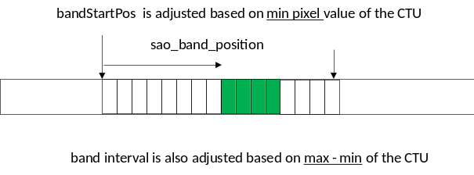
Figure: Illustration of band position adjustment and band interval selection

Detailed Step for proposal
Step1: Check min and max value in CTU (minCTU and maxCTU)

It is noted that 4 pixels in the right and bottom position in CTU is not used considering that part will be processed by deblocking filter.

Step2: Search appropriate band interval (choose addShift, which ranges from 0 to 4)
“addShift” = 4 means that the band interval is 1024 >> (4 + 4) = 4
“addShift” = 3, 2, 1, 0 means that the band interval is 8, 16, 32, 64 respectively
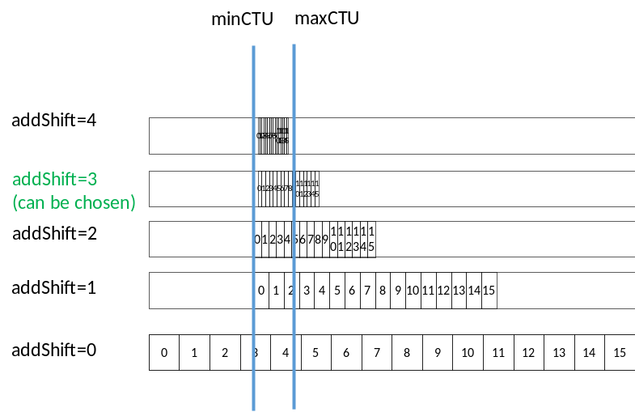
Step 3: check whether shifted position (dblOffset) is used for not.
If the max value (maxbandIdx) is less than 15, there would be the non-used band. We use re-use these band as shifted band position.
In shifted band posision case, the min position is shifted by 0.5 band offset range. In the following figure, band 10 indicates between band 0 and band1.
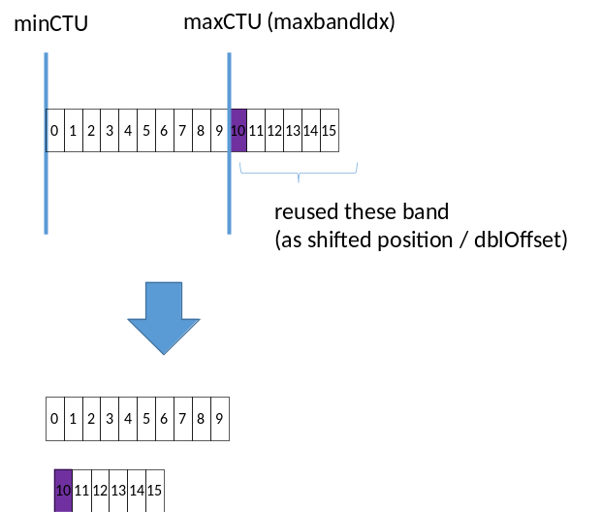
It is noted this feature is only enabled if maxbandIdx < 10.

Step 4: derive bandIdx based on pixel value (in essence same as HEVC)

Text (compare to HEVC text)

- Otherwise (SaoTypeIdx[ cIdx ][ rx ][ ry ] is equal to 1), the following ordered steps apply:
- The variable bandShift is set equal to bitDepth − 5.
- The variable saoLeftClass is set equal to sao_band_position[ cIdx ][ rx ][ ry ].
- The list bandTable is defined with 32 elements and all elements are initially set equal to 0. Then, four of its elements (indicating the starting position of bands for explicit offsets) are modified as follows:
for( k = 0; k < 4; k++ )
bandTable[ ( k + saoLeftClass ) & 31 ] = k + 1 (8-416)
- The variable minCTU and maxCTU is derived as follows
minCTU = Min (recPicture[ xCtb + i][ yCtb + j ], minCTU), i = 0..nCtbSw − 5 and j = 0..nCtbSh – 5
maxCTU = Max (recPicture[ xCtb + i][ yCtb + j ], maxCTU), i = 0..nCtbSw − 5 and j = 0..nCtbSh – 5
- The variable addShift, which specifies the offset range, is derived as follows
channelBitDepth = bitDepth
minCTU0 = (minCTU >> (bitDepth – 8) ) << (bitDepth – 8)
for (shift = 4; shift >= 1; shift=shift–1)
{
minCTU = (minCTU0>>(bitDepth–4–shift))<<(bitDepth–4–shift)
maxbandIdx = (maxCTU – minCTU) >> (bitDepth – 4 – shift)
if (maxbandIdx < (10)
break
}
}
addShift = shift
- The dblOffset, which specifies , is derived as folllows
maxbandIdx = (maxCTU – minCTU) >> (bitDepth – 4 – addShift)
dblOffset = (maxbandIdx < 10) ? 1 : 0
maxbandIdx = Max (7, maxbandIdx)
- The variable bandIdx0, which specifies band position, is derived as follows
bandShift = bitDepth – 4 – addShift
bandIdx0 = (recPicture[ xSi ][ ySj ] – minCTU) >> bandShift
if (dblOffset && bandIdx0 > maxbandIdx)
{
minCTU = minCTU + (( 1<<bitDepth ) >> (4 + addShift + 1))
bandIdx0 = ((recPicture[ xSi ][ ySj ] – minCTU) >> bandShift ) + maxbandIdx + 1
bandIdx0 = Clip3(maxbandIdx + 1, 15, bandIdx0)
}
- The variable bandIdx is set equal to bandTable[ bandIdx0 ].
- The modified picture sample array saoPicture[ xS_{i} ][ yS_{j} ] is derived as follows:
saoPicture[ xS_{i} ][ yS_{j} ] = Clip3( 0, ( 1 << bitDepth ) − 1, recPicture[ xS_{i} ][ yS_{j} ] +
SaoOffsetVal[ cIdx ][ rx ][ ry ][ bandIdx ] ) (8-417)

Result
Table 1 Proposed SAO (CTC), anchor SAO on
 | All Intra Main10
 | Over VTM-1.0 |  |  |  |  | Over BMS-1.0
 | Y | U | V | EncT | DecT | Y | U | V | EncT | DecT
Class A1 | 0.03% | -0.35% | -0.24% | 99% | 101% | 0.03% | -0.51% | -0.40% | 101% | 101%
Class A2 | 0.07% | -0.98% | -0.54% | 101% | 101% | 0.07% | -1.11% | -0.57% | 100% | 100%
Class B | 0.08% | -0.98% | -1.50% | 100% | 102% | 0.09% | -1.15% | -1.77% | 100% | 102%
Class C | 0.05% | -0.52% | -0.60% | 100% | 102% | 0.05% | -0.55% | -0.66% | 100% | 102%
Class E | 0.08% | -0.84% | -0.93% | 100% | 102% | 0.10% | -1.15% | -1.31% | 100% | 102%
Overall | 0.06% | -0.75% | -0.84% | 100% | 101% | 0.07% | -0.90% | -1.02% | 100% | 102%
Class D | 0.02% | -0.37% | -0.66% | 100% | 105% | 0.04% | -0.49% | -0.75% | 100% | 102%
Class F (optional) | 0.09% | -0.71% | -0.74% | 100% | 105% | 0.08% | -0.94% | -1.15% | 100% | 103%
 | Random Access Main 10
 | Over VTM-1.0 |  |  |  |  | Over BMS-1.0
 | Y | U | V | EncT | DecT | Y | U | V | EncT | DecT
Class A1 | -0.02% | -0.34% | -0.20% | 100% | 101% | 0.03% | -0.50% | -0.27% | 100% | 100%
Class A2 | -0.12% | -1.29% | -0.81% | 100% | 100% | 0.00% | -1.25% | -0.72% | 100% | 101%
Class B | -0.06% | -1.21% | -1.62% | 100% | 102% | -0.01% | -1.23% | -1.80% | 100% | 98%
Class C | -0.03% | -0.71% | -0.76% | 100% | 98% | 0.04% | -0.44% | -0.62% | 100% | 101%
Class E
Overall | -0.06% | -0.92% | -0.94% | 100% | 100% | 0.02% | -0.88% | -0.96% | 100% | 100%
Class D | -0.09% | -0.72% | -1.03% | 100% | 101% | -0.05% | -0.41% | -0.59% | 100% | 101%
Class F (optional) | 0.05% | -0.86% | -0.70% | 101% | 105% | 0.09% | -0.84% | -1.03% | 102% | 107%
 | Low delay B Main10
 | Over VTM-1.0 |  |  |  |  | Over BMS-1.0
 | Y | U | V | EncT | DecT | Y | U | V | EncT | DecT
Class A1
Class A2
Class B | -0.16% | -2.19% | -3.07% | 100% | 101% | -0.09% | -2.36% | -2.96% | 100% | 103%
Class C | -0.04% | -1.18% | -1.14% | 100% | 101% | -0.08% | -0.69% | -1.10% | 100% | 100%
Class E | -0.27% | -0.87% | -1.50% | 100% | 102% | -0.28% | -1.61% | -1.56% | 100% | 101%
Overall | -0.15% | -1.52% | -2.03% | 100% | 101% | -0.13% | -1.62% | -1.99% | 100% | 101%
Class D | -0.08% | -1.08% | -1.37% | 100% | 103% | -0.03% | -0.25% | -0.93% | 101% | 102%
Class F (optional) | -0.31% | -2.07% | -1.47% | 100% | 99% | 0.01% | -1.64% | -1.58% | 109% | 104%
 | Low delay P Main10
 | Over VTM-1.0 |  |  |  |  | Over BMS-1.0
 | Y | U | V | EncT | DecT | Y | U | V | EncT | DecT
Class A1
Class A2
Class B | -0.09% | -2.03% | -3.10% | 100% | 101% | -0.08% | -1.93% | -3.23% | 101% | 102%
Class C | -0.10% | -1.17% | -1.36% | 100% | 96% | -0.01% | -0.65% | -1.25% | 101% | 109%
Class E | -0.13% | -0.77% | -0.98% | 100% | 99% | -0.23% | -0.97% | -1.80% | 100% | 106%
Overall | -0.11% | -1.43% | -1.99% | 100% | 99% | -0.09% | -1.26% | -2.21% | 101% | 105%
Class D | -0.06% | -0.83% | -1.29% | 100% | 99% | -0.03% | -0.56% | -1.23% | 101% | 105%
Class F (optional) | -0.29% | -2.15% | -1.55% | 100% | 96% | 0.08% | -1.41% | -1.46% | 101% | 108%

Table 2 Proposed SAO (CE2 condition), anchor SAO off
 | All Intra Main10
 | Over VTM-1.0 sao off |  |  |  |  | Over BMS-1.0 sao off
 | Y | U | V | EncT | DecT | Y | U | V | EncT | DecT
Class A1 | -0.31% | -1.30% | -1.24% | 99% | 108% | -0.09% | -2.67% | -2.38% | 100% | 103%
Class A2 | -0.57% | -2.58% | -1.63% | 100% | 107% | -0.16% | -2.30% | -1.37% | 100% | 104%
Class B | -0.33% | -2.52% | -3.99% | 99% | 107% | 0.00% | -2.82% | -4.53% | 99% | 102%
Class C | -0.37% | -2.28% | -3.27% | 99% | 101% | -0.07% | -2.47% | -3.17% | 100% | 102%
Class E | -0.34% | -2.95% | -3.86% | 100% | 107% | -0.02% | -3.13% | -4.11% | 100% | 104%
Overall | -0.38% | -2.35% | -2.96% | 99% | 106% | -0.06% | -2.68% | -3.27% | 100% | 103%
Class D | -0.31% | -1.63% | -2.24% | 99% | 104% | -0.05% | -1.41% | -2.07% | 100% | 103%
Class F (optional) | -1.00% | -2.90% | -3.89% | 100% | 106% | -0.98% | -4.67% | -5.85% | 99% | 103%
 | Random Access Main 10
 | Over VTM-1.0 sao off |  |  |  |  | Over BMS-1.0 sao off
 | Y | U | V | EncT | DecT | Y | U | V | EncT | DecT
Class A1 | -1.10% | -1.30% | -1.32% | 98% | 105% | -0.37% | -1.65% | -1.53% | 99% | 100%
Class A2 | -1.94% | -3.74% | -2.41% | 98% | 105% | -0.97% | -3.74% | -2.63% | 99% | 102%
Class B | -1.74% | -3.67% | -3.93% | 98% | 103% | -0.68% | -3.54% | -4.49% | 99% | 97%
Class C | -0.63% | -2.29% | -3.13% | 98% | 99% | -0.32% | -2.15% | -2.66% | 99% | 101%
Class E
Overall | -1.35% | -2.84% | -2.89% | 98% | 103% | -0.58% | -2.83% | -3.04% | 99% | 100%
Class D | -0.21% | -1.66% | -1.72% | 98% | 99% | -0.29% | -1.39% | -1.65% | 99% | 104%
Class F (optional) | -1.63% | -3.13% | -4.09% | 99% | 121% | #VALUE! | #VALUE! | #VALUE! | #DIV/0! | #DIV/0!
 | Low delay B Main10
 | Over VTM-1.0 sao off |  |  |  |  | Over BMS-1.0 sao off
 | Y | U | V | EncT | DecT | Y | U | V | EncT | DecT
Class A1
Class A2
Class B | -1.46% | -7.07% | -8.83% | 99% | 104% | #VALUE! | #VALUE! | #VALUE! | #DIV/0! | #DIV/0!
Class C | -0.89% | -5.07% | -7.84% | 98% | 103% | -1.15% | -5.56% | -7.60% | 99% | 99%
Class E | -1.43% | -3.28% | -5.28% | 100% | 107% | -1.50% | -4.30% | -5.02% | 100% | 101%
Overall | -1.26% | -5.46% | -7.61% | 99% | 104% | #VALUE! | #VALUE! | #VALUE! | #DIV/0! | #DIV/0!
Class D | -0.36% | -3.53% | -3.44% | 99% | 102% | -0.66% | -3.51% | -3.93% | 99% | 99%
Class F (optional) | -4.54% | -7.87% | -10.15% | 99% | 105% | -4.44% | -10.54% | -10.21% | 99% | 105%
 | Low delay P Main10
 | Over VTM-1.0 sao off |  |  |  |  | Over BMS-1.0 sao off
 | Y | U | V | EncT | DecT | Y | U | V | EncT | DecT
Class A1
Class A2
Class B | -8.30% | -11.03% | -13.33% | 97% | 105% | -1.38% | -7.70% | -10.43% | 100% | 103%
Class C | -4.68% | -7.54% | -10.26% | 98% | 96% | -1.24% | -6.22% | -8.33% | 100% | 105%
Class E | -5.61% | -7.51% | -9.59% | 99% | 104% | -1.38% | -5.48% | -5.92% | 100% | 105%
Overall | -6.42% | -8.99% | -11.37% | 98% | 102% | -1.33% | -6.65% | -8.60% | 100% | 104%
Class D | -2.73% | -4.49% | -5.69% | 98% | 98% | -0.81% | -4.41% | -4.86% | 101% | 107%
Class F (optional) | -5.26% | -9.37% | -10.50% | 99% | 101% | -4.80% | -8.87% | -10.57% | 100% | 110%
Table 3 Proposed SAO (AI HDR CTC), anchor SAO on
 |  | BD-rate
 |  | DE100 | PSNRL100 | wPsnrY | wPsnrU | wPsnrV | psnrY | psnrU | psnrV
HDR-A | DayStreet | #VALUE! | #VALUE! | #VALUE! | #VALUE! | #VALUE! | 0.2% | -1.9% | -5.0%
 | FlyingBirds | #VALUE! | #VALUE! | #VALUE! | #VALUE! | #VALUE! | 0.0% | -0.4% | -1.2%
 | PeopleInShoppingCenter | #VALUE! | #VALUE! | #VALUE! | #VALUE! | #VALUE! | 0.1% | -0.7% | -1.1%
 | SunsetBeach | #VALUE! | #VALUE! | #VALUE! | #VALUE! | #VALUE! | 0.0% | -0.3% | -1.0%
HDR-B | Market | #VALUE! | #VALUE! | 0.2% | -5.6% | -9.6% | 0.1% | -4.9% | -7.9%
 | SunRise | #VALUE! | #VALUE! | 0.2% | -2.8% | -4.9% | 0.1% | -4.5% | -7.9%
 | ShowGirl2 | #VALUE! | #VALUE! | 0.1% | -3.3% | -5.7% | 0.1% | -5.6% | -7.4%
 | BalloonFestival | #VALUE! | #VALUE! | 0.1% | -0.5% | -1.0% | 0.1% | -0.5% | -0.9%
 | Hurdles | #VALUE! | #VALUE! | 0.3% | -7.8% | -11.7% | 0.4% | -6.4% | -8.8%
 | Starting | #VALUE! | #VALUE! | 0.1% | -1.2% | -2.4% | 0.1% | -1.6% | -2.3%
 | Cosmos1 | #VALUE! | #VALUE! | -0.1% | -1.1% | -5.8% | -0.1% | -1.3% | -6.4%
 | Average HDR-A | #VALUE! | #VALUE! | #VALUE! | #VALUE! | #VALUE! | 0.1% | -0.8% | -2.1%
 | Average HDR-B | #VALUE! | #VALUE! | 0.1% | -3.2% | -5.9% | 0.1% | -3.5% | -5.9%
 | Average all | #VALUE! | #VALUE! | #VALUE! | #VALUE! | #VALUE! | 0.1% | -2.6% | -4.5%
 | Enc Time[%] | 99%
 | Dec Time[%] | 100%

Table 4 Proposed SAO (RA HDR CTC), anchor SAO on
 |  | BD-rate
 |  | DE100 | PSNRL100 | wPsnrY | wPsnrU | wPsnrV | psnrY | psnrU | psnrV
HDR-A | DayStreet | #VALUE! | #VALUE! | #VALUE! | #VALUE! | #VALUE! | 0.0% | -2.0% | -4.9%
 | FlyingBirds | #VALUE! | #VALUE! | #VALUE! | #VALUE! | #VALUE! | 0.0% | -0.3% | -0.9%
 | PeopleInShoppingCenter | #VALUE! | #VALUE! | #VALUE! | #VALUE! | #VALUE! | 0.0% | -0.8% | -1.0%
 | SunsetBeach | #VALUE! | #VALUE! | #VALUE! | #VALUE! | #VALUE! | -0.1% | -0.1% | -0.7%
HDR-B | Market | #VALUE! | #VALUE! | 0.1% | -4.7% | -6.9% | 0.0% | -4.4% | -6.3%
 | SunRise | #VALUE! | #VALUE! | 0.1% | -2.6% | -3.4% | 0.0% | -4.0% | -5.5%
 | ShowGirl2 | #VALUE! | #VALUE! | 0.1% | -4.1% | -5.7% | 0.0% | -5.8% | -7.1%
 | BalloonFestival | #VALUE! | #VALUE! | 0.1% | -1.2% | -2.5% | 0.0% | -1.2% | -2.5%
 | Hurdles | #VALUE! | #VALUE! | 0.1% | -10.7% | -13.3% | 0.1% | -8.7% | -10.5%
 | Starting | #VALUE! | #VALUE! | 0.0% | -1.2% | -2.9% | 0.0% | -1.5% | -2.4%
 | Cosmos1 | #VALUE! | #VALUE! | -0.1% | -1.9% | -10.7% | -0.1% | -2.0% | -11.1%
 | Average HDR-A | #VALUE! | #VALUE! | #VALUE! | #VALUE! | #VALUE! | 0.0% | -0.8% | -1.9%
 | Average HDR-B | #VALUE! | #VALUE! | 0.0% | -3.8% | -6.5% | 0.0% | -3.9% | -6.5%
 | Average all | #VALUE! | #VALUE! | #VALUE! | #VALUE! | #VALUE! | 0.0% | -2.8% | -4.8%
 | Enc Time[%] | 100%
 | Dec Time[%] | 99%

Patent rights declaration(s)
Sharp Corporation may have current or pending patent rights relating to the technology described in this contribution and, conditioned on reciprocity, is prepared to grant licenses under reasonable and non-discriminatory terms as necessary for implementation of the resulting ITU-T Recommendation | ISO/IEC International Standard (per box 2 of the ITU-T/ITU-R/ISO/IEC patent statement and licensing declaration form).

