Joint Video Experts Team (JVET)  of ITU-T SG 16 WP 3 and ISO/IEC JTC 1/SC 29/WG 11  11th Meeting: Ljubljana, SI, 10–18 July 2018 | Document: JVET-K0076-v3

Title: | CE8-2.2: Current picture referencing using reference index signaling
Status: | Input document to JVET
Purpose: | Proposal
Author(s) or  Contact(s): | Xiaozhong Xu, Xiang Li, Guichun Li and Shan Liu  661 Bryant St  Palo Alto, CA 94301  USA | Email: | xiaozhongxu@tencent.com
Source: | Tencent America
_____________________________

Abstract
In the contribution, the results of CE8 test 2.2: current picture referencing (CPR) using reference picture index signaling are reported. In this approach, the current partially decoded picture is considered as a reference picture. The use of CPR is signaled by using a reference picture index pointing to this current reference picture. In this way, the syntax structure and decoding process of CPR mode are aligned with the regular inter mode. It is reported that under VTM configurations, the BD rate changes relative to the VTM anchors are:
- In AI, -1.26%/-20.65%/-53.88% for CTC/Class F/SCC 1080p classes, separately.
- In RA, -0.49%/-15.98%/-39.14% for CTC/Class F/SCC 1080p classes, separately.
- In LB, -0.13%/-9.81%/-31.01% for CTC/Class F/SCC 1080p classes, separately.
It is also reported in this document that under BMS configurations, the BD rate changes relative to the BMS anchors are:
- In AI, -0.58%/-18.20%/-51.59% for CTC/Class F/SCC 1080p classes, separately.
- In RA, -0.19%/-14.52%/-36.85% for CTC/Class F/SCC 1080p classes, separately.
- In LB, -0.19%/-8.55%/-27.95% for CTC/Class F/SCC 1080p classes, separately.

Introduction
Current picture referencing (CPR) or Intra block copy (IBC) [1] has been proposed during the standardization of HEVC SCC extensions [2]. It has been proved to be efficient when coding of screen content video materials. This method was previously proposed in JVET-J0029 and JVET-J0050 to address the need for efficient screen content coding. In this contribution, the method is implemented on the BMS software version 1.0 [8] and tested under CE8 test conditions [4]. In this proposal, the CPR mode is coded in the same way as the regular inter mode. For each block, the use of CPR mode is signaled by using a reference picture index, which points to the current picture itself.

Algorithm details
Decoder aspect:
In this approach, the current (partially) decoded picture is considered as a reference picture. This current picture is put in the last position of reference picture list 0. Therefore, for a slice using the current picture as the only reference picture, its slice type is considered as a P slice. The bitstream syntax in this approach follows the same syntax structure for inter coding while the decoding process is unified with inter coding. The only outstanding difference is that the block vector (which is the motion vector pointing to the current picture) always uses integer-pel resolution.
Changes from block level CPR_flag approach are:
- In encoder search for this mode, both block width and height are smaller than or equal to 16.
- Enable chroma interpolation when luma block vector is an odd integer number [5][6][7].
- Enable adaptive motion vector resolution (AMVR) for CPR mode when the SPS flag is on. In this case, when AMVR is used, a block vector can switch between 1-pel integer and 4-pel integer resolutions at block level.
Encoder aspect:
The encoder performs RD check for blocks with either width or height no larger than 16. For non-merge mode, the block vector search is performed using hash-based search first. If there is no valid candidate found from hash search, block matching based local search will be performed.
In the hash-based search, hash key matching (32-bit CRC) between the current block and a reference block is extended to all allowed block sizes. The hash key calculation for every position in current picture is based on 4x4 blocks. For the current block of a larger size, a hash key matching to a reference block happens when all its 4×4 blocks match the hash keys in the corresponding reference locations. If multiple reference blocks are found to match the current block with the same hash key, the block vector costs of each candidates are calculated and the one with minimum cost is selected.
In block matching search, the search range is set to be 64 pixels to the left and on top of current block.

Simulations results
The proposed method is tested with both VTM and BMS configurations under common test conditions [3]. For tests in CE8, in addition to the sequences in CTC, both class F and additional 4 SCC 1080p sequences are to be tested.

Table I: RefIdx approach under VTM configurations (default search range = 64)
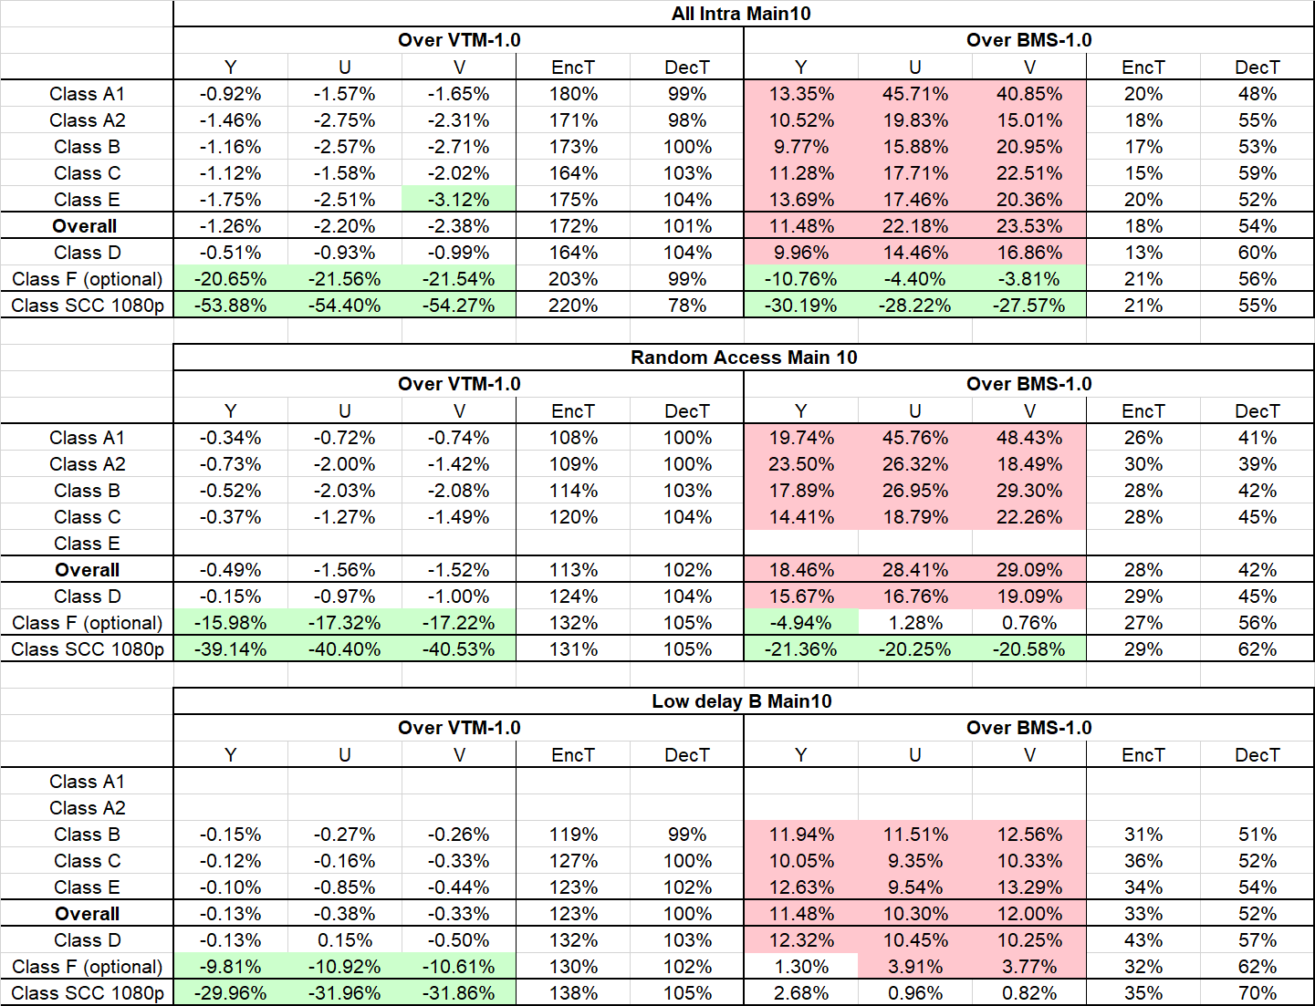

Table II: RefIdx approach under BMS configurations
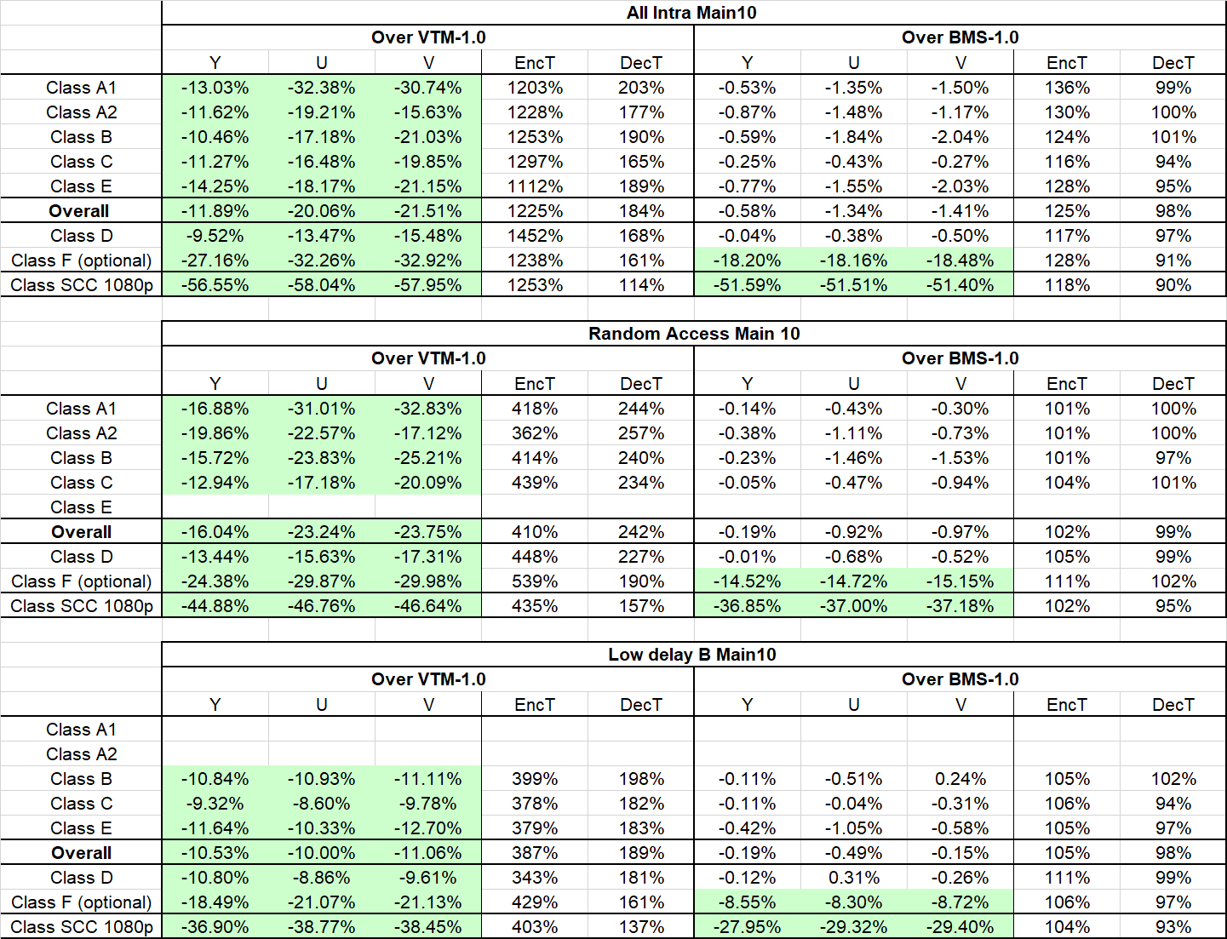

Additional information
By adjusting the search range of block-matching based local search, the RD-performance of the proposed method vs its encoder complexity can be adjusted at different tradeoff points. Below are results for a few alternative search range assignments.
Table III: RefIdx approach under VTM configurations (search range = 16)
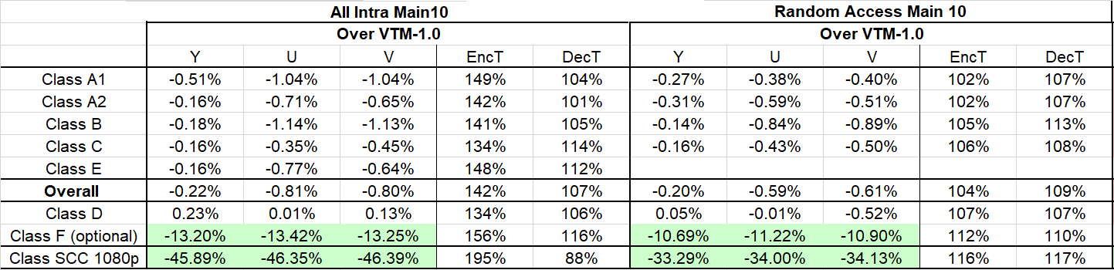

Table IV: RefIdx approach under VTM configurations (search range = 32)
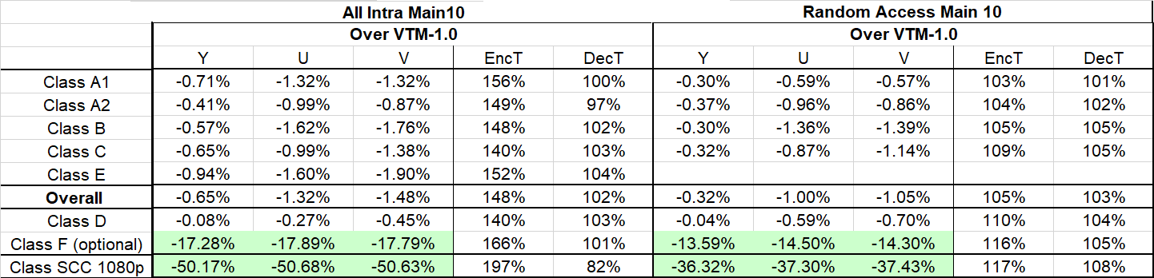

Table V: RefIdx approach under VTM configurations (default search range = 64)
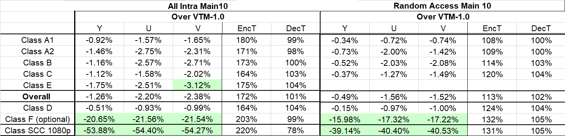

Table VI: RefIdx approach under VTM configurations (search range = 96)
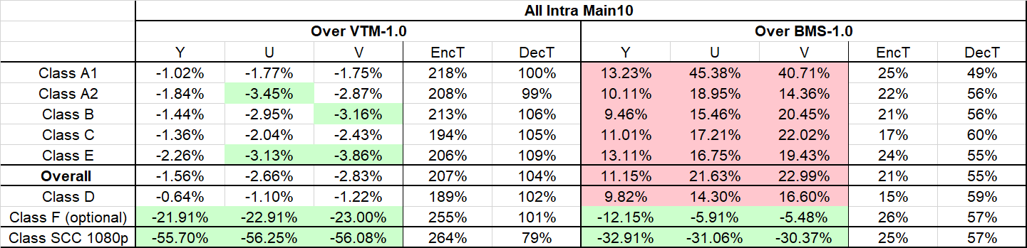

Table VII: RefIdx approach under VTM configurations (search range = 128)
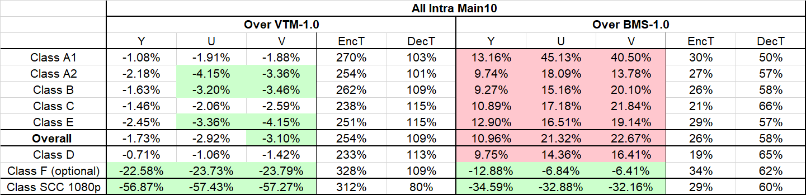

The runtime % increase vs. BD rate saving for three categories (CTC, class F and class SCC) in different search ranges are plot in Fig. 1 and Fig. 2.
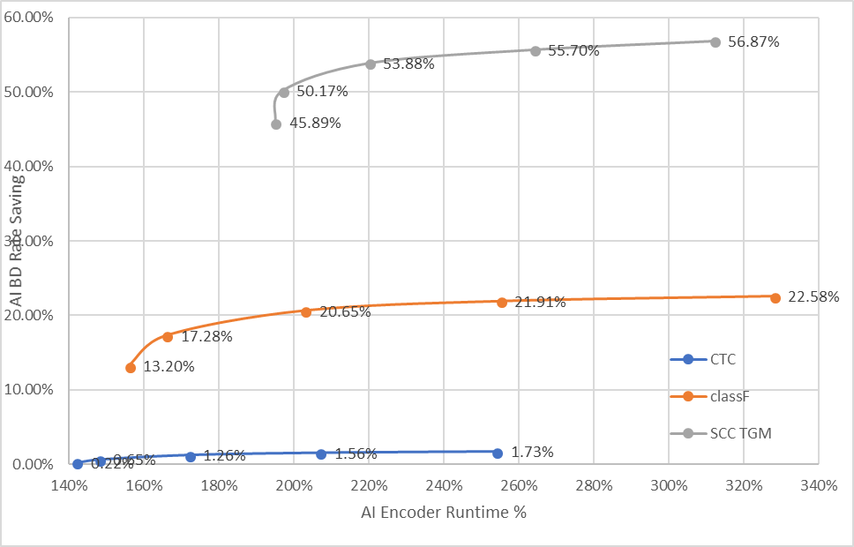
Fig. 1: AI BD rate savings vs. run time increase in different operating points

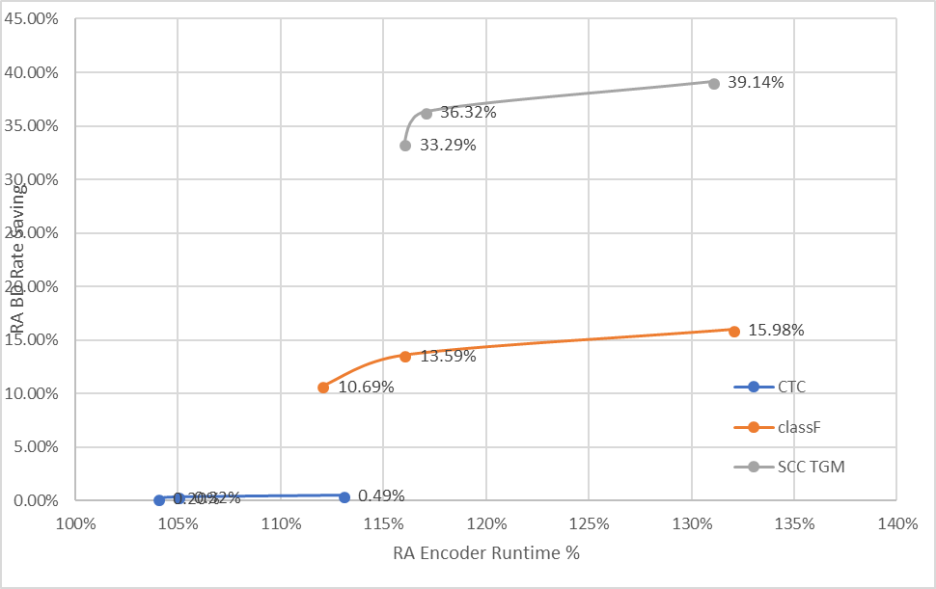
Fig. 2: RA BD rate savings vs. run time increase in different operating points

Conclusion
In this contribution, an implementation of CPR mode using reference index signaling approach is proposed and tested. Large coding gains for screen content materials are observed from the simulation results. It is recommended to include this method into the test model for further consideration.

References
[1] X. Xu, S. Liu, T. Chuang, Y. Huang, S. Lei, K. Rapaka, C. Pang, V. Seregin, Y. Wang, and M. Karczewicz, “Intra Block Copy in HEVC Screen Content Coding Extensions,” IEEE J. Emerg. Sel. Topics Circuits Syst., vol. 6, no. 4, pp. 409-419, 2016.
[2] High Efficiency Video Coding (HEVC), Rec. ITU-T H.265 and ISO/IEC 23008-2, Dec. 2016.
[3] J. Boyce, K. Suehring, X. Li, V. Seregin, “JVET common test conditions and software reference configurations”, JVET-J1010
[4] X. Xu, K. Müller and L. Wang, “Description of Core Experiment 8 (CE8): Current Picture Referencing”, JVET-J1028
[5] X. Xu, S. Liu, and S. Lei, On Chroma Motion Vector Derivation for Intra Block Copy, document JCTVC-U0077, Jun. 2015.
[6] K. Rapaka, V. Seregin, R. Joshi, and M. Karczewicz, Intra Block Copy Chroma Interpolation for Non-444, document JCTVC-U0080, Jun. 2015.
[7] X. Xiu, Y. Ye, and Y. He, On Chroma Derivation of Intra Block Copy for Non-444 Video, document JCTVC-U0103, Jun. 2015.
[8] https://jvet.hhi.fraunhofer.de/svn/svn_VVCSoftware_BMS/tags/BMS-1.0/

Patent rights declaration(s)
Tencent may have current or pending patent rights relating to the technology described in this contribution and, conditioned on reciprocity, is prepared to grant licenses under reasonable and non-discriminatory terms as necessary for implementation of the resulting ITU-T Recommendation | ISO/IEC International Standard (per box 2 of the ITU-T/ITU-R/ISO/IEC patent statement and licensing declaration form).

