    Joint Video Experts Team (JVET)  of ITU-T SG 16 WP 3 and ISO/IEC JTC 1/SC 29/WG 11  11th Meeting: Ljubljana, SI, 10–18 July 2018 | Document: JVET-K0022-v1

Title: | CE2: Summary Report on In-Loop Filters
Status: | Input document to JVET
Purpose: | Report
Author(s) or  Contact(s): | Li Zhang  Kenneth Andersson  Ching-Yeh Chen | Tel  Email: | lizhang.idm@bytedance.com  kenneth.r.andersson@ericsson.com chingyeh.chen@mediatek.com
Source: | CE2 coordinators
_____________________________

Abstract
This contribution provides a summary report of Core Experiment 2 on in-loop filters. Five categories, including 1) bilateral filter, 2) deblocking filters, 3) sample adaptive offset (SAO) filter, 4) Adaptive Loop Filters (ALF), and 5) non-local filters are covered by this CE.
Test conditions are specified for each category. The corresponding coding performance of each coding tool under evaluated in CE2 are summarized in this contribution. In addition, answers to questions mentioned in [1] crosschecking results are also integrated in this contribution.

CE2.1: Bilateral filter

Test conditions
Sub-CE | Tool on (VTM_tool_test) | Tool off (BMS_tool_test)
2.1 | VTM + sub-CE test vs VTM | BMS + sub-CE test vs BMS

Test specification
Test# | Description | Document#
2.1.1 | Same as BMS version
2.1.2 | Bilateral filter - spatial filter strength adjustment | JVET-K0231
2.1.3 | In-loop bilateral filter | JVET-K0384

Comparisons of technologies
Test# | # of filter taps | Sample difference calculation | Parallel friendly | Table Size
2.1.1 | 5 | 1×1 | Y | 2778 bytes
2.1.2 | 5 | 1×1 | Y | 2778 bytes
2.1.3 | 5 | 1×1 for intra  3×3 for inter | Y | 30000 18bits

Test results (mandatory)
*: SIMD optimization for the proposed technology
**: running time unrealizable
***: different SIMD settings (other than default settings) are used

All Intra Main 10
 | VTM_tool_test |  |  |  |  | BMS_tool_test
Test# | Y | U | V | EncT | DecT | Y | U | V | EncT | DecT
2.1.1 | -0.11% | -0.09% | -0.12% |  | 110% | -0.37% | 0.26% | 0.31% |  | 109%
2.1.2 | -0.10% | -0.10% | -0.15% | 103% | 109% | -0.26% | -0.39% | -0.39% | 103% | 104%
2.1.3 | -0.29% | -0.08% | -0.15% | 105% | 109% | -0.33% | -0.25% | -0.24% | 105% | 106%

Random Access Main 10
 | VTM_tool_test |  |  |  |  | BMS_tool_test
Test# | Y | U | V | EncT | DecT | Y | U | V | EncT | DecT
2.1.1 | -0.41% | -0.14% | -0.29% |  | 110% | -0.41% | -0.38% | -0.47% |  | 102%
2.1.2 | -0.40% | -0.18% | -0.29% | 102% | 103% | -0.44% | -0.45% | -0.52% | 104% | 100%
2.1.3 | -0.79% | -0.24% | -0.28% | 105% | 107% | -0.54% | -0.27% | -0.28% | 107% | 103%

Low delay B
 | VTM_tool_test |  |  |  |  | BMS_tool_test
Test# | Y | U | V | EncT | DecT | Y | U | V | EncT | DecT
2.1.1 | -0.37% | 0.26% | 0.31% |  | 109% | -0.51% | -0.12% | 0.08% |  | 102%
2.1.2 | -0.37% | 0.12% | 0.14% | 101% | 101% | -0.46% | 0.06% | 0.06% | 103% | 101%
2.1.3 | -0.63% | 0.30% | 0.42% | 105% | 109% | -0.62% | 0.20% | 0.38% | 106% | 104%

Crosscheck report of mandatory test results
Test# | Cross-checker | PSNR&BR Match  (Y/N) | RunT matched?  (Y/N) | SW implemented by cc?  (Y/N) | SW studied?  (Y/N) | significant inconsistencies between the description and the provided software? (Y/N) | Other comments? | Other  tests?  (Y/N)
2.1.1 | J. Pfaff  J. Rasch | Y |  | N |  |  |  | N
2.1.2 | J. Pfaff  J. Rasch | Y |  | N |  |  |  | N
2.1.3 | J. Pfaff  J. Rasch | Y |  | N |  |  |  | N

Test# | Cross-checker | All Intra Main 10 |  |  |  | Random Access Main 10 |  |  |  | Low Delay B Main 10
Test# | Cross-checker | VTM_tool_test |  | BMS_tool_test |  | VTM_tool_test |  | BMS_tool_test |  | VTM_tool_test |  | BMS_tool_test
Test# | Cross-checker | EncT | DecT | EncT | DecT | EncT | DecT | EncT | DecT | EncT | DecT | EncT | DecT
2.1.1 | J. Pfaff  J. Rasch | 106% | 107% | 105% | 98% | 105% | 104% | 107% | 95% | 104% | 106% | 106% | 96%
2.1.2 | J. Pfaff  J. Rasch | 107% | 109% | 106% | 98% | 108% | 108% | 107% | 96% | 108% | 115% | 106% | 96%
2.1.3 | J. Pfaff  J. Rasch | 106% | 108% | 106% | 97% | 105% | 103% | 109% | 96% | 105% | 105% | 108% | 99%

Detailed description of tests

CE2.1.1 JEM’s bilateral filter (JVET-J0012 [5])
[1] Technology to be investigated
JEM’s bilateral filter is a 5-tap bilateral filter which is applied on the reconstructed block when the transform has non-zero coefficients and QP is larger than 17. The strength of the filter is controlled by QP and the center weight of the filter based on following mapping:
Table 1. center weight used in bilateral filter
 | min (CU Width, CU Height)
 | 4 | 8 | 16
Intra prediction | 65 | 81 | 196
Inter prediction | 113 | 196 | -

CE2.1.2 Bilateral filter JVET-K0231
[1] Technology to be investigated:
JEM’s bilateral filter is a 5-tap bilateral filter which is applied on the reconstructed block when the transform has non-zero coefficients and QP is larger than 17. The strength of the filter is controlled by QP and the center weight of the filter based on following mapping:
Table 2. The center weight values based on the prediction mode and CU area size.
 | CU Area
 | 16 | 32 | 64 | >=128 and <256 | >=256
Intra Prediction | 65 | 65 | 81 | 113 | 113
Inter Prediction | 81 | 113 | 113 | 196

CE2.1.3 Bilateral filter JVET-K0384
[1] Technology to be investigated:
Bilateral filter is always applied to luma blocks with non-zero transform coefficients and slice quantization parameter larger than 17. Therefore, there is no need to signal the usage of the bilateral filter. Bilateral filter, if applied, is performed on decoded samples right after the inverse transform. In addition, the filter parameters, i.e., weights are explicitly derived from the coded information.
The filtering process is defined as:
$P_{0, 0}^{'}=P_{0, 0}+\sum_{k=1}^{K}{W_{k}\left(P_{k, 0}-P_{0, 0}\right)×\left(P_{k, 0}-P_{0, 0}\right)},$ (1)
where $P_{0, 0}$ is the intensity of the current sample and $P_{0, 0}^{'}$ is the modified intensity of the current sample, $P_{k, 0}$ and $W_{k}(∙)$ are the intensity and weighting parameter for the k-th neighboring sample, respectively. An example of one current sample and its four neighboring samples (i.e., K=4), in the shape of a plus sign, is depicted in Figure 1.
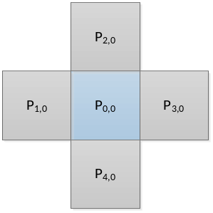
Figure 1: Neighboring samples utilized in bilateral filter.
More specifically, the weight $W_{k}(x)$ associated with the k-th neighboring sample is defined as follows:
$W_{k}(x)={Distance}_{k}× {Range}_{k}(x)$ (2)

wherein
$${Distance}_{k}={e^{\left(- \frac{10000}{2σ_{d}^{2}}\right)}}/{1+4*e^{\left(- \frac{10000}{2σ_{d}^{2}}\right)},}$$
$${Range}_{k}\left(x\right)=e^{\left(– \frac{x^{2}}{8*\left(QP – 17\right)*(QP – 17) }\right)}$$
and $σ_{d}$ is dependent on the coded mode and coding block sizes. To further improve the coding performance, for inter-coded blocks, the intensity difference between current sample and one of its neighboring samples is replaced by a representative intensity difference among two windows covering current sample and the neighboring sample. Therefore, the equation of filtering process is revised to:
$P_{0, 0}^{'}=P_{0, 0}+\sum_{k=1}^{N}{W_{k}\left(\frac{1}{M}\sum_{m=-M/2}^{M/2}{abs(P_{k, m}-P_{0, m})}\right)×(P_{k, 0}-P_{0, 0})}$(3)
wherein $P_{k, m}$ and $P_{0, m}$ represent the m-th sample value within the windows centered at ${ P}_{k, 0}$ and $P_{0, 0}$, respectively. In this proposal, the window size is set to 3×3. An example of two windows covering${ P}_{2, 0}$ and $P_{0, 0}$ are depicted in Figure 2.
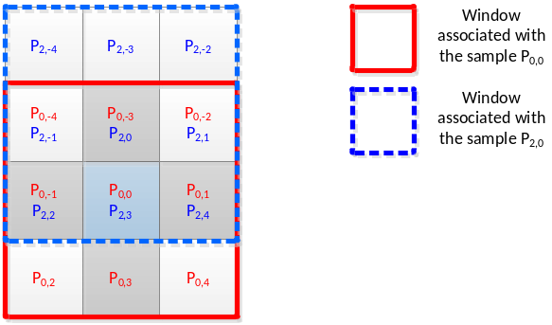
Figure 2: Windows covering two samples utilized in weight calculation.

Related contributions
JVET number | Title
JVET-K0274 | CE2 related: Reduced complexity bilateral filter
JVET-K0068 | CE2 related: Hadamard Transform Domain Filter

CE2.2: Deblocking filter

Test conditions
Sub-CE | Tool on (VTM_tool_test) | Tool off (BMS_tool_test)
2.1 | VTM + sub-CE test vs VTM | BMS + sub-CE test vs BMS

Test specification
Test# | Description | Document#
2.2.1.1.a | Long deblocking filters and fixes | JVET-K0307
2.2.1.1.b | Long deblocking filters and fixes (only fixes) | JVET-K0307
2.2.1.2 | Extended Deblocking Filter | JVET-K0393
2.2.1.3 | Long deblocking filters | JVET-K0232
2.2.1.4 | Tests on long deblocking | JVET-K0334
2.2.1.5 | Long-tap deblocking filter | JVET-K0112
2.2.1.6.a | Long-tap deblocking filter for luma | JVET-K0152
2.2.1.6.b | Long-tap deblocking filter for chroma | JVET-K0152
2.2.1.6.c | Long-tap deblocking filter for luma and chroma | JVET-K0152
2.2.1.7 | Deblocking Improvements for Large CUs both luma and chroma | JVET-K0315
2.2.2.1 | Deblocking filter with asymmetric weighting | JVET-K0129
2.2.2.2 | Luma-adaptive deblocking filter | JVET-K0386

Comparisons of technologies

Filter characteristics
Test# | Color  component | Additional sets of number of samples to filter on respective side | Maximum number of taps to filter one line | Max filter accuracy (>>N) | Line buffers | Other
2.2.1.1 | Luma | 7+7/5+5/3+3 | 46 | 6 | 8
2.2.1.2 | Luma | 7+7/7+3/3+7 | 138 | 4 | 8
2.2.1.3 | Luma | 7+7/7+4/4+7/4+4  /7u+7u/  7: strong filter  7u: ultra filter | 218 | 5 | 8
2.2.1.4 | Luma | 4+4/3+0/0+3  /4+0/0+4 | 72 | 6 | 9 | Changes to bs derivation
2.2.1.5 | Luma | 7+7/7+3 | 138 | 4 | 4
2.2.1.6 | Luma | 7+7 | 168 | 4 | 8
2.2.1.6 | Chroma | 3+3 | 36 | 3 | 4
2.2.1.7 | Luma | 7+7/7+3/3+7 | 168 | 4 | 8
2.2.1.7 | Chroma | 3+3 | 28 | 3 | 4
2.2.2.1 | Luma | No additional filters | 28 | 4 | 4 | Multiplication of delta for weak filter with 1.25 for P side and 0.75 for Q side
2.2.2.2 | Luma | No additional filters | 28 | 4 | 4 | Adding offset to QP based on luma level. Offset depends on SDR or HDR characteristics.

Filter decision characteristics
Test# | Color component | Switching frequency in number of lines | Total number of taps for smooth decisions per line | Other
2.2.1.1 | Luma | 16 | 22
2.2.1.2 | Luma | 4 | 3 | Strong filter decision do not check smoothness of all samples to be filtered. Modify weak filter decision for intra
2.2.1.3 | Luma | 4 | 20 | Needs to check size of adjacent boundary to determine use of ultra filter? Additional QP dependent table for decisions.
2.2.1.4 | Luma | 4 | 39 | Additional QP dependent table for decisions. Different thresholds for intra, RA and LDB
2.2.1.5 | Luma | 4 | 2 | Strong filter decision do not check smoothness of all samples to be filtered.
2.2.1.6 | Luma | 4 | 19
2.2.1.6 | Chroma | 2 | 6 | Filters chroma component if intra or component cbf nonzero
2.2.1.7 | Luma | 4 | 24
2.2.1.7 | Chroma | 2 | 0 | Filters chroma component if intra.
2.2.2.1 | Luma | 4 | 6
2.2.2.2 | Luma | 4 | 6 | 2 taps per line for determine average luma. Signals transfer characteristics and uses different thresholds for HDR and SDR

Other characteristics
Test# | Impacted color component | Deblock implicit split TUs | Deblock without overlap between CUs | Deblock sub-block boundaries
2.2.1.1 | Luma | Yes | Yes | Yes (BMS)
2.2.1.2 | Luma/Chroma | No | No | No
2.2.1.3 | Luma/Chroma | Yes | No | No
2.2.1.4 | Luma/Chroma | No | No | No
2.2.1.5 | Luma/Chroma | No | No | No
2.2.1.6 | Luma/Chroma | No | No | No
2.2.1.7 | Luma/Chroma | Yes | No | No
2.2.2.1 | Luma/Chroma | No | No | No
2.2.2.2 | Luma/Chroma | No | No | No

Test results (mandatory)
*: SIMD optimization for the proposed technology
**: running time unrealizable
***: different SIMD settings (other than default settings) are used

All Intra Main 10
 | VTM_tool_test |  |  |  |  | BMS_tool_test
Test# | Y | U | V | EncT | DecT | Y | U | V | EncT | DecT
2.2.1.1.a | -0.20% | 0.00% | 0.00% | 104%** | 103% | -0.13% | 0.00% | 0.00% | 106%** | 100%
2.2.1.1.b | -0.19% | 0.00% | 0.00% | 103%** | 101% | -0.12% | 0.00% | 0.00% | 106%** | 100%
2.2.1.2 | 0.32% | -0.01% | -0.01% | 100% | 102% | 0.33% | 0.00% | -0.01% | 100% | 100%
2.2.1.3 | 0.00% | 0.00% | 0.00% | 100% | 104% | 0.00% | 0.00% | 0.00% | 100% | 101%
2.2.1.4 | 0.01% | 0.01% | -0.01% | 103%** | 114%** | 0.0% | 0.0% | 0.0% | 111%** | 103**
2.2.1.5 | 0.03% | 0.00% | 0.00% | 98% | 100% | 0.03% | 0.00% | 0.00% | 99% | 99%
2.2.1.6.a | -0.03% | 0.00% | 0.00% | 105%** | 102% | -0.01% | 0.00% | 0.00% | 97% | 101%
2.2.1.6.b | 0.00% | -1.06% | -0.83% | 100%** | 102% | 0.00% | -1.52% | -1.29% | 99% | 100%
2.2.1.6.c | -0.04% | -1.06% | -0.83% | 113%** | 104% | -0.02% | -1.52% | -1.29% | 99%** | 101%
2.2.1.7 | -0.01% | 0.33% | 0.33% | 105% | 106% | 0.00% | 0.28% | 0.27% | 109% | 109%
2.2.2.1 | -0.11% | 0.00% | 0.01% | 99% | 99% | -0.13% | 0.00% | 0.00% | 100% | 101%
2.2.2.2 | 0.00% | 0.00% | 0.00% | 100% | 101% | 0.01% | 0.00% | 0.00% | 101% | 102%

Random Access Main 10
 | VTM_tool_test |  |  |  |  | BMS_tool_test
Test# | Y | U | V | EncT | DecT | Y | U | V | EncT | DecT
2.2.1.1.a | -0.17% | -0.05% | -0.01% | 103%** | 103% | -0.10% | -0.02% | -0.05% | 103%** | 102%
2.2.1.1.b | -0.12% | -0.01% | 0.06% | 104%** | 101% | -0.14% | -0.01% | 0.01% | 101%** | 101%
2.2.1.2 | 0.14% | 0.01% | 0.03% | 100% | 101% | 0.18% | -0.02% | 0.02% | 101% | 100%
2.2.1.3 | -0.02% | -0.02% | -0.01% | 100% | 103% | -0.01% | -0.04% | -0.01% | 100% | 101%
2.2.1.4 | -0.09% | -0.39% | -0.44% | 105%** | 110%** | -0.02% | -0.34% | -0.51% | 109%** | 101%**
2.2.1.5 | -0.02% | -0.03% | 0.03% | 99% | 105% | 0.03% | 0.02% | 0.01% | 109% | 109%
2.2.1.6.a | -0.08% | -0.03% | 0.04% | 95%** | 101% | 0.00% | 0.03% | 0.24% | 91%** | 101%
2.2.1.6.b | -0.04% | -1.93% | -1.88% | 102%** | 100% | -0.01% | -1.95% | -1.89% | 100%** | 99%
2.2.1.6.c | -0.10% | -1.95% | -1.89% | 115%** | 102% | -0.02% | -1.95% | -1.83% | 100%** | 101%
2.2.1.7 | -0.08% | 0.22% | 0.26% | 105% | 107% | -0.01% | 0.25% | 0.24% | 101% | 104%
2.2.2.1 | 0.08% | 0.02% | 0.05% | 100% | 100% | 0.05% | -0.01% | 0.02% | 100% | 100%
2.2.2.2 | 0.01% | -0.04% | 0.01% | 100% | 100% | 0.01% | -0.02% | -0.04% | 100% | 100%

Low delay B
 | VTM_tool_test |  |  |  |  | BMS_tool_test
Test# | Y | U | V | EncT | DecT | Y | U | V |  | EncT | DecT
2.2.1.1.a | -0.05% | 0.04% | -0.15% | 99%** | 102% | -0.11% | -0.12% | -0.01% | 104%** |  | 101%
2.2.1.1.b | -0.11% | 0.12% | 0.02% | 102%** | 100% | -0.19% | -0.11% | -0.23% | 101%** |  | 101%
2.2.1.2 | 0.04% | 0.08% | -0.01% | 100% | 101% | 0.00% | 0.05% | 0.09% | 101% |  | 100%
2.2.1.3 | 0.01% | 0.06% | 0.05% | 100% | 103% | -0.05% | -0.19% | 0.04% | 101% |  | 101%
2.2.1.4 | 0.02% | -0.35% | -0.47% | 112%** | 123%** | -0.07% | -0.76% | -0.60% | 117% |  | 111**
2.2.1.5 | 0.10% | 0.12% | 0.17% | 100% | 98% | 0.07% | -0.05% | 0.18% | 99% |  | 97%
2.2.1.6.a | 0.01% | -0.04% | 0.03% | 104%** | 101% | -0.03% | -0.04% | 0.02% | 98%** |  | 102%
2.2.1.6.b | -0.07% | -1.65% | -1.79% | 104%** | 101% | -0.11% | -2.16% | -1.96% | 100%** |  | 100%
2.2.1.6.c | -0.04% | -1.66% | -1.76% | 124% | 103% | -0.10% | -1.95% | -2.03% | 101%** |  | 101%
2.2.1.7 | 0.02% | 0.20% | 0.20% | 104% | 90% | -0.01% | -0.14% | 0.12% | 101% |  | 105%
2.2.2.1 | 0.13% | 0.15% | 0.16% | 100% | 101% | -0.03% | -0.10% | 0.05% | 100% |  | 100%
2.2.2.2 | 0.03% | 0.02% | 0.03% | 100% | 101% | -0.04% | -0.03% | -0.08% | 99% |  | 96%

Crosscheck report of mandatory test results
Test# | Cross-checker | PSNR&BR Match  (Y/N) | RunT matched?  (Y/N) | SW implemented by cc?  (Y/N) | SW studied?  (Y/N) | significant inconsistencies between the description and the provided software? (Y/N) | Other comments? | Other  tests?  (Y/N)
2.2.1.1.1 | M. Ikeda | Y |  | N | Y |  |  | N
2.2.1.1.a | D.Rusanovskyy | Y |  | N | Y |  |  | N
2.2.1.1.2 | M. Ikeda | Y |  | N | Y |  |  | N
2.2.1.2 | K. Andersson | Y (AI BMS running) |  | N | Y |  |  | N
2.2.1.3 | K. Andersson | Y (AI BMS running) |  | N | Y |  |  | N
2.2.1.4 | K. Andersson |  |  | N | Y |  |  | N
2.2.1.5 | K. Andersson | Y (AI BMS running) |  | N | Y |  |  | N
2.2.1.6.1 | K. Andersson | Y (AI, RA BMS running) |  | N | Y |  |  | N
2.2.1.6.2 | K. Andersson | Y (AI BMS running) |  | N | Y |  |  | N
2.2.1.6.3 | K. Andersson
2.2.1.7 | K. Andersson | Y (only VTM tested) |  | N | Y |  |  | N
2.2.2.1 | T. Ikai | Y | Y | N | N
2.2.2.2

Test# | Cross-checker | All Intra Main 10 |  |  |  | Random Access Main 10 |  |  |  | Low Delay B Main 10
Test# | Cross-checker | VTM_tool_test |  | BMS_tool_test |  | VTM_tool_test |  | BMS_tool_test |  | VTM_tool_test |  | BMS_tool_test
Test# | Cross-checker | EncT | DecT | EncT | DecT | EncT | DecT | EncT | DecT | EncT | DecT | EncT | DecT
2.2.1.1.1 | M. Ikeda
2.2.1.1.2 | M. Ikeda
2.2.1.2  ** | K. Andersson | 110% |  |  |  | 101% |  | 102% |  | 101% |  | 102%
2.2.1.3  ** | K. Andersson | 111% |  |  |  | 102% |  | 103% |  | 105% |  | 100%
2.2.1.4  ** | K. Andersson | 102% |  |  |  | 101% |  |  |  | 100%
2.2.1.5  ** | K. Andersson | 111% |  |  |  | 103% |  | 105% |  | 106% |  | 98%
2.2.1.6.1  ** | K. Andersson | 107% |  |  |  | 100% |  |  |  | 103% |  | 101%
2.2.1.6.2  ** | K. Andersson | 110% |  |  |  | 103% |  | 100% |  | 105% |  | 100%
2.2.1.6.3 | K. Andersson
2.2.1.7  ** | K. Andersson | 112% |  |  |  | 103% |  |  |  | 106%
2.2.2.1 | T. Ikai | 100% | 100% | 100% | 101% | 101% | 102% | 100% | 98% | 100% | 98% | 100% | 103%
2.2.2.2

Detailed description of tests

CE2.2.1.1 JVET-K0307
- Technology to be investigated
HEVC deblocking filters are extended with longer deblocking filters for luma. One of 7, 5 and 3 sample filtering on respective side of the block boundary can be applied for a 16-sample segment of the block boundary if current and neighbouring block size >= 32, >=16, >=8 respectively and corresponding conditions for 8 lines of the boundary are fulfilled as shown below.
Size | Conditions for each of the 8 lines of a 16 sample segment (line 0, 3, 4, 7, 8, 11, 12, 15)
7 | $HEVC_{strong_weak}\&\& \left(\left|p_{0}-2*p_{2}+p_{4}\right|+\left|q_{0}-2*q_{2}+q_{4}\right|<\frac{3*β}{32}\right) \&\&$  $$\left(\left|p_{0}-p_{2}-p_{3}+p_{5}\right|+\left|q_{0}-q_{2}-q_{3}+q_{5}\right|<\frac{3*β}{32}\right)\&\&$$  $$\left(\left|p_{0}-2*p_{3}+p_{6}\right|+\left|q_{0}-2*q_{3}+q_{6}\right|<\frac{3*β}{32}\right) \&\&$$  $$\left(\left|p_{0}-p_{3}-p_{4}+p_{7}\right|+\left|q_{0}-q_{3}-q_{4}+q_{7}\right|<\frac{3*β}{32}\right)$$
5 | $HEVC_{strong_weak}\&\& \left(\left|p_{0}-p_{4}\right|+\left|q_{0}-q_{4}\right|<\frac{β}{8}\right) \&\&$  $$\left(\left|p_{0}-p_{5}\right|+\left|q_{0}-q_{5}\right|<\frac{β}{8}\right)$$
3 | $$HEVC_{strong_weak}\&\& \left(\left|p_{0}-p_{1}-p_{2}+p_{3}\right|+\left|q_{0}-q_{1}-q_{2}+q_{3}\right|<\frac{3*β}{32}\right)$$
0-3 | HEVC filter and decisions apply but reducing maximum filter length to half the minimum distance between current and neighboring CU boundaries

Block boundary samples p_{i} and q_{i} for i=0 to S-1 are then replaced by linear interpolation as follows:
- $p_{i}´={(f}_{i}*{Middle}_{s}+\left(64-f_{i}\right)*P_{s})+32)≫6, clipped to p_{i}±tc$
- $q_{i}´={(f}_{i}*{Middle}_{s}+\left(64-f_{i}\right)*Q_{s}+32)≫6), clipped to q_{i}±tc$
where f, Middle, P and Q are given below:
S | Filter kernels
7 | $$f_{i}=59-i*9, can also be described as f=\left\{59,50,41,32,23,14,5\right\}$$  $${Middle}_{7}=(2*\left(p_{o}+q_{o}\right)+p_{1}+q_{1}+p_{2}+q_{2}{+p}_{3}+q_{3}{+p}_{4}+q_{4}{+p}_{5}+q_{5}{+p}_{6}+q_{6}+8)≫4$$  $$P_{7}=(p_{6}+p_{7}+1)≫1, Q_{7}=(q_{6}+q_{7}+1)≫1$$
5 | $$f_{i}=58-i*13, can also be described as f=\left\{58,45,32,19,6\right\}$$  $${Middle}_{5}=(2*\left(p_{o}+q_{o}+p_{1}+q_{1}+p_{2}+q_{2}\right){+p}_{3}+q_{3}{+p}_{4}+q_{4}+8)≫4$$  $${ P}_{5}=(p_{4}+p_{5}+1)≫1, Q_{5}=(q_{4}+q_{5}+1)≫1$$
3 | $$f_{i}=53-i*21, can also be described as f=\left\{53,32,11\right\}$$  $${Middle}_{3}=(3*\left(p_{o}+q_{o}+p_{1}+q_{1}\right)+2*(p_{2}+q_{2})+8)≫4$$  $${ P}_{3}=(p_{2}+p_{3}+1)≫1, Q_{3}=(q_{2}+q_{3}+1)≫1$$
- Questions to be answered
Is it sufficient to filter 7 pixels on both sides of a large block boundary? Expects improvements in subjective quality from reducing discontinuities across large blocks, especially for low bitrates.
A: Visual tests are expected to be done during the meeting

CE2.2.1.2 JVET-K0393
- Technology to be investigated
HEVC deblocking filters are extended with longer deblocking filters for luma.
The proposed method consisted of two parts; edge boundary detection of large intra block and extension of the filtered samples on edge filtering process.
When the following conditions are true, the proposed decision process is continued:
- Edge boundary is located between two blocks of which cross edge sizes are 16 or longer than 16.
- The filter type is strong.
- Both blocks are not intra coded
It is noted that a block size is replaced by an edge size. Direction of edge size depends on that of edge boundary like EDGE_VER or EDGE_HOR.
When the above criteria is not true, the default short deblocking filter may be applied.
The longer filter is applied on both sides if above conditions are true and gradient checks for samples p0 to p7 and q0 to q7 of smoothness are passed. Following filter kernels are used.
p6 = 3,5,2,1,1,1,1,1,1,0,0,0,0,0,0,0
p5 = 1,2,5,2,1,1,1,1,1,1,0,0,0,0,0,0
p4 = 0,1,3,3,3,1,1,1,1,1,1,0,0,0,0,0
p3 = 0,1,2,2,2,2,2,1,1,1,1,1,0,0,0,0
p2 = 0,0,1,2,2,2,2,2,2,1,1,1,0,0,0,0
p1 = 0,0,1,1,2,2,2,2,2,2,1,1,0,0,0,0
p0 = 0,0,0,1,2,2,2,2,2,2,2,1,0,0,0,0
There are no changes for chroma deblocking filter process.

CE2.2.1.3 JVET-K0232
- Technology to be investigated
HEVC deblocking filters are extended with longer deblocking filters for luma. Three sets of long filters include ultra-long, long, or normal filter using different number of samples on respective side of the boundary (e.g.16/12/10, 8, and 4 samples, respectively). The proposed length-adaptive filtering is applied when the gap value which represents the smoothness of the signal on both sides of the block boundary is larger than a threshold. Different labels are determined for the current segment (4-sample length boundary) and coherence checks for labels within a window of segments are performed. The final with different taps are applied according to the label and the length of each side.
16/12/10 samples, 7 samples or 4 samples on respective side of the boundary may be filtered.

CE2.2.1.4 JVET-K0334
- Technology to be investigated
HEVC deblocking filters are extended with longer deblocking filters for luma. A longer filter that filters 4 samples on each side of the boundary when block size on both sizes are >= 16, HEVC strong/weak filter is indicating strong filter and sum of absolute value of Laplacian for every second line for the whole block boundary and compare that with a threshold. The threshold is specific for intra and non intra slices and also depends on a PPS flag indicate smooth threshold flag. This decision process was further extended in JVET-J0056 with multi-factor selection of deblocking filter.
Following filter kernels are used:
$$h_{0}=\left[0, 2, 9, 12, 1, 3, 13, 16, 5, 3, 0\right],$$
$$h_{1}=\left[-1, 6, 7, 8, -2, 13, 15, 10, 8, 0, 0\right],$$
$$h_{2}=\left[-1, 4, 12, -3, 6, 14, 14, 16, 2, 0, 0\right],$$
$$h_{3}=\left[-3, 16, -3, 1, 5, 16, 18, 14, 0, 0, 0\right]$$
This above filter kernels are further extended in JVET-J0056, e.g. Table 1 presents 15 pre-selected filters which are adaptively selected.
Clipping is used to limit the amount of filtering. A boundary strength of 3 is used to determine tc for both luma and chroma. Increase tc offset if QP > 42 and decrease if QP<= 35, used for both luma and chroma. Tc is then scaled by 3 for first two samples near the boundary and scaled by 2 for the other samples.
Long filter can be turned on for respective 4 sample segment. Deblocking applied for 4x4 grid for luma.

CE2.2.1.5 JVET-K0112
- Technology to be investigated
HEVC deblocking filters are extended with longer deblocking filters for luma. 7 samples on a side of the boundary is filtered when length orthogonal to block boundary is >= 16, strong/weak filter determines use strong filter, sum of absolute pixel difference for pixel p8 and p0 and q8 and q0 compared to a threshold. Only 3 samples are filtered for the upper block when filtering horizontal boundaries. Decision on 4 sample segments of an 8x8 grid.
Following filters are used for left block in vertical filtering:
p6 {3, 5, 2, 1, 1, 1, 1, 1, 1} p7 ~ q0
p5 {1, 2, 5, 2, 1, 1, 1, 1, 1, 1} p7 ~ q1
p4 {1, 3, 3, 3, 1, 1, 1, 1, 1, 1} p6 ~ q2
p3 {1, 2, 2, 2, 2, 2, 1, 1, 1, 1, 1} p6 ~ q3
p2 {1, 2, 2, 2, 2, 2, 2, 1, 1, 1} p5 ~ q3
p1 {1, 1, 2, 2, 2, 2, 2, 2, 1, 1} p5 ~ q3
p0 {1, 2, 2, 2, 2, 2, 2, 2, 1} p4 ~ q3
For the upper block in horizontal filtering only p0 to p2.
p2 {3, 5, 2, 2, 1, 1, 1, 1} p3 ~ q3
p1 {2, 2, 4, 2, 2, 2, 1, 1} p3 ~ q3
P0 {2, 2, 2, 2, 2, 2, 2, 2} p3 ~ q3

CE2.2.1.6 JVET-K0152
- Technology to be investigated
HEVC deblocking filters are extended with longer deblocking filters for luma and chroma. 7 samples on each side of the boundary is filtered when the minimal length orthogonal to block boundary is >= 32, sum of absolute pixel difference and also Laplacians, and comparison with absolute value of pixel difference across boundary in comparison with tc. Decision is taken on two lines of 4 sample segments on a 4x4 grid.
Following filtering apply to P side and similar for Q side:
p₆′= (7*p₇+2*p₆+p₅+p₄+p₃+p₂+ p₁+p₀+q₀+ 8) >> 4
p₅′= (6*p₇+p₆+2*p₅+p₄+p₃+p₂+p₁+p₀+q₀+q₁+ 8) >> 4
p₄′= (5*p₇+p₆+p₅+2*p₄+p₃+p₂+p₁+p₀+q₀+q₁+q₂+ 8) >> 4
p₃′= (4*p₇+p₆+p₅+p₄+2*p₃+p₂+p₁+p₀+q₀+q₁+q₂+q₃+ 8) >> 4
p₂′= (3*p₇+p₆+p₅+p₄+p₃+2*p₂+p₁+p₀+q₀+q₁+q₂+q₃+q₄+8) >> 4
p₁′= (2*p₇+p₆+p₅+p₄+p₃+p₂+2*p₁+p₀+q₀+q₁+q₂+q₃+q₄+q₅+8) >> 4
p₀′= (p₇+p₆+p₅+p₄+p₃+p₂+p₁+2*p₀+q₀+q₁+q₂+q₃+q₄+q₅+q₆+8) >> 4

The decision which has two additional conditions is also modified, accordingly. The first one is for large block decision since the proposed filter can be applied when the block width or height which orthogonally crosses the block edge is equal to or larger than 32. The second one is for wide strong filter decision. It is extended based on strong filter decision.
Also propose a longer filter for chroma for filtering of p0 to p2 and similarly for q0 to q2 as follows:
p₂′= (3*p₃+2*p₂+p₁+p₀+q₀+4) >> 3
p₁′= (2*p₃+p₂+2*p₁+p₀+q₀+q₁+4) >> 3
p₀′= (p₃+p₂+p₁+2*p₀+q₀+q₁+q₂+4) >> 3
The decision which has three additional conditions is also modified, accordingly. The first one is for decision of boundary strength as well as large block. The proposed filter can be applied when the block width or height which orthogonally crosses the block edge is larger than 16. The second and third one are basically similar to luma’s decision, which are on/off decision and strong filter decision, respectively.

- Questions to be answered
  - Subjective and objective impact of modified luma filter
  - Subjective and objective impact of modified chorma filter
  - Subjective and objective impact of the whole proposal
A: Visual tests are expected to be done to evaluate the subjective quality during the meeting. For objective quality, please refer to test 2.2.1.6a/b/c in section 2.4

CE2.2.1.7 JVET-K0315
[1] Technology to be investigated
JVET-J0077 incorporates stronger filters for both luma and chroma, compared to JEM deblocking. Additionally, the proposed modification includes a control process that considers the block sizes on both sides of the boundary being deblocked. The stronger filters are used for luma samples that correspond to larger block sizes, while the JEM deblocking filters are still used for luma samples corresponding to the smaller block sizes. For chroma, the filter selection uses a different approach, and a stronger filter is applied when chroma samples on either sides of the deblocking boundary belong to a large block.

Luma stronger filters (same as JVET-J0038):
p₆′= (7*p₇+2*p₆+p₅+p₄+p₃+p₂+ p₁+p₀+q₀+ 8) >> 4
p₅′= (6*p₇+p₆+2*p₅+p₄+p₃+p₂+p₁+p₀+q₀+q₁+ 8) >> 4
p₄′= (5*p₇+p₆+p₅+2*p₄+p₃+p₂+p₁+p₀+q₀+q₁+q₂+ 8) >> 4
p₃′= (4*p₇+p₆+p₅+p₄+2*p₃+p₂+p₁+p₀+q₀+q₁+q₂+q₃+ 8) >> 4
p₂′= (3*p₇+p₆+p₅+p₄+p₃+2*p₂+p₁+p₀+q₀+q₁+q₂+q₃+q₄+8) >> 4
p₁′= (2*p₇+p₆+p₅+p₄+p₃+p₂+2*p₁+p₀+q₀+q₁+q₂+q₃+q₄+q₅+8) >> 4
p₀′= (p₇+p₆+p₅+p₄+p₃+p₂+p₁+2*p₀+q₀+q₁+q₂+q₃+q₄+q₅+q₆+8) >> 4
q₆′= (7*q₇+2*q₆+q₅+q₄+q₃+q₂+ q₁+q₀+p₀+ 8) >> 4
q₅′= (6*q₇+q₆+2*q₅+q₄+q₃+q₂+q₁+q₀+p₀+p₁+ 8) >> 4
q₄′= (5*q₇+q₆+q₅+2*q₄+q₃+q₂+q₁+q₀+p₀+p₁+p₂+ 8) >> 4
q₃′= (4*q₇+q₆+q₅+q₄+2*q₃+q₂+q₁+q₀+p₀+p₁+p₂+p₃+ 8) >> 4
q₂′= (3*q₇+q₆+q₅+q₄+q₃+2*q₂+q₁+q₀+p₀+p₁+p₂+p₃+p₄+8) >> 4
q₁′= (2*q₇+q₆+q₅+q₄+q₃+q₂+2*q₁+q₀+p₀+p₁+p₂+p₃+p₄+p₅+8) >> 4
q₀′= (q₇+q₆+q₅+q₄+q₃+q₂+q₁+2*q₀+p₀+p₁+p₂+p₃+p₄+p₅+p₆+8) >> 4

Luma stronger filters are used for large blocks where large block corresponds to width >= 32 for a vertical edge, and height>=32 for a horizontal edge. The control process is further based on gradients computed for two lines of 4 sample segments; comparison of absolute pixel value difference with tc; and comparison of other absolute pixel value differences with β. More gradients are computed for large block side.
Chroma stronger filters:
p₀′ = ( p₂ + 2 * p₁ + 2 * p₀ + 2 * q₀ + q₁ + 4 ) >> 3
p₁′ = ( p₂ + p₁ + p₀ + q₀ + 2 ) >> 2
p₂′ = ( 2 * p₃ + 3 * p₂ + p₁ + p₀ + q₀ + 4 ) >> 3
q₀′ = ( p₁ + 2 * p₀ + 2 * q₀ + 2 * q₁ + q₂ + 4 ) >> 3
q₁′ = ( p₀ + q₀ + q₁ + q₂ + 2 ) >> 2
q₂′= ( p₀ + q₀ + q₁ + 3 * q₂ + 2 * q₃ + 4 ) >> 3
Chroma stronger filters are used on both sides of the block boundary. Specifically, the strong filter is used when any of the following conditions is true:
- The edge type is vertical an p₀ belongs to CU with width >= 32
- The edge type is horizontal and p₀ belongs to CU with height >= 32
- The edge type is vertical and q₀ belongs to CU with width >= 32
- The edge type is horizontal and q₀ belongs to CU with height >= 32
[2] Questions to be answered
- Subjective impact on quality for CfP sequences, CTC sequences, and sequences with real strong edges (e.g. screen content) at low bit rates
- Objective impact of the changes for the same set of sequences content under CTC.
A: Visual tests are expected to be done to evaluate the subjective quality during the meeting. For objective quality, please refer to test 2.2.2.1 in section 2.4.

CE2.2.2.1 Deblocking filter with asymmetric weighting JVET-K0129
- Technology to be investigated
Generally, the image quality on the top or left boundaries of a CU is likely to be better than the image quality on the bottom or right boundaries. Therefore, the symmetric deblocking filter of HEVC and JEM tends to increase the SAD of the top and left boundaries, whereas the SAD of the bottom and right boundaries tends to decrease.
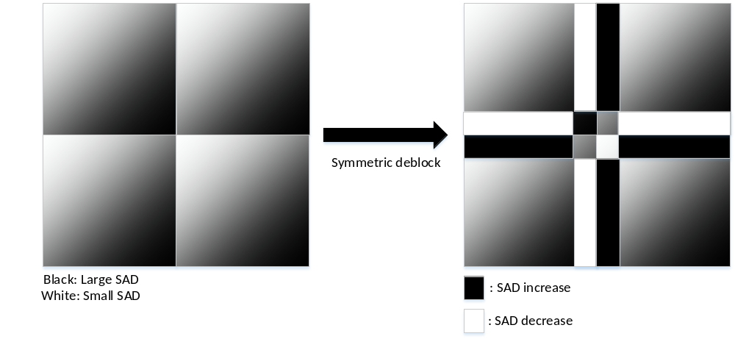
Figure 3: SAD change caused by symmetric deblocking filter used in HEVC and JEM
The deblocking filter in HEVC and JEM changes the pixel value as , where and are filtered and original pixel values respectively, and is the displacement of the deblocking filter. In PEM, in order to further reduce SAD both in the bottom/right part and in the top/left part of the CU, an asymmetric weight is introduced to the original displacement. A pixel value is filtered as , where is a weight for the displacement of the deblocking filter. for the top/left boundary is set to be 0.75. for the bottom/right boundary is set to be 1.25. This asymmetric weight is applied only to the weak deblocking filter for luma component. Calculation for is the same as in HEVC and JEM.

CE2.2.2.2 Luma-adaptive deblocking filter JVET-K0386
- Technology to be investigated
The variable LL of the reconstructed luma level is derived as follow:
LL= ( ( p_{0,0} + p_{0,3} + q_{0,0} + q_{0,3} ) >> 2 ) / ( 1 << iBitDepth ), (4)
where, the sample values p_{i,k} and q_{i,k} with i = 0..3 and k = 0 and 3 are derived the same as HEVC as shown in Figure 4.

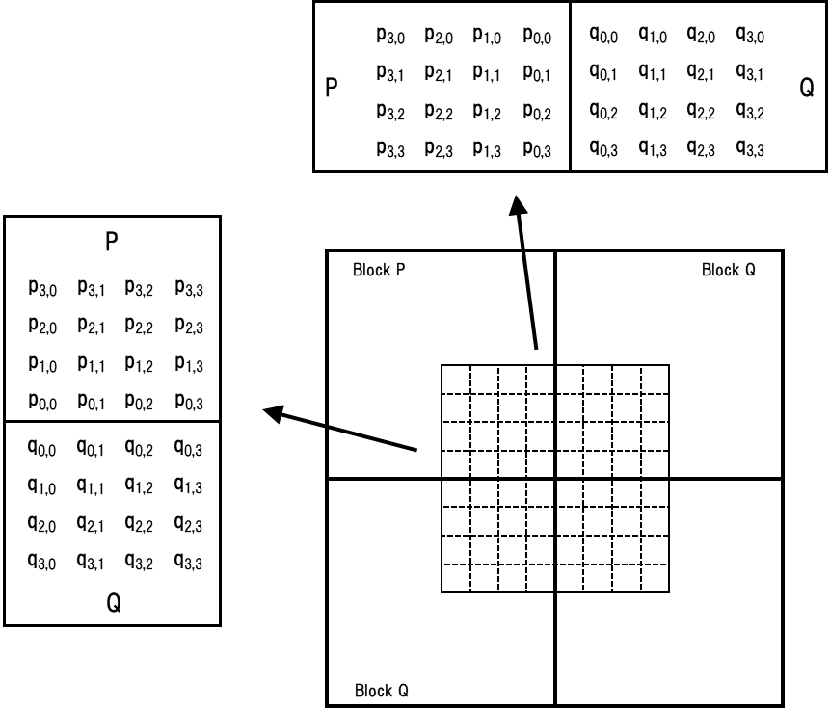
Figure 4: Sample position of p_{i,k} and q_{i,k}

The variables Qp_{Q} and Qp_{P} are set equal to the Qp_{Y} values of the coding units which include the coding blocks containing the sample q_{0,0} and p_{0,0}, respectively.
The variable qP_{L} is derived as follows:
qP_{L} = ( ( QP_{Q} + QP_{P} +1 ) >> 1 ) + qpOffset, (5)
where qpOffset is specified in Table 3.
The subsequent derivation processes of the variables β and t_{C} are same as HEVC.

Table 3. Specification of qpOffset as a function of LL
transfer_characteristics == 18  (HLG format) |  | transfer_characteristics == 16  (PQ format) |  | Otherwise  (conventional SDR format)
Conditions | qpOffset | Conditions | qpOffset | Conditions | qpOffset
LL <= 0.84 | 0 | LL <= 0.8 | 0 | LL <= 0.875 | 0
0.84 < LL <= 0.91 | 1 | 0.8 < LL <= 0.9 | 1 | 0.875 < LL | 1
0.91 < LL <= 0.99 | 2 | 0.9 < LL | 2
0.99 < LL | 3

Related contributions
JVET number | Title
JVET-K0203 | Non-CE2: Higher-precision modifications to VVC deblocking filters
JVET-K0237 | CE2-related: Bugfix for deblocking at maximum transform block
JVET-K0318 | CE2-2.1.1-related: HEVC luma filters and decisions for chroma deblocking
JVET-K0369 | CE2-related: Longer Tap Deblocking Filter

Subjective evaluation
Informal subjective viewing will be held at the Ljublijana meeting.

CE2.3: Sample adaptive offset

Test conditions
Sub-CE | Tool on (VTM_tool_test) | Tool off (BMS_tool_test) | Notes
Mandatory  (overall gain of SAO) | VTM – SAO + sub-CE test vs VTM – SAO | BMS – SAO + sub-CE test vs  BMS – SAO | SAO: the SAO design in VTM
Option  (additional gains compared to the SAO in VTM) | VTM – SAO + sub-CE test vs VTM | BMS – SAO + sub-CE test vs BMS | SAO: the SAO design in VTM

Test specification
Test# | Description | Document#
AhG13 | Coding gain of SAO in VTM | JVET-K0013
2.3.1.a | SAO with EO sign constraints removal | JVET-K0233
2.3.1.b | SAO with EO sign constraints removal and more EO patterns | JVET-K0233
2.3.2.a | SAO Merge with 128x128 unit | JVET-K0324
2.3.2.b | SAO Merge with 128x128 or 256x256 unit | JVET-K0324
2.3.2.c | SAO Merge with 64x64x or 128x128 unit | JVET-K0324
2.3.3.a | SAO Palette results and discussion: Test a | JVET-K0192
2.3.3.b | SAO Palette results and discussion: Test b | JVET-K0192
2.3.4.a | SAO Modification: EO | JVET-K0176
2.3.4.b | SAO Modification: BO offset quantization | JVET-K0176
2.3.4.c | SAO Modification: BO offset band | JVET-K0176
2.3.4.d | SAO Modification: shifted region | JVET-K0176
2.3.4.e | SAO Modification: offset range | JVET-K0176
2.3.4.f | SAO Modification: All | JVET-K0176
2.3.4.g | SAO Modification: a+b+d | JVET-K0176
2.3.5 | CTU adaptive sample adaptive offset | JVET-K0153

Comparisons of technologies
Test# | Syntax position | # of EO modes | # of BO bands | Encoding algorithm
AhG13 | Interleaved with each CTU | 4 | 32 | CTU-based
2.3.1.a | Interleaved with each CTU | 4 | 32 | CTU-based
2.3.1.b | Interleaved with each CTU | 7 | 32 | CTU-based
2.3.2.a | Before the first CTU | 4 | 32 | Picture-based
2.3.2.b | Before the first CTU | 4 | 32 | Picture-based
2.3.2.c | Before the first CTU | 4 | 32 | Picture-based
2.3.3.a | Before the first CTU | 4 | 32 | Picture-based
2.3.3.b | Before the first CTU | 4 | 32 | Picture-based
2.3.4.a | Interleaved with each CTU | 4 | 32 | CTU-based
2.3.4.b | Interleaved with each CTU | 4 | 32 | CTU-based
2.3.4.c | Interleaved with each CTU | 4 | 32 | CTU-based
2.3.4.d | Interleaved with each CTU | 4 | 32 | CTU-based
2.3.4.e | Interleaved with each CTU | 4 | 32 | CTU-based
2.3.4.f | Interleaved with each CTU | 4 | 32 | CTU-based
2.3.4.g | Interleaved with each CTU | 4 | 4 | CTU-based
2.3.5 | Interleaved with each CTU | 4 | 16 with 5 kinds of intervals | CTU-based

Test results (mandatory)
*: SIMD optimization for the proposed technology
**: running time unrealizable
***: different SIMD settings (other than default settings) are used

All Intra Main 10
 | VTM_tool_test |  |  |  |  | BMS_tool_test
Test# | Y | U | V | EncT | DecT | Y | U | V | EncT | DecT
AhG13
2.3.1.a | -0.44% | -1.59% | -2.12% | 100% | 106% | -0.13% | -1.81% | -2.36% | 100% | 103%
2.3.1.b | -0.48% | -1.67% | -2.22% | 101% | 106% | -0.16% | -1.84% | -2.41% | 100% | 103%
2.3.2.a | -0.55% | -2.46% | -3.05% | 99% | 111% | -0.23% | -2.53% | -2.97% | 99% | 105%
2.3.2.b | -0.56% | -2.44% | -3.04% | 99% | 111% | -0.23% | -2.50% | -2.94% | 98% | 104%
2.3.2.c | -0.55% | -2.57% | -3.24% | 93%** | 104%**
2.3.3.a | -0.61% | -2.04% | -2.58% |  |  | -0.28% | -1.94% | -2.30%
2.3.3.b | -0.61% | -1.95% | -2.56% |  |  | -0.28% | -1.83% | -2.23%
2.3.4.a | -0.52% | -1.76% | -2.33% | 100% | 104% | -0.13% | -1.70% | -2.28% | 99% | 99%
2.3.4.b | -0.48% | -1.23% | -1.66% | 100% | 105% | -0.17% | -1.19% | -1.62% | 100% | 106%
2.3.4.c | -0.50% | -0.76% | -1.00% | 101% | 106% | -0.20% | -0.60% | -0.89% | 101% | 106%
2.3.4.d | -0.44% | -1.74% | -2.30% | 100% | 104% | -0.13% | -1.93% | -2.42% | 99% | 99%
2.3.4.e | -0.44% | -1.62% | -2.14% | 101% | 108% | -0.13% | -1.81% | -2.30% | 100% | 101%
2.3.4.f | -0.59% | -0.98% | -1.27% | 101% | 104% | -0.21% | -0.46% | -0.85% | 101% | 100%
2.3.4.g | -0.56% | -1.45% | -1.93% | 101% | 106%
2.3.5 | -0.38% | -2.35% | -2.96% | 99% | 106% | -0.06% | -2.68% | -3.27% | 100% | 103%

Random Access Main 10
 | VTM_tool_test |  |  |  |  | BMS_tool_test
Test# | Y | U | V | EncT | DecT | Y | U | V | EncT | DecT
AhG13
2.3.1.a | -1.34% | -2.04% | -2.04% | 100% | 105% | -0.57% | -2.05% | -2.17% | 100% | 102%
2.3.1.b | -1.42% | -2.14% | -2.07% | 100% | 104% | -0.63% | -2.20% | -2.28% | 100% | 101%
2.3.2.a | -1.55% | -3.91% | -3.77% | 101% | 114% | -0.75% | -4.27% | -4.27% | 101% | 106%
2.3.2.b | -1.56% | -3.93% | -3.79% | 99% | 111% | -0.77% | -4.28% | -4.28% | 99% | 105%
2.3.2.c | -1.60% | -4.00% | -4.03% | 100%** | 104%**
2.3.3.a | -1.59% | -2.83% | -2.70% |  |  | -0.78% | -3.05% | -2.98%
2.3.3.b | -1.67% | -3.09% | -2.99% |  |  | -0.83% | -3.33% | -3.33%
2.3.4.a | -1.41% | -1.87% | -1.84% | 98% | 98% | -0.59% | -1.88% | -2.07% | 98% | 97%
2.3.4.b | -1.34% | -1.53% | -1.48% | 99% | 100% | -0.58% | -1.48% | -1.55% | 100% | 101%
2.3.4.c | -1.17% | -0.99% | -0.73% | 100% | 105% | -0.51% | -1.16% | -1.09% | 100% | 102%
2.3.4.d | -1.31% | -2.09% | -2.11% | 98% | 98% | -0.58% | -2.14% | -2.24% | 98% | 97%
2.3.4.e | -1.30% | -1.94% | -1.94% | 100% | 99% | -0.58% | -1.98% | -2.11% | 99% | 98%
2.3.4.f | -1.31% | -0.90% | -0.58% | 98% | 98% | -0.56% | -1.00% | -1.01% | 97% | 98%
2.3.4.g | -1.46% | -1.50% | -1.38% | 99% | 102% | -0.60% | -1.41% | -1.48% | 98% | 98%
2.3.5 | -1.35% | -2.84% | -2.89% | 98% | 103% | -0.58% | -2.83% | -3.04% | 99% | 100%

Low delay B
 | VTM_tool_test |  |  |  |  | BMS_tool_test
Test# | Y | U | V | EncT | DecT | Y | U | V | EncT | DecT
AhG13 | - | - | - | - | - | - | - | - | - | -
2.3.1.a | -1.29% | -3.92% | -5.75% | 99% | 102% | -1.16% | -4.03% | -5.88% | 100% | 102%
2.3.1.b | -1.27% | -4.30% | -5.92% | 100% | 103% | -1.23% | -4.52% | -6.15% | 100% | 102%
2.3.2.a | -1.40% | -6.96% | -9.37% | 100% | 108% | -1.46% | -7.31% | -9.80% | 99% | 106%
2.3.2.b | -1.37% | -6.76% | -9.27% | 100% | 108% | -1.51% | -7.46% | -10.07% | 98% | 105%
2.3.2.c | -1.55% | -7.22% | -9.92% | 96%** | 99%**
2.3.3.a | -1.49% | -5.60% | -7.60% |  |  | -1.56% | -5.95% | -8.28%
2.3.3.b | -1.63% | -6.04% | -8.45% |  |  | -1.65% | -6.54% | -8.98%
2.3.4.a | -1.09% | -3.51% | -5.11% | 99% | 99% | -1.14% | -3.77% | -5.21% | 100% | 101%
2.3.4.b | -1.16% | -3.95% | -5.39% | 101% | 108% | -1.20% | -3.96% | -5.62% | 100% | 107%
2.3.4.c | -0.63% | -2.46% | -3.12% | 101% | 106% | -1.01% | -2.73% | -3.78% | 100% | 108%
2.3.4.d | -1.10% | -4.19% | -6.20% | 99% | 99% | -1.16% | -4.36% | -6.05% | 99% | 101%
2.3.4.e | -1.10% | -3.96% | -5.78% | 101% | 106% | -1.18% | -3.96% | -5.81% | 99% | 104%
2.3.4.f | -0.66% | -1.80% | -2.33% | 99% | 99% | -1.01% | -2.24% | -2.71% | 97% | 100%
2.3.4.g | -1.18% | -3.47% | -4.70% | 99% | 102%
2.3.5 | -1.26% | -5.46% | -7.61% | 99% | 104% | -1.25% | -5.70% | -7.44% | 99% | 101%

Crosscheck report of mandatory test results
Test# | Cross-checker | PSNR&BR Match  (Y/N) | RunT matched?  (Y/N) | SW implemented by cc?  (Y/N) | SW studied?  (Y/N) | significant inconsistencies between the description and the provided software? (Y/N) | Other comments? | Other  tests?  (Y/N)
2.3.1.a
2.3.1.b
2.3.2.a
2.3.2.b | J. Chen | Y | Y | N | N
2.3.3.a
2.3.3.b | J. Chen | Y | N/A | N | N
2.3.4.a
2.3.4.b
2.3.4.c
2.3.4.d
2.3.4.e
2.3.4.f | C. Chen | Y | N | N | Y | N | N | N
2.3.4.g
2.3.5 | T. Toma | Y | Y | N | N

Test# | Cross-checker | All Intra Main 10 |  |  |  | Random Access Main 10 |  |  |  | Low Delay B Main 10
Test# | Cross-checker | VTM_tool_test |  | BMS_tool_test |  | VTM_tool_test |  | BMS_tool_test |  | VTM_tool_test |  | BMS_tool_test
Test# | Cross-checker | EncT | DecT | EncT | DecT | EncT | DecT | EncT | DecT | EncT | DecT | EncT | DecT
2.3.1.a
2.3.1.b
2.3.2.a
2.3.2.b |  | 103% | 111% | 100% | 101% | 103% | 114% | 100% | 104% | 102% | 111% | 98% | 108%
2.3.3.a
2.3.3.b |  | 103% | 112% | 101% | 102% | 103% | 111% | 100% | 102% | 101% | 110% | 98% | 107%
2.3.4.a
2.3.4.b
2.3.4.c
2.3.4.d
2.3.4.e
2.3.4.f | C. Chen
2.3.4.g | C. Chen
2.3.5 | T. Toma | 100% | 107% | 101% | 104% | 100% | 104% | 100% | 101% | 100% | 105% | 100% | 104%

Test results (option)
*: SIMD optimization for the proposed technology
**: running time unrealizable
***: different SIMD settings (other than default settings) are used

All Intra Main 10
 | VTM_tool_test |  |  |  |  | BMS_tool_test
Test# | Y | U | V | EncT | DecT | Y | U | V | EncT | DecT
2.3.1.a | 0.00% | 0.03% | 0.03% | 100% | 100% | 0.00% | -0.01% | -0.07% | 100% | 100%
2.3.1.b | -0.04% | -0.06% | -0.07% | 101% | 100% | -0.03% | -0.03% | -0.12% | 100% | 100%
2.3.2.a | -0.12% | -0.86% | -0.92% | 99% | 104% | -0.09% | -0.74% | -0.69% | 99% | 102%
2.3.2.b | -0.12% | -0.84% | -0.91% | 99% | 103% | -0.10% | -0.70% | -0.67% | 98% | 101%
2.3.2.c | -0.11% | -0.97% | -1.12%
2.3.3.a | -0.17% | -0.43% | -0.43% | 100% | 92% | -0.15% | -0.13% | 0.00% | 99% | 94%
2.3.3.b | -0.17% | -0.33% | -0.41% | 102% | 93% | -0.14% | -0.02% | 0.07% | 101% | 96%
2.3.4.a | -0.08% | -0.15% | -0.18% | 99% | 96% | 0.00% | 0.11% | 0.02% | 100% | 98%
2.3.4.b | -0.04% | 0.39% | 0.51% | 99% | 97% | -0.04% | 0.63% | 0.70% | 101% | 105%
2.3.4.c | -0.06% | 0.86% | 1.17% | 100% | 98% | -0.07% | 1.22% | 1.43% | 102% | 106%
2.3.4.d | 0.00% | -0.13% | -0.15% | 99% | 96% | 0.00% | -0.13% | -0.13% | 100% | 98%
2.3.4.e | 0.00% | 0.00% | 0.01% | 100% | 100% | 0.00% | 0.00% | 0.00% | 100% | 100%
2.3.4.f | -0.15% | 0.63% | 0.90% | 100% | 96% | -0.08% | 1.37% | 1.49% | 101% | 100%
2.3.4.g | -0.13% | 0.17% | 0.23% | 100% | 98%
2.3.5 | 0.06% | -0.75% | -0.84% | 100% | 101% | 0.07% | -0.90% | -1.02% | 100% | 102%

Random Access Main 10
 | VTM_tool_test |  |  |  |  | BMS_tool_test
Test# | Y | U | V | EncT | DecT | Y | U | V | EncT | DecT
2.3.1.a | -0.04% | -0.10% | -0.07% | 100% | 101% | 0.02% | -0.08% | -0.06% | 100% | 100%
2.3.1.b | -0.13% | -0.21% | -0.11% | 100% | 100% | -0.03% | -0.24% | -0.17% | 100% | 100%
2.3.2.a | -0.25% | -2.00% | -1.82% | 101% | 109% | -0.15% | -2.34% | -2.19% | 101% | 105%
2.3.2.b | -0.26% | -2.02% | -1.85% | 100% | 107% | -0.17% | -2.36% | -2.20% | 99% | 104%
2.3.2.c | -0.30% | -2.10% | -2.10%
2.3.3.a | -0.29% | -0.90% | -0.72% | 100% | 87% | -0.18% | -1.10% | -0.87% | 101% | 92%
2.3.3.b | -0.38% | -1.16% | -1.03% | 97% | 100% | -0.24% | -1.38% | -1.23% | 100% | 95%
2.3.4.a | -0.12% | 0.08% | 0.14% | 97% | 94% | 0.01% | 0.10% | 0.05% | 98% | 98%
2.3.4.b | -0.04% | 0.43% | 0.51% | 97% | 97% | 0.02% | 0.50% | 0.59% | 100% | 101%
2.3.4.c | 0.13% | 0.97% | 1.29% | 98% | 101% | 0.08% | 0.83% | 1.05% | 100% | 102%
2.3.4.d | -0.01% | -0.15% | -0.14% | 97% | 94% | 0.01% | -0.17% | -0.13% | 98% | 98%
2.3.4.e | -0.01% | 0.00% | 0.03% | 98% | 96% | 0.02% | -0.01% | 0.01% | 99% | 99%
2.3.4.f | -0.02% | 1.06% | 1.44% | 97% | 94% | 0.04% | 0.99% | 1.14% | 97% | 99%
2.3.4.g | -0.17% | 0.46% | 0.62% | 98% | 98% | -0.01% | 0.59% | 0.67% | 98% | 99%
2.3.5 | -0.06% | -0.92% | -0.94% | 100% | 100% | 0.02% | -0.88% | -0.96% | 100% | 100%

Low delay B
 | VTM_tool_test |  |  |  |  | BMS_tool_test
Test# | Y | U | V | EncT | DecT | Y | U | V | EncT | DecT
2.3.1.a | -0.17% | 0.06% | -0.04% | 100% | 99% | -0.07% | -0.07% | -0.04% | 100% | 100%
2.3.1.b | -0.15% | -0.32% | -0.21% | 100% | 100% | -0.14% | -0.57% | -0.30% | 101% | 100%
2.3.2.a | -0.28% | -2.99% | -3.68% | 101% | 104% | -0.37% | -3.37% | -3.99% | 100% | 103%
2.3.2.b | -0.25% | -2.80% | -3.58% | 100% | 105% | -0.42% | -3.53% | -4.27% | 99% | 103%
2.3.2.c | -0.43% | -3.28% | -4.30%
2.3.3.a | -0.37% | -1.60% | -1.87% | 96% | 92% | -0.47% | -1.99% | -2.43% | 101% | 97%
2.3.3.b | -0.52% | -2.07% | -2.75% | 98% | 111% | -0.56% | -2.60% | -3.15% | 105% | 97%
2.3.4.a | 0.03% | 0.51% | 0.66% | 98% | 95% | -0.05% | 0.21% | 0.71% | 101% | 97%
2.3.4.b | -0.05% | 0.06% | 0.38% | 100% | 103% | -0.11% | 0.03% | 0.30% | 101% | 103%
2.3.4.c | 0.49% | 1.59% | 2.82% | 100% | 101% | 0.09% | 1.26% | 2.18% | 101% | 105%
2.3.4.d | 0.02% | -0.20% | -0.49% | 98% | 95% | -0.07% | -0.41% | -0.19% | 99% | 97%
2.3.4.e | 0.02% | 0.03% | -0.06% | 101% | 101% | -0.09% | 0.01% | 0.07% | 100% | 100%
2.3.4.f | 0.46% | 2.30% | 3.71% | 98% | 95% | 0.09% | 1.80% | 3.39% | 98% | 97%
2.3.4.g | -0.06% | 0.58% | 1.14% | 99% | 97%
2.3.5 | -0.15% | -1.52% | -2.03% | 100% | 101% | -0.13% | -1.62% | -1.99% | 100% | 101%

Crosscheck report of option test results
Test# | Cross-checker | PSNR&BR Match  (Y/N) | RunT matched?  (Y/N) | SW implemented by cc?  (Y/N) | SW studied?  (Y/N) | significant inconsistencies between the description and the provided software? (Y/N) | Other comments? | Other  tests?  (Y/N)
2.3.1.a
2.3.1.b
2.3.2.a
2.3.2.b | P. Bordes | Y |  | N | Y | description: blk size divided by 4, provided SW blk size x4
2.3.2.b | J. Chen | Y | Y | N | N
2.3.2.a
2.3.3.b | J. Chen | Y | N/A | N | N
2.3.4.a
2.3.4.b
2.3.4.c
2.3.4.d
2.3.4.e
2.3.4.f | C. Chen | Y | N | N | Y | N | N | N
2.3.4.g
2.3.5 | T. Toma | Y | Y | N | N

Test# | Cross-checker | All Intra Main 10 |  |  |  | Random Access Main 10 |  |  |  | Low Delay B Main 10
Test# | Cross-checker | VTM_tool_test |  | BMS_tool_test |  | VTM_tool_test |  | BMS_tool_test |  | VTM_tool_test |  | BMS_tool_test
Test# | Cross-checker | EncT | DecT | EncT | DecT | EncT | DecT | EncT | DecT | EncT | DecT | EncT | DecT
2.3.1.a
2.3.1.b
2.3.2.a
2.3.2.b | P. Bordes |  |  |  |  | 108% | 104% |  |  | 106% | 104%
2.3.2.b | J. Chen | 103% | 111% | 100% | 101% | 103% | 114% | 100% | 104% | 103%
2.3.3.a
2.3.3.b | J. Chen | 103% | 112% | 101% | 102% | 103% | 111% | 100% | 102% | 103%
2.3.4.a
2.3.4.b
2.3.4.c
2.3.4.d
2.3.4.e
2.3.4.f | C. Chen | 101% | 100% | 101% | 100% | 100% | 100% | 101% | 100% | 100% | 100% | 101% | 100%
2.3.4.g | C. Chen | 101% | 100% | 101% | 100% | 100% | 100% | 101% | 100% | 100% | 100% | 101% | 100%
2.3.5 | T. Toma | 100% | 102% | 100% | 101% | 100% | 100% | 100% | 100% | 100% | 99% | 100% | 100%

Detailed description of tests

CE2.3.1 JVET-K0233
In HEVC, SAO supports 4 classes in edge offset (EO) and 32 different sets of selected bands in band offset (BO). In this contribution, there are two modifications related to SAO. One is to add 3 EO classes, as shown in Figure 5 (e), (f), and (g), and the other is to remove the constraint related to the sign of EO offsets. The signs of EO offsets are coded to indicate whether the sign of EO offset is positive or negative.

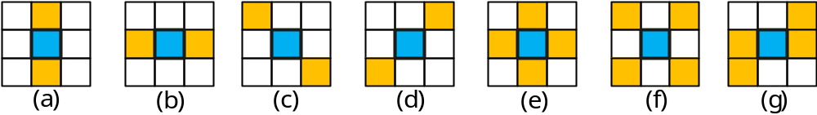
Figure 5: Supported EO classes in SAO.

- Questions to be answered
  - Separate gain of EO patterns and offset constraint removal
A: Compared to SAO on, it is reported that:
1) Offset constraint removal achieves 0.00%, -0.04%, and -0.17% luma BD-rates for AI, RA, and LB in VTM1.0 and 0.00%, 0.02%, and -0.07% luma BD-rates for AI, RA, and LB in BMS1.0. Simulation results are provided in CE2.3.1.1.
2) On top of Offset constraint removal, more EO patterns provides additional -0.04%, -0.09%, and 0.02% luma BD-rates for AI, RA, and LB in VTM1.0 and additional -0.02%, -0.05%, and -0.07% luma BD-rates for AI, RA, and LB in BMS1.0. Simulation results are provided in CE2.3.1.2.
No noticeable run time increase at encoder and decoder.

CE2.3.2 JVET-K0324
Signalling of SAO parameters could be done at block level, wherein the block could be smaller than an CTU. An index indicating the block size is selected by the encoder based on the RD cost and signaled in the bitstream for each slice. Specifically, in this proposal, the SAO parameters may be signaled for each square block of size equal to CTU size or CTU size divided by 4.
Two merge flags (i.e., sao_merge_left_flag and sao_merge_up_flag) may be signaled and are allowed to be both true. A common virtual label can then be assigned to all blocks which share the same SAO filter parameters as indicated by the merge flags. To simplify the parsing process, a merge flag can be true only if it does not lead to virtual labels such that two non-consecutive blocks in the same row share the same label.
- Questions to be answered
  - Separate gain of merge flags signalling and adaptive block sizes for SAO parameters signalling
A: Compared to SAO on, it is reported that:
1) SAO merge signaling achieves -0.12%, -0.25%, and -0.28% luma BD-rates for AI, RA, and LB in VTM1.0 and -0.09%, -0.15%, and -0.37% luma BD-rates for AI, RA, and LB in BMS1.0.
The decoding time increases are 4%, 9%, and 4% for AI, RA, and LB in VTM1.0 and 2%, 5%, and 3% for AI, RA, and LB in BMS1.0. Simulation results are provided in CE2.3.2.1.
2) On top of SAO merge signaling, adaptive block size provides additional 0.00%, -0.01%, and 0.03% BD-rates for AI, RA, and LB in VTM1.0 and additional -0.01%, -0.02%, and -0.05% BD-rates for AI, RA, and LB in BMS1.0.
The overall decoding time increases are 3%, 7%, and 5% for AI, RA, and LB in VTM1.0 and 1%, 4%, and 3% for AI, RA, and LB in BMS1.0. Simulation results are provided in CE2.3.2.2.
No noticeable encoding time increase

CE2.3.3 JVET-K0192
The inheritance of the SAO parameters is modified so that the blocks may inherit parameters from all the other blocks, as described in JVET-J0022. This brings more flexibility to SAO by widening the range of possible SAO parameters for one block, as depicted in Figure 6. The SAO palette is composed of a set of different SAO parameters. For each block, the syntax element sao_palette_idx indicates which SAO parameter to use.
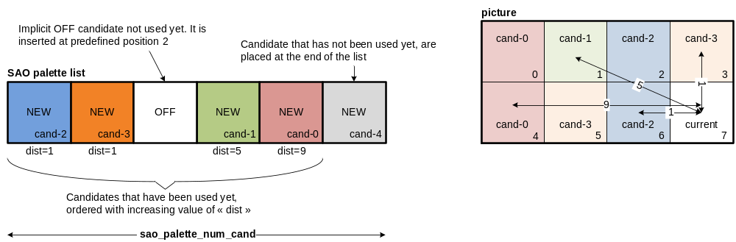
Figure 6: SAO palette
The size of the SAO palette is decoded first (sao_palette_num_cand), next the SAO parameters of the palette are decoded in their order of use, so they can be parsed progressively. The syntax of the SAO parameters is the same as HEVC, except the merge flags. For each block, the syntax element sao_palette_idx is parsed. At the post-filtering stage, the list of SAO parameters in the palette is reordered so that the SAO parameters which were already used by the closest neighboring blocks appear on top of the list.
Several different SAO block sizes are evaluated. In the slice header, a flag slice_sao_size_id indicates whether the SAO block size is same as CTU (cuWidth, cuHeight) or if it is different. Several sets of SAO size will be used (see Table 4).
Table 4: SAO block sizes.
slice_sao_size_id | SAO block width | SAO block height
0 | cuWidth | cuHeight
1 | cuWidth/2 | cuHeight/2
2 | cuWidth/2 | cuHeight
3 | cuWidth | cuHeight/2
4 | 2 * cuWidth | cuHeight
5 | cuWidth | 2 * cuHeight
6 | 2 * cuWidth | 2 * cuHeight
- Questions to be answered
  - Coding gains of SAO palette
  - Coding gains of the whole proposal, i.e., SAO palette + SAO block size
A: Compared to SAO on,
SAO palette achieves -0.17%, -0.29%, and -0.37% luma BD-rates for AI, RA, and LB in VTM1.0 and -0.15%, -0.18%, and -0.47% luma BD-rates for AI, RA, and LB in BMS1.0. Simulation results are provided in CE2.3.3.1.
On top of SAO palette signaling, adaptive block size provides additional 0.00%, -0.09%, and -0.15% BD-rates for AI, RA, and LB in VTM1.0 and additional 0.01%, -0.06%, and -0.09% BD-rates for AI, RA, and LB in BMS1.0. The overall reported cross-checker decoding time increases are 12%, 2%, and 11% for AI, RA, and LB in VTM1.0 and 2%, 10%, and 7% for AI, RA, and LB in BMS1.0. Simulation results are provided in CE2.3.3.2.
No noticeable encoding time increase.

CE2.3.4 JVET-K0176
The SAO parameters for each CTU are interleaved into slice data. However, to align with deblocking filter implementation, the SAO filtering region is shifted from the current CTU to the left and up. That is to say, the SAO parameters signaled in the current CTU are applied to a region with a position difference from the current CTU shown as Figure 7. The shifting number should be set according to the tap length of deblocking filter (e.g., 4 pixels in both horizontal and vertical direction).
signaled
applied

Figure 7. Example of SAO filter region and CTU.
The edge offset mode uses four 1-D directional patterns for sample classification: horizontal, vertical, 135°diagonal and 45°diagonal as HEVC. For a given EO patterns, samples of current CTU are classified into one of five categories. The classification rules to determine the category for each sample are summarized in Table 5. The offset values to be added to the reconstructed samples are signaled for each category except the category 0 in which the edge offset is not used.
Table 5: Classification rules for edge offset
Category | Condition | Offset Range
1 | c < a -3 && c < b -3 | 0 <= offset <= 10
2 | ( c < a -3 && |c-b|≤3) || (|c - a|≤3 && c < b -3) | 0 <= offset <= 10
3 | ( c > a +3 && |c-b|≤3) || ((|c - a|≤3 && c > b +3 ) | –10 <= offset <= 0
4 | c > a +3 && c > b +3 | –10 <= offset <= 0
0 | None of the above | None
For BO, the whole sample value range is equally divided into 32 bands, and sample values from 32k to 32k+31 belong to band k, where k ranges from 0 to 31. The low band (k=0 and 1) and the high band (k=30 and 31) are modified by offsets derived by encoder. Thus, there are 4 offsets in the bitstream if band offset mode is selected and the bands to be offset is no longer signalled. The range of signalled band offset for all the bands is [–10, 10]. And the offsets are left shifted 2-bit after parsing in 10bit sequences decoding.

- Questions to be answered
  - Coding performance of EO classification
A: Simulation results are provided in CE2.3.4.a.
  - Coding performance of BO modification
A: Simulation results are provided in CE2.3.4.b, CE2.3.4.c, .
  - Coding performance of shifted filtering region
A: Simulation results are provided in CE2.3.4.d.
  - Coding performance of the coding gain of offset range change only
A: Simulation results are provided in CE2.3.4.e.

CE2.3.5 JVET-K0153
CTU adaptive band offset method is used. The CTU adaptive band offset is an extension of HEVC band offset, and it adds offset value based on signalled band position and four continuous offset values. The differences are:
- The band position is adjusted based on min value of the target CTU in addition to signalled band position
- The band range is chosen based on CTU pixel range (i.e. max-min)
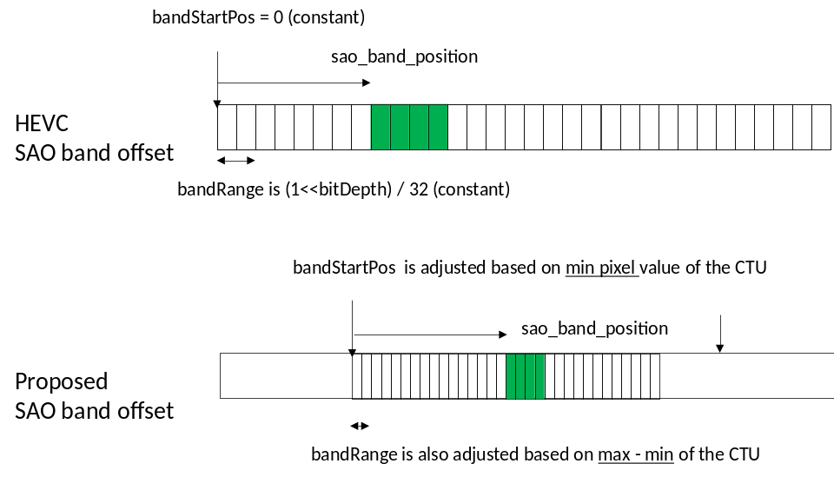
Figure 8: Illustration of band position adjustment and band range selection

Related contributions
JVET number | Title
JVET-K0201 | Non-CE2: On SAO parameter signalling
JVET-K0202 | Non-CE2: On SAO Edge Offset classification
JVET-K0238 | CE2-related: Improvements of sample adaptive offset

CE2.4: Adaptive loop filters

Test conditions
Sub-CE | Tool on (VTM_tool_test) | Tool off (BMS_tool_test) | Notes
Mandatory  (overall gain of ALF) | VTM + sub-CE test vs VTM | BMS – ALF + sub-CE test vs BMS – ALF | ALF: the ALF design in BMS
Option  (gains compared to the ALF in BMS) | VTM + sub-CE test vs VTM + ALF | BMS – ALF + sub-CE test vs BMS | ALF: the ALF design in BMS

Test specification
Test# | Description | Document#
AhG13 | Coding gain of ALF in BMS | JVET-K0013
2.4.1.1.a | Subsampled sum-modified-Laplacian with 4×4 level classification | JVET-K0164
2.4.1.1.b | Subsampled sum-modified-Laplacian with 2×2 level classification | JVET-K0164
2.4.1.2 | Adaptive Loop Filter Simplification | JVET-K0327
2.4.1.3 | ALF with Multiplication Replaced by Bit-Shifting | JVET-K0215
2.4.1.4.a | luma 7×7, classifier 2×2, chroma 5×5 | JVET-K0371
2.4.1.4.b | luma 7×7, classifier 2×2, chroma 7×7 | JVET-K0371
2.4.1.4.c | luma 7×7, classifier 4×4, chroma 5×5 | JVET-K0371
2.4.1.4.d | luma 7×7, classifier 4×4, chroma 7×7 | JVET-K0371
2.4.1.4.e | luma 9×9, classifier 2×2, chroma 5×5 | JVET-K0371
2.4.1.4.f | luma 9×9, classifier 2×2, chroma 7×7 | JVET-K0371
2.4.1.4.g | luma 9×9, classifier 4×4, chroma 5×5 | JVET-K0371
2.4.1.4.h | luma 9×9, classifier 4×4, chroma 7×7 | JVET-K0371
2.4.1.4.i | deblocking TC offset setting (-6 for AI, and TC offset -2 for RA and LB) | JVET-K0371
2.4.2.1.a | Multiple-feature based adaptive loop filter (MCALF)  with 4 classifiers (whole proposal) | JVET-K0285
2.4.2.1.b | MCALF with two classifiers $D_{G}$ (GALF classification) and $D_{S}$  (sample-based classification, like BO) | JVET-K0285
2.4.2.1.c | MCALF with two classifiers$D_{G}$ and $D_{R}^{1}$  (ranking with sample-based classification, 3×3 pattern) | JVET-K0285
2.4.2.1.d | MCALF with two classifiers $D_{G}$ and $D_{R}^{2}$  (ranking with local variation-based, cross-sign pattern) | JVET-K0285
2.4.2.2.a | CTB-based ALF with slice filter sets, 3 classification methods (whole proposal)  ( IntensitySA (like BO), SimilaritySA(5x5 diamond),  and GeometricBA (GALF classification)) | JVET-K0235
2.4.2.2.b | CTB-based ALF with slice filter sets, only IntensitySA and GeometricBA | JVET-K0235
2.4.2.2.c | CTB-based ALF with slice filter sets, only GeometricBA | JVET-K0235
2.4.2.2.d | CTB-based ALF with slice filter sets, only IntensitySA | JVET-K0235
2.4.2.2.e | CTB-based ALF with slice filter sets, single filter | JVET-K0235
2.4.2.3 | Unified Adaptive Loop Filter for Luma and Chroma | JVET-K0132
2.4.2.4 | Modified ALF classification: horizontal and vertical gradients  are calculated using Sobel filter | JVET-K0151

Comparisons of technologies
Notes: L for Luma and C for chroma; FF: Fixed Filters; ×: Multiplication; <<: shift; modifications are highlighted
Test# | Block classification granularity | # Samples for 1-D Laplacian value calculations  (worst case) | Line buffer size | Filter supports | FF | Filter | Max. Num. of filters per slice to be stored | Classification method selection | Filter decision require whole slice data?
BMS | 2×2 (L), N/A (C) | # samples in the whole slice (M) | 8 (L), 4 (C) | 9×9/7×7/5×5 diamond (L);  5×5 diamond (C) | Y | × | 25 (L)  1 (C) | N/A | Y
2.4.1.1.a | 4×4 (L), N/A (C) | M/2  (one dimension  subsample by 2) | 8 (L), 4 (C) | Same as BMS | Y | × | 25 (L)  1 (C) | N/A | Y
2.4.1.1.b | 2×2 (L), N/A (C) | M/2  (one dimension  subsample by 2) | 8 (L), 4 (C) | Same as BMS | Y | × | 25 (L)  1 (C) | N/A | Y
2.4.1.2 | 2×2 (L), N/A (C) | M/4 for highest temporal layer; and M for others  (two dimensions subsampled by 2) | 8 (L), 4 (C) | Same as BMS | Y | × | 25 (L)  1 (C) | N/A | Y
2.4.1.3 | 2×2 (L), N/A (C) | M | 8 (L), 4 (C) | Same as BMS | N | × and << | 25 (L)  1 (C) | N/A | Y
2.4.1.4.a | 2×2 (L), N/A (C) | M | 6(L), 4(C) | 7×7 (L), 5×5 (C) | Y | × | 25 (L)  1 (C) | N/A | Y
2.4.1.4.b | 2×2 (L), N/A (C) | M | 6(L), 6(C) | 7×7 (L), 7×7 (C) | Y | × | 25 (L)  1 (C) | N/A | Y
2.4.1.4.c | 4×4 (L), N/A (C) | M | 6(L), 4(C) | 7×7 (L), 5×5 (C) | Y | × | 25 (L)  1 (C) | N/A | Y
2.4.1.4.d | 4×4 (L), N/A (C) | M | 6(L), 6(C) | 7×7 (L), 7×7 (C) | Y | × | 25 (L)  1 (C) | N/A | Y
2.4.1.4.e | 2×2 (L), N/A (C) | M | 8(L), 4(C) | 9×9 (L), 5×5 (C) | Y | × | 25 (L)  1 (C) | N/A | Y
2.4.1.4.f | 2×2 (L), N/A (C) | M | 8(L), 6(C) | 9×9 (L), 7×7 (C) | Y | × | 25 (L)  1 (C) | N/A | Y
2.4.1.4.g | 4×4 (L), N/A (C) | M | 8(L), 4(C) | 9×9 (L), 5×5 (C) | Y | × | 25 (L)  1 (C) | N/A | Y
2.4.1.4.h | 4×4 (L), N/A (C) | M | 8(L), 6(C) | 9×9 (L), 7×7 (C) | Y | × | 25 (L)  1 (C) | N/A | Y
2.4.1.4.i | Same as in BMS |  |  |  |  |  | 25 (L)  1 (C) | N/A | Y
2.4.2.1 | 2×2, 1×1 (L),  N/A (C) | M | 8 (L), 4 (C) | Same as BMS | Y | × | 16 (L)  1 (C) | Slice-level | Y
2.4.2.2.a | 2×2, 1×1 (L),  N/A (C) | M | 8(L), 8(C) | 9×9 Cross +3×3Square with half or symmetry | N | × | 16 (L)  2 (C) | Slice-level | Y
2.4.2.2.b | 2×2, 1×1 (L),  N/A (C) | M | 8(L), 8(C) | 9×9 Cross +3×3Square with half or symmetry | N | × | 16 (L)  2 (C) | Slice-level | Y
2.4.2.2.c | 2×2 (L)  N/A (C) | M | 8(L), 8(C) | 9×9 Cross +3×3Square with half or symmetry | N | × | 16 (L)  2 (C) | Slice-level | Y
2.4.2.2.d | 1×1 (L),  N/A (C) | M | 8(L), 8(C) | 9×9 Cross +3×3Square with half or symmetry | N | × | 16 (L)  2(C) | Slice-level | Y
2.4.2.2.e | N/A (L),  N/A (C) | 0 | 8(L), 8(C) | 9×9 Cross +3×3Square with half or symmetry | N | × | 16L + 2C + (# of CTUs in one CTU row) * 3 (L)  2 (C) | N/A | Y
2.4.2.3 | 2×2 (L),  1×1 (C, inherited from luma) | M | 8 (L), 4 (C) | 9×9/7×7/5×5 diamond (L);  5×5 diamond (C) | Y | × | 25 (L)  1 (C) | N/A | Y
2.4.2.4 | Same as BMS (except gradient calculation is replaced by Sobel filter)

Test results (mandatory)
*: SIMD optimization for the proposed technology
**: running time unrealizable
***: different SIMD settings (other than default settings) are used

All Intra Main 10
 | VTM_tool_test |  |  |  |  | BMS_tool_test
Test# | Y | U | V | EncT | DecT | Y | U | V | EncT | DecT
AhG13 | -3.30% | -3.55% | -4.06% | 101% | 155% | -2.74% | -3.43% | -3.57% | 100% | 139%
2.4.1.1.a | -3.11% | -3.55% | -4.06% | 110% | 205% | -2.59% | -3.43% | -3.57% | 101% | 171%
2.4.1.1.b | -3.19% | -3.55% | -4.06% | 111% | 209% | -2.65% | -3.43% | -3.57% | 101% | 174%
2.4.1.2 | -3.30% | -3.55% | -4.06% | 102% | 170% | -2.74% | -3.43% | -3.57% | 100% | 154%
2.4.1.3 | -3.04% | -3.44% | -3.95% | 102% | 149% | -2.50% | -3.32% | -3.46% | 101% | 139%
2.4.1.4.a* | -3.10% | -3.56% | -4.07% | 101% | 124% | Missing
2.4.1.4.b* | -3.09% | -4.20% | -4.73% | 101% | 123% | -2.55% | -4.11% | -4.25% | 101% | 116%
2.4.1.4.c* | -2.99% | -3.56% | -4.07% | 101% | 114% | Missing
2.4.1.4.d* | -2.98% | -4.20% | -4.73% | 102% | 114% | -2.47% | -4.11% | -4.25% | 101% | 111%
2.4.1.4.e* | -3.28% | -3.54% | -4.05% | 103% | 130% | Missing
2.4.1.4.f* | -3.27% | -4.19% | -4.71% | 102% | 129% | -2.71% | -4.09% | -4.24% | 100% | 122%
2.4.1.4.g* | -3.17% | -3.54% | -4.05% | 102% | 119% | Missing
2.4.1.4.h* | -3.16% | -4.19% | -4.71% | 103% | 121% | -2.63% | -4.09% | -4.23% | 101% | 115%
2.4.1.4.i* | - | - | - | - | - | - | - | - | - | -
2.4.2.1.a | -3.32% | -3.55% | -4.06% | 103% | 162% | -2.77% | -3.43% | -3.57% | 100% | 145%
2.4.2.1.b | -3.31% | -3.55% | -4.06% | 102% | 165% | -2.76% | -3.43% | -3.57% | 100% | 144%
2.4.2.1.c | -3.31% | -3.55% | -4.06% | 102% | 164% | -2.76% | -3.43% | -3.57% | 100% | 145%
2.4.2.1.d | -3.30% | -3.55% | -4.06% | 102% | 166% | -2.75% | -3.43% | -3.57% | 100% | 146%
2.4.2.2.a | -2.70% | -4.94% | -5.69% | 102% | 133% | -2.18% | -4.95% | -5.60% | 100% | 124%
2.4.2.2.b | -2.69% | -4.94% | -5.69% | 101% | 132% | -2.17% | -4.95% | -5.60% | 100% | 123%
2.4.2.2.c | -2.66% | -4.94% | -5.69% | 101% | 134% | -2.13% | -4.94% | -5.60% | 100% | 125%
2.4.2.2.d | -2.07% | -4.96% | -5.71% | 101% | 117% | -1.66% | -4.99% | -5.63% | 100% | 113%
2.4.2.2.e | -1.89% | -4.97% | -5.71% | 101% | 114% | -1.49% | -5.00% | -5.65% | 100% | 110%
2.4.2.3 | Missing |  |  |  |  | Missing
2.4.2.4** | -3.10% | -3.37% | -3.89% | 109% | 249%

Random Access Main 10
 | VTM_tool_test |  |  |  |  | BMS_tool_test
Test# | Y | U | V | EncT | DecT | Y | U | V | EncT | DecT
AhG13 | -5.34% | -2.21% | -1.66% | 108% | 184% | -5.06% | -2.20% | -1.33% | 102% | 152%
2.4.1.1.a | -5.18% | -2.26% | -1.65% | 113% | 268% | -4.91% | -2.23% | -1.37% | 101% | 183%
2.4.1.1.b | -5.25% | -2.19% | -1.64% | 114% | 273% | -4.96% | -2.25% | -1.36% | 101% | 186%
2.4.1.2 | -5.26% | -2.23% | -1.67% | 109% | 200% | -4.98% | -2.24% | -1.34% | 102% | 169%
2.4.1.3 | -5.15% | -2.19% | -1.56% | 107% | 176% | -4.84% | -2.20% | -1.25% | 102% | 150%
2.4.1.4.a* | -5.10% | -2.29% | -1.69% | 105% | 135% | Missing
2.4.1.4.b* | -5.11% | -3.16% | -2.66% | 104% | 134% | -4.83% | -3.22% | -2.43% | 101% | 122%
2.4.1.4.c* | -4.99% | -2.24% | -1.66% | 104% | 122% | Missing
2.4.1.4.d* | -4.98% | -3.14% | -2.66% | 104% | 122% | -4.71% | -3.22% | -2.42% | 101% | 114%
2.4.1.4.e* | -5.33% | -2.21% | -1.63% | 108% | 143% | Missing
2.4.1.4.f* | -5.35% | -3.11% | -2.57% | 107% | 142% | -5.05% | -3.17% | -2.39% | 101% | 127%
2.4.1.4.g* | -5.21% | -2.20% | -1.66% | 107% | 129% | Missing
2.4.1.4.h* | -5.23% | -3.15% | -2.63% | 108% | 129% | -4.96% | -3.16% | -2.42% | 102% | 119%
2.4.1.4.i* | - | - | - | - | - | - | - | - | - | -
2.4.2.1.a | -5.61% | -2.22% | -1.66% | 111% | 197% | -5.34% | -2.19% | -1.31% | 102% | 159%
2.4.2.1.b | -5.53% | -2.21% | -1.67% | 109% | 200% | -5.26% | -2.22% | -1.32% | 102% | 157%
2.4.2.1.c | -5.60% | -2.21% | -1.64% | 109% | 197% | -5.34% | -2.17% | -1.31% | 102% | 159%
2.4.2.1.d | -5.53% | -2.24% | -1.66% | 110% | 201% | -5.27% | -2.24% | -1.32% | 102% | 158%
2.4.2.2.a | -4.85% | -5.25% | -5.08% | 101% | 145% | -4.62% | -5.40% | -5.18% | 101% | 129%
2.4.2.2.b | -4.82% | -5.24% | -5.09% | 101% | 144% | -4.57% | -5.39% | -5.17% | 101% | 127%
2.4.2.2.c | -4.66% | -5.26% | -5.10% | 100% | 148% | -4.43% | -5.42% | -5.20% | 100% | 131%
2.4.2.2.d | -3.72% | -5.12% | -4.95% | 100% | 123% | -3.56% | -5.29% | -5.05% | 100% | 114%
2.4.2.2.e | -3.41% | -5.16% | -4.96% | 100% | 118% | -3.27% | -5.31% | -5.09% | 100% | 112%
2.4.2.3 | Missing |  |  |  |  | Missing
2.4.2.4** | -5.33% | -2.18% | -1.79% | 117% | 343% | -5.06% | -2.21% | -1.50% | 104%

Low delay B
 | VTM_tool_test |  |  |  |  | BMS_tool_test
Test# | Y | U | V | EncT | DecT | Y | U | V | EncT | DecT
AhG13 | - | - | - | - | - | - | - | - | - | -
2.4.1.1.a | -4.41% | -1.80% | -1.85% | 119% | 216% | -4.14% | -1.65% | -1.57% | 102% | 171%
2.4.1.1.b | -4.45% | -1.81% | -1.94% | 120% | 219% | -4.24% | -1.72% | -1.62% | 105% | 173%
2.4.1.2 | -4.55% | -1.80% | -1.95% | 114% | 170% | -4.24% | -1.63% | -1.64% | 103% | 154%
2.4.1.3 | -4.52% | -1.79% | -2.16% | 112% | 154% | -4.29% | -1.74% | -1.92% | 103% | 143%
2.4.1.4.a* | -4.32% | -1.79% | -1.77% | 106% | 119% | Missing
2.4.1.4.b* | -4.31% | -2.63% | -2.72% | 107% | 122% | -4.04% | -2.39% | -2.31% | 101% | 118%
2.4.1.4.c* | -4.19% | -1.64% | -1.85% | 107% | 114% | Missing
2.4.1.4.d* | -4.23% | -2.44% | -2.57% | 107% | 116% | -3.98% | -2.31% | -2.55% | 101% | 111%
2.4.1.4.e* | -4.56% | -1.81% | -2.01% | 110% | 125% | Missing
2.4.1.4.f* | -4.63% | -2.61% | -2.88% | 111% | 128% | -4.35% | -2.48% | -2.53% | 103% | 124%
2.4.1.4.g* | -4.46% | -1.83% | -2.01% | 110% | 117% | Missing
2.4.1.4.h* | -4.49% | -2.59% | -2.72% | 111% | 116% | -4.30% | -2.48% | -2.62% | 103% | 118%
2.4.1.4.i* | - | - | - | - | - | - | - | - | - | -
2.4.2.1.a | -5.19% | -1.74% | -2.04% | 117% | 167% | -4.86% | -1.76% | -1.83% | 104% | 148%
2.4.2.1.b | -4.97% | -1.96% | -2.13% | 115% | 167% | -4.71% | -1.75% | -1.73% | 104% | 149%
2.4.2.1.c | -5.14% | -1.99% | -1.94% | 113% | 165% | -4.83% | -1.76% | -1.60% | 103% | 149%
2.4.2.1.d | -4.90% | -1.67% | -2.04% | 115% | 169% | -4.63% | -1.89% | -1.88% | 104% | 151%
2.4.2.2.a | -4.60% | -7.42% | -7.19% | 102% | 137% | -4.35% | -7.24% | -6.96% | 100% | 128%
2.4.2.2.b | -4.52% | -7.51% | -6.97% | 101% | 135% | -4.24% | -7.40% | -6.72% | 101% | 126%
2.4.2.2.c | -4.19% | -7.48% | -6.97% | 101% | 136% | -3.95% | -7.42% | -6.79% | 100% | 128%
2.4.2.2.d | -3.38% | -7.30% | -6.96% | 101% | 118% | -3.19% | -7.37% | -7.11% | 101% | 115%
2.4.2.2.e | -2.94% | -7.33% | -6.95% | 101% | 113% | -2.78% | -7.41% | -6.80% | 101% | 111%
2.4.2.3 | Missing |  |  |  |  | Missing
2.4.2.4** | -4.58% | -1.66% | -2.01% | 126% | 259% | Missing

Low delay P
 | VTM_tool_test |  |  |  |  | BMS_tool_test
Test# | Y | U | V | EncT | DecT | Y | U | V | EncT | DecT
AhG13 | - | - | - | - | - | - | - | - | - | -
2.4.2.1.a | -7.74% | -2.54% | -3% | 121% | 166% | -7.38% | -2% | -2% | 104% | 150%

Crosscheck report of mandatory test results
Test# | Cross-checker | PSNR&BR Match  (Y/N) | RunT matched?  (Y/N) | SW implemented by cc?  (Y/N) | SW studied?  (Y/N) | significant inconsistencies between the description and the provided software? (Y/N) | Other comments? | Other  tests?  (Y/N)
2.4.1.1.a
2.4.1.1.b
2.4.1.2
2.4.1.3
2.4.1.4.a
2.4.1.4.b | Y.-C. Su | Y | Y | N | Y | N | Use SIMD to speed up block classification and filtering process | N
2.4.1.4.c
2.4.1.4.d | Y.-C. Su | Y | Y | N | Y | N | Use SIMD to speed up block classification and filtering process | N
2.4.1.4.e
2.4.1.4.f
2.4.1.4.g
2.4.1.4.h
2.4.1.4.i
2.4.2.1.a
2.4.2.1.b
2.4.2.1.c
2.4.2.1.d
2.4.2.2.a
2.4.2.2.b
2.4.2.2.c
2.4.2.2.d
2.4.2.2.e
2.4.2.3 | C.-M. Tsai | Y | Y | N | Y | N | N | Only BMS is tested
2.4.2.4

Test# | Cross-checker | All Intra Main 10 |  |  |  | Random Access Main 10 |  |  |  | Low Delay B Main 10
Test# | Cross-checker | VTM_tool_test |  | BMS_tool_test |  | VTM_tool_test |  | BMS_tool_test |  | VTM_tool_test |  | BMS_tool_test
Test# | Cross-checker | EncT | DecT | EncT | DecT | EncT | DecT | EncT | DecT | EncT | DecT | EncT | DecT
2.4.1.1.a
2.4.1.1.b
2.4.1.2
2.4.1.3
2.4.1.4.a
2.4.1.4.b | Y.-C. Su | 101% | 124% | 100% | 118% | 105% | 138% | 102% | 122% | 108% | 124% | 102% | 119%
2.4.1.4.c
2.4.1.4.d | Y.-C. Su | 102% | 117% | 100% | 113% | 105% | 127% | 101% | 118% | 108% | 117% | 102% | 114%
2.4.1.4.e
2.4.1.4.f
2.4.1.4.g
2.4.1.4.h
2.4.1.4.i
2.4.2.1.a
2.4.2.1.b
2.4.2.1.c
2.4.2.1.d
2.4.2.2.a
2.4.2.2.b
2.4.2.2.c
2.4.2.2.d
2.4.2.2.e
2.4.2.3 | C.-M. Tsai  (anchor is ALF on) |  |  | 100% | 100% |  |  | 101% | 100% |  |  | 102% | 101%
2.4.2.4

Test results (option)
*: SIMD optimization for the proposed technology
**: running time unrealizable
***: different SIMD settings (other than default settings) are used

All Intra Main 10
 | VTM_tool_test |  |  |  |  | BMS_tool_test
Test# | Y | U | V | EncT | DecT | Y | U | V | EncT | DecT
2.4.1.1 | 0.19% | 0.00% | 0.00% | 101% | 96% | 0.15% | 0.01% | 0.01% | 101% | 97%
2.4.1.2 | - | - | - | - | - | - | - | - | - | -
2.4.1.3 |  |  |  |  |  | 0.25% | 0.11% | 0.11% | 101% | 100%
2.4.1.4.i* |  |  |  |  |  | -0.87% | -0.57% | -0.10% | 100% | 100%
2.4.2.3 |  |  |  |  |  | 0.04% | -1.06% | -1.14% | 100% | 100%

Random Access Main 10
 | VTM_tool_test |  |  |  |  | BMS_tool_test
Test# | Y | U | V | EncT | DecT | Y | U | V | EncT | DecT
2.4.1.1 | 0.18% | -0.05% | 0.02% | 100% | 96% | 0.17% | -0.03% | -0.04% | 100% | 97%
2.4.1.2 | 0.09% | -0.02% | -0.01% | 100% | 97% | 0.09% | -0.04% | -0.01% | 100% | 97%
2.4.1.3 |  |  |  |  |  | 0.24% | 0.00% | 0.07% | 100% | 100%
2.4.1.4.i* |  |  |  |  |  | -0.19% | -0.55% | -0.50% | 100% | 100%
2.4.2.3 |  |  |  |  |  | 0.03% | -4.02% | -2.95% | 101% | 100%

Low delay B
 | VTM_tool_test |  |  |  |  | BMS_tool_test
Test# | Y | U | V | EncT | DecT | Y | U | V | EncT | DecT
2.4.1.1 | 0.15% | 0.00% | 0.10% | 100% | 96% | 0.10% | -0.03% | 0.08% | 100% | 97%
2.4.1.2 | - | - | - | - | -
2.4.1.3 |  |  |  |  |  | -0.06% | -0.12% | -0.28% | 100% | 101%
2.4.1.4.i* |  |  |  |  |  | -0.44% | -0.33% | -0.09% | 100% | 99%
2.4.2.3 |  |  |  |  |  | -0.13% | -6.38% | -5.29% | 102% | 101%

Low delay P
 | VTM_tool_test |  |  |  |  | BMS_tool_test
Test# | Y | U | V | EncT | DecT | Y | U | V | EncT | DecT
2.4.2.1 |  |  |  |  |  | -0.14% | -7.55% | -6.56% | 101% | 100%

Crosscheck report of option test results
Test# | Cross-checker | PSNR&BR Match  (Y/N) | RunT matched?  (Y/N) | SW implemented by cc?  (Y/N) | SW studied?  (Y/N) | significant inconsistencies between the description and the provided software? (Y/N) | Other comments? | Other  tests?  (Y/N)
CE2.1.1 | A
CE2.1.1 | B

Test# | Cross-checker | All Intra Main 10 |  |  |  | Random Access Main 10
Test# | Cross-checker | VTM_tool_test |  | BMS_tool_test |  | VTM_tool_test |  | BMS_tool_test
Test# | Cross-checker | EncT | DecT | EncT | DecT | EncT | DecT | EncT | DecT
AhG13
CE2.1.1 | A

Test# | Cross-checker | Low Delay B Main 10 |  |  |  | Low Delay P Main 10
Test# | Cross-checker | VTM_tool_test |  | BMS_tool_test |  | VTM_tool_test |  | BMS_tool_test
Test# | Cross-checker | EncT | DecT | EncT | DecT | EncT | DecT | EncT | DecT
AhG13
CE2.1.1 | A

Detailed description of tests

CE2.4.1: Low-Complexity ALF

CE2.4.1.1 JVET-K0164
4×4 block classification based on subsampled sum-modified-Laplacian (SSML) is used. Figure 9 (a), (b), (c), and (d) show positions of calculating 1-D Laplacian, for gradients, g_{v}, g_{h}, g_{d1} and g_{d2}, respectively, for a 4×4 block. All of them are calculated at the subsampled positions within 8×8 window. The rest of derivation process for class index with the calculated gradients, g_{v}, g_{h}, g_{d1} and g_{d2}, is the same as in BMS1.0.

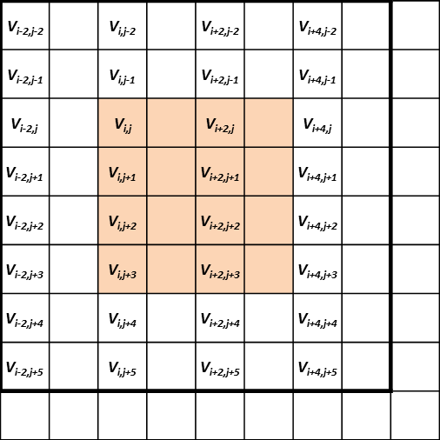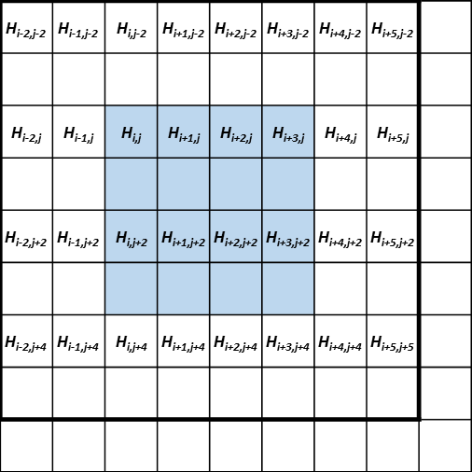
(a) Calculation of vertical gradient, g_{v} (b) Calculation of horizontal gradient, g_{h}

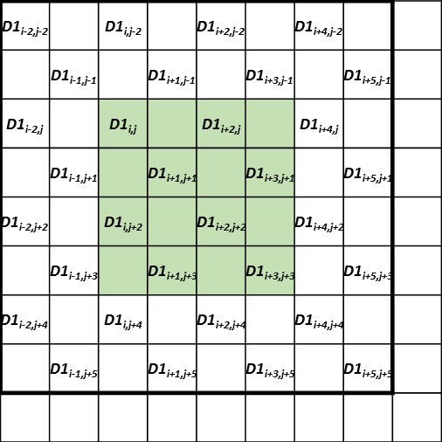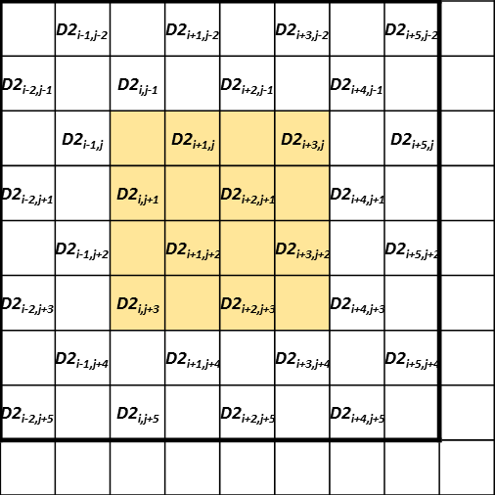
(c) Calculation of diagonal gradients, g_{d1} (d) Calculation of diagonal gradients, g_{d2}
Figure 9: Calculation of gradients

CE2.4.1.2 JVET-K0327
- Technology to be investigated
The adaptive loop filter in this response is based on JEM-7.0. The derivative calculation of 2×2 block for those pictures at the highest temporal layer is simplified by calculating the derivative only at top-left sample position (the gray circles in Figure 10) of each 2×2 block as follows
$$G_{2×2}^{dir}=\left|g^{dir}\left(i_{0},j_{0}\right)\right|$$ | (6)
where dir is the direction such as horizontal, vertical, diagonal and anti-diagonal, and $g^{dir}\left(i_{0},j_{0}\right)$ is the derivative at the top-left sample position of each 2×2 luma block.
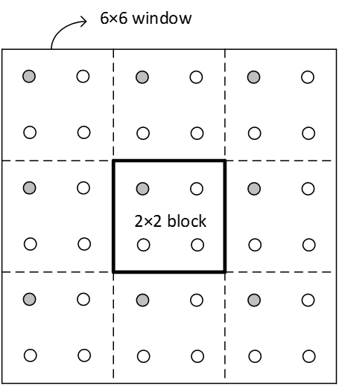
Figure 10. Block classification for a 2×2 block. (Gray circles represent pixels for which derivatives are calculated)
[2] Questions to be answered
Q: Impact on the complexity and BD-rate performance.
A: For the highest temporal layer, the classification computational complexity could be reduced by 75% with 3% decoding time saving and 0.09% loss for the RA.

CE2.4.1.3 JVET-K0215 [14]
Two aspects have been proposed:
- filter coefficient prediction from predefined fixed filters are prohibited
- Replacing multiplication with bit-shifting
In the proposed ALF, the filter coefficients used in filtering of the luma component is divided into 2 groups. The first group contains that coefficients {L0, L1, L2, L3, L4, L5, L7, L8, L9, L10. L14, L15, L16, L17}, and the second group contains the rest of the coefficients. The first group coefficients are normatively restricted to use only the following set of values: {–64, –32, –16, –8, –4, 0, 4, 8, 16, 32, 64}, hence multiplication with those coefficients can be implemented as a single bit shit operation. The allowed filter coefficient values are mapped to {–5, –4, –3, –2, –1, 0, 1, 2, 3, 4, 5} respectively before binarization in order to reduce the signalling overhead.

CE2.4.1.4 JVET-K0371 [11]
- Technology to be investigated
As in JEM7.0, the diagonal gradients are taken into consideration during classification, geometric transformations of filter coefficients and prediction from fixed filters are also employed. For the luma component, each 2×2 block is classified based on its directionality and 2D Laplacian activity. Three filter supports are allowed, i.e., 9×9, 7×7 and 5×5 diamond filter supports. For each slice, one of the three filter supports is chosen according to rate-distortion cost and signaled in the bitstream. For the chroma component, there is no classification and only 5×5 diamond filter support is allowed without being signalled.
- Questions to be answered
- Coding performance impact of replacing 2×2 luma block classification by 4×4 luma block classification.
A: 0.11% loss with 10% decoding time saving (by comparing CE2.4.1.4a vs CE2.4.1.4.c, CE2.4.1.4.e vs CE2.4.1.4.g)
- Coding performance impact of limitation of one filter support for luma component, such as only 7×7 or 5×5 diamond filter support.
A: 0.20%, 0.24% loss for AI and RA, respectively with xx decoding time saving (by comparing CE2.4.1.4.a vs AhG13 ALF results)

CE2.4.2: High-Efficiency ALF

CE2.4.2.1 Multiple-feature based adaptive loop filter (JVET-K0285 [7])
- Technology to be investigated
The adaptive loop filter uses the same approach for filtering and signalling of filter coefficients as ALF (JEM). However, the classification for the luma component is modified. In general, a classification of the reconstructed samples $s'(i,j)$ is given as
$C_{k}^{D}=\left\{\left(i,j\right)∈I :D\left(i,j\right)=k\right\}$ for $k=0,…,K-1$
where $I$ is a set of all sample locations of the reconstructed samples $s'(i,j)$. $D$ is a classifier that assign a class index $k ∈\left\{0,…,K-1\right\}$ to each sample location $(i,j)$. And a class $C_{k}^{D}$ is the collection of all sample to which the class index $k$ is assigned by the classifier $D$. $K$ specifies the number of classes. The MCALF supports four different classifiers, each of which provides $K=25$ classes$.$ The classifier that is used in the decoder is specified by the syntax element classification_idx, which is transmitted at a slice level. Given the classes $C_{k}^{D}$, with $k ∈\left\{0,…,K-1\right\}$, the adaptive loop filter proceeds as in JEM.
Depending on the value of classification_idx, the following applies:
- If classification_idx is equal to 0, the classifier $D_{G}$ specified for ALF in JEM is used. The classifier provides $K=25$ classes. The samples are classified based on the direction and activity of local gradient in the reconstructed picture$.$
- Otherwise, if classification_idx is equal to 1, a sample-based feature descriptor $D_{S}$ is used
as classifier. $D_{S}(i,j)$ simply takes the quantized sample value of each sample $s'\left(i,j\right)$ according to

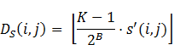
where $B$ is the sample bit depth, the number of classes $K$ is set equal $K=25$, and the operator
specifies rounding to the largest integer not larger than the argument$.$

- Otherwise, if classification_idx is equal to 2, a ranking with sample-based feature descriptor $D_{R}^{1}$ is used. The ranking with sample-based feature descriptor $D_{R}^{1}$ is specified as follows. Let $r_{8}\left(i,j\right)$ be a descriptor that ranks a sample value $s'\left(i,j\right)$ in order of its magnitude compared to its 8 neighboring samples,
$$r_{8}\left(i,j\right)=\sum_{k=i-1}^{i+1}{\sum_{l=j-1}^{j+1}{\left( s^{'}\left(i,j\right)<s'\left(k,l\right) ? 1 : 0 \right)}}.$$
The descriptor $r_{8}\left(i,j\right)$ can take values in the range of 0 to 8, inclusive. If the sample $s'\left(i,j\right)$ is the largest sample inside the $3×3$ block centered around $\left(i,j\right)$, the value of $r_{8}\left(i,j\right)$ is equal to 0. If $s'\left(i,j\right)$ is the second largest sample, $r_{8}\left(i,j\right)$ is equal to 1, etc. After that, the value of $r_{8}\left(i,j\right)$ is quantized to 5 distinct values, 0,1,..,4 by$min⁡(\left\lfloor \frac{5}{8}⋅r_{8}\left(i,j\right)\right\rfloor ,4)$. Then the dynamic range for the samples is divided into 5 bands with about equal size and inside each band, the quantized rank of the sample in its local neighborhood is used as additional criterion, which gives $5×5$ = 25 classes.
- Otherwise (classification_idx is equal to 3), a ranking with local variation-based feature descriptor $D_{R}^{2}$ is used. The feature descriptor $D_{R}^{2}$ applies the same procedure as $D_{R}^{1}$ except that the dynamic range for local variation $v\left(i,j\right)$ instead of the samples is divided into 4 bands, where the local variation $v\left(i,j\right)$ at each sample location$(i,j)$ is given as
$$v\left(i,j\right)={|4*s}^{'}\left(i,j\right)-(s^{'}\left(i-1,j\right)+s^{'}\left(i+1,j\right){+s}^{'}\left(i,j+1\right)+s^{'}(i,j-1))|$$
Those 4 bands are specified by some fixed threshold parameters $T_{1}$,$T_{2}$,$T_{3}$.
- Questions to be answered
- Separate coding gains from sample-based feature descriptor and ranking-based feature descriptor
A: On top of BMS1.0, under RA configuration, additional 0.20%, 0.28%, 0.21% coding gains for $D_{S}$, $D_{R}^{1}$,$D_{R}^{2}. P$lease refer to section 4.4.2 for details.

CE2.4.2.2 CTU-based ALF with slice filter set (JVET-J0018 [9])
- Technology to be investigated
CTB-based ALF with slice filter set is proposed in JVET-J0018. At slice level, up to 16 filters with three pixel classification methods, i.e., IntensityClassifier, HistogramClassifier, and DirectionalActivityClassifier, can be used for current slice. At CTB level, based on the control flags signalled in slice header, three modes, NewFilterMode, SpatialFilterMode, and SliceFilterMode, at most are supported to achieve CTB-based adaptation. As for filter footprint, two kinds of symmetries are supported in ALF, as shown in Figure 11 (a) and (b).
- IntensityClassifier is the same as band offset in SAO. The range of sample intensity is divided into 32 groups, and the group index is decided based on the intensity of to-be-processed sample.
- In SimilarityClassifier, neighboring samples in one 5x5 diamond shape are used to compare with the to-be-processed sample, as shown in Figure 11 (c). The group index of the to-be-processed sample is first reset to zero. If the difference between a neighboring sample and the to-be-processed sample is larger than one pre-defined threshold, then the group index is increased by 1. If the difference between the neighboring sample and the to-be-processed sample is larger than two times of the pre-defined threshold, then additional 1 is added to the group index. Totally, there are 25 groups in SimilarityClassifier.
- RotBAClassifier is almost the same as the block classification with geometric transform in JEM ALF, except the size of activity window for one 2x2 block is reduced from 6x6 to 4x4. In this classification, there are 25 groups at most. Although the number of groups is up to 25 or 32 in different classifiers, the number of filters in one set of slice filters is limited to 16 at most. That is, the encoder merges successive groups to keep the number of merged groups smaller than or equal to 16.

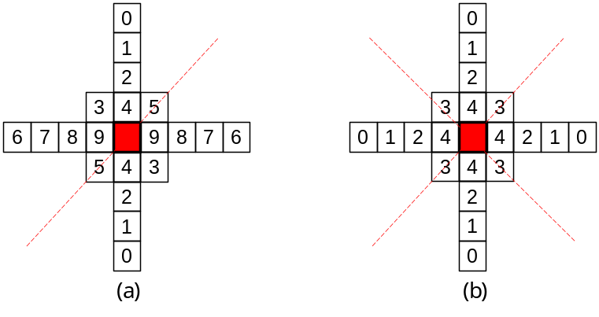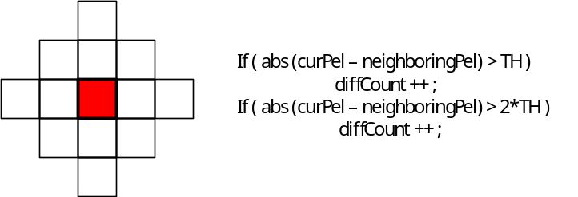
(c)
Figure 11. ALF FilterShape and footprint of SimilarityClassifier. (a) 9x9Cross + 3x3Square with half symmetry, 11 coefficients. (b) 9x9Cross + 3x3Square with full symmetry, 6 coefficients. (c) Footprint of SimilarityClassifier.

- Questions to be answered
  - Separate coding gains from the slice-level filter set
A: Missing.

  - Coding loss by disabling IntensityClassifier
A: The coding performance of disabling IntensityClassifier can be derived by comparing the results of CE2.4.2.2.b and CE2.4.2.2.c or comparing the results of CE2.4.2.2.e and CE2.4.2.2d.
When GeometricBA (RotBAClassifier) is used , disabling IntensityClassifer suffers 0.03%, 0.16%, and 0.33% BD-rates loss with 2%, 4% and 1% decoding time increase for AI, RA, and LB in VTM1.0. For BMS, disabling IntensityClassifer suffers 0.04%, 0.14%, and 0.29% BD-rates loss with 2%, 4% and 2% decoding time increase for AI, RA, and LB.
Compared CE2.4.2.2.d with CE2.4.2.2e, enabling IntensityClassifer can achieve 0.18%, 0.31%, and 0.44% BD-rates saving with 3%, 5%, and 5% decoding time increase for AI, RA, and LB in VTM1.0. For BMS, enabling IntensityClassifer provides 0.17%, 0.29%, and 0.41% BD-rates saving with 3%, 2% and 4% decoding time increase for AI, RA, and LB.
  - Coding loss by disabling SimilarityClassifier
A: On top of VTM, 0.01%, 0.03% and 0.08% loss for AI, RA, LDB, respectively. On top of BMS, 0.01%, 0.05%, 0.11% loss for AI, RA, LDB, respectively (by comparing 2.4.2.2.a to 2.4.2.2.b).

CE2.4.2.3 Luma and chroma unified ALF (JVET-K0132 [14])
- Technology to be investigated
In the proposed unified ALF mode, the chroma sample classification and on/off decision directly re-use the results of the co-located luma sample so that there is no complexity increase for the chroma classification. The chroma ALF coefficients also re-use those of luma but with a constant 5x5 diamond taps to keep the complexity of chroma filtering unchanged. The ALF coefficients conversion from luma 9x9 taps to chroma 5x5 taps is shown in Figure 11 and equations (7) - (13). For luma 7x7 and 5x5 taps, the outermost coefficients in Figure 11 (a) are set to 0 accordingly, and the equations (7) - (13) still work. As a special case, for luma 5x5 taps, the luma ALF coefficients are exactly the same as chroma.

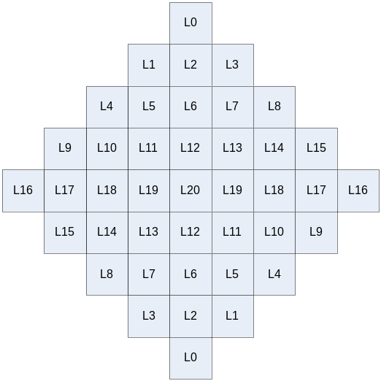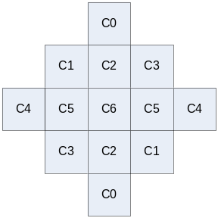
- (b)
Figure 12. 9x9 diamond taps luma filter (a) and 5x5 diamond taps chroma filter (b)

 | C0=L0+L1+L2+L3+L6 | (7)
 | C1=L4+L5+L10+L11 | (8)
 | C2=L12 | (9)
 | C3=L7+L8+L13+L14 | (10)
 | C4=L9+L15+L16+L17+L18 | (11)
 | C5=L19 | (12)
 | C6=L20 | (13)
Figure 12 illustrates the idea behind the coefficients conversion from luma to chroma as shown in (7)-(13). In the Figure 13:(a) the luma coefficients are directly applied to chroma pixels resulting in an increased number of pixels (9x9 diamond) participating in the chroma ALF processing. In order to keep the chroma ALF still using only 5x5 diamond pixels, the pixels out of the 5x5 diamond border are replaced by the pixels lying in the 5x5 diamond border as shown in Figure 13:(b). Apparently, applying the 9x9 diamond coefficients to a border-extended 5x5 diamond pixels as shown in Figure 13:(b) is equivalent to applying a 5x5 diamond coefficients to the 5x5 diamond pixels as shown in Figure 13:(c). The 5x5 diamond coefficients in Figure 13:(c) are converted from the 9x9 diamond coefficients as shown in (7)-(13).

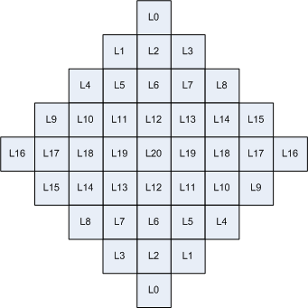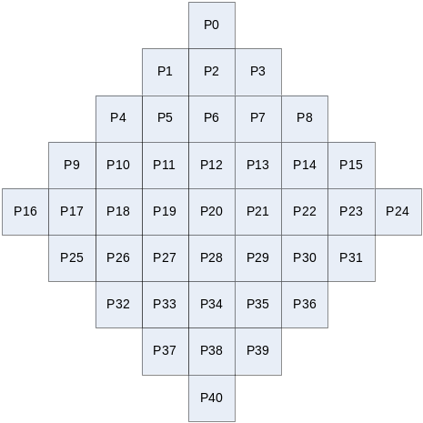
- Apply 9x9 luma coeff.(left) to chroma pixels (right) directly

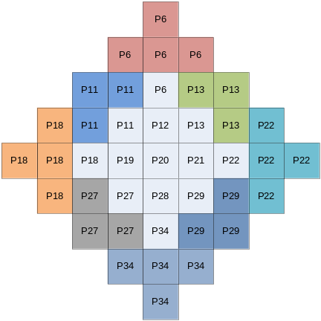
- Apply 9x9 luma coeff.(left) to border-extended chroma pixels (right) for simplification

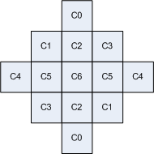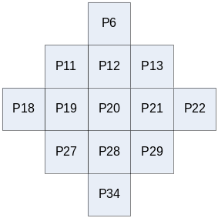
- Apply 5x5 coeff. (left) to 5x5 chroma pixels (right). Equivalent to (b)
Figure 13:The evolution process of the coefficients conversion from luma 9x9 diamond to chroma 5x5 diamond.
Besides the proposed unified ALF mode, the original separate ALF for luma and chroma as in JEM is also supported. For the separate ALF mode, a CTU level on/off control for chroma ALF is newly added in this proposed method. A flag is added at picture level to indicate whether the unified mode or the separate mode is used.

- Questions to be answered
  - Separate coding gain from each of the four aspects
A: Missing
  - Impact on subjective quality
A: needs to be evaluated

CE2.4.2.4 Modified ALF classification method (JVET-J0028 [17])
In JEM, each 2x2 block for the luma component is classified based on its directionality and 2D Laplacian activity. Proposed gradient feature can provide a better classification for the ALF. Values of horizontal and vertical gradients are calculated using Sobel filter:

$$\frac{∂}{∂x}=\left(\begin{matrix}-1 & 0 & 1 \\ -2 & 0 & 2 \\ -1 & 0 & 1\end{matrix}\right) \frac{∂}{∂y}=\left(\begin{matrix}-1 & -2 & -1 \\ 0 & 0 & 0 \\ 1 & 2 & 1\end{matrix}\right)$$
The representative vector is calculated so that a given condition below is satisfied for gradient vectors within a certain window size (e.g. 6x6). According to $θ$, the direction and transformation are identified.
$$arg\max_{θ}{J\left(θ\right)}=arg\max_{θ}{\sum_{i}{〈\vec{e\left(θ\right)}, {\vec{t}}_{i}〉}}=arg\max_{θ}{\sum_{i}{{\left|t_{i}\right|}^{2}{\cos\left(θ-∅_{i}\right)}^{2}}}$$
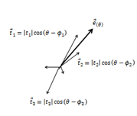
Figure 14: Calculatoin of ${\vec{t}}_{i}$.
Then the similarity between the representative vector and each gradient vector within the window are calculated using the inner product.
$$S=\sum_{i}{〈\vec{e\left(θ\right)}, {\vec{t}}_{i}〉}$$
If $S >{th}_{1 }$, D is set to 0.
If $θ ∈\left(D0 or D1\right) and S <{th}_{2 }$, D is set to 2, otherwise D is set to 1.
If $θ ∈\left(V or H\right) and S <{th}_{2 }$, D is set to 4, otherwise D is set to 3.
The total number of class which is the same as for JEM is twenty-five.

Related contributions
JVET number | Title
JVET-K0239 | CE2-related: Filter size reduction in CTB-based ALF
JVET-K0372 | CE2-related: Additional results for CE2.4.1.4 with chroma filter shape aligned with luma
JVET-K0373 | CE2-related: Two-dimensional ALF classification
JVET-K0382 | CE2-related: CTU Based Adaptive Loop Filtering
JVET-K0388 | CE2-related: Improvement on the implementation of adaptive loop filter

CE2.5: Non-local filters

Test conditions
Sub-CE | Tool on (VTM_tool_test) | Tool off (BMS_tool_test)
Mandatory  (overall gain of non-local filters) | VTM + sub-CE test vs VTM | BMS + sub-CE test vs BMS

Test specification
Test# | Description | Document#
2.5.1 | Non-local Structure-based Filter | JVET-K0160
2.5.2 | Non-local mean in-loop filter | JVET-K0236
2.5.3 | Noise Suppression Filter | JVET-K0053

Comparisons of technologies
Notes: SVD: singular-value decomposition
Test# | Line buffer size | Filter unit | Search window size | Overlapped units? | matching criterion | Division  Required? | How to filter | Matrix size/filter tap | Filter coeffs | On/off control | Stage
2.5.1 | 8 (L), 4 (C) | 6×6 | 32×32 | Y | SSD | Y | SVD-based filtering | 21×6×6 | Derived on-the-fly | Frame and CTU level | After deblocking, before SAO
2.5.2 |  | 8×8 | 33 x 33 | N | SSD | Y | Linear filter with normalization | 16-tap | Based on estimated quantization noise (signalled index) and SSD between current and reference patch | Slice/CTB/  32×32 | After deblocking, before SAO
2.5.3 | 0 (L)  0 (C) | 8×8 | 16×16 within CTB | N | SSD | Y | Noise Suppressor’s Collaborative Filter in Hadamard transform domain | Hadamard transform 8x1; 8x1-tap filter | Based on QP value | Slice/256×256/128×128/64×64/32×32 | After SAO, before ALF

Test results (mandatory)
*: SIMD optimization for the proposed technology
**: running time unrealizable
***: different SIMD settings (other than default setting) are used

All Intra Main 10
 | VTM_tool_test |  |  |  |  | BMS_tool_test
Test# | Y | U | V | EncT | DecT | Y | U | V | EncT | DecT
2.5.1 | -2.55% | -4.26% | -5.03% | 108%
2.5.2* | -0.63% | -1.98% | -1.99% | 102% | 235% | -0.31% | -1.45% | -1.48% | 100% | 167%
2.5.3.a* | -0.61% | -1.58% | -1.79% | 100% | 135% | -0.34% | -0.81% | -0.90% | 100% | 119%
2.5.3.b* | -0.61% | 0.09% | 0.09% | 100% | 125% | -0.34% | 0.11% | 0.11% | 100% | 113%

Random Access Main 10
 | VTM_tool_test |  |  |  |  | BMS_tool_test
Test# | Y | U | V | EncT | DecT | Y | U | V | EncT | DecT
2.5.1
2.5.2* | -1.24% | -3.95% | -3.49% | 100% | 211% | -0.57% | -3.57% | -3.25% | 100% | 139%
2.5.3.a* | -1.03% | -2.04% | -1.89% | 100% | 134% | -0.62% | -2.41% | -2.42% | 100% | 114%
2.5.3.b* | -0.99% | -0.02% | 0.00% | 100% | 123% | -0.60% | 0.18% | 0.18% | 100% | 109%

Low delay B
 | VTM_tool_test |  |  |  |  | BMS_tool_test
Test# | Y | U | V | EncT | DecT | Y | U | V | EncT | DecT
2.5.1 | -2.20% | -0.84% | -1.27% | 112%
2.5.2* | -1.00% | -3.99% | -4.24% | 101% | 179% | -0.76% | -3.94% | -3.99% | 101% | 138%
2.5.3.a* | -0.67% | -1.49% | -1.59% | 100% | 128% | -0.73% | -2.58% | -2.35% | 100% | 117%
2.5.3.b* | -0.62% | 0.69% | 0.50% | 100% | 119%

Low delay P
 | VTM_tool_test |  |  |  |  | BMS_tool_test
Test# | Y | U | V | EncT | DecT | Y | U | V | EncT | DecT
2.5.1
2.5.2
2.5.3.a | -2.61% | -3.40% | -3.47% | 100% | 138% | -0.93% | -4.03% | -3.84% | 100% | 120%
2.5.3.b | -2.50% | -0.03% | -0.22% | 100% | 126%

Crosscheck report of mandatory test results
Test# | Cross-checker | PSNR&BR Match  (Y/N) | RunT matched?  (Y/N) | SW implemented by cc?  (Y/N) | SW studied?  (Y/N) | significant inconsistencies between the description and the provided software? (Y/N) | Other comments? | Other  tests?  (Y/N)
2.5.1 | J. Lai | Y | N | N | Y | N | SSE42 is used to run simulation | N
2.5.2
2.5.3.a
2.5.3.b

Test# | Cross-checker | All Intra Main 10 |  |  |  | Random Access Main 10 |  |  |  | Low Delay B Main 10
Test# | Cross-checker | VTM_tool_test |  | BMS_tool_test |  | VTM_tool_test |  | BMS_tool_test |  | VTM_tool_test |  | BMS_tool_test
Test# | Cross-checker | EncT | DecT | EncT | DecT | EncT | DecT | EncT | DecT | EncT | DecT | EncT | DecT
2.5.1 | J. Lai | 109% | 5620% | 101% | 2873% | 108% | 4162% | 103% | 1762% | 112% | 3428% | 105% | 2029%
2.5.2
2.5.3.a
2.5.3.b

CE2.5.1 Non-Local Structure-based Filter JVET-K0160
- Technology to be investigated
NLSF (Non-Local Structure-based Filter) targets at the reduction of noise by using non-local reconstructed pixels. It is employed between Deblocking Filter (DF) and Sample Adaptive Offset (SAO), which includes group construction by block matching and SVD-based filtering processes.
For each 6×6 filter unit, no more than $c$ (defaulted to 20) similar blocks are collected within the corresponding search window (32×32) to construct the block group. For each group, it is decomposed by SVD and hard threshold operation to singular values are applied. As the hard threshold $τ$ used in hard thresholding process is related to Qstep. The relationship between QP and Qstep for an orthonormal transform is formulated as follow,
$Qstep= 2^{\frac{QP-4}{6}}$ (14)
The relationship between $τ$ and $Qstep$ is linear as follow,
$τ=\left(a×Qstep+b\right)×\left({B_{s}}^{2}+ \sqrt{c}\right)$ (15)
where $a$ and $b$ represent the parameter trained offline. $a$ and $b$ are double type variables.
The filtered image can be reconstructed from the shrunk singular values $α_{G_{k}}$, and the reconstruction for group ${\hat{X}}_{G_{k}}$ can be formulated as,
${\hat{X}}_{G_{k}}= \sum_{i=1}^{m}{α_{G_{k}⊗i}(u_{G_{k}⊗i}v_{G_{k}⊗i}^{T})}$ (16)
This process is applied for all $K$ groups to achieve ${\hat{X}}_{G_{k}}, k=1,2,…,K$. At last, all ${\hat{X}}_{G_{k}}$ are averaged to get the frame $\hat{x}$.

CE2.5.2 Non-local mean loop filter JVET-K0236
- Technology to be investigated
The current frame is divided into non-overlapping 8x8 patches. For each enabled patch, 15 best matched reference patches within [-16, 16] x [-16, 16] search range are found in this search range, based on sum of squared differences (SSD) between current patch samples and reference patch samples. One current patch and 15 best reference patches are formed as one patch group.
Two methods can be used to modify samples in one patch group, NLM and LowRank-SVD. The selection is dependent on the SSD calculated in the search process. If the SSD is small, then NLM is used. Otherwise, LowRank-SVD is used.
After applying NLM or LowRank-SVD, one filtered patch group with corresponding weights are derived, and the weighted filtered value and the corresponding weight of one sample in this patch group are accumulated into one frame buffer according to the sample position. After processing all enabled patches, each final NLMLF output sample value is derived by normalizing the accumulation of weighted filtered values with the accumulation of weights
The weight is derived based on the estimated quantization noise and SSD between the current patch and the reference patch. In order to estimate the quantization noise, one compression noise model is introduced, and the quantization parameters, prediction type, and standard deviation of the current patch are used in this model.
The side information of NLMLF includes two parts, parameter selection in noise model and multi-level on/off control flags.

CE2.5.3 Noise suppression filter JVET-K0053
Noise Suppressor filter is non-local in-loop filter which is applied after DBF and allows to achieve quality improvement. The filter operates with $n×n$blocks and consists of following main steps:
- Block matching and collecting similar blocks into stacks;
Each CTU is split into multiple super blocks (128x128), and super block could be split into multiple root sub-blocks (8x8). Find matched set of patches (up to 8) within one CTU in pixel domain;
- Collaborative filtering within the stacks.
Transform domain filtering of Hadamard spectrums for co-located samples in multiple patches;
${\hat{f}}_{i}=\frac{f_{i}^{3}}{f_{i}^{2}+σ^{2}}$(17)
where filter parameter σ is calculated based on QP value.
and inverse transform; then the average of all co-located samples is used as the filtered sample value.
- Application map is calculated at final stage and specifies whether the filter applied or not for each certain picture region.

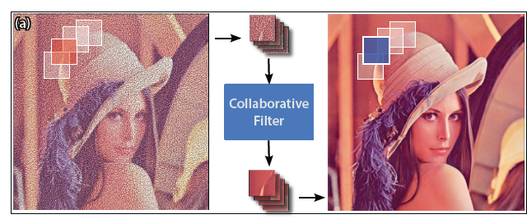
Figure 15: Example of coding flow in noise suppression filter.
The filter parameters $σ^{2}$are derived based on QP value and not signalled in bit-stream.
Application map is used signalled to bit-stream to determining which regions of picture are filtered.

Appendix
Test | Proponent(s) | Cross-checker(s)
CE2.1.1 | Jacob Ström  jacob.strom@ericsson.com  JVET-F0034 | Jonathan Pfaff  jonathan.pfaff@hhi.fraunhofer.de  Jennifer Rasch Jennifer.Rasch@hhi.fraunhofer.de
CE2.1.2 | Yu-Chi Su  yu-chi.su@mediatek.com  JVET-J0018 | Jonathan Pfaff  jonathan.pfaff@hhi.fraunhofer.de  Jennifer Rasch Jennifer.Rasch@hhi.fraunhofer.de
CE2.1.3 | Akshay Gadde  gadde@qti.qualcomm.com  JVET-J0021 | Jonathan Pfaff  jonathan.pfaff@hhi.fraunhofer.de  Jennifer Rasch Jennifer.Rasch@hhi.fraunhofer.de
CE2.2.1.1 | Kenneth Andersson  kenneth.r.andersson@ericsson.com  JVET-J0012 | Masaru Ikeda  Masaru.Ikeda@sony.com;  Jie Dong  jiedong@qti.qualcomm.com
CE2.2.1.2 | Kei Kawamura  ki-kawamura@kddi.com  JVET-J0016 | Kenneth Andersson kenneth.r.andersson@ericsson.com
CE2.2.1.3 | Chia-Ming Tsai  chia-ming.tsai@mediatek.com  JVET-J0018 | Kenneth Andersson kenneth.r.andersson@ericsson.com
CE2.2.1.4 | Dmytro Rusanovskyy  dmytror@qti.qualcomm.com  JVET-J0021 | Kenneth Andersson kenneth.r.andersson@ericsson.com
CE2.2.1.5 | Woong IL Choi  woongil.choi@samsung.com  JVET-J0024 | Kei Kawamura  ki-kawamura@kddi.com  Kenneth Andersson kenneth.r.andersson@ericsson.com
CE2.2.1.6 | Masaru Ikeda  masaru.ikeda@sony.com  JVET-J0028 | Kenneth Andersson  kenneth.r.andersson@ericsson.com
CE2.2.1.7 | Kiran Misra  misrak@sharplabs.com  JVET-J0077 | Kenneth Andersson  kenneth.r.andersson@ericsson.com  Anand Meher Kotra  anand.meher.kotra@huawei.com
CE2.3.1 | Ching-Yeh Chen  chingyeh.chen@mediatek.com  JVET-J0018 | Vadim Seregin  vseregin@qti.qualcomm.com
CE2.3.2 | Akshay Gadde  gadde@qti.qualcomm.com  JVET-J0021 | Philippe Bordes  Philippe.bordes@technicolor.com  Jie Chen  jie1222.chen@samsung.com
CE2.3.3 | Philippe Bordes  Philippe.bordes@technicolor.com  JVET-J0022 | Shuqing Fang  fangshuqing@hikvision.com  Jie Chen  jie1222.chen@samsung.com
CE2.3.4 | Jie Chen  jie1222.chen@samsung.com  JVET-J0024 | Ching-Yeh Chen  chingyeh.chen@mediatek.com
CE2.3.5 | Tomohiro Ikai  ikai.tomohiro@sharp.co.jp  JVET-J0026 | Tadamasa TOMA  toma.tadamasa@jp.panasonic.com
CE2.4.1.1 | Jungwon Kang  jungwon@etri.re.kr  JVET-J0013 | Ivan Krasnov  ivan.krasnov@huawei.com
CE2.4.1.2 | Rahul Vanam  Rahul.Vanam@InterDigital.com  JVET-J0015 | Masaru Ikeda  masaru.ikeda@sony.com
CE2.4.1.3 | Semih Esenlik  semih.esenlik@huawei.com  JVET-J0025 | Johannes Erfurt  johannes.erfurt@hhi.fraunhofer.de
CE2.4.1.4 | Marta Karczewicz  martak@qti.qualcomm.com  JVET-J0021 | Ching-Yeh Chen  chingyeh.chen@mediatek.com
CE2.4.2.1 | Wang-Q Lim  wang.lim@hhi.fraunhofer.de  JVET-J0014 | Li Zhang  lizhang@qti.qualcomm.com
CE2.4.2.2 | Ching-Yeh Chen  chingyeh.chen@mediatek.com  JVET-J0018 | Chernyak Roman  chernyak.roman@huawei.com
CE2.4.2.3 | QuanheYu  yuquanhe@hisilicon.com  Jianhua Zheng  zhengjianhua@hisilicon.com  JVET-J0025 | Chia-Ming Tsai  chia-ming.tsai@mediatek.com
CE2.4.2.4 | Masaru Ikeda  masaru.ikeda@sony.com  JVET-J0028 | Rahul Vanam  Rahul.Vanam@InterDigital.com
CE2.5.1 | Xiaozhen Zheng  xiaozhen.zheng@dji.com  JVET-J0011 | Chen-Yen Lai  jenny.lai@mediatek.com  Wenhao Zhang wenhao.zhang@hulu.com
CE2.5.2 | Ching-Yeh Chen  chingyeh.chen@mediatek.com  JVET-J0018
CE2.5.3 | Chernyak Roman chernyak.roman@huawei.com  JVET-J0025 | SehoonYea  sehoonyea@tencent.com

