    Joint Video Exploration Team (JVET)  of ITU-T SG 16 WP 3 and ISO/IEC JTC 1/SC 29/WG 11  10th Meeting: San Diego, US, 10–20 Apr. 2018 | Document: JVET-J0075r1

Title: | Partition only software of the video coding technology proposal by Qualcomm and Technicolor
Status: | Input document
Purpose: | Proposal
Author(s) or  Contact(s): | Yi-Wen Chen, Wei-Jung Chien, Hsiao-Chiang Chuang, Muhammed Coban, Jie Dong, Hilmi E. Egilmez, Nan Hu, Marta Karczewicz, Adarsh K. Ramasubramonian, Dmytro Rusanovskyy, Amir Said, Vadim Seregin, Geert Van Der Auwera, Kai Zhang, Li Zhang  (Qualcomm)  P. Bordes, Y. Chen, C. Chevance, E. Francois, F. Galpin, F. Hiron, P. de Lagrange, F. Le Léannec, K. Naser, T. Poirier, F. Racapé, G. Rath, A. Robert, F. Urban, T. Viellard (Technicolor) | Tel:  Email: | +1-858-658-5673  martak@qti.qualcomm.com  edouard.francois@technicolor.com
Source: | Qualcomm, Technicolor
_____________________________

Abstract
This contribution describes the subset of the partitioning structure of Qualcomm Inc. and Technicolor’s joint call-for-proposals response and it includes clean software containing only structure without new tools used in JVET-J0021 and JVET-J0022. Partition only test provides 14.27%, 17.38% and 18.04% average luma BD-rate improvement in constrained set 1 tests for QTBT, QTBT+TT and QTBT+ABT configurations, respectively.

Introduction
In this contribution a clean software of JVET-J0021/JVET-J0022 is provided, where all CfP response tools with associated code have been removed except partition structure. Three proposed partition structures are considered: QTBT, QTBT + Triple-Tree (TT), and QTBT + Asymmetric Binary Tree (ABT).

QTBT and TT partitioning
Proposed partitioning includes QTBT structure as in JEM and triple-tree (TT) partitioning as shown on the next figures.
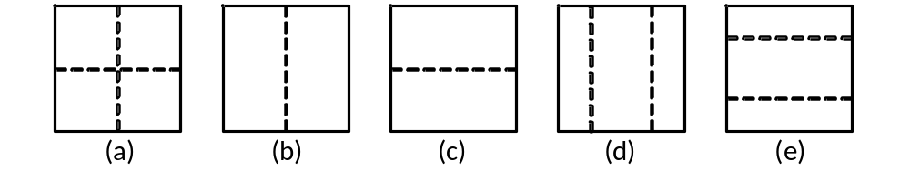
Figure 1: (a) quad-tree partitioning (b) vertical binary-tree partitioning (c) horizontal binary-tree partitioning (d) vertical triple-tree partitioning (e) horizontal triple-tree partitioning

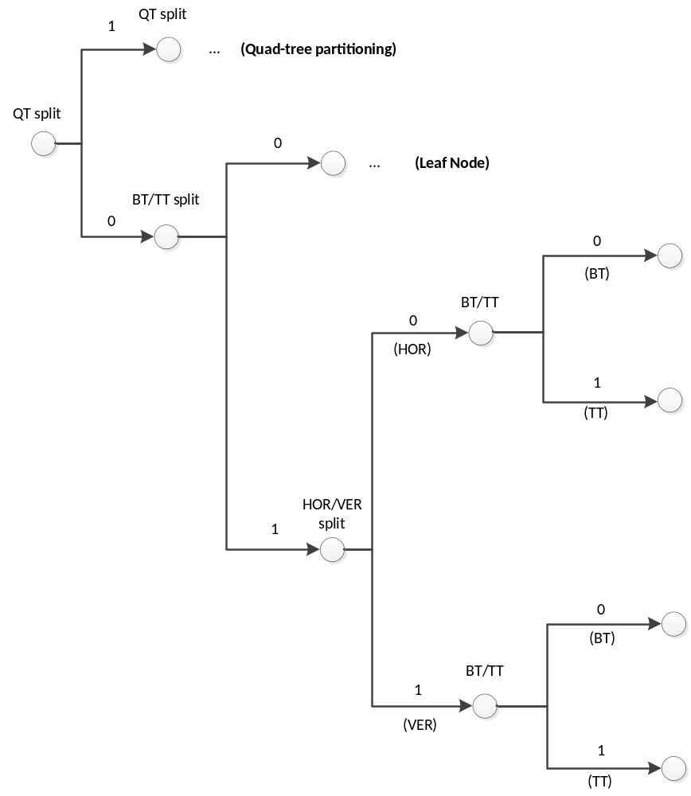
Figure 2: Illustration of tree-type signalling.
In general, QT signalling is the same as in JEM with exception of the context derivation. For BT/TT signalling, up to 3 bins are required, as illustrated in Figure 2. If it is not a QT split, the first bin indicates whether BT or TT partition is further split. If split, then the second bin indicates whether it is horizontal or vertical split, and the third bin indicates the partition type BT or TT.

QTBT and ABT partitioning
Alternate proposed partitioning includes QTBT and asymmetric binary tree (ABT) partitioning as shown on the next figures.
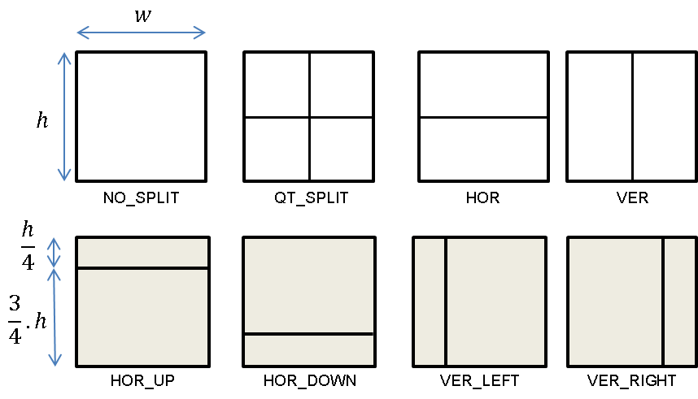
Figure 3: (top) quad-tree and symmetric binary tree partitioning (bottom) asymmetric binary tree partitioning

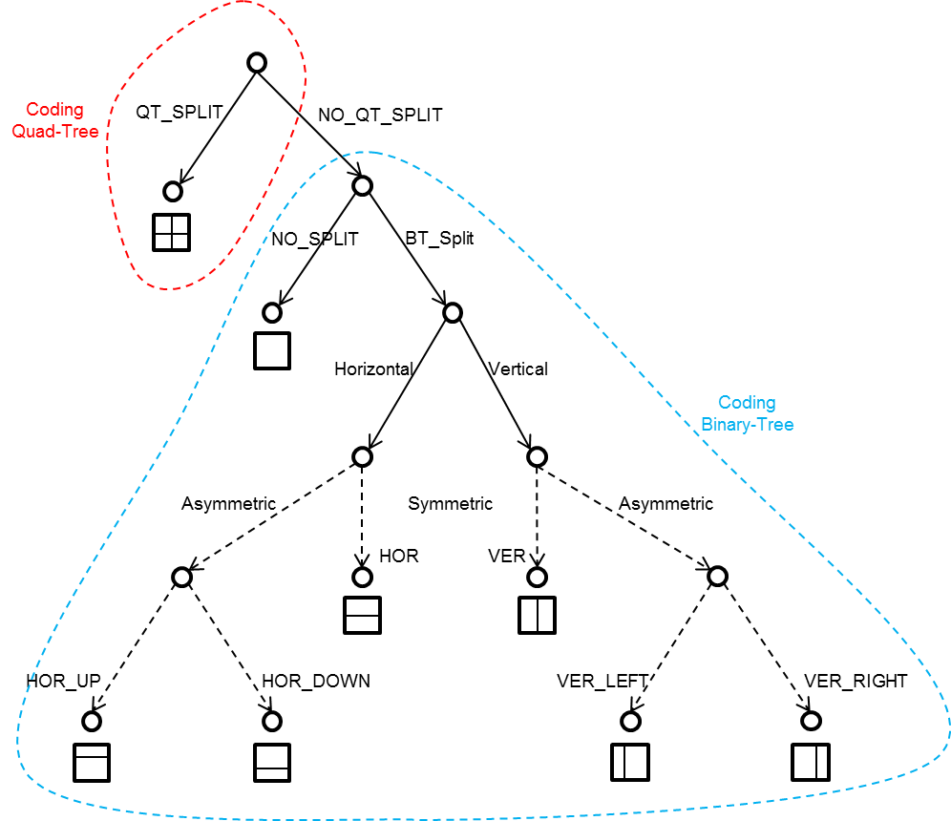
Figure 4: Illustration of ABT-type signalling.

When ABT is activated, for BT/ABT signalling, up to 4 bins are required, as illustrated in Figure 4. The 2 first bins are coded similarly as the 2 first additional bins of the BT/TT case.
The third bin indicates whether ABT is used, in case BT or TT is available. If BT and TT are not available, the bin is not coded and ABT is inferred to 1. Only 1 context is used for coding the third bin.
If ABT is activated, the fourth bin indicates the asymmetric split position: 0 for left/top (vertical split); 1 for right/bottom (horizontal split). Only 1 context is used for coding the third bin.

Compression performance for constrained set 1
The following tables summarize partitioning only results for Constraint Set 1 relative to HM anchor using four QP points for BD rate calculation. Three set of results are presented: QTBT only, QTBT + TT and QTBT + TT high complexity setting with more partition depth tried at encoder, and settings with QTBT + ABT.

QTBT only
Table 1. Low complexity configuration with QTBT partition
 | BD-rate(Y) | BD-rate(U) | BD-rate(V)
Average SDR-A | -17.19% | -9.69% | -11.02%
Average SDR-B | -9.63% | -11.07% | -13.97%
Average all | -13.41% | -10.38% | -12.50%
Enc Time[%] | 72%
Dec Time[%] | 111%

QTBT+TT
Table 2. Mid complexity configuration with QTBT+TT partition
 | BD-rate(Y) | BD-rate(U) | BD-rate(V)
Average SDR-A | -20.05% | -14.07% | -15.91%
Average SDR-B | -12.94% | -16.38% | -18.85%
Average all | -16.50% | -15.22% | -17.38%
Enc Time[%] | 139%
Dec Time[%] | 112%

Table 3. High complexity configuration with QTBT+TT partition
 | BD-rate(Y) | BD-rate(U) | BD-rate(V)
Average SDR-A | -20.93% | -15.66% | -17.68%
Average SDR-B | -13.98% | -18.32% | -20.99%
Average all | -17.46% | -16.99% | -19.33%
Enc Time[%] | 202%
Dec Time[%] | 114%

QTBT+ABT

Table 4. Configuration with QTBT+ABT partition
 | BD-rate(Y) | BD-rate(U) | BD-rate(V)
Average SDR-A | -20.57% | -15.49% | -17.80%
Average SDR-B | -13.46% | -19.00% | -21.76%
Average all | -17.02% | -17.24% | -19.78%
Enc Time[%] | 163%
Dec Time[%] | 110%

The following table reports results combining TT and ABT on top of QTBT.
Table 5. Configuration with QTBT+TT+ABT partition
 | BD-rate(Y) | BD-rate(U) | BD-rate(V)
Average SDR-A | -22.08% | -17.40% | -19.83%
Average SDR-B | -15.04% | -21.03% | -23.66%
Average all | -18.56% | -19.21% | -21.74%
Enc Time[%] | 301%
Dec Time[%] | 112%

Compression performance for CS 1 with BT boundary fitting
The following tables summarize partitioning only results for Constraint Set 1 relative to HM anchor using four QP points for BD rate calculation and BT boundary fitting applied. In JEM, picture boundary can be fit only by doing QT splits, in this test it can be done by QT or BT.

QTBT only
Table 6. Low complexity configuration with QTBT partition
 | BD-rate(Y) | BD-rate(U) | BD-rate(V)
Average SDR-A | -17.67% | -10.18% | -11.56%
Average SDR-B | -10.86% | -12.55% | -15.50%
Average all | -14.27% | -11.36% | -13.53%
Enc Time[%] | 75%
Dec Time[%] | 110%

QTBT+TT
Table 7. Mid complexity configuration with QTBT+TT partition
 | BD-rate(Y) | BD-rate(U) | BD-rate(V)
Average SDR-A | -20.52% | -14.56% | -16.41%
Average SDR-B | -14.25% | -17.99% | -20.45%
Average all | -17.38% | -16.27% | -18.43%
Enc Time[%] | 145%
Dec Time[%] | 111%

Table 8. High complexity configuration with QTBT+TT partition
 | BD-rate(Y) | BD-rate(U) | BD-rate(V)
Average SDR-A | -21.44% | -16.18% | -18.26%
Average SDR-B | -15.31% | -19.91% | -22.74%
Average all | -18.38% | -18.05% | -20.50%
Enc Time[%] | 214%
Dec Time[%] | 111%

QTBT+ABT
Table 9. Configuration with QTBT+ABT partition
 | BD-rate(Y) | BD-rate(U) | BD-rate(V)
Average SDR-A | -21.12% | -16.04% | -18.46%
Average SDR-B | -14.96% | -20.84% | -23.73%
Average all | -18.04% | -18.44% | -21.09%
Enc Time[%] | 160%
Dec Time[%] | 111%
The following table reports results combining TT and ABT on top of QTBT.
Table 10. Configuration with QTBT+TT+ABT partition
 | BD-rate(Y) | BD-rate(U) | BD-rate(V)
Average SDR-A | -22.61% | -17.95% | -20.42%
Average SDR-B | -16.53% | -22.82% | -25.48%
Average all | -19.57% | -20.38% | -22.95%
Enc Time[%] | 317%
Dec Time[%] | 113%

Patent rights declaration(s)
Qualcomm Inc. may have current or pending patent rights relating to the technology described in this contribution and, conditioned on reciprocity, is prepared to grant licenses under reasonable and non-discriminatory terms as necessary for implementation of the resulting ITU-T Recommendation | ISO/IEC International Standard (per box 2 of the ITU-T/ITU-R/ISO/IEC patent statement and licensing declaration form).
Technicolor may have current or pending patent rights relating to the technology described in this contribution and, conditioned on reciprocity, is prepared to grant licenses under reasonable and non-discriminatory terms as necessary for implementation of the resulting ITU-T Recommendation | ISO/IEC International Standard (per box 2 of the ITU-T/ITU-R/ISO/IEC patent statement and licensing declaration form).

