    Joint Video Exploration Team (JVET)  of ITU-T SG 16 WP 3 and ISO/IEC JTC 1/SC 29/WG 11  10th Meeting: San Diego, US, 10–20 Apr. 2018 | Document: JVET-J0021

Title: | Description of SDR, HDR and 360° video coding technology proposal by Qualcomm and Technicolor – low and high complexity versions
Status: | Input document
Purpose: | Proposal
Author(s) or  Contact(s): | Y. Chen, W.-J. Chien, H.-C. Chuang, M. Coban, J. Dong, H. E. Egilmez, N. Hu, M. Karczewicz, A. Ramasubramonian, D. Rusanovskyy, A. Said, V. Seregin, G. Van Der Auwera, K. Zhang, L. Zhang  (Qualcomm)  P. Bordes, Y. Chen, C. Chevance, E. Francois, F. Galpin, F. Hiron, P. de Lagrange, F. Le Léannec, K. Naser, T. Poirier, F. Racapé, G. Rath, A. Robert, F. Urban, T. Viellard (Technicolor) | Tel:  Email: | +1-858-658-5673  martak@qti.qualcomm.com
Source: | Qualcomm, Technicolor
_____________________________

Abstract
This contribution describes Qualcomm Inc. and Technicolor’s joint proposal in response to the call for proposal (CfP) issued jointly by ISO/IEC JTC1/SC29/WG11 MPEG and ITU-T SG16/Q.6 VCEG. The proposal contains majority of the tools that have been adopted into the JEM software. Triple-Tree (TT) and Asymmetric Binary-Tree (ABT) partition types are added to increase flexibility. Several JEM tools such as merge, AMVP and affine motion are modified, and sign prediction and motion compensated padding tools are added. For HDR, pre-/post-dynamic range adaptation is used. For 360° video, ACP with geometric padding is used as a coding tool.
Objective SDR gains of 43.1% and 15.5% in terms of average luma BD-rate improvement have been achieved for constraint set 1 in high complexity mode relative to HM and JEM anchors, respectively. For constraint set 2, the average luma BD-rate improvements are 33.7% relative to the HM anchor and 12.7 % relative to the JEM anchor. In the low complexity mode SDR gains of 39.7% and 10.3% in terms of average luma BD-rate improvement have been achieved for constraint set 1 relative to HM and JEM anchors, respectively. For constraint set 2, the average luma BD-rate improvements are 31.7% relative to the HM anchor and 9.9 % relative to the JEM anchor in low complexity mode.

Contents
Abstract 1
Contents 1
1 Introduction 3
2 General algorithm description 4
2.1 Partitioning structure 4
2.1.1 Restrictions at frame boundaries 6
2.1.2 Partition emulation prevention 7
2.1.3 Signalling of tree types 7
2.2 Separable primary transforms 8
2.3 Non-separable secondary transforms 8
2.4 Sign prediction of transform coefficients 9
2.4.1 Conditions for sign prediction usage 9
2.4.2 Sign prediction method 9
2.4.3 Across block discontinuity measure 10
2.5 Intra prediction 10
2.5.1 Planar mode 11
2.5.2 DC mode 11
2.5.3 Angular directional modes 11
2.5.4 Position dependent intra prediction combination 12
2.5.5 Secondary boundary filtering 13
2.5.6 Cross-component linear model prediction 13
2.6 Luma intra mode coding 13
2.6.1 Most probable mode derivation 13
2.6.2 Secondary most probable list derivation 14
2.6.3 Intra mode signalling 14
2.7 Chroma intra mode coding 15
2.8 Inter prediction modes 15
2.8.1 Inter Mode 15
2.8.2 Merge/Skip modes 16
2.9 Affine motion compensation prediction 18
2.9.1 Adaptive affine model selection 18
2.9.2 Affine motion vector prediction 19
2.9.3 Unified affine/normal merge candidate list 20
2.9.4 Adaptive motion vector difference resolution 20
2.9.5 Bi-directional optical flow 21
3.1 Motion Compensated Boundary Pixel Padding (MC Padding) 21
2.10 In-loop filtering 21
2.10.1 Bilateral filter 21
2.10.2 Sample Adaptive Offset filter 23
2.10.3 Deblocking filter 23
2.11 Arithmetic coding main engine 24
2.11.1 Bin probability estimation 24
2.11.2 Context-dependent adaptation parameters 24
3 360° 25
4 HDR 26
4.1 HDR Video Codec design 27
4.2 Color Volume Transform 27
5 Compression performance 28
5.1 SDR 28
5.1.1 SDR category: Constraint Set 1 configuration (high complexity) 28
5.1.2 SDR category: Constraint Set 2 configuration (high complexity) 29
5.1.3 SDR category: Constraint Set 1 configuration (low complexity) 30
5.1.4 SDR category: Constraint Set 2 configuration (low complexity) 31
5.1.5 Partitioning only results 32
5.2 HDR 32
5.2.1 HDR category: Constraint Set 1 configuration (high complexity) 33
5.2.2 HDR category: Constraint Set 1 configuration (low complexity) 33
5.3 360° Video 34
5.3.1 360° category: Constraint Set 1 configuration (high complexity) 34
5.3.2 360° category: Constraint Set 1 configuration (low complexity) 35
6 Software Description 36
7 Annex 1: Questionnaire 37
7.1 Codec level Q&A 37
7.2 Tool level Q&A 38
7.2.1 Category 1. Partitioning structure 38
7.2.2 Category 2. Entropy coding 38
7.2.3 Category 3. Control data derivation process 39
7.2.4 Category 4. Decoder-side motion refinement 39
7.2.5 Category 5. Intra prediction 40
7.2.6 Category 6. Inter prediction 40
7.2.7 Category 7. Quantization 41
7.2.8 Category 8. Transforms 41
7.2.9 Category 9. In-loop filtering 42
8 References 43
9 Patent rights declaration(s) 43

Introduction
This document describes the video encoder and decoder proposed by Qualcomm Inc. and Technicolor in response to the call for proposals (CfP) [1] issued jointly by ISO/IEC JTC 1/SC 29/WG 11 (MPEG) and ITU-T SG 16 Question 6. Our proposal is based on JEM [2] with addition of new tools, enhancements and removal of various existing tools.
The new tools introduced to JEM tools are the Sign Prediction and Motion Compensated Padding methods. Decoder side motion vector refinement (JVET-E0052) tool from JEM is not included in our proposal.
A number of JEM tools were modified to improve coding efficiency and/or reduce complexity.The major modifications to JEM tools are the following:
- Merge candidate list includes affine merge and non-adjacent spatial candidates. Bilateral or template matching refinement is done for one candidate identified by signalled merge index. Sub-block level refinement for template matching and bilateral refinement is removed.
- AMVP number of initial motion candidates is reduced from 15 to 2.
- Introduced 6 parameter affine model in addition to the 4 parameter model. Affine motion vector prediction is simplified.
- Introduced two more partition types to increase flexibility: Triple-Tree (TT) and Asymmetric Binary-Tree (ABT).
In case of other tools, incremental improvements were introduced.
The HDR category proposal is implemented as an add-on to the core video coding system. It is an implementation of Color Volume Transform (CVT) which is applied in the Y’CbCr 4:2:0 sample domain and is performed on the input video signal prior to coding and the inverse process is performed on the signal after decoding.
In the 360° video category, Adjusted Cubemap Projection (ACP) with with geometric padding for motion compensation, loop filtering and intra prediction is implemented on top of SDR proposal.
The software is developed based on HM/JEM where many parts were rewritten to improve software design:
- Over 50% reduced memory footprint compared to JEM.
- Methods associated with each coding tool are encapsulated under a single macro, where all new coding tools can be disabled to fall back to HM tools plus the new structure.
- Improved fast encoding encoder methods. QTBT only enabled encoder time is 95% of HM-16.16 providing 13.4 luma BD-rate improvement.
- Uses global addressing expressed as 2D offset from the top-left picture corner to indicate the location of a block, instead of z-scan ordering used in HM.

The following table summarizes objective performance of the SDR (high complexity) proposal:
SDR | Over HM anchors |  |  |  |  | Over JEM anchors
 | BD-rate PSNR |  |  | Time variation |  | BD-rate PSNR |  |  | Time variation
 | Y | U | V | Enc | Dec | Y | U | V | Enc | Dec
CS1 | -43.08% | -44.38% | -46.05% | 1180% | 639% | -15.53% | -3.66% | -5.97% | 148% | 84%
CS2 | -33.74% | -51.94% | -53.10% | 969% | 607% | -12.65% | -17.40% | -19.95% | 120% | 91%

The following table summarizes objective performance of the SDR (low complexity) proposal:
SDR | Over HM anchors |  |  |  |  | Over JEM anchors
 | BD-rate PSNR |  |  | Time variation |  | BD-rate PSNR |  |  | Time variation
 | Y | U | V | Enc | Dec | Y | U | V | Enc | Dec
CS1 | -39.72% | -42.80% | -43.94% | 369% | 646% | -10.26% | 0.05% | -1.65% | 46% | 85%
CS2 | -31.69% | -48.95% | -50.44% | 449% | 610% | -9.87% | -11.73% | -14.88% | 56% | 91%
In HDR category, high complexity configuration provides 39.9% and 15.6% of dBR gain (PSNR L100 HDR metric) over HM and JEM HDR anchor respectively. The low complexity configuration provides 37.3% and 11.9% of PSNR L100 dBR reduction over HM and JEM anchors, respectively.
In 360° video category, high complexity configuration provides 38.1% (Y), 57.4% (U), 60.0% (V) average BD-rate (E2E WS-PSNR) gain over HM, and 19.4% (Y), 26.4% (U), 28.7% (V) average BD-rate (E2E WS-PSNR) gain over JEM anchors. The low complexity configuration provides 35.3% (Y), 55.0% (U), 57.3% (V) average BD-rate (E2E WSPNR) gain over HM, and 15.7%, 21.9%, 23.4% average BD-rate (E2E WS-PSNR) gain over JEM anchors.

General algorithm description

Partitioning structure
The tree structure used in this response, called Multi-Tree Type (MTT), is a generalization of the QTBT. In QTBT, as shown in Figure 1, a Coding Tree Unit (CTU) is firstly partitioned by a quad-tree structure. The quad-tree leaf nodes are further partitioned by a binary-tree structure.
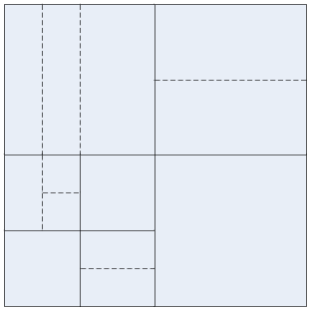
Figure 1: Illustration of a QTBT structure.
The fundamental structure of MTT constitutes of two types of tree nodes: Region Tree (RT) and Prediction Tree (PT), supporting nine types of partitions, as shown in Figure 2. A region tree can recursively split a CTU into square blocks down to a 4x4 size region tree leaf node. At each node in a region tree, a prediction tree can be formed from one of three tree types: Binary Tree, Triple Tree, and Asymmetric Binary Tree. In a PT split, it is prohibited to have a quadtree partition in branches of the prediction tree. As in JEM, the luma tree and the chroma tree are separated in I slices.
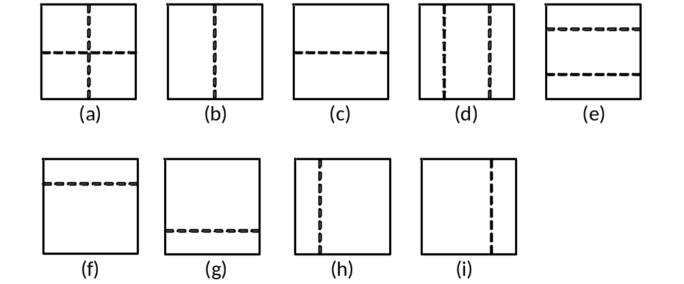
Figure 2: (a) quad-tree partitioning (b) vertical binary-tree partitioning (c) horizontal binary-tree partitioning (d) vertical triple-tree partitioning (e) horizontal triple-tree partitioning (f) horizontal-up asymmetric binary-tree partitioning (g) horizontal-down asymmetric binary-tree partitioning (h) vertical-left asymmetric binary-tree partitioning (i) vertical-right asymmetric binary-tree partitioning.
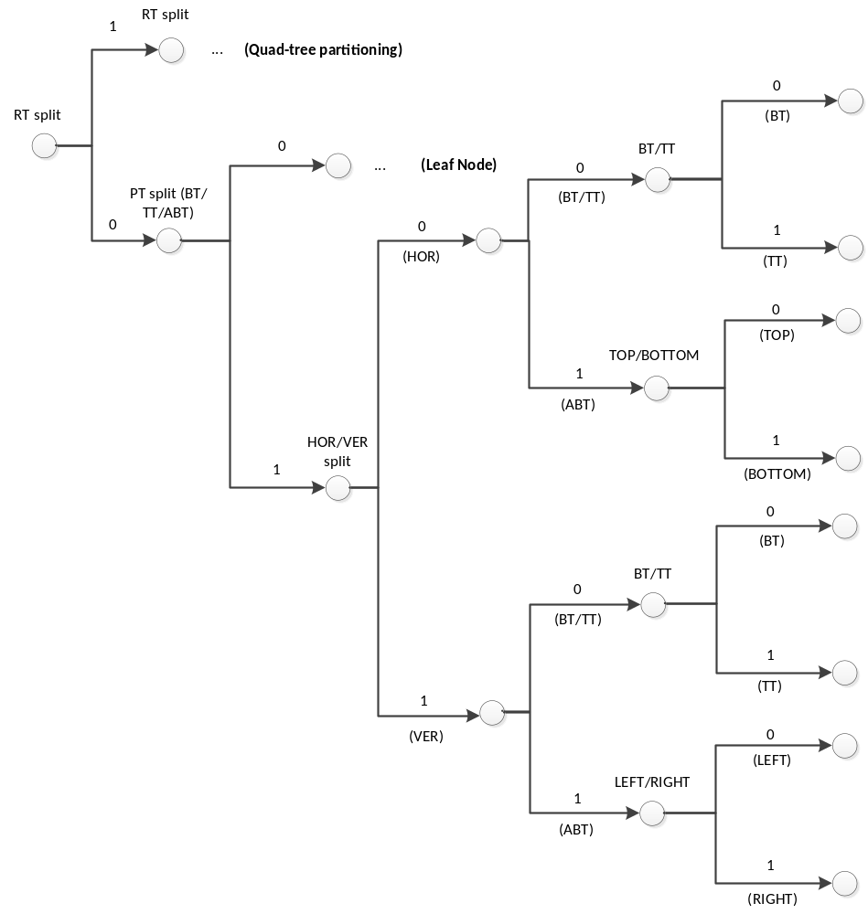
Figure 3: Illustration of tree-type signalling.

Restrictions at frame boundaries
Some partition types are disallowed at the frame boundaries. Following horizonal partitions are not allowed:
- All horizontal partitions when the right end of the block exceeds the right frame boundary.
- Horizontal triple-tree, when the bottom end of the block exceeds the bottom frame boundary and the bottom frame boundary is not aligned with the ¾ of the block height.
- Horizontal-up asymmetric binary-tree, when the bottom end of the block exceeds the bottom frame boundary and the bottom frame boundary is not aligned with the ¼ of the block height.
- Horizontal-down asymmetric binary-tree, when the bottom end of the block exceeds the bottom frame boundary and the bottom frame boundary is not aligned with the ¾ of the block height.
Following vertical partitions are not allowed:
- All vertical partitions when the bottom end of the block exceeds the bottom frame boundary.
- Vertical triple-tree, when the right end of the block exceeds the right frame boundary and the right frame boundary is not aligned with the ¾ of the block width.
- Vertical-left asymmetric binary-tree, when the right end of the block exceeds the right frame boundary and the right frame boundary is not aligned with the ¼ of the block width.
- Vertical-right asymmetric binary-tree, when the right end of the block exceeds the right frame boundary and the right frame boundary is not aligned with the ¾ of the block width.

Partition emulation prevention
Some additional constraints are imposed to restrict tree partitioning to avoid (nearly) duplicated partitioning. For example:
- If the parent partition type is horizontal-bottom or horizontal-top asymmetric binary tree, then horizontal-top asymmetric and horizontal-bottom asymmetric binary trees are prohibited.
- If the parent partition type is vertical-right or vertical-left asymmetric binary tree, then vertical-left asymmetric and vertical-right asymmetric binary trees are prohibited.
- If the parent partition type is horizontal triple tree, then horizontal binary tree is prohibited.
- If the parent partition type is vertical triple tree, then vertical binary tree is prohibited.
- If the parent partition type is vertical binary tree and the first partition is the horizontal binary tree, then the horizontal binary tree is prohibited for the second partition.
- If the parent partition type is horizontal binary tree and the first partition is the vertical binary tree, then the vertical binary tree is prohibited for the second partition.

Signalling of tree types
In general, RT signalling is same as QT signalling in JEM with exception of the context derivation. For PT signalling, up to 4 additional bins are required, as illustrated in Figure 3. The first bin indicates whether the PT is further split or not. The context for this bin is calculated based on the observation that the likelihood of further split is highly correlated to the relative size of the current block to its neighbors. Let W, H, and A be the width, the height, and the area size of the current block, respectively. The context model Ctx is calculated by comparing the size of the current block relative to those of the neighboring blocks:
- Ctx=0;
- Ctx += H > H_{L};
- Ctx += W > W_{T};
- Ctx += A > A_{TL};
- Ctx += A > A_{TR};
where H_{L}, W_{T}, A_{TL}, A_{TR} represent the height of the left block, width of the top block, area size of the top-left block, and the area size of the top-right block, respectively. As illustrated in Figure 4, the reference positions for the top and left blocks are located with offsets of H/2 and W/2 from the top-left corner of the block, respectively.

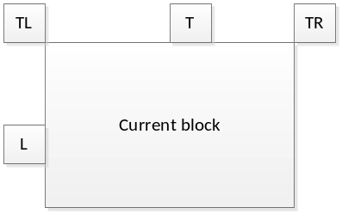
Figure 4: Reference positions for context modeling of PT split flag and PT direction flag.

If PT is further split, the second bin indicates whether it is a horizontal partitioning or vertical partitioning. The presence of the center-sided triple tree and the asymmetric binary trees increase the occurrence of “tall” or “wide” blocks and hence, the context model exploits this property to signal this flag more efficiently:
Ctx= (W==H ? 0 : (W > H ? 1 : 2));
if (W > 2H) Ctx = 3;
if (H > 2W) Ctx = 4;
The third bin indicates the tree-type of the partition, i.e., whether it is a binary-tree/triple-tree, or an asymmetric binary tree. In case of a binary-tree/triple-tree, the fourth bin indicates the type of the tree. In case of asymmetric binary trees, the four bin indicates up or down type for horizontally partitioned trees and right or left type for vertically partitioned trees.

Separable primary transforms
Primary transform design is based on JEM EMT. In addition to transforms used in JEM, which are DCT-2, DCT-5, DCT-8, DST-1, and DST7, two more cores are added for each intra and inter coded blocks. Namely, DST-4 and identity transform are added to intra, KLT-1 and KLT-2 are added to inter. It was proposed in JVET-C0022 and JVET-D0126, respectively.
To accommodate more flexible partitioning, where a block size is not power of 2, such as 4x24 and 8x48, corresponding transform cores are included.
In intra coding, the following 7 transform sets, where each set has 4 transform pairs, are defined:
T_{0, intra} = { (DST-4, DST-4), (DST-7, DST-7), (DST-4, DCT-8), (DCT-8, DST-4) }
T_{1, intra} = { (DST-7, DST-7), (DST-7, DCT-5), (DCT-5, DST-7), (DST-1, DCT-5) }
T_{2, intra} = { (DST-7, DST-7), (DST-7, DCT-8), (DCT-8, DST-7), (DCT-5, DCT-5) }
T_{3, intra} = { (DST-4, DST-4), (DST-4, DCT-5), (DCT-8, DST-4), (DST-1, DST-7) }
T_{4, intra} = { (DST-4, DST-7), (DST-7, DCT-5), (DCT-8, DST-7), (DST-1, DST-7) }
T_{5, intra} = { (DST-7, DST-7), (DST-7, DCT-5), (DCT-8, DST-7), (DST-1, DST-7) }
T_{6, intra} = { (DST-7, DST-7), (DST-7, DCT-5), (DCT-5, DST-7), (DST-1, DST-7) }.
The first entry in the transform pair determines vertical transform, and the second entry specifies the horizontal transform.
A look-up table is defined to assign each of the 7 transform sets based on different intra prediction modes and block sizes.
Identity transform is applied for blocks that are not exceeding 16x16 and have intra modes within the proximity of horizontal and vertical intra directions, the proximity is defined by a block size-based threshold. If transform index is equal to 3 and block satisfies the above condition, the horizontal and/or vertical identity transform is applied.
In inter coding, the following 2 transform sets are used, where each set has 4 transform pairs defined as follows:
T_{0, inter} = { (DCT-8, DCT-8), (DCT-8, DST-7), (DST-7, DCT-8), (DST-7, DST-7) }
T_{1, inter} = { (KLT-1, KLT-1), (KLT-1, KLT-2), (KLT-2, KLT-1), (KLT-2, KLT-2) }.
The transform set with KLTs (i.e., T_{1, inter}) is used for blocks that are smaller than or equal to 16x16, and for larger blocks the transforms from T_{0, inter} set are used.

Non-separable secondary transforms
The non-separable secondary transform (NSST) is the same as in JEM, including the JEM NSST signalling, with the following three modifications:
- To support additional intra modes, which can be up to 131 directions, the look-up table that maps intra mode to NSST transform was extended, where each entry in the table was simply duplicated.
- To lower the complexity, the restriction is imposed on EMT and NSST use that NSST can be applied and signaled only when EMT transform index is equal to 0, it also happens when EMT flag is equal to 0.
- NSST transform choice is separately signaled for Cb and Cr chroma components.

Sign prediction of transform coefficients
Sign prediction for transform coefficients was proposed in JVET-D0031. In the proposed method, performing an inverse transform is required to measure a discontinuity across a block boundary. To lower the complexity, the reconstructed residuals are prestored and final reconstruction is composed from the prestored residuals to avoid applying the inverse transform.

Conditions for sign prediction usage
Sign prediction is applied to all colour components, and to transform coefficients located in the first top left 4x4 frequency area or the first coefficient group (CG). Sign prediction is only applied when secondary transform is not used, i.e. NSST index is equal to 0. The number of signs to be predicted is configurable, and the number of predicted signs is signalled in SPS. By default, 6 coefficient signs are predicted.

Sign prediction method
Following JVET-D0031, basic idea of the coefficient sign prediction method is for applicable transform coefficients to calculate reconstructed residual for both negative and positive sign combinations and select the hypothesis that minimizes a cost function.
For example, if two signs are predicted, then there can be 4 possible combinations as (+, +), (+, –), (–, +), (–, –). For all four combinations, the cost function is calculated and the combination with the minimum cost is selected as a sign predictor combination. The same process is applied if more signs are predicted with more combinations to be tried, and trade-off can be determined between the complexity and compression efficiency.
For the coefficients that can use sign prediction algorithm, instead of bypass signalling, a context coded bin is signaled to indicate whether a coefficient sign is equal to the hypothesis or not. The contexts are dependent on the coefficient magnitude, and two contexts are used per luma and chroma components separately.
As mentioned earlier, inverse transform is not performed, instead the reconstructed residual is derived based on the prestored elemental residuals multiplied by coefficient magnitude and accumulated for all coefficients for which sign is predicted.
In more detail, any coefficient block can be represented as a sum of blocks where only one coefficient is nonzero, moreover that one nonzero coefficient value can be set to 1 and to get the final reconstructed residual, the reconstructed residual corresponding to coefficient magnitude equal to 1 is multiplied by the signed coefficient magnitude. An example of the decomposition is shown in the figure below.
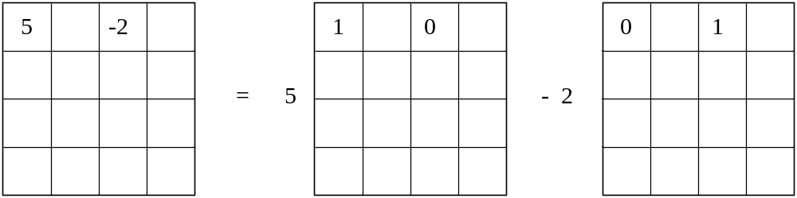
Figure 5: Transform block decomposition.
As can be seen from the example, the inverse transform needs to be calculated only once for every single nonzero coefficient with magnitude equal to 1, and the final reconstruction is derived as a scaled sum of the reconstructed elemental residuals. The reconstructed elemental residuals or templates are pre-calculated and stored in a look-up table with 8-bit accuracy for each element of the table. Since the discontinuity is measured considering only the first row and first column of a block as it will be explained later, then the look-up table size can be reduced to the length of width + height per transform basis. The transform basis functions, which are used to calculate the templates, correspond to a primary transform EMT basis. However, since the accuracy is reduced to 8, the resulted templates could be the same or similar, in such cases the templates are merged to reduce the storage memory.
Sign prediction accuracy depends on the coefficient magnitude, smaller magnitude makes discontinuity measure difference less noticeable. So, for the given number of predicted signs, the non-zero coefficients in the top left frequency area are selected according to the coefficient threshold, which classifies the coefficients into two groups with sign being predicted with high or low probability. The coefficients are scanned in the raster scan order and the coefficients with magnitude above the threshold are classified to be in the high prediction probability group, otherwise it is classified to be in the low probability prediction group. If the number of coefficients in the high predicted probability group is smaller than the total number of coefficient signs to be predicted, then the coefficients from the low predicted probability group are added.

Across block discontinuity measure
To derive the best sign prediction hypothesis among all possible combinations, a cost function needs to be defined. Following JVET-D0031, the cost function is defined as discontinuity measure across block boundary. It is measured for all hypothesises, and the one with the smallest cost is selected as a predictor for coefficient signs.
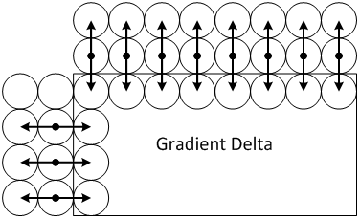
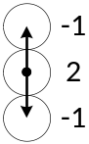
The cost function is defined as a sum of absolute second derivatives in the residual domain for the above row and left column and it is shown in Figure 6.
Figure 6: Discontinuity measure.

$$cost=\sum_{x=0}^{w}{\left|\left(-R_{x,-1}+2R_{x,0}-P_{x,1}\right)-r_{x,1}\right|+ }\sum_{y=o}^{h}{\left|\left(-R_{-1,y}+2R_{0,y}-P_{1,y}\right)-r_{1,y}\right| }$$
where R is reconstructed neighbors, P is prediction of the current block, and r is the residual hypothesis. The term $\left(-R_{-1}+2R_{0}-P_{1}\right)$ can be calculated only once per block and only residual hypothesis is subtracted.

Intra prediction
The samples of an intra block are predicted from up to two adjacent reference sample lines consisting of reconstructed samples from neighboring blocks. Depending on the prediction mode, the two reference lines can be used filtered or unfiltered in the prediction. A bilateral filter is used to filter the reference lines. There are four prediction mode types: planar, DC, angular directional and cross-component linear model (CCLM). An adaptive set of angular modes is defined with the number of angular modes depending on the block area. Interpolation filters are used for deriving extended reference samples and predicted samples. Position dependent intra prediction combination is employed without signalling for planar, DC, horizontal and vertical modes. Secondary boundary filtering is applied to diagonal and adjacent modes, as well as adjacent horizontal and vertical modes.

Planar mode
Planar mode is identical to JEM where two predictions, one horizontal and one vertical, are combined by averaging. The horizontal prediction consists of interpolating between the left reference sample line adjacent to the block and the sample in the top-right location. The vertical prediction consists of interpolating between the top reference sample line adjacent to the block and the sample in the bottom-left location.

DC mode
DC mode is essentially identical to JEM, except when the sum of block width and height is equal to a power of two, in which case the division is replaced by a shift operator when calculating the average DC value for prediction. In other cases, the division is implemented by a look-up table.

Angular directional modes

Adaptive number of angular modes
The number of angular intra prediction modes is dependent on the block area. The number of modes increases with the block area and is equal to 33, 65 or 129 depending on signaled threshold values. When 33 or 65 angular modes are used, they are respectively identical to the modes defined in HEVC and JEM. There are two block area threshold values, which are signaled in the SPS as log2 values minus 4 and minus 6, respectively. The first threshold indicates the largest block area with 33 angular directions, and the second threshold indicates the largest block area with 65 angular directions, all other blocks use 129 angular directions. In the default setting, thresholds are signalled as 4 and 6, respectively, and for higher resolution pictures (width greater than 2000 pixels) thresholds are set to 5 and 8.

Prediction based on multi-line reference
In JEM, only the nearest reference line is used for intra prediction. However, additional reference lines provide a better prediction. In this proposal, the two nearest reference lines are used. For each angular mode two predictor blocks are generated, each based on one reference line, and a weighted predictor is used as the final one. The weights are (3, 1) where the predictor based on the nearest line has the higher weight. Multi-line prediction is not used for planar, DC, horizontal and vertical modes.

Filtering of multi-line references
Intra prediction is based on unfiltered or filtered multi-line references. The decision whether to use filtering is identical to JEM, except for planar mode which uses the nearest filtered reference line when the block area is larger than 32×32. 5-tap bilateral filter is used to generate the filtered reference, which reduces noise while preserving edges. The filter taps are given by:
f={f₋₂, f₋₁, f₀, f₁, f₂}/( f₋₂+f₋₁+f₀+f₁+f₂), where $f_{i}=e^{-(\frac{{\left|i\right|}^{2}}{σ_{0}} + \frac{{\left|r_{x+i}-r_{x}\right|}^{2}}{σ_{1}})}$

with $r_{x}$, the unfiltered reference at position $x$, $σ_{0}=2.4$, $σ_{1}=260$ and $i=-2, -1, 0, 1, 2$.
To save computational complexity, values of $e^{- \frac{{\left|i\right|}^{2}}{σ_{0}} }$ and $e^{- \frac{{\left|r_{x+i}-r_{x}\right|}^{2}}{σ_{1}}}$ are stored in look-up tables.

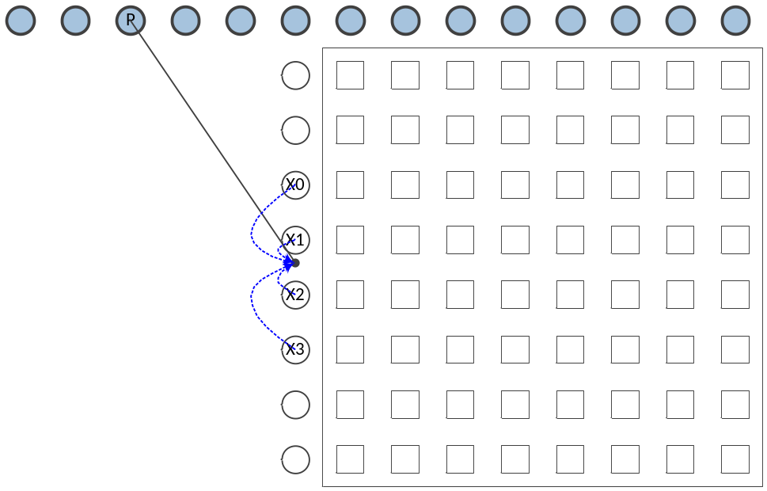
Figure 7: Example of interpolation to derive extended intra reference sample.

Interpolation filters
Interpolation filters are used for angular intra prediction in two cases as described in JVET-D0119. The first case is the derivation of the extended intra reference samples, and the second case is the derivation of the predicted samples from the references samples. To derive the extended intra reference samples, the 4-tap cubic interpolation filter is used instead of the nearest neighbor rounding. As shown in the example in Figure 7, to derive the value of reference sample P, the 4-tap cubic interpolation filter is used, while in JEM or HEVC, the P sample is directly set as X1.To generate a prediction sample from reference samples, two interpolation filters can be used. If a block’s width is larger than 8 pixels, the 4-tap Gaussian filter from JEM is used; otherwise, a 6-tap cubic interpolation filter is used which is the extension of the 4-tap cubic filter in JEM. To accommodate the increased number of angular intra modes, the interpolation filter accuracy is equal to 1/64 fractional pixels.

Position dependent intra prediction combination
Position dependent intra prediction (PDPC) is applied to planar, DC, horizontal and vertical modes without signalling. The prediction sample $P\left(x,y\right)$ located at (x, y) is calculated as follows:
$$P\left(x,y\right)=\left(wL×R_{-1,y}+wT×R_{x,-1}+wTL×R_{-1,-1}+\left(64-wl-wT-wTL\right)×P\left(x,y\right)+32\right)≫6$$
where R_{x,-1}, R_{-1,y} represents the reference samples located at top and left of the current sample (x, y), and R_{-1,-1} represents the reference sample located in the top-left corner of the current block. The DC mode weights are calculated as follows:
$$wT=32≫\left(\left(y≪1\right)≫shift\right), wL=32≫\left(\left(x≪1\right)≫shift\right), wTL=-\left(wL≫4\right)-\left(wT≫4\right),$$
where
$$shift=\left(\log_{2}\left(width\right)+\log_{2}\left(height\right)+2\right)≫2.$$
For planar mode wTL = 0, while for the horizontal mode wTL = wT and for vertical mode wTL = wL.
In Figure 8, DC mode PDPC weights (wL, wT, wTL) for (0, 0) and (1, 0) positions inside one 4x4 block are shown.
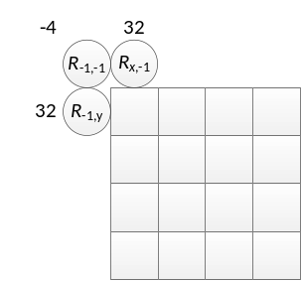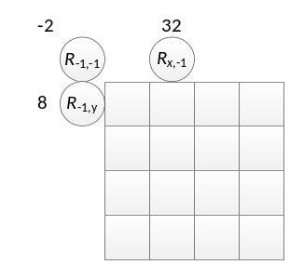
Figure 8: DC mode PDPC weights for (0, 0) and (1, 0) positions inside one 4x4 block.

Secondary boundary filtering
JEM boundary filters are applied to both diagonal modes (bottom-left and top-right directions) and to 16 angular modes that are adjacent to each diagonal mode. In addition, boundary filters are applied to two angular modes that are directly adjacent to, and on both sides of, the vertical or horizontal modes. There is no secondary boundary filtering for planar, DC, horizontal and vertical modes.

Cross-component linear model prediction
CCLM included in JEM is extended by adding LM-Angular mode as proposed in JVET-D0110. In this mode final chroma prediction $P\left(x,y\right)$is a combination of LM prediction, $P_{0}\left(x,y\right)$, and prediction, $P_{1}\left(x,y\right)$, obtained using DC, planar or angular mode:
$$P\left(x,y\right)={\left(P_{0}\left(x,y\right)+P_{1}\left(x,y\right)\right)}/2.$$

Luma intra mode coding
To signal a luma intra mode, two most probable mode (MPM) lists are derived for a block. MPM lists consist of intra modes of the neighboring blocks and modes derived from those intra modes. The process of the MPM list derivation is similar to JEM with additional modifications proposed in JVET-D0113, JVET-D0114, JVET-D0115, JVET-D0119, and JVET-G0060.
The number of intra modes in a block can vary between 35, 67, or 131 modes, depending on the block size, and two thresholds are signaled in SPS to identify the allowed number of intra modes. An intra mode index is represented by 131 mode index range regardless of the number of intra modes used in a block. For 67 modes, only every second angular mode is allowed; and for 35 modes, only every fourth angular mode is allowed. Therefore, during intra mode signalling, intra mode of the neighboring block may need to be rounded towards nearest second or fourth angular intra mode if the current block uses smaller than 131 intra mode directions. This conversion is done by applying right and left shifts of 1 or 2 to an intra mode. Planar and DC modes are kept unchanged and do not require mode conversion.

Most probable mode derivation
Available neighboring intra modes relative to the current block at predefined locations are added to the MPM list, and only unique modes are included. Those predefined five locations are the same as in JEM and depicted in Figure 9. The MPM list size is set to seven.
For the inter coded neighbor block, the intra mode is assigned from the collocated block in the collocated picture and is used in the MPM derivation.
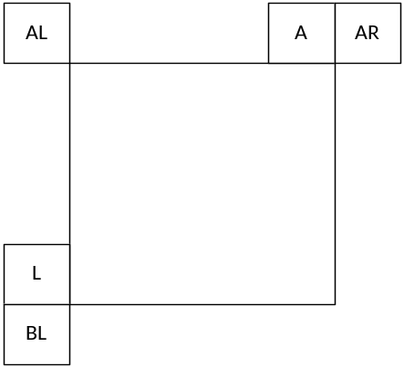
Figure 9: Neighboring blocks for MPM derivation
The initial MPM list is derived by adding the intra modes in the following order: left (L), above (A), planar, below-left (BL), above-right (AR), above-left (AL), and DC.
Differently from HEVC, rectangular shape blocks can be used for intra prediction, and depending on the shape of a block some intra modes can be preferred. For a rectangular shape block, if the block is vertically oriented, i.e. when the height is greater than the width, the left (L) and above (A) modes are swapped in the MPM list.
Similarly, the neighboring intra mode closed to horizontal intra direction may be preferable for the horizontally oriented rectangular blocks, and intra mode closed to vertical intra direction may be preferable for vertically oriented rectangular blocks. In such cases, neighboring intra mode from left (L) and above (A) locations, which is closer to vertical or horizontal intra directions is inserted first into the MPM list.
If MPM list is not complete, then the intra modes derived by adding ±1 (±2 for 67 modes, ±4 for 35 modes) to the angular most probable modes already included into the MPM list.
Finally, if MPM list is not complete, the following default modes: VER_IDX, HOR_IDX, 2, DIA_IDX, VDIA_IDX, 10, 26 are added to the list.
At the end of this derivation process, MPM list of size 7 containing only unique intra modes is obtained.

Secondary most probable list derivation
As proposed in JVET-D0114, secondary MPM list is constructed based on the primary MPM list. The size of the secondary MPM list depends on the total number of intra modes used in the current block, and it can be 32, 16, or 8, for 131, 67, 35 total number modes, respectively.

The secondary MPM modes are derived from the modes already included into the MPM list and only for the angular MPMs coming from a neighboring block. This process is not applied for the derived or default primary MPM modes. Derivation of the secondary mode is done by adding an offset ±1, ±2, ±3, … to the MPM modes and only unique modes are added into the secondary MPM list. This process is similar to the derivation of MPM modes in the primary MPM list. Number of derived modes depends on the MPM index as {x>>2, (x>>2)-1, (x>>2)-1, x>>3, x>>3, 1, 1}, where x is the length of the secondary MPM list, where the first number in the list indicates the maximum value of the offset that is used during the secondary MPM derivation, which is applied to the first mode in the primary MPM list.
Similarly, to the primary MPM list construction, if secondary MPM list is not complete, default modes are added. The default mode list is defined as {2, 18, 34, 50, 66; 10, 26, 42, 58; 6, 14, 22, 30, 38, 46, 54, 62; 17, 19, 49, 51}.

Intra mode signalling
First, a context coded flag is signaled to indicate whether the intra mode is from the primary MPM list, this process is the same as in JEM.
If the mode is MPM, then the MPM index is signaled using truncated unary binarization, where the first three bins are context coded. Like JEM, contexts are dependent on intra mode index and 4 contexts are used in total.
If mode is not from the primary MPM list, a context coded flag is signaled to indicate whether the mode is from the secondary MPM list. If the mode is from the secondary MPM list, the secondary MPM index is signaled in bypass mode otherwise the intra mode index is signalled using truncated binary (TB) binarization with maximum value depending on the total number of intra modes as follows.
Number of available intra mode | 35 | 67 | 131
MaxVal | 19 | 43 | 91
Due to symmetry in horizontal and vertical intra modes, during intra mode signalling the remaining mode index of the vertical intra modes is mapped to horizontal mode indices for the rectangular blocks with height greater or equal to the width as follows
new_mode_index = MaxVal – mode_index.

Chroma intra mode coding
Chroma intra mode coding is the same as in JEM. To accommodate LM and chroma intra mode combination, a context coded flag is signaled after chroma intra mode, only if the chroma mode is not LM, to indicate whether the combined prediction is used. The combined chroma prediction is not applied for small block sizes, the block size threshold is defined for each slice type.

Inter prediction modes
For each inter block, one of four prediction modes including inter, affine inter, skip, and merge, can be selected. The following sub-sections give detailed descriptions of the inter prediction modes in this proposal.

Inter Mode
For the inter mode, inter prediction indicators (List 0, List 1, or bi-directional prediction), reference indices, motion vector differences (MVDs) and prediction residual are transmitted. In the proposed scheme, a decoder-side motion refinement method, Template Matching (TM), is used to derive the motion vector predictor for the inter mode. First, the two HEVC AMVP candidates are checked and the candidate which leads to the smaller cost (e.g. SAD) is selected as the starting point. Then a local search based on template matching around the starting point is performed and the MV which results in the minimum matching cost is selected as the MVP for the current block without signalling MVP index to the decoder.
As shown in the Figure 10, TM is utilized to derive motion information of the current block by finding the best match between a current template (top and/or left neighboring blocks of the current block) in the current picture and a reference template (same size as the current template) in a reference picture within a local search region with search range [-8, 8] integer-pixel precision. The process of TM motion refinement is the one used in JEM with the proposed weighted TM. As shown in Figure 10, the weighted TM is used by applying different weights to each sample based on its row and column indices in template block when calculating the distortion between the current and reference templates.
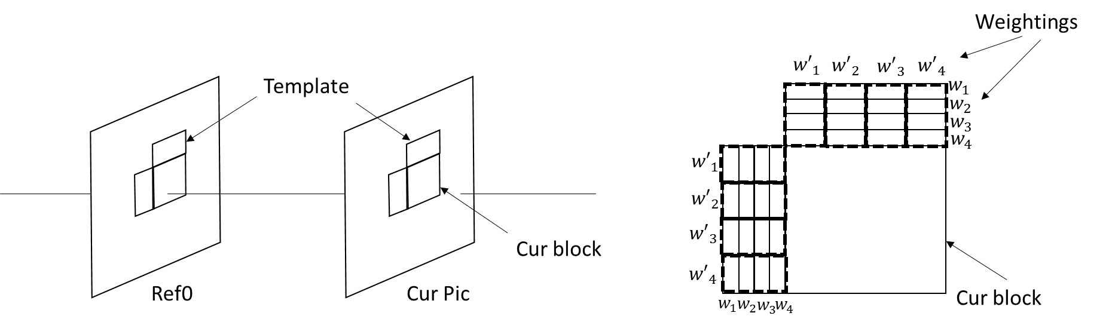
Figure 10: Template matching.

Merge/Skip modes
For the skip mode and the merge mode, a motion vector competition scheme is introduced to select a motion candidate from a given candidate set that includes spatial and temporal motion candidates. In the case of a skip mode, the residual signal is omitted.
Only merge indices are transmitted for the block coded in merge or skip mode, and the current block inherits the inter prediction indicator, reference indices, and motion vectors from a neighboring block referred by the coded merge index. The inherited motion information might be further refined by different decoder-side MV derivation (DMVD) methods and thus different merge modes are introduced in this proposal according to different DMVD approaches. A merge/skip flag is first signaled, followed by a TM flag when merge/skip mode is selected. When the TM flag is false, merge/skip mode is used which can use Bilateral Matching refinement. When the TM flag is true, an additional IC flag is signalled to indicate which method (Template Matching or IC Template Matching) is to be used to derive motion information for the block. The proposal does not include the decoder-side motion vector refinement (DMVR) method which is part of JEM (JVET-D0029).

Merge/Skip mode with Bilateral Matching refinement
A merge candidate list is first constructed by inserting the motion vectors and reference indices of the spatial neighboring and temporal neighboring blocks into the candidate list with redundancy checking until the number of the available candidates reaches the maximum candidate size of 19. The merge candidate list for the merge/skip mode is constructed by inserting spatial candidates (Figure 11), temporal candidates, affine candidates, advanced temporal MVP (ATMVP) candidate, spatial temporal MVP (STMVP) candidate and the additional candidates as used in HEVC (Combined candidates and Zero candidates) according to a pre-defined insertion order:
- Spatial candidates for blocks 1-4.
- Extrapolated affine candidates for blocks 1-4.
- ATMVP.
- STMVP.
- Virtual affine candidate.
- Spatial candidate (block 5) (used only when the number of the available candidates is smaller than 6).
- Extrapolated affine candidate (block 5).
- Temporal candidate (derived as in HEVC).
- Non-adjacent spatial candidate followed by extrapolated affine candidate (blocks 6 to 49).
- Combined candidates.
- Zero candidates.

It is noted that IC flags are also inherited from merge candidates except for STMVP and affine. Moreover, for the first four spatial candidates, the bi-prediction ones are inserted before the ones with uni-prediction.
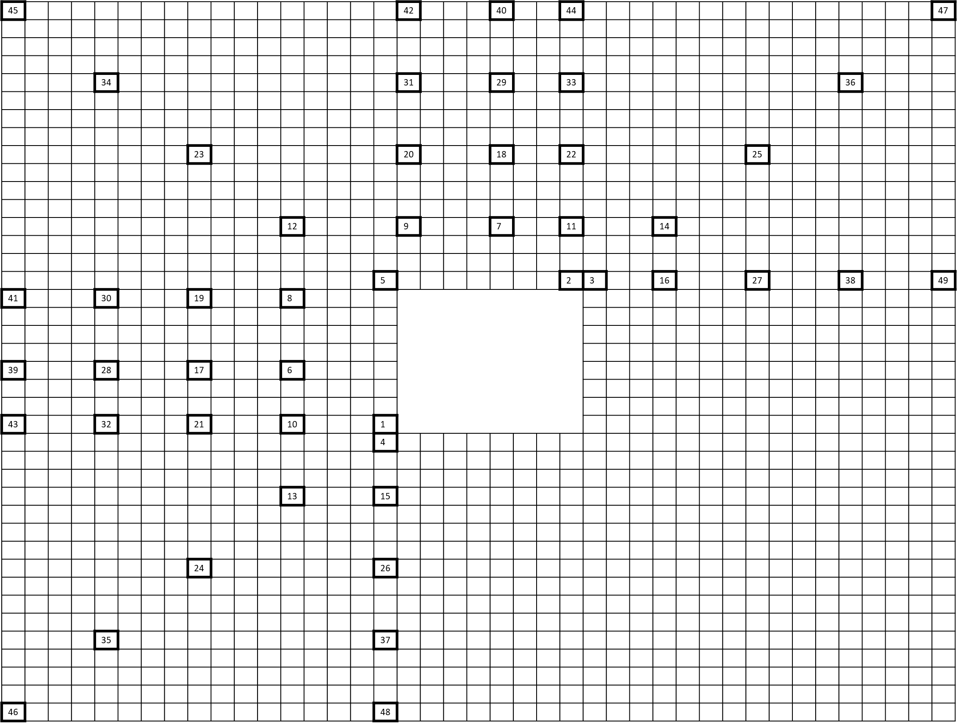
Figure 11: Spatial neighboring blocks used to derive the spatial merge candidates.
In this proposal, the sub-block merge candidates ATMVP and STMVP are identical to those used in JEM. The derivation of extrapolated affine candidates and the virtual affine candidate is described in the following sections.
The selected merge candidate is signalled to the decoder. The Bilateral Matching can be applied to this merge candidate if the following conditions are met:
- Uni-directional, ATMVP, STMVP, affine and candidates using IC mode are excluded.
- If only one of (POC_{ref0} – POC_{cur}) and (POC_{ref1} – POC_{cur}) values is negative.
- The MV difference between the selected candidate and any of the previous candidates is larger than a pre-defined threshold (e.g. one integer pixel).
A local search, with search range [-8,8], based on Bilateral Matching around the selected candidate is performed and the MVs which result in the minimum matching cost are taken as the final MVs. The process of Bilateral Matching used in this proposal is same as used in JEM with three modifications:
- The bilinear interpolation filter is used to generate the L0/L1 reference blocks in JEM, but the conventional DCTIF is used in the proposed scheme.
- When calculating the distortion between L0 and L1 reference blocks, SAD and mean-removal SAD might be selectively utilized according to the size of the current block (mean removal used for blocks larger than 64 pixels).
- The motion information is further refined at sub-block level in JEM, but the sub-block level refinement is removed in the proposed scheme.

Template Matching (TM) Merge/Skip mode
In the proposed scheme, when a block is coded using Template Matching (TM) merge mode, a merge candidate list is first constructed by inserting the motion vectors and the reference index of the spatial neighboring and temporal neighboring blocks into the candidate list with redundancy checking according to a predefined order:
- Spatial candidates (blocks 1- 5).
- Temporal candidates (block 1 or 2).
- Non-adjacent spatial candidates (block 6 - 49).
- Combined candidates (as in HEVC).
- Zero candidates (as in HEVC).
For the first four spatial candidates, the bi-prediction ones are inserted before the ones with uni-prediction. The candidates are inserted until the number of the available candidates reaches the maximum candidate size 4. After the merge candidates list is constructed, all the uni-prediction are converted into bi-prediction candidates by simply mirroring the available MV in one list to the other list.
The Template Matching refinement is applied only to the merge candidate signalled to the decoder. The weighted Template Matching (as described in Section 2.8.1) is used combined with the process as proposed in JVET-E0035.

Affine motion compensation prediction

Adaptive affine model selection
4-parameter affine model with two control points Figure 12 (a), and an additional 6-parameter affine model with three control point MVs Figure 12 (b), are used.
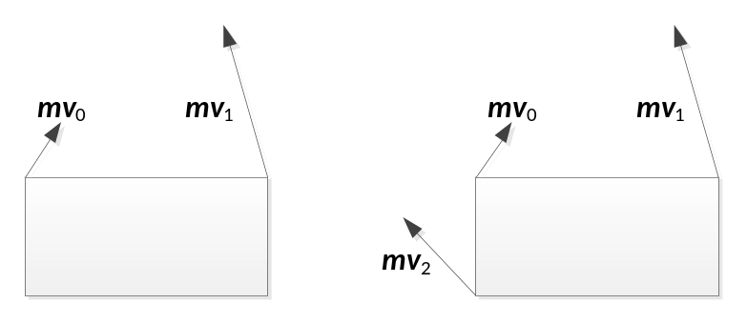
(a) (b)
Figure 12: 4-paramenter affine model (a) and 6-parameter affine model (b).
When the 6-parameter affine model is applied, the current block is divided into sub-blocks in the same way as for the 4-parameter affine model in JEM. The motion vector $mv=[{mv}^{x},{mv}^{y}]$ at a location (x,y) in W×H block can be derived from the MVs of the three control points (${mv}_{0}$, ${mv}_{1}$, and ${mv}_{2}$) as follows
$${mv}_{ }^{x}=\frac{\left({mv}_{1}^{x}-{mv}_{0}^{x}\right)}{w}x+\frac{\left({mv}_{2}^{x}-{mv}_{0}^{x}\right)}{h}y+{mv}_{0}^{x}$$
$${mv}_{ }^{y}=\frac{\left({mv}_{1}^{y}-{mv}_{0}^{y}\right)}{w}x+\frac{\left({mv}_{2}^{y}-{mv}_{0}^{y}\right)}{h}y+{mv}_{0}^{x}.$$
The affine models are adaptively selected at both slice level and block level. Slice header flags affine4_flag and affine6_flag indicate whether the 4-parameter affine and 6-parameter affine model are applied. If one of them is equal to 1, affine_flag signaled at block level indicates whether the allowed affine model is used for this block. If both are equal to 1, there is an affine_type flag signaled at block level. If affine_type is equal to 1, the 6-parameter affine model is used, otherwise the 4-parameter affine model is applied. To determine the affine4_flag and affine6_flag for the current slice the statistics from the previous slice are used.

Affine motion vector prediction
Two candidate sets with two (three) candidates $\left\{{\overline{mv}}_{0}, {\overline{mv}}_{1}\right\}$ $\left(\left\{{\overline{mv}}_{0}, {\overline{mv}}_{1}, {\overline{mv}}_{2}\right\}\right)$ are used to predict two (three) control points of the affine motion model. Given motion vector difference vectors, ${mvd}_{0}, {mvd}_{1}, {mvd}_{2}$, the control points are calculated:
$${mv}_{0}={\overline{mv}}_{0}+{mvd}_{0}$$
$${mv}_{1}={\overline{mv}}_{1}+{mvd}_{1}+{mvd}_{0}$$
$${mv}_{2}={\overline{mv}}_{2}+{mvd}_{2}+{mvd}_{0}$$
The affine candidate list is appended sequentially by extending affine motion from spatial neighboring blocks (extrapolated affine candidates), the combination of motion vectors from spatial neighboring blocks (virtual affine candidates) and HEVC motion vector prediction (MVP) candidates until there are two affine MVPs in the candidate list. The candidate sets are constructed as follows:
- Up to two different affine MV predictor sets are derived from affine motion of the neighboring blocks. Neighboring blocks A0, A1, B0, B1, and B2 as shown in Figure 13 are checked. If the neighboring block is coded using affine motion model and its reference frame is same as the reference frame of the current block, MVs at two (for 4-parameter affine model) or three (for 6-parameter affine model) control points of the current block are derived from the affine model of this neighbor.
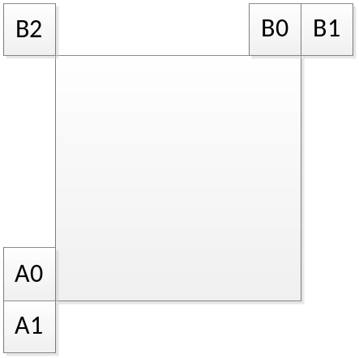
Figure 13: Affine motion predictors derivation from affine motion of neighboring blocks.
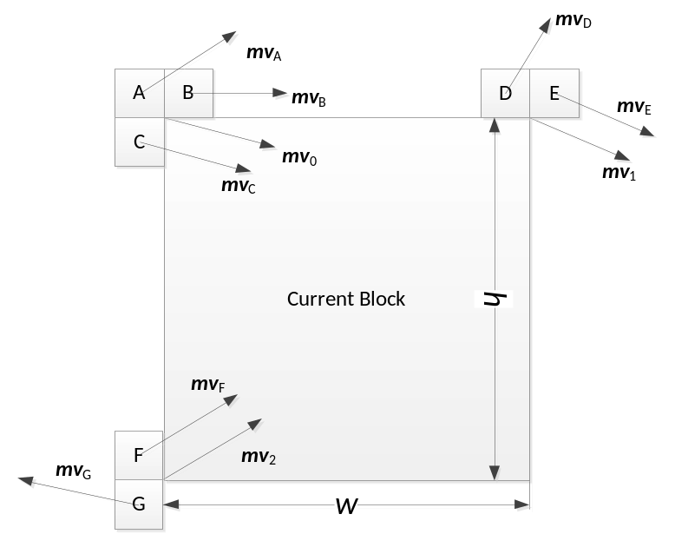
Figure 14: Affine motion predictors derivation from motion vectors of neighboring blocks.

- Virtual affine candidates. Figure 14 shows the neighboring blocks used to generate the virtual affine candidate set. The neighboring MVs are divided into three groups: $S_{0}=\left\{{mv}_{A},{mv}_{B},{mv}_{C} \right\}$, $S_{1}=\left\{{mv}_{D},{mv}_{E}\right\}$ and $S_{2}=\left\{{mv}_{F},{mv}_{G}\right\}$. ${\overline{mv}}_{0}$ is the first MV in S₀ that refers to the same reference picture as the current block; ${\overline{mv}}_{1}$ is the first MV in S₁ that refers to the same reference picture of the current block; and ${\overline{mv}}_{2}$ is the first in S₂ that refers to the same reference picture of the current block.
- If only ${\overline{mv}}_{0}$ and ${\overline{mv}}_{1}$ can be found, ${\overline{mv}}_{2}$ is derived as:
${\overline{mv}}_{2}^{x}={\overline{mv}}_{0}^{x}-h\frac{\left({\overline{mv}}_{1}^{y}-{\overline{mv}}_{0}^{y}\right)}{w}, {\overline{mv}}_{2}^{y}={\overline{mv}}_{0}^{y}+h\frac{\left({\overline{mv}}_{1}^{x}-{\overline{mv}}_{0}^{x}\right)}{w},$
where the current block size is W×H.
- If only ${\overline{mv}}_{0}$ and ${\overline{mv}}_{2}$ can be found, ${\overline{mv}}_{1}$ is derived as:
${\overline{mv}}_{1}^{x}={\overline{mv}}_{0}^{x}+h\frac{\left({\overline{mv}}_{2}^{y}-{\overline{mv}}_{0}^{y}\right)}{w}, {\overline{mv}}_{1}^{y}={\overline{mv}}_{0}^{y}-h\frac{\left({\overline{mv}}_{2}^{x}-{\overline{mv}}_{0}^{x}\right)}{w}.$

Unified affine/normal merge candidate list
Unlike in JEM there is no separate merge mode for affine. A merge candidate in the merge candidate list can be an affine merge candidate or a normal merge candidate. For each adjacent or non-adjacent spatial neighboring block, an affine merge candidate is derived from the affine model as in JEM. The candidate construction process starts with generating four non-affine spatial merge candidates (left, top, top-right, left-bottom), and followed by up to four affine merge candidates if the corresponding spatial neighboring blocks are coded in affine mode. For top-left spatial neighboring block and each non-adjacent spatial neighboring block an affine merge candidate from a spatial neighboring block is inserted into the merge candidate list after the normal merge candidate from that neighboring block has been inserted.

In addition, affine merge candidate constructed as combination of motion vectors from spatial neighboring blocks is inserted after the ATMVP/STMVP candidate. This candidate is constructed in the same way as the candidate for the affine motion vector prediction described in the previous section, except that the target reference picture is not known beforehand. The target reference picture is determined as follows. If there is a reference picture that is simultaneously referred to by motion vectors in S₀, S₁ and S₂, then such a reference picture with the smallest reference index is selected as the target one; otherwise, if there is a reference picture that is simultaneously referred to by motion vectors in S₀ and in S₁, then such a reference picture with the smallest reference index is selected as the target one; otherwise, if there is a reference picture that is simultaneously referred to by a MV_{X} in S₀ and a MV_{Z} in S₂, then such a reference picture with the smallest reference index is selected as the target one; otherwise, the artificial candidate is unavailable.

Adaptive motion vector difference resolution
A locally adaptive motion vector resolution (LAMVR) is used. As in JEM, MVD can be coded in units of quarter luma samples, integer luma samples or four luma samples. The MVD resolution is controlled at the block level, and MVD resolution flags are conditionally signalled for each block that has at least one non-zero MVD component.
When signalling MVD, the binarization and context modeling are dependent on the MVD precision and the POC distance between the current frame and the reference frame (JVET-D0123). The contexts used to code the flags abs_mvd_greater0_flag and abs_mvd_greater1_flag are listed in Table 1. Remaining value of MVD (abs_mvd_remaining_value) is coded using Exponential-Golomb code. Parameter of the Exponential-Golomb is set to 2 if the quarter-pel precision is used or POC distance is larger than 1, and to 1 otherwise. The unary portion of the Exponential-Golomb is context coded, two different contexts are used depending on the parameter of the Exponential-Golomb code.

Syntax element | Integer or four luma sample precision | Quarter luma sample precision
abs_mvd_greater0_flag | 0 | 0
abs_mvd_greater1_flag | 2 | 1
Table 1: Context models (context numbers) used in MVD coding.

Bi-directional optical flow
Bi-directional Optical flow (BIO) is sample-wise motion refinement. The BIO design in this proposal is same as in JEM except for gradient calculation which follows the design proposed in JVET-G0083.
The gradient values are calculated using the interpolated prediction samples $I(u,v)$. The gradient filter coefficients are: {2, -9, 0, 9, 2}. The horizontal and vertical gradient values, $G_{x}$ and $G_{y}$, are calculated using the following equations:
$$G_{x}\left(x,y\right)=\sum_{u=x-2}^{x+2}{I\left(u,y\right)×c\left(u-x+2\right)}$$
$$G_{y}\left(x,y\right)=\sum_{v=y-2}^{y+2}{I\left(x,v\right)×c\left(v-y+2\right)}$$
where c represents the coefficient values of the gradient filter. The range of x is between 0 and w-1 and the range of y is between 0 and h-1 (w, h are the width and height of the block, respectively). Two extra interpolated samples on each side (above, left, bottom, right) of the block are required for the gradient calculation. Interpolation that requires reference samples outside of the samples used in the regular motion compensation, the reference samples are padded by repeating the outmost reference samples.

Motion Compensated Boundary Pixel Padding (MC Padding)
When the decoder performs motion compensation, if the motion vector points to a block outside the frame boundary, a part of the refence block is not available. For each region with size of 4xM or Mx4 along the boundary of the reference picture to be padded, M being the desired frame boundary extension, a motion vector is derived from the nearest 4x4 block inside the frame. If the nearest 4x4 block is intra coded, a zero motion vector is used. If the nearest 4x4 block is coded with bi-directional inter prediction, only the motion vector, which points to the pixel farther away from the frame boundary, is used in motion compensation for padding. After the motion vector derivation, motion compensation is then performed to obtain the pixels in the padding region with the consideration of average pixel value offset between the nearest 4x4 block and its corresponding block in its reference picture.

In-loop filtering
Following in-loop filters are used: deblocking filter, Sample Adaptive Offset filter, Adaptive Loop Filter (ALF) and bilateral filter. ALF is the same as in JEM.

Bilateral filter
In this proposal, bilateral filter is always applied to luma blocks with non-zero transform coefficients and slice quantization parameter larger than 17. Therefore, there is no need to signal the usage of the bilateral filter. Bilateral filter, if applied, is performed on decoded samples right after the inverse transform. In addition, the filter parameters, i.e., weights are explicitly derived from the coded information.
The filtering process is defined as:
$$P_{0, 0}^{'}=P_{0, 0}+\sum_{k=1}^{K}{W_{k}\left(P_{k, 0}-P_{0, 0}\right)×\left(P_{k, 0}-P_{0, 0}\right)},$$
where $P_{0, 0}$ is the intensity of the current sample and $P_{0, 0}^{'}$ is the modified intensity of the current sample, $P_{k, 0}$ and $W_{k}(∙)$ are the intensity and weighting parameter for the k-th neighboring sample, respectively. An example of one current sample and its four neighboring samples (i.e., K=4), in the shape of a plus sign, is depicted in Figure 15.
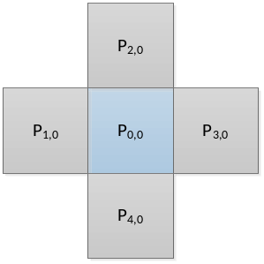
Figure 15: Neighboring samples utilized in bilateral filter.
More specifically, the weight $W_{k}(x)$ associated with the k-th neighboring sample is defined as follows:
$$W_{k}(x)={Distance}_{k}× {Range}_{k}(x)$$
wherein
$${Distance}_{k}={e^{\left(- \frac{10000}{2σ_{d}^{2}}\right)}}/{1+4*e^{\left(- \frac{10000}{2σ_{d}^{2}}\right)},}$$
$${Range}_{k}\left(x\right)=e^{\left(– \frac{x^{2}}{8*\left(QP – 17\right)*(QP – 17) }\right)}$$
and $σ_{d}$ is dependent on the coded mode and coding block sizes. To further improve the coding performance, for inter-coded blocks, the intensity difference between current sample and one of its neighboring samples is replaced by a representative intensity difference among two windows covering current sample and the neighboring sample. Therefore, the equation of filtering process is revised to:
$$P_{0, 0}^{'}=P_{0, 0}+\sum_{k=1}^{N}{W_{k}\left(\frac{1}{M}\sum_{m=-M/2}^{M/2}{abs(P_{k, m}-P_{0, m})}\right)×(P_{k, 0}-P_{0, 0})}$$
wherein $P_{k, m}$ and $P_{0, m}$ represent the m-th sample value within the windows centered at ${ P}_{k, 0}$ and $P_{0, 0}$, respectively. In this proposal, the window size is set to 3×3. An example of two windows covering${ P}_{2, 0}$ and $P_{0, 0}$ are depicted in Figure 16.
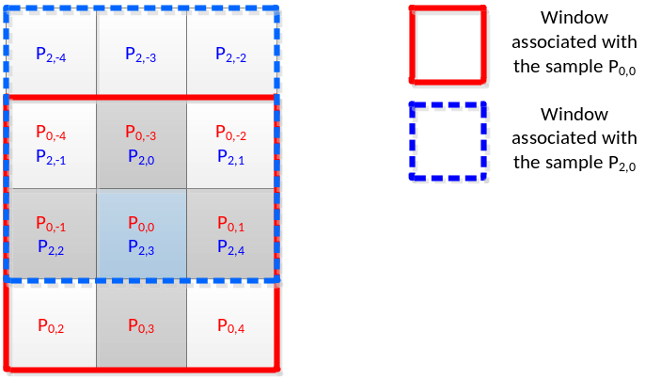
Figure 16: Windows covering two samples utilized in weight calculation.

Sample Adaptive Offset filter
Sample Adaptive Offset (SAO) is applied to the reconstructed image after the deblocking filter. Unlike in in HEVC or JEM, signalling of SAO parameters could be done at block level, wherein the block could be smaller than an CTU. An index indicating the block size is selected by the encoder based on the RD cost and signaled in the bitstream for each slice. Specifically, in this proposal, the SAO parameters may be signaled for each square block of size equal to CTU size or CTU size divided by 4.
Two merge flags (i.e., sao_merge_left_flag and sao_merge_up_flag) are used to indicate whether the current block inherits the SAO parameters from neighboring blocks. If sao_merge_left_flag is equal to 1, the current block will reuse the SAO parameters of the block to the left. If sao_merge_up_flag is equal to 1, the current block will reuse SAO parameters of the above block. In HEVC and JEM, sao_merge_up_flag is signaled only if sao_merge_left_flag equals 0. This limits the sharing SAO parameters among blocks. Examples of block merging not allowed with this signalling are shown in Figure 17. To overcome this limitation, in this proposal, both sao_merge_left_flag and sao_merge_up_flag may be signaled and are allowed to be true. A common virtual label can then be assigned to all blocks which share the same SAO filter parameters as indicated by the merge flags. To simplify the parsing process, a merge flag can be true only if it does not lead to virtual labels such that two non-consecutive blocks in the same row share the same label.

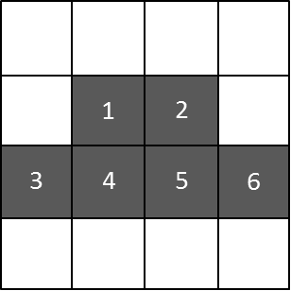
Figure 17: The shaded blocks share the same SAO parameters.

Deblocking filter
Deblocking filter process is same as in JEM with exception of addition of long filter. The long filter can be only applied to boundaries between blocks with height and width larger than or equal to 16. In addition, the sum of the absolute values of second derivatives must be smaller than the threshold specified below:
$$(((perCountTh×count+1)≫1)+1)≫1) ×(BitDepth-8)$$
In the above equation, count equals the number of second derivative terms added to compute the signal variation. The $perCountTh$ value differs for different slice types. The sum of the absolute values of second derivatives is calculated for pixels shown in Figure 18. The horizontal second derivative at a sample $p_{n,m}$ equals $p_{n-1,m}-2p_{n,m}+p_{n+1,m}$.

$$\begin{matrix}p_{15,0} & p_{14,0} & ⋯ & p_{1,0} & p_{0,0} & q_{0,0} & q_{1,0} & ⋯ & q_{14,0} & q_{15,0} \\ p_{15,1} & p_{14,1} & ⋯ & p_{1,1} & p_{0,1} & q_{0,1} & q_{1,1} & ⋯ & q_{14,1} & q_{15,1} \\ p_{15,2} & p_{14,2} & ⋯ & p_{1,2} & p_{0,2} & q_{0,2} & q_{1,2} & ⋯ & q_{14,2} & q_{15,2} \\ p_{15,3} & p_{14,3} & ⋯ & p_{1,3} & p_{0,2} & q_{0,3} & q_{1,3} & ⋯ & q_{14,3} & q_{15,3}\end{matrix}$$
Figure 18: Second derivatives are calculated for pixels marked by dashed lines.
When long filter is selected, the following 11-tap filters are used to modify pixels $q_{0},q_{1}, q_{2},q_{3}$ and $p_{0},p_{1}, p_{2},p_{3}$ as shown in Figure 18 (when the second index denoting the row number is omitted for brevity, the operation is applied to all pixels in the column):
$$h_{0}=\left[0, 2, 9, 12, 1, 3, 13, 16, 5, 3, 0\right],$$
$${ h}_{1}=\left[-1, 6, 7, 8, -2, 13, 15, 10, 8, 0, 0\right],$$
$$h_{2}=\left[-1, 4, 12, -3, 6, 14, 14, 16, 2, 0, 0\right],$$
${ h}_{3}=\left[-3, 16, -3, 1, 5, 16, 18, 14, 0, 0, 0\right]$.

The filter $h_{i}$ is centered at pixel $p_{i}$, where $i=0,1,2,3$.

Arithmetic coding main engine
The proposed implementation preserves all features of the arithmetic coding main engine used JEM-7.1 software with exception of bin probability estimation, which follows proposal JVET-G0112. As an option submission also includes reduced precision engine described in JVET-E0119.

Bin probability estimation
The probability estimation part of the binary arithmetic coding used in JEM employs the “parallel double window” technique. It uses two independent sequences, U[k] and V[k], which are estimated probabilities scaled by 2¹⁵ and converted to integers. Those probability estimates are updated using the recursive equations
$$bin=1→U\left[k+1\right]=U\left[k\right]+\left(\left(2^{15}-U\left[k\right]\right)≫4\right), V\left[k+1\right]=V\left[k\right]+\left(\left(2^{15}-V\left[k\right]\right)≫8\right),$$
$$bin=0→U\left[k+1\right]=U\left[k\right]-\left(U\left[k\right]≫4\right), V\left[k+1\right]=V\left[k\right]+\left(V\left[k\right]≫8\right),$$
where >> represents right bit shifts. The probability estimate actually used for encoding and decoding is defined as
$$P\left[k\right]=\left(U\left[k\right]+V\left[k\right]\right)≫1.$$
This corresponds to taking the average of two estimators with “virtual windows” of 16 and 256 bins, respectively. The same equations and window parameters (bit shift values) are used for all coding contexts, and those shift values were chosen to obtain the best balance between speed of adaptation, when probability changes within a context, and immunity to deviations, which occur due to the randomness of the data.

Context-dependent adaptation parameters
Many of coding contexts are used in JEM for coding very different syntax elements, and coding data from very different data sources. Thus, even though the separation into contexts is expected to reduce statistical variations within a context, there is still significant differences between contexts, with regards to the speed in which probabilities may change, and the expected magnitudes of the changes.
To increase the accuracy of bin probability estimation, the estimation is changed to use two positive integer window shift parameters a and b, which can be different for each context, and use the following parameterized recursive equations for updating scaled probability estimates
$$bin=1→U\left[k+1\right]=U\left[k\right]+\left(\left(2^{15}-U\left[k\right]\right)≫a\right), V\left[k+1\right]=V\left[k\right]+\left(\left(2^{15}-V\left[k\right]\right)≫b\right) ,$$
$$bin=0→U\left[k+1\right]=U\left[k\right]-\left(U\left[k\right]≫a\right), V\left[k+1\right]=V\left[k\right]+\left(V\left[k\right]≫b\right) ,$$
$$P\left[k\right]=\left(U\left[k\right]+V\left[k\right]\right)≫1.$$
where parameters a and b are such that 2 ≤ a ≤ b ≤ 9. Due to their limited range, a and b can be stored using only 3 bits each.
With this modification, it is possible to find the values of a and b that optimize compression efficiency, for each context. To preserve the computational complexity of the current method, the bit-shift values a and b are set only when the context probability is re-initialized (i.e., when probabilities are set to pre-defined values, depending on the quantization parameter QP) at each slice.
Since shift parameters and probabilities are changed together during context re-initialization, they were jointly optimized to obtain the largest gains per context. Furthermore, instead of having different arrays of context initializers per B, P, and I slice type, this is replaced by the same arrays of initializers for all slice types, plus two pairs of shifts parameters (a, b) per context, with one pair used if QP < 30, and another if QP ≥ 30. With this setup the total amount of memory needed for context initialization is maintained as 20 bits per context.

360°
The 360 codec is based on the SDR proposal above and employs the adjusted cubemap projection (ACP) included in JVET 360Lib5.0 [4] and originally proposed in JVET-F0025 to convert ERP input pictures into ACP pictures. The benefit of ACP over the ordinary cubemap and ERP is the more regular sampling of the sphere as is illustrated in Figure 19. The cube faces are packed into the 3×2 format with the top and bottom picture halves continuous as is illustrated in Figure 20 (a).

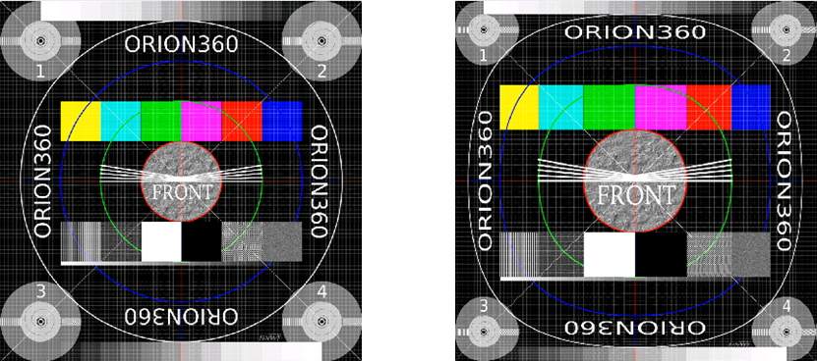
(a) (b)
Figure 19: Example of one cubemap face obtained with (a) ordinary cubemap projection, (b) ACP.
The 360 inter prediction utilizes symmetric ACP cube face padding to overcome 360 motion wraparound issues and is essentially identical to the proposal JVET-G0058. The padding is added to the reconstructed cube faces and is symmetric around each cube face with width 64 samples as is illustrated in Figure 20 (b). The padded samples are obtained based on the ACP geometry and nearest-neighbor rounding. The reconstructed ACP pictures are padded one time prior to in-loop filtering. The 360 inter prediction disables the motion compensated padding tool for the picture and OBMC for blocks on the boundary between top and bottom row of cube faces. The colocated block locations on reference pictures are adjusted to compensate for padding around the cube faces for motion compensation. The motion prediction and coding are unmodified.

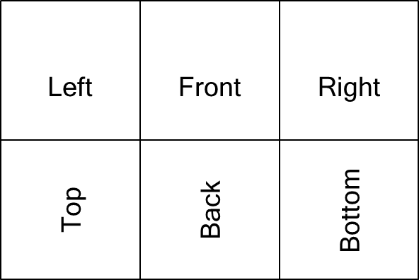  (a) | 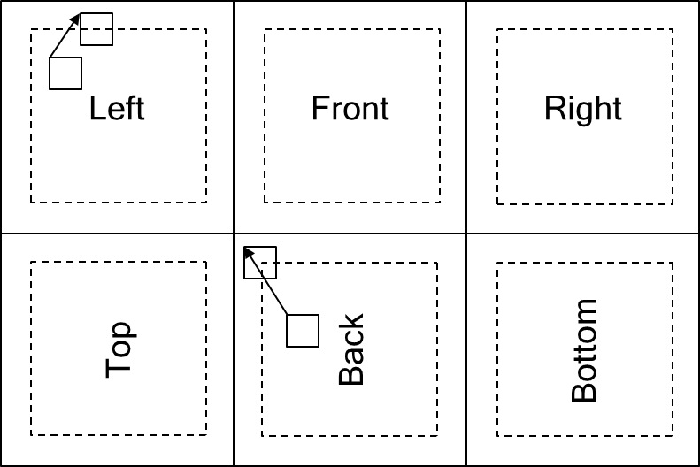  (b)
Figure 20: (a) ACP 3×2 frame packing. (b) Padded ACP reference frame.
The padded reconstructed ACP pictures are sequentially processed by the deblocking filter, SAO and ALF before storage as reference pictures. The three in-loop filters are adapted to take the pixel location offsets introduced by the padding of the cube faces into account and process the cube face areas and in case of deblocking outer edges of each cube face to reduce seam artifacts. In addition, the deblocking boundary strength derivation is adapted so that the boundary strength for an edge is determined based on blocks that are spherical neighbors.
The intra prediction process that fills the reference sample lines is adapted to copy samples from neighboring cube faces. Blocks with top boundaries located on the middle picture boundary and blocks with left boundaries located on the bottom half of the left picture boundary benefit from using copying neighboring samples from spherically adjacent faces.
In SPS the ACP projection type and padding width is included.

HDR
In order to allow evaluation of CfP responses in HDR category and selection of HDR tools without interfering with the generic video coding tools technology response in the HDR category of the CfP was implemented as an add-on to the video coding system described above. Response in the HDR category included High Complexity and Low complexity submissions which differentiate in the core coding and utilize identical HDR-related technology and settings.
Proposed HDR technology is implementation of Color Volume Transform (CVT) which is applied in the Y’CbCr 4:2:0 sample domain. CVT is performed on the input video signal prior to coding and the inverse process is performed on the signal after decoding. CVT modifies luma and chroma samples in the picture based on the value of the luma or chroma samples and on the value of other component samples located at the same or closest relative location. Single CVT was used for coding of all video sequences of the CfP; parameters of the CVT in the submitted response were configured to be static for a sequence across of all rate points. Response was configured to utilize no multi-pass processing and no dynamic change in parameters of CVT.
Proposed CVT consists of following major components:
- Dynamic Range Adjustment (DRA)
- Cross-Component DRA (CC-DRA)
- DRA and scalar quantizer harmonization
The response, like HDR anchors of the CfP, also employs different encoder-side configurations to address properties of the utilized HDR formats (HLG/PQ) and properties of the color gamut.

HDR Video Codec design
Block diagram of the response in the HDR category is shown in Figure 21. At the encoder, the CVT is applied to the input Y’CbCr 4:2:0 picture (10 bits per sample) which results in the intermediate picture (stored at 4:2:0 10 bits per sample); this intermediate picture is coded. Parameters of inverse CVT are encapsulated in the coded bitstream and used at the decoder side to configure inverse CVT which is applied to the decoded picture (stored at 4:2:0 10 bits per sample).

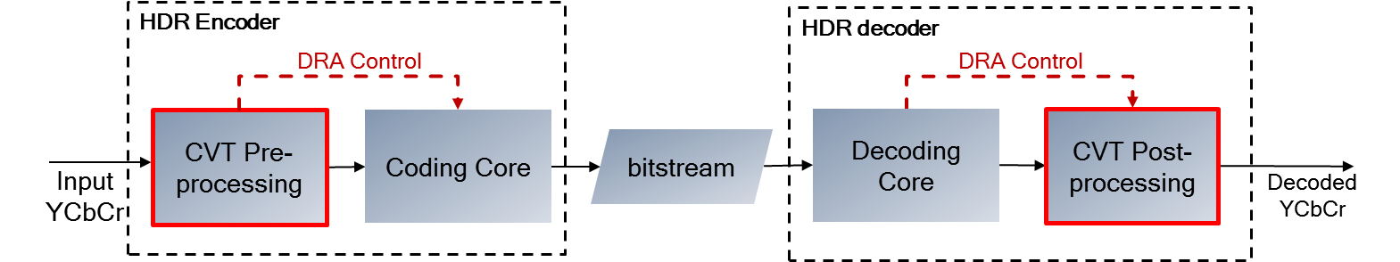
Figure 21: Block diagram of the response in HDR category.

Color Volume Transform
Dynamic Range Adjustment (DRA) is a main component of the proposed CVT and it was originally described in VCEG document T13-SG16-C-1027 and in the MPEG document m37064. The main principle of the DRA is range-adaptive scaling of luma and chroma samples which is applied at the pre-processing stage and its inverse is applied at the decoder side as post-processing. Inverse DRA operations at post-processing are described as:
$X_{Y}=x_{Y}*S_{Y}\left(i\right)+O_{Y}\left(i\right)$ ( 1 )
$X_{Cb}=x_{Cb}*S_{Cb}\left(j\right)+O_{Cb}\left(j\right)$ ( 2 )
$X_{Cr}=x_{Cr}*S_{Cr}\left(k\right)+O_{Cr}\left(k\right)$ ( 3 )
where terms S and O terms define the piece-wise linear function of the DRA for a particular dynamic range partition of color component, x is a decoded sample, X are post-processed samples and i, j and k are indices of dynamic range partitioning to which the Y, Cb and Cr components, respectively, of x sample belong.
Parameters of DRA are derived from a piece-wise linear function defined through dynamical range partitions (called ranges) and scale values which are applied to all samples belonging to a particular range partition. Independent DRA curve is defined for each color component.
Cross-Component DRA (CC-DRA) is carried to preserve luma/chroma bitrate allocation for different brightness ranges following the application of the DRA on input chroma samples. At the decoder side, inverse CC-DRA precedes the inverse DRA process. In this approach, for each decoded chroma sample x_{Cx}, the chroma scaling component ${S2}_{cx}\left(Y\right)$ is derived from luma DRA scales $S_{Y}\left(i\right)$ of associated Luma sample:
${S2}_{cx}\left(Y\right)=fun\left(S_{Y}\left(x_{Y}\right)\right)$ ( 4 )
The CC-DRA scales ${S2}_{cx}\left(Y\right)$ is obtained by linear interpolation of luma DRA scales of adjacent intervals, e.g. $S_{Y}\left(i\right) and S_{Y}\left(i+1\right)$, Figure 22 shows the example of such linearization.
Following this, in the process of DRA scales and scalar quantizer harmonization, the CC-DRA scale ${S2}_{cx}\left(Y\right)$is adjusted by a multiplication factor ${S3}_{cx}\left(QP\right)$ to preserve a luma/chroma bit allocation assumed by the core coding design for a given QP settings introduced by chroma QP offset table.
The derived CC-DRA scales are applied to a zero-mean chroma samples $x_{Cb}$ and $x_{Cr}$ based on the luma values $x_{Y}$ associated with these chroma samples.
${X2}_{Cx}=\left(x_{Cx}-2^{bitDepth-1}\right)*{S2}_{x}\left(Y\right)*{S3}_{x}\left(QP\right)+2^{bitDepth-1}$ ( 5 )

Figure 22: CC-DRA scaling function for chroma components (red curve) derived from luma DRA scales (blue curve) .

Compression performance
Two different sets of simulation were conducted in this proposal. The first simulation is the high complexity mode and the second simulation is the low complexity mode. The main difference in these two modes resides on the Prediction Tree. For the high complexity mode, the proposal enables full Prediction Tree (Binary Tree, Triple Tree, and Asymmetric Binary Tree) in Constraint Set 1 and only Binary Tree and Triple Tree in Constraint Set 2. For the low complexity mode, the proposal enables only Binary Tree in both Constraint Sets 1 and 2. Note that JVET-J0022 contains the information on medium complexity mode.

SDR
In the high complexity mode, both simulations for the anchor (HM16.16) and the proposal were conducted on CPU: Intel(R) Xeon(R) CPU E5-2673 v2 @ 3.30GHz. On the other hand, in the high complexity mode, both simulation for the anchor (HM16.16) and the proposal were conducted on CPU: Intel(R) Xeon(R) CPU E5-2680 0 @ 2.70GHz. The compression performance of both modes is detailed in the following sections, additional RD curve plot information of each test point is included in the excel sheets.

SDR category: Constraint Set 1 configuration (high complexity)
The following table presents summary of the Constraint Set 1 BD-rate and BD-PSNR performance of the proposal (high complexity mode) relative to the HM-16.16 anchor.
 | BD-rate(Y) | BD-rate(U) | BD-rate(V) | BD-PSNR(Y) | BD-PSNR(U) | BD-PSNR(V)
FoodMarket4 | -41.44% | -42.72% | -46.32% | 2.16 | 1.24 | 1.47
CatRobot1 | -47.69% | -58.82% | -51.32% | 1.93 | 1.11 | 1.51
DaylightRoad2 | -49.51% | -63.00% | -48.83% | 1.43 | 1.43 | 0.96
ParkRunning3 | -45.16% | -19.44% | -23.44% | 1.63 | 0.32 | 0.32
Campfire | -51.13% | -26.39% | -58.00% | 1.63 | 0.93 | 1.88
BQTerrace | -39.62% | -54.12% | -61.16% | 1.23 | 1.07 | 1.23
RitualDance | -35.97% | -37.55% | -40.06% | 2.03 | 1.07 | 1.32
MarketPlace | -36.88% | -46.89% | -45.91% | 1.37 | 0.82 | 0.85
BasketballDrive | -40.58% | -46.90% | -42.03% | 1.53 | 1.05 | 1.27
Cactus | -42.87% | -47.98% | -43.43% | 1.85 | 0.78 | 1.14
Average SDR-A | -46.98% | -42.07% | -45.58% | 1.76 | 1.00 | 1.23
Average SDR-B | -39.18% | -46.69% | -46.52% | 1.60 | 0.96 | 1.16
Average all | -43.08% | -44.38% | -46.05% | 1.68 | 0.98 | 1.20
Enc Time[%] | 1180%
Dec Time[%] | 639%
The following table presents summary of the Constraint Set 1 BD-rate and BD-PSNR performance of the proposal (high complexity mode) relative to the JEM 7.0 anchor.
 | BD-rate(Y) | BD-rate(U) | BD-rate(V) | BD-PSNR(Y) | BD-PSNR(U) | BD-PSNR(V)
FoodMarket4 | -12.68% | 1.56% | 0.29% | 0.50 | -0.03 | 0.00
CatRobot1 | -14.39% | -14.96% | -11.02% | 0.39 | 0.16 | 0.22
DaylightRoad2 | -15.66% | -15.76% | -13.71% | 0.30 | 0.20 | 0.20
ParkRunning3 | -20.66% | 7.87% | 5.51% | 0.64 | -0.10 | -0.06
Campfire | -27.61% | 11.99% | -17.32% | 0.63 | -0.36 | 0.37
BQTerrace | -13.43% | -19.44% | -18.35% | 0.32 | 0.25 | 0.20
RitualDance | -12.16% | -0.52% | 0.16% | 0.58 | 0.01 | 0.00
MarketPlace | -11.55% | 0.67% | -2.94% | 0.35 | -0.01 | 0.04
BasketballDrive | -14.23% | -2.85% | 1.70% | 0.41 | 0.05 | -0.04
Cactus | -12.89% | -5.18% | -4.02% | 0.41 | 0.06 | 0.08
Average SDR-A | -18.20% | -1.86% | -7.25% | 0.49 | -0.03 | 0.15
Average SDR-B | -12.85% | -5.47% | -4.69% | 0.42 | 0.07 | 0.06
Average all | -15.53% | -3.66% | -5.97% | 0.45 | 0.02 | 0.10
Enc Time[%] | 148%
Dec Time[%] | 84%

SDR category: Constraint Set 2 configuration (high complexity)
The following table presents summary of the Constraint Set 2 BD-rate and BD-PSNR performance of the proposal (high complexity mode) relative to the HM-16.16 anchor.
 | BD-rate(Y) | BD-rate(U) | BD-rate(V) | BD-PSNR(Y) | BD-PSNR(U) | BD-PSNR(V)
BQTerrace | -36.50% | -58.64% | -63.98% | 1.14 | 0.79 | 0.86
RitualDance | -30.07% | -44.55% | -46.78% | 1.63 | 1.16 | 1.40
MarketPlace | -29.51% | -50.02% | -50.83% | 1.00 | 0.69 | 0.77
BasketballDrive | -33.86% | -53.58% | -52.57% | 1.33 | 1.24 | 1.66
Cactus | -38.75% | -52.93% | -51.36% | 1.65 | 0.82 | 1.25
Average SDR-B | -33.74% | -51.94% | -53.10% | 1.35 | 0.94 | 1.19
Enc Time[%] | 969%
Dec Time[%] | 607%
The following table presents summary of the Constraint Set 2 BD-rate and BD-PSNR performance of the proposal (high complexity mode) relative to the JEM-7.0 anchor.
 | BD-rate(Y) | BD-rate(U) | BD-rate(V) | BD-PSNR(Y) | BD-PSNR(U) | BD-PSNR(V)
BQTerrace | -14.57% | -22.95% | -29.48% | 0.36 | 0.23 | 0.24
RitualDance | -10.82% | -16.53% | -17.77% | 0.52 | 0.33 | 0.42
MarketPlace | -11.25% | -12.94% | -16.36% | 0.34 | 0.13 | 0.19
BasketballDrive | -11.44% | -15.69% | -15.79% | 0.36 | 0.25 | 0.37
Cactus | -15.19% | -18.89% | -20.37% | 0.52 | 0.21 | 0.37
Average SDR-B | -12.65% | -17.40% | -19.95% | 0.42 | 0.23 | 0.32
Enc Time[%] | 120%
Dec Time[%] | 91%
In addition, results are provided for high complexity configuration without ABT for Constraint Set 1 BD- relative to the HM-16.16 and JEM anchors.
 | Over HM16.16
 | BD-rate(Y) | BD-rate(U) | BD-rate(V) | BD-PSNR(Y) | BD-PSNR(U) | BD-PSNR(V)
FoodMarket4 | -40.97% | -40.36% | -43.96% | 2.12 | 1.15 | 1.37
CatRobot1 | -46.07% | -57.46% | -49.85% | 1.83 | 1.07 | 1.45
DaylightRoad2 | -49.62% | -62.58% | -48.62% | 1.42 | 1.41 | 0.95
ParkRunning3 | -44.57% | -19.31% | -23.69% | 1.62 | 0.32 | 0.33
Campfire | -50.69% | -27.11% | -58.07% | 1.61 | 0.97 | 1.88
BQTerrace | -39.47% | -49.89% | -57.26% | 1.21 | 0.98 | 1.15
RitualDance | -35.70% | -37.58% | -40.13% | 2.02 | 1.08 | 1.33
MarketPlace | -35.73% | -42.31% | -40.68% | 1.32 | 0.74 | 0.73
BasketballDrive | -40.21% | -46.42% | -41.46% | 1.50 | 1.03 | 1.24
Cactus | -42.38% | -46.48% | -42.21% | 1.82 | 0.76 | 1.11
Average SDR-A | -46.38% | -41.36% | -44.84% | 1.72 | 0.98 | 1.20
Average SDR-B | -38.70% | -44.54% | -44.35% | 1.57 | 0.92 | 1.11
Average all | -42.54% | -42.95% | -44.59% | 1.65 | 0.95 | 1.15
Enc Time[%] | 1153%
Dec Time[%] | 573%

 | Over JEM7.0
 | BD-rate(Y) | BD-rate(U) | BD-rate(V) | BD-PSNR(Y) | BD-PSNR(U) | BD-PSNR(V)
FoodMarket4 | -12.08% | 5.70% | 4.72% | 0.47 | -0.11 | -0.10
CatRobot1 | -11.90% | -12.24% | -8.41% | 0.32 | 0.13 | 0.17
DaylightRoad2 | -15.78% | -14.64% | -13.32% | 0.30 | 0.19 | 0.19
ParkRunning3 | -19.83% | 7.81% | 5.10% | 0.62 | -0.10 | -0.06
Campfire | -27.35% | 11.40% | -17.85% | 0.62 | -0.34 | 0.38
BQTerrace | -13.23% | -12.82% | -11.88% | 0.31 | 0.16 | 0.13
RitualDance | -11.81% | -0.71% | 0.00% | 0.57 | 0.02 | 0.01
MarketPlace | -9.96% | 7.21% | 5.15% | 0.30 | -0.09 | -0.07
BasketballDrive | -13.92% | -2.09% | 2.80% | 0.40 | 0.05 | -0.05
Cactus | -12.35% | -3.66% | -2.99% | 0.39 | 0.04 | 0.05
Average SDR-A | -17.39% | -0.39% | -5.95% | 0.47 | -0.05 | 0.12
Average SDR-B | -12.26% | -2.41% | -1.38% | 0.39 | 0.04 | 0.01
Average all | -14.82% | -1.40% | -3.67% | 0.43 | -0.01 | 0.07
Enc Time[%] | 145%
Dec Time[%] | 75%

SDR category: Constraint Set 1 configuration (low complexity)
The following table presents summary of the Constraint Set 1 BD-rate and BD-PSNR performance of the proposal (low complexity mode) relative to the HM-16.16 anchor.
 | BD-rate(Y) | BD-rate(U) | BD-rate(V) | BD-PSNR(Y) | BD-PSNR(U) | BD-PSNR(V)
FoodMarket4 | -39.19% | -42.38% | -45.81% | 2.02 | 1.22 | 1.45
CatRobot1 | -44.58% | -55.13% | -48.18% | 1.78 | 1.02 | 1.39
DaylightRoad2 | -46.19% | -59.09% | -43.98% | 1.32 | 1.30 | 0.83
ParkRunning3 | -40.99% | -20.81% | -23.95% | 1.42 | 0.34 | 0.33
Campfire | -45.88% | -28.76% | -54.95% | 1.42 | 1.03 | 1.75
BQTerrace | -36.00% | -48.38% | -56.30% | 1.10 | 0.91 | 1.10
RitualDance | -33.01% | -37.21% | -39.77% | 1.83 | 1.05 | 1.30
MarketPlace | -34.51% | -45.15% | -43.73% | 1.26 | 0.79 | 0.80
BasketballDrive | -37.06% | -45.79% | -41.86% | 1.37 | 1.02 | 1.26
Cactus | -39.81% | -45.28% | -40.85% | 1.69 | 0.72 | 1.05
Average SDR-A | -43.37% | -41.24% | -43.38% | 1.59 | 0.98 | 1.15
Average SDR-B | -36.08% | -44.36% | -44.50% | 1.45 | 0.90 | 1.10
Average all | -39.72% | -42.80% | -43.94% | 1.52 | 0.94 | 1.12
Enc Time[%] | 370%
Dec Time[%] | 646%
The following table presents summary of the Constraint Set 1 BD-rate and BD-PSNR performance of the proposal (low complexity mode) relative to the JEM 7.0 anchor.
 | BD-rate(Y) | BD-rate(U) | BD-rate(V) | BD-PSNR(Y) | BD-PSNR(U) | BD-PSNR(V)
FoodMarket4 | -9.23% | 2.19% | 1.35% | 0.36 | -0.04 | -0.03
CatRobot1 | -9.04% | -6.69% | -4.93% | 0.24 | 0.07 | 0.10
DaylightRoad2 | -10.02% | -5.79% | -5.19% | 0.19 | 0.07 | 0.07
ParkRunning3 | -14.56% | 6.03% | 4.92% | 0.43 | -0.08 | -0.06
Campfire | -18.84% | 8.63% | -11.12% | 0.42 | -0.26 | 0.23
BQTerrace | -8.19% | -7.31% | -6.39% | 0.19 | 0.09 | 0.07
RitualDance | -8.04% | 0.06% | 0.88% | 0.38 | 0.00 | -0.02
MarketPlace | -8.02% | 4.04% | 1.17% | 0.24 | -0.04 | -0.01
BasketballDrive | -8.86% | -0.64% | 2.25% | 0.25 | 0.01 | -0.05
Cactus | -7.84% | 0.01% | 0.60% | 0.25 | 0.00 | -0.01
Average SDR-A | -12.34% | 0.87% | -2.99% | 0.33 | -0.05 | 0.06
Average SDR-B | -8.19% | -0.77% | -0.30% | 0.26 | 0.01 | 0.00
Average all | -10.26% | 0.05% | -1.65% | 0.29 | -0.02 | 0.03
Enc Time[%] | 46%
Dec Time[%] | 85%

SDR category: Constraint Set 2 configuration (low complexity)
The following table presents summary of the Constraint Set 2 BD-rate and BD-PSNR performance of the proposal (low complexity mode) relative to the HM 16.16 anchor.
 | BD-rate(Y) | BD-rate(U) | BD-rate(V) | BD-PSNR(Y) | BD-PSNR(U) | BD-PSNR(V)
BQTerrace | -34.35% | -54.94% | -61.87% | 1.06 | 0.71 | 0.81
RitualDance | -27.81% | -41.46% | -43.79% | 1.48 | 1.05 | 1.28
MarketPlace | -27.67% | -47.01% | -47.63% | 0.92 | 0.63 | 0.71
BasketballDrive | -31.73% | -50.70% | -49.58% | 1.23 | 1.15 | 1.53
Cactus | -36.91% | -50.65% | -49.34% | 1.56 | 0.77 | 1.19
Average SDR-B | -31.69% | -48.95% | -50.44% | 1.25 | 0.86 | 1.10
Enc Time[%] | 449%
Dec Time[%] | 610%
The following table presents summary of the Constraint Set 2 BD-rate and BD-PSNR performance of the proposal (low complexity mode) relative to the JEM 7.0 anchor.
 | BD-rate(Y) | BD-rate(U) | BD-rate(V) | BD-PSNR(Y) | BD-PSNR(U) | BD-PSNR(V)
BQTerrace | -11.52% | -14.95% | -23.28% | 0.28 | 0.15 | 0.20
RitualDance | -7.93% | -11.52% | -12.96% | 0.37 | 0.23 | 0.30
MarketPlace | -8.90% | -7.52% | -11.04% | 0.27 | 0.08 | 0.13
BasketballDrive | -8.45% | -10.21% | -10.37% | 0.27 | 0.17 | 0.24
Cactus | -12.54% | -14.45% | -16.76% | 0.43 | 0.16 | 0.30
Average SDR-B | -9.87% | -11.73% | -14.88% | 0.32 | 0.16 | 0.23
Enc Time[%] | 56%
Dec Time[%] | 91%

Partitioning only results
The following tables summarize partitioning only results for Constraint Set 1 relative to HM anchor. Three set of results are presented: Low complexity setting with QTBT only, mid and high complexity settings with QTBT + TT.
 | Over HM-16.16
 | Y | U | V
UHD | -17.19% | -9.69% | -11.02%
HD | -9.63% | -11.07% | -13.97%
Average | -13.41% | -10.38% | -12.50%
Enc Time[%] | 81%
Dec Time[%] | 127%
Table 2: Low complexity configuration with QTBT.
 | Over HM-16.16
 | Y | U | V
UHD | -20.05% | -14.07% | -15.91%
HD | -12.94% | -16.38% | -18.85%
Average | -16.50% | -15.22% | -17.38%
Enc Time[%] | 151%
Dec Time[%] | 128%
Table 3: Mid complexity configuration with QTBT + TT.
 | Over HM-16.16
 | Y | U | V
UHD | -20.93% | -15.66% | -17.68%
HD | -13.98% | -18.32% | -20.99%
Average | -17.46% | -16.99% | -19.33%
Enc Time[%] | 218%
Dec Time[%] | 127%
Table 4: High complexity configuration with QTBT+TT.
Increase of the decoder complexity is due to usage of larger transform and transform multiplications for all the transform sizes.

HDR
Response in the HDR category included High complexity and Low complexity submissions. Both submissions utilize identical CVT and HDR settings and differentiate in the underling coding technology.
Identical CVT was utilized for coding of all video sequences and rate points of the CfP response. However, parameters of the CVT have been adjusted to address properties of HDR video content. Three different CVT configurations were used in submitted response for HLG, PQ/P3 and PQ/BT.709 and video sequences. Luma DRA function for PQ/BT.709 sequences was derived from the dQP table used for the HM and JEM HDR anchors. Luma DRA functions for HLG and PQ/P3 sequences differ from the dQP table of the HDR anchors. Encoder parameters were kept static for a sequence across all rate points. No multi-pass processing and no dynamic change in parameters within a sequence of CVT were utilized.
Complete simulation results are available in the CfP specified template attached to this document. This section provides a summary of BD-rate and BD-PSNR results for DeltaE and PSNR L100 HDR metrics only, which was found to be most correlated with visual quality.

HDR category: Constraint Set 1 configuration (high complexity)
The following table presents summary of the Constraint Set 1 BD-rate and BD-PSNR performance of the proposal (high complexity mode) relative to the HM-16.16 HDR anchor.
 | BD-rate |  | BD-PSNR
 | DE100 | PSNRL100 | DE100 | PSNRL100
DayStreet | -67.7% | -43.8% | 0.96 | 1.05
PeopleInShoppingCenter | -55.0% | -36.6% | 1.01 | 1.04
SunsetBeach | -62.7% | -32.1% | 0.50 | 0.36
Market | -37.7% | -36.4% | 0.44 | 0.81
ShowGirl2 | -26.0% | -34.8% | 0.25 | 0.86
Hurdles | -57.3% | -47.2% | 0.81 | 1.03
Starting | -28.8% | -45.6% | 0.38 | 1.49
Cosmos1 | -34.2% | -42.5% | 0.38 | 0.71
Average HDR-A | -61.8% | -37.5% | 0.82 | 0.81
Average HDR-B | -36.8% | -41.3% | 0.45 | 0.98
Average HDR | -46.2% | -39.9% | 0.59 | 0.92
Enc Time[%] | 1023%
Dec Time[%] | 515%
The following table presents summary of the Constraint Set 1 BD-rate and BD-PSNR performance of the proposal (high complexity mode) relative to the JEM 7.0 HDR anchor.
 | BD-rate |  | BD-PSNR
 | DE100 | PSNRL100 | DE100 | PSNRL100
DayStreet | -21.2% | -12.1% | 0.19 | 0.22
PeopleInShoppingCenter | -11.8% | -10.0% | 0.16 | 0.24
SunsetBeach | -18.0% | -8.3% | 0.09 | 0.08
Market | 4.5% | -16.2% | -0.04 | 0.31
ShowGirl2 | 3.6% | -11.6% | -0.03 | 0.23
Hurdles | -13.5% | -20.1% | 0.12 | 0.33
Starting | 7.3% | -21.7% | -0.05 | 0.55
Cosmos1 | -5.2% | -24.5% | 0.05 | 0.36
Average HDR-A | -17.0% | -10.1% | 0.15 | 0.18
Average HDR-B | -0.7% | -18.8% | 0.01 | 0.36
Average HDR | -6.8% | -15.6% | 0.06 | 0.29
Enc Time[%] | 146%
Dec Time[%] | 62%

HDR category: Constraint Set 1 configuration (low complexity)
The following table presents summary of the Constraint Set 1 BD-rate and BD-PSNR performance of the proposal (low complexity mode) relative to the HM-16.16 HDR anchor.
 | BD-rate |  | BD-PSNR
 | DE100 | PSNRL100 | DE100 | PSNRL100
DayStreet | -65.8% | -41.1% | 0.91 | 0.97
PeopleInShoppingCenter | -51.4% | -33.5% | 0.91 | 0.93
SunsetBeach | -62.3% | -30.2% | 0.49 | 0.33
Market | -29.8% | -33.7% | 0.34 | 0.73
ShowGirl2 | -18.3% | -32.3% | 0.18 | 0.78
Hurdles | -51.9% | -44.3% | 0.72 | 0.95
Starting | -21.4% | -43.4% | 0.28 | 1.40
Cosmos1 | -28.8% | -40.3% | 0.31 | 0.66
Average HDR-A | -59.8% | -34.9% | 0.77 | 0.74
Average HDR-B | -30.0% | -38.8% | 0.37 | 0.91
Average HDR | -41.2% | -37.3% | 0.52 | 0.84
Enc Time[%] | 313%
Dec Time[%] | 514%
The following table presents summary of the Constraint Set 1 BD-rate and BD-PSNR performance of the proposal (low complexity mode) relative to the JEM 7.0 HDR anchor.
 | BD-rate |  | BD-PSNR
 | DE100 | PSNRL100 | DE100 | PSNRL100
DayStreet | -16.0% | -7.9% | 0.14 | 0.14
PeopleInShoppingCenter | -4.3% | -5.7% | 0.06 | 0.13
SunsetBeach | -16.1% | -5.7% | 0.08 | 0.05
Market | 17.6% | -12.5% | -0.14 | 0.24
ShowGirl2 | 16.3% | -8.1% | -0.10 | 0.16
Hurdles | -3.0% | -15.5% | 0.03 | 0.25
Starting | 19.9% | -18.5% | -0.15 | 0.47
Cosmos1 | 2.7% | -21.5% | -0.03 | 0.31
Average HDR-A | -12.1% | -6.4% | 0.09 | 0.11
Average HDR-B | 10.7% | -15.2% | -0.08 | 0.29
Average HDR | 2.1% | -11.9% | -0.01 | 0.22
Enc Time[%] | 45%
Dec Time[%] | 62%

360° Video
The ACP projection used in the proposal is configured to 1280x1280 for all sequences. The 360Lib v5.0 packing parameters are “CodingFPStructure: 2 3 4 0 0 0 5 0 2 180 1 90 3 0”. All simulations for the anchors (HM16.16 & JEM 7.0) and the proposal were conducted on CPU: Intel(R) Xeon(R) CPU E5-2673 v2 @ 3.30GHz. and CPU: Intel(R) Xeon(R) CPU E5-2680 0 @ 2.70GHz. Increase in encoding/decoding times is mainly due to use of 360Lib 5.0 functions for performing geometric padding around cube faces.

360° category: Constraint Set 1 configuration (high complexity)
The following tables present summary of the Constraint Set 1 BD-rate and BD-PSNR performance of the proposal (high complexity mode) relative to the HM-16.16 anchor.
 | E2E WS-PSNR |  |  | E2E SPSNR-NN
 | BD-rate(Y) | BD-rate(U) | BD-rate(V) | BD-rate(Y) | BD-rate(U) | BD-rate(V)
Balboa | -50.9% | -59.5% | -64.2% | -51.0% | -59.6% | -64.3%
Chairlift | -52.4% | -64.9% | -63.1% | -52.4% | -64.9% | -63.0%
KiteFlite | -28.1% | -57.1% | -62.0% | -28.2% | -57.1% | -62.1%
Harbor | -32.7% | -60.6% | -60.4% | -32.6% | -60.6% | -60.4%
Trolley | -26.5% | -44.8% | -50.3% | -26.5% | -44.9% | -50.3%
Average 360 | -38.1% | -57.4% | -60.0% | -38.1% | -57.4% | -60.0%
Enc Time[%] | 1060%
Dec Time[%] | 686%

 | E2E WS-PSNR |  |  | E2E SPSNR-NN
 | BD-PSNR(Y) | BD-PSNR(U) | BD-PSNR(V) | BD-PSNR(Y) | BD-PSNR(U) | BD-PSNR(V)
Balboa | 2.33 | 1.91 | 2.04 | 2.33 | 1.91 | 2.04
Chairlift | 2.19 | 2.41 | 1.57 | 2.19 | 2.41 | 1.56
KiteFlite | 1.29 | 2.13 | 2.07 | 1.30 | 2.14 | 2.08
Harbor | 1.31 | 2.47 | 2.14 | 1.30 | 2.47 | 2.14
Trolley | 1.32 | 1.97 | 1.97 | 1.32 | 1.97 | 1.98
Average 360 | 1.69 | 2.18 | 1.96 | 1.69 | 2.18 | 1.96
Enc Time[%] | 133%
Dec Time[%] | 90%
The following tables present summary of the Constraint Set 1 BD-rate and BD-PSNR performance of the proposal (high complexity mode) relative to the JEM 7.0 anchor.
 | E2E WS-PSNR |  |  | E2E SPSNR-NN
 | BD-rate(Y) | BD-rate(U) | BD-rate(V) | BD-rate(Y) | BD-rate(U) | BD-rate(V)
Balboa | -24.6% | -33.0% | -36.3% | -24.7% | -33.0% | -36.4%
Chairlift | -31.5% | -31.7% | -35.1% | -31.5% | -31.7% | -35.1%
KiteFlite | -12.9% | -19.5% | -20.8% | -13.0% | -19.6% | -21.0%
Harbor | -15.6% | -31.1% | -30.2% | -15.5% | -31.2% | -30.3%
Trolley | -12.6% | -16.6% | -21.4% | -12.6% | -16.6% | -21.5%
Average 360 | -19.4% | -26.4% | -28.7% | -19.5% | -26.4% | -28.8%
Enc Time[%] | 133%
Dec Time[%] | 90%

 | E2E WS-PSNR |  |  | E2E SPSNR-NN
 | BD-PSNR(Y) | BD-PSNR(U) | BD-PSNR(V) | BD-PSNR(Y) | BD-PSNR(U) | BD-PSNR(V)
Balboa | 0.88 | 0.59 | 0.59 | 0.88 | 0.59 | 0.59
Chairlift | 1.12 | 0.66 | 0.54 | 1.12 | 0.66 | 0.54
KiteFlite | 0.55 | 0.42 | 0.39 | 0.55 | 0.43 | 0.40
Harbor | 0.57 | 0.72 | 0.58 | 0.56 | 0.73 | 0.59
Trolley | 0.59 | 0.45 | 0.50 | 0.59 | 0.45 | 0.51
Average 360 | 0.74 | 0.57 | 0.52 | 0.74 | 0.57 | 0.52
Enc Time[%] | 133%
Dec Time[%] | 90%

360° category: Constraint Set 1 configuration (low complexity)
The following tables present summary of the Constraint Set 1 BD-rate and BD-PSNR performance of the proposal (low complexity mode) relative to the HM-16.16 anchor.
 | E2E WS-PSNR |  |  | E2E SPSNR-NN
 | BD-rate(Y) | BD-rate(U) | BD-rate(V) | BD-rate(Y) | BD-rate(U) | BD-rate(V)
Balboa | -48.2% | -56.9% | -61.2% | -48.2% | -57.0% | -61.3%
Chairlift | -50.5% | -63.5% | -60.6% | -50.5% | -63.5% | -60.6%
KiteFlite | -25.1% | -55.4% | -60.7% | -25.1% | -55.5% | -60.8%
Harbor | -29.2% | -57.3% | -56.9% | -29.1% | -57.4% | -56.9%
Trolley | -23.7% | -41.9% | -47.1% | -23.8% | -42.0% | -47.1%
Average 360 | -35.3% | -55.0% | -57.3% | -35.3% | -55.1% | -57.3%
Enc Time[%] | 302%
Dec Time[%] | 705%

 | E2E WS-PSNR |  |  | E2E SPSNR-NN
 | BD-PSNR(Y) | BD-PSNR(U) | BD-PSNR(V) | BD-PSNR(Y) | BD-PSNR(U) | BD-PSNR(V)
Balboa | 2.15 | 1.83 | 1.94 | 2.16 | 1.83 | 1.94
Chairlift | 2.08 | 2.32 | 1.47 | 2.08 | 2.32 | 1.46
KiteFlite | 1.13 | 2.05 | 2.00 | 1.13 | 2.06 | 2.01
Harbor | 1.14 | 2.28 | 1.97 | 1.13 | 2.28 | 1.97
Trolley | 1.16 | 1.84 | 1.82 | 1.16 | 1.84 | 1.82
Average 360 | 1.53 | 2.06 | 1.84 | 1.53 | 2.07 | 1.84
Enc Time[%] | 302%
Dec Time[%] | 705%
The following tables present summary of the Constraint Set 1 BD-rate and BD-PSNR performance of the proposal (low complexity mode) relative to the JEM 7.0 anchor.
 | E2E WS-PSNR |  |  | E2E SPSNR-NN
 | BD-rate(Y) | BD-rate(U) | BD-rate(V) | BD-rate(Y) | BD-rate(U) | BD-rate(V)
Balboa | -20.2% | -29.2% | -31.3% | -20.3% | -29.3% | -31.4%
Chairlift | -28.8% | -27.9% | -29.7% | -28.8% | -27.9% | -29.8%
KiteFlite | -9.1% | -16.2% | -17.9% | -9.1% | -16.3% | -18.0%
Harbor | -11.1% | -24.1% | -22.4% | -11.0% | -24.2% | -22.6%
Trolley | -9.2% | -11.8% | -15.6% | -9.3% | -11.8% | -15.6%
Average 360 | -15.7% | -21.9% | -23.4% | -15.7% | -21.9% | -23.5%
Enc Time[%] | 38%
Dec Time[%] | 93%

 | E2E WS-PSNR |  |  | E2E SPSNR-NN
 | BD-PSNR(Y) | BD-PSNR(U) | BD-PSNR(V) | BD-PSNR(Y) | BD-PSNR(U) | BD-PSNR(V)
Balboa | 0.71 | 0.51 | 0.50 | 0.71 | 0.51 | 0.50
Chairlift | 1.01 | 0.56 | 0.44 | 1.01 | 0.56 | 0.44
KiteFlite | 0.38 | 0.34 | 0.33 | 0.38 | 0.35 | 0.33
Harbor | 0.40 | 0.53 | 0.41 | 0.40 | 0.54 | 0.41
Trolley | 0.43 | 0.32 | 0.35 | 0.43 | 0.32 | 0.35
Average 360 | 0.58 | 0.45 | 0.41 | 0.58 | 0.45 | 0.41
Enc Time[%] | 38%
Dec Time[%] | 93%
Coding tools on top of the projection provides 2.2% average luma BD-rate (E2E WS-PSNR) gain. For higher motion sequences, the BD-rate gain is 4-5%.

Software Description
MTT (Multi-Tree Type) software is based on redesign of JEM (Joint Exploration Model) [2]. It provides a generic framework to support different partitioning structures. The test model used in this response has the following features:
- Optimized memory usage. Max. memory usage is around 2.7GB for encoding UHD-resolution sequences in RA (GOP16) configuration under CTC, as compared to greater than 6GB memory requirement for JEM-7.0.
- Improved encoder fast methods and optimized SIMD implementation. With structure-only tests, encoder runtime with structure only is slightly faster (95%) than HM-16.16 [3].
- Coding order and addressing scheme: Encoding order follows the depth-first traversal of the Region Tree followed by the Prediction Tree. Causality is established using the rule of “left-then-right” and “top-then-bottom” with a given partitioning. Two-dimensional coordinate system is used to indicate the location of a block instead of z-scan ordering.
- Simplified macro structure. Methods associated with each coding tool are encapsulated under one macro.
- Support for structure-only test setting where all new coding tools can be disabled to fall back to HM tools plus new structure.
- Inherit the principle of JCTVC-H1001 software guideline to ensure software quality.
- Cross-platform support with CMake [4].
- Automatic source-code formatting. Use of clang-format [6] to enable automatic re-formatting of source code to maintain consistency.
In summary, the goal of the MTT software is to create a platform which is easy to develop or experiment with new coding methods with software stability and speed.

Annex 1: Questionnaire

Codec level Q&A

Codec Level Q&A |  | HM | JEM | J0021
1 | Maximum number of reference frames used by encoder | 4 | 4 | 4
2 | Maximum coding unit (e.g. CTU in HEVC) | luma 64×64  chroma 32×32 | luma 128×128  chroma 64×64 | luma 256×256  chroma 128×128
3 | Minimum and maximum transform block size | luma 4×4/32×32 chroma 4×4/16×16 | luma 4×4/128×128 chroma 2×2/64×64 | luma 4×4/128×128 chroma 2×2/64×64
4 | Minimum and maximum intra prediction block | luma 4×4  chroma 4×4 | luma 4×4  chroma 2×2 | luma 4×4  chroma 2×2
5 | Minimum inter uni- and multi-hypothesis prediction block size and associated filter tap length | luma 4×8/8×4 (uni-pred) and 8×8 (bi-pred), 8-tap  Chroma 2×4/4×2 (uni-pred) and 4×4 bi-pred, 4-tap | luma 4×4 (uni/bi-pred), 8-tap  Chroma 2×2 (uni/bi-pred), 4-tap | luma 4×4 (uni/bi-pred), 8-tap  Chroma 2×2 (uni/bi-pred), 4-tap
6 | List all the tools that require access of the neighboring reconstructed block samples (before in-loop filtering) for the reconstruction of the current block (excluding tools in intra-prediction category) | n/a | template matching in FRUC, LIC | template matching, LIC
7 | List all the tools that require unconventional operation and/or memory access for video codec such as floating point operations, operations exceeding 32-bit arithmetic, divisions, sample-by-sample recursion, and irregular memory access (e.g. isolated samples, position unforeseeable) | n/a | 64-bit arithmetic: BIO  Floating point: Affine  Division: intra DC | 64-bit arithmetic: BIO  Floating point: Affine (only for asymmetric binary tree)  Division: Intra DC and Planar, Affine (only for asymmetric binary tree)
8 | List all the tools that use non-rectangular (e.g. triangle) partitions | n/a | n/a | n/a
9 | Indicate whether reference frame resampling is used (e.g. the current picture is in 1080p, while the reference picture is in 720p, and vice versa) | n/a | n/a | n/a
10 | Indicate whether luma and chroma use separate partitioning structures | no | Yes, in I-slices | Yes, in I-slices
11 | Indicate whether there are parsing dependencies (e.g. depending on motion vector reconstruction, reconstructed samples and other complex reconstruction processes) | Entropy parsing depends on intra prediction mode reconstruction, which requires an intra MPM list derivation | Entropy parsing depends on intra prediction mode reconstruction, which requires a more advanced (complex) intra MPM list derivation | Entropy parsing depends on intra prediction mode reconstruction, which requires a more advanced (complex) intra MPM list derivation

Tool level Q&A

Category 1. Partitioning structure

Tool Level Q&A
Category 1. Partitioning structure |  | HM | JEM | J0021
1.a | Whether the prediction unit partitioning is different from transform unit partitioning | Yes, PU and TU partitioning for a CU can differ | No | No
1.b | Maximum tree depth | CU maximum depth 4  TU maximum depth 3 PU maximum depth 1 | QT maximum depth 5  BT maximum depth 3 | QT maximum depth 5  BT maximum depth 3 (low complexity)  BT/TT/ABT maximum depth 2 (high complexity)

Category 2. Entropy coding

Tool Level Q&A
Category 2. Entropy coding |  | HM | JEM | J0021
2.a | Total number of context models | 186 | 329 | 351
2.b | Memory storage size for each context model | 8-bit | 30-bit | 30-bit
2.c | Range table size if table look up is used for range update | LPSTable[64×4×8bits]; RenormTable[32× 3bits] | LPSTable[512×64×9bits]; RenormTable[128×3bits] | LPSTable[512×64×9bits]; RenormTable[128×3bits]
2.d | Initialization table size | 3×186×8 bits | 3×329×8 + 329×15×5 bits | 351×20 + 351×15×5 bits
2.e | Other memory associated with context model adaptation | LPS transition table:  64*6 bits  MPS transition table:  64*6 bits | n/a | n/a

Category 3. Control data derivation process

Tool Level Q&A
Category 3. Control data derivation process |  | HM | JEM | J0021
3.a | Temporal motion data storage granularity | 16×16 | 4×4 | 4×4
3.b | Worst case number of reference pictures which provide temporal motion data for temporal motion vector derivation (if both list0 and list1 motion data from a bi-directional reference picture are used, count this picture as 2) | 1 | 4 | 4

Category 4. Decoder-side motion refinement

Tool Level Q&A
Category 4. Decoder-side motion refinement |  | HM | JEM | J0021
4.a | Operation type (e.g. SAD, block gradient), minimum processing unit, worst case number of operations (e.g. number of SADs per processing unit) and interpolation filter associated with the motion refinement. | n/a | - BIO 2×2D separable 6 taps filter (for gradients), mults per sample in refinement calculation 5+5*4 +1/8+2, minimum processing unit same as regular bi-pred, no SAD calculation  - FRUC minimum processing unit 4×4, sequential PU followed by sub-PU level refinement, number of SAD calculations and additional MC interpolations per unit for MV refinement is not constrained (refinement is terminated when cost no longer decreases); bi-linear filter at MV refinement stage | - BIO 2×2D separable 6 taps filter (for gradients), mults per sample in refinement calculation 5+5*4 +1/8+2, minimum processing unit → same as regular bi-pred, no SAD calculation  - Template Matching, Weighted SAD is calculated 8x375+2x4, on block level. No subblock search or MC.  - Bilateral Matching, mean-removal SAD is calculated 8x26+8 on block level. No subblock search or MC.
4.b | Indicate whether additional reference samples are needed in addition to reference blocks used for regular motion compensation. If yes, describe the largest search window size. | n/a | - DMVR needs to access (H+7+2)×(W+7+2) MC instead of (H+7)×(W+7) in HEVC MC  - FRUC not constrained | - Template Matching needs to access ((H+1+16) + (W+1+16))x4 for decoder search  - Bilateral Matching needs to access (H+7+16)×(W+7+16) for decoder search

Category 5. Intra prediction

Tool Level Q&A
Category 5. Intra prediction |  | HM | JEM | J0021
5.a | Line buffer size in terms of luma and chroma sample lines | luma 1, chroma 1 | luma 4, chroma 2 | Luma 4, chroma 2
5.b | List all the filters used for intra prediction | Reference sample smoothing: {1,2,1},  Strong intra smoothing filter: 2-tap bilinear filter (only for 32×32 luma TU)  Interpolation: 2×32×5 bits (bi-linear 32 phases) | Reference sample smoothing: {1,2,1}, {3,7,14,16,14,7,3}, {4,9,12,14,12,9,4}  Interpolation: 2×4×32×8 bits (4 taps, 2 sets, 32 phase) | Reference sample smooting: 5-tap bilateral filter  Interpolation:  4 taps, 64 phases, 9 bits (cubic),  6 taps, 64 phases, 9 bits (polynomial),  4 taps, 64 phases, 8 bit (Gauss)
5.c | Indicate whether there are cross-component dependencies in intra prediction reconstruction | n/a | LM-CHROMA (Cb depends on Y, and Cr depends on Cb&Y) | LM-CHROMA (Cb depends on Y, and Cr depends on Cb&Y)

Category 6. Inter prediction

Tool Level Q&A
Category 6. Inter prediction |  | HM | JEM | J0021
6.a | Motion vector accuracy | luma ¼ pel  chroma 1/8 pel | luma 1/16 pel  chroma 1/32 pel | luma 1/16 pel  chroma 1/32 pel
6.b | Storage size for a motion vector component | 16-bit | 16-bit | 16-bit
6.c | List all the interpolation filters used for luma/chroma motion compensation | luma 8-tap, 8×4×6 bits  chroma 4-tap, 4×8×6 bits | luma 8-tap, 8×16×6 bits  chroma 4-tap, 4×32×6 bits | luma 8-tap, 8×16×6 bits  chroma 4-tap, 4×32×6 bits

Category 7. Quantization

Tool Level Q&A
Category 7. Quantization |  | HM | JEM | J0021
7.a | Storage size associated with quantization | n/a | n/a | n/a

Category 8. Transforms

Tool Level Q&A
Category 8. Transforms |  | HM | JEM | J0021
8.a | List all the combinations of transform block size and transform type for primary transforms | - 8-bit 4×4, 8×8, 16×16 and 32×32 DCT-II,  - 8-bit 4×4 DST VII | HEVC transform mode (10-bit DCT-II), transform size combinations:  - (4, 8, 16, 32, 64, 128) × (4, 8, 16, 32, 64, 128) TUs for luma CTUs  - (2, 4, 8, 16, 32, 64) × (2, 4, 8, 16, 32, 64) TUs for inter-coded chroma CTUs  - (2, 4, 8, 16, 32, 64,) × (2, 4, 8, 16, 32, 64) TUs for intra-coded chroma CTUs  EMT transform mode (10-bit DST VII, DCT-V, DCT-VIII, DST-I), only applied to CTUs up to 64×64, transform size combinations:  - (4, 8, 16, 32, 64) × (4, 8, 16, 32, 64) TUs for luma CTUs | HEVC transform mode (10-bit DCT-II), transform size combinations:  Low complexity  (4, 8, 16, 32, 64, 128, 256) × (4, 8, 16, 32, 64, 128, 256) for luma blocks  (2, 4, 8, 16, 32, 64, 128) × (2, 4, 8, 16, 32, 64, 128) for chroma blocks  High complexity  (4, 8, 16, 32, 64, 128, 256, 12, 24, 48) × (4, 8, 16, 32, 64, 128, 256, 12, 24, 48) for luma blocks  (2, 4, 8, 16, 32, 64, 128, 6, 12, 24) × (2, 4, 8, 16, 32, 64, 128, 6, 12, 24 ) for chroma blocks  EMT transform mode uses 10-bit transforms for luma blocks up to 64x64:  (i) for intra blocks, DST VII, DCT-V, DCT-VIII, DST-I, DST-IV and identity transforms  (ii) for inter blocks, DST-7, DCT-8 and 2 KLTs
8.b | List all the combinations of transform block size and transform type for secondary transforms | n/a | 35×3 4×4 and 8×8 non-separable Hypercube-Givens Transform (HyGT) | 35×3 4×4 and 8×8 non-separable Hypercube-Givens Transform (HyGT)
8.c | List all the non-separable transforms used | n/a | 4×4/8×8 HyGT | 4×4/8×8 HyGT
8.d | Indicate whether transforms can be fully/partially implemented using direct matrix multiply | partial factorization equivalent to matrix multiplication | factorized form not equivalent to matrix multiplication | factorized form not equivalent to matrix multiplication
8.e | List all the transforms that need multiple iterations (where transform output is fed back as input to the transform logic, and multiple iterations are required to produce final transform output) | n/a | 4×4 HyGT 2-interations, 8×8 HyGT 4-interations | 4×4 HyGT 2-interations, 8×8 HyGT 4-interations

Category 9. In-loop filtering

Tool Level Q&A
Category 9. In-loop filtering |  | HM | JEM | J0021
9.a | List line buffer size in terms of luma and chroma lines (if any) | Deblocking (luma 4 & chroma 2)  SAO (luma 1 & chroma 1) | Deblocking (luma 4 & chroma 2)  SAO (luma 1 & chroma 1)  ALF (luma 8, chroma 4) | Deblocking (luma 6 & chroma 2)  SAO (luma 1 & chroma 1)  ALF (luma 8, chroma 4)  Non-local division-free Bilateral filter (luma 1)
9.b | List all the filters used for in-loop filtering | Deblocking:  For luma: (3 7 9 −3)/16; (8 19 −1 9 −3)/32; (1 2 2 2 1)/8, (1 1 1 1)/4, and  (2 3 1 1 1)/8;  For chroma: (1 4 4 –1)/8. | Deblocking:  For luma: (3 7 9 −3)/16; (8 19 −1 9 −3)/32; (1 2 2 2 1)/8, (1 1 1 1)/4, and  (2 3 1 1 1)/8;  For chroma: (1 4 4 –1)/8.  ALF: 9×9/7×7/5×5 diamond filter support for luma; and 5×5 diamond filter support for chroma | Deblocking:  For luma: (3 7 9 −3)/16; (8 19 −1 9 −3)/32; (1 2 2 2 1)/8, (1 1 1 1)/4, and (2 3 1 1 1)/8; (2,9,12,1,3,13,16,5,3)/64; (-1,6,7,8,-2,13,15,10,8)/64; (-1,4,12,-3,6,14,14,16,2)/64; (-3,16,-3,1,5,16,18,14,0)/64;  For chroma: (1 4 4 –1)/8.  ALF: 9×9/7×7/5×5 diamond filter support for luma; and 5×5 diamond filter support for chroma
9.c | Minimum processing unit size | Deblocking (luma: 8×8 grid with 4×4 filter decision, chroma 8×8 grid with 4×4 filter decision) | Deblocking (luma 4×4 grid with 4×4 filter decision, chroma 8×8 grid with 2×2 filter decision)  ALF: for luma, filter decision is based on 2×2 block  Bilateral filter: sample level filter switch (luma only) | Deblocking (luma 4×4 grid with 4×4 filter decision, chroma 8×8 grid with 2×2 filter decision)  ALF: for luma, filter decision is based on 2×2 block  Bilateral filter: sample level filter switch (luma only)

References
- “Joint Call for Proposals on Video Compression with Capability beyond HEVC”, JVET-H1002, Macau, October, 2017.
- Joint Exploration Model (JEM) 7.0, https://jvet.hhi.fraunhofer.de/svn/svn_HMJEMSoftware/tags/HM-16.6-JEM-7.0/
- HEVC Test Model (HM) 16.16, https://hevc.hhi.fraunhofer.de/svn/svn_HEVCSoftware/tags/HM-16.16/.
- 360Lib software, https://jvet.hhi.fraunhofer.de/svn/svn_360Lib/tags/360Lib-5.0.
- CMake, https://cmake.org/.
- Clang-format, https://clang.llvm.org/docs/ClangFormat.html.

Patent rights declaration(s)
Qualcomm Inc. may have current or pending patent rights relating to the technology described in this contribution and, conditioned on reciprocity, is prepared to grant licenses under reasonable and non-discriminatory terms as necessary for implementation of the resulting ITU-T Recommendation | ISO/IEC International Standard (per box 2 of the ITU-T/ITU-R/ISO/IEC patent statement and licensing declaration form).
Technicolor may have current or pending patent rights relating to the technology described in this contribution and, conditioned on reciprocity, is prepared to grant licenses under reasonable and non-discriminatory terms as necessary for implementation of the resulting ITU-T Recommendation | ISO/IEC International Standard (per box 2 of the ITU-T/ITU-R/ISO/IEC patent statement and licensing declaration form).

