    Joint Video Exploration Team (JVET)  of ITU-T SG 16 WP 3 and ISO/IEC JTC 1/SC 29/WG 11  8th Meeting: Macao, CN, 18–24 Oct. 2017 | Document: JVET-H0048

Title: | AhG8: Dynamic viewport based subjective evaluation of Balboa and Landing
Status: | Input Document to JVET
Purpose: | Information
Author(s) or  Contact(s): | Philippe Hanhart, Yuwen He, Yan Ye  9710 Scranton Rd, #250  San Diego, CA 92121, USA | Tel:  Email: | +1 858 210 4841  Philippe.Hanhart@interdigital.com  Yuwen.He@interdigital.com  Yan.Ye@interdigital.com
Source: | InterDigital Communications Inc.
_____________________________

Abstract
This document reports results of a subjective evaluation comparing dynamic viewports for the newly adopted Balboa and Landing sequences. The HM and JEM CfP anchors were used in the evaluation, as well as the updated Landing sequence (JVET-H0021), which was encoded with HM-16.16 and JEM-7.0 in the padded equirectangular projection (PERP) format under CfP coding conditions for the current Landing sequence. The double stimulus impairment scale (DSIS) method was used to assess the subjective quality of these sequences coded using HM and JEM. Results show that JEM achieves some visual quality improvements over HM across the selected target bit rates. Finally, some comments regarding the Landing sequence are made based on the feedback from the viewers.

Introduction
Subjective evaluations of the responses to the Joint Call for Evidence (CfE) on Video Compression with Capability beyond HEVC were conducted at the 7th JVET meeting [1]. For the 360-degree video category, five sequences were included in the CfE, namely SkateboardInLot, Chairlift, KiteFlite, Harbor, and Trolley. However, the SkateboardInLot sequence was not tested in the subjective evaluations and not included in the draft Joint Call for Proposals (CfP) [2]. Instead, two new sequences, which were contributed at the 7th JVET meeting, namely Balboa [3] and Landing [4], were included in the draft CfP. The target bit rate points for these two new sequences were selected based on the coding results provided by their contributors for the CTC QPs (i.e., 22, 27, 32, and 37), but without conducting viewing at the selected target bit rate points. Therefore, we conducted a subjective evaluation to assess the coding performance of the HM and JEM CfP anchors for these newly adopted sequences. Additionally, the updated Landing sequence (referred to as Landing2 in the remaining of this document), which was uploaded by GoPro on September 27th [5], was encoded with HM-16.16 and JEM-7.0 in the padded equirectangular projection (PERP) format under CfP test conditions and included in our subjective evaluation. The subjective evaluation was conducted using dynamic viewports rendered according to the specifications in [6] and displayed on a 4K monitor. The double stimulus impairment scale (DSIS) method was used in the subjective evaluation as it is among the test methods anticipated to be used for the subjective evaluation of the CfP responses [2].

Methodology

Dataset
The dataset was built using the HM and JEM CfP anchors provided on the JVET FTP. Additionally, the Landing2 sequence was encoded following the CfP anchor definition in [2]. The encoding was done in the padded ERP (PERP) format, using the Random Access configuration. The Landing2 sequence was encoded to within +/−1% of the target bit rate points defined in [2] (see Table 1). Then, for each sequence, two dynamic viewports were rendered from the decoded bit stream using the 360Lib software [6] according to the parameters defined in [7] (see Table 2).
Table 1. Target bit rate points.
Sequence | bit rate [kbps]
Sequence | Rate 1 | Rate 2 | Rate 3 | Rate 4
Balboa | 2000 | 3300 | 6000 | 10000
Landing/Landing2 | 1500 | 2400 | 4000 | 7000
Table 2. Dynamic viewport parameters.
Sequence | Viewport size | Viewport center  (yaw, pitch in degrees) |  | Viewport range relative to center  (yaw, pitch in degrees)
Sequence | Viewport size | Viewport 1 | Viewport 2 | Viewport range relative to center  (yaw, pitch in degrees)
Balboa | 1816x1816 | 41, 18 | -71, -9 | -45, -15 to 45, 15
Landing/Landing2 | 1816x1816 | 0, 15 | -180, 15 | -45, -15 to 45, 15

Test environment
The experiment was conducted in a dark room with grey walls and no ambient light. To display the test stimuli, a Eizo ColorEdge CG318-4K display with a native resolution of 4096×2160 pixels was used. The monitor was calibrated to the following profile: 120 cd/m² brightness, 6500 K white point, Rec. 709 color gamut, and gamma 2.2. The experiment involved one subject per test session. The subject was seated in line with the center of the monitor at a distance of 1.6 times the image height, as suggested in [6].

Test method
The double stimulus impairment scale (DSIS) method [7], Variant I, was selected to perform the test. Subjects were presented with pairs of video sequences (i.e., stimuli), where the first sequence was always source reference sequence (SRC) (reference stimulus), followed by the processed video sequence (PVS) (test stimulus) to be evaluated. After the presentation of the test stimulus, a five-seconds voting time followed. A five-grade impairment scale was used (see Table 3). Subjects were asked to rate the impairments of the test stimulus in relation to the reference stimulus, and to express these judgments in terms of the wordings used to define the rating scale.
Table 3. Meaning of the five-grade impairment scale.
Score | Definition
5 | Imperceptible
4 | Perceptible, but not annoying
3 | Slightly annoying
2 | Annoying
1 | Very annoying
The test material was presented in random order, but never with the same video content in consecutive pairs. To allow the viewers to have an immediate impression of the quality range, a stabilization phase was included at the beginning of the test, with test material corresponding to the “worst” and “mid quality”.

Results
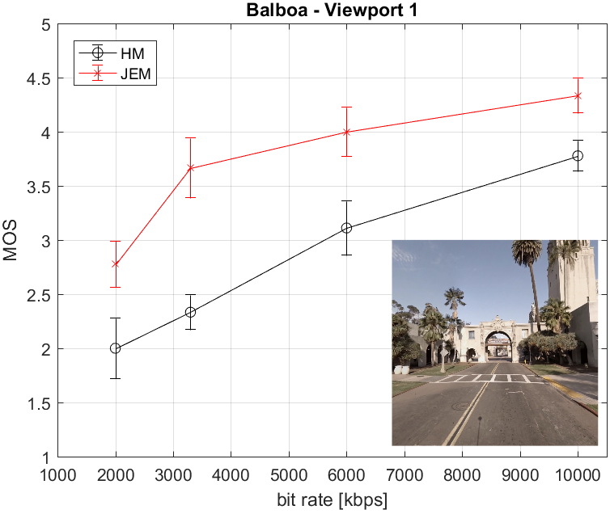 | 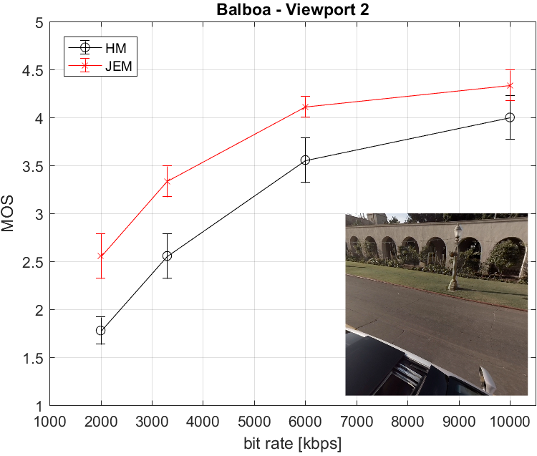
(a) | (b)
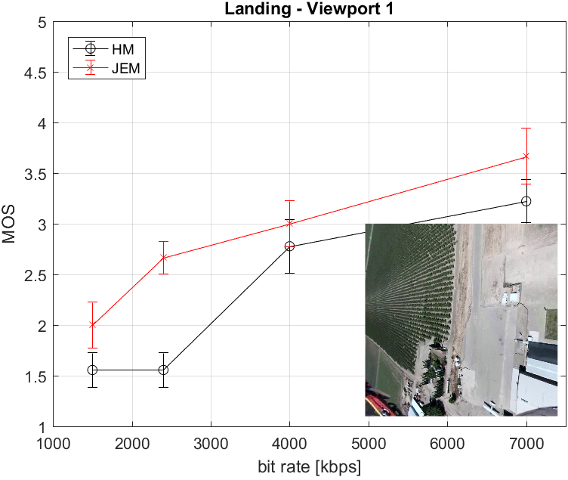 | 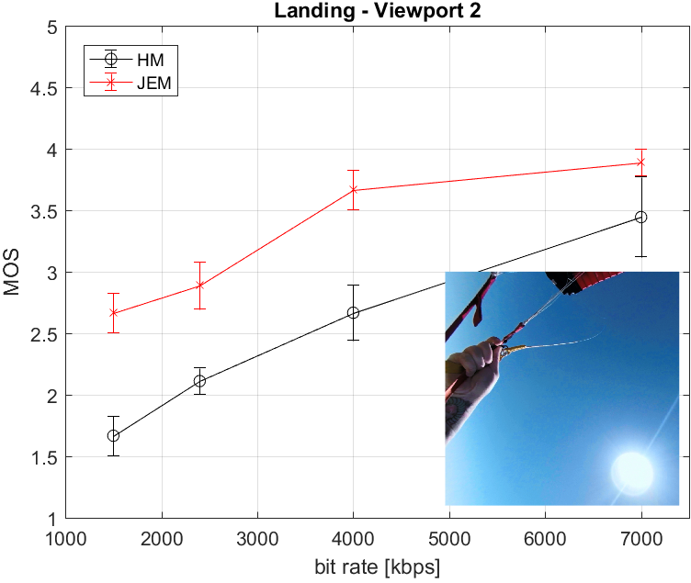
(c) | (d)
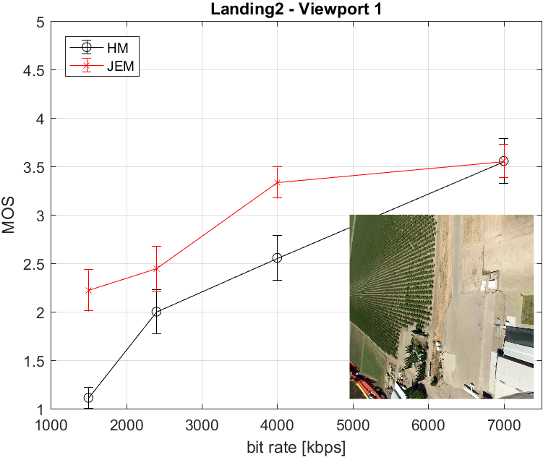 | 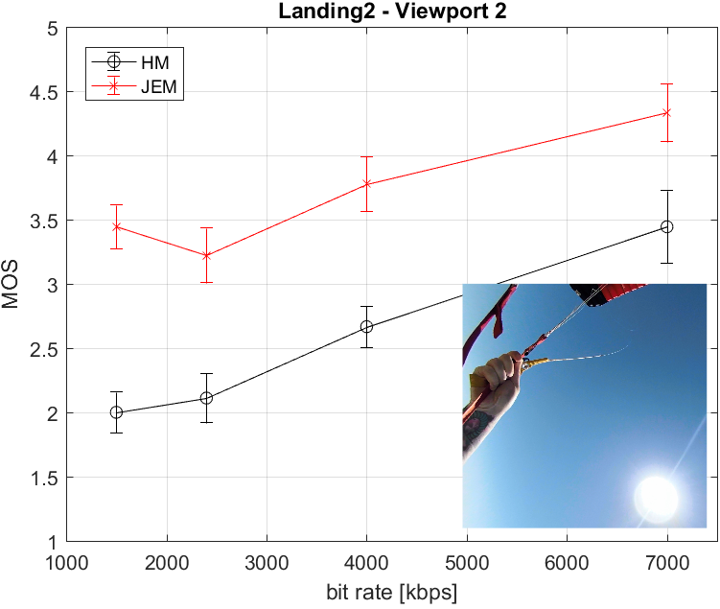
(e) | (f)
Figure 1. Subjective results.

A total of nine expert viewers took part in the experiment. The subjective scores were processed by first detecting and removing subjects whose scores deviated strongly from others. The outlier detection was applied to the set of results obtained from the nine subjects and performed according to the guidelines described in Section 2.3.1 of Annex 2 of [7]. In this study, no outlier was detected. Then, the mean opinion score (MOS) was computed for each test stimulus as the mean across scores by valid subjects, as well as associated 95% confidence interval (CI). Figure 1 reports the final MOSs and associated 95% CIs.
For the Balboa sequence, results show that, for both viewports, JEM outperforms HM across all target bit rate points. For the Landing and Landing2 sequences, an increase of about 1 point in MOS can be observed for the second viewport. However, for the first viewport, the difference is not so clear and the MOSs are generally lower, even at the highest bit rate point. Multiple expert viewers reported that they felt some visual discomfort when viewing this viewport because of the fast motion in the sequence, which is also amplified by the inherent motion of the dynamic viewport. Therefore, for the CfP subjective evaluations, it is essential that viewports are carefully selected in order to avoid the roller coaster effect, which might induce some visual discomfort to the naïve subjects.

References
- V. Baroncini, P. Hanhart, M. Wien, J. Boyce, A. Segall, T. Suzuki, “Results of the Call for Evidence on Video Compression with Capability beyond HEVC”, Joint Video Exploration Team of ITU-T SG16 WP3 and ISO/IEC JTC1/SC29/WG11, JVET-G1004, 7th Meeting, July 2017.
- A. Segall, M. Wien, V. Baroncini, J. Boyce, T. Suzuki, “Draft Joint Call for Proposals on Video Compression with Capability beyond HEVC”, Joint Video Exploration Team of ITU-T SG16 WP3 and ISO/IEC JTC1/SC29/WG11, JVET-G1002, 7th Meeting, July 2017.
- E. Asbun, Y. He, P. Hanhart, Y. He, Y. Ye, “Test Sequences for Virtual Reality Video Coding from InterDigital”, Joint Video Exploration Team of ITU-T SG16 WP3 and ISO/IEC JTC1/SC29/WG11, JVET-G0055, 7th Meeting, July 2017.
- A. Abbas, D. Newman, “New Test Sequences for Spherical Video Coding from GoPro”, Joint Video Exploration Team of ITU-T SG16 WP3 and ISO/IEC JTC1/SC29/WG11, JVET-G0147, 7th Meeting, July 2017.
- A. Abbas, D. Newman, “Updated Test Sequences for Spherical Video Coding from GoPro”, Joint Video Exploration Team of ITU-T SG16 WP3 and ISO/IEC JTC1/SC29/WG11, JVET-H0021, 8th Meeting, Oct. 2017.
- 360Lib-4.0, https://jvet.hhi.fraunhofer.de/svn/svn_360Lib/tags/360Lib-4.0
- J. Boyce, E. Alshina, A. Abbas, Y. Ye, “JVET common test conditions and evaluation procedures for 360° video”, Joint Video Exploration Team of ITU-T SG16 WP3 and ISO/IEC JTC1/SC29/WG11, JVET-G1030, 7th Meeting, July 2017.
- ITU-R BT.2022, “General viewing conditions for subjective assessment of quality of SDTV and HDTV television pictures on flat panel displays”, International Telecommunication Union, Aug. 2012.
- ITU-R BT.500-13, “Methodology for the subjective assessment of the quality of television pictures”, International Telecommunication Union, Jan. 2012.

