    Joint Video Exploration Team (JVET)  of ITU-T SG 16 WP 3 and ISO/IEC JTC 1/SC 29/WG 11  7th Meeting: Torino, IT, 13–21 July 2017 | Document: JVET-G1001-v1

Title: | Algorithm Description of Joint Exploration Test Model 7 (JEM 7)
Status: | Output document of JVET
Purpose: | Algorithm Description of Joint Exploration Test Model 7
Author(s) or  Contact(s): | Jianle Chen  Qualcomm Inc.  Elena Alshina  Samsung Electronics  Gary J. Sullivan  Microsoft Corp.  Jens-Rainer Ohm  RWTH Aachen University  Jill Boyce  Intel | Email: | cjianle@qti.qualcomm.com  elena_a.alshina@samsung.com  garysull@microsoft.com  ohm@ient.rwth-aachen.de  jill.boyce@intel.com
Source: | Editors
_____________________________

Abstract
ITU-T VCEG (Q6/16) and ISO/IEC MPEG (JTC 1/SC 29/WG 11) are studying the potential need for standardization of future video coding technology with a compression capability that significantly exceeds that of the current HEVC standard (including its current extensions). The groups are working together on this exploration activity in a joint collaboration effort known as the Joint Video Exploration Team (JVET) to evaluate compression technology designs proposed by their experts in this area.
This document is the Joint Exploration Model 7 (JEM 7) algorithm description. It describes the coding features that are under coordinated test model study by JVET as potential enhanced video coding technology. The description of encoding strategies used in experiments for the study of the new technology in the JEM is also provided.

Ed. Notes (JVET-G1001) (changes to JVET-F1001 release 3)

-----------Release 1-----------
- (Affine fix): add the text of sub-block size derivation in affine MC
- (Review_JC0): Editorial improvement
- (JVET-G0104): EE1 Test 7, removal of ARSS; PDPC always applied to planar mode and no PDPC for all other modes; MDIS is applied for a block with non-zero NSST index and strong intra smoothing is disabled
- (JVET-G0082): EE2, block-based design for Bi-directional optical flow (BIO)

Ed. Notes (JVET-F1001) (changes to JVET-E1001 release 2)

-----------Release 2-----------
- (Review_Gary0): Editorial improvement

-----------Release 1-----------
- (Ticket #49): Fix of inconsistent software implementation and text description of coefficients zero-out for large transform
- (JVET-F0028): BIO w/o block extension
- (JVET-F0031): Removal of redundant syntax signalling for transform skip
- (JVET-F0032): Enhanced FRUC Template Matching Mode, Aspect 2
- (JVET-F0096): Division-free bilateral filter

Ed. Notes (JVET-E1001) (changes to JVET-D1001 release 3)

-----------Release 2-----------
- (Review_Gary0): Editorial improvement
- (Review_Robert0): Fix of FRUC starting point candidates

-----------Release 1-----------
- (JVET-E0052): decoder-side motion vector refinement based on bilateral template matching with integer (pel step search only (8 positions around the start position with integer pel MV offset)
- (JVET-E0060): test 3 case, FRUC with additional candidates
- (JVET-E0076): MVD coding in unit of four luma sample precision
- (JVET-E0062): multiple Direct Modes for chroma intra coding: the total number of chroma intra modes is kept as 6 (unchanged), the list construction of chroma mode is modified with the first six as proposed
- (JVET-E0077): enhanced Cross-component Linear Model intra-prediction, includes
  - Multiple-model Linear Model intra prediction
  - Multiple-filter Linear Model intra prediction
- (JVET-E0104): ALF parameters temporal prediction with temporal scalability
- (JVET-E0023): improved fast algorithm test case B: skip depth is set equal to 2 always for LDB and LDP, skip depth is set equal to 2 for highest temporal layer in RA, and is set equal to 3 for temporal other layers
- (Review_JC0): FRUC description improvement and other minor fixes
- (Review_EL0): Editorial improvement

Ed. Notes (JVET-D1001) (changes to JVET-C1001 release 3)
----------- Release 2-----------
- (JVET-D0049/D0064): QTBT MaxBTSizeISliceC set to 64 (corresponding to 32 chroma samples)
- (JVET-D0127): Removal of software redundancy in MDNSST encoding process
- (JVET-D0077): Speed-up for JEM-3.1, test2 condition
- (JVET-D0120): 4x4 and 8x8 non-separable secondary transform based on Hyper-Givens transform (HyGT)
- (JVET-D0033): Adaptive clipping, in the format of simple version with explicit signalling of clipping values for the three components in the slice header

-----------Release 1-----------
- (Review_JC0): AMT-related table update, solving mismatch of text and software related to ALF and AMT, Typo fixes

Ed. Notes (JVET-C1001) (changes to JVET-B1001 release 3)
-----------Release 2-----------
- (JVET-C0046): Enabling TS with 64x64 transform blocks
- (Review_JC1): Cross-component linear model (CCLM) prediction description improvement and other minor changes.

-----------Release 1-----------
- (JVET-C0024): QTBT replaces quadtree in main branch of JEM3
- (JVET-C0025): Simplification/unification of MC filters for affine prediction
- (JVET-C0027): Simplification/improvement of BIO
- (JVET-C0035): ATMVP simplification
- (JVET-C0038): Modifications of ALF: Diagonal classification, geometric transformations of filters, prediction of coefficients from fixed set, alignment of luma and chroma filter shapes, removal of context-coded bins for filter coefficient signalling
- (JVET-C0042/JVET-C0053): Unified binarization of NSST index
- (JVET-C0055): Simplified derivation of MPM in intra prediction
- (NSST & TS): Disable NSST and do not code NSST index if all components in a block use TS; otherwise, if NSST is on, it shall not be used for a block of a component that uses TS.
- (Review_JC0): AMT description improvement and other review modification.
- (Review_Lena0): BIO description improvement

Contents
1. Introduction 1
2. Description of new coding features and encoding methods 1
2.1. Quadtree plus binary tree block structure with larger CTUs 1
2.1.1. QTBT block partitioning structure 1
2.1.2. Encoder implementation 4
2.2. Intra prediction modifications 6
2.2.1. Intra mode coding with 67 intra prediction modes 6
2.2.2. Four-tap intra interpolation filter 9
2.2.3. Boundary prediction filters 9
2.2.4. Cross-component linear model prediction 10
2.2.5. Position dependent intra prediction combination for Planar mode 12
2.3. Inter prediction modifications 13
2.3.1. Sub-CU based motion vector prediction 13
2.3.2. Adaptive motion vector difference resolution 15
2.3.3. Higher motion vector storage accuracy 16
2.3.4. Overlapped block motion compensation 16
2.3.5. Local illumination compensation 17
2.3.6. Affine motion compensation prediction 18
2.3.7. Pattern matched motion vector derivation 20
2.3.8. Bi-directional optical flow 23
2.3.9. Decoder-side motion vector refinement 27
2.4. Transform modifications 28
2.4.1. Large block-size transforms with high-frequency zeroing 28
2.4.2. Adaptive multiple core transform 28
2.4.3. Mode-dependent non-separable secondary transforms 30
2.4.4. Signal dependent transform 33
2.5. In-loop filtering 35
2.5.1. Bilateral filter 35
2.5.2. Adaptive loop filter 37
2.5.3. Content adaptive clipping 40
2.6. CABAC modifications 41
2.6.1. Context modeling for transform coefficients 41
2.6.2. Multi-hypothesis probability estimation 42
2.6.3. Initialization for context models 42
3. Software and common test conditions 43
3.1. Reference software 43
4. References 43

Introduction
The Joint Exploration Test Model (JEM) is build up on top of the HEVC test model [1][2][16][19]. The basic encoding and decoding flowchart of HEVC is kept unchanged in the JEM; however, the design elements of most important modules, including the modules of block structure, intra and inter prediction, residue transform, loop filter and entropy coding, are somewhat modified and additional coding tools are added. The following new coding features are included in the JEM.
- Block structure
  - Quadtree plus binary tree (QTBT) block structure with larger CTUs [5] 2.1
- Intra prediction modifications
  - 65 intra prediction directions [4][6][7][8] 2.2.1
  - 4-tap interpolation filter for intra prediction [4][6] 2.2.2
  - Boundary filter applied to other directions in addition to horizontal and vertical ones [4][6] 2.2.3
  - Cross-component linear model (CCLM) prediction [3][4] 2.2.4
  - Position dependent intra prediction combination (PDPC) [9] 2.2.5

- Inter prediction modifications
  - Sub-PU level motion vector prediction [3][4][10] 2.3.1
  - Locally adaptive motion vector resolution (LAMVR) [3][4] 2.3.2
  - 1/16 pel motion vector storage accuracy 2.3.3
  - Overlapped block motion compensation (OBMC) [3][4] 2.3.4
  - Local illumination compensation (LIC) [4][11] 2.3.5
  - Affine motion prediction [12] 2.3.6
  - Pattern matched motion vector derivation [4][6][5] 2.3.7
  - Bi-directional optical flow (BIO) [7][8] 2.3.8
  - Decoder-side motion vector refinement (DMVR)[14] 2.3.9
- Transform
  - Large block-size transforms with high-frequency zeroing 2.4.1
  - Adaptive multiple core transform [3][4] 2.4.2
  - Mode dependent non-separable secondary transforms [4][13] 2.4.3
  - Signal dependent transform (SDT) [15] 2.4.4
- In loop filter
  - Bilateral filter [16] 2.5.1
  - Adaptive loop filter (ALF) [3][4] 2.5.2
  - Content adaptive clipping [17] 2.5.3
- CABAC design modifications [4][6]
  - Context model selection for transform coefficient levels 2.6.1
  - Multi-hypothesis probability estimation 2.6.2
  - Initialization for context models 2.6.3
All the methods listed above have been integrated into the main software branch of the JEM. In the software implementation of the JEM, the signal dependent transform (SDT) is turned off by default.

Description of new coding features and encoding methods
Technical detail of each new coding method is described in the following sub-sections. The description of encoding strategies is also provided. The JEM Encoder reuses all basic encoding methods in the HM encoder [16]. In this document, the additions needed for the new coding features are included.

Quadtree plus binary tree block structure with larger CTUs

QTBT block partitioning structure
In HEVC, a CTU is split into CUs by using a quadtree structure denoted as coding tree to adapt to various local characteristics. The decision whether to code a picture area using inter-picture (temporal) or intra-picture (spatial) prediction is made at the CU level. Each CU can be further split into one, two or four PUs according to the PU splitting type. Inside one PU, the same prediction process is applied and the relevant information is transmitted to the decoder on a PU basis. After obtaining the residual block by applying the prediction process based on the PU splitting type, a CU can be partitioned into transform units (TUs) according to another quadtree structure similar to the coding tree for the CU. One of key feature of the HEVC structure is that it has the multiple partition conceptions including CU, PU, and TU.
The QTBT structure removes the concepts of multiple partition types, i.e. it removes the separation of the CU, PU and TU concepts, and supports more flexibility for CU partition shapes. In the QTBT block structure, a CU can have either a square or rectangular shape. As shown in Figure 1, a coding tree unit (CTU) is first partitioned by a quadtree structure. The quadtree leaf nodes are further partitioned by a binary tree structure. There are two splitting types, symmetric horizontal splitting and symmetric vertical splitting, in the binary tree splitting. The binary tree leaf nodes are called coding units (CUs), and that segmentation is used for prediction and transform processing without any further partitioning. This means that the CU, PU and TU have the same block size in the QTBT coding block structure. In the JEM, a CU sometimes consists of coding blocks (CBs) of different colour components, e.g. one CU contains one luma CB and two chroma CBs in the case of P and B slices of the 4:2:0 chroma format and sometimes consists of a CB of a single component, e.g., one CU contains only one luma CB or just two chroma CBs in the case of I slices.
The following parameters are defined for the QTBT partitioning scheme.
– CTU size: the root node size of a quadtree, the same concept as in HEVC
– MinQTSize: the minimum allowed quadtree leaf node size
– MaxBTSize: the maximum allowed binary tree root node size
– MaxBTDepth: the maximum allowed binary tree depth
– MinBTSize: the minimum allowed binary tree leaf node size
In one example of the QTBT partitioning structure, the CTU size is set as 128×128 luma samples with two corresponding 64×64 blocks of chroma samples, the MinQTSize is set as 16×16, the MaxBTSize is set as 64×64, the MinBTSize (for both width and height) is set as 4×4, and the MaxBTDepth is set as 4. The quadtree partitioning is applied to the CTU first to generate quadtree leaf nodes. The quadtree leaf nodes may have a size from 16×16 (i.e., the MinQTSize) to 128×128 (i.e., the CTU size). If the leaf quadtree node is 128×128, it will not be further split by the binary tree since the size exceeds the MaxBTSize (i.e., 64×64). Otherwise, the leaf quadtree node could be further partitioned by the binary tree. Therefore, the quadtree leaf node is also the root node for the binary tree and it has the binary tree depth as 0. When the binary tree depth reaches MaxBTDepth (i.e., 4), no further splitting is considered. When the binary tree node has width equal to MinBTSize (i.e., 4), no further horizontal splitting is considered. Similarly, when the binary tree node has height equal to MinBTSize, no further vertical splitting is considered. The leaf nodes of the binary tree are further processed by prediction and transform processing without any further partitioning. In the JEM, the maximum CTU size is 256×256 luma samples.
Figure 1 (left) illustrates an example of block partitioning by using QTBT, and Figure 1 (right) illustrates the corresponding tree representation. The solid lines indicate quadtree splitting and dotted lines indicate binary tree splitting. In each splitting (i.e., non-leaf) node of the binary tree, one flag is signalled to indicate which splitting type (i.e., horizontal or vertical) is used, where 0 indicates horizontal splitting and 1 indicates vertical splitting. For the quadtree splitting, there is no need to indicate the splitting type since quadtree splitting always splits a block both horizontally and vertically to produce 4 sub-blocks with an equal size.
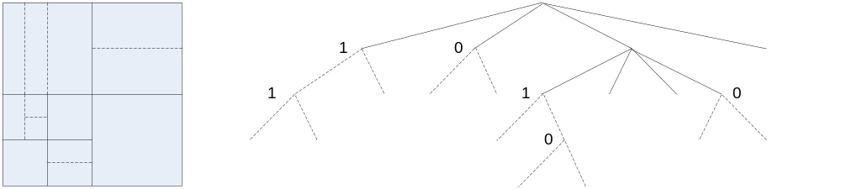
Figure 1: Illustration of a QTBT structure
In addition, the QTBT scheme supports the ability for the luma and chroma to have a separate QTBT structure. Currently, for P and B slices, the luma and chroma CTBs in one CTU share the same QTBT structure. However, for I slices, the luma CTB is partitioned into CUs by a QTBT structure, and the chroma CTBs are partitioned into chroma CUs by another QTBT structure. This means that a CU in an I slice consists of a coding block of the luma component or coding blocks of two chroma components, and a CU in a P or B slice consists of coding blocks of all three colour components.
In HEVC, inter prediction for small blocks is restricted to reduce the memory access of motion compensation, such that bi-prediction is not supported for 4×8 and 8×4 blocks, and inter prediction is not supported for 4×4 blocks. In the QTBT of the JEM, these restrictions are removed.

Encoder implementation
The encoder rate-distortion optimization (RDO) process for the QTBT structure that is used to determine the block partitioning shape is illustrated by the pseudocode shown in Figure 2.
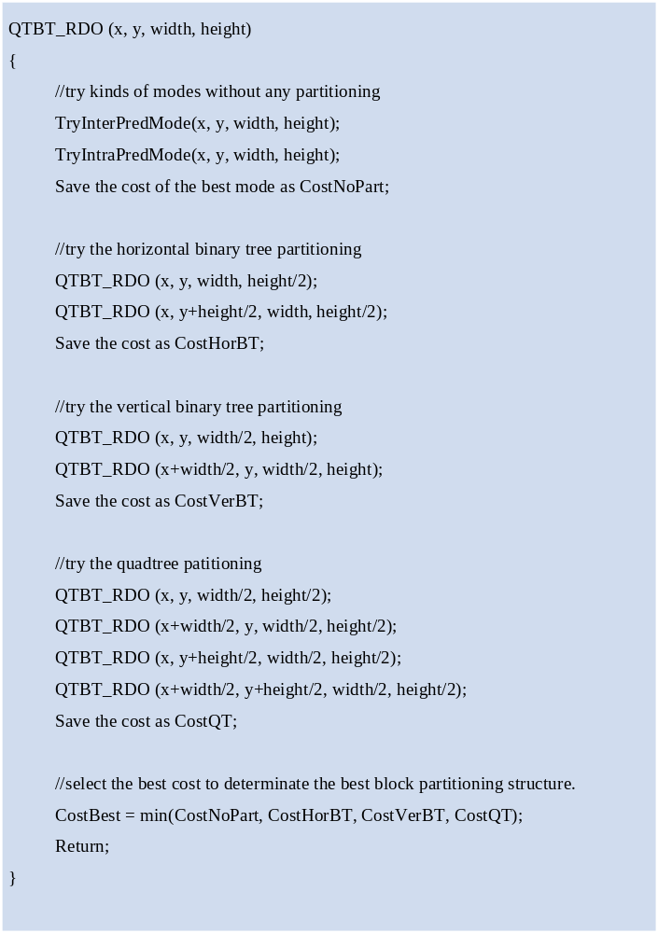
Figure 2: Pseudocode of the QTBT RDO process
As shown in Figure 2, the function QTBT_RDO() is used by the encoder to determine the partition for an input block which is specified by the four input parameters x, y, width, and height, indicating the x-coordinate and y-coordinate of the top-left position and the width, and height of the block, respectively. Firstly, the input block is treated as a leaf node (i.e., CU or CB) of the coding tree to try all kinds of modes without any further partitioning for prediction and transform, and then the RD cost of the selected mode is stored as CostNoPart. Then, if the condition of the horizontal binary tree split criterion is met, the input block is split into two sub-blocks horizontally. Each of them has the same width but half the height of the input block. The top one has its top-left position the same as the current input block and the bottom one has its y-coordinate increased by half the height. The function QTBT_RDO() is called recursively for each sub-block to determine the partitioning. The cost of this horizontal binary tree split of current input block is stored as CostHorBT. Similarly, the cost of the vertical binary tree split and quadtree split of current input block are derived as CostVerBT and CostQT, respectively. After comparing the CostNoPart, CostHorBT, CostVerBT, and CostQT, the block partition shape that has the minimum RD cost is selected.
For I slices, the QTBT_RDO() for a luma CTB is processed before the QTBT_RDO() for the two corresponding chroma CTBs since the chroma CBs may reuse the collocated luma intra prediction mode as in HEVC.
The recursive calling of the function QTBT_RDO() within the quadtree and binary tree segmentation optimization process is time-consuming, so several fast encoding schemes have been implemented to speed up the RDO process in the JEM software, as described below.
If a block has its CostNoPart smaller than CostHorBT and CostVerBT when the binary tree with deep depth is tried, then the CostQT is very likely also to be larger than CostNoPart, so the RD check of quadtree split can be skipped.
The quadtree split of one node can be equivalently represented by using both a horizontal binary tree split and vertical binary tree split. The same partition shape can also be generated by applying the horizontal and vertical binary tree split in different orders. Even if the signalled flags representing the tree structure and the processing order of the generated CUs are different, the RD performance would be similar except for the signalling overhead, since the block partition shape is the same. Therefore, the binary tree split is constrained to avoid some redundant cases.
In the QTBT_RDO() process, one block may be accessed more than once. In Figure 3(left) the block is first split vertically and the right sub-block is further split horizontally. In Figure 3 (right) the block is firstly split horizontally and the top sub-block is further split vertically. In each of these cases, the sub-block in the top-right position will be accessed twice. The whole block itself may also be accessed many times. Since the selected mode of a particular block region is likely to be unchanged during such multiple RDO accesses, the selected mode information is stored during the first RDO checking stage to be reused during later RDO accesses to save encoding time. As one example, for a CU with multiple RDO accesses, the selected mode of the current CU during different RDO accesses is kept the same when all its neigbouring blocks of different RDO accesses have the same encoded/decoded information. In this case, the RDO process of the current CU is skipped when performing later RDO accesses, and the mode selected for the earlier RDO access is re-used. In the JEM software implementation, the encoded/decoded information of the neighbouring blocks are checked in this process. The related terms and methods are described in later sections of this document. The following properties are determined in this process:
a. EMT flag and index
b. NSST index
c. PDPC flag
d. FRUC flag
e. LAMVR flag
f. LIC flag
g. Affine flag
h. Merge flag
i. Inter prediction direction
The saved information of a CU from an earlier RDO access can also be used for early termination of RDO process when the same CU is evaluated in a later RDO access. If a CU is determined to be coded in intra mode, then the RD checks for some inter prediction modes (such as affine merge mode, FRUC mode and integer MV AMVP mode) are skipped when evaluating the same CU in the following RDO accesses. If a CU is determined to be coded in skip mode, then RD check for the LIC enabled mode is skipped for the same CU in the following RDO accesses.
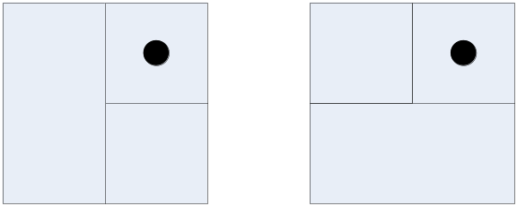
Figure 3: Illustration of one block accessed twice
If the selected mode of the current CU is skip mode and the current CU depth is deep enough, then there is usually no need to consider further quadtree or binary tree splitting of that CU. In the JEM, when the selected CU mode is skip mode and the current BT depth is greater than or equal to SKIP_DEPTH, further QT and BT partitioning is stopped. The value of SKIP_DEPTH is set equal to 2 for all coding pictures in the low delay configuration. The value of SKIP_DEPTH is set equal to 2 for the coding pictures of highest temporal layer and is set equal to 3 for the coding pictures of other temporal layers in the random access configuration.
The maxBTSize and minQTSize (for both luma and chroma in I slice) are two critical factors for the RD performance and the encoding time. In the JEM software, these two picture-level parameters are set adaptively larger when the average CU size of the previous coded picture in the same temporal layer is larger, and vice-versa. This picture-level adaptive setting is only used for P and B slices. The default values of the two parameters as well as maxBTDepth and minBTSize as used in the JEM software are shown in Table 1.
Table 1: Derivation QTBT high level parameters setting and experimental results
QTBT high level parameters | I slice | P or B slice
CTU size | 128×128 | 128×128
minQTSizeLuma | 8×8 | 8×8 (init)
minQTSizeChroma | 4×4 | n/a
maxBTSizeLuma | 32×32 | 128×128 (init)
maxBTSizeChroma | 64×64 | n/a
maxBTDepthLuma | 3 | 3
maxBTDepthChroma | 3 | n/a
minBTSize | 4 | 4
The values of minQTSizeChroma and maxBTSizeChroma in Table 1 are measured in units of luma samples. For example, in the case of 4:2:0 video, the maximum allowed binary tree root node size for chroma component is 32×32 chroma samples when maxBTSizeChroma is set to 64×64.

Intra prediction modifications

Intra mode coding with 67 intra prediction modes
To capture the arbitrary edge directions presented in natural video, the number of directional intra modes is extended from 33, as used in HEVC, to 65. The additional directional modes are depicted as red dotted arrows in Figure 4, and the planar and DC modes remain the same. These denser directional intra prediction modes apply for all block sizes and for both luma and chroma intra predictions.

Luma intra mode coding
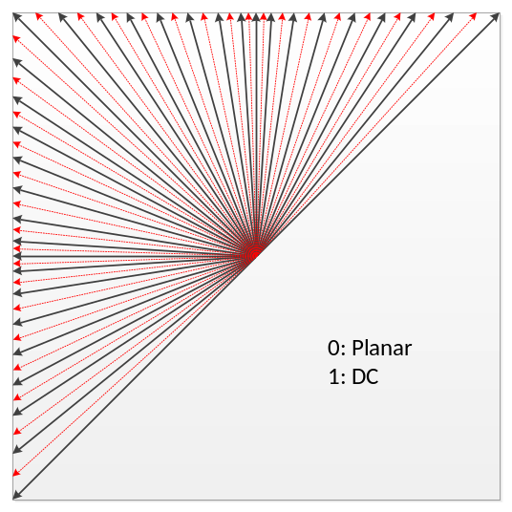
Figure 4: Proposed 67 intra prediction modes
To accommodate the increased number of directional intra modes, an intra mode coding method with 6 Most Probable Modes (MPMs) is used. Two major technical aspects are involved: 1) the derivation of 6 MPMs, and 2) entropy coding of 6 MPMs and non-MPM modes.
In the JEM, the modes included into the MPM lists are classified into three groups:
- Neighbour intra modes
- Derived intra modes
- Default intra modes
Five neighbouring intra prediction modes are used to form the MPM list. Those locations of the 5 neighbouring blocks are the same as those used in the merge mode, i.e., left (L), above (A), below-left (BL), above-right (AR), and above-left (AL) as shown in Figure 5. An initial MPM list is formed by inserting 5 neighbour intra modes and the planar and DC modes into the MPM list. A pruning process is used to remove duplicated modes so that only unique modes can be included into the MPM list. The order in which the initial modes are included is: left, above, planar, DC, below-left, above-right, and then above-left.

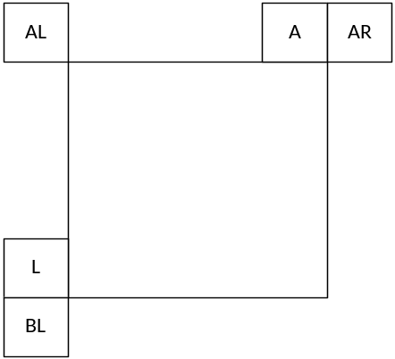
Figure 5: Neighbouring blocks for MPM derivation
If the MPM list is not full (i.e., there are less than 6 MPM candidates in the list), derived modes are added; these intra modes are obtained by adding −1 or +1 to the angular modes that are already included in the MPM list. Such additional derived modes are not generated from the non-angular modes (DC or planar).
Finally, if the MPM list is still not complete, the default modes are added in the following order: vertical, horizontal, mode 2, and diagonal mode. As a result of this process, a unique list of 6 MPM modes is generated.
For entropy coding of the selected mode using the 6 MPMs, a truncated unary binarization is used. The first three bins are coded with contexts that depend on the MPM mode related to the bin currently being signalled. The MPM mode is classified into one of three categories: (a) modes that are predominantly horizontal (i.e., the MPM mode number is less than or equal to the mode number for the diagonal direction), (b) modes that are predominantly vertical (i.e., the MPM mode is greater than the mode number for the diagonal direction), and (c) the non-angular (DC and planar) class. Accordingly, three contexts are used to signal the MPM index based on this classification.
The coding for selection of the remaining 61 non-MPMs is done as follows. The 61 non-MPMs are first divided into two sets: a selected modes set and a non-selected modes set. The selected modes set contains 16 modes and the rest (45 modes) are assigned to the non-selected modes set. The mode set that the current mode belongs to is indicated in the bitstream with a flag. If the mode to be indicated is within the selected modes set, the selected mode is signalled with a 4-bit fixed-length code, and if the mode to be indicated is from the non-selected set, the selected mode is signalled with a truncated binary code. The selected modes set is generated by sub-sampling the 61 non-MPM modes as follows:
Selected modes set = {0, 4, 8, 12, 16, 20 … 60}
Non-selected modes set = {1, 2, 3, 5, 6, 7, 9, 10 … 59}
At the encoder side, the similar two-stage intra mode decision process of HM is used. In the first stage, i.e., the intra mode pre-selection stage, a lower complexity Sum of Absolute Transform Difference (SATD) cost is used to pre-select N intra prediction modes from all the available intra modes. In the second stage, a higher complexity R-D cost selection is further applied to select one intra prediction mode from the N candidates. However, when 67 intra prediction modes is applied, since the total number of available modes is roughly doubled, the complexity of the intra mode pre-selection stage will also be increased if the same encoder mode decision process of HM is directly used. To minimize the encoder complexity increase, a two-step intra mode pre-selection process is performed. At the first step, N (N depends on intra prediction block size) modes are selected from the original 35 intra prediction modes (indicated by black solid arrows in Figure 4) based on the Sum of Absolute Transform Difference (SATD) measure; At the second step, the direct neighbours (additional intra prediction directions as indicated by red dotted arrows in Figure 4) of the selected N modes are further examined by SATD, and the list of selected N modes are updated. Finally, the first M MPMs are added to the N modes if not already included, and the final list of candidate intra prediction modes is generated for the second stage R-D cost examination, which is done in the same way as HM. The value of M is increased by one based on the original setting in the HM, and N is decreased somewhat as shown below in Figure 3.
Table 2: Number of mode candidates at the intra mode pre-selection step
Intra prediction block size | 4×4 | 8×8 | 16×16 | 32×32 | 64×64 | >64×64
HM | 8 | 8 | 3 | 3 | 3 | 3
JEM with 67 intra prediction modes | 7 | 7 | 2 | 2 | 2 | 2

Chroma intra mode coding
In the JEM, a total of 11 intra modes are allowed for chroma CB coding. Those modes include 5 traditional intra modes and 6 cross-component linear model modes, which are described in section 2.2.4. The list of chroma mode candidates includes the following three parts:
- CCLM modes
- DM modes, intra prediction modes derived from luma CBs covering the collocated five positions of the current chroma block
  - The five positions to be checked in order are: center (CR), top-left (TL), top-right (TR), bottom-left (BL) and bottom-right (BR) 4×4 block within the corresponding luma block of current chroma block for I slices. For P and B slices, only one of these five sub-blocks is checked since they have the same mode index. An example of five collocated luma positions is shown in Figure 6.
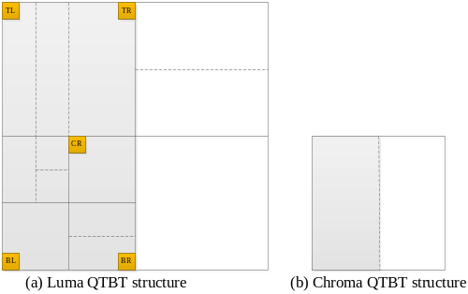
Figure 6: Corresponding sub-blocks for a chroma CB in I slice
- Chroma prediction modes from spatial neighbouring blocks:
  - 5 chroma prediction modes: from left, above, below-left, above-right, and above-left spatially neighbouring blocks
  - Planar and DC modes
  - Derived modes are added, these intra modes are obtained by adding −1 or +1 to the angular modes which are already included into the list
  - Vertical, horizontal, mode 2
A pruning process is applied whenever a new chroma intra mode is added to the candidate list. The non-CCLM chroma intra mode candidates list size is then trimmed to 5. For the mode signalling, a flag is first signalled to indicate whether one of the CCLM modes or one of the traditional chroma intra prediction mode is used. Then a few more flags may follow to specify the exact chroma prediction mode used for the current chroma CBs.

Four-tap intra interpolation filter
In HEVC, a two-tap linear interpolation filter is used to generate the intra prediction block in the directional prediction modes (i.e., excluding the planar and DC predictors). In the JEM, four-tap intra interpolation filters are used for directional intra prediction filtering. Two types of four-tap interpolation filters are used: cubic interpolation filters for blocks with size smaller than or equal to 64 samples, and Gaussian interpolation filters for block with size larger than 64 samples. The parameters of the filters are fixed according to block size, and the same filter is used for all predicted samples, in all directional modes.

Boundary prediction filters
In HEVC, after the intra prediction block has been generated for the vertical or horizontal intra modes, the left-most column or top-most row of prediction samples are further adjusted, respectively. Here this method is further extended to several diagonal intra modes, and boundary samples up to four columns or rows are further adjusted using a two-tap (for intra modes 2 & 34) or three-tap filter (for intra modes 3–6 & 30–33). Examples of the boundary prediction filters for intra modes 34 and 30–33 are shown in Figure 7, and the boundary prediction filters for intra modes 2 and 3–6 are similar.
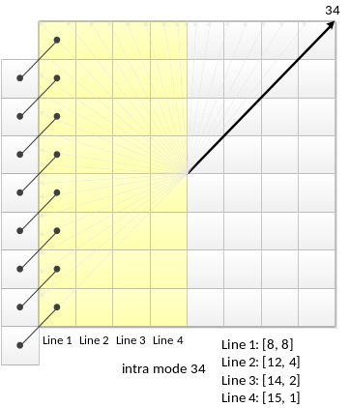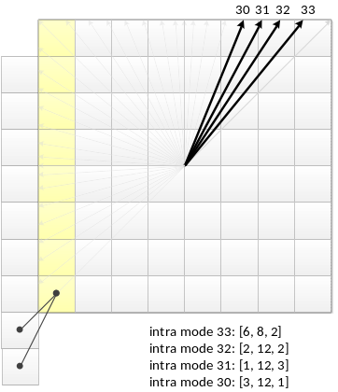
Figure 7: Examples of boundary prediction filters for intra modes 30–34

Cross-component linear model prediction
To reduce the cross-component redundancy, a cross-component linear model (CCLM) prediction mode is used in the JEM, for which the chroma samples are predicted based on the reconstructed luma samples of the same CU by using a linear model as follows:
${pred}_{C}\left(i, j\right)=α·{rec}_{L}'\left(i, j\right)+ β$ (1)
where ${pred}_{C}\left(i, j\right)$ represents the predicted chroma samples in a CU and ${rec}_{L}\left(i, j\right)$ represents the downsampled reconstructed luma samples of the same CU. Parameters $α$ and $β$ are derived by minimizing the regression error between the neighbouring reconstructed luma and chroma samples around the current block as follows:
$α= \frac{N·∑\left(L\left(n\right)·C\left(n\right)\right)-∑L\left(n\right)·∑C\left(n\right)}{N·∑\left(L\left(n\right)·L\left(n\right)\right)-∑L\left(n\right)·∑L\left(n\right)}$ (2)
$β= \frac{∑C\left(n\right)-α·∑L\left(n\right)}{N}$ (3)
where $L\left(n\right)$ represents the down-sampled top and left neighbouring reconstructed luma samples, $C\left(n\right)$ represents the top and left neighbouring reconstructed chroma samples, and value of $N$is equal to twice of the minimum of width and height of the current chroma coding block. For a coding block with a square shape, the above two equations are applied directly. For a non-square coding block, the neighbouring samples of the longer boundary are first subsampled to have the same number of samples as for the shorter boundary. Figure 8 shows the location of the left and above causal samples and the sample of the current block involved in the CCLM mode.
This regression error minimization computation is performed as part of the decoding process, not just as an encoder search operation, so no syntax is used to convey the α and β values.
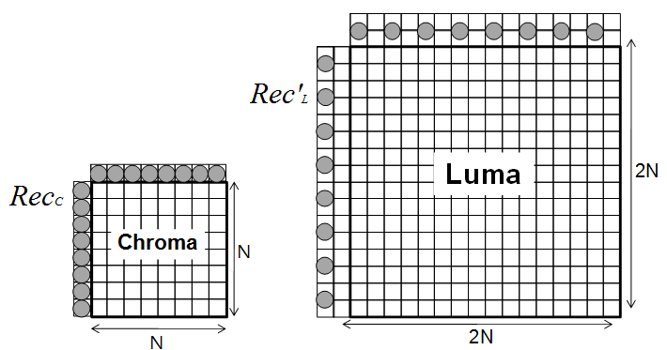
Figure 8: Locations of the samples used for the derivation of α and β

The CCLM prediction mode also includes prediction between the two chroma components, i.e., the Cr component is predicted from the Cb component. Instead of using the reconstructed sample signal, the CCLM Cb-to-Cr prediction is applied in residual domain. This is implemented by adding a weighted reconstructed Cb residual to the original Cr intra prediction to form the final Cr prediction:
${pred}_{Cr}^{*}\left(i, j\right)={pred}_{Cr}\left(i, j\right)+ {α·resi}_{Cb}'\left(i, j\right)$ (4)
The scaling factor$α$ is derived in a similar way as in the CCLM luma-to-chroma prediction. The only difference is an addition of a regression cost relative to a default $α$ value in the error function so that the derived scaling factor is biased towards a default value of −0.5 as follows:
$α= \frac{N·∑\left(Cb\left(n\right)·Cr\left(n\right)\right)-∑Cb\left(n\right)·∑Cr\left(n\right)+λ·(-0.5)}{N·∑\left(Cb\left(n\right)·Cb\left(n\right)\right)-∑Cb\left(n\right)·∑Cb\left(n\right)+λ}$ (5)
where $Cb\left(n\right)$ represents the neighbouring reconstructed Cb samples, $Cr\left(n\right)$ represents the neighbouring reconstructed Cr samples, and $λ$ is equal to $∑\left(Cb\left(n\right)·Cb\left(n\right)\right)≫9$.
The CCLM luma-to-chroma prediction mode is added as one additional chroma intra prediction mode. At the encoder side, one more RD cost check for the chroma components is added for selecting the chroma intra prediction mode. When intra prediction modes other than the CCLM luma-to-chroma prediction mode is used for the chroma components of a CU, CCLM Cb-to-Cr prediction is used for Cr component prediction.

Multiple model CCLM
In the JEM, there are two CCLM modes: the single model CCLM mode and the multiple model CCLM mode (MMLM). As indicated by the name, the single model CCLM mode employs one linear model for predicting the chroma samples from the luma samples for the whole CU, while in MMLM, there can be two models. In MMLM, neighbouring luma samples and neighbouring chroma samples of the current block are classified into two groups, each group is used as a training set to derive a linear model (i.e., a particular α and β are derived for a particular group). Furthermore, the samples of the current luma block are also classified based on the same rule for the classification of neighbouring luma samples.
Figure 9 shows an example of classifying the neighbouring samples into two groups. Threshold is calculated as the average value of the neighbouring reconstructed luma samples. A neighbouring sample with Rec′_{L}[x,y] <= Threshold is classified into group 1; while a neighbouring sample with Rec′_{L}[x,y] > Threshold is classified into group 2.
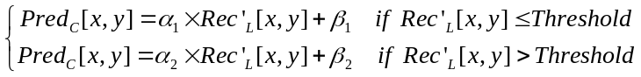 (6)
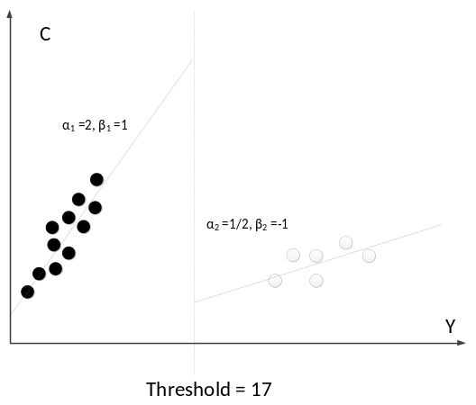
Figure 9: An example of classifying the neighbouring samples into two groups

Downsampling filters in CCLM mode
To perform cross-component prediction, for the 4:2:0 chroma format, the reconstructed luma block needs to be downsampled to match the size of the chroma signal. The default downsampling filter used in CCLM mode is as follows.
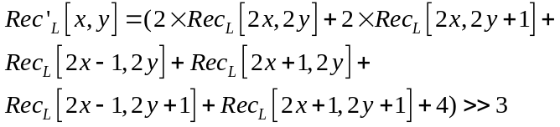 (7)
Note that this downsampling assumes the “type 0” phase relationship for the positions of the chroma samples relative to the positions of the luma samples – i.e., collocated sampling horizontally and interstitial sampling vertically.
The above 6-tap downsampling filter is used as the default filter for both the single model CCLM mode and the multiple model CCLM mode.
For the MMLM mode, the encoder can alternatively select one of four additional luma downsampling filters to be applied for prediction in a CU, and send a filter index to indicate which of these is used. The four selectable luma downsampling filters for the MMLM mode are as follows:
(8)
(9)
(10)
(11)

Position dependent intra prediction combination for Planar mode
In the JEM, the results of intra prediction of planar mode is further modified by a position dependent intra prediction combination (PDPC) method. PDPC is an intra prediction method which invokes a combination of the un-filtered boundary reference samples and HEVC style intra prediction with filtered boundary reference samples.

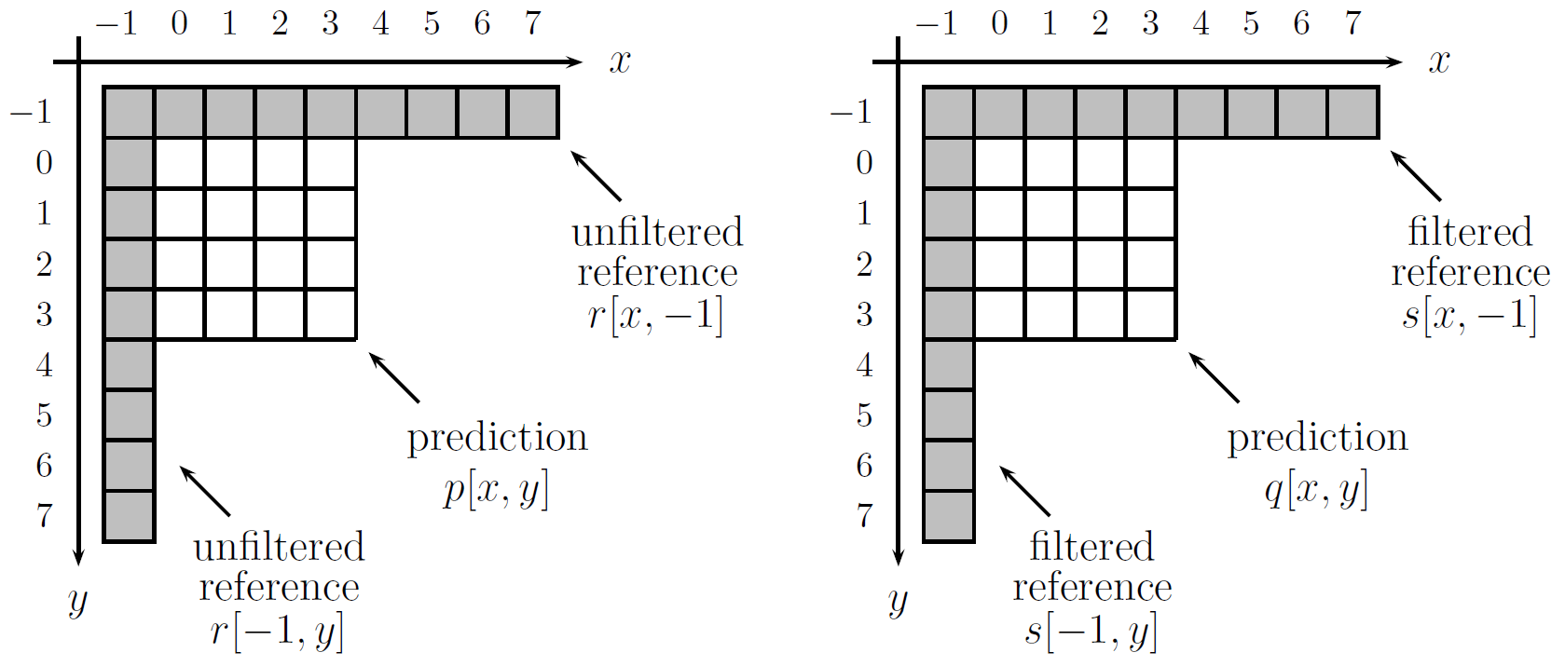
Figure 10: Example of intra prediction in 4×4 blocks, with notation for unfiltered and filtered reference samples
The notation used to define PDPC is shown in Figure 10. r and s represents the boundary samples with unfiltered and filtered references, respectively. $q[x,y]$ is the HEVC style intra prediction (only planar mode in the JEM) based on filtered reference boundary samples s. $x$ and $y$ are the horizontal and vertical distance from the block boundary.
The prediction $p[x,y]$ combines weighted values of boundary elements with $q[x,y]$ as follows:
$p\left[x,y\right]=\left\{\left(c_{1}^{(v)}≫\left\lfloor y/d_{y}\right\rfloor \right)r\left[x,-1\right]-\left(c_{2}^{(v)}≫\left\lfloor y/d_{y}\right\rfloor \right)r\left[-1,-1\right]+ \left(c_{1}^{(h)}≫\left\lfloor x/d_{x}\right\rfloor \right)r\left[-1,y\right]-\left(c_{2}^{(h)}≫\left\lfloor x/d_{x}\right\rfloor \right)r\left[-1,-1\right]+b\left[x,y\right]q\left[x,y\right]+64\right\}≫7$ (12)
where $c_{1}^{v}, c_{2}^{v}, c_{1}^{h}, c_{2}^{h}$ are stored prediction parameters, $d_{x}=1$ for blocks with width smaller than or equal to 16 and$d_{x}=2$ for blocks with width larger than 16, $d_{y}=1$for blocks with height smaller than or equal to 16 and $d_{y}=2$ for blocks with height larger than 16. b[x, y] is a normalization factor derived as follows:
$b\left[x,y\right]=128-\left(c_{1}^{\left(v\right)}≫\left\lfloor y/{d_{y}}\right\rfloor \right)+\left(c_{2}^{\left(v\right)}≫\left\lfloor y/{d_{y}}\right\rfloor \right)-\left(c_{1}^{(h)}≫\left\lfloor x/d_{x}\right\rfloor \right)+\left(c_{2}^{(h)}≫\left\lfloor x/d_{x}\right\rfloor \right)$ (13)
One of three pre-defined low pass filters are used to smooth the boundary samples. The three pre-defined low-pass filters include one 3-tap, one 5-tap and one 7-tap filter. The selection of smoothing filter is based on the block size and the intra prediction mode. Defining h_{k} as the impulse response of a filter k, and an additional stored parameter a, the filtered reference is computed as follows:
$s=a r+(1-a)(h_{k}*r)$ (14)
where “*” represents convolution.
One set of prediction parameters ($c_{1}^{v}, c_{2}^{v}, c_{1}^{h}, c_{2}^{h}$, a and filter index k) is defined per block size. The total storage size for those parameters are 30 bytes
.

Inter prediction modifications

Sub-CU based motion vector prediction
In the JEM with QTBT, each CU can have at most one set of motion parameters for each prediction direction. Two sub-CU level motion vector prediction methods are considered in the encoder by splitting a large CU into sub-CUs and deriving motion information for all the sub-CUs of the large CU. Alternative temporal motion vector prediction (ATMVP) method allows each CU to fetch multiple sets of motion information from multiple blocks smaller than the current CU in the collocated reference picture. In spatial-temporal motion vector prediction (STMVP) method motion vectors of the sub-CUs are derived recursively by using the temporal motion vector predictor and spatial neighbouring motion vector.
To preserve more accurate motion field for sub-CU motion prediction, the motion compression for the reference frames is currently disabled.
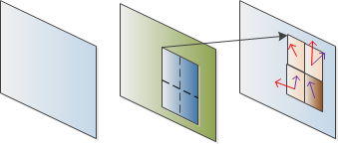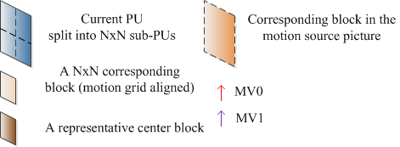
Figure 11: ATMVP motion prediction for a CU

Alternative temporal motion vector prediction
In the alternative temporal motion vector prediction (ATMVP) method, the motion vectors temporal motion vector prediction (TMVP) is modified by fetching multiple sets of motion information (including motion vectors and reference indices) from blocks smaller than the current CU. As shown in Figure 11, the sub-CUs are square N×N blocks (N is set to 4 by default).
ATMVP predicts the motion vectors of the sub-CUs within a CU in two steps. The first step is to identify the corresponding block in a reference picture with a so-called temporal vector. The reference picture is called the motion source picture. The second step is to split the current CU into sub-CUs and obtain the motion vectors as well as the reference indices of each sub-CU from the block corresponding to each sub-CU, as shown in Figure 11.
In the first step, a reference picture and the corresponding block is determined by the motion information of the spatial neighbouring blocks of the current CU. To avoid the repetitive scanning process of neighbouring blocks, the first merge candidate in the merge candidate list of the current CU is used. The first available motion vector as well as its associated reference index are set to be the temporal vector and the index to the motion source picture. This way, in ATMVP, the corresponding block may be more accurately identified, compared with TMVP, wherein the corresponding block (sometimes called collocated block) is always in a bottom-right or center position relative to the current CU.
In the second step, a corresponding block of the sub-CU is identified by the temporal vector in the motion source picture, by adding to the coordinate of the current CU the temporal vector. For each sub-CU, the motion information of its corresponding block (the smallest motion grid that covers the center sample) is used to derive the motion information for the sub-CU. After the motion information of a corresponding N×N block is identified, it is converted to the motion vectors and reference indices of the current sub-CU, in the same way as TMVP of HEVC, wherein motion scaling and other procedures apply. For example, the decoder checks whether the low-delay condition (i.e. the POCs of all reference pictures of the current picture are smaller than the POC of the current picture) is fulfilled and possibly uses motion vector MV_{x} (the motion vector corresponding to reference picture list X) to predict motion vector MV_{y} (with X being equal to 0 or 1 and Y being equal to 1−X) for each sub-CU.

Spatial-temporal motion vector prediction
In this method, the motion vectors of the sub-CUs are derived recursively, following raster scan order. Figure 12 illustrates this concept. Let us consider an 8×8 CU which contains four 4×4 sub-CUs A, B, C, and D. The neighbouring 4×4 blocks in the current frame are labelled as a, b, c, and d.
The motion derivation for sub-CU A starts by identifying its two spatial neighbours. The first neighbour is the N×N block above sub-CU A (block c). If this block c is not available or is intra coded the other N×N blocks above sub-CU A are checked (from left to right, starting at block c). The second neighbour is a block to the left of the sub-CU A (block b). If block b is not available or is intra coded other blocks to the left of sub-CU A are checked (from top to bottom, staring at block b). The motion information obtained from the neighbouring blocks for each list is scaled to the first reference frame for a given list. Next, temporal motion vector predictor (TMVP) of sub-block A is derived by following the same procedure of TMVP derivation as specified in HEVC. The motion information of the collocated block at location D is fetched and scaled accordingly. Finally, after retrieving and scaling the motion information, all available motion vectors (up to 3) are averaged separately for each reference list. The averaged motion vector is assigned as the motion vector of the current sub-CU.
A
B
C
D
c
d
b
a

Figure 12: Example of one CU with four sub-blocks (A-D) and its neighbouring blocks (a–d)

Sub-CU motion prediction mode signalling
The sub-CU modes are enabled as additional merge candidates and there is no additional syntax element required to signal the modes. Two additional merge candidates are added to merge candidates list of each CU to represent the ATMVP mode and STMVP mode. Up to seven merge candidates are used, if the sequence parameter set indicates that ATMVP and STMVP are enabled. The encoding logic of the additional merge candidates is the same as for the merge candidates in the HM, which means, for each CU in P or B slice, two more RD checks is needed for the two additional merge candidates.
In the JEM, all bins of merge index is context coded by CABAC. While in HEVC, only the first bin is context coded and the remaining bins are context by-pass coded.

Adaptive motion vector difference resolution
In HEVC, motion vector differences (MVDs) (between the motion vector and predicted motion vector of a PU) are signalled in units of quarter luma samples when use_integer_mv_flag is equal to 0 in the slice header. In the JEM, a locally adaptive motion vector resolution (LAMVR) is introduced. In the JEM, MVD can be coded in units of quarter luma samples, integer luma samples or four luma samples. The MVD resolution is controlled at the coding unit (CU) level, and MVD resolution flags are conditionally signalled for each CU that has at least one non-zero MVD components.
For a CU that has at least one non-zero MVD components, a first flag is signalled to indicate whether quarter luma sample MV precision is used in the CU. When the first flag (equal to 1) indicates that quarter luma sample MV precision is not used, another flag is signalled to indicate whether integer luma sample MV precision or four luma sample MV precision is used.
When the first MVD resolution flag of a CU is zero, or not coded for a CU (meaning all MVDs in the CU are zero), the quarter luma sample MV resolution is used for the CU. When a CU uses integer-luma sample MV precision or four-luma-sample MV precision, the MVPs in the AMVP candidate list for the CU are rounded to the corresponding precision.
In the encoder, CU-level RD checks are used to determine which MVD resolution is to be used for a CU. That is, the CU-level RD check is performed three times for each MVD resolution. To accelerate encoder speed, the following encoding schemes are applied in the JEM.
- During RD check of a CU with normal quarter luma sample MVD resolution, the motion information of the current CU (integer luma sample accuracy) is stored. The stored motion information (after rounding) is used as the starting point for further small range motion vector refinement during the RD check for the same CU with integer luma sample and 4 luma sample MVD resolution so that the time-consuming motion estimation process is not duplicated three times.
- RD check of a CU with 4 luma sample MVD resolution is conditionally invoked. For a CU, when RD cost integer luma sample MVD resolution is much larger than that of quarter luma sample MVD resolution, the RD check of 4 luma sample MVD resolution for the CU is skipped.

Higher motion vector storage accuracy
In HEVC, motion vector accuracy is one-quarter pel (one-quarter luma sample and one-eighth chroma sample for 4:2:0 video). In the JEM, the accuracy for the internal motion vector storage and the merge candidate increases to 1/16 pel. The higher motion vector accuracy (1/16 pel) is used in motion compensation inter prediction for the CU coded with skip/merge mode. For the CU coded with normal AMVP mode, either the integer-pel or quarter-pel motion is used, as described in section 2.3.2.
SHVC upsampling interpolation filters, which have same filter length and normalization factor as HEVC motion compensation interpolation filters, are used as motion compensation interpolation filters for the additional fractional pel positions. The chroma component motion vector accuracy is 1/32 sample in the JEM, the additional interpolation filters of 1/32 pel fractional positions are derived by using the average of the filters of the two neighbouring 1/16 pel fractional positions.

Overlapped block motion compensation
Overlapped Block Motion Compensation (OBMC) has previously been used in H.263. In the JEM, unlike in H.263, OBMC can be switched on and off using syntax at the CU level. When OBMC is used in the JEM, the OBMC is performed for all motion compensation (MC) block boundaries except the right and bottom boundaries of a CU. Moreover, it is applied for both the luma and chroma components. In the JEM, a MC block is corresponding to a coding block. When a CU is coded with sub-CU mode (includes sub-CU merge, affine and FRUC mode), each sub-block of the CU is a MC block. To process CU boundaries in a uniform fashion, OBMC is performed at sub-block level for all MC block boundaries, where sub-block size is set equal to 4×4, as illustrated in Figure 13.
When OBMC applies to the current sub-block, besides current motion vectors, motion vectors of four connected neighbouring sub-blocks, if available and are not identical to the current motion vector, are also used to derive prediction block for the current sub-block. These multiple prediction blocks based on multiple motion vectors are combined to generate the final prediction signal of the current sub-block.
Prediction block based on motion vectors of a neighbouring sub-block is denoted as P_{N}, with N indicating an index for the neighbouring above, below, left and right sub-blocks and prediction block based on motion vectors of the current sub-block is denoted as P_{C}. When P_{N} is based on the motion information of a neighbouring sub-block that contains the same motion information to the current sub-block, the OBMC is not performed from P_{N}. Otherwise, every sample of P_{N} is added to the same sample in P_{C}, i.e., four rows/columns of P_{N} are added to P_{C}. The weighting factors {1/4, 1/8, 1/16, 1/32} are used for P_{N} and the weighting factors {3/4, 7/8, 15/16, 31/32} are used for P_{C}. The exception are small MC blocks, (i.e., when height or width of the coding block is equal to 4 or a CU is coded with sub-CU mode), for which only two rows/columns of P_{N} are added to P_{C}. In this case weighting factors {1/4, 1/8} are used for P_{N} and weighting factors {3/4, 7/8} are used for P_{C}. For P_{N} generated based on motion vectors of vertically (horizontally) neighbouring sub-block, samples in the same row (column) of P_{N} are added to P_{C} with a same weighting factor.
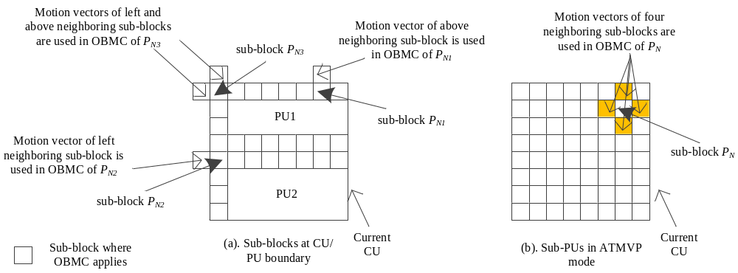
Figure 13: Illustration of sub-blocks where OBMC applies
In the JEM, for a CU with size less than or equal to 256 luma samples, a CU level flag is signalled to indicate whether OBMC is applied or not for the current CU. For the CUs with size larger than 256 luma samples or not coded with AMVP mode, OBMC is applied by default. At the encoder, when OBMC is applied for a CU, its impact is taken into account during the motion estimation stage. The prediction signal formed by OBMC using motion information of the top neighbouring block and the left neighbouring block is used to compensate the top and left boundaries of the original signal of the current CU, and then the normal motion estimation process is applied.

Local illumination compensation
Local Illumination Compensation (LIC) is based on a linear model for illumination changes, using a scaling factor a and an offset b. And it is enabled or disabled adaptively for each inter-mode coded coding unit (CU).
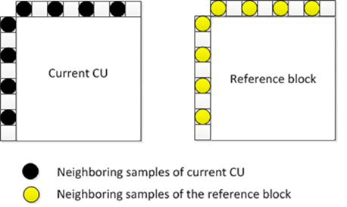
Figure 14: Neighbouring samples used for deriving IC parameters
When LIC applies for a CU, a least square error method is employed to derive the parameters a and b by using the neighbouring samples of the current CU and their corresponding reference samples. More specifically, as illustrated in Figure 14, the subsampled (2:1 subsampling) neighbouring samples of the CU and the corresponding samples (identified by motion information of the current CU or sub-CU) in the reference picture are used. The IC parameters are derived and applied for each prediction direction separately.
When a CU is coded with merge mode, the LIC flag is copied from neighbouring blocks, in a way similar to motion information copy in merge mode; otherwise, an LIC flag is signalled for the CU to indicate whether LIC applies or not.
When LIC is enabled for a pciture, addtional CU level RD check is needed to determine whether LIC is applied or not for a CU. When LIC is enabled for a CU, mean-removed sum of absolute diffefference (MR-SAD) and mean-removed sum of absolute Hadamard-transformed difference (MR-SATD) are used, instead of SAD and SATD, for integer pel motion search and fractional pel motion search, respectively.
To reduce the encoding complexity, the following encoding scheme is applied in the JEM.
- LIC is disabled for the entire picture when there is no obvious illumination change between a current picture and its reference pictures. To identify this situation, histograms of a current picture and every reference picture of the current picture are calculated at the encoder. If the histogram difference between the current picture and every reference picture of the current picture is smaller than a given threshold, LIC is disabled for the current picture; otherwise, LIC is enabled for the current picture.

Affine motion compensation prediction
In HEVC, only translation motion model is applied for motion compensation prediction (MCP). While in the real world, there are many kinds of motion, e.g. zoom in/out, rotation, perspective motions and he other irregular motions. In the JEM, a simplified affine transform motion compensation prediction is applied. As shown Figure 15, the affine motion field of the block is described by two control point motion vectors.
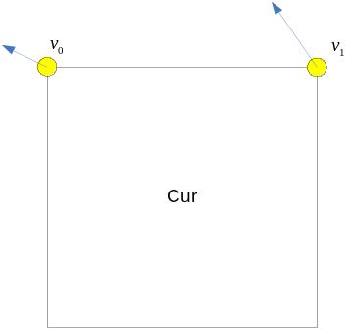
Figure 15: Simplified affine motion model
The motion vector field (MVF) of a block is described by the following equation:
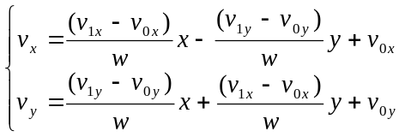 (15)
Where (v_{0x}, v_{0y}) is motion vector of the top-left corner control point, and (v_{1x}, v_{1y}) is motion vector of the top-right corner control point.
In order to further simplify the motion compensation prediction, sub-block based affine transform prediction is applied. The sub-block size $M×N$ is derived as in Equation 16, where MvPre is the motion vector fraction accuracy (1/16 in JEM), (v_{2x}, v_{2y}) is motion vector of the bottom-left control point, calculated according to Equation 15.
M=clip3(4,w,w×MvPremaxabsv1x-v0x,absv1y-v0y)N=clip3(4,h,h×MvPremaxabsv2x-v0x,absv2y-v0y) (16)
After derived by Equation 16, M and N should be adjusted downward if necessary to make it a divisor of w and h, respectively.
To derive motion vector of each M×N sub-block, the motion vector of the center sample of each sub-block, as shown in Figure 16, is calculated according to Equation 15, and rounded to 1/16 fraction accuracy. Then the motion compensation interpolation filters mentioned in section 2.3.3 are applied to generate the prediction of each sub-block with derived motion vector.
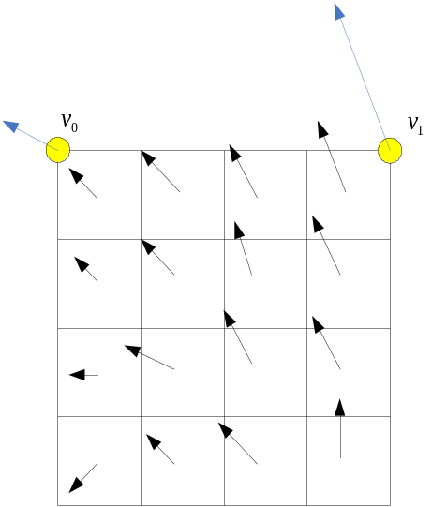
Figure 16: Affine MVF per sub-block
After MCP, the high accuracy motion vector of each sub-block is rounded and saved as the same accuracy as the normal motion vector.
In the JEM, there are two affine motion modes: AF_INTER mode and AF_MERGE mode. For CUs with both width and height larger than 8, AF_INTER mode can be applied. An affine flag in CU level is signalled in the bitstream to indicate whether AF_INTER mode is used. In this mode, a candidate list with motion vector pair $\left\{\left(v_{0},v_{1}\right)|v_{0}=\{v_{A},v_{B},v_{c}\},v_{1}=\{v_{D, }v_{E}\}\right\}$ is constructed using the neighbour blocks. As shown in Figure 17, $v_{0}$ is selected from the motion vectors of the block A, B or C. The motion vector from the neighbour block is scaled according to the reference list and the relationship among the POC of the reference for the neighbour block, the POC of the reference for the current CU and the POC of the current CU. And the approach to select $v_{1}$ from the neighbour block D and E is similar. If the number of candidate list is smaller than 2, the list is padded by the motion vector pair composed by duplicating each of the AMVP candidates. When the candidate list is larger than 2, the candidates are firstly sorted according to the consistency of the neighbouring motion vectors (similarity of the two motion vectors in a pair candidate) and only the first two candidates are kept. An RD cost check is used to determine which motion vector pair candidate is selected as the control point motion vector prediction (CPMVP) of the current CU. And an index indicating the position of the CPMVP in the candidate list is signalled in the bitstream. After the CPMVP of the current affine CU is determined, affine motion estimation is applied and the control point motion vector (CPMV) is found. Then the difference of the CPMV and the CPMVP is signalled in the bitstream.
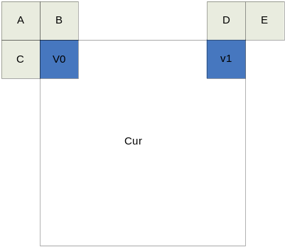
Figure 17: MVP for AF_INTER
When a CU is applied in AF_MERGE mode, it gets the first block coded with affine mode from the valid neighbour reconstructed blocks. And the selection order for the candidate block is from left, above, above right, left bottom to above left as shown in Figure 18.a. If the neighbour left bottom block A is coded in affine mode as shown in Figure 18.b, the motion vectors$v_{2}$ , $v_{3}$ and $v_{4}$ of the top left corner, above right corner and left bottom corner of the CU which contains the block A are derived. And the motion vector $v_{0}$of the top left corner on the current CU is calculated according to $v_{2}$ , $v_{3}$ and $v_{4}$. Secondly, the motion vector $v_{1 }$of the above right of the current CU is calculated.
After the CPMV of the current CU $v_{0}$ and $v_{1 }$are derived, according to the simplified affine motion model Equation 15, the MVF of the current CU is generated. In order to identify whether the current CU is coded with AF_MERGE mode, an affine flag is signalled in the bitstream when there is at least one neighbour block is coded in affine mode.

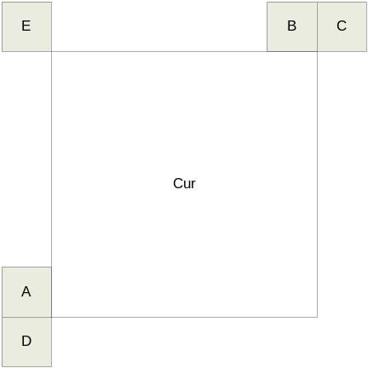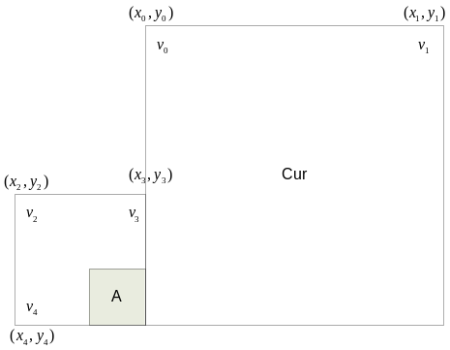
(a) (b)
Figure 18: Candidates for AF_MERGE

Pattern matched motion vector derivation
Pattern matched motion vector derivation (PMMVD) mode is a special merge mode based on Frame-Rate Up Conversion (FRUC) techniques. With this mode, motion information of a block is not signalled but derived at decoder side.
A FRUC flag is signalled for a CU when its merge flag is true. When the FRUC flag is false, a merge index is signalled and the regular merge mode is used. When the FRUC flag is true, an additional FRUC mode flag is signalled to indicate which method (bilateral matching or template matching) is to be used to derive motion information for the block.
At encoder side, the decision on whether using FRUC merge mode for a CU is based on RD cost selection as done for normal merge candidate. That is the two matching modes (bilateral matching and template matching) are both checked for a CU by using RD cost selection. The one leading to the minimal cost is further compared to other CU modes. If a FRUC matching mode is the most efficient one, FRUC flag is set to true for the CU and the related matching mode is used.
Motion derivation process in FRUC merge mode has two steps. A CU-level motion search is first performed, then followed by a Sub-CU level motion refinement. At CU level, an initial motion vector is derived for the whole CU based on bilateral matching or template matching. First, a list of MV candidates is generated and the candidate which leads to the minimum matching cost is selected as the starting point for further CU level refinement. Then a local search based on bilateral matching or template matching around the starting point is performed and the MV results in the minimum matching cost is taken as the MV for the whole CU. Subsequently, the motion information is further refined at sub-CU level with the derived CU motion vectors as the starting points.
For example, the following derivation process is performed for a $W×H$ CU motion information derivation. At the first stage, MV for the whole $W×H$ CU is derived. At the second stage, the CU is further split into $M×M$ sub-CUs. The value of $M$ is calculated as in (16), $D$ is a predefined splitting depth which is set to 3 by default in the JEM. Then the MV for each sub-CU is derived.
$M=max⁡\{4,min⁡\{\frac{M}{2^{D}},\frac{N}{2^{D}}\}$} (17)
As shown in the Figure 19, the bilateral matching is used to derive motion information of the current CU by finding the closest match between two blocks along the motion trajectory of the current CU in two different reference pictures. Under the assumption of continuous motion trajectory, the motion vectors MV0 and MV1 pointing to the two reference blocks shall be proportional to the temporal distances, i.e., TD0 and TD1, between the current picture and the two reference pictures. As a special case, when the current picture is temporally between the two reference pictures and the temporal distance from the current picture to the two reference pictures is the same, the bilateral matching becomes mirror based bi-directional MV.
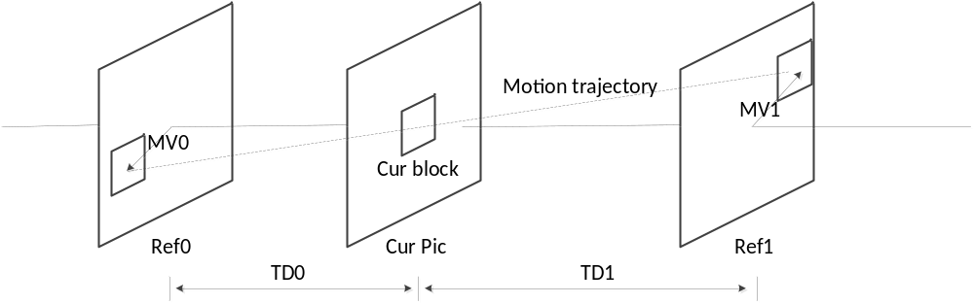
Figure 19: Bilateral matching
As shown in Figure 20, template matching is used to derive motion information of the current CU by finding the closest match between a template (top and/or left neighbouring blocks of the current CU) in the current picture and a block (same size to the template) in a reference picture. Except the aforementioned FRUC merge mode, the template matching is also applied to AMVP mode. In the JEM, as done in HEVC, AMVP has two candidates. With template matching method, a new candidate is derived. If the newly derived candidate by template matching is different to the first existing AMVP candidate, it is inserted at the very beginning of the AMVP candidate list and then the list size is set to two (meaning remove the second existing AMVP candidate). When applied to AMVP mode, only CU level search is applied.
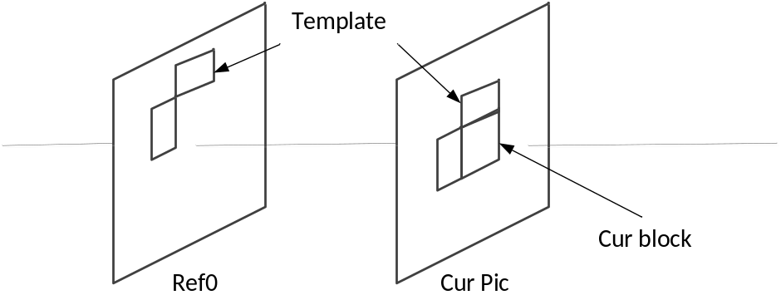
Figure 20: Template matching

CU level MV candidate set
The MV candidate set at CU level consists of:
- Original AMVP candidates if the current CU is in AMVP mode
- all merge candidates,
- several MVs in the interpolated MV field, which is introduced in section 2.3.7.3.
- top and left neighbouring motion vectors
When using bilateral matching, each valid MV of a merge candidate is used as an input to generate a MV pair with the assumption of bilateral matching. For example, one valid MV of a merge candidate is (MVa, refa) at reference list A. Then the reference picture refb of its paired bilateral MV is found in the other reference list B so that refa and refb are temporally at different sides of the current picture. If such a refb is not available in reference list B, refb is determined as a reference which is different from refa and its temporal distance to the current picture is the minimal one in list B. After refb is determined, MVb is derived by scaling MVa based on the temporal distance between the current picture and refa, refb.
Four MVs from the interpolated MV field are also added to the CU level candidate list. More specifically, the interpolated MVs at the position (0, 0), (W/2, 0), (0, H/2) and (W/2, H/2) of the current CU are added.
When FRUC is applied in AMVP mode, the original AMVP candidates are also added to CU level MV candidate set.
At the CU level, up to 15 MVs for AMVP CUs and up to 13 MVs for merge CUs are added to the candidate list.

Sub-CU level MV candidate set
The MV candidate set at sub-CU level consists of:
- an MV determined from a CU-level search,
- top, left, top-left and top-right neighbouring MVs,
- scaled versions of collocated MVs from reference pictures,
- up to 4 ATMVP candidates,
- up to 4 STMVP candidates
The scaled MVs from reference pictures are derived as follows. All the reference pictures in both lists are traversed. The MVs at a collocated position of the sub-CU in a reference picture are scaled to the reference of the starting CU-level MV.
ATMVP and STMVP candidates are limited to the four first ones.
At the sub-CU level, up to 17 MVs are added to the candidate list.

Generation of interpolated MV field
Before coding a frame, interpolated motion field is generated for the whole picture based on unilateral ME. Then the motion field may be used later as CU level or sub-CU level MV candidates.
First, the motion field of each reference pictures in both reference lists is traversed at 4×4 block level. For each 4×4 block, if the motion associated to the block passing through a 4×4 block in the current picture (as shown in Figure 21) and the block has not been assigned any interpolated motion, the motion of the reference block is scaled to the current picture according to the temporal distance TD0 and TD1 (the same way as that of MV scaling of TMVP in HEVC) and the scaled motion is assigned to the block in the current frame. If no scaled MV is assigned to a 4×4 block, the block’s motion is marked as unavailable in the interpolated motion field.
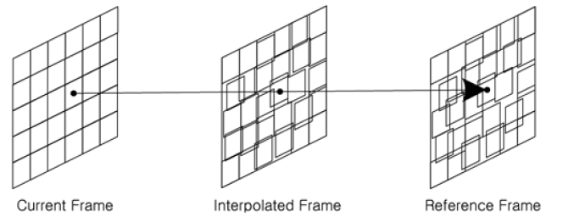
Figure 21: Unilateral ME in FRUC

Interpolation and matching cost
When a motion vector points to a fractional sample position, motion compensated interpolation is needed. To reduce complexity, bi-linear interpolation instead of regular 8-tap HEVC interpolation is used for both bilateral matching and template matching.
The calculation of matching cost is a bit different at different steps. When selecting the candidate from the candidate set at the CU level, the matching cost is the absolute sum difference (SAD) of bilateral matching or template matching. After the starting MV is determined, the matching cost $C$ of bilateral matching at sub-CU level search is calculated as follows:
$C=SAD+w⋅(\left|MV_{x}-MV_{x}^{s}\right|+\left|MV_{y}-MV_{y}^{s}\right|)$ (18)
where $w$ is a weighting factor which is empirically set to 4, $MV$ and $MV^{s}$ indicate the current MV and the starting MV, respectively. SAD is still used as the matching cost of template matching at sub-CU level search.
In FRUC mode, MV is derived by using luma samples only. The derived motion will be used for both luma and chroma for MC inter prediction. After MV is decided, final MC is performed using 8-taps interpolation filter for luma and 4-taps interpolation filter for chroma.

MV refinement
MV refinement is a pattern based MV search with the criterion of bilateral matching cost or template matching cost. In the JEM, two search patterns are supported – an unrestricted center-biased diamond search (UCBDS) and an adaptive cross search for MV refinement at the CU level and sub-CU level, respectively. For both CU and sub-CU level MV refinement, the MV is directly searched at quarter luma sample MV accuracy, and this is followed by one-eighth luma sample MV refinement. The search range of MV refinement for the CU and sub-CU step are set equal to 8 luma samples.

Selection of prediction direction in template matching FRUC merge mode
In the bilateral matching merge mode, bi-prediction is always applied since the motion information of a CU is derived based on the closest match between two blocks along the motion trajectory of the current CU in two different reference pictures. There is no such limitation for the template matching merge mode. In the template matching merge mode, the encoder can choose among uni-prediction from list0, uni-prediction from list1 or bi-prediction for a CU. The selection is based on a template matching cost as follows:
If costBi <= factor * min (cost0, cost1)
bi-prediction is used;
Otherwise, if cost0 <= cost1
uni-prediction from list0 is used;
Otherwise,
uni-prediction from list1 is used;
where cost0 is the SAD of list0 template matching, cost1 is the SAD of list1 template matching and costBi is the SAD of bi-prediction template matching. The value of factor is equal to 1.25, which means that the selection process is biased toward bi-prediction.
The inter prediction direction selection is only applied to the CU-level template matching process.

Bi-directional optical flow
Bi-directional Optical flow (BIO) is sample-wise motion refinement which is performed on top of block-wise motion compensation for bi-prediction. The sample-level motion refinement doesn’t use signalling.
τ₀
τ₁
Ref₀
Ref₁
B-picture
−v_{y}τ₁
v_{y}τ₀

v_{x}τ₀
−v_{x}τ₁
A
B
t
(MVx_{1;} MVy₁)
(MVx_{0;} MVy₀)
Figure 22: Optical flow trajectory
Let 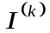 be the luma value from reference k (k=0, 1) after block motion compensation, and 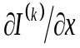, 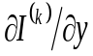are horizontal and vertical components of the gradient, respectively. Assuming the optical flow is valid, the motion vector field 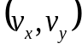 is given by an equation
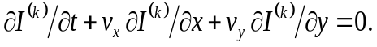 (19)
Combining this optical flow equation with Hermite interpolation for the motion trajectory of each sample results in a unique third-order polynomial that matches both the function values and derivatives , at the ends. The value of this polynomial at t=0 is the BIO prediction:
(20)
Here, 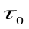 and 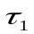 denote the distances to the reference frames as shown on a Figure 22. Distances and are calculated based on POC for Ref0 and Ref1: τ₀=POC(current) − POC(Ref0), τ₁= POC(Ref1) − POC(current). If both predictions come from the same time direction (either both from the past or both from the future) then the signs are different (i.e., 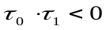). In this case, BIO is applied only if the prediction is not from the same time moment (i.e., 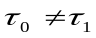), both referenced regions have non-zero motion () and the block motion vectors are proportional to the time distance ().
The motion vector field is determined by minimizing the difference $∆$between values in points A and B (intersection of motion trajectory and reference frame planes on Fig. 9). Model uses only first linear term of a local Taylor expansion for $∆$:
(21)
All values in Equation 21 depend on the sample location $\left(i^{'},j' \right)$, which was omitted from the notation so far. Assuming the motion is consistent in the local surrounding area, we minimize $∆$ inside the (2M+1)×(2M+1) square window $Ω$ centered on the currently predicted point $\left(i,j\right)$, where M is equal to 2:
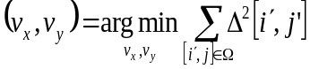 (22)
For this optimization problem, the JEM uses a simplified approach making first a minimization in the vertical direction and then in the horizontal direction. This results in
$v_{x}=\left(s_{1}+r\right)>m?clip3\left(-thBIO,thBIO,-\frac{s_{3}}{\left(s_{1}+r\right)}\right):0$ (23)
$v_{y}=\left(s_{5}+r\right)>m?clip3\left(-thBIO,thBIO,-\frac{s_{6}-v_{x}{s_{2}}/2}{\left(s_{5}+r\right)}\right):0$ (24)
where,
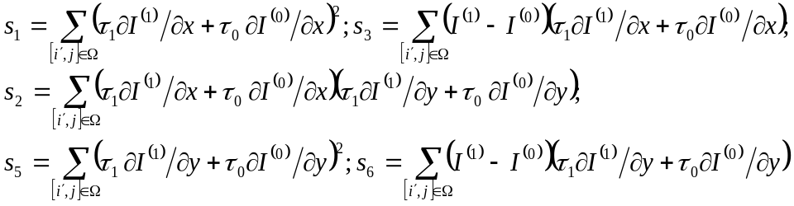 (25)
In order to avoid division by zero or a very small value, regularization parameters r and m are introduced in Equations 23 and 24.
$r=500∙4^{d-8}$ (26)
$m=700∙4^{d-8}$ (27)
Here $d$ is bit depth of the video samples.
In order to keep the memory access for BIO the same as for regular bi-predictive motion compensation, all prediction and gradients values, $I^{\left(k\right)}, {∂I^{\left(k\right)}}/{∂x}, {∂I^{\left(k\right)}}/{∂y}$, are calculated only for positions inside the current block. In Equation 25, (2M+1)×(2M+1) square window $Ω$ centered in currently predicted point on a boundary of predicted block needs to accesses positions outside of the block (as shown in Figure 23 (a)). In the JEM, values of $I^{\left(k\right)}, {∂I^{\left(k\right)}}/{∂x}, {∂I^{\left(k\right)}}/{∂y}$ outside of the block are set to be equal to the nearest available value inside the block. For example, this can be implemented as padding, as shown in Figure 23 (b).
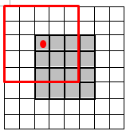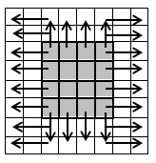
- (b)
Figure 23: BIO w/o block extension: a) access positions outside of the block;
b) padding isused in order to avoid extra memory access and calculation
With BIO, it’s possible that the motion field can be refined for each sample. To reduce the computational complexity, a block-based design of BIO is used in the JEM. The motion refinement is calculated based on 4×4 block. In the block-based BIO, the values of s_{n} in Equation 25 of all samples in a 4×4 block are aggregated, and then the aggregated values of s_{n} in are used to derived BIO motion vectors offset for the 4×4 block. More specifically, the following formula is used for block-based BIO derivation:

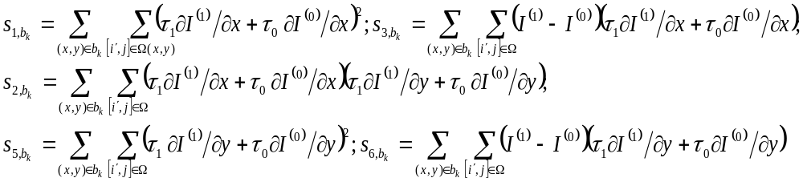 (28)
where b_{k} denotes the set of samples belonging to the k-th 4x4 block of the predicted block. s_{n} in Equations 23 and 24 are replaced by ( (s_{n,bk}) >> 4 ) to derive the associated motion vector offsets.

In some cases, MV regiment of BIO might be unreliable due to noise or irregular motion. Therefore, in BIO, the magnitude of MV regiment is clipped to a threshold value thBIO. The threshold value is determined based on whether the reference pictures of the current picture are all from one direction. If all the reference pictures of the current picture are from one direction, the value of the threshold is set to ${12×2}^{14-d}$; otherwise, it is set to ${12×2}^{13-d}$.
Gradients for BIO are calculated at the same time with motion compensation interpolation using operations consistent with HEVC motion compensation process (2D separable FIR). The input for this 2D separable FIR is the same reference frame sample as for motion compensation process and fractional position (fracX, fracY) according to the fractional part of block motion vector. In case of horizontal gradient ${∂I}/{∂x}$ signal first interpolated vertically using BIOfilterS corresponding to the fractional position fracY with de-scaling shift d−8, then gradient filter BIOfilterG is applied in horizontal direction corresponding to the fractional position fracX with de-scaling shift by 18−d. In case of vertical gradient ${∂I}/{∂y}$ first gradient filter is applied vertically using BIOfilterG corresponding to the fractional position fracY with de-scaling shift d−8, then signal displacement is performed using BIOfilterS in horizontal direction corresponding to the fractional position fracX with de-scaling shift by 18−d. The length of interpolation filter for gradients calculation BIOfilterG and signal displacement BIOfilterF is shorter (6-tap) in order to maintain reasonable complexity. Table 3 shows the filters used for gradients calculation for different fractional positions of block motion vector in BIO. Table 4 shows the interpolation filters used for prediction signal generation in BIO.
Table 3: Filters for gradients calculation in BIO
Fractional pel position | Interpolation filter for gradient(BIOfilterG)
0 | { 8, −39, −3, 46, −17, 5}
1/16 | { 8, −32, −13, 50, −18, 5}
1/8 | { 7, −27, −20, 54, −19, 5}
3/16 | { 6, −21, −29, 57, −18, 5}
1/4 | { 4, −17, −36, 60, −15, 4}
5/16 | { 3, −9, −44, 61, −15, 4}
3/8 | { 1, −4, −48, 61, −13, 3}
7/16 | { 0, 1, −54, 60, −9, 2}
1/2 | { −1, 4, −57, 57, −4, 1}
Table 4: Interpolation filters for prediction signal generation in BIO
Fractional pel position | Interpolation filter for prediction signal(BIOfilterS)
0 | { 0, 0, 64, 0, 0, 0}
1/16 | { 1, −3, 64, 4, −2, 0}
1/8 | { 1, −6, 62, 9, −3, 1}
3/16 | { 2, −8, 60, 14, −5, 1}
1/4 | { 2, −9, 57, 19, −7, 2}
5/16 | { 3, −10, 53, 24, −8, 2}
3/8 | { 3, −11, 50, 29, −9, 2}
7/16 | { 3, −11, 44, 35, −10, 3}
1/2 | { 3, −10, 35, 44, −11, 3}
In the JEM, BIO is applied to all bi-predicted blocks when the two predictions are from different reference pictures. When LIC is enabled for a CU, BIO is disabled.
In the JEM, OBMC is applied for a block after normal MC process. To reduce the computational complexity, BIO is not applied during the OBMC process. This means that BIO is only applied in the MC process for a block when using its own MV and is not applied in the MC process when the MV of a neighboring block is used during the OBMC process.

Decoder-side motion vector refinement
In bi-prediction operation, for the prediction of one block region, two prediction blocks, formed using a motion vector (MV) of list0 and a MV of list1, respectively, are combined to form a single prediction signal. In the decoder-side motion vector refinement (DMVR) method, the two motion vectors of the bi-prediction are further refined by a bilateral template matching process. The bilateral template matching applied in the decoder to perform a distortion-based search between a bilateral template and the reconstruction samples in the reference pictures in order to obtain a refined MV without transmission of additional motion information.
In DMVR, a bilateral template is generated as the weighted combination (i.e. average) of the two prediction blocks, from the initial MV0 of list0 and MV1 of list1, respectively, as shown in Figure 24. The template matching operation consists of calculating cost measures between the generated template and the sample region (around the initial prediction block) in the reference picture. For each of the two reference pictures, the MV that yields the minimum template cost is considered as the updated MV of that list to replace the original one. In the JEM, nine MV candidates are searched for each list. The nine MV candidates include the original MV and 8 surrounding MVs with one luma sample offset to the original MV in either the horizontal or vertical direction, or both. Finally, the two new MVs, i.e., MV0′ and MV1′ as shown in Figure 24, are used for generating the final bi-prediction results. A sum of absolute differences (SAD) is used as the cost measure.
DMVR is applied for the merge mode of bi-prediction with one MV from a reference picture in the past and another from a reference picture in the future, without the transmission of additional syntax elements. In the JEM, when LIC, affine motion, FRUC, or sub-CU merge candidate is enabled for a CU, DMVR is not applied.

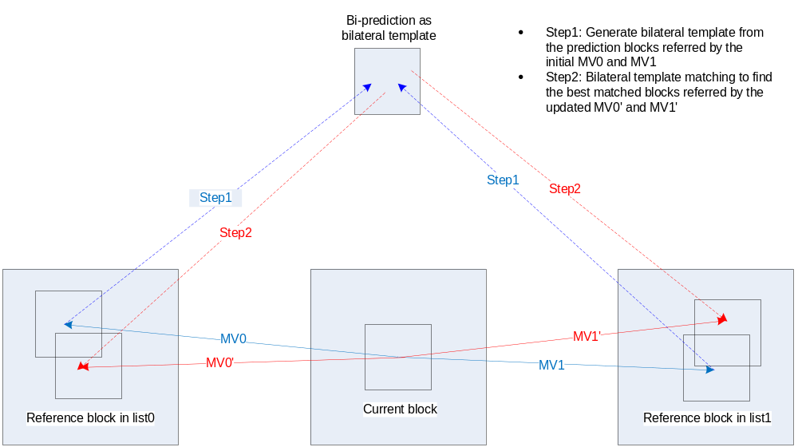
Figure 24: Proposed DMVR based on bilateral template matching

Transform modifications

Large block-size transforms with high-frequency zeroing
In the JEM, large block-size transforms, up to 128×128 in size, are enabled, which is primarily useful for higher resolution video, e.g., 1080p and 4K sequences. High frequency transform coefficients are zeroed out for the transform blocks with size (width or height, or both width and height) larger than or equal to 64, so that only the lower-frequency coefficients are maintained. For example, for an M×N transform block, with M as the block width and N as the block height, when M is larger than or equal to 64, only the left 32 columns of transform coefficients are kept. Similarly, when N is larger than or equal to 64, only the top 32 rows of transform coefficients are kept. When transform skip mode is used for a large block, the entire block is used without zeroing out any values.

Adaptive multiple core transform
In addition to DCT-II and 4×4 DST-VII which have been employed in HEVC, an Adaptive Multiple Transform (AMT) scheme is used for residual coding for both inter and intra coded blocks. It uses multiple selected transforms from the DCT/DST families other than the current transforms in HEVC. The newly introduced transform matrices are DST-VII, DCT-VIII, DST-I and DCT-V. Table 5 shows the basis functions of the selected DST/DCT.
Table 5: Transform basis functions of DCT-II/V/VIII and DST-I/VII for N-point input
Transform Type | Basis function T_{i}(j), i, j=0, 1,…, N−1
DCT-II | $$T_{i}(j)=ω_{0}∙\sqrt{\frac{2}{N}}∙\cos\left(\frac{π∙i∙\left(2j+1\right)}{2N}\right)$$  where $ω_{0}=\left\{\begin{matrix}\sqrt{\frac{2}{N}} & i=0 \\ 1 & i≠0\end{matrix}\right.$
DCT-V | $T_{i}(j)=ω_{0}∙ω_{1}∙\sqrt{\frac{2}{2N-1}}∙\cos\left(\frac{2π∙i∙j}{2N-1}\right)$,  where $ω_{0}=\left\{\begin{matrix}\sqrt{\frac{2}{N}} & i=0 \\ 1 & i≠0\end{matrix}\right.$,$ω_{1}=\left\{\begin{matrix}\sqrt{\frac{2}{N}} & j=0 \\ 1 & j≠0\end{matrix}\right.$
DCT-VIII | $$T_{i}(j)=\sqrt{\frac{4}{2N+1}}∙\cos\left(\frac{π∙(2i+1)∙(2j+1)}{4N+2}\right)$$
DST-I | $$T_{i}(j)=\sqrt{\frac{2}{N+1}}∙\sin\left(\frac{π∙(i+1)∙(j+1)}{N+1}\right)$$
DST-VII | $$T_{i}(j)=\sqrt{\frac{4}{2N+1}}∙\sin\left(\frac{π∙(2i+1)∙(j+1)}{2N+1}\right)$$
In order to keep the orthogonality of the transform matrix, the transform matrices are quantized more accurately than the transform matrices in HEVC. To keep the intermediate values of the transformed coefficients within the range of 16-bit, after horizontal and after vertical transform, all the coefficients are right shifted by 2 more bits, comparing to the right shift used in the current HEVC transforms.
The AMT applies to the CUs with both width and height smaller than or equal to 64, and whether AMT applies or not is controlled by a CU level flag. When the CU level flag is equal to 0, DCT-II is applied in the CU to encode the residue. For luma coding block within an AMT enabled CU, two additional flags are signalled to identify the horizontal and vertical transform to be used. As in HEVC, the residual of a block can be coded with transform skip mode in the JEM. To avoid the redundancy of syntax coding, the transform skip flag is not signalled when the CU level AMT flag is not equal to zero.
For intra residue coding, due to the different residual statistics of different intra prediction modes, a mode-dependent transform candidate selection process is used. Three transform subsets have been defined as shown in Table 6, and the transform subset is selected based on the intra prediction mode, as specified in Table 7.
Table 6: Three pre-defined transform candidate sets
Transform Set | Transform Candidates
0 | DST-VII, DCT-VIII
1 | DST-VII, DST-I
2 | DST-VII, DCT-VIII
With the subset concept, a transform subset is first identified based on Table 6 using the intra prediction mode of a CU with the CU-level AMT flag is equal to 1. After that, for each of the horizontal and vertical transform, one of the two transform candidates in the identified transform subset, according to in Table 7, is selected based on explicitly signalled with flags.
Table 7: Selected (H)orizontal and (V)ertical transform sets for each intra prediction mode
Intra Mode | 0 | 1 | 2 | 3 | 4 | 5 | 6 | 7 | 8 | 9 | 10 | 11 | 12 | 13 | 14 | 15 | 16 | 17
V | 2 | 1 | 0 | 1 | 0 | 1 | 0 | 1 | 0 | 1 | 0 | 1 | 0 | 1 | 0 | 0 | 0 | 0
H | 2 | 1 | 0 | 1 | 0 | 1 | 0 | 1 | 0 | 1 | 0 | 1 | 0 | 1 | 2 | 2 | 2 | 2
Intra Mode | 18 | 19 | 20 | 21 | 22 | 23 | 24 | 25 | 26 | 27 | 28 | 29 | 30 | 31 | 32 | 33 | 34
V | 0 | 0 | 0 | 0 | 0 | 1 | 0 | 1 | 0 | 1 | 0 | 1 | 0 | 1 | 0 | 1 | 0
H | 2 | 2 | 2 | 2 | 2 | 1 | 0 | 1 | 0 | 1 | 0 | 1 | 0 | 1 | 0 | 1 | 0
Intra Mode | 35 | 36 | 37 | 38 | 39 | 40 | 41 | 42 | 43 | 44 | 45 | 46 | 47 | 48 | 49 | 50 | 51 | 52
V | 1 | 0 | 1 | 0 | 1 | 0 | 1 | 0 | 1 | 0 | 1 | 2 | 2 | 2 | 2 | 2 | 2 | 2
H | 1 | 0 | 1 | 0 | 1 | 0 | 1 | 0 | 1 | 0 | 1 | 0 | 0 | 0 | 0 | 0 | 0 | 0
Intra Mode | 53 | 54 | 55 | 56 | 57 | 58 | 59 | 60 | 61 | 62 | 63 | 64 | 65 | 66
V | 2 | 2 | 1 | 0 | 1 | 0 | 1 | 0 | 1 | 0 | 1 | 0 | 1 | 0
H | 0 | 0 | 1 | 0 | 1 | 0 | 1 | 0 | 1 | 0 | 1 | 0 | 1 | 0
For inter prediction residual, however, only one transform set, which consists of DST-VII and DCT-VIII, is used for all inter modes and for both horizontal and vertical transforms.
The complexity of AMT would be relatively high at the encoder side, since totally five (DCT-II and four multiple transform candidates) different transform candidates need to be evaluated with rate-distortion cost for each residual block when brute-force search is used. To alleviate this complexity issue at the encoder, several optimization methods are designed for algorithm acceleration in the JEM.
At the encoder, for each CU-level coding mode, two-pass coding is applied. As shown in Figure 25 (left), the first pass examines the R-D cost of applying only DCT-II for the CU (CU level flag is 0), while the second pass further examines the R-D cost of applying multiple transforms for the CU (CU level flag is 1). In addition, it is observed that the CU-level coding mode is relatively consistent no matter which pass is actually applied. Therefore, when checking the multi-transform pass for the CU, the statistics of applying only DCT-II is collected and are used to skip unnecessary R-D calculations in the second multi-transform pass. As shown in Figure 25 (right), when the R-D cost of a certain CU coding mode with AMT CU-level flag 0 exceeds the minimum R-D cost of a certain threshold, as indicated by the condition highlighted in red in Figure 25, the second pass, i.e., encode the CU with the current CU coding mode with AMT CU-level flag 1, is skipped.
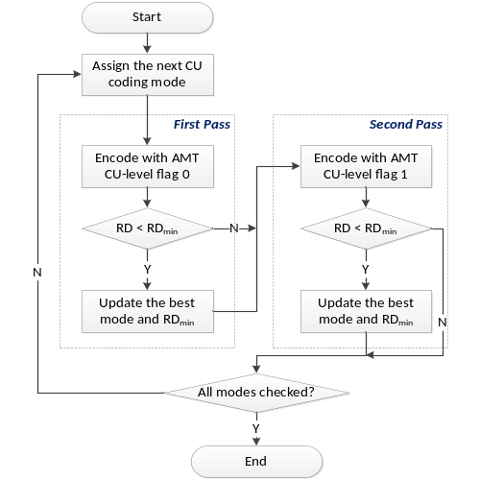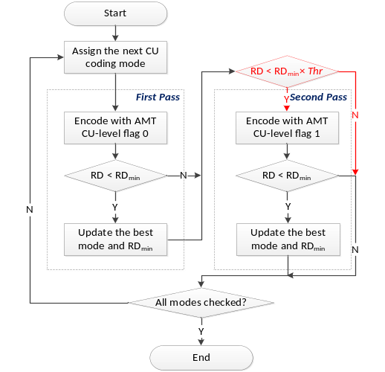
Figure 25: Flowchart of the CU encoding process using AMT w/o(left) and w/(right) the fast algorithms

Mode-dependent non-separable secondary transforms
In the JEM, a mode-dependent non-separable secondary transform (MDNSST) is applied between the forward core transform and quantization (at the encoder) and between the de-quantization and inverse core transform (at the decoder). To keep low complexity, MDNSST is only applied to the low frequency coefficients after the primary transform. If both width (W) and height (H) of a transform coefficient block is larger than or equal to 8, then 8×8 non-separable secondary transform is applied to the top-left 8×8 region of the transform coefficients block. Otherwise, if either W or H of a transform coefficient block is equal to 4, a 4×4 non-separable secondary transform is applied and the 4×4 non-separable transform is performed on the top-left min(8,W)×min(8,H) region of the transform coefficient block. The above transform selection rule is applied for both luma and chroma components.
Matrix multiplication implementation of a non-separable transform is described as follows using a 4×4 input block as an example. To apply the non-separable transform, the 4×4 input block X
$X=\left[\begin{matrix}\begin{matrix}X_{00} & X_{01} \\ X_{10} & X_{11}\end{matrix} & \begin{matrix}X_{02} & X_{03} \\ X_{12} & X_{13}\end{matrix} \\ \begin{matrix}X_{20} & X_{21} \\ X_{30} & X_{31}\end{matrix} & \begin{matrix}X_{22} & X_{23} \\ X_{32} & X_{33}\end{matrix}\end{matrix}\right]$ (29)
is represented as a vector $\overset{⃑}{X}$:
$\overset{⃑}{X}={\left[\begin{matrix}\begin{matrix}\begin{matrix}\begin{matrix}X_{00} & X_{01}\end{matrix} & \begin{matrix}X_{02} & X_{03}\end{matrix}\end{matrix} & \begin{matrix}\begin{matrix}X_{10} & X_{11}\end{matrix} & \begin{matrix}X_{12} & X_{13}\end{matrix}\end{matrix}\end{matrix} & \begin{matrix}\begin{matrix}\begin{matrix}X_{20} & X_{21}\end{matrix} & \begin{matrix}X_{22} & X_{23}\end{matrix}\end{matrix} & \begin{matrix}\begin{matrix}X_{30} & X_{31}\end{matrix} & \begin{matrix}X_{32} & X_{33}\end{matrix}\end{matrix}\end{matrix}\end{matrix}\right]}^{T}$ (30)
The non-separable transform is calculated as $\overset{⃑}{F}=T∙\overset{⃑}{X}$, where $\overset{⃑}{F}$ indicates the transform coefficient vector, and T is a 16×16 transform matrix. The 16×1 coefficient vector $\overset{⃑}{F}$ is subsequently re-organized as 4×4 block using the scanning order for that block (horizontal, vertical or diagonal). The coefficients with smaller index will be placed with the smaller scanning index in the 4×4 coefficient block. In the JEM, a Hypercube-Givens Transform (HyGT) with butterfly implementation is used instead of matrix multiplication to reduce the complexity of non-separable transform.

Mode dependent transform core selection
There are totally 35×3 non-separable secondary transforms for both 4×4 and 8×8 block size, where 35 is the number of transform sets specified by the intra prediction mode, denoted as set, and 3 is the number of NSST candidate for each intra prediction mode. The mapping from the intra prediction mode to the transform set is defined in Table 8. The transform set applied to luma/chroma transform coefficients is specified by the corresponding luma/chroma intra prediction modes, according to Table 8. For intra prediction modes larger than 34 (diagonal prediction direction), the transform coefficient block is transposed before/after the secondary transform at the encoder/decoder.
For each transform set, the selected non-separable secondary transform candidate is further specified by the explicitly signalled CU-level MDNSST index. The index is signalled in a bitstream once per intra CU after transform coefficients and truncated unary binarization is used. The truncated value is 2 in case of planar or DC mode, and 3 for angular intra prediction mode. This MDNSST index is signalled only when there is more than one non-zero coefficient in a CU. The default value is zero when it is not signalled. Zero value of this syntax element indicates secondary transform is not applied to the current CU, values 1-3 indicates which secondary transform from the set should be applied.
In the JEM, MDNSST is not applied for a block coded with transform skip mode. When the MDNSST index is signalled for a CU and not equal to zero, MDNSST is not used for a block of a component that is coded with transform skip mode in the CU. When a CU with blocks of all components are coded in transform skip mode or the number of non-zero coefficients of non-transform-skip mode CBs is less than 2, the MDNSST index is not signalled for the CU.
In the JEM, MDNSST also has impact on how mode dependent reference samples intra smoothing (MDIS) is applied when intra prediction is generated. MDIS is disabled (i.e. no reference samples smoothing) for a block when its MDNSST index is zero. A HEVC-style MDIS is applied for a block when its MDNSST index is not equal to zero. This rule is applied for all intra prediction modes except planar mode, where PDPC process is applied. In the JEM, the strong intra smoothing, which is applied for 32×32 intra block size in HEVC, is disabled.
Table 8: Mapping from intra prediction mode to transform set index
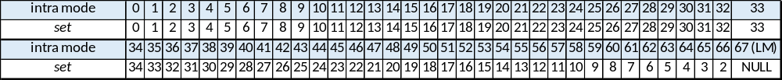
At the encoder side, CU level RD checks are used to select the NSST index for a CU. That is, for an intra-coded CU, the CU level RD check is looped four times by using NSST index value as loop index. To accelerate encoder speed, the following fast methods are used:
- Early stopping of the loop is applied. The RD check for a NSST index with larger value is skipped when there is no non-zero transformed coefficients in the current CU for a NSST index with smaller value.
- The intra mode decision for each of the NSST indices in the reference software comprises the rough mode decision (RMD) stage and the RDO stage. In the RMD stage, 3 out of 67 intra prediction modes are selected based on the SATD cost. This process is applied twice (one for NSST index equal to zero and one for NSST index equal to non-zero) instead of four times. For all non-zero NSST indices, the SATD costs of different NSST indices for an intra prediction mode should be the same. Therefore, RMD process only needs to be applied once (as NSST index = 1) for all non-zero NSST indices, and the result are reused for the other non-zero NSST index.

Non-separable transform based on HyGT
A Hypercube-Givens Transform (HyGT) is used in the computation of the non-separable secondary transform. The basic elements of this orthogonal transform are Givens rotations, which are defined by orthogonal matrices G(m, n, θ), which have elements defined by
$G_{i,j}\left(m,n\right)=\left\{\begin{matrix}\cos{θ}, & i=j=m or i=j=n, \\ \sin{θ,} & i=m, j=n, \\ -sin{θ,} & i=n, j=m, \\ 1, & i=j and i≠m and i≠n, \\ 0, & otherwise.\end{matrix}\right.$ (31)
These transformations can be graphically represented as in Figure 26.
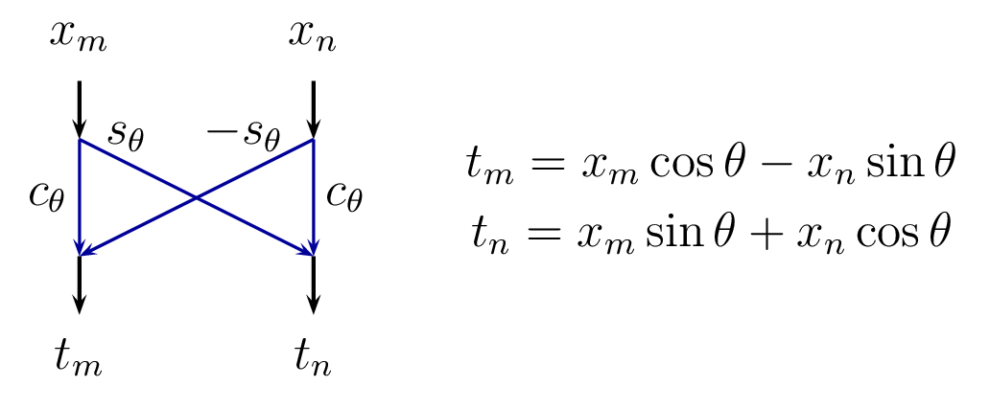
Figure 26: Graphical representation of Givens rotations
HyGT is implemented by combining sets of Givens rotations in a hypercube arrangement. Figure 27 shows the the “butterfly” shape flowchart of HyGT for 16 elements (4×4 non-separable transform). Assuming that N is a power of two, a HyGT round is defined as a sequence of log2(N) passes, where in each pass, the indexes in vectors m and n are defined by edges of a hypercube with dimension log2(N), sequentially in each direction.

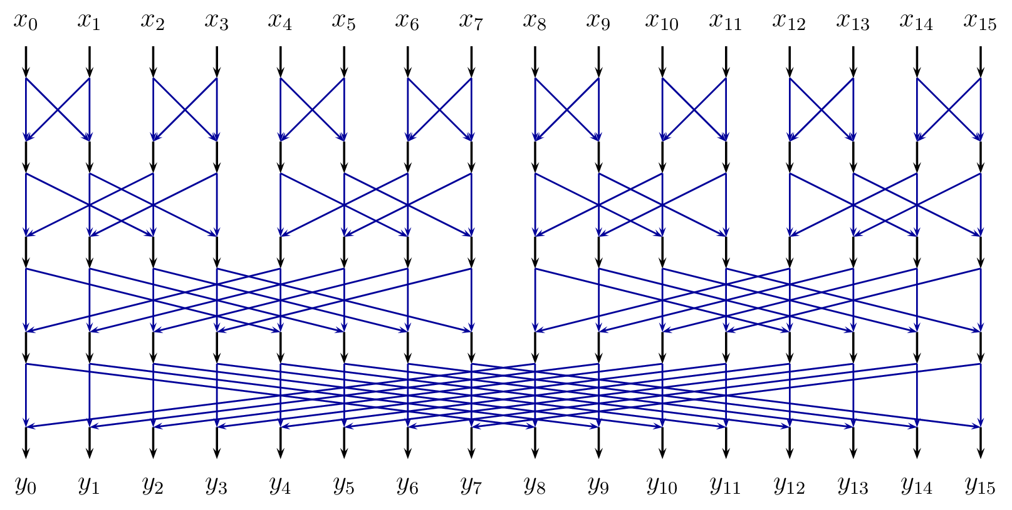
Figure 27: HyGT is defined by combinations of Givens rotations in a hypercube arrangement
To obtain good compression, more than one HyGT round are used. As shown in Figure 28, a full non-separable secondary transform is composed of R rounds HyGT, and may include an optional permutation pass, to sort transform coefficients according to their variance. In the JEM, 2-round HyGT is applied for 4×4 secondary transform and 4-round HyGT is applied for 8×8 secondary transform.
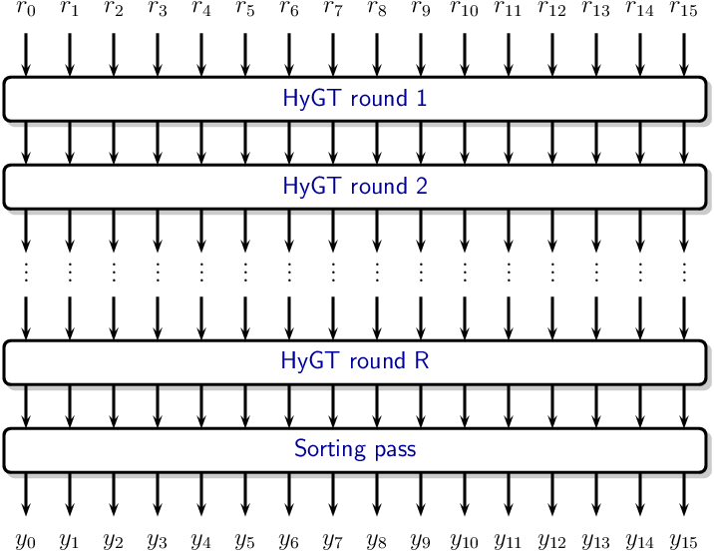
Figure 28: HyGT is defined by combinations of Givens rotations in a hypercube arrangement

Signal dependent transform
Considering that there are many similar patches within a frame and across frames, signal dependent transform explores such correlations can enhance coding performance by means of KLT. This trained KLT plays the role of a transform that is intended to compact the energy more efficiently.

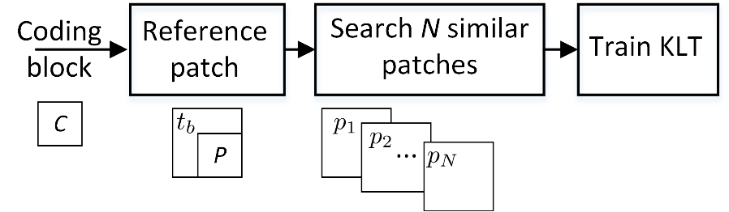
Figure 29: Flowchart of KLT exploring the non-local correlations
The flowchart in Figure 29 describes this idea. For the current coding block indicated by C, at first, a reference patch R which consists of the reconstructed left-up template $t_{b}$ and the prediction block p of the coding block is obtained. Then, this reference patch is used to search for N most similar patches over the reconstructed regions. Finally, one-dimensional KLT based on these blocks and prediction block is calculated. The coding block is unknown at the decoder for the collection of similar candidate blocks. The prediction block and the reconstructed template are used to guide the searching of similar blocks instead of using the original block. This tool is used for various block sizes 4×4, 8×8, 16×16 and 32×32.
It is known that Karhunen-Loéve transform (KLT) is the optimal transform in terms of the energy compaction efficiency. By searching over the reconstructed regions, N blocks $x_{i}$, i = 1, 2, …, N, which are most similar to the reference patch are obtained. Here, $x_{i}$ = ${(x_{i1}, x_{i2}, …, x_{iD})}^{T}$ and D indicates the vector dimension which is the transform block size. For an example, for 4×4 coding block, N is 16. The prediction p from those blocks is subtracted and obtain the residual blocks as $u_{i}$, i = 1, 2, …, N, where $u_{i}$ = ($x_{i}$ – p)/$\sqrt{N}$. The, these residual blocks are used as the training samples with zero mean for the KLT derivation. These N training samples can be represented by U = ($u_{1}$,$u_{2}$,…,$u_{N}$), which is an D$×$N matrix. Consider the covariance matrix $Σ$ as given by:
$Σ=UU^{T}$ (32)
where the dimension of this covariance matrix is D$×$D. KLT bases are then the eigenvectors of this covariance matrix. For natural image/video contents, we find the selection of the candidate number N as 100 is enough for the good performance.
The computation complexity for the eigenvalue decomposition is $O(D^{3})$. For 4×4 block with D being 16, the complexity is $O({16}^{3})$, which is acceptable. For a large block, the complexity will be very high. For 32×32 block with D being 1024, the time complexity will be 262144 times slower than that for 4×4 block, being intolerable in the coding framework.
In considering this, a fast algorithm is used to make the large block size KLT feasible. The dimension of $Σ$ is D$×$D. However, $U^{T}U$ has a much lower dimension as N$×N$. We calculate the eigenvectors $ϕ$of $Σ^{'}=U^{T}U$, which satisfy the equation as
$U^{T}Uϕ=ϕΛ$ (33)
$ϕ$ indicates the eigenvector matrix while $Λ$ denotes the diagonal matrix with the eigenvalues being the diagonal elements. Let’s multiply both sides of Equation 33 by $U$ to get
$UU^{T}Uϕ=UϕΛ$ (34)
Add brackets to this equation and obtain
$(UU^{T})(Uϕ)=(Uϕ)Λ$ (35)
The column vectors of $Uϕ$ are the eigenvectors of $UU^{T}$ with their corresponding eigenvalues being the diagonal elements of matrices $Λ$. Let $φ=Uϕ$. This indicates the eigenvectors of the high dimensional covariance matrix $U^{T}U$ can be obtained by multiplying $U$ with the eigenvectors $ϕ$ which are obtained from the low dimensional covariance matrix $U^{T}U$. The dimensions of $φ$ and $Λ$ are both D$×$N. All the other (D$-$N) eigenvectors of $UU^{T}$ have zero eigenvectors. We can use Schmidt orthogonalization to fill these (D$-$N) eigenvectors to get D$×$D eigenvector matrix.
To reduce the complexity for matrix multiplication, one can use the obtained N eigenvectors to perform KLT transform, leaving the remaining (D$-$N) transform coefficients as zeros. This will not attenuate the performance since the first N projections can cover most of the signal energy while the bases are trained from samples being highly correlated with the coding block.
The described KLT is implemented at the block level on the coding block in the JEM. To have high adaptability to the image/video contents, the proposed scheme supports the proposed KLT on 4×4, 8×8, 16×16 and 32×32 coding blocks. At the JEM encoder side, rate-distortion optimization is used to determine the transform mode among the SDT and the adaptive multiple transform (AMT).

In-loop filtering
Besides deblocking filter and SAO (the two loop filters in HEVC), two more filters are applied in the JEM. They are bilateral filter and adaptive loop lilter (ALF). The order of the filtering process in the JEM is to first apply the bilateral filter, then the deblocking filter, then SAO, and then ALF. It should be noted that intra blocks predict from the bilaterally filtered result, whereas deblocking, SAO and ALF is performed after prediction. In addition to those filtering process, a content-adaptive clipping is employed in the JEM. It is used to replace all the clipping operations in HEVC, which clamps the sample value within the bounds determined by bit depth of the sample component.
In the JEM, the SAO and deblocking filtering processes are the same as those in HEVC. However, in the JEM, the deblocking filter configuration is modified when ALF is enabled. The LoopFilterTcOffset parameter of deblocking strength is set as −2 instead of 0.

Bilateral filter
The bilateral filter is the first loop filter in the decoding process chain of the JEM. Just after a TU is reconstructed, each luma sample in the reconstructed TU is replaced by a weighted average of itself and its neighbours within the TU. The weights are calculated based on the distance from the center sample as well as the difference in sample values. The filter shape is a small plus sign as shown in Figure 30.
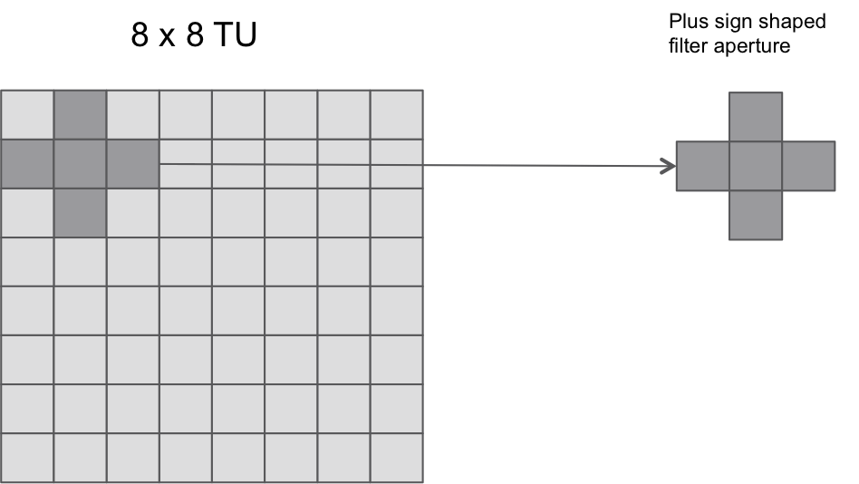
Figure 30: Example of an 8×8 TU block and the filter aperture for the sample located at position (1,1)
The bilateral filter works by basing the filter weights not only on the distance to neighbouring samples but also on their values. A sample located at $(i, j)$, is filtered using its neighbouring sample $(k, l)$. The weight $ω\left(i,j,k,l\right)$ is the weight assigned for sample $(k, l)$ to filter the sample $(i, j)$, and it is defined as
$ω\left(i,j,k,l\right)=e^{\left(- \frac{{\left(i-k\right)}^{2}+{\left(j-l\right)}^{2}}{2σ_{d}^{2}} - \frac{{\left\|I\left(i,j\right)-I\left(k,l\right)\right\|}^{2}}{2σ_{r}^{2}}\right)}$ (36)
Here, $I(i, j )$ and $I(k, l)$ are the original reconstructed intensity value of samples $(i, j)$ and $(k,l)$ respectively.$σ_{d}$ is the spatial parameter, and $σ_{r}$ is the range parameter. The properties (or strength) of the bilateral filter are controlled by these two parameters. Samples located closer to the sample to be filtered, and samples having smaller intensity difference to the sample to be filtered, will have a larger weight than samples further away and with larger intensity difference. In the JEM, $σ_{d}$ is set dependent on the transform unit size and prediction mode, and $σ_{r}$ is set based on the QP used for the current block.
$σ_{d}=0.92-\frac{\min\left(TU block width, TU block height\right)}{40},$ for intra blocks (37)
$σ_{d}= 0.72 – \frac{\min\left(TU block width, TU block height\right)}{40},$ for inter blocks (38)
$σ_{r}=\max\left(\frac{QP-17}{2}, 0.01\right).$ (39)
The different values for $σ_{d}$ means that filter strength for inter prediction blocks is relatively weaker compared to that of intra prediction blocks. Inter predicted blocks typically have less residual than intra predicted blocks and therefore the bilateral filter is designed to filter the reconstruction of inter predicted blocks less.
The output filtered sample value $I_{D}\left(i, j\right)$is calculated as:
$I_{F}\left(i, j\right)= \frac{\sum_{k,l}{I\left(k,l\right)* ω(i,j,k,l)}}{\sum_{k,l}{ω(i,j,k,l)}}$ (40)
Due to the fact that the filter only touches the sample and its 4-neighbours, this equation can be written as
$I_{F}=\frac{I_{C}ω_{C}+I_{L}ω_{L}+I_{R}ω_{R}+I_{A}ω_{A}+I_{B}ω_{B}}{ω_{C}+ω_{L}+ ω_{R}+ ω_{A}+ω_{B}}$ (41)
where $I_{C}$ is the intensity of the center sample, and $I_{L}$, $I_{R}$, $I_{A}$ and $I_{B}$ are the intensities for the left, right, above and below samples, respectively. Likewise, $ω_{C}$ is the weight for the center sample, and $ω_{L}$, $ω_{R}$, $ω_{A}$ and $ω_{B}$ are the corresponding weights for the neighbouring samples. The filter only uses samples within the block for filtering – weights outside are set to 0.
In order to reduce the number of calculations, the bilateral filter in the JEM has been implemented using a look-up-table (LUT). For every QP, there is a one-dimensional LUT for the values $ω_{L}$, $ω_{R}$, $ω_{A}$ and $ω_{B}$ where the value
$ω_{other}=round\left(65*e^{\left(-\frac{1}{2*{0.82}^{2}}-\frac{{\left\|I-I_{c}\right\|}^{2}}{2σ_{r}^{2}}\right)}\right)$ (42)
is stored, where $σ_{r}^{2}$ is calculated from Equation 39 depending upon QP. Since $σ_{d}=0.92-\frac{4}{40}=0.82$ in the LUT, it can be used directly for the intra 4×4 case with a center weight $ω_{C}$ of 65, which represents 1.0. For the other modes, we use the same LUT, but instead use a center weight of
$ω_{C}=round\left(65*\frac{e^{-\frac{1}{2*{0.82}^{2}}}}{e^{-\frac{1}{2*σ_{d}^{2}}}}\right),$ (43)
where $σ_{d}$ is obtained by Equation 37 or 38. The final filtered value is calculated as
$I_{F}=floor\left(\frac{I_{C}ω_{C}+I_{L}ω_{L}+I_{R}ω_{R}+I_{A}ω_{A}+I_{B}ω_{B}+\left(\left(ω_{C}+ω_{L}+ ω_{R}+ ω_{A}+ω_{B}\right)≫1\right)}{ω_{C}+ω_{L}+ ω_{R}+ ω_{A}+ω_{B}}\right)$ (44)
where the division used is integer division and the term $\left(ω_{C}+ω_{L}+ ω_{R}+ ω_{A}+ω_{B}\right)≫1$ is added to get correct rounding.
In the JEM reference software, the division operation in Equation 44 is replaced by LUT, multiplication and shift operations. To reduce the size of the numerator and denominator, Equation 44 is further refined to
${ I}_{F}=I_{C}+\frac{{ω_{L}(I}_{L}-I_{C})+{ω_{R}(I}_{R}-I_{C}) +{ω_{A}(I}_{A}-I_{C})+{ω_{B}(I}_{B}-I_{C})}{ω_{C}+ω_{L}+ ω_{R}+ ω_{A}+ω_{B}}$ (45)
In the JEM reference software, Equation 45 is implemented in a way so that it is bit exact to Equation 44, see [16] for more details on this. Using Equation 44 as is, (i.e., with the division operation) provides the same results as the division-free implementation in the JEM.
The filter is turned off if QP<18 or if the block is of inter type and the block dimensions are 16×16 or larger.

Adaptive loop filter
In the JEM, an adaptive loop filter (ALF) with block-based filter adaption is applied. For the luma component, one among 25 filters is selected for each 2×2 block, based on the direction and activity of local gradients.

Filter shape
In the JEM, up to three diamond filter shapes (as shown in Figure 31) can be selected for the luma component. An index is signalled at the picture level to indicate the filter shape used for the luma component.
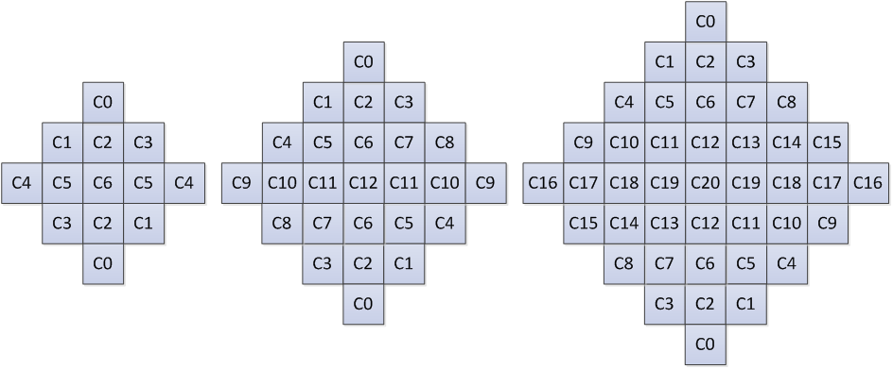
Figure 31: ALF filter shapes (left: 5×5 diamond, middle: 7×7 diamond, right: 9×9 diamond)
For chroma components in a picture, the 5×5 diamond shape is always used.

Block classification
Each $2×2$ block is categorized into one out of 25 classes. The classification index C is derived based on its directionality $D$ and a quantized value of activity $\hat{A}$, as follows:
 | $C=5D+\hat{A}$. | (46)
To calculate $D$ and $\hat{A}$, gradients of the horizontal, vertical and two diagonal direction are first calculated using 1-D Laplacian:
 | $$g_{v}=\sum_{k=i-2}^{i+3}{\sum_{l=j-2}^{j+3}{V_{k,l}}, V_{k,l}=\left|2R\left(k,l\right)-R\left(k,l-1\right)-R\left(k,l+1\right)\right|,}$$ | (47)
 | $$g_{h}=\sum_{k=i-2}^{i+3}{\sum_{l=j-2}^{j+3}{H_{k,l}}, H_{k,l}=\left|2R\left(k,l\right)-R\left(k-1,l\right)-R\left(k+1,l\right)\right|, }$$ | (48)
 | $$g_{d1}=\sum_{k=i-2}^{i+3}{\sum_{l=j-3}^{j+3}{{D1}_{k,l}}, {D1}_{k,l}=\left|2R\left(k,l\right)-R\left(k-1,l-1\right)-R\left(k+1,l+1\right)\right|}$$ | (49)
 | $$g_{d2}=\sum_{k=i-2}^{i+3}{\sum_{j=j-2}^{j+3}{{D2}_{k,l}},} {D2}_{k,l}=\left|2R\left(k,l\right)-R\left(k-1,l+1\right)-R\left(k+1,l-1\right)\right|$$ | (50)
Indices $i$ and $j$ refer to the coordinates of the upper left sample in the $2×2$ block and $R(i,j)$ indicates a reconstructed sample at coordinate $(i,j)$.
Then $D$maximum and minimum values of the gradients of horizontal and vertical directions are set as:
 | $g_{h,v}^{max}=max\left(g_{h},g_{v}\right)$, $g_{h,v}^{min}=min\left(g_{h},g_{v}\right)$, | (51)
and the maximum and minimum values of the gradient of two diagonal directions are set as:
 | $g_{d0,d1}^{max}=max\left(g_{d0},g_{d1}\right)$, $g_{d0,d1}^{min}=min\left(g_{d0},g_{d1}\right)$, | (52)
To derive the value of the directionality $D$, these values are compared against each other and with two thresholds $t_{1}$ and $t_{2}$:
Step 1. If both $g_{h,v}^{max}≤t_{1}∙g_{h,v}^{min}$ and $g_{d0,d1}^{max}≤t_{1}∙ g_{d0,d1}^{min}$ are true, $D$ is set to $0$.
Step 2. If ${g_{h,v}^{max}}/{g_{h,v}^{min}}>{g_{d0,d1}^{max}}/{g_{d0,d1}^{min}}$, continue from Step 3; otherwise continue from Step 4.
Step 3. If $g_{h,v}^{max}>t_{2}∙g_{h,v}^{min}$, $D$ is set to $2$; otherwise $D$ is set to $1$.
Step 4. If $g_{d0,d1}^{max}>t_{2}∙g_{d0,d1}^{min}$, $D$ is set to $4$; otherwise $D$ is set to $3$.
The activity value $A$ is calculated as:
 | $$A=\sum_{k=i-2}^{i+3}{\sum_{l=j-2}^{j+3}{\left(V_{k,l}+H_{k,l}\right).}}$$ | (53)
$A$ is further quantized to the range of 0 to 4, inclusively, and the quantized value is denoted as $\hat{A}$.
For both chroma components in a picture, no classification method is applied, i.e. a single set of ALF coefficients is applied for each chroma component.

Geometric transformations of filter coefficients
Before filtering each 2×2 block, geometric transformations such as rotation or diagonal and vertical flipping are applied to the filter coefficients $f(k, l)$ depending on gradient values calculated for that block. This is equivalent to applying these transformations to the samples in the filter support region. The idea is to make different blocks to which ALF is applied more similar by aligning their directionality.
Three geometric transformations, including diagonal, vertical flip and rotation are introduced:
Diagonal: $f_{D}\left(k,l\right)=f\left(l,k\right),$  Vertical flip: $f_{V}\left(k,l\right)=f\left(k,K-l-1\right)$,  Rotation: $f_{R}\left(k,l\right)=f\left(K-l-1,k\right).$ | (54)
where $K$ is the size of the filter and $0≤k,l≤K-1$ are coefficients coordinates, such that location $\left(0,0\right)$ is at the upper left corner and location $\left(K-1,K-1\right)$ is at the lower right corner. The transformations are applied to the filter coefficients f (k, l) depending on gradient values calculated for that block. The relationship between the transformation and the four gradients of the four directions are summarized in Table 9.
Table 9: Mapping of the gradient calculated for one block and the transformations
Gradient values | Transformation
g_{d2} < g_{d1} and g_{h} < g_{v} | No transformation
g_{d2} < g_{d1} and g_{v} < g_{h} | Diagonal
g_{d1} < g_{d2} and g_{h} < g_{v} | Vertical flip
g_{d1} < g_{d2} and g_{v} < g_{h} | Rotation

Filter parameters signalling
In the JEM, ALF filter parameters are signalled for the first CTU, i.e., after the slice header and before the SAO parameters of the first CTU. Up to 25 sets of luma filter coefficients could be signalled. To reduce bits overhead, filter coefficients of different classification can be merged. Also, the ALF coefficients of reference pictures are stored and allowed to be reused as ALF coefficients of a current picture. The current picture may choose to use ALF coefficients stored for the reference pictures, and bypass the ALF coefficients signalling. In this case, only an index to one of the reference pictures is signalled, and the stored ALF coefficients of the indicated reference picture are inherited for the current picture.
To support ALF temporal prediction, a candidate list of ALF filter sets is maintained. At the beginning of decoding a new sequence, the candidate list is empty. After decoding one picture, the corresponding set of filters may be added to the candidate list. Once the size of the candidate list reaches the maximum allowed value (i.e., 6 in current JEM), a new set of filters overwrites the oldest set in decoding order, and that is, first-in-first-out (FIFO) rule is applied to update the candidate list. To avoid duplications, a set could only be added to the list when the corresponding picture doesn’t use ALF temporal prediction. To support temporal scalability, there are multiple candidate lists of filter sets, and each candidate list is associated with a temporal layer. More specifically, each array assigned by temporal layer index (TempIdx) may compose filter sets of previously decoded pictures with equal to lower TempIdx. For example, the k-th array is assigned to be associated with TempIdx equal to k, and it only contains filter sets from pictures with TempIdx smaller than or equal to k. After coding a certain picture, the filter sets associated with the picture will be used to update those arrays associated with equal or higher TempIdx.
Temporal prediction of ALF coefficients is used for inter coded frames to minimize signalling overhead. For intra frames, temporal prediction is not available, and a set of 16 fixed filters is assigned to each class. To indicate the usage of the fixed filter, a flag for each class is signalled and if required, the index of the chosen fixed filter. Even when the fixed filter is selected for a given class, the coefficients of the adaptive filter $f(k,l)$ can still be sent for this class in which case the coefficients of the filter which will be applied to the reconstructed image are sum of both sets of coefficients.
The filtering process of luma component can controlled at CU level. A flag is signalled to indicate whether ALF is applied to the luma component of a CU. For chroma component, whether ALF is applied or not is indicated at picture level only.

Filtering process
At decoder side, when ALF is enabled for a CU, each sample $R(i,j)$within the CU is filtered, resulting in sample value $R'(i,j)$ as shown below, where L denotes filter length, $f_{m,n}$ represents filter coefficient, and $f(k, l)$ denotes the decoded filter coefficients.
$R'(i,j)=\sum_{k=-L/2}^{L/2}{\sum_{l=-L/2}^{L/2}{f(k, l)×R(i+k,j+l)}}$ (55)

Encoding side filter parameters determination process
Overall encoder decision process for ALF is illustrated in Figure 32. For luma samples of each CU, the encoder makes a decision on whether or not the ALF is applied and the appropriate signalling flag is included in the slice header. For chroma samples, the decision to apply the filter is done based on the picture-level rather than CU-level. Furthermore, chroma ALF for a picture is checked only when luma ALF is enabled for the picture.
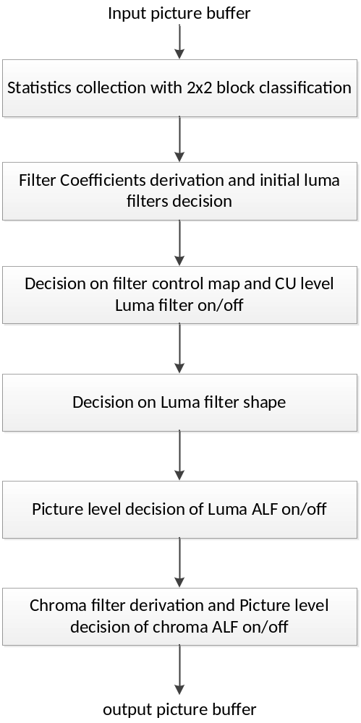
Figure 32: Flow-graph of encoder decision for ALF

Content adaptive clipping
In HEVC, a clipping operation is used to clamp the sample value within a certain range in the various steps of the coding/decoding process. The clipping operation is as follows:
$T_{clip} ={Clip}_{BD}\left(T, bitdepth\right)=Clip3\left( 0 , (1<<bitdepth)-1 , T\right)$ (56)
where $T_{clip}$ is the resulting clipped value, the function $Clip3(min,max,T)$ clips the value $T$ between the bounds $min$ and $max$, and $bitdepth$ corresponds to the internal bit depth used for the current component type. In HEVC, the bounds ($min$ and $max$) are merely determined based on the internal bit depth.
In the JEM, the above regular clipping function is replaced by the following component-wise adaptive clipping:
$T_{clip} = {Clip}_{BD}\left(T, bitdepth,C\right)=Clip3\left( \min_{C}, \max_{C} , T\right)$ (57)
Where:
- $C$ is the component ID (typically Y, Cb or Cr)
- $\min_{C}$ is the lower clipping bound used in current slice for component ID $C$
- $\max_{C}$ is the upper clipping bound used in current slice for component ID $C$
The clipping bounds may change from slice to slice. In every step of the codec where a clipping is performed between 0 and $(\left(1<<bitdepth\right)-1)$, the content adaptive clipping process is used instead.
The clipping bounds are encoded in the slice header without prediction. The clipping uses these clipping bounds in place of the regular clipping bounds, including for pictures stored in the DPB.
To further benefit from the content adaptive clipping mechanism, the encoding process is modified in the JEM. The residual can be modified to take into account the reconstructed signal is likely to be clipped. Practically, for a residual block to transform, quantize and encode, if the corresponding original block contains some samples equal to the clipping bounds, then the residual block undergoes a smoothing process.

CABAC modifications
In the JEM, CABAC contains the following three major changes compared to the design in HEVC:
- Modified context modeling for transform coefficients
- Multi-hypothesis probability estimation with context-dependent updating speed
- Adaptive initialization for context models

Context modeling for transform coefficients
In HEVC, transform coefficients of a coding block are coded using non-overlapped coefficient groups (CGs), and each CG contains the coefficients of a 4×4 block of a coding block. The CGs inside a coding block, and the transform coefficients within a CG, are coded according to pre-defined scan orders. The coding of transform coefficient levels of a CG with at least one non-zero transform coefficient may be separated into multiple scan passes. In the first pass, the first bin (denoted by bin0, also referred as significant_coeff_flag, which indicates the magnitude of the coefficient is larger than 0) is coded. Next, two scan passes for context coding the second/third bins (denoted by bin1 and bin2, respectively, also referred as coeff_abs_greater1_flag and coeff_abs_greater2_flag) may be applied. Finally, two more scan passes for coding the sign information and the remaining values (also referred as coeff_abs_level_remaining) of coefficient levels are invoked, if necessary. Only bins in the first three scan passes are coded in a regular mode and those bins are termed regular bins in the following descriptions.
In the JEM, the context modeling for regular bins is changed. When coding bin i in the i-th scan pass (i being 0, 1, 2), the context index is dependent on the values of the i-th bins of previously coded coefficients in the neighbourhood covered by a local template. More specifically, the context index is determined based on the sum of the i-th bins of neighbouring coefficients. As depicted in Figure 33, the local template contains up to five spatial neighbouring transform coefficients wherein x indicates the position of current transform coefficient and xi (i being 0 to 4) indicates its five neighbours. To capture the characteristics of transform coefficients at different frequencies, one coding block may be split into up to three regions and the splitting method is fixed regardless of the coding block sizes. For example, when coding bin0 of luma transform coefficients, as depicted in Figure 33, one coding block is split into three regions marked with different colours, and the context index assigned to each region is listed. Luma and chroma components are treated in a similar way but with separate sets of context models. Moreover, the context model selection for bin0 (i.e., significant flags) of the luma component is further dependent on transform size. For the coding of the remaining values of coefficient levels, please refer to reference [4] or [6].
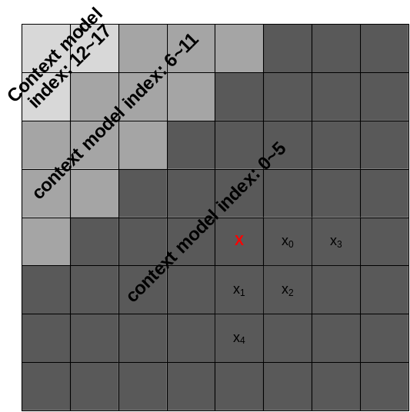
Figure 33: Definition of template used in transform coefficient context modelling

Multi-hypothesis probability estimation
The binary arithmetic coder is applied with a “multi-hypothesis” probability update model based on two probability estimates P₀ and P₁ that are associated with each context model and are updated independently with different adaptation rates as follows:
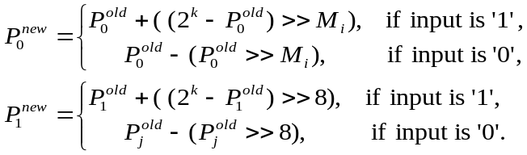 (58)
where 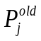 and 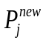 (j=0, 1) represent the probabilities before and after decoding a bin, respectively. The variable M_{i} (being 4, 5, 6, 7) is a parameter which controls the probability updating speed for the context model with index equal to i; and k represents the precision of probabilities (here it is equal to 15). The probability estimate P used for the interval subdivision in the binary arithmetic coder is the average of the estimates from the two hypotheses:
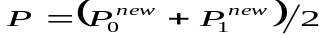 (59)
In the JEM, the value of the parameter M_{i} used in Equation 58 that controls the probability updating speed for each context model is assigned as follows.
At the encoder side, the coded bins associated with each context model are recorded. After one slice is coded, for each context model with index equal to i, the rate costs of using different values of M_{i} (being 4, 5, 6, 7) are calculated and the one that provides the minimum rate cost is selected. For simplicity, this selection process is performed only when a new combination of slice type and slice-level quantization parameter are encountered.
A 1 bit flag is signalled for each context model i to indicate whether M_{i} is different from the default value 4. When the flag is 1, two bits are used to indicate whether M_{i} is equal to 5, 6, or 7.

Initialization for context models
Instead of using fixed tables for context model initialization in HEVC, the initial probability states of context models for inter-coded slices can be initialized by copying states from previously coded pictures. More specifically, after coding a centrally-located CTU of each picture, the probability states of all context models are stored for potential use as the initial states of the corresponding context models on later pictures. In the JEM, the set of initial states for each inter-coded slice is copied from the stored states of a previously coded picture that has the same slice type and the same slice-level QP as the current slice. This lacks loss robustness, but is used in the current JEM scheme for coding efficiency experiment purposes.

Software and common test conditions

Reference software
The main software branch of the JEM is developed on top of the HEVC test model HM software [19]. The reference software for the JEM can be downloaded from the SVN link shown in [20].
The related source code for each added tool is associated with a dedicated macro. The macro name for the tools in the main software branch are provided in Table 10.
Table 10: Macros for the tools in the JEM software
Macro name | Tool
JVET_C0024_QTBT | Quadtree plus binary tree (QTBT) block structure
VCEG_AZ07_INTRA_65ANG_MODES | 65 intra prediction directions
VCEG_AZ07_INTRA_4TAP_FILTER | 4-tap interpolation filter for intra prediction
VCEG_AZ07_INTRA_BOUNDARY_FILTER | Additional boundary filter or intra prediction
COM16_C806_LMCHROMA | Cross-component linear model (CCLM) prediction
COM16_C1046_PDPC_INTRA | Position dependent intra prediction combination
COM16_C806_VCEG_AZ10_SUB_PU_TMVP | Sub-CU level motion vector prediction
JVET_B058_HIGH_PRECISION_MOTION_VECTOR_MC | 1/16 pel motion vector storage accuracy
VCEG_AZ07_IMV | Locally adaptive motion vector resolution (LAMVR)
COM16_C806_OBMC | Overlapped block motion compensation (OBMC)
VCEG_AZ06_IC | Local illumination compensation (LIC)
COM16_C1016_AFFINE | Affine motion prediction
VCEG_AZ07_FRUC_MERGE | Pattern matched motion vector derivation
VCEG_AZ05_BIO | Bi-directional optical flow (BIO)
JVET_E0052_DMVR | Decoder-side motion vector refinement based on bilateral template matching
COM16_C806_EMT | Explicit multiple core transform
COM16_C1044_NSST | Mode dependent non-separable secondary transforms
INTRA_KLT & INTER_KLT | Signal dependent transform (SDT)
ALF_HM3_REFACTOR | Adaptive loop filter (ALF)
JVET_F0096_BILATERAL_FILTER | Bilateral filter
VCEG_AZ07_CTX_RESIDUALCODING | Context modelling for transform coefficient levels
VCEG_AZ07_BAC_ADAPT_WDOW | Multi-hypothesis probability estimation
VCEG_AZ07_INIT_PREVFRAME | Initialization for context models
JVET_D0033_ADAPTIVE_CLIPPING | Content adaptive clipping

References
- High Efficiency Video Coding (HEVC), Rec. ITU-T H.265 and ISO/IEC 23008-2, Jan. 2013.
- G. J. Sullivan, J.-R. Ohm, W.-J. Han, and T. Wiegand, “Overview of the High Efficiency Video Coding (HEVC) Standard”, IEEE Trans. Circuits and Systems for Video Technology, Vol. 22, No. 12, pp. 1649‒1668, Dec. 2012.
- J. Chen, Y. Chen, M. Karczewicz, X. Li, H. Liu, L. Zhang, X. Zhao, “Coding tools investigation for next generation video coding”, ITU-T SG16 Doc. COM16–C806, Feb. 2015.
- M. Karczewicz, J. Chen, W.-J. Chien, X. Li, A. Said, L. Zhang, X. Zhao, “Study of coding efficiency improvements beyond HEVC”, MPEG doc. m37102, Oct. 2015.
- J. An, Y.-W. Chen, K. Zhang, H. Huang, Y.-W. Huang, S. Lei, “Block partitioning structure for next generation video coding”, MPEG doc. m37524 and ITU-T SG16 Doc. COM16–C966, Oct. 2015.
- J. Chen, W.-J. Chien, M. Karczewicz, X. Li, H. Liu, A. Said, L. Zhang, X. Zhao, “Further improvements to HMKTA-1.0”, ITU-T SG16/Q6 Doc. VCEG-AZ07, Jun. 2015.
- E. Alshina, A. Alshin, J.-H. Min, K. Choi, A. Saxena, M. Budagavi, “Known tools performance investigation for next generation video coding”, ITU-T SG16/Q6 Doc. VCEG-AZ05, Jun. 2015.
- K. Choi, E. Alshina, A. Alshin, C. Kim, “Information on coding efficiency improvements over HEVC for 4K content”, MPEG doc. m37043, Oct. 2015.
- A. Said, X. Zhao, J. Chen, M. Karczewicz, W.-J. Chien, F. Zhou, “Position dependent intra prediction combination”, MPEG doc. m37502 and ITU-T SG16 Doc. COM16–C1016, Oct. 2015.

- W.-J. Chien, M. Karczewicz, “Extension of Advanced Temporal Motion Vector Predictor”, ITU-T SG16/Q6 Doc. VCEG-AZ10, Jun. 2015.
- H. Liu, Y. Chen, J. Chen, L. Zhang, M. Karczewicz, “Local Illumination Compensation”, ITU-T SG16/Q6 Doc. VCEG-AZ06, Jun. 2015.
- S. Lin, H. Chen, H. Zhang, S. Maxim, H. Yang, J. Zhou, “Affine transform prediction for next generation video coding”, MPEG doc. m37525 and ITU-T SG16 Doc. COM16–C1016, Oct. 2015.
- X. Zhao, J. Chen, M. Karczewicz, “Mode-dependent non-separable secondary transform”, ITU-T SG16/Q6 Doc. COM16–C1044, Oct. 2015.
- X. Chen, J. An, J. Zheng, “EE3: Decoder-Side Motion Vector Refinement Based on Bilateral Template Matching”, Joint Video Exploration Team of ITU-T SG16 WP3 and ISO/IEC JTC1/SC29/WG11, JVET-E0052, 5th Meeting, Jan. 2017.
- C. Lan, J. Xu and F. Wu, “Enhancement of HEVC using Signal Dependent Transform (SDT)”, MPEG doc. m37503, Oct. 2015 and ITU-T SG16/Q6 Doc. VCEG-AZ08, Jun. 2015.
- J. Ström, K. Andersson, P. Wennersten, M. Pettersson, J. Enhorn, R. Sjöberg, “EE2-JVET related: Division-free bilateral filter”, Joint Video Exploration Team of ITU-T SG16 WP3 and ISO/IEC JTC1/SC29/WG11, JVET-F0096, 6th Meeting, Apr. 2017.
- F. Galpin, P. Bordes, F. Leleannec, E. François, “EE7: Adaptive Clipping in JEM3.0”, Joint Video Exploration Team of ITU-T SG16 WP3 and ISO/IEC JTC1/SC29/WG11, JVET-D0033 4th Meeting, Apr. 2017.
- C. Rosewarne, B. Bross, M. Naccari, K. Sharman, G. J. Sullivan, “High Efficiency Video Coding (HEVC) Test Model 16 (HM 16) Encoder Description Update 9”, Joint Collaborative Team of ITU-T SG16 WP3 and ISO/IEC JTC1/SC29/WG11 on Video Coding, JCTVC-AB1002, 28th Meeting, Jul. 2017.
- HEVC reference software, https://hevc.hhi.fraunhofer.de/svn/svn_HEVCSoftware/.
- JEM reference software, https://jvet.hhi.fraunhofer.de/svn/svn_HMJEMSoftware/.

