    Joint Video Exploration Team (JVET)  of ITU-T SG 16 WP 3 and ISO/IEC JTC 1/SC 29/WG 11  7th Meeting: Torino, IT, 13–21 July 2017 | Document: JVET-G0097

Title: | EE4: ERP/EAP-based segmented sphere projection with different padding sizes
Status: | Input Document to JVET
Purpose: | Proposal
Author(s) or  Contact(s): | Ya-Hsuan Lee, HungChih Lin, Jian-Liang Lin, Shen-Kai Chang, Chi-Cheng Ju  No. 1, Dusing Rd. 1, Hsinchu Science Park, Hsinchu, Taiwan 30078 | Tel:  Email: | Jian-Liang Lin  +886-3-5670766 ext. 25250  {louise.lee, hungchih.lin, jl.lin, shenkai.chang, cc.ju} @mediatek.com
Source: | MediaTek Inc.
_____________________________

Abstract
This contribution reports the experimental results of test 1-7 in EE4, including the segmented sphere projection (SSP) using EAP or ERP on the equatorial segment with different padding sizes. As compared to the ERP, the simulation results reportedly demonstrate that, in terms of end-to-end S-PSNR-I, the EAP-based SSP achieves 9.8%, 10.6%, 10.6% and 10.3% BD-rate reduction when the padding sizes are 0, 8, 16, and 32 pixels, respectively, while the ERP-based SSP has 9.3%, 10.2%, 10.1%, and 9.8% BD-rate reduction when the padding sizes are 0, 8, 16, and 32 pixels, respectively. Furthermore, videos of the decoded evil viewports are also provided for the quality comparison of the visual artifact among different padding sizes.

Introduction
The projection layout of SSP [1] has three segments, including one equatorial segment and two pole segments. In the original SSP [1], visual artifact could be observed when the viewport contains the area of ±45° latitude. This visual artifact is mainly resulted from the coding error at the boundary of these three segments and the non-active (grey) pixels. In the last meeting, we proposed an EAP-based SSP with padding [2] to noticeably reduce the visual artifact; moreover, better quality consistency can be reached and the BD-rate performance are also improved. As recommended by the JVET committee in last meeting, seven test settings as listed in Table I are conducted to further investigate the BD-rate performance between the ERP-based and EAP-based projection on the equatorial segment and the effect of different padding sizes on visual artifact.
Table I. Test settings in EE4
# | Test
1 | EAP-based SSP (with padding size = 0)
2 | EAP-based SSP with padding size = 8
3 | EAP-based SSP with padding size = 16
4 | EAP-based SSP with padding size = 32
5 | ERP-based SSP with padding size = 8
6 | ERP-based SSP with padding size = 16
7 | ERP-based SSP with padding size = 32

Segmented Sphere Projection with Padding
In Fig. 1, the padding process is applied on the boundary of the two pole segments and the non-active pixels, and the boundary between the pole segment and the equatorial segment. In addition, the distance of these two pole segments and the distance of the south and equatorial segments are both fixed to be 16 pixels. When the padding size of each pole segment is larger than 8 pixels, pixels in the overlapped region are filled with the padding value of the nearest segment. Fig. 2 shows the example images of the padding result between the north pole and the south pole segments and the padding result between the south pole and the equatorial segments, both of which have a padding size of 32 pixels.
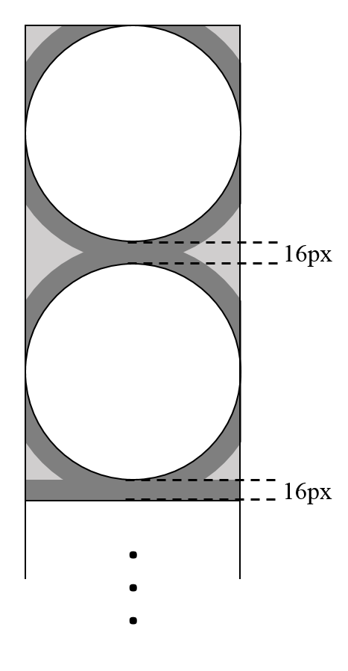
Fig.1 Padding on SSP projection
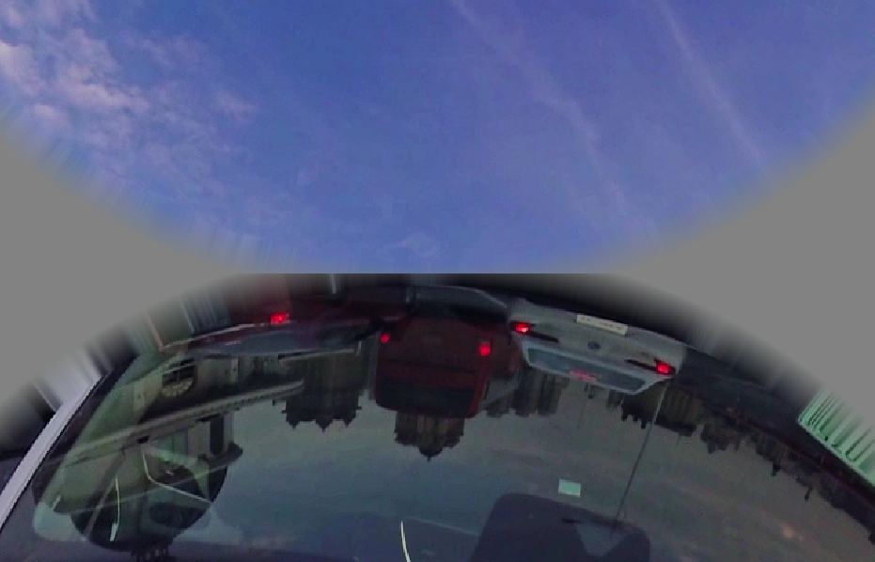 |  | 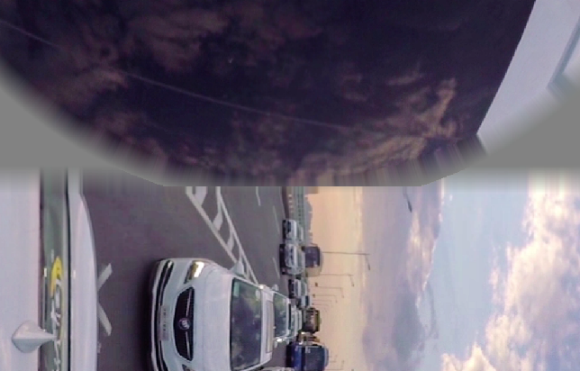
(a) |  | (b)
Fig. 2 Padding size of 32 pixels (a) The north pole and the south pole segments (b) The south pole and the equatorial segments

Experimental Results
The experiments on these seven tests of the EE4 are conducted on the 360Lib-3.0 [3] and the HM-16.15 [4] followed by the JVET common test conditions and evaluation procedures for 360° video [5]. The face and frame sizes for the SSP layout are also listed in Table II. As compared to the ERP, Table III demonstrates the average BD-rate reduction on Y component over the ten test sequences with various quality metrics.

Table II. Frame size of the ERP-based and EAP-based SSP formats
 |  | Face Width | Face Height | Width | Height | Ratio vs. ERP coded
SSP w/o padding [1] | 8K | 1184 | 1184 | 1184 | 7104 | 100.3%
SSP w/o padding [1] | 4K | 960 | 960 | 960 | 5760 | 99.9%
SSP with padding | 8K | 1184 | 1184 | 1184 | 7136 | 100.7%
SSP with padding | 4K | 960 | 960 | 960 | 5792 | 100.4%
Table III. BD-rate performance
EE4 settings | EAP-based SSP |  |  |  | ERP-based SSP
EE4 settings | Test1 | Test2 | Test3 | Test4 | SSP[1] | Test5 | Test6 | Test7
Padding Size (in pixels) | 0 | 8 | 16 | 32 | 0 | 8 | 16 | 32
End to End S-PSNR-I | -9.8% | -10.6% | -10.6% | -10.3% | -9.3% | -10.2% | -10.1% | -9.8%
End to End S-PSNR-NN | -10.0% | -10.8% | -10.8% | -10.5% | -9.6% | -10.5% | -10.4% | -10.1%
End to End CPP-PSNR | -9.8% | -10.7% | -10.7% | -10.4% | -9.3% | -10.3% | -10.2% | -9.9%
End to End WS-PSNR | -10.0% | -10.9% | -10.8% | -10.6% | -9.7% | -10.6% | -10.5% | -10.2%

Subjective Quality Testing
In this section, the evil viewports [6][7] are provided for the quality comparison of the visual artifact. As shown in Fig. 3, the SSP layout has two evil viewports that encounter the most number of discontinuous edges at layout boundary and within the layout. These two evil viewports are indicated by two vertexes on the SSP layout, which are (yaw, pitch) = (-180°, 45°) and (90°, -45°), as their centers. Furthermore, each vertex has two static viewports for the five selected sequences (SkateboardInLot, ChairLift, KiteFlite, Harbor, and Trolley), listed in Table IV. Accordingly, for each sequence, there are four decoded evil viewports for subjective quality comparison: (1) static viewport 1 centered at vertex 1, (2) static viewport 1 centered at vertex 2, (3) static viewport 2 centered at vertex 1, and (4) static viewport 2 centered at vertex 2. In Table V, the four decoded evil viewports for the sequence “Chairlift” are demonstrated for the quality comparison of the EAP-based SSP with and without padding. Moreover, the illustrated viewport frames are coded under a constant QP setting of 37.
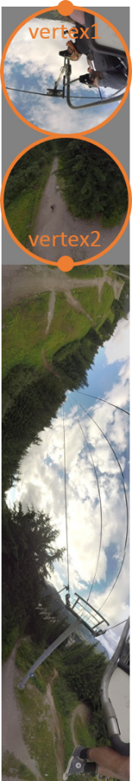
Fig. 3 Two vertexes of the SSP layout
Table IV. Static viewport center of evil viewports for each sequence
Sequence | Viewport size | Static viewport 1  (yaw, pitch)  (in degrees) | Static viewport 2  (yaw, pitch)  (in degrees)
SkateboardInLot | 1816×1816 | −225, 20 | −20, 10
ChairLift | 1816×1816 | 0, 0 | −156, −58
KiteFlite | 1816×1816 | −69, −38 | 58, −26
Harbor | 1816×1816 | −38, −41 | −95, 27
Trolley | 1816×1816 | 255, −3 | 75, −29

Table V. Four decoded evil viewports with QP = 37 comparing EAP-based SSP without padding and with a padding size of 32 pixels
 | without padding | with a padding size of 32 pixels
Static viewport 1 centered at Vertex 1 | 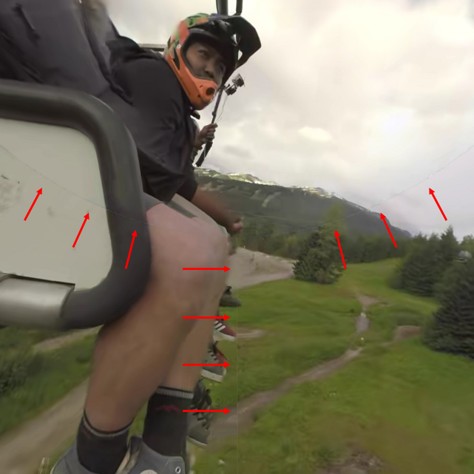 | 
Static viewport 1 centered at Vertex 2 | 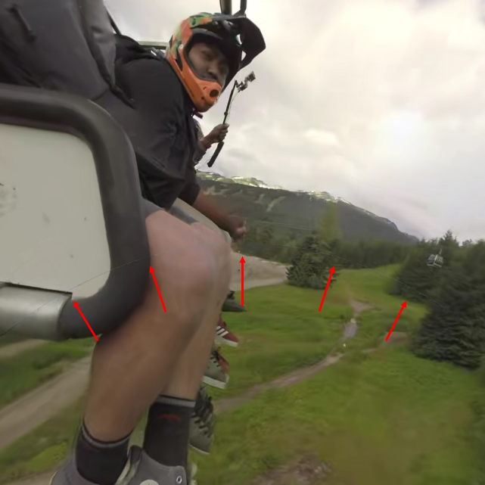 | 
Static viewport 2 centered at Vertex 1 | 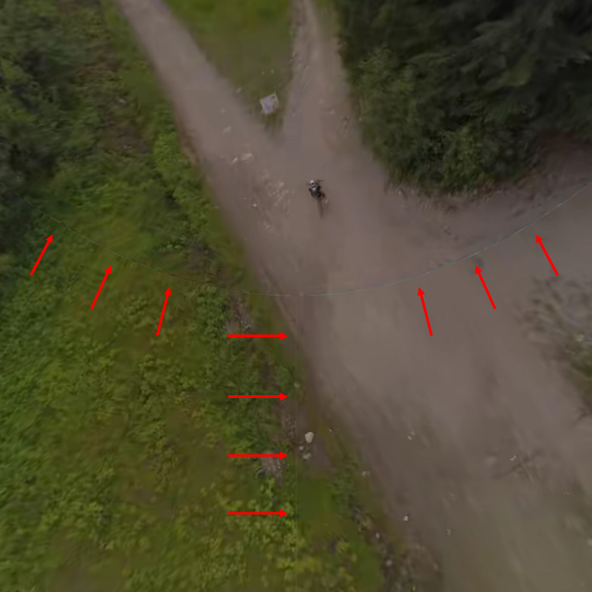 | 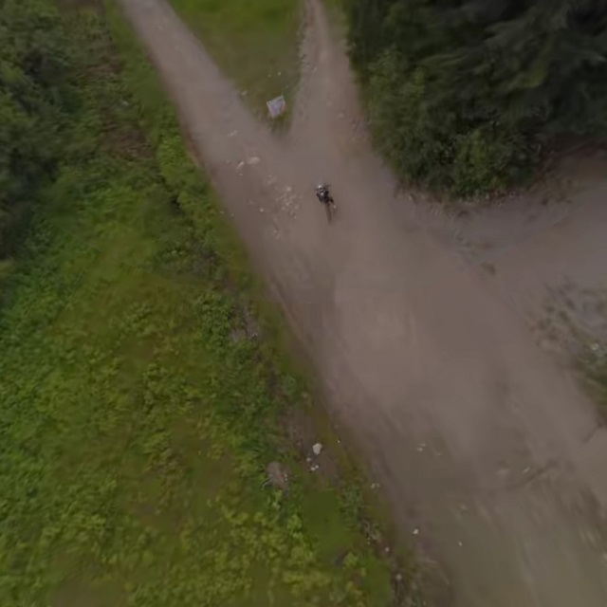
Static viewport 2 centered at Vertex 2 | 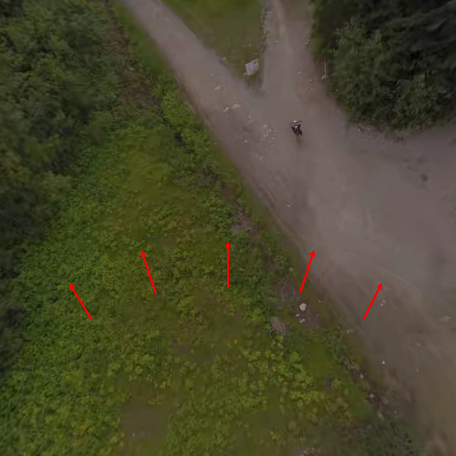 | 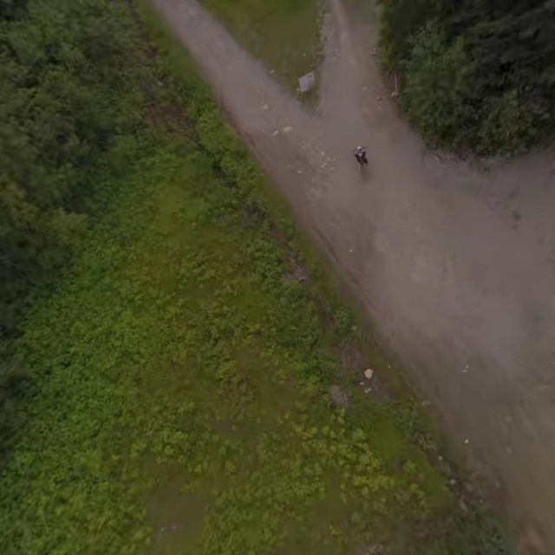

Conclusion
In this contribution, test 1-7 in EE4 thoroughly investigate the BD-rate performance of the ERP-based and the EAP-based SSP with the padding sizes of 0, 8, 16, and 32 pixels. The experimental data report that the EAP-based SSP has higher BD-rate reduction as compared to the ERP-based SSP. In addition, the visual artifact could be significantly reduced by pixel padding at the boundary of these three segments and the non-active pixels.

References
- C. Zhang, Y. Lu, J. Li, and Z. Wen, “AHG8: Segmented Sphere Projection for 360-degree video,” Joint Video Exploration Team of ITU-T SG16 WP3 and ISO/IEC JTC1/SC29/WG11, JVET-E0025, Jan. 2017
- Y.-H. Lee, J.-L. Lin, S.-K. Chang, and C.-C. Ju, “AHG 8: EAP-based segmented sphere projection with padding,” Joint Video Exploration Team of ITU-T SG16 WP3 and ISO/IEC JTC1/SC29/WG11, JVET-F0052, Mar. 2017
- 360Lib, https://jvet.hhi.fraunhofer.de/svn/svn_360Lib/
- HM reference software, https://hevc.hhi.fraunhofer.de/svn/svn_HEVCSoftware/
- J. Boyce, E. Alshina, A. Abbas, and Y. Ye, “JVET common test conditions and evaluation procedures for 360° video,” Joint Video Exploration Team of ITU-T SG16 WP3 and ISO/IEC JTC1/SC29/WG11, JVET-F1030, Mar. 2017
- Z. Deng, L. Xu, and J. Boyce, “AHG8: Subjective test pilot study of 360º video projection/packing formats,” Joint Video Exploration Team of ITU-T SG16 WP3 and ISO/IEC JTC1/SC29/WG11, JVET-F0083, Mar. 2017
- J. Boyce, E. Alshina, and D. Zeng, “Subjective testing method for comparison of 360 video projection formats using HEVC,” Joint Video Exploration Team of ITU-T SG16 WP3 and ISO/IEC JTC1/SC29/WG11, JVET-F1004, Mar. 2017

Patent rights declaration(s)
MediaTek Inc. may have current or pending patent rights relating to the technology described in this contribution and, conditioned on reciprocity, is prepared to grant licenses under reasonable and non-discriminatory terms as necessary for implementation of the resulting ITU-T Recommendation | ISO/IEC International Standard (per box 2 of the ITU-T/ITU-R/ISO/IEC patent statement and licensing declaration form).

