    Joint Video Exploration Team (JVET)  of ITU-T SG 16 WP 3 and ISO/IEC JTC 1/SC 29/WG 11  7th Meeting: Torino, IT, 13–21 July 2017 | Document: JVET-G0088

Title: | AHG8: On the derivation of weighted to spherically uniform PSNR (WS-PSNR) for adjusted cubemap projection (ACP) format
Status: | Input document to JVET
Purpose: | Proposal
Author(s) or  Contact(s): | Xiaoyu Xiu, Yuwen He, Yan Ye  9710 Scranton Rd, #250  San Diego, CA 92121, USA | Tel:  Email: | + 1-858-210-4830  Xiaoyu.Xiu@InterDigital.com  Yuwen.He@InterDigital.com  Yan.Ye@InterDigital.com
Source: | InterDigital Communications Inc.
_____________________________

Abstract
This contribution presents one modified derivation method of weighted to spherically uniform PSNR (WS-PSNR) for the adjusted cubemap projection (ACP) format in the 360Lib-3.0. Based on the concept of the ACP (i.e., adjusting the sample coordinates in a cubemap face), the proposed method calculates the WS-PSNR weight of each sample in one ACP face by firstly deriving the weight value of its correspondence sample in the cubemap face and then adjusting the weight value according to the relationship between the sample coordinates in the cubemap face and the ACP face. It is asserted that compared to the existing WS-PSNR calculation method for the ACP in 360Lib-3.0, the proposed method can more accurately reflect the true spherical sampling characteristics of the ACP. Simulation results also show that the WS-PSNR values reported by the proposed method are more consistent with the S-PSNR-NN.

Introduction
In Hobart, the adjusted cubemap projection (ACP) was proposed [1] and adopted as one representation format of 360-degree video in the current 360Lib-3.0 [2]. In general, the ACP format follows the same face definition of the cubemap projection (CMP) format, but improves the spherical sampling uniformity by adjusting sample coordinates in one cubemap face before it is generated. For 2D-to-3D conversion, given one sample coordinate (u’, v’) in one ACP face, the coordinate of its corresponding sample, i.e., (u, v), in the cubemap face is calculated as
$$u=f\left(u'\right)=sgn\left(u'\right)∙\frac{0.34-\sqrt{{0.34}^{2}-0.09∙\left|u'\right|}}{0.18}$$ | (1)
$$v=f\left(v'\right)=sgn\left(v'\right)∙\frac{0.34-\sqrt{{0.34}^{2}-0.09∙\left|v'\right|}}{0.18}$$ | (2)
where both (u’, v’) and (u, v) are the normalized coordinates which are defined within [-1, 1]. For 3D-to-2D conversion, the inverse functions of (1) and (2) are applied, which are defined as
$$u'=g\left(u\right)=sgn\left(u\right)∙\left(-0.36∙u^{2}+1.36∙\left|u\right|\right)$$ | (3)
$$v'=g\left(v\right)=sgn\left(v\right)∙\left(-0.36∙v^{2}+1.36∙\left|v\right|\right)$$ | (4)
In the current 360Lib-3.0 [2], one weight calculation method is applied to derive the WS-PSNR for the ACP format. Specifically, for one position (x’, y’) in one ACP face, its WS-PSNR weight value $w_{(x^{'},y^{'})}^{acp}$ is calculated as follows:
$$w_{(x^{'},y^{'})}^{acp}=\frac{{\left(t_{x^{'}}^{2}+t_{y^{'}}^{2}+1\right)}^{-3/2}}{\sqrt{\left({1.36}^{2}-1.44*t_{x^{'}}\right)*\left({1.36}^{2}-1.44*t_{y^{'}}\right)}}$$ | (5)
where $t_{x^{'}}$ and $t_{y^{'}}$ are computed based on (x’, y’) as
$$t_{x^{'}}=\frac{0.34-\sqrt{{0.34}^{2}-0.09*\left|2(x^{'}+0.5)/W-1\right|}}{0.18}$$ | (6)
$$t_{y^{'}}=\frac{0.34-\sqrt{{0.34}^{2}-0.09*\left|2(y^{'}+0.5)/H-1\right|}}{0.18}$$ | (7)
where W and H are the width and the height of the ACP face. It should be mentioned that in (5) to (7), (x’, y’) is the digitized ACP coordinates, i.e., $0≤x^{'}<W$, $0≤y^{'}<H$. However, it is unclear how equations (5) to (7) were derived.

The proposal
In this proposal, it is proposed to modify the derivation method of the weight values for the WS-PSNR calculation of the ACP format. To calculate the weight of each sample in one ACP face, the proposed method starts with using the weight value of its corresponding sample in the cubemap face, then adjusting the weight value based on the transform functions between the coordinates in the cubemap face and the ACP face. Specifically, it is assumed (x’, y’) and (x, y) are two corresponding coordinates in the ACP face and the cubemap face, respectively. Given that the weight used for each sample in the WS-PSNR calculation is proportional to the corresponding area that the sample covers on the sphere [3], it can be achieved that
$${Area}_{sphere}=w_{(x^{'},y^{'})}^{acp}∙\left|dx^{'}\right|\left|dy^{'}\right|=w_{\left(x, y\right)}^{cube}∙\left|dx\right|\left|dy\right|$$ | (8)
This further leads to
$$w_{(x^{'},y^{'})}^{acp}=w_{\left(x, y\right)}^{cube}∙\left|\frac{dx}{dx^{'}}\right|∙\left|\frac{dy}{dy^{'}}\right|$$ | (9)
where $w_{\left(x, y\right)}^{cube}$ is the weight value at the coordinate (x, y) in the cubemap face, which can be derived according to [3] as
$$w_{\left(x, y\right)}^{cube}=\frac{1}{{\left\{1+4∙\left[{\left((x+\frac{1}{2}-\frac{W}{2})/W\right)}^{2}+{\left((y+\frac{1}{2}-\frac{H}{2})/H\right)}^{2}\right]\right\}}^{\frac{3}{2}}}$$ | (10)
Additionally, based on the mapping functions as shown in (1) and (2), dx and dy can be computed with respective to dx’ and dy’ as
$$\frac{dx}{dx^{'}}=\frac{1}{4∙\sqrt{{0.34}^{2}-0.09∙\left|2(x^{'}+0.5)/W-1\right|}}$$ | (11)
$$\frac{dy}{dy^{'}}=\frac{1}{4∙\sqrt{{0.34}^{2}-0.09∙\left|2(y^{'}+0.5)/H-1\right|}}$$ | (12)
By substituting (10), (11) and (12) into (9), $w_{(x^{'},y^{'})}^{acp}$ can be derived as
$$w_{(x^{'},y^{'})}^{acp}=\frac{1}{{\left\{1+4∙\left[{\left((x+\frac{1}{2}-\frac{W}{2})/W\right)}^{2}+{\left((y+\frac{1}{2}-\frac{H}{2})/H\right)}^{2}\right]\right\}}^{\frac{3}{2}}}∙\frac{1}{16∙\sqrt{{0.34}^{2}-0.09∙\left|2(x^{'}+0.5)/W-1\right|}∙\sqrt{{0.34}^{2}-0.09∙\left|2(y^{'}+0.5)/H-1\right|}}$$ | (13)

Simulation results
The proposed method is incorporated into the WS-PSNR calculation for the ACP in the current reference software 360Lib-3.0 [4]. The codec-based WS-PSNR values of the ACP format, which are calculated based on both the existing weight calculation and the proposed weight calculation, are compared with the S-PSNR-NN. The reason why the SPSNR-NN is selected as the “ground-truth” is because the WS-PSNR and the SPSNR-NN should converge to the same value when all the samples in the projection picture are considered. All the simulations are performed based on the JEM-6.0 based 360Lib-3.0 and follow the common test conditions (CTCs) [5]. Additionally, besides the default S-PSNR-NN value (which is calculated based 655352 spherical positions), the SPSNR-NN values that are calculated using the increased number of spherical sampling positions [6] are also used for a better comparison.
Table 1 compares the WS-PSNR values (computed by the existing and the proposed methods) and the S-PSNR-NN values using 655362 spherical positons, 4 million spherical positions and 8 million spherical positions. The comparison is conducted by averaging different quality metrics for all ten CTC sequence, for only six 8K sequences, and for only four 4K sequences. As shown in Table 1, the WS-PSNR values calculated by the proposed method are more consistent with the S-PSNR-NN than the existing method. For example, when only 655362 spherical positions are used for the S-PSNR-NN calculation, the difference between the proposed WS-PSNR and the S-PSNR-NN is 0.0049dB while it becomes 0.021dB for the existing WS-PSNR calculation method. Additionally, such difference could completely disappear for the proposed method when 8M spherical positions are used to calculate the S-PSNR-NN. In contrast, for the existing WS-PSNR calculation method, the difference between the WS-PSNR and the S-PSNR-NN cannot be further reduced when the number of spherical positions is further increased. Figure 1 shows the frame-by-frame comparison of the absolute difference between the WS-PSNR values and the S-PSNR-NN values using 8M spherical positions when the existing and the proposed methods are used for calculating the WS-PSNR for the ACP. As shown in Figure 1, similar observation can also be achieved for the frame-by-frame comparison, i.e., compared to the existing WS-PSNR calculation method for the ACP, the proposed method can more closely match with the S-PSNR-NN for each individual frame. Figure 2 compares the weight values derived for one ACP face by the existing method and the proposed method, where the proposed method represents a more uniform distribution of the weight values inside one ACP face.
Table 1 The comparison of the existing WS-PSNR, the proposed WS-PSNR, the S-PSNR-NN using 655362, 4M and 8M spherical sampling positions, for the ACP
Quality metric | Overall |  |  | 8K |  |  | 4K
Quality metric | Y | U | V | Y | U | V | Y | U | V
WS-PSNR (existing) | 39.3077 | 47.0260 | 47.3860 | 40.0309 | 48.6676 | 49.1740 | 38.2228 | 44.5637 | 44.7041
WS-PSNR (proposed) | 39.3240 | 47.0404 | 47.3986 | 40.0464 | 48.6828 | 49.1871 | 38.2403 | 44.5769 | 44.7158
S-PSNR-NN (default) | 39.3289 | 47.0397 | 47.3985 | 40.0573 | 48.6846 | 49.1873 | 38.2361 | 44.5724 | 44.7152
S-PSNR-NN (4M) | 39.3249 | 47.0419 | 47.3994 | 40.0468 | 48.6846 | 49.1887 | 38.2421 | 44.5779 | 44.7154
S-PSNR-NN (8M) | 39.3240 | 47.0406 | 47.3983 | 40.0466 | 48.6822 | 49.1865 | 38.2402 | 44.5782 | 44.7159
Delta between WS-PSNR (existing) and S-PSNR-NN (8M) | -0.0163 | -0.0146 | -0.0122 | -0.0156 | -0.0146 | -0.0125 | -0.0174 | -0.0144 | -0.0118
Delta between WS-PSNR (proposed) and S-PSNR-NN (8M) | 0.0000 | -0.0001 | 0.0003 | -0.0001 | 0.0006 | 0.0006 | 0.0001 | -0.0012 | -0.0002

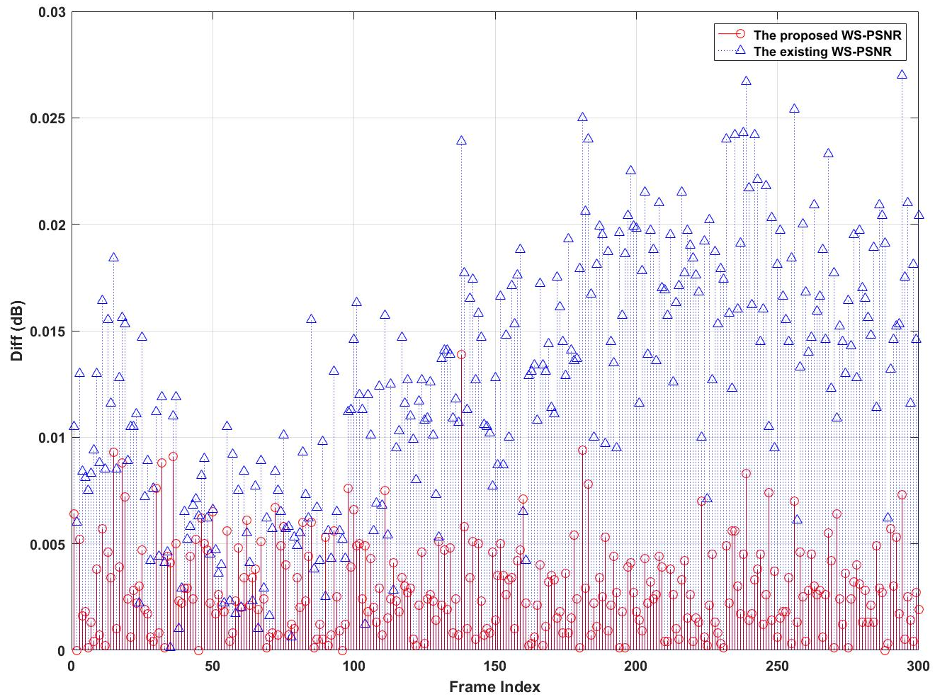
Figure 1 The frame-by-frame difference between the WS-PSNR values calculated by the existing and proposed methods and the S-PSNR-NN values using 8M spherical sampling positions, for the sequence DrivingIncountry at QP 22.

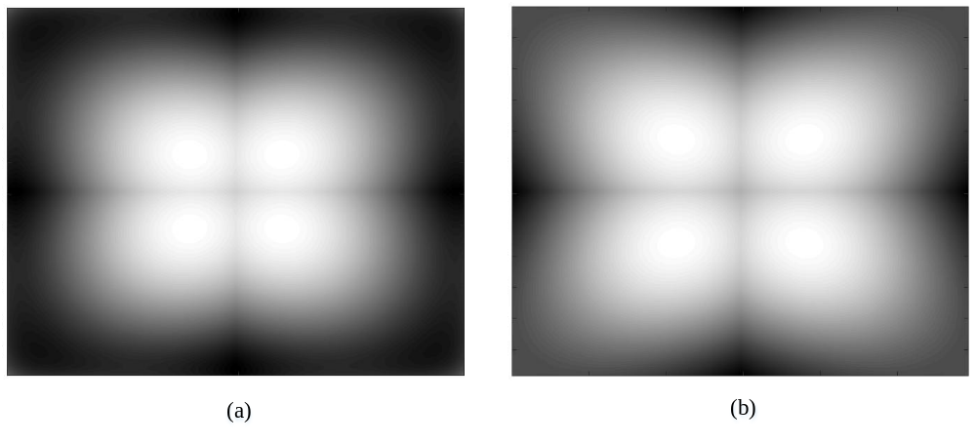
Figure 2 The WS-PSNR weight values derived by (a) the existing weight calculation method in [2] and (b) the proposed weight calculation method

References
- M. Coban, G. Van der Auwera, M. Karczewicz, “AHG8: adjusted cubemap projection for 360-degree video”, JVET-F0025, Mar. 2017, Hobart, AU.
- Y. Ye, E. Alshina, J. Boyce, “Algorithm descriptions of projection format conversion and video quality metrics in 360Lib”, JVET-F1003, Mar. 2017, Hobart, AU.
- Y. Sun, A. Lu, L. Yu, “AHG8: WS-PSNR for 360 video objective quality evaluation”, JVET-D0040, Oct. 2016, Chengdu, China.
- 360Lib-3.0: https://jvet.hhi.fraunhofer.de/svn/svn_360Lib/tags/360Lib-3.0/
- E. Alshina, J. Boyce, A. Abbas, Y. Ye, “JVET common test conditions and evaluation procedures for 360 video”, JVET-F1030, Mar. 2017, Hobart, AU.
- Y. Ye, Y. He, “On reliability of S-PSNR-NN and S-PSNR-I as quality metrics for 360-degree video”, JVET-G0075, July 2017, Torino, Italy.

Patent rights declaration(s)
InterDigital Communications Inc. may have current or pending patent rights relating to the technology described in this contribution and, conditioned on reciprocity, is prepared to grant licenses under reasonable and non-discriminatory terms as necessary for implementation of the resulting ITU-T Recommendation | ISO/IEC International Standard (per box 2 of the ITU-T/ITU-R/ISO/IEC patent statement and licensing declaration form).

