    Joint Video Exploration Team (JVET)  of ITU-T SG 16 WP 3 and ISO/IEC JTC 1/SC 29/WG 11  7th Meeting: Torino, IT, 13–21 July 2017 | Document: JVET-G0076_r1

Title: | Bilateral filter simplification
Status: | Input document to JVET
Purpose: | Proposal
Author(s) or  Contact(s): | Rahul Vanam, Yuwen He, and Yan Ye  9710 Scranton road, suite 250,  San Diego, CA 92121, USA | Tel:  Email: | +1-858-210-4800  rahul.vanam@interdigital.com  yuwen.he@interdigital.com  yan.ye@interdigital.com
Source: | InterDigital Communications, Inc.
_____________________________

Abstract
A division-free bilateral filter was adopted in the JEM-6.0 reference software during the Hobart meeting. In this proposal, a scheme is presented to simplify this bilateral filter. The proposed scheme by-passes the bilateral filtering on a reconstructed block when its associated inverse quantized transform coefficients are zeros except for the DC coefficient. It is reported that this simplification yields an average decoding speed-up of 1% for AI, with negligible luma BD rate increase of up to 0.03% across all configurations.

Introduction
In JVET-F0096, a division-free bilateral filter was proposed for filtering reconstructed luma samples for reducing the quantization noise [2]. The filter is applicable to all intra/inter reconstructed luma blocks that satisfy certain conditions, and therefore it does not require to signal the filtering decision in the bitstream. The weight of the bilateral filter for the sample at position $(k,l)$ when filtering a sample at $(i,j)$ is defined as
$\text{ω}\text{(i, j, k, l)}=e^{\left(- \frac{{\left(i-k\right)}^{2} + {\left(j-l\right)}^{2}}{2σ_{d}^{2}} – \frac{{\left\|{\tilde{x}}_{ij}– {\tilde{x}}_{kl}\right\|}^{2}}{2σ_{r}^{2}}\right)}$, (1)
where ${\tilde{x}}_{ij}$ and ${\tilde{x}}_{kl}$ are the reconstructed samples at $(i,j)$ and $(k,l)$, respectively, $σ_{d}$ is the spatial parameter, and $σ_{r}$ is the range parameter.

The proposed bilateral filter simplification
When the inversed quantized transform coefficients have only one non-zero coefficient at the DC position, the associated residual samples ${\hat{r}}_{ij}$ are constant, i.e., ${\hat{r}}_{ij}=K$. Therefore, the difference in reconstructed samples in Equation (1) can be simplified as follows:
xij- xkl=pij+rij-(pkl+rkl) =pij+K-(pkl+K) =pij-pkl., (2)
where $p_{ij}$ is the prediction sample at $\left(i,j\right).$ This is similar to the case when the Cbf is zero, where $K$ is equal to zero in Equation (2). In JEM-6.0, bilateral filtering is skipped when Cbf is zero [1]. Since the filter coefficients under the new condition would be identical to the filter coefficients when Cbf is zero, if the filter were to be used, we skip bilateral filtering under the new condition.
We next describe our approach for simplifying the bilateral filter for intra- and inter-coded blocks.

Intra-coded blocks
In intra coding, the bilateral filter is applied to a reconstructed block only when the following set of conditions are all satisfied [1], as illustrated in Figure 1(a):
- Color component is luma;
- Cbf flag is not equal to zero;
- QP > 17.
In the proposed approach, we include an additional condition to the above list, as illustrated in Figure 1(b). The inverse quantized primary transform coefficients of one CU are examined to see if they contain only one non-zero coefficient that is at the DC frequency position, and the result of this condition is indicated by the variable “only_non_zero_DC” in Figure 1(b). If this condition is true, then bilateral filtering is skipped for the CU, as shown in Figure 1(b).
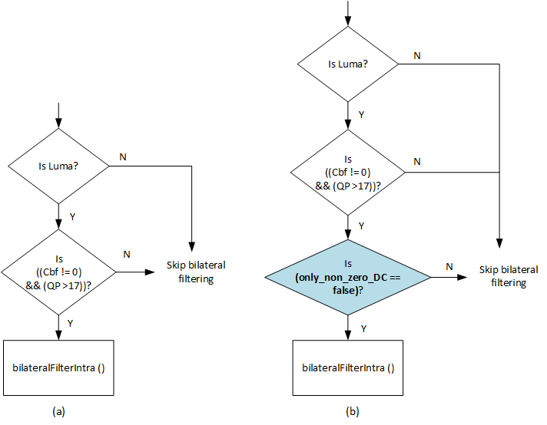
Figure 1. (a) Conditions that need to be satisfied to apply the bilateral filter for intra-coded blocks in JEM-6.0. (b) Conditions for the proposed approach, where the change is highlighted.

Inter-coded blocks
In inter coding, the bilateral filter is applied to a reconstructed block only when the following set of conditions are satisfied [1], as illustrated in Figure 2(a):
- Color component is luma;
- Cbf flag is not equal to zero;
- QP > 17;
- Minimum of CU width and height is less than 16.
In the proposed approach, an additional condition is added, as illustrated in Figure 2(b). The inverse quantized transform coefficients are examined to see if they contain only one non-zero DC coefficient and remaining zero coefficients, and the result of this condition is indicated by the variable “only_non_zero_DC”. If this condition is true, bilateral filtering is skipped.
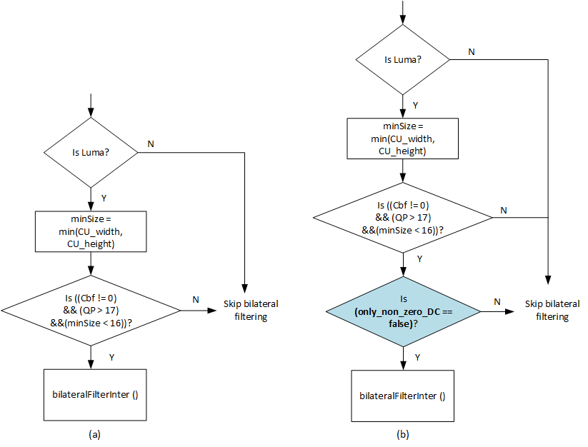
Figure 2. (a) Conditions that need to be satisfied to apply the bilateral filter for inter-coded blocks in JEM-6.0. (b) Conditions for the proposed approach, where the change is highlighted.

Experimental results
The proposed simplification is applied to the HM-16.6-JEM-6.0 software. The unmodified HM-16.6-JEM-6.0 is used as the anchor for comparing the proposed approach. Tests are conducted as specified by the CTC [3], and results are summarized in Tables 1, 2, 3, and 4. The accompanying Excel sheets contain detailed results.

Table 1. AI results compared to JEM-6.0 anchor.
 | Over HM-16.6-JEM-6.0 (parallel)
 | Y | U | V | EncT | DecT
Class A1 | 0.00% | -0.01% | 0.02% | 99% | 99%
Class A2 | 0.04% | 0.11% | 0.00% | 99% | 99%
Class B | 0.03% | -0.02% | -0.04% | 100% | 100%
Class C | 0.05% | 0.05% | 0.05% | 100% | 99%
Class D | 0.04% | -0.03% | -0.10% | 100% | 99%
Class E | 0.04% | -0.01% | -0.09% | 100% | 100%
Overall | 0.03% | 0.01% | -0.02% | 100% | 99%

Table 2. RA results compared to JEM-6.0 anchor.
 | Over HM-16.6-JEM-6.0 (parallel)
 | Y | U | V | EncT | DecT
Class A1 | 0.01% | 0.01% | 0.04% | 100% | 99%
Class A2 | 0.05% | -0.15% | -0.06% | 100% | 100%
Class B | 0.00% | 0.01% | -0.02% | 100% | 100%
Class C | 0.04% | -0.06% | -0.09% | 100% | 100%
Class D | 0.02% | 0.06% | -0.33% | 100% | 100%
Class E | - | - | - | - | -
Overall | 0.02% | -0.02% | -0.09% | 100% | 100%

Table 3. LDB results compared to JEM-6.0 anchor.
 | Over HM-16.6-JEM-6.0 (parallel)
 | Y | U | V | EncT | DecT
Class A1 | - | - | - | - | -
Class A2 | - | - | - | - | -
Class B | 0.03% | 0.05% | -0.23% | 100% | 99%
Class C | 0.00% | -0.18% | -0.38% | 100% | 100%
Class D | 0.02% | 0.08% | -0.09% | 100% | 100%
Class E | 0.06% | 0.42% | 0.84% | 100% | 100%
Overall | 0.02% | 0.07% | -0.03% | 100% | 100%

Table 4. LDP results compared to JEM-6.0 anchor.
 | Over HM-16.6-JEM-6.0 (parallel)
 | Y | U | V | EncT | DecT
Class A1 | - | - | - | - | -
Class A2 | - | - | - | - | -
Class B | -0.01% | -0.04% | -0.30% | 100% | 100%
Class C | 0.02% | 0.11% | -0.13% | 100% | 100%
Class D | 0.02% | 0.14% | -0.62% | 100% | 100%
Class E | -0.01% | -0.39% | 0.46% | 100% | 100%
Overall | 0.01% | -0.02% | -0.19% | 100% | 100%

Conclusion
This contribution proposes a simplification approach for the bilateral filter. For each block, the inverse quantized transform coefficients are examined, and if they contain only one non-zero coefficient that is at the DC position, then bilateral filtering is skipped for the associated reconstructed block. This simplification yields 1% decoding speed-up for AI, with an average luma BD rate performance loss up to 0.03% across all configurations.

References
- Joint exploration model reference software version 6 (JEM-6.0), https://jvet.hhi.fraunhofer.de/svn/svn_HMJEMSoftware/tags/HM-16.6-JEM-6.0/
- J. Ström et al., “EE2-JVET related: Division-free bilateral filter,” JVET-F0096, 6th Meeting, Mar. 2017, Hobart, AU.
- K. Suehring, and X. Li, “JVET common test conditions and software reference configurations,” JVET-B1010, 2nd meeting, Feb. 2016, San Diego, USA.

Patent rights declaration(s)
InterDigital Communications Inc. may have current or pending patent rights relating to the technology described in this contribution and, conditioned on reciprocity, is prepared to grant licenses under reasonable and non-discriminatory terms as necessary for implementation of the resulting ITU-T Recommendation | ISO/IEC International Standard (per box 2 of the ITU-T/ITU-R/ISO/IEC patent statement and licensing declaration form).

