    Joint Video Exploration Team (JVET)  of ITU-T SG 16 WP 3 and ISO/IEC JTC 1/SC 29/WG 11  7th Meeting: Torino, IT, 13–21 July 2017 | Document: JVET-G0057_r2

Title: | AHG8: Influence of coding size on objective gain in 360-degree video CTC
Status: | Input Document to JVET
Purpose: | Proposal
Author(s) or  Contact(s): | Geert Van der Auwera, Muhammed Coban, Marta Karczewicz  5775 Morehouse Drive  San Diego, CA 92121, USA | Email: | geertv@qti.qualcomm.com, mcoban@qti.qualcomm.com, martak@qti.qualcomm.com
Source: | Qualcomm Inc.
_____________________________

Abstract
In the JVET 360-degree video CTC, the original ERP input sequences are first converted into a lower resolution projection format to be coded. For the 4K input sequences, the chosen size of the coded pictures contains 75% of the samples of the 4K input size. However, for the 8K input sequences the chosen resolution is only 25% of the samples of the 8K input size. This contribution studies the impact of the coding size on the objective metrics for the 8K inputs. For the studied projections, it is reported that the objective gain decreases significantly with increasing coding size. In one example, the gain decreases from 23.5% to 5.7% (E2E-WSPSNR). Suggestions are made to adjust the CTC for the evaluation of 8K input sequences.

Introduction
The JVET 360-degree video CTC [1] prescribe for the 8K ERP original sequences (high-fidelity) that the coding size of a tested projection format must be 25% of the samples of the original 8K ERP inputs, while for the 4K ERP test sequences the coding size is 75% of the samples of the original 4K ERP inputs. Similarly, the coding size of the ERP anchor matches the prescribed sizes of 25% and 75%, respectively, for 8K and 4K inputs.
Since the coding size for the 8K inputs is significantly smaller percentwise than for the 4K inputs, this contribution studies the coding gains that are achieved for different coding sizes of the 8K inputs. Similarly, the coding size of the ERP anchor is matched with the studied coding sizes, to be consistent with current evaluation in the CTC.
Table 1 enumerates the tested coding sizes for the ERP anchor and for the tested projections. The current CTC coding size for 8K inputs corresponds with the shaded row indicated by the scale ‘100’, which corresponds with ERP coding size 4096×2048 and with face size equal to 1184×1184 for the following projections: CMP, ACP, SSP, RSP. The ratio of the number of projection samples to the ERP anchor samples does not exceed 101% of the coded ERP samples as specified by the CTC.

Table 1. Coding sizes of ERP anchors and tested projection formats.
Scale / Condition | ERP Width | ERP Height | ERP Samples | Ratio | Face Size (CMP, …) | Tested Proj. Samples | Sample Ratio Test/ERP
8K input | 8192 | 4096 | 33554432 | 100%
175 | 7104 | 3552 | 25233408 | 75% | 2048 | 25165824 | 1.00
150 | 6208 | 3104 | 19269632 | 57% | 1792 | 19267584 | 1.00
125 | 5088 | 2544 | 12943872 | 39% | 1472 | 13000704 | 1.00
100 ‘CTC’ | 4096 | 2048 | 8388608 | 25% | 1184 | 8411136 | 1.00
75 | 3104 | 1552 | 4817408 | 14% | 896 | 4816896 | 1.00

Results and Discussion
Results are obtained using the 360Lib3.0 software integrated with HM16.15. Figure 1 plots the average E2E-WSPSNR coding gains (8K inputs only) per tested coding size (‘Scale’) for the following projection formats: CMP, SSP-vert, ACP, RSP. The ‘Scale100’ column corresponds with the current CTC gains: 12% for ACP, 10.7% for SSP-vert, 11.3% for RSP, 4.6% for CMP. For the smaller coding size ‘Scale75’ the average coding gain increases significantly to 23.5% for ACP, 20.3% for SSP-vert, 21.2% for RSP, 11.8% for CMP. When the coding size increases, it is observed that the coding gain decreases significantly, for example, in case of the largest tested coding size ‘Scale175’ the gain decreases to 5.7% for ACP, 4.4% for SSP-vert, 2.0% for CMP. A significant loss is observed for RSP at ‘Scale150’ and ‘Scale175’ caused by an unknown issue at this time. This data suggests significant dependency of the current reported coding gains under CTC for 8K inputs on the chosen coding size (‘Scale100’). Observations are made based on the E2E-WSPSNR metric; however, results are consistent across CTC metrics.

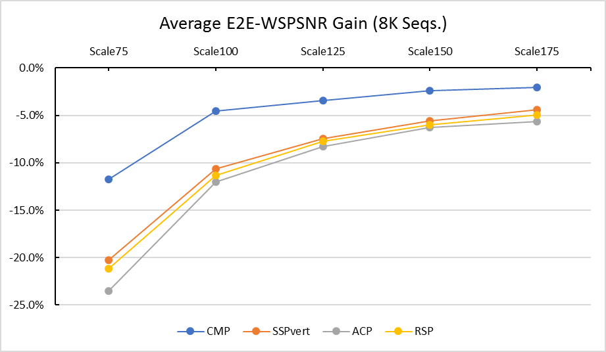

Figure 1. Average E2E-WSPSNR results of CMP, ACP, SSP-vert projection formats as a function of coding sizes.
In the tables and figures below, per projection and per sequence (8K) detailed results are enumerated.

Table 2. E2E-WSPSNR results per sequence for ACP projection format.
ACP | Scale75 | Scale100 | Scale125 | Scale150 | Scale175
Trolley | -21.0% | -7.6% | -2.9% | -0.5% | 0.03%
GasLamp | -16.3% | -4.2% | -1.1% | 0.4% | 0.8%
Skateboarding_in_lot | -26.1% | -16.0% | -13.3% | -11.2% | -10.1%
Chairlift | -31.8% | -25.2% | -23.1% | -21.3% | -20.6%
KiteFlite | -20.7% | -9.8% | -6.1% | -4.5% | -4.2%
Harbor | -25.4% | -9.5% | -3.2% | -0.4% | 0.2%
Average gain | -23.5% | -12.0% | -8.3% | -6.2% | -5.7%

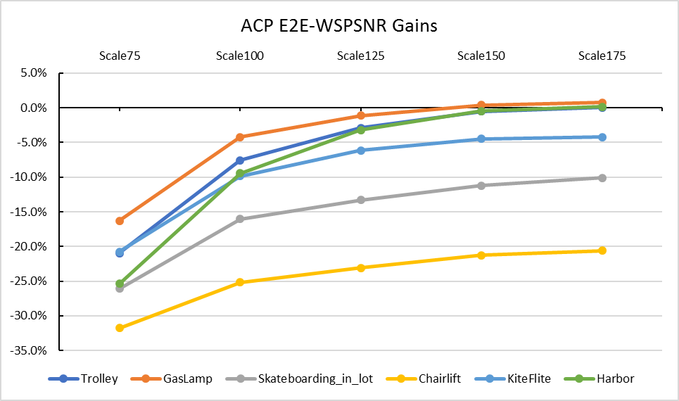

Figure 2. Plot of E2E-WSPSNR results per sequence for ACP projection format.

Table 3. E2E-WSPSNR results per sequence for CMP projection format.
CMP | Scale75 | Scale100 | Scale125 | Scale150 | Scale175
Trolley | -13.8% | -2.1% | 0.9% | 2.8% | 3.2%
GasLamp | -5.1% | 2.4% | 3.3% | 4.1% | 4.2%
Skateboarding_in_lot | -9.0% | -5.7% | -6.4% | -5.6% | -4.4%
Chairlift | -22.2% | -18.2% | -17.7% | -16.8% | -16.3%
KiteFlite | -12.9% | -4.9% | -3.1% | -2.2% | -2.1%
Harbor | -7.6% | 1.1% | 2.3% | 3.2% | 3.2%
Average gain | -11.8% | -4.6% | -3.5% | -2.4% | -2.0%

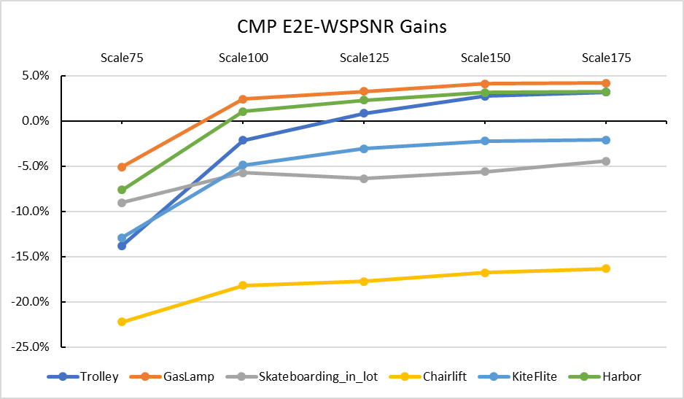

Figure 3. Plot of E2E-WSPSNR results per sequence for CMP projection format.

Table 4. E2E-WSPSNR results per sequence for SSP-vert projection format.
SSP-vert | Scale75 | Scale100 | Scale125 | Scale150 | Scale175
Trolley | -19.8% | -8.1% | -3.9% | -1.8% | -0.7%
GasLamp | -15.5% | -5.1% | -2.4% | -0.8% | 0.4%
Skateboarding_in_lot | -21.8% | -14.4% | -12.2% | -10.4% | -8.8%
Chairlift | -24.8% | -19.9% | -18.1% | -16.7% | -15.9%
KiteFlite | -18.4% | -9.2% | -6.1% | -4.7% | -3.7%
Harbor | -21.3% | -7.4% | -1.8% | 0.7% | 2.2%
Average gain | -20.3% | -10.7% | -7.4% | -5.6% | -4.4%

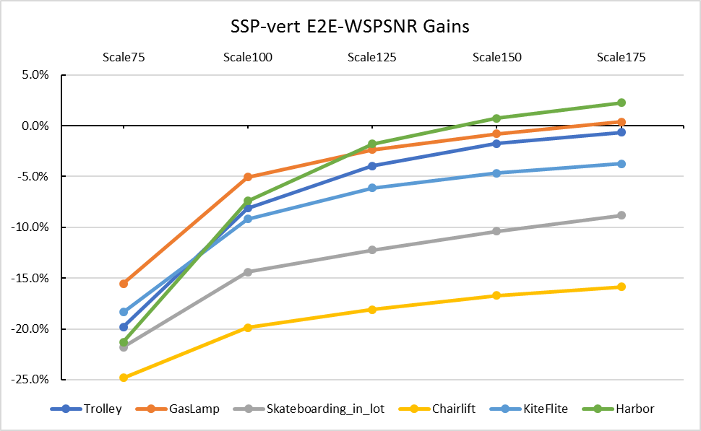

Figure 4. Plot of E2E-WSPSNR results per sequence for SSP-vert projection format.

Table 5. E2E-WSPSNR results per sequence for RSP projection format.
RSP | Scale75 | Scale100 | Scale125 | Scale150 | Scale175
Trolley | -19.8% | -7.7% | -3.6% | -1.0% | 0.0%
GasLamp | -14.3% | -3.8% | -0.9% | 0.6% | 1.5%
Skateboarding_in_lot | -23.8% | -15.8% | -13.4% | -11.5% | -10.0%
Chairlift | -29.1% | -23.6% | -20.6% | -19.8% | -19.0%
KiteFlite | -18.0% | -8.9% | -5.7% | -4.2% | -3.5%
Harbor | -22.3% | -8.2% | -2.5% | -0.2% | 1.1%
Avg gain | -21.2% | -11.3% | -7.8% | -6.0% | -5.0%

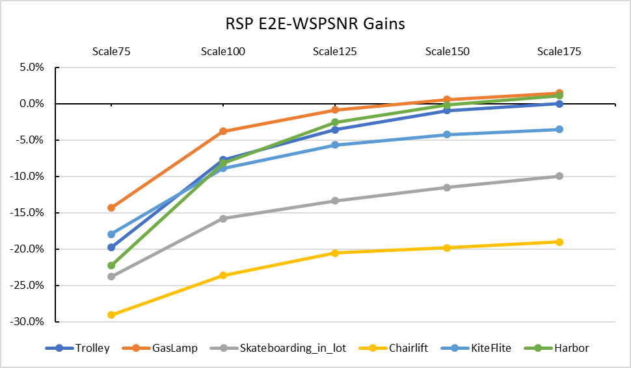

Figure 5. Plot of E2E-WSPSNR results per sequence for RSP projection format.

Conclusion
In the JVET 360-degree video CTC, the 8K inputs are converted to a coding size that is 25% of the input size for both the anchor and the tested projection format. Variations of this coding size were studied and it was observed that the coding gain varies significantly for the tested projection formats and decreases with increasing coding size. Therefore, the coding results for 8K inputs that are reported per CTC are for the specific CTC size only. It is suggested to reconsider the CTC coding size for 8K inputs by adding a second larger coding size or by modifying it; for example, 75% of the 8K input size to be consistent with coding size of 4K inputs.

References
- E. Alshina, J. Boyce, A. Abbas, Y. Ye, “JVET common test conditions and evaluation procedures for 360-degree video”, 6th JVET Meeting, Hobart, AU, March-April 2017, JVET-F1030.

Patent rights declaration
Qualcomm Inc. may have current or pending patent rights relating to the technology described in this contribution and, conditioned on reciprocity, is prepared to grant licenses under reasonable and non-discriminatory terms as necessary for implementation of the resulting ITU-T Recommendation | ISO/IEC International Standard (per box 2 of the ITU-T/ITU-R/ISO/IEC patent statement and licensing declaration form).

