    Joint Video Exploration Team (JVET)  of ITU-T SG 16 WP 3 and ISO/IEC JTC 1/SC 29/WG 11  7th Meeting: Torino, IT, July 13-21, 2017 | Document: JVET-G0052

Title: | AHG8: A study on quality impact of coded picture resolution in 360 video coding
Status: | Input Document to JVET
Purpose: | Information
Author(s) or  Contact(s): | Minhua Zhou  16340 West Bernardo DR  San Diego, CA 92127, USA | Tel:  Email: | [+1 858 521 5838]  minhua.zhou@broadcom.com
Source: | Broadcom Limited
_____________________________

Abstract
This contribution studied the quality impact of coded picture resolution in 360 video coding. Projection formats ERP, AEP (Adjusted EAP), ACP and RSP were investigated. For 8K ERP input, six coded picture resolutions (i.e. 75%, 100%, 133%, 200%, 300% and 400% of CTC) were tested. The experimental results revealed that when the coded picture resolution increases the compression efficiency of a projection format also increases, but the performance gap between an alternative format and ERP decreases. Overall RA results (E2E SPSNR-NN) for 8K input only are provided in the Table below:
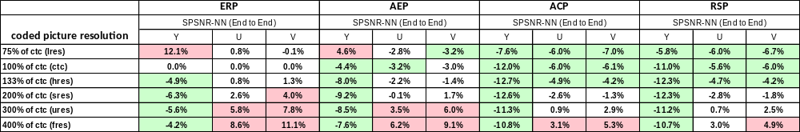

Introduction
This contribution shares information about coding efficiency impact of different coded picture resolutions after projection format conversion from the high fidelity 360 video input. In the study ERP, AEP [4], ACP and RSP are used. The coded picture resolution settings are summarized in Table 1.

Coded picture resolution settings | ERP/AEP |  | ACP/RSP |  | Number of active sample ratio relative to CTC (for 8K input)
Coded picture resolution settings | 8K Input  (FW x FH) | 4K Input  (FW x FH) | 8K Input  (FW x FH) | 4K Input  (FW x FH) | Number of active sample ratio relative to CTC (for 8K input)
Low resolution (lres) | 3568 x 1784 | 2896 x 1448 | 1024 x 1024 | 832 x 832 | ~75%
CTC resolution (ctc) | 4096 x 2048 | 3328 x 1664 | 1184 x 1184 | 960 x 960 | 100%
High resolution (hres) | 4736 x 2368 | 3840 x 1920 | 1368 x 1368 | 1112 x 1112 | ~133%
Super resolution (sres) | 5792 x 2896 | 3840 x 1920 | 1680 x 1680 | 1112 x 1112 | ~200%
Ultra resolution (ures) | 7096 x 3552 | 3840 x 1920 | 2056 x 2056 | 1112 x 1112 | ~300%
Full resolution (fres) | 8192 x 4096 | 3840 x 1920 | 2368 x 2368 | 1112 x 1112 | ~400%
Table 1. Coded picture resolution settings used in the test

Experimental results
Simulations were carried out by using HM16.15 + JVET 360Lib-3.0 library [2]. For RSP a fix was integrated to avoid problems identified in high resolution coding. The JVET 360 common test conditions (CTC) [3] were followed except for coded picture resolutions which were configured as Table 1. Although results for both 8K and 4K input are made available, only results of 8K input are reported below. For more detailed results including results of 4K input, please refer to the attached spreadsheets.
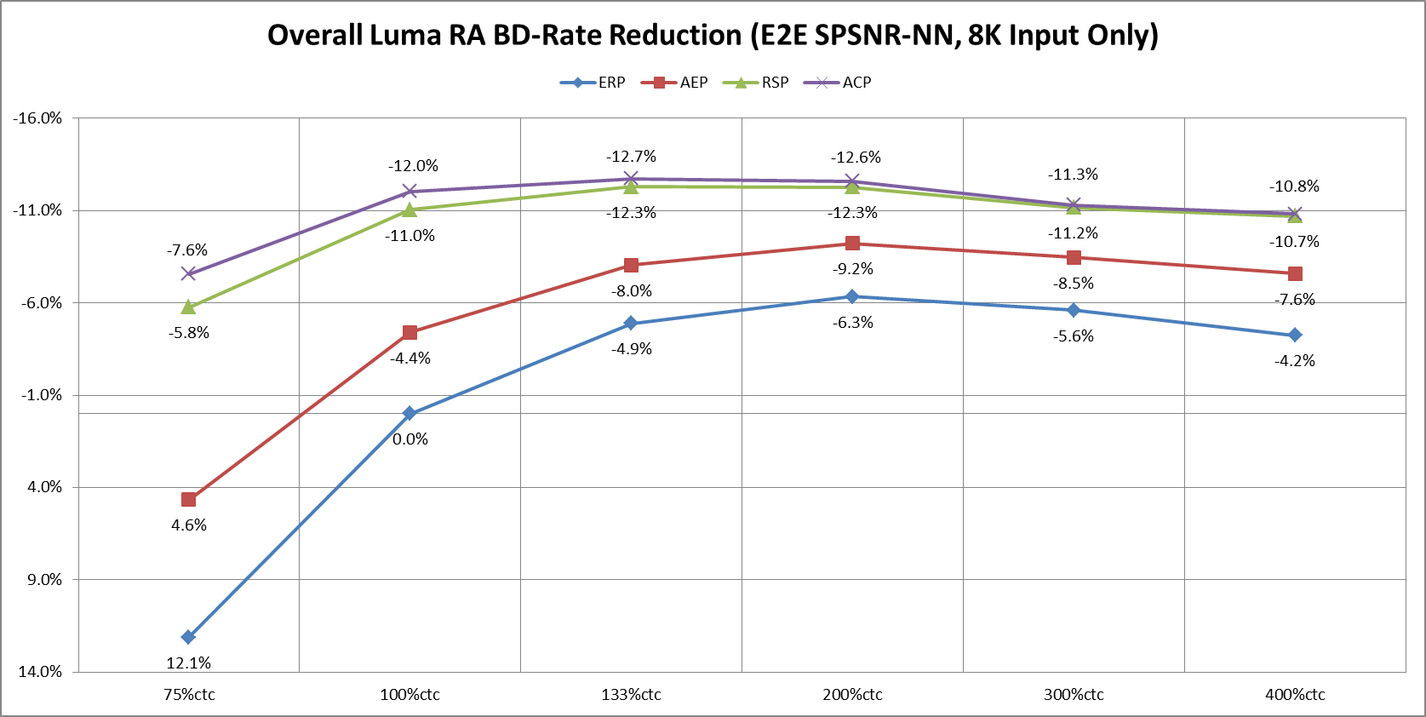
Figure 1. E2E SPSNR-NN summary of experimental results (8K input only)
As shown in Figure 1, as the coded picture resolution increases, the compress efficiency of a projection format increases and the performance gap between an alternative projection format and ERP decreases.
More detailed summary results can be found in Table 2 below.
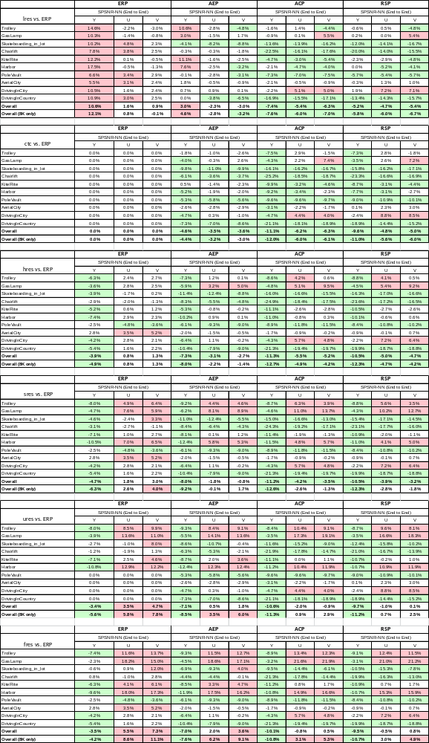

Table 2. RA BD-rates (E2E SPSNR-NN) per common test conditions for different coded picture resolutions (8K input only)

References
- Y. Ye, E. Alshina, J. Boyce, “Algorithm descriptions of projection format conversion and video quality metrics in 360Lib”, JVET-F1003, April 2017.
- 360Lib-3.0: https://jvet.hhi.fraunhofer.de/svn/svn_360Lib/tags/360Lib-3.0/
- J. Boyce, E. Alshina, A. Abbas, Y. Ye, “JVET common test conditions and evaluation procedures for 360-degree video”, JVET-F1030, April 2017.
- M. Zhou, “AHG8: A study on quality impact of line re-sampling rate in EAP”, JVET-G0051, July 2017.

Patent rights declaration(s)
Broadcom Limited does not have current or pending patent rights relating to the technology described in this contribution.

