    Joint Video Exploration Team (JVET)  of ITU-T SG 16 WP 3 and ISO/IEC JTC 1/SC 29/WG 11  7th Meeting: Torino, IT, July 13-21, 2017 | Document: JVET-G0024

Title: | InterDigital’s Response to the 360º Video Category in Joint Call for Evidence on Video Compression with Capability beyond HEVC
Status: | Input Document to JVET
Purpose: | Proposal
Author(s) or  Contact(s): | Philippe Hanhart, Xiaoyu Xiu, Fanyi Duanmu, Yuwen He, Yan Ye | Tel:  Email: | philippe.hanhart@interdigital.com  xiaoyu.xiu@interdigital.com  fanyi.duanmu@interdigital.com  yuwen.he@interdigital.com  yan.ye@interdigital.com
Source: | InterDigital Communications Inc.
_____________________________

Abstract
This proposal is the response to the joint Call for Evidence (CfE) on video compression with capability beyond HEVC by InterDigital in the 360º video category. Technologies used in this response include: the hybrid cubemap projection format; intra prediction using face continuity; inter prediction with geometry padding; and in-loop filtering using face continuity. It is asserted that the coding technologies in this Response provide sufficient evidence that the coding efficiency of the HEVC can be significantly improved for 360º video content.

Introduction
Recently, a joint Call for Evidence (CfE) was issued by ITU-T VCEG (Q6/16) and ISO/IEC MPEG (JTC 1/SC 29/WG 11) [1]. This proposal is InterDigital’s response to the CfE in the 360º video category. To improve 360º video coding efficiency and the subjective quality of reconstructed video, the following coding technologies are included in this response:
- The hybrid cubemap projection (HCP) format: the cubemap projection (CMP) and adjusted cubemap projection (ACP) are generalized. The encoder can select an appropriate set of projection format parameters to code the input video content;
- Intra prediction using face continuity: reference sample derivation for intra prediction is modified to consider the spherical nature of the 360º video;
- Inter prediction with geometry padding: padding in motion compensated prediction is modified to consider the spherical nature of the 360º video;
- In-loop filtering using face continuity: spherical neighbors are used to perform in-loop filtering.
Detailed description of each technology is provided in the next section.

360º video coding technologies

Hybrid cubemap projection format
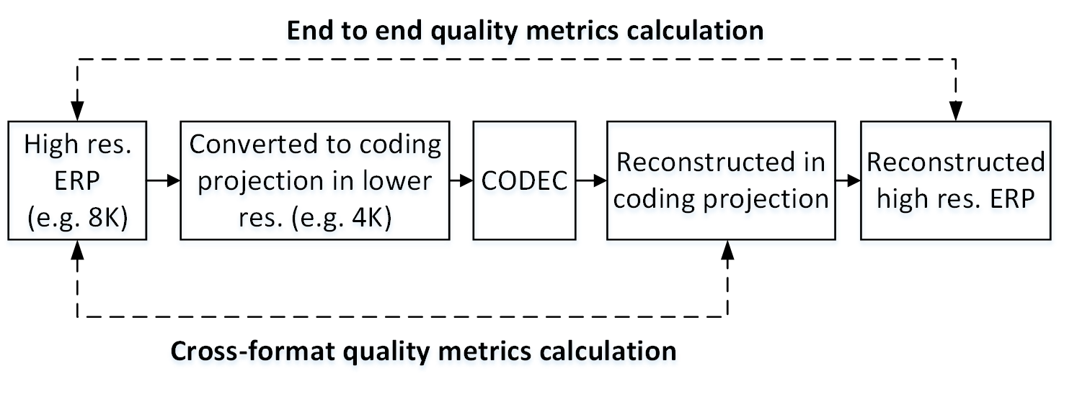
Figure 1. Testing work flow for 360º video coding.
360º video coding work flow is shown in Figure 1. Various projection formats, such as equi-rectangular projection (ERP), cubemap projection (CMP), etc., can be used for the coding [3]. The source video is converted to the coding projection format before encoding as shown in Figure 1. The reconstructed video is converted back from the coding projection format to the source projection format for end to end quality metrics calculation.
Under the 360º video common test conditions (CTC) [2], different coding projection formats achieve different compression results. Therefore, projection format can be used as a coding tool to improve compression efficiency depending on the input video content. In this response, a hybrid cubemap projection (HCP) format is proposed to improve coding performance by customizing the cubemap-like projection format based on the input signal.
CMP is one widely used projection format for 360º video coding. However, the uniform sampling in the CMP face will get non-uniform sampling on the sphere [3]: the sampling density is lower in the face center and is higher at the face boundary. Adjusted cubemap projection (ACP) [6] and equal-angular cubemap (EAC) projection [7] were proposed to solve the sampling problem in the CMP domain by adjusting the sampling distribution in the CMP face in such a way that sampling on the sphere is distributed with equal angle spacing in between.
Both ACP and EAC can improve coding efficiency compared to conventional CMP projection. However, the sampling distribution of ACP and EAC is fixed. In this response, the HCP format is proposed to generalize CMP and other CMP-like projections. Similar to ACP and EAC, HCP is related to CMP with forward and backward mapping functions. Assuming (x, y) is defined in a CMP face with side length equal to 2, and (x’, y’) is the corresponding point in an HCP face, the Equations (1) (2) are used for the mapping function from CMP to HCP.
$$x'=f_{X}\left(x\right)=sgn\left(x\right)∙\left(a∙x^{2}+(1-a)∙\left|x\right|\right)$$ | (1)
$$y'=f_{Y}\left(y\right)=sgn\left(y\right)∙\left(b∙y^{2}+(1-b)∙\left|y\right|\right)$$ | (2)
The Equations (3) (4) are used for the mapping from HCP to CMP.
$$x=g_{X}\left(x'\right)=sgn\left(x'\right)∙\frac{-(1-a)+\sqrt{{(1-a)}^{2}+4a∙\left|x'\right|}}{2a}$$ | (3)
$$y=g_{Y}\left(y'\right)=sgn\left(y'\right)∙\frac{-(1-b)+\sqrt{{(1-b)}^{2}+4b∙\left|y'\right|}}{2b}$$ | (4)
where a and b are the HCP horizontal and vertical mapping function parameters, and are defined in the range of (-1, 0]. If the parameter a or b is 0, the sampling distribution in that corresponding direction is exactly the same as CMP.

Table 1. Face definition of HCP
Face index | Notes
0 | Front face
1 | Back face
2 | Top face
3 | Bottom face
4 | Right face
5 | Left face
HCP has 6 faces, with face index and orientation as defined in Table 1. The sampling distribution of HCP (that is, parameters a and b) can be adaptively selected based on the content. In this response, the 3x2 layout is used in HCP frame packing. Figure 2 shows an example for the frame packed picture. Assuming F_{i} is i-th face of HCP, and (a_{i}, b_{i}) are the parameters defining the mapping functions of face F_{i}. In order to keep continuities at face boundaries in between two neighboring faces, the following constraint is applied in HCP.
$$b_{4}=b_{0}=b_{5}$$ | (5)
$$b_{2}=b_{1}=b_{3}$$ | (6)
In other words, the first row faces F₄, F₀ and F₅ will share the same vertical mapping function, and the second row faces F₂, F₁ and F₃ will share the same vertical mapping function.
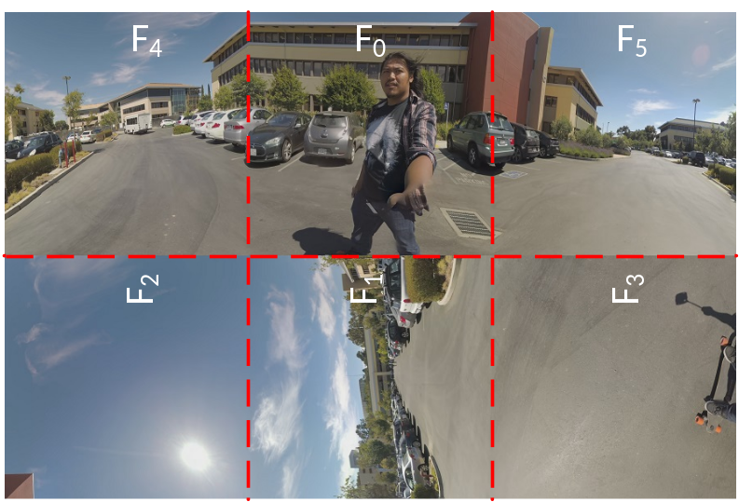
Figure 2. Frame packed picture in 3x2 layout for SkateboardInLot.

HCP parameter derivation
Taking into account the constraints in (5)(6), the HCP parameter derivation process for the 3x2 frame packing scheme is separated into two sub-processes: (a) deriving parameters for the first face row consisting of F₄, F₀ and F₅; (b) deriving parameters for the second face row consisting of F₂, F₁ and F₃. For each face row, the following iterative parameters searching algorithm for horizontal and vertical mapping functions is applied:
Step1: search parameters for the horizontal direction while fixing parameters for the vertical direction, and update the parameters for the horizontal direction with the optimal parameters found in searching; if there is no update, searching process stops; otherwise, go to Step2;
Step2: search parameters for the vertical direction while fixing parameters for the horizontal direction, and update the parameters for the vertical direction with the optimal parameters found in searching; if there is no update, searching process stops; otherwise, go to Step1.
The search algorithm usually converges after 3~4 iterations. The HCP parameters are selected by minimizing end-to-end weighted conversion-only error calculated as in Equation (7). The weights are the same as those used in WS-PSNR calculation for ERP in 360Lib [3][5].
$$Dist=\sum_{F_{i}∈face_row}{SSE(F_{i}(ERP), F_{i}(ERP'))}$$ | (7)
where $F_{i}(ERP)$ is the portion of source ERP corresponding to face F_{i} in HCP, and $F_{i}(ERP')$ is the portion of reconstructed ERP corresponding to face F_{i} in HCP.
In this response, only projection format conversion distortion is considered. The HCP parameters are selected by the encoder using the first picture of each IRAP and signalled once per IRAP.

Projection format parameter signaling
High level syntax is modified to include projection format parameter signalling. The SPS and PPS are modified as described below. SPS and PPS are signalled at the beginning of each IRAP.
- SPS: projection format, frame packing parameters including number of faces in horizontal and vertical directions in the frame packed picture, and each face’s position and orientation in the frame packed picture.
- PPS: the horizontal and vertical HCP parameters (a and b in Equations (1)(2)(3)(4)).

Coding tools

Intra prediction using face continuity
In this response, intra prediction is modified to consider face continuity in 3D geometry. Specifically, if a reference sample position is located outside of the face that the current block belongs to, then the reference samples are derived from previously coded samples located in a neighboring face, which are referred to as spherical neighbors. Spherical neighbors may not necessarily coincide with adjacent samples in the frame packed picture, which are referred to as frame packed neighbors. In the example depicted in Figure 3a, the left reference samples for block “A” should be derived from face F₀ (front face) (see Figure 3b) instead of using mid grey sample values (as the block is located at the picture boundary). Similarly, the above reference samples for block “B” should be derived from face F₅ (left face) (see Figure 3c) instead of using samples located directly above the block in the frame packed picture (which are located in non-neighboring face F₀ in 3D geometry), and the above reference samples for block “C” should be derived from samples located at the top of face F₅ instead of samples located at the bottom of F₅ (see Figure 3c).

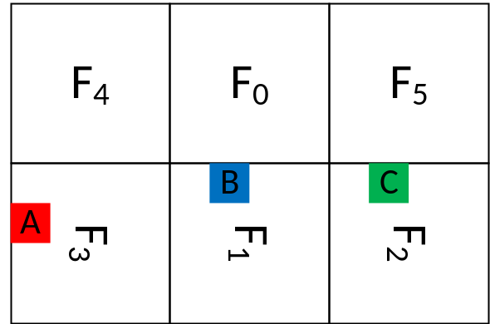
(a)
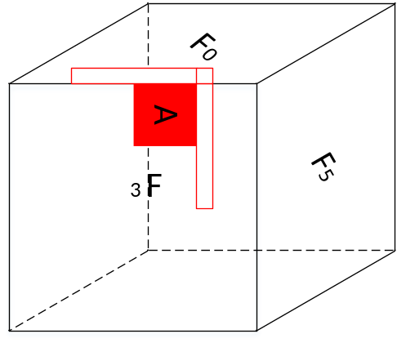 | 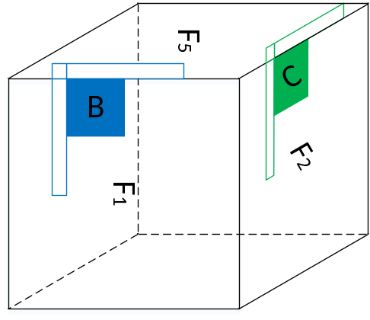
(b) | (c)
Figure 3. Intra prediction using spherical neighbors as reference samples. For CMP 3x2 frame packing configuration shown in (a), spherical neighbors are used to predict block A (b) and blocks B and C (c). The reference samples in the hatched areas are spherical neighbors, whereas the reference samples in the non-hatched areas are frame packed neighbors.
The availability of spherical neighbors may be determined by the frame packing configuration, raster scan processing order, as well as face and CTU size. For example, for the 3x2 packing configuration, if the face size is not a multiple of the CTU size, part of the second face row may be coded before the first face row is fully coded. Therefore, when coding some of the blocks in the second face row, some spherical neighbors in the first face row may not be available. In particular, for the default 3x2 packing configuration in 360Lib, as depicted in Figure 4, when encoding the blocks in the first (partial) CTU row of F₃ (bottom face) (shaded area in Figure 4), spherical neighbors may not be derived from F₀ (front face) and F₅ (left face), as the corresponding blocks have not been encoded yet. Similarly, for F₁ (back face), the first blocks within a width of size h = mod(face size, CTU size) in the first (partial) CTU row (shaded area in Figure 4) may not be able to derive spherical neighbors from F₅, as the corresponding blocks have not been encoded yet. To overcome these problems, a different 3x2 packing configuration, as depicted in Figure 5, is used in this response. Compared to the 3x2 frame packing configuration depicted in Figure 4, the second face row is rotated by 180 degrees in the proposed 3x2 frame packing configuration depicted in Figure 5. With this configuration, spherical neighbors in F₄ (right face), F₀ (front face), and F₅ (left face) are always available to predict F₂ (top face), F₁ (back face), and F₃ (bottom face).
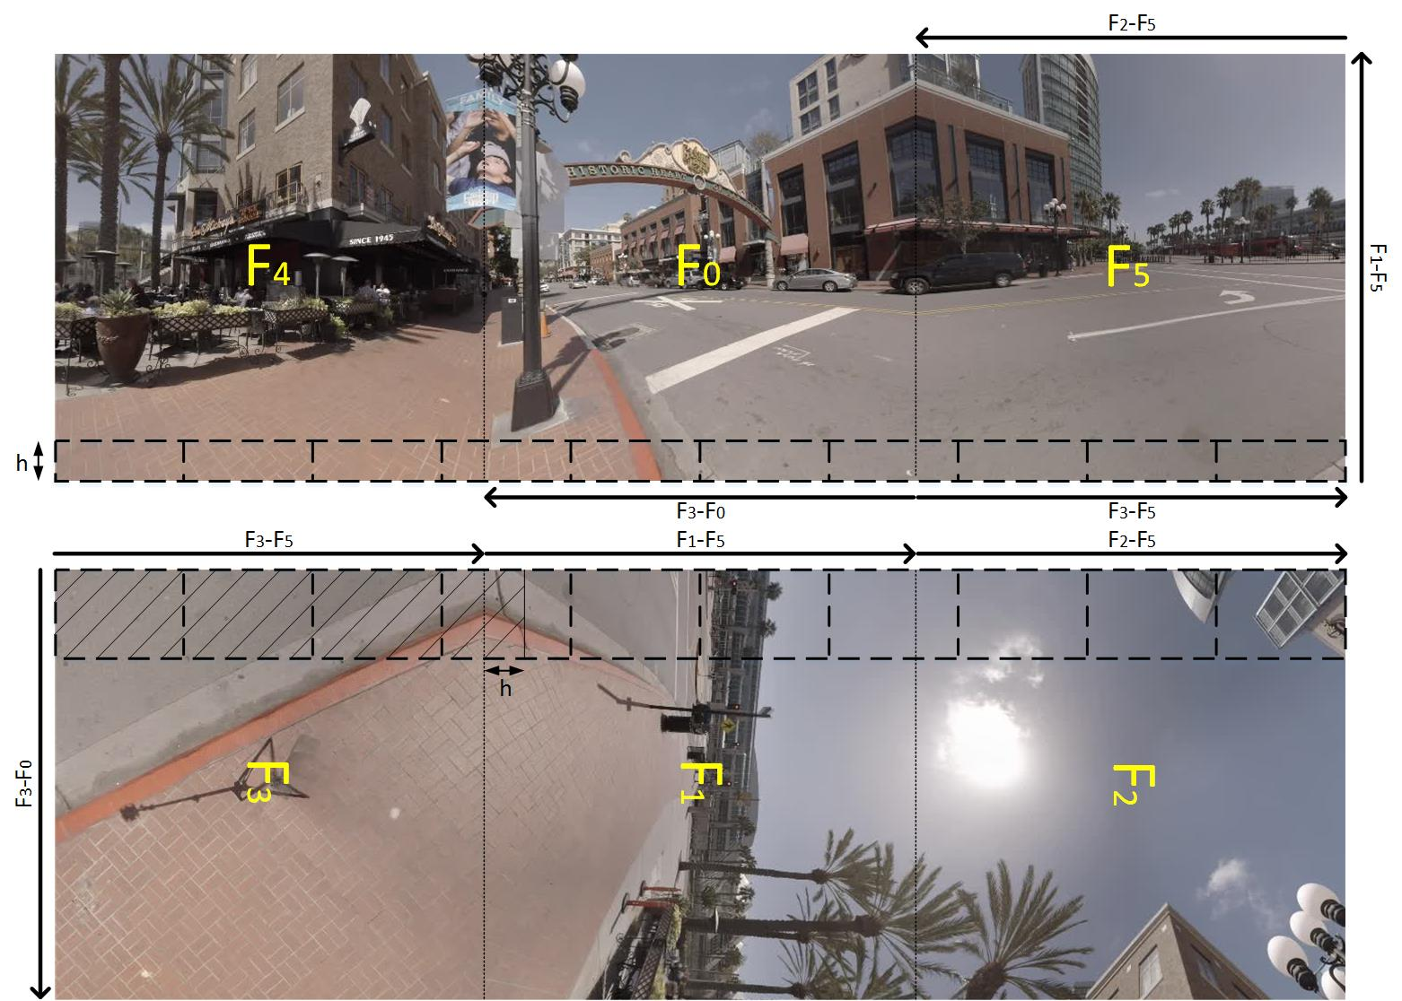
Figure 4. Default 3x2 frame packing configuration in 360Lib. The dashed lines represent the CTU boundaries. The arrows represent the shared boundary between two faces.
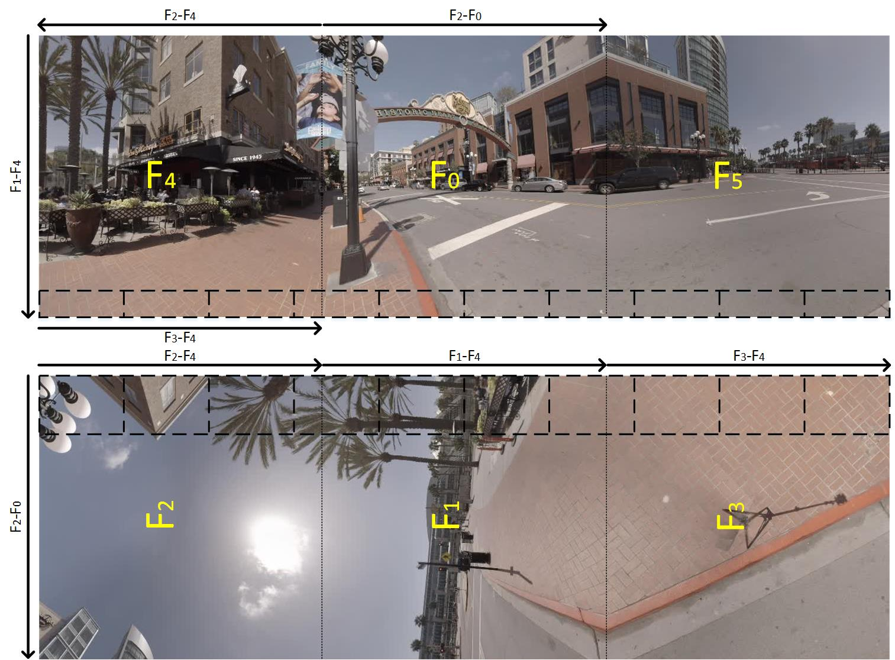
Figure 5. Used 3x2 frame packing configuration. The dashed lines represent the CTU boundaries. The arrows represent the shared boundary between two faces.
In this response, to get the corresponding sample value of the spherical neighbors, nearest neighbor in the 2D plane is used to avoid interpolation. This operation is performed on the fly for each spherical neighbor using a LUT. Figure 6 illustrates whether JEM default reference sample derivation or the proposed reference sample derivation using spherical neighbors is used for deriving neighbor reference samples for intra prediction across the different face boundaries.
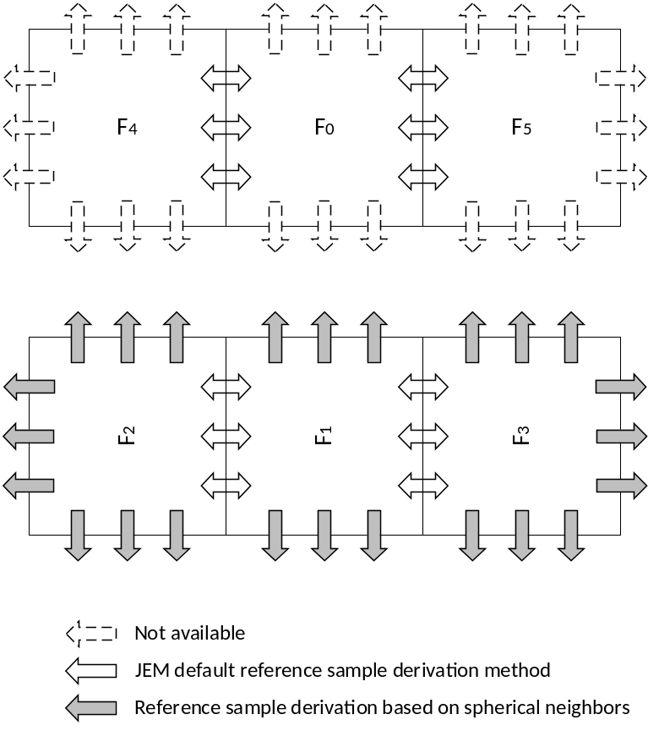
Figure 6. Methods used for deriving spherical neighbor reference samples for intra prediction.
In this response, the same approach is used for deriving the reconstructed samples in cross-component linear model prediction.

Inter prediction with geometry padding
Existing video codecs are designed only considering conventional 2D video captured on a plane. When motion compensated prediction uses any samples outside of a reference picture’s boundaries, padding will be performed by simply copying the sample values from the picture boundaries. However, the 360º video encompasses video information on a whole sphere, and thus intrinsically has a cyclic property. When considering this cyclic property, the reference pictures of a 360º video no longer have “boundaries,” as the information they contain is all wrapped around a sphere. This cyclic property holds regardless of which projection format is used to represent the 360º video on a 2D plane. Taking into account this very specific 360º video property, in this response, geometry padding for inter prediction is proposed, which introduces a different padding method in motion compensated prediction for 360º video coding.
In the response, geometry padding is applied in the motion compensated prediction when the reference sample is outside of the face that current block belongs to. For example, if coding block B₀ is located inside face F₀ (front face) and its reference block B₀’ is partially outside of face F₀ as shown in Figure 7, those samples in the shaded region are not directly derived from samples in face F₁ (back face), but derived from face F₂ (bottom face) with geometry padding. Figure 8 shows how the geometry padding is performed for a given face. Point P is on face F₁, but outside of face F₁’s boundaries. Therefore, it needs to be padded. Point O is the center of the sphere. R is the left boundary point closest to P and is inside face F₁. Point Q is the projection point of point P on face F₂ from the center point O. Rather than using sample value at point R to fill the sample value at point P, geometry padding uses the sample value at point Q to fill the sample value at point P. Figure 9 is an example of applying geometry padding for HCP 3x2 projection format. Figure 10 shows an example of extended pictures with the repetitive padding method and the proposed geometry padding method for the picture shown in Figure 2. Compared to the repetitive padding method currently used in HEVC, the proposed geometry padding can provide more meaningful reference samples for areas outside of the face boundaries.
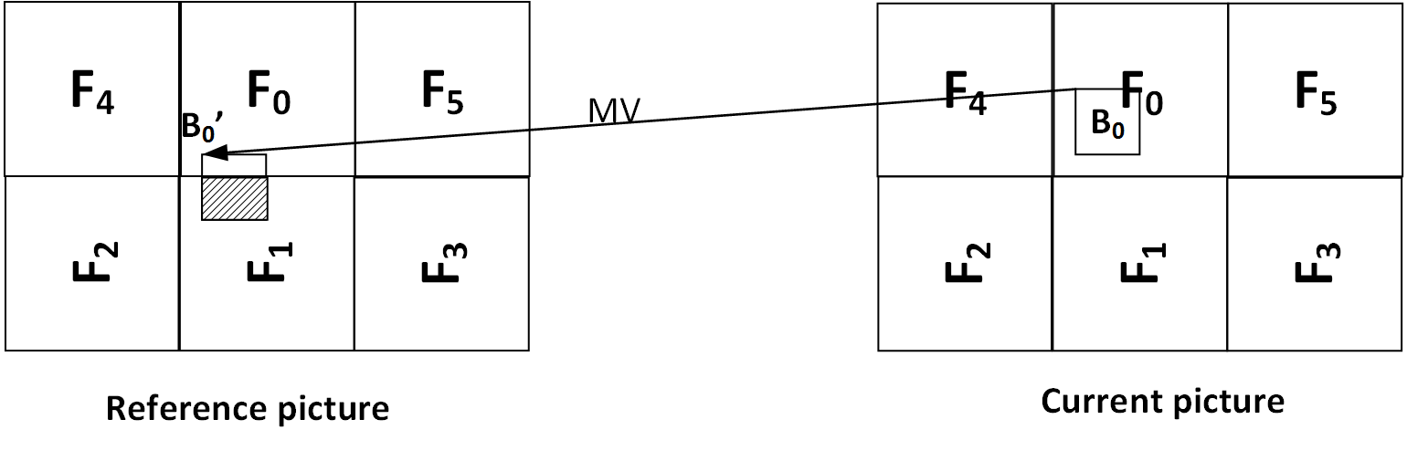
Figure 7. Motion compensated prediction for the pictured coded in HCP 3x2 frame packing.

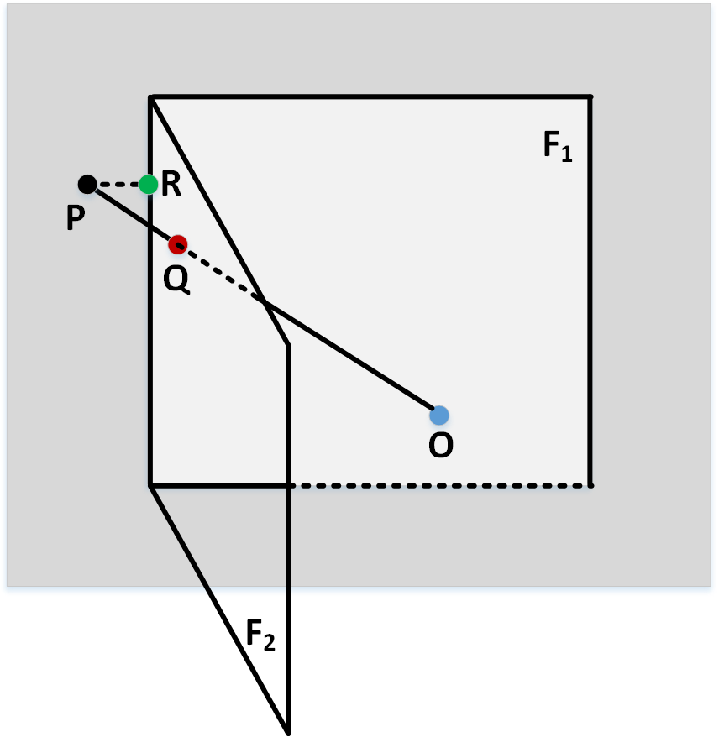
Figure 8. Geometry padding for CMP. Point P is outside of face F₁ and needs to be padded. Point Q is the projected point on face F₂ of point P from the center of the sphere point O. The sample value at point P will be filled with the sample value at point Q on face F₂.

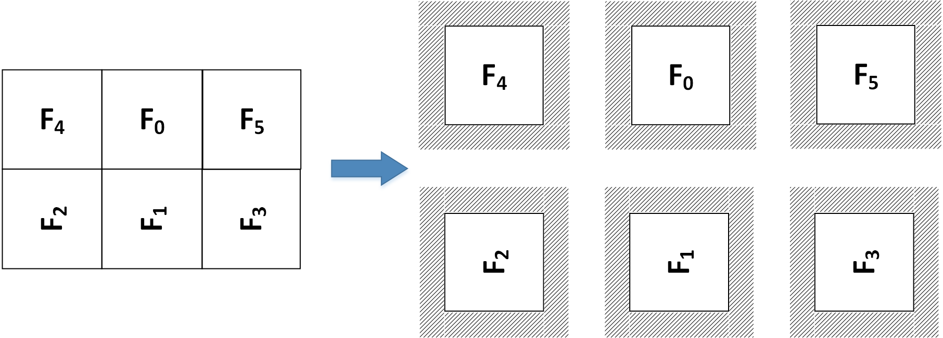
Figure 9. Extended face pictures of HCP 3x2 with geometry padding: figure on the left is the HCP 3x2 frame packing configuration, and figure on the right is the extended face picture. The shadow areas are padded with geometry padding.
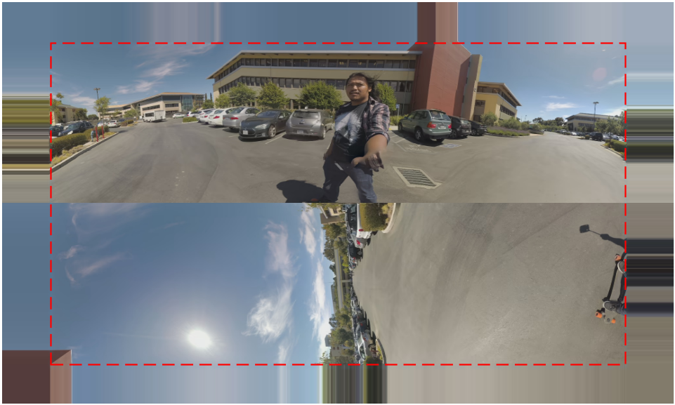
(a)
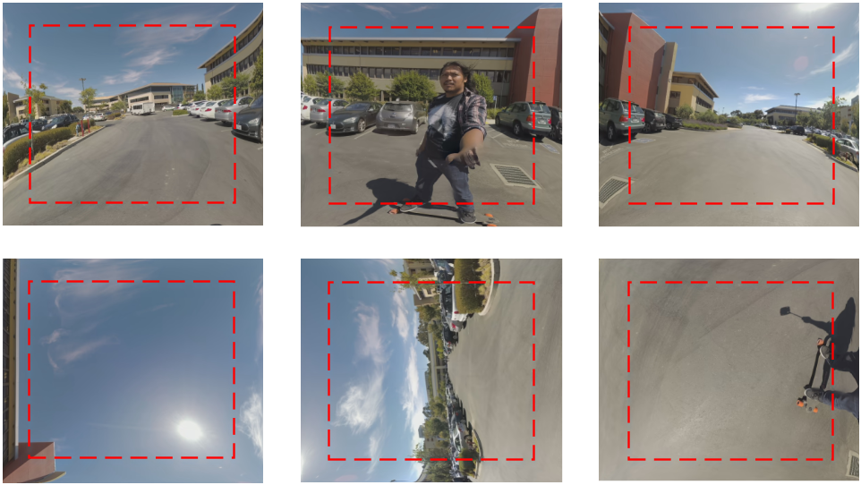
(b)
Figure 10. Extended picture with different padding methods: (a) Extended picture of HCP 3x2 with repetitive padding; (b) Extended face pictures of HCP 3x2 with geometry padding. Padded areas are outside of the red box.

In-loop filtering using face continuity
In regular 2D video coding, the top, right, bottom, and left picture boundaries may not be filtered during the in-loop filtering process. Take deblocking for example. As there is no actual sample outside of these boundaries, it is not meaningful to apply filtering on those boundary samples. However, for 360º video coding, because of the intrinsic circular characteristic, the top, right, bottom, and left boundaries of each face are connected to another face boundary and thus in-loop filtering should be applied across all face boundaries and across picture boundaries. Therefore, in this response, each in-loop filter (deblocking, SAO, and ALF) is applied by processing one face at a time, instead of the frame packed picture as a whole. The spherical neighbors, instead of frame packed neighbors, are used in all in-loop filters. To get the corresponding sample value of the spherical neighbors, nearest neighbor in the 2D plane is used to avoid interpolation. This operation may be performed on the fly for each spherical neighbor using a LUT. With the in-loop filtering method in this response, all samples on the boundaries of the frame packed picture are also filtered with their spherical neighbors.

Simulation Results
The response software is built on JEM-6.0 [4] and 360Lib-3.0 [5]. The decoder in the response software supports dynamic viewport generation directly from the bitstream, and does not require first fully decoding the bitstream and then generating viewport video using the decoded video. The simulation results are reported using the test conditions specified in the CfE document [1]. The size of each HCP face was set to 1184×1184 luma samples, which is the same face size used for CMP and ACP in 360º video CTC [2]. This means this response uses a similar number of coded samples as ERP. The actual bit rates of all bitstreams satisfy the CfE requirement, i.e., within +/-2% of the target bit rates as defined in [1]. Only results for the end-to-end WS-PSNR (E2E WS-PSNR) metric are reported in this document. Readers are referred to the accompanying spreadsheets for further details.

Comparison with the HM-based 360° anchors
Table 5 reports the BD-rate of the response compared to the HM 360° anchors.
Table 5 Comparison of the response with the HM 360° anchors in terms of coding performance.
Sequence | E2E WS-PSNR Y | E2E WS-PSNR U | E2E WS-PSNR V
SkateboardInLot | -39.64% | -63.18% | -70.08%
Chairlift | -45.95% | -66.27% | -60.73%
KiteFlite | -23.02% | -56.60% | -63.16%
Harbor | -25.92% | -56.11% | -56.50%
Trolley | -21.56% | -44.27% | -50.52%
Average | -31.22% | -57.29% | -60.20%

Comparison with the JEM-based 360° anchors
Table 6 reports the BD-rate of the response compared to the JEM 360° anchors. As reported in Table 6, the response can effectively improve the coding performance of the current JEM by providing an average BD-rate savings of 11.5% based on E2E WS-PSNR Y. The maximum bit rate savings of the response can reach 22% (sequence Chairlift).
Table 6 Comparison of the response with the JEM 360° anchors in terms of coding performance.
Sequence | E2E WS-PSNR Y | E2E WS-PSNR U | E2E WS-PSNR V
SkateboardInLot | -15.38% | -25.27% | -24.29%
Chairlift | -22.06% | -17.77% | -17.60%
KiteFlite | -6.35% | -9.09% | -14.69%
Harbor | -7.41% | -12.71% | -12.91%
Trolley | -6.41% | -6.88% | -11.25%
Average | -11.52% | -14.35% | -16.15%

Projection format conversion performance
Table 7 reports the E2E WS-PSNR values comparing each original sequence to the result of applying HCP mapping and then converting this result back to ERP without compression.
Table 7 Projection conversion performance for HCP.
Sequence | E2E WS-PSNR Y | E2E WS-PSNR U | E2E WS-PSNR V
SkateboardInLot | 50.14 | 61.48 | 61.10
Chairlift | 50.06 | 59.55 | 59.61
KiteFlite | 46.44 | 57.68 | 57.68
Harbor | 49.22 | 59.14 | 58.09
Trolley | 45.39 | 57.95 | 57.83
Average | 48.25 | 59.16 | 58.86
Gain over ERP anchor | 3.01 | 0.91 | 0.87

Visual comparison
Compared to the HM 360° anchors, visual quality improvements from this response, for example in the form of better texture and edges with reduced blocking artifacts, are clearly visible in real-time playback. Visual quality improvements are also observed over the JEM 360° anchors. The overall visual quality improvement over the JEM 360° anchors is particularly visible for the Chairlift sequence, as illustrated in Figure 11 for Rate 2 (2400 kbit/s). As can be observed, details are more visible in the response, particularly in the gondola lift cable, on the ground, on the trees, as well as on the person sitting on the chairlift.

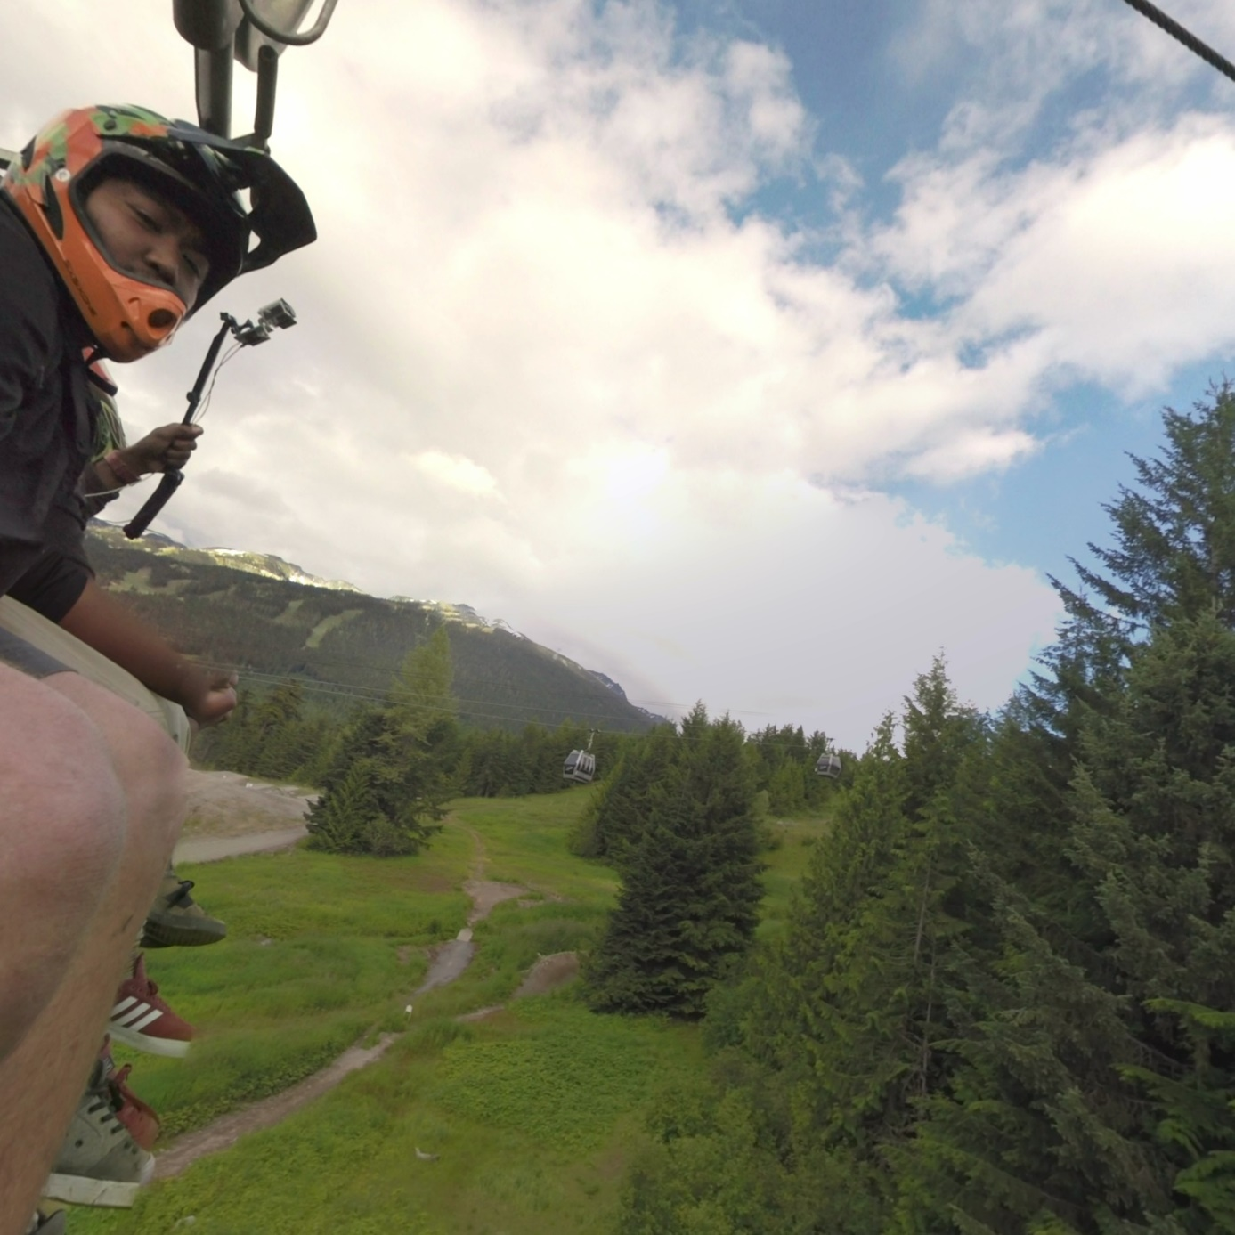
(a)
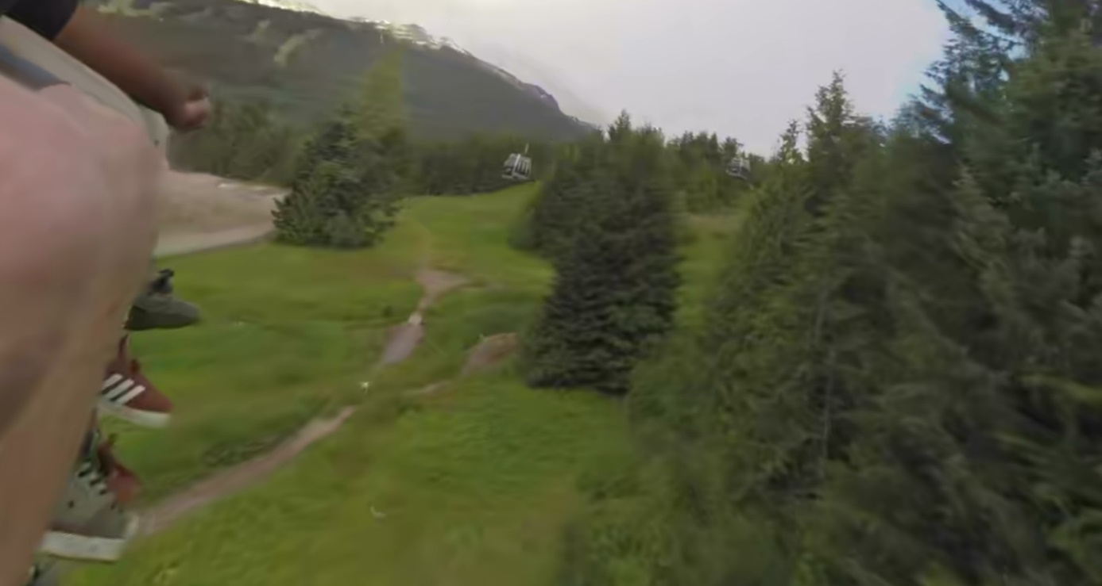
(b)
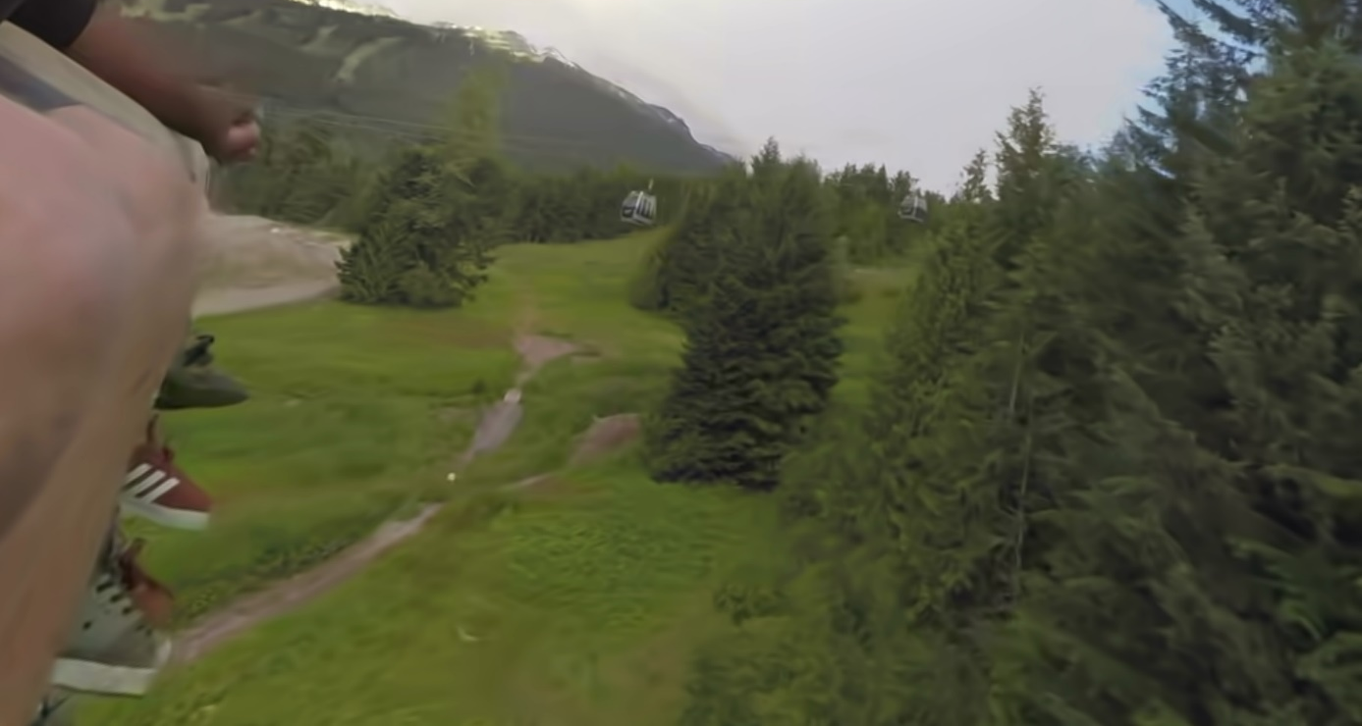
(c)
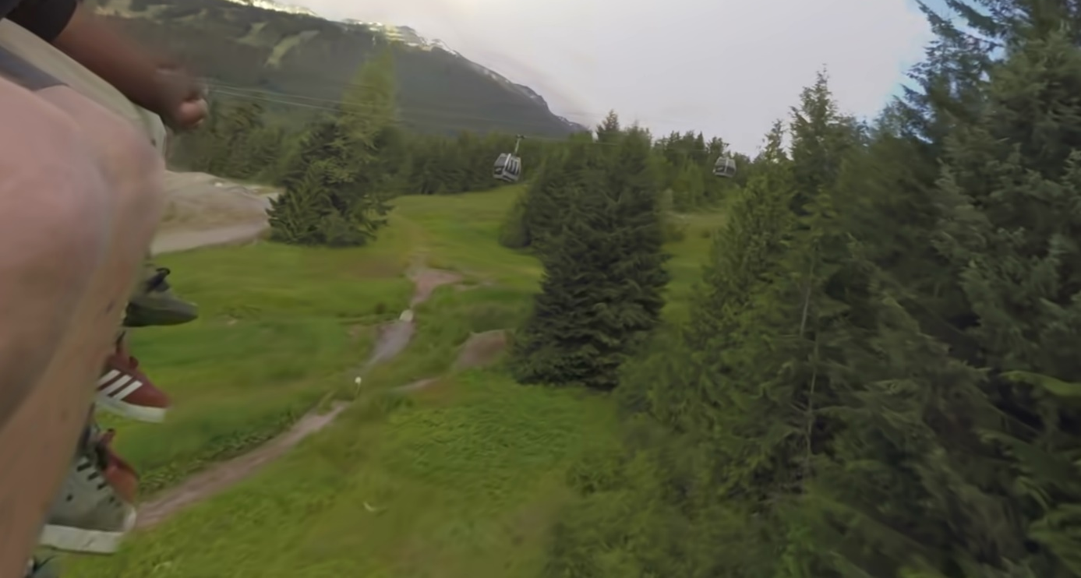
(d)
Figure 11. Screen shot illustrating visual quality improvements over the 360° anchors: viewport extracted from uncompressed sequence (a); HM 360° anchor (b); JEM 360° anchor (c); response (d).

In addition to general improvement, 360º video specific video quality problems were also reportedly fixed. In particular, no face seams are observed in the reconstructed video sequences encoded with this response, whereas the face seams between the left and right ERP picture boundaries are clearly visible in both the HM and JEM 360° anchors, as illustrated in Figure 12 for the SkateboardInLot sequence at Rate 2 (2000 kbit/s). Face seams artifacts are even more visible during video playback, as the video appears to flicker where face seams occur.
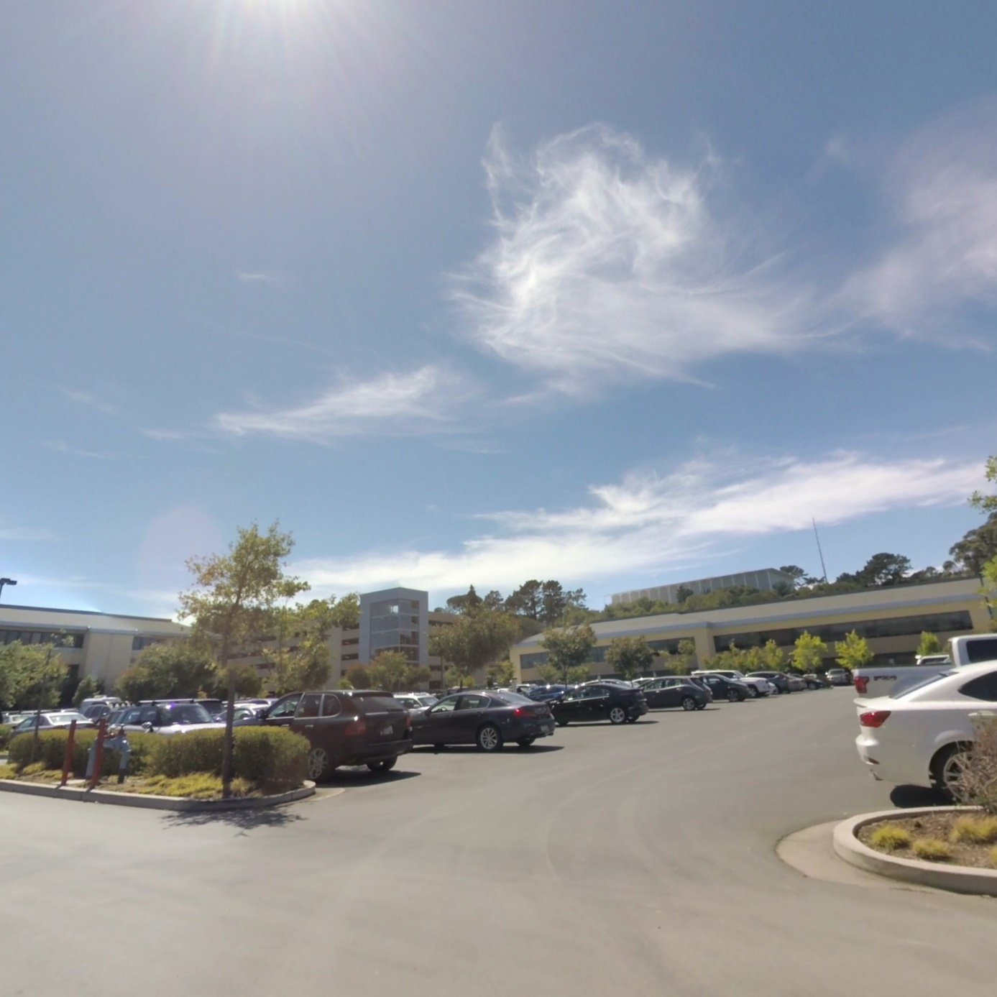
(a)
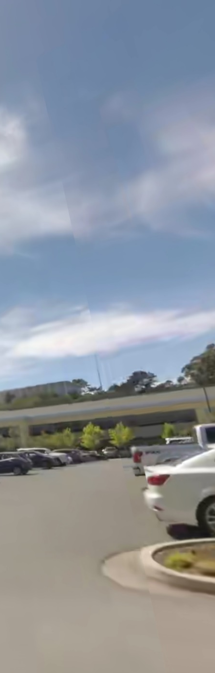 | 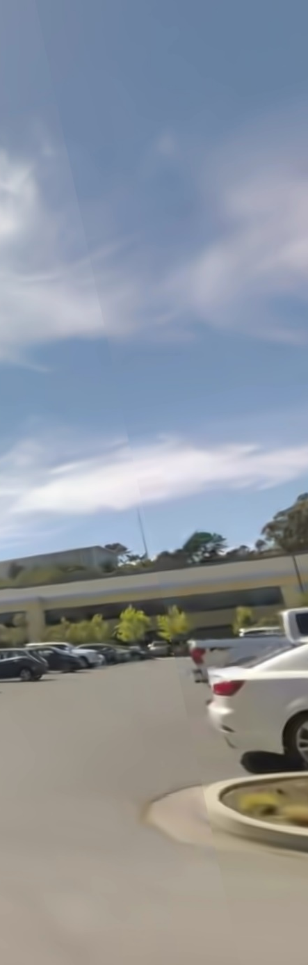 | 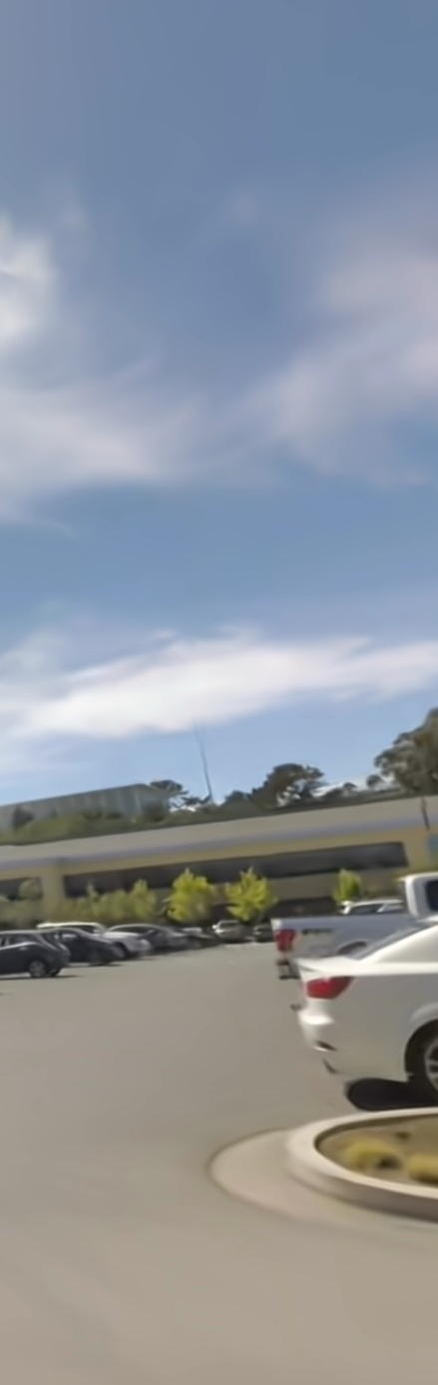
(b) | (c) | (d)
Figure 12. Screen shot illustrating a face seam artifact: viewport extracted from uncompressed sequence (a); HM 360° anchor (b); JEM 360° anchor (c); response (d).

Conclusions
This response shows that it is feasible to significantly improve the compression performance of HEVC for 360º video. In addition to coding efficiency improvement evidenced by the reported objective BD rate reduction, improvement in subjective quality of the reconstructed video is also observed. In addition to general improvement in the form of reduced blocking artifacts, better texture and edges, 360º video specific video quality problems were also reportedly fixed. In particular, no face seams are observed in the reconstructed video sequences encoded with this response, whereas the face seams between the left and right ERP picture boundaries are clearly visible in both the HM and JEM 360° anchors.

References
- M. Wien, V. Baroncini, J. Boyce, A. Segall, T. Suzuki, “Joint Call for Evidence on Video Compression with Capability beyond HEVC,” JVET-F1002, Mar. 2017, Hobart, AU.
- J. Boyce, E. Alshina, A. Abbas, Y. Ye, “JVET common test conditions and evaluation procedures for 360° video”, JVET-F1030, Mar. 2017, Hobart, AU.
- Y. Ye, E. Alshina, J. Boyce, “Algorithm descriptions of projection format conversion and video quality metrics in 360Lib”, JVET-F1003, Mar. 2017, Hobart, AU.
- JEM-6.0 software, https://jvet.hhi.fraunhofer.de/svn/svn_HMJEMSoftware/tags/HM-16.6-JEM-6.0
- 360Lib-3.0 software, https://jvet.hhi.fraunhofer.de/svn/svn_360Lib/tags/360Lib-3.0
- M. Coban, G. Van der Auwera, M. Karczewicz, “AHG8: Adjusted cubemap projection for 360-degree video,” JVET-F0025, Mar. 2017, Hobart, AU.
- Equi-Angular Cubemaps (EAC), https://www.blog.google/products/google-vr/bringing-pixels-front-and-center-vr-video/

Patent rights declaration(s)
InterDigital Communications Inc. may have current or pending patent rights relating to the technology described in this contribution and, conditioned on reciprocity, is prepared to grant licenses under reasonable and non-discriminatory terms as necessary for implementation of the resulting ITU-T Recommendation | ISO/IEC International Standard (per box 2 of the ITU-T/ITU-R/ISO/IEC patent statement and licensing declaration form).

