    Joint Video Exploration Team (JVET)  of ITU-T SG 16 WP 3 and ISO/IEC JTC 1/SC 29/WG 11  7th Meeting: Torino, IT, 13–21 July 2017 | Document: JVET-G0023_r1

Title: | Qualcomm’s response to Joint CfE in 360-degree video category
Status: | Input Document to JVET
Purpose: | Proposal
Author(s) or  Contact(s): | Muhammed Coban, Geert Van der Auwera, Marta Karczewicz  5775 Morehouse Drive  San Diego, CA 92121, USA | Tel:  Email: | +1 858 658 3973  mcoban@qti.qualcomm.com, geertv@qti.qualcomm.com, martak@qti.qualcomm.com
Source: | Qualcomm Inc.
_____________________________

Abstract
The adjusted cubemap projection (ACP) with padding is submitted to JVET’s Call for Evidence on 360-degree video coding. The padded ACP offers efficient compression of 360-degree video and reduced seam artifacts in the rendered viewports. ACP is an enhancement of CMP by adjusting the sampling on the cube faces to be nearly uniform. With proposed padding scheme for ACP, the RA coding gain is 10.7% (e2e WS-PSNR) compared with the equirectangular projection in accordance with the JVET common test conditions for 360-degree video, while for CfE conditions, reported coding gain is 8.1% (e2e WS-PSNR).

Introduction
After stitching of multiple input camera pictures, 360-degree video pictures are typically represented in the equirectangular projection format (ERP), which projects the 360-degree environment onto a spherical geometry and maps the sphere onto a 2D projected picture. Another popular projection format is the cubemap projection (CMP). The CMP projects the surface of the sphere onto planes (six faces of the cube) that are tangent to the sphere surface. The adjusted cubemap projection ACP [1][2][3] is an enhancement of CMP, which adjusts the sampling on the cube faces to be nearly uniform.
In ACP, the cubemap lookup vectors are modified to approximate uniform sphere sampling for addressing the non-uniform sampling problem of the CMP while preserving the packing scheme. The function
$$f(x)=sgn(x)\frac{0.34-\sqrt{{0.34}^{2}-0.09\left|x\right|}}{0.18}$$
is used to modify the lookup vectors in the forward 2D-to-3D conversion. For the inverse 3D-to-2D conversion, its inverse function
$$g(x)=sgn(x)(-0.36x^{2}+1.36\left|x\right|)$$
is used to modify the lookup vectors. The mapping functions are illustrated in Figure 1. The mapping enlarges the center of the cubemap face with respect to the CMP projection.
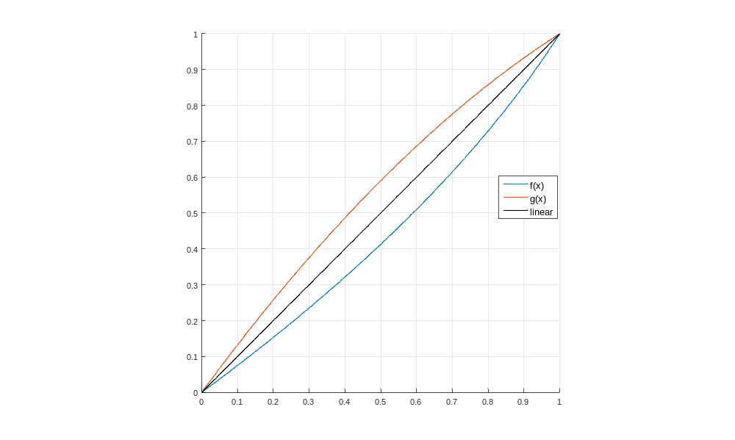
Figure 1. ACP forward and inverse mapping functions.
Video pictures of the ‘PoleVault’ sequence obtained with ERP, CMP, and ACP are illustrated in Figure 2.

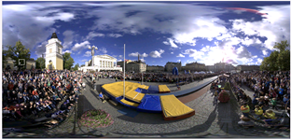  (a) | 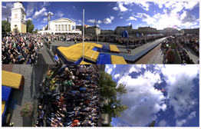  (b)
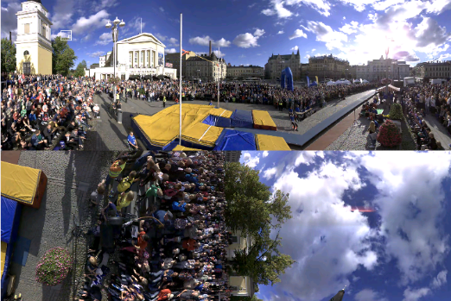
(c)

Figure 2. (a) ERP picture, (b) CMP 3x2 picture, and (c) ACP 3x2 picture from ‘PoleVault’ sequence.
After the projection process, the video pictures are coded, stored or transmitted, and decoded at the receiver side where the renderer generates the viewport that matches the viewer’s head orientation. Depending on this orientation and the field of view, the viewport may cross the picture boundaries or boundaries within the picture between adjacent or non-adjacent regions. To adequately address these conditions, guard bands or padded regions are added to the ACP projection. Guard bands are regions added into the projected picture consisting of additional samples that are not essential for projecting the picture back onto the sphere, but they are helpful in reducing artifacts such as seams on the sphere or in the rendered viewport. The added padded regions consist of additional projected samples, i.e., samples obtained around the projected regions with the ACP projection process. Figure 3 illustrates the guard bands for 3×2 packed ACP pictures. The padding is added along the top and bottom 3×1 halves of the projected picture.
Detailed descriptions and discussions about the padded ACP are available in [6].
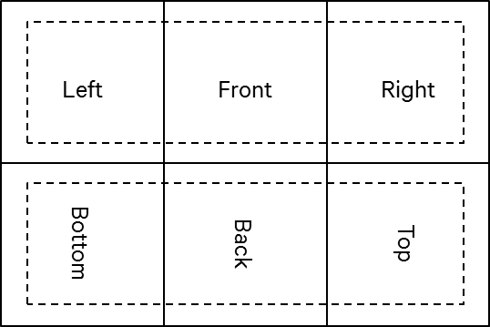
Figure 3. Proposed guard bands for 3x2 packed ACP. Guard bands are added around the top and bottom 3x1 picture halves.

Results
The proposed ACP with padding is implemented into the JVET 360Lib-3.0 [3] library (HM16.15) for evaluation. The padding width is made configurable and is set to 4 samples in the simulations. The ACP face sizes are set equal to cubemap face sizes in [4]. Frame sizes are 3552×2368 for 8K test sequences with coded sample ratio of 99.7%.

CfE test conditions
CTC conditions with frame level QP adaptation for target rate matching is used without any pre- or post-processing or rotation. Table 1 summarizes coding results according to the CfE conditions.

ACP with padding  vs. ERP |  |  | SPSNR-NN (End to End) |  |  | SPSNR-I (End to End) |  |  | CPP-PSNR (End to End) |  |  | WS-PSNR (End to End)
ACP with padding  vs. ERP | Face W | Face H | Y | U | V | Y | U | V | Y | U | V | Y | U | V
Trolley | 1184 | 1184 | -2.5% | -0.5% | -7.0% | -2.5% | -0.6% | -7.0% | -2.5% | -0.6% | -7.0% | -2.5% | -0.5% | -7.0%
Skateboarding_in_lot | 1184 | 1184 | -6.1% | -11.9% | -13.2% | -6.2% | -12.0% | -13.3% | -6.1% | -11.9% | -13.4% | -6.1% | -11.8% | -13.3%
Chairlift | 1184 | 1184 | -23.7% | -20.1% | -20.7% | -23.8% | -20.1% | -20.7% | -23.8% | -20.1% | -20.8% | -23.8% | -20.1% | -20.7%
KiteFlite | 1184 | 1184 | -4.7% | -2.7% | -6.9% | -4.7% | -2.8% | -7.0% | -4.6% | -3.0% | -7.0% | -4.6% | -2.8% | -6.9%
Harbor | 1184 | 1184 | -3.5% | -8.8% | -7.1% | -3.7% | -8.8% | -7.1% | -3.9% | -8.9% | -7.0% | -3.8% | -8.8% | -6.9%
Overall |  |  | -8.1% | -8.8% | -11.0% | -8.2% | -8.9% | -11.0% | -8.2% | -8.9% | -11.0% | -8.1% | -8.8% | -10.9%
ACP with padding  vs. ERP |  |  | SPSNR-NN (Cross Format) |  |  | SPSNR-I (Cross Format) |  |  | SPSNR-NN (Cross Format) |  |  | WS-PSNR (codec)
ACP with padding  vs. ERP | Face W | Face H | Y | U | V | Y | U | V | Y | U | V | Y | U | V
Trolley | 1184 | 1184 | -2.5% | -0.7% | -7.0% | -2.4% | -0.7% | -7.0% | -2.8% | -0.6% | -7.1% | 3.5% | -0.2% | -7.0%
Skateboarding_in_lot | 1184 | 1184 | -6.1% | -11.9% | -13.3% | -6.1% | -11.9% | -13.3% | -6.1% | -11.9% | -13.3% | -3.6% | -10.0% | -10.9%
Chairlift | 1184 | 1184 | -23.7% | -20.1% | -20.7% | -23.7% | -20.2% | -20.8% | -23.8% | -20.2% | -20.9% | -22.0% | -19.7% | -20.1%
KiteFlite | 1184 | 1184 | -4.7% | -2.8% | -6.8% | -4.7% | -2.8% | -7.0% | -4.8% | -3.2% | -7.2% | -2.0% | -2.5% | -6.8%
Harbor | 1184 | 1184 | -3.6% | -8.7% | -7.1% | -3.6% | -8.8% | -7.2% | -3.8% | -9.0% | -7.1% | 3.3% | -7.3% | -5.2%
Overall |  |  | -8.1% | -8.8% | -11.0% | -8.1% | -8.9% | -11.1% | -8.2% | -9.0% | -11.1% | -4.2% | -7.9% | -10.0%
Table 1: CfE conditions ACP coding results.
Conversion-only results are summarized in Table 2. These results are obtained by performing projection from 8K ERP source to target projection (10-bit) and projecting back to 8K ERP (10-bit). The conversion results are with ACP padding enabled.

ACP conversion (with padding) |  |  | WS-PSNR (End to End)
ACP conversion (with padding) | Face W | Face H | Y | U | V
Trolley | 1184 | 1184 | 45.21 | 57.94 | 57.83
Skateboarding_in_lot | 1184 | 1184 | 49.66 | 61.39 | 61.06
Chairlift | 1184 | 1184 | 49.91 | 59.50 | 59.57
KiteFlite | 1184 | 1184 | 46.32 | 57.66 | 57.65
Harbor | 1184 | 1184 | 48.91 | 59.09 | 58.06
Overall |  |  | 48.00 | 59.12 | 58.83

Table 2: ACP conversion only results.

CTC test conditions
Per common test conditions for 360-degree video [4], the random access (RA) coding gain of ACP with padding (width=4 samples) and 3×2 packing is enumerated per sequence in Table 3. The ACP face sizes are set equal to cubemap face sizes in [4]. Frame sizes are 3552×2368 for 8K test sequences and 2880×1920 for 4K. The end-to-end coding gain (e2e WS-PSNR) slightly decreases from 11.0% to 10.7% compared to the ACP without padding.

ACP with padding  vs. ERP |  |  | SPSNR-NN (End to End) |  |  | SPSNR-I (End to End) |  |  | CPP-PSNR (End to End) |  |  | WS-PSNR (End to End)
ACP with padding  vs. ERP | Face W | Face H | Y | U | V | Y | U | V | Y | U | V | Y | U | V
Trolley | 1184 | 1184 | -6.7% | 3.1% | -1.1% | -6.9% | 2.9% | -1.2% | -6.9% | 2.9% | -1.2% | -6.8% | 3.0% | -1.2%
GasLamp | 1184 | 1184 | -3.6% | 2.3% | 7.4% | -3.7% | 2.2% | 7.2% | -3.7% | 2.2% | 7.3% | -3.6% | 2.4% | 7.4%
Skateboarding_in_lot | 1184 | 1184 | -16.0% | -16.4% | -17.1% | -16.1% | -16.6% | -17.2% | -16.0% | -16.6% | -17.3% | -15.9% | -16.4% | -17.2%
Chairlift | 1184 | 1184 | -25.0% | -18.1% | -18.3% | -25.0% | -18.1% | -18.3% | -25.1% | -18.1% | -18.4% | -25.0% | -18.1% | -18.4%
KiteFlite | 1184 | 1184 | -9.3% | -2.5% | -4.2% | -9.5% | -2.7% | -4.3% | -9.4% | -2.7% | -4.3% | -9.2% | -2.6% | -4.2%
Harbor | 1184 | 1184 | -8.7% | -3.8% | -2.9% | -8.9% | -3.9% | -2.9% | -9.2% | -3.9% | -2.9% | -9.0% | -3.8% | -2.8%
PoleVault | 960 | 960 | -8.9% | -9.9% | -9.8% | -8.5% | -9.7% | -9.7% | -8.5% | -9.7% | -9.9% | -8.8% | -9.8% | -9.8%
AerialCity | 960 | 960 | -3.3% | -1.8% | -1.4% | -3.5% | -2.1% | -1.7% | -3.4% | -2.1% | -1.7% | -3.2% | -1.8% | -1.4%
DrivingInCity | 960 | 960 | -4.5% | 4.4% | 4.1% | -3.9% | 4.0% | 3.6% | -3.7% | 4.0% | 3.6% | -4.4% | 4.4% | 4.1%
DrivingInCountry | 960 | 960 | -20.7% | -18.2% | -19.0% | -20.1% | -18.4% | -19.1% | -20.1% | -18.4% | -19.0% | -20.7% | -18.2% | -18.9%
Overall |  |  | -10.7% | -6.1% | -6.2% | -10.6% | -6.2% | -6.4% | -10.6% | -6.2% | -6.4% | -10.7% | -6.1% | -6.2%
Table 3: CTC conditions for ACP with 4 sample padding.

JVET-F1004 test conditions
Proposed ACP with padding scheme is also evaluated at CfE target rate points with “evil viewports” defined in [5]. Table 4 summarizes the padded ACP performance vs. the ERP per JVET-F1004.

 | Y | U | V
SPSNR-NN (End to End) | -8.1% | -8.8% | -11.0%
SPSNR-I (End to End) | -8.2% | -8.9% | -11.0%
CPP-PSNR (End to End) | -8.2% | -8.9% | -11.0%
WS-PSNR (End to End) | -8.1% | -8.8% | -10.9%
PSNR_DYN_Viewport0 | -12.0% | -12.3% | -11.7%
PSNR_DYN_Viewport1 | -12.0% | -7.5% | -8.5%
SPSNR-NN (Cross Format) | -8.1% | -8.8% | -11.0%
SPSNR-I (Cross Format) | -8.1% | -8.9% | -11.1%
CPP-PSNR (Cross Format) | -8.2% | -9.0% | -11.1%
WS-PSNR (codec) | -4.2% | -7.9% | -10.0%
PSNR (codec) | 16.6% | 23.6% | 22.8%
Table 4. JVET-F1004 coding results summary.

Conclusion
ACP with padding implemented on top of HM-16.15 was presented to JVET’s Call for Evidence on 360-degree video. For CfE conditions, the reported coding gain is 8.2% (e2e WS-PSNR) for RA conditions. For CTC conditions, the reported coding gain is 10.7% (e2e WS-PSNR). It is claimed that the seam artifacts in the rendered viewports are adequately reduced.

References
- M. Coban, G. Van der Auwera, M. Karczewicz, “AHG8: Adjusted cubemap projection for 360-degree video,” 6th JVET Meeting, Hobart, AU, March-April 2017, JVET-F0025.
- Y. Ye, E. Alshina, J. Boyce, “Algorithm descriptions of projection format conversion and video quality metrics in 360Lib,” 6th JVET Meeting, Hobart, AU, March-April 2017, JVET-F1003.
- 360Lib-3.0: https://jvet.hhi.fraunhofer.de/svn/svn_360Lib/tags/360Lib-3.0/
- E. Alshina, J. Boyce, A. Abbas, Y. Ye, “JVET common test conditions and evaluation procedures for 360-degree video”, 6th JVET Meeting, Hobart, AU, March-April 2017, JVET-F1030.
- J. Boyce, E. Alshina, Z. Deng, “Subjective testing method for comparison of 360° video projection formats using HEVC”, 6th JVET Meeting, Hobart, AU, March-April 2017, JVET-F1004.
- G. Van der Auwera, M. Coban, M. Karczewicz, “AHG8: ACP with padding for 360-degree video,” 7th JVET Meeting, Torino, Italy, July 2017, JVET-G0071.

Patent rights declaration
Qualcomm Inc. may have current or pending patent rights relating to the technology described in this contribution and, conditioned on reciprocity, is prepared to grant licenses under reasonable and non-discriminatory terms as necessary for implementation of the resulting ITU-T Recommendation | ISO/IEC International Standard (per box 2 of the ITU-T/ITU-R/ISO/IEC patent statement and licensing declaration form).

