    Joint Video Exploration Team (JVET)  of ITU-T SG 16 WP 3 and ISO/IEC JTC 1/SC 29/WG 11  6th Meeting: Hobart, AU, 31 March – 7 April 2017 | Document: JVET-F1030-v4

Title: | JVET common test conditions and evaluation procedures for 360° video
Status: | Output Document of JVET
Purpose: | Report
Author(s) or  Contact(s): | Jill Boyce, Elena Alshina, Adeel Abbas, Yan Ye | Email: | jill.boyce@intel.com,  elena_a.alshina@samsung.com,  aabbas@gopro.com, Yan.Ye@InterDigital.com
Source: | Editors
_____________________________

Abstract
This document defines common test conditions and software reference configurations to be used in video codec performance evaluation for 360° video. These 360° video test conditions are also recommended for use in technical contributions to the 7th JVET meeting.

Introduction
360° video common test conditions are desirable to conduct experiments in a well-defined environment and ease the comparison of the outcome of experiments.
Version 16.15 of HM HEVC reference software should be used for experiments using the HM. For 360°-specific coding tool proposals, JEM6.0 software is recommended.

Testing procedure

Definitions
Here and after following abbreviations are used to specify formats (projections) representing 360° video, which are further described in JVET-F1003 ‎[2].
ERP – Equi-rectangular projection
CISP – Compact Icosahedral projection
CMP –Cube Map projection
COHP – Compact Octahedron projection
SSP – Segmented sphere projection
EAP – Equal-area projection
ACP – Adjusted cube map projection
RSP – Rotated sphere projection

There are two categories of frame packing for three projections ISP, CMP and OHP listed above. They are known as “native” and “compact” layouts.
Additionally to PSNR specific quality metric for spherical video listed below will be used, as defined in JVET-F1003 ‎[2]:
- WS-PSNR
- CPP-PSNR
- S-PSNR-I
- S-PSNR-NN (w/o interpolation)

Processing chain
High fidelity test materials are provided in YUV 4:2:0 format representing 360° video in ERP. Prior to the encoding those materials are converted to one of the projection formats listed above according to the testing procedure specified by Figure 1.

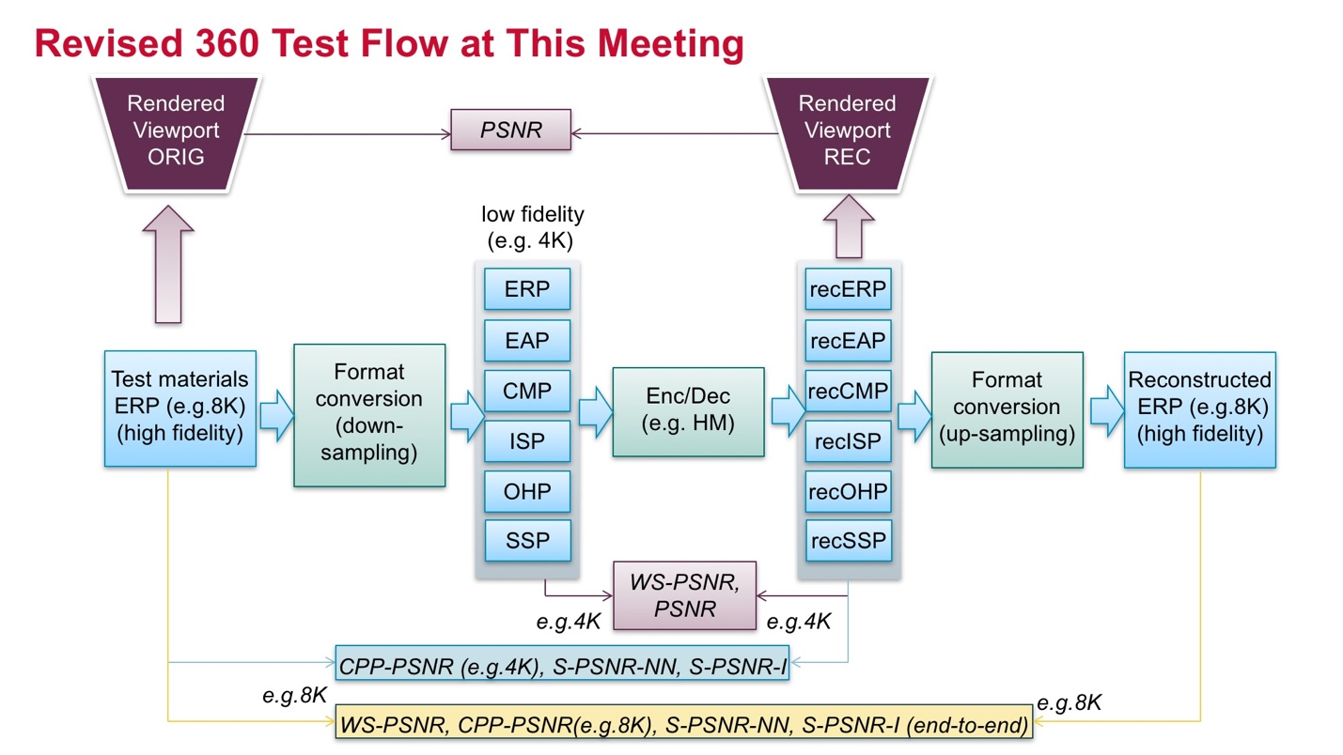
Figure 1 – 360° video testing procedure

Software
For conversions and quality measurement, the 360Lib-3.0 software package located at https://jvet.hhi.fraunhofer.de/svn/svn_360Lib/tags/360Lib-3.0/ should be used.
JVET-F1003 ‎[2] “Algorithm description of projection format conversion and video quality metrics in 360Lib” provides additional information about the projection format conversion process, packing formats, and the video quality metric computations supported in the software package.

Test sequences and sizes

High fidelity input
Table 1 defines the set of test sequences agreed to be used. They are all in YUV 4:2:0 format representing 360° video in ERP. Height (H) of the picture in ERP projection is half of the width (W) reported in Table 1. All frames (as defined by frame count in the table) shall be processed and encoded for all sequences.
Test sequences are available on ftp://jvet@ftp.ient.rwth-aachen.de and ftp://jvet@ftp.hhi.fraunhofer.de in the /testsequences/testset360 directory. Accredited members of VCEG and MPEG may contact the JVET chairs for login information.
Table 1 – High fidelity input test sequences in ERP format
Class | Sequence name | Frame count | Resolution@FPS | Bit-depth | Proposed in
8K | SkateboardInLot | 300 | 8192×4096@30 | 10 | JVET-D0026
8K | ChairLift | 300 | 8192×4096@30 | 10 | JVET-D0026
8K | KiteFlite | 300 | 8192×4096@30 | 8 | JVET-D0039
8K | Harbor | 300 | 8192×4096@30 | 8 | JVET-D0039
8K | Trolley | 300 | 8192×4096@30 | 8 | JVET-D0039
8K | GasLamp | 300 | 8192×4096@30 | 8 | JVET-D0039
4K | PoleVault_le | 300 | 3840×1920@30 | 8 | JVET-D0143
4K | AerialCity | 300 | 3840×1920@30 | 8 | JVET-D0179
4K | DrivingInCity | 300 | 3840×1920@30 | 8 | JVET-D0179
4K | DrivingInCountry | 300 | 3840×1920@30 | 8 | JVET-D0179

The final versions of the test sequence files names and md5 check sums are given in Table 2:
Table 2 – Test sequences and Md5 checksums
Sequence | Md5
SkateboardInLot_8192x4096_30fps_10bit_420_erp.yuv | e8eae04c43e959060f641fec4892fced
ChairliftRide_8192x4096_30fps_10bit_420_erp.yuv | 9126f753bb216a73ec7573ecc4a280c3
KiteFlite_8192x4096_30fps_8bit_420_erp.yuv | 18c0ea199b143a2952cf5433e8199248
Harbor_8192x4096_30fps_8bit_420_erp.yuv | aa827fdd01a58d26904d1dbdbd91a105
Trolley_8192x4096_30fps_8bit_420_erp.yuv | 25c1082d1e572421da2b16530718156d
GasLamp_8192x4096_30fps_8bit_420_erp.yuv | 3417d0b862ffb0fd34f65c3bc810d25c
PoleVault_le_3840x1920_30fps_8bit_420_erp.yuv | d038b3b1497df2ce5894a9f28cb467a8
AerialCity_3840x1920_30fps_8bit_420_erp.yuv | a9eb9e7d44722c76dcbb6a56a8dd7248
DrivingInCity_3840x1920_30fps_8bit_420_erp.yuv | 909667e65a9a6ad67780b6ada28328d8
DrivingInCountry_3840x1920_30fps_8bit_420_erp.yuv | d982a6d1d186f8015b4f2eae080b2b61

Coding projections
Prior to the encoding, high fidelity test materials are converted to one of the coding projections listed above. Frame sizes for each projection listed in Table 3 will be used for generation of anchors. For the 8K ERP source, the coding size is half width and half height of the high fidelity ERP, and for the remaining coding projections the sizes are selected to have approximately the same number of coded samples as for the coded ERP (that is, 25% of the high fidelity 8K ERP). For the 4K ERP source, encoding size is 75% of the high fidelity ERP for all projections.
For new projection format proposals, the number of coded samples should not exceed 101% of the coded samples for the ERP coded format.
For all conversions between projections prior to the encoding and after decoding conversion software shall use 6-taps Lanczos filter for Luma and 4-taps Lanczos filter for Chroma.
Table 3 – Frame sizes for different projections
Class  Format | 8K |  |  |  | 4K
Class  Format | faceW | faceH | W | H | faceW | faceH | W | H
ERP high fidelity | NA | NA | 8192 | 4096 | NA | NA | 3840 | 1920
ERP for coding | NA | NA | 4096 | 2048 | NA | NA | 3328 | 1664
CISP | 952 | 824 | 2496 | 3320 | 776 | 672 | 2056 | 2712
CMP compact | 1184 | 1184 | 3552 | 2368 | 960 | 960 | 2880 | 1920
COHP | 1544 | 1336 | 2672 | 3096 | 1264 | 1096 | 2192 | 2536
SSP | 1184 | 1184 | 1184 | 7104 | 960 | 960 | 960 | 5760
EAP | NA | NA | 4096 | 2048 | NA | NA | 3328 | 1664
ACP | 1184 | 1184 | 3552 | 2368 | 960 | 960 | 2880 | 1920
RSP | 1184 | 1184 | 3552 | 2368 | 960 | 960 | 2880 | 1920

Referring to Figure 1, first the input projection is converted to the coding projection at resolutions specified in Table 3. The output of conversion process is YUV 4:2:0 10 bits video. So input bit-depth for encoding is 10 bits. Encoding and decoding are performed using 10 bits internal bit-depth.After encoding and decoding WS-PSNR is calculated between original and reconstructed video. In 360Lib, WS-PSNR is available for all projection formats except TSP.
Between reconstructed coding projection and high fidelity ERP CPP-PSNR and S-PSNRs are calculated. CPP-PSNR is currently available for all projections except EAP. For CPP-PSNR, the metric is calculated at the lower resolution (that is, resolution of the reconstructed coding projection) according to Figure 1.
Two variants of S-PSNR calculation will be performed: S-PSNR-I original metric developed with 6-taps Lanczos interpolation for matching between positions on sphere and S-PSNR-NN w/o interpolation and instead with rounding to the nearest integer sample position.
Reconstructed coding projection is converted to ERP format with picture size equal to the high fidelity ERP original video. WS-PSNR is measured between original and reconstructed ERP in high fidelity resolution.
Objective metrics are calculated for dynamic viewports within a Field Of View (FoV), calculated based on 2D rectilinear viewport pictures generated from 360°×180° video. The viewport rendered from the reconstructed coding projection (reconstructed viewport) will be compared with an anchor generated from the high fidelity ERP (original viewport). For each test sequence, 2 dynamic viewports will be generated, with a field of view size of 75°×75°. Viewport parameters for each test sequence are listed in Table 4. A center position of each viewport is provided in (yaw, pitch). For the dynamic viewport, a range of (yaw, pitch) offset positions are provided for the first and last pictures of the sequence, with linear interpolation of the offset position for the other pictures in the sequence. 360Lib software is used to generate the dynamic viewports. The output of viewport generation is 10 bits 4:2:0 YUV video of the size listed in Table 4. Between original viewport and reconstructed viewport. PSNR will be measured.
Table 4 – Dynamic view port parameters
Class | Sequence name | Viewport Size | V1 start  (yaw, pitch) | V1 end  (yaw, pitch) | V2 start  (yaw, pitch) | V2 end  (yaw, pitch)
8K | SkateboardInLot | 1816×1816 | −180, 35 | −270, 5 | −65, −5 | 25, 25
8K | ChairliftRide | 1816×1816 | −45, −15 | 45, 15 | −201, −73 | −111, −43
8K | KiteFlite | 1816×1816 | −114, −53 | −24, −23 | 13, −41 | 103, −11
8K | Harbor | 1816×1816 | −83, −56 | 7, −26 | −140, 12 | −50, 42
8K | Trolley | 1816×1816 | 210, −18 | 300, 12 | 30, −44 | 120, −14
8K | GasLamp | 1816×1816 | −51, −11 | 39, 19 | 61, −15 | 151, 15
4K | PoleVault | 856×856 | −45, −15 | 45, 15 | 32, −53 | 122, −23
4K | AerialCity | 856×856 | −45, −15 | 45, 15 | 77, −54 | 167, −24
4K | DrivingInCity | 856×856 | −31, −44 | 59, −14 | 45, −15 | 135, 15
4K | DrivingInCountry | 856×856 | −45, −15 | 45, 15 | 91, −47 | 181, −17

In total 11 different metrics will be reported: both PSNR reported by codec and WS-PSNR between input and output of the codec, CPP-PSNR, S-PSNR-I and S-PSNR-NN between decoded output and input high fidelity ERP, CPP-PSNR, S-PSNR-I, S-PSNR-NN and WS-PSNR between original and reconstructed ERP in highest resolution, and PSNR for 2 dynamic viewports.
In addition, for each projection format, an end-to-end WS-PSNR calculation of the projection mapping process without compression should be provided, calculated between the original and reconstructed video, but skipping the Enc/Dec step in Figure 1.
For coding tool propoposals, test results for ERP are mandatory to be reported. Test results for other projection formats are optional.

Subjective quality check using “evil viewports”
For each projection format, a subjective quality check test should be performed to evaluate the impact of discontinuous edges, as described in ‎[3]. Bitstreams or decoded video should be provided for viewing by the AHG, according to the following procedure.
Two vertex locations will be identified for each projection format, as indicated in Table 5. The first vertex will be along the picture border at a discontinuous edge. The second vertex will be within the picture, not along the picture border, at a position with a maximum number of discontinuous edges. For ERP, the second “vertex” is at the (0, 0) center of the picture, and does not align with a discontinuos edge, as the only discontinuous edge in the format is already represented by the first vertex ‎[4].
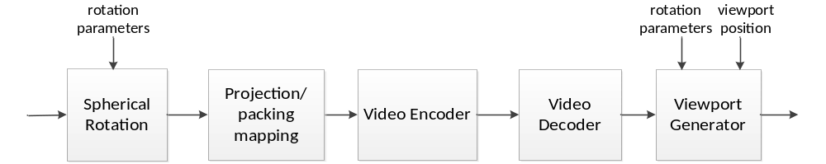
Figure 2 – 360° video subjective testing procedure with “evil viewports”

Table 5 – Vertex positions for “evil viewports”
Format | Vertex 1 (yaw, pitch) (in degrees) | Vertext 2 (yaw, pitch) (in degrees)
ERP | −180, 0 | 0, 0
CMP | −135, 35 | 45, −35
CISP | 0, 27 | −141, −90
COHP | −180, 45 | 0, 45
SSP | −180, 45 | 90, −45
EAP | −180, −90 | 0, −90
ACP | −135, 35 | 45, −35
RSP | −135, 0 | 0, −45

Table 6 – Static viewport center before rotation
Class | Sequence name | Viewport Size | Static viewport 1 (yaw, pitch) center (in degrees) | Static viewport 2 (yaw, pitch) center (in degrees)
8K | SkateboardInLot | 1816×1816 | −225, 20 | −20, 10
8K | ChairLift | 1816×1816 | 0, 0 | −156, −58
8K | KiteFlite | 1816×1816 | −69, −38 | 58, −26
8K | Harbor | 1816×1816 | −38, −41 | −95, 27
8K | Trolley | 1816×1816 | 255, −3 | 75, −29
8K | GasLamp | 1816×1816 | −6, 4 | 106, 0
4K | PoleVault | 856×856 | 0, 0 | 77, −38
4K | AerialCity | 856×856 | 0, 0 | 122, −39
4K | DrivingInCity | 856×856 | 14, −29 | 90, 0
4K | DrivingInCountry | 856×856 | 0, 0 | 136, −32

As the sequence is rotated prior to encoding, as illustrated in Figure 2, it requires a separate encoding at the lowest rate point for each identified vertex and each identified static viewport. Note that the vertex indicated in Table 5 is the destination viewport center in the rotated projection format, and the static viewport center defined in Table 6 is the source viewport center in the original picture before rotation. After decoding, static viewports centered at the vertex defined in Table 5 should be extracted for subjective quality check. For a particular projection format, 4 decoded evil viewports shall be provided for each sequence, including (a) Static viewport 1 centered at Vertex 1, (b) Static viewport 1 centered at Vertex 2, (c) Static viewport 2 centered at Vertex 1, and (d) Static viewport 2 centered at Vertex 2. To force the identified vertex to be located in the center of the identified viewport, two steps of rotations are needed by using the 360lib software. Specifically, for a given vertex in (dst_yaw, dst_pitch) Table 5 and a given source viewport center in (src_yaw, src_pitch) Table 6, firstly, the input ERP is rotated to let the source viewport center to be located at the (0, dst_pitch) center of the picture, secondly, it is further rotated to let the (0, dst_pitch) center of the picture to the identified vertex (dst_yaw, dst_pitch). The first step is a pure ERP–to-ERP rotation and the output frame size is the same with the input. The second step is done together with the encoding and format conversion (down-sampling).

Encoder configurations and quantization parameter values
Encoder configuration files and their usage, as well as software configuration for both HM and JEM are described in ‎[1]. For each video sequence four quantization parameter values are to be used: 22, 27, 32 and 37.
Aligned with JVET common test condition document [1], four tests, reflecting intra-only, random-access, and low-delay settings are defined:
- Intra, 10 bit
- Random access, 10 bit
- Low delay, 10 bit
- Low delay, P slices only, 10 bit
Among them, Random access is mandatory while remaining are optional. To be aligned with JVET and JCT-VC CTC, in random access tests motion search range is set to 256, GOP size is set to 16 for both HM and JEM.

Test results
Templates for reporting test results for HM and JEM coding can be found in https://jvet.hhi.fraunhofer.de/svn/svn_360Lib/.

References
- K. Suehring, X. Li, “JVET common test conditions and software reference configurations”, Joint Video Exploration Team of ITU-T SG16 WP3 and ISO/IEC JTC1/SC29/WG11, JVET-B1010, 2nd Meeting, Feb. 2016.
- Y. Ye, E. Alshina, J. Boyce, “Algorithm descriptions of projection format conversion and video quality metrics in 360Lib”, Joint Video Exploration Team of ITU-T SG 16 WP 3 and ISO/IEC JTC 1/SC 29/WG 11, JVET-F1003, 6th Meeting, Apr. 2017.
- J. Boyce, Z. Deng, “AHG8: Subjective testing of 360º video projection/packing formats”, Joint Video Exploration Team of ITU-T SG 16 WP 3 and ISO/IEC JTC 1/SC 29/WG 11, JVET-F0021, 6th Meeting, Apr. 2017.
- Z. Deng, L. Xu, J. Boyce, “AHG8: Subjective test pilot study of 360º video projection/packing formats”, Joint Video Exploration Team of ITU-T SG 16 WP 3 and ISO/IEC JTC 1/SC 29/WG 11, JVET-F0083, 6th Meeting, Apr. 2017.

