    Joint Video Exploration Team (JVET)  of ITU-T SG 16 WP 3 and ISO/IEC JTC 1/SC 29/WG 11  6th Meeting: Hobart, AU, 31 March – 7 April 2017 | Document: JVET-F0050

Title: | AhG8: Dynamic viewport based subjective evaluation of 360-degree video coding under CfE test conditions
Status: | Input Document to JVET
Purpose: | Information
Author(s) or  Contact(s): | Philippe Hanhart, Yuwen He, Yan Ye  9710 Scranton Rd, #250  San Diego, CA 92121, USA | Tel:  Email: | +1 858 210 4841  Philippe.Hanhart@interdigital.com  Yuwen.He@interdigital.com  Yan.Ye@interdigital.com
Source: | InterDigital Communications Inc.
_____________________________

Abstract
A preliminary Joint Call for Evidence (CfE) on Video Compression with Capability beyond HEVC was issued at the 5th JVET meeting (JVET-E1002). The preliminary CfE covers 360-degree video among other test cases and defines the test conditions, e.g., coding configuration, sequences, and bit rates, for the evaluations. For subjective evaluation, it is specified that dynamic viewports will be viewed on ordinary monitors and assessed using the expert viewing protocol (EVP) method (Rec. ITU-R BT.2095-0). This document reports results of a subjective evaluation comparing dynamic viewports as defined in JVET-E1030 rendered from 360-degree video sequences encoded with HM-16.15 and JEM-5.0.1 in the equirectangular projection (ERP) format under CfE test conditions. The EVP method was used to assess the compression efficiency of HM and JEM. Results show that JEM achieves some visual quality improvements over HM at low and mid bit rate. Finally, based on observations made during the experiment, this document discusses issues regarding the use of the EVP method.

Introduction
An important question is whether JEM can provide better visual quality than HM for 360-degree video sequences. In our previous contribution [1], we have reported the results of two subjective evaluations comparing HM and JEM at low bit rates. Two static viewports were presented side-by-side on a 4K monitor and assessed using the stimulus comparison method to compare the quality difference between HM and JEM. At the 5th JVET meeting, the common test conditions and evaluation procedures for 360-degree video coding were refined [2]. In particular, it was decided to consider dynamic viewports instead of static viewports in order to cover a larger portion of the sphere. However, a major question was what are the proper parameters for the yaw and pitch velocity in order to cover a larger portion of the sphere without inducing visual discomfort. Based on the dynamic viewport examples provided in [3], it was decided to restrict the yaw and pitch change to a rather limited range to preserve visual comfort.
Considering the change in 360-degree video common test conditions and evaluation procedures, we conducted a new subjective evaluation to assess the coding performance of HM and JEM using dynamic viewports rendered according to the specifications in JVET-E1030 and displayed on a 4K monitor. The HM and JEM bitstreams were generated in compliance with the CfE conditions [4]. Additionally, the same EVP method was used in the subjective evaluation since this methodology was selected for the evaluation of the CfE responses [4].

Methodology

Datasets
The dataset was built following the CfE anchor definition in [4]. In total, four 360-degree video sequences in 8K ERP original format were used. The encoding was done in the ERP format, using the Random Access configuration. The QP was adjusted to match the targeted bit rates defined in [4] (see Table 1). Then, for each sequence, two dynamic viewports were rendered from the decoded bit stream using the 360Lib software [5] according to the parameters defined in [2] (see Table 2).
Table 1. Target bit rates.
Sequence | bit rate [kbps]
Sequence | Rate 1 | Rate 2 | Rate 3 | Rate 4
SkateboardInLot | 2000 | 3300 | 6000 | 10000
ChairLift | 1500 | 2400 | 4000 | 7000
KiteFlite | 1500 | 2400 | 4000 | 7000
Harbor | 1200 | 2000 | 3300 | 6000
Table 2. Dynamic viewport parameters.
Sequence | Viewport size | Viewport center  (yaw, pitch in degrees) |  | Viewport range relative to center  (yaw, pitch in degrees)
Sequence | Viewport size | Viewport 1 | Viewport 2 | Viewport range relative to center  (yaw, pitch in degrees)
SkateboardInLot | 1816x1816 | 0, 0 | −76, −28 | -45, -15 to 45, 15
ChairLift | 1816x1816 | 0, 0 | −156, −58 | -45, -15 to 45, 15
KiteFlite | 1816x1816 | −69, −38 | 58, −26 | -45, -15 to 45, 15
Harbor | 1816x1816 | −38, −41 | −95, 27 | -45, -15 to 45, 15

Test environment
The experiment was conducted in a dark room with grey walls, black curtains, and no ambient light. To display the test stimuli, a Samsung UN55HU6950 55” 4K LCD TV with a native resolution of 3840×2160 pixels was used. The monitor was calibrated to the following profile: sRGB gamut, D65 white point, 120 cd/m² brightness, and minimum black level. The experiment involved one subject per test session. The subject was seated in line with the center of the monitor at a distance of 1.6 times the image height, as suggested in [6].

Test method
The EVP method [7] was used to perform the test. Subjects were presented with triplets of video sequences (i.e., stimuli), where the first sequence was always the source reference sequence (SRC) (reference stimulus), followed by two processed video sequences (PVSs) to be evaluated (stimuli A and B). After the presentation of the second PVS, a six-second voting time followed. An 11-grade numerical categorical scale was used (see Table 3). Subjects were asked to rate the impairments of stimuli A and B in relation to the reference stimulus, without comparing stimuli A and B directly, and to express these judgments in terms of the wordings used to define the rating scale.

Table 3. Meaning of the 11-grade numerical scale.
Score | Definition
10 | Imperceptible
9 | Slightly perceptible | Somewhere
8 | Slightly perceptible | Everywhere
7 | Perceptible | Somewhere
6 | Perceptible | Everywhere
5 | Clearly perceptible | Somewhere
4 | Clearly perceptible | Everywhere
3 | Annoying | Somewhere
2 | Annoying | Everywhere
1 | Severely annoying | Somewhere
0 | Severely annoying | Everywhere
One PVS was always the HM anchor whereas the other PVS was the JEM anchor. The position and rate points of the HM and JEM anchors were randomized. The test material was presented in random order, but never with the same video content in consecutive triplets. To allow the viewers to have an immediate impression of the quality range, a stabilization phase was included at the beginning of the test, with test material corresponding to the “best”, “worst”, and “mid quality”.
Before the test starts, oral instructions were provided to the subject to explain his/her task. Additionally, a brief training session was organized to allow subjects to familiarize with the assessment procedure. The training materials were presented to subjects exactly as for the test materials.

Results
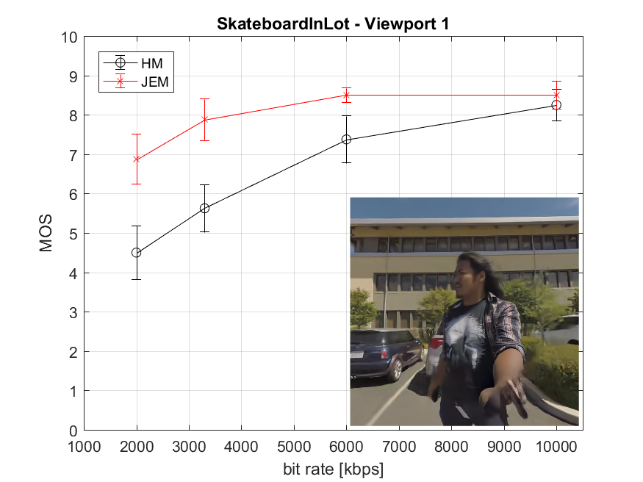 | 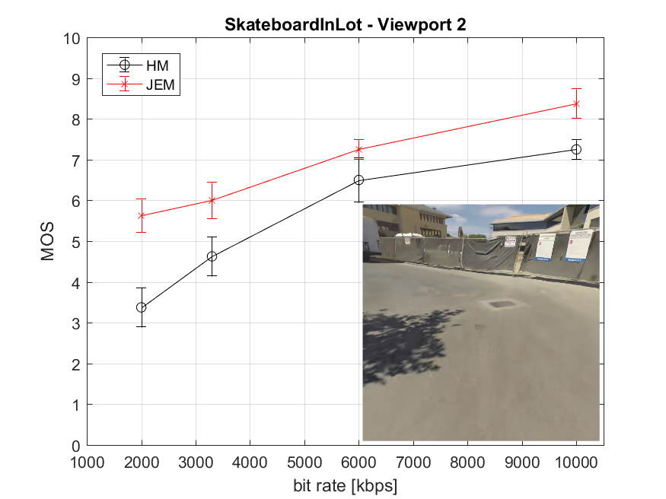
(a) | (b)
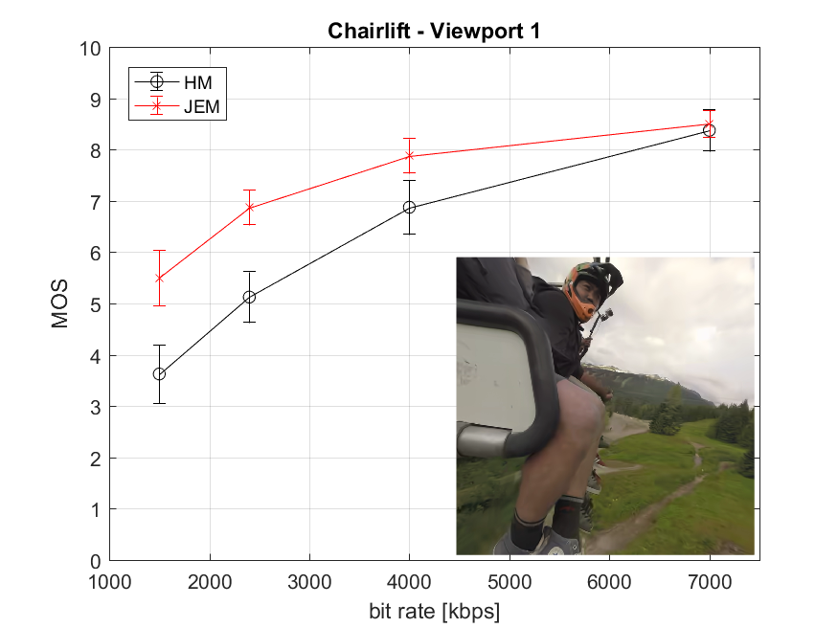 | 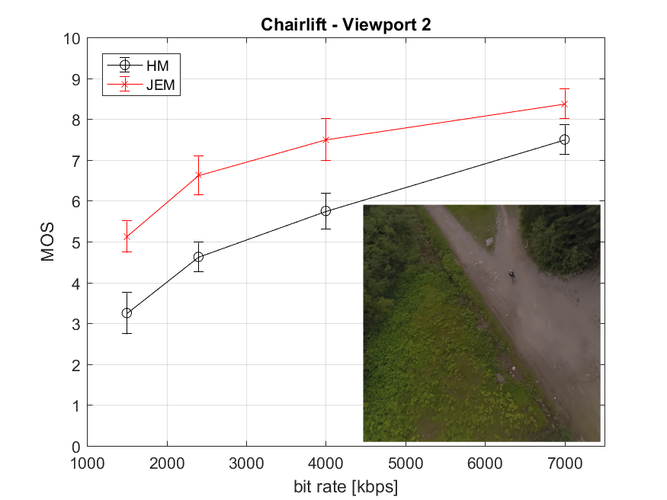
(c) | (d)
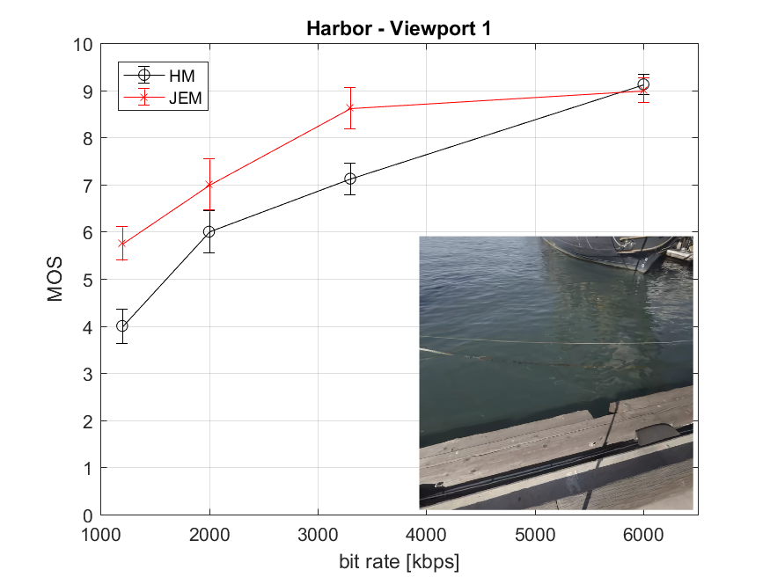 | 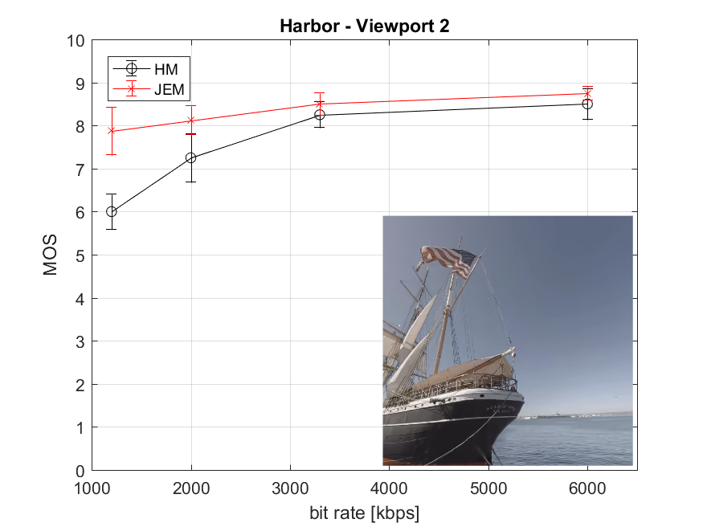
(e) | (f)
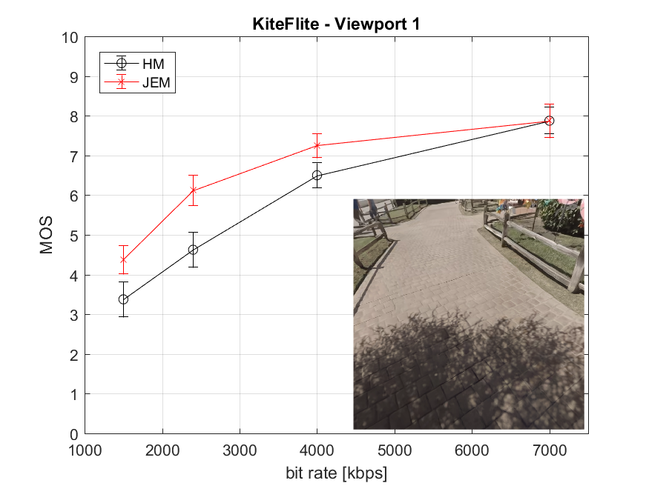 | 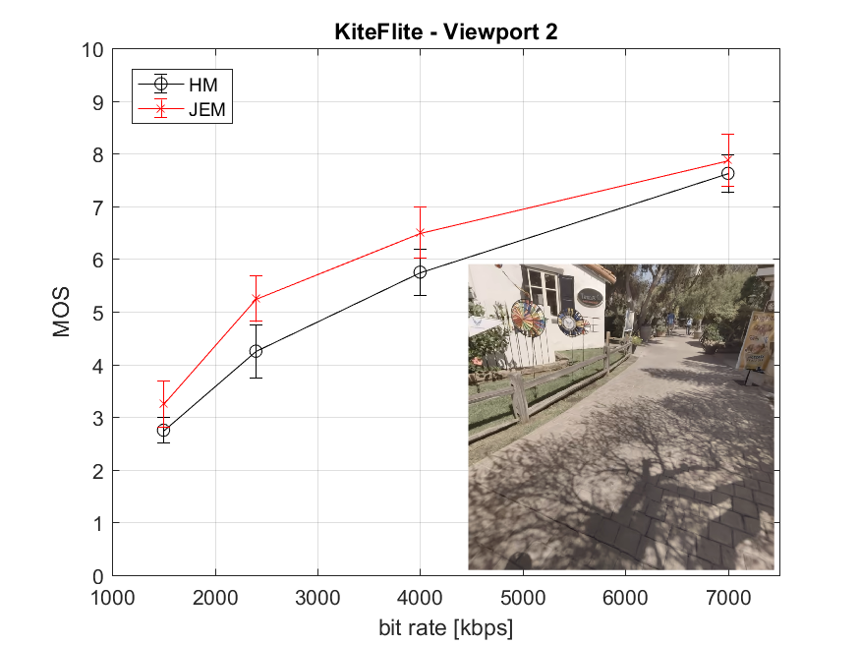
(g) | (h)
Figure 1. Subjective results.
A total of 10 expert viewers took part in the experiment. The subjective scores were processed by first detecting and removing subjects whose scores deviated strongly from others. The outlier detection was applied to the set of results obtained from the 10 subjects based on the Pearson’s linear correlation between the individual scores of each subject and the mean scores computed across all subjects [7]. According to [7], subjects whose correlation coefficient was below 0.75 were rejected. In this study, two outliers were detected. Then, the mean opinion score (MOS) was computed for each test stimulus as the mean across scores by valid subjects, as well as associated 95% confidence interval (CI). Figure 1 reports the final MOSs and associated 95% CIs.
Results show that JEM outperforms HM on all sequences at the lowest and intermediate rates, whereas the performance of HM and JEM is quite similar at the highest rate point. As it can be observed in Figure 1, even at the highest bit rate, impairments are still slightly perceptible. For sequences SkateboardingInLot and Harbor, banding artifacts were always visible in the sky for both HM and JEM compressed sequences at all bit rates. Another observation is that the quality variation is content and viewport dependent. In particular, for sequence Harbor, blockiness can easily be observed in the water in the first viewport, whereas mainly banding artifacts can be observed in the sky in the second viewport. This example shows that the viewport selection may impact the results of the subjective evaluation.

Discussion
Despite the fact that viewers are instructed to compare each PVS to the SRC and not to compare the two PVSs between each other, viewers are typically influenced by the first PVS when evaluating the second PVS. Therefore, because of the presentation order, viewers naturally tend to perform an absolute grading for the first PVS and a relative grading for the second PVS, i.e., compare it to the first PVS instead of the SRC. As a result, the grading of stimulus B is biased when compared to the grading of stimulus A. One possible way to reduce this bias is to have different presentation orders for different group of viewers and to ensure that both AB and BA pairs are evaluated. However, 360-degree video creates another challenge that may not be solved using different presentation order, as the source 360-video sequences contain stitching artifacts. Considering that the PVSs may contain face discontinuities, which have similar characteristics to stitching artifacts, they may easily be confused with stitching artifacts from the SRC. Since different projection formats and/or rotations may be used, the locations of the face discontinuities may vary between two PVSs. Therefore, face boundary artifacts in the second PVS may be wrongly classified as stitching artefacts, as viewers tend to remember the first PVS better than the SRC when assessing the second PVS. This problem can be addressed by using a double-stimulus impairment scale (DSIS) method instead of the EVP method. In this way, the SRC is presented before each PVS.
Multiple expert viewers reported that they sometimes had difficulty completing the votes within the voting time allocated (6s). This was primarily caused by two factors: 1) viewers have to provide their vote for two PVSs in the same amount of time that is considered for only one PVS in the methods defined in [8]; 2) the 11-grade scale is more complex to handle for viewers when compared to the typical 5-grade scale defined in [8], especially if one wants to relate to the exact meaning of the wordings used to define the scale in the EVP method. As a results, subjects may miss the beginning of the SRC in the next presentation. Considering all these aspects, even if the EVP method is designed for expert viewers, it creates a higher cognitive load and is more stressful when compared to traditional test methods.

References
- P. Hanhart, Y. He, Y. Ye, “AhG8: Viewport-based subjective evaluation of 360-degree video coding”, Joint Video Exploration Team of ITU-T SG16 WP3 and ISO/IEC JTC1/SC29/WG11, JVET-E0071, 5th Meeting, Jan. 2017.
- J. Boyce, E. Alshina, A. Abbas, Y. Ye, “JVET common test conditions and evaluation procedures for 360° video”, Joint Video Exploration Team of ITU-T SG16 WP3 and ISO/IEC JTC1/SC29/WG11, JVET-E1030, 5th Meeting, Jan. 2017.
- J. Boyce, Z. Deng, “Dynamic viewport examples”, Joint Video Exploration Team of ITU-T SG16 WP3 and ISO/IEC JTC1/SC29/WG11, JVET-E0133, 5th Meeting, Jan. 2017.
- M. Wien, V. Baroncini, J. Boyce, A. Segall, T. Suzuki, “Preliminary Joint Call for Evidence on Video Compression with Capability beyond HEVC”, Joint Video Exploration Team of ITU-T SG16 WP3 and ISO/IEC JTC1/SC29/WG11, JVET-E1002, 5th Meeting, Jan. 2017.
- 360Lib-2.1, https://jvet.hhi.fraunhofer.de/svn/svn_360Lib/tags/360Lib-2.1
- ITU-R BT.2022, “General viewing conditions for subjective assessment of quality of SDTV and HDTV television pictures on flat panel displays”, International Telecommunication Union, Aug. 2012.
- ITU-R BT.2095-0, “Subjective assessment of video quality using expert viewing protocol”, International Telecommunication Union, Apr. 2016.
- ITU-R BT.500-13, “Methodology for the subjective assessment of the quality of television pictures”, International Telecommunication Union, Jan. 2012.

