    Joint Video Exploration Team (JVET)  of ITU-T SG 16 WP 3 and ISO/IEC JTC 1/SC 29/WG 11  5th Meeting: Geneva, CH, 12–20 January 2017 | Document: JVET-E0071

Title: | AhG8: Viewport-based subjective evaluation of 360-degree video coding
Status: | Input Document to JVET
Purpose: | Information
Author(s) or  Contact(s): | Philippe Hanhart, Yuwen He, Yan Ye  9710 Scranton Rd, #250  San Diego, CA 92121, USA | Tel:  Email: | +1 858 210 4841  Philippe.Hanhart@interdigital.com  Yuwen.He@interdigital.com  Yan.Ye@interdigital.com
Source: | InterDigital Communications Inc.
_____________________________

Abstract
At the 4th JVET meeting, common test conditions and evaluation procedures for 360-degree video coding were established (JVET-D1030). Different viewports (VPs) were defined for each 360-degree video sequence for evaluation on 2D displays. This document reports results of two subjective evaluations comparing VPs rendered from 360-degree video sequences encoded with HM-16.14 and JEM-4.1 in the equirectangular projection (ERP) format at low bit rates. A preliminary experiment was conducted using QP=37 for both HM and JEM. To have a fairer comparison, a second experiment was conducted using QP=37 for JEM and floating QP for HM in order to match the JEM bit rate. In both experiments, the stimulus comparison method was used to compare the quality difference between HM and JEM. Two video sequences were presented side-by-side on a 4K TV and expert subjects were asked to rate which video has better overall quality. Results show that JEM achieves some visual quality improvements over HM at low bit rate. Finally, based on observations made during the subjective tests, this document discusses issues regarding viewport selection.

Introduction
An important question is whether JEM can provide better visual quality than HM for 360-degree video sequences. At the 4th JVET meeting, common test conditions and evaluation procedures for 360-degree video coding were established [1]. In total, eight different metrics should be reported: six PSNR-based metrics computed on the whole 360-degree video and the PSNR computed on two static rendered VPs. Correlation between objective quality metrics and perceived visual quality is still an open question for 360-degree video. Even if PSNR is well-known and widely used for regular video quality assessment, its usage for VP-based quality assessment for 360-degree video is also an open question, especially considering the potential impact of VP selection. The field of view (FOV) size of VP may be different from conventional 2D video. The PSNR may not be accurate when the FOV size is large, which corresponds to wide-angle view. Therefore, subjective quality assessment remains the ultimate means to quantify or qualify improvements in 360-degree video compression.
Currently there is an open debate on whether subjective assessment for 360-degree video should be performed using head mounted display (HMD) or regular 2D display using VP rendering. Ultimately, the consumption of 360-degree video would be on HMD devices, where the viewer will be presented a rendered VP based on the viewer’s head orientation. However, considering currently available technologies, the quality of experience provided by HMD devices is far from perfect, mostly due to relatively low resolution and framerate. Therefore, most of current and short-term consumption of 360-degree video will be on standard 2D displays using VP rendering.
Considering these aspects, we have designed a subjective evaluation to assess the quality difference between JEM and HM encoded 360-degree video sequences. For this aim, we selected a test method that allows a direct comparison of the two codecs. In particular, we selected the stimulus comparison method [4]. To minimize visual working memory limitations, the video sequences were presented in pairs in side-by-side fashion for a direct comparison. Additionally, each pair of video sequences were displayed twice before asking the subjects to rate the quality difference between the pair. This method was selected to achieve more reliable results and reduce the impact of stitching artefacts, which are not due to video compression but are already visible in the source material.

Methodology
To evaluate the performance of JEM-4.1 over HM-16.14, a preliminary informal subjective evaluation was conducted with five expert viewers considering sequences encoded at QP=37. A second informal subjective evaluation was conducted with nine expert viewers considering sequences encoded at QP=37 for JEM and matching bit rate for HM.

Datasets
The two datasets were built following the common test conditions defined in [1]. In total, ten 360-degree video sequences were used: six sequences in 8K ERP original format and four sequences in 4K ERP original format. The sequences were encoded with HM-16.14 and JEM-4.1 following the common test conditions defined in [2]. The encoding was done in the ERP format, using the Random Access configuration. For the first dataset, QP was set to 37 for both HM and JEM. For the second dataset, the HM QP was adjusted by step 0.5 in order to match the JEM bit rate. Then, for each sequence, two VPs were rendered from the decoded bit stream using the 360Lib software [5] according to the parameters defined in [1]. Table 1 reports the resulting bit rates for HM and JEM encoded at QP=37, as well as the PSNR measured on the luma channel of the rendered VPs. Table 2 reports the bit rate for JEM encoded at QP=37 and the HM matching bit rate, as well as the PSNR measured on the luma channel of the rendered VPs.
Table 1. Encoding at QP=37: bit rates and VP PSNR for HM and JEM.
Sequence name | bit rate [kbps] |  |  | luma PSNR [dB]
Sequence name |  |  |  | VP1 |  | VP2
Sequence name | HM | JEM | JEM-rate / HM-rate (%) | HM | JEM | HM | JEM
Train_le | 1519.4 | 1291.9 | 85.0 | 33.49 | 34.20 | 33.02 | 33.69
SkateboardingTrick_le | 2009.6 | 1769.9 | 88.1 | 30.16 | 30.62 | 38.47 | 39.08
SkateboardInLot | 1865.0 | 1598.9 | 85.7 | 32.84 | 33.41 | 34.10 | 34.69
ChairLift | 1508.5 | 1295.2 | 85.9 | 36.43 | 37.00 | 33.90 | 34.46
KiteFlite | 2676.6 | 2506.7 | 93.7 | 34.37 | 34.86 | 32.93 | 33.38
Harbor | 910.4 | 854.3 | 93.8 | 34.33 | 34.79 | 36.17 | 36.79
PoleVault_le | 1649.8 | 1512.4 | 91.7 | 33.89 | 34.33 | 32.81 | 33.24
AerialCity | 822.0 | 709.8 | 86.4 | 34.57 | 35.19 | 33.91 | 34.53
DrivingInCity | 1118.7 | 907.3 | 81.1 | 33.34 | 34.08 | 33.28 | 33.90
DrivingInCountry | 2129.8 | 1806.8 | 84.8 | 30.73 | 31.48 | 29.88 | 30.47

Table 2. Encoding at matching bit rate: bit rates and VP PSNR for HM and JEM.
Sequence name | QP | bit rate [kbps] |  |  | luma PSNR [dB]
Sequence name | QP |  |  |  | VP1 |  | VP2
Sequence name | HM | HM | JEM | JEM-rate / HM-rate (%) | HM | JEM | HM | JEM
Train_le | 38 | 1331.8 | 1291.9 | 97.0 | 32.90 | 34.20 | 32.45 | 33.69
SkateboardingTrick_le | 37.5 | 1865.6 | 1769.9 | 94.9 | 29.94 | 30.62 | 38.24 | 39.08
SkateboardInLot | 38 | 1587.4 | 1598.9 | 100.7 | 32.39 | 33.41 | 33.73 | 34.69
ChairLift | 38 | 1275.2 | 1295.2 | 101.6 | 36.02 | 37.00 | 33.53 | 34.46
KiteFlite | 37.5 | 2500.4 | 2506.7 | 100.3 | 34.12 | 34.86 | 32.66 | 33.38
Harbor | 37.5 | 847.7 | 854.3 | 100.8 | 34.11 | 34.79 | 35.92 | 36.79
PoleVault_le | 37.5 | 1551.9 | 1512.4 | 97.5 | 33.63 | 34.33 | 32.55 | 33.24
AerialCity | 38 | 733.8 | 709.8 | 96.7 | 34.08 | 35.19 | 33.40 | 34.53
DrivingInCity | 38.5 | 914.6 | 907.3 | 99.2 | 32.56 | 34.08 | 32.58 | 33.90
DrivingInCountry | 38 | 1786.6 | 1806.8 | 101.1 | 30.22 | 31.48 | 29.44 | 30.47

Test environment
Both experiments were conducted in a dark room with grey walls, black curtains, and no ambient light. To display the test stimuli, a Samsung UN55HU6950 55” 4K LCD TV with a native resolution of 3840×2160 pixels was used. The monitor was calibrated to the following profile: sRGB gamut, D65 white point, 120 cd/m² brightness, and minimum black level. The experiment involved one subject per test session. The subject was seated in line with the center of the monitor at a distance of 1.6 times the image height, as suggested in [3].

Test method
In both experiments, the stimulus-comparison method [4] was chosen to compare the performance of JEM over HM. To minimize visual working memory limitations, the video sequences were presented in pairs in side-by-side fashion. One sequence was always the HM anchor whereas the other sequence was the same content but encoded with JEM. The position of the HM and JEM versions was randomized. The two video sequences were separated by a 20-pixels black border. Each pair was presented twice, with a one-second message before each playback. After the second presentation of each video pair, a five-second voting time followed. The following semantic adjectival categorical judgement scale was used: left is much better, left is better, left is slightly better, the same, right is slightly better, right is better, right is much better. Subjects were asked to rate the quality difference between the pair of video sequences to be evaluated and to express these judgments in terms of the wordings used to define the rating scale.
Before the test starts, oral instructions were provided to the subject to explain his/her task. Additionally, a brief training session was organized to allow subjects to familiarize with the assessment procedure. The training materials were presented to subjects exactly as for the test materials.

Results

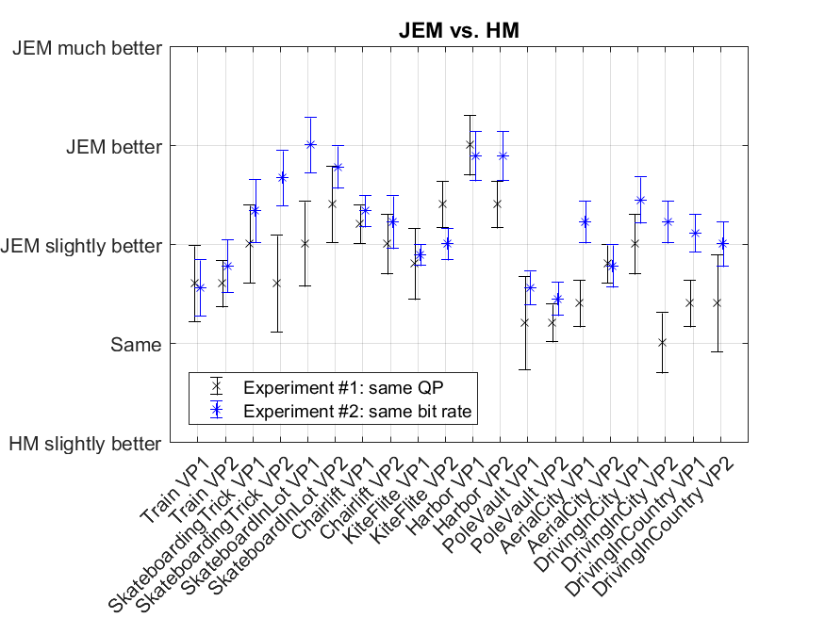
Figure 1. Subjective results.
Figure 1 reports the mean opinion scores (MOSs) and associated 95% confidence intervals (CIs) from both subjective experiments. We first analyze results for the experiment comparing HM and JEM at QP=37. Results demonstrate that JEM improves visual quality in most cases. Table 3 depicts the viewport sequences used in the subjective evaluation and the areas where visual quality difference are noticeable between HM and JEM. The improvements are particularly observed for sequence Harbor, where the rendering of the water appears less blocky in the JEM encoded sequence when compared to HM (see Figure 2). For this sequence, improvements can also be perceived in the flag floating on the boat as well as on the different ropes attached to the boat (see Figure 3). For sequence KiteFlite, improvements can be observed in the pavement, the sign boards, some textures in the grass, as well as in the weathercock. In ChairLift, improvements are observed on the face of one of the persons seating on the lift, as well as some textures on the ground below the lift, particularly in the grass and on the dirt road. For SkateboardingTrick, more details can be observed in the pavement and there are less artifacts in the JEM version in the structure on which the skateboarder is sliding. Regarding sequence SkateboardInLot (see Figure 4), improvements are mostly visible on the face, in the sky, in the buildings behind, as well as in the road. Improvements in the road are even more visible when pausing the video. However, because of the relatively high motion in the sequence, these improvements are mostly masked by motion during playback. Similarly, for the Train sequence, improvements from JEM can be perceived in the moving train when displayed as still frames, but are rather small during playback. In general, improvements are less visible for the 4K ERP source sequences because of the relatively small size of the rendered VPs (856x856 for 4K ERP source versus 1816x1816 for 8K ERP source). In particular, for sequence PoleVault, there are very few details because most of the objects are relatively far from the camera. The same observation applies for sequence AerialCity, where improvements can mostly be observed in the road. Improvements are also mostly observed in the road in DrivingInCity, where blocking artefacts can be observed in the HM encoded sequence when compared to JEM. For this sequence, results are significantly different for the two selected VPs. Finally, regarding DrivingInCountry, there is a lot of camera motion probably due to a lack of camera stabilization. As a result, the VP looking at the river is rather unpleasant to watch and tends to create some sort of simulator sickness.
Table 3. Representative frames of the viewport sequences used in the subjective evaluation. The red circles indicate areas where visual quality difference are noticeable between HM and JEM.
 | VP1 | VP2
Train | 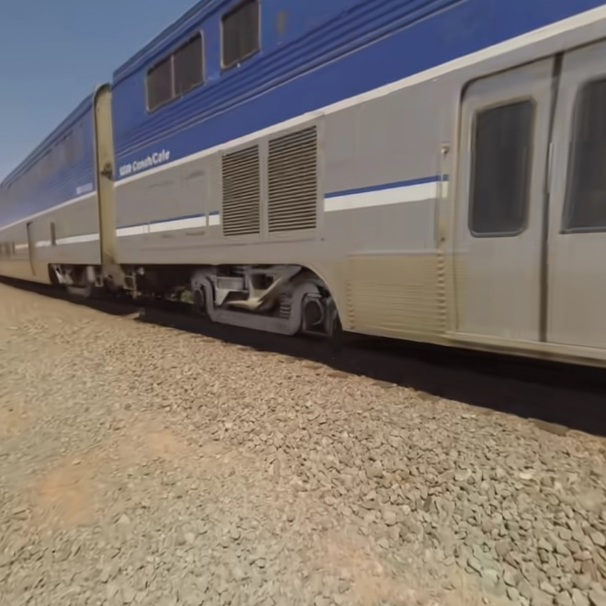 | 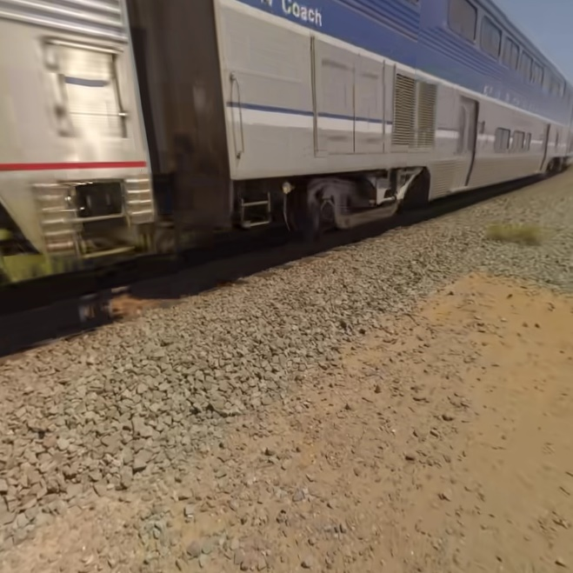
SkateboardingTrick | 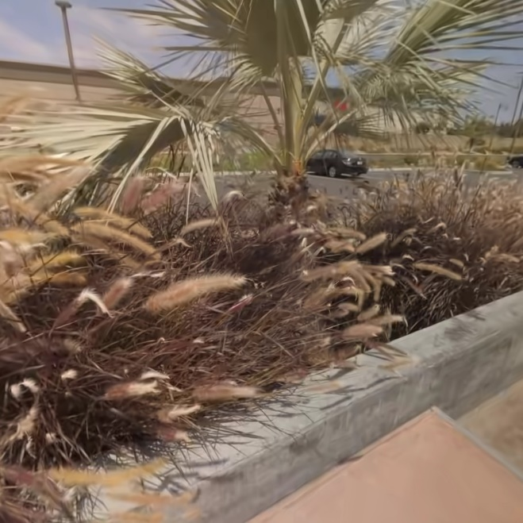 | 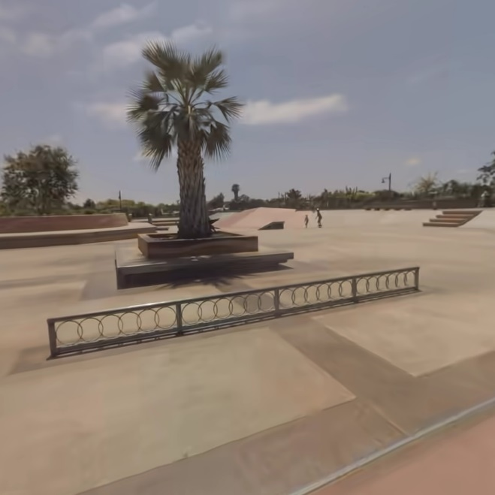
SkateboardInLot | 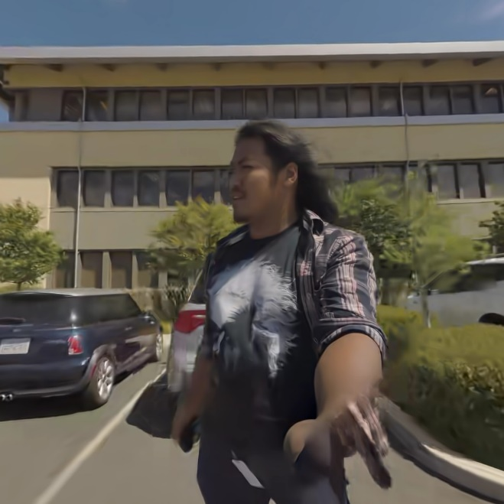 | 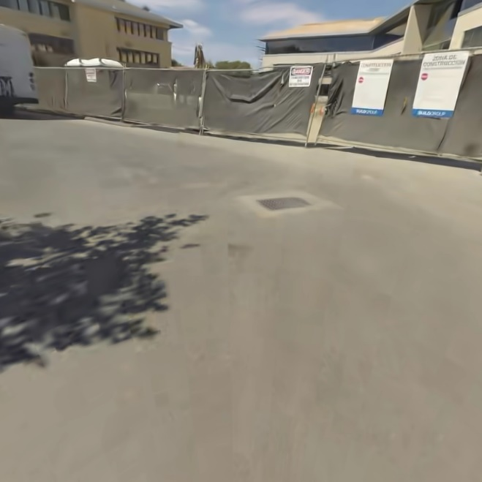
ChairLift | 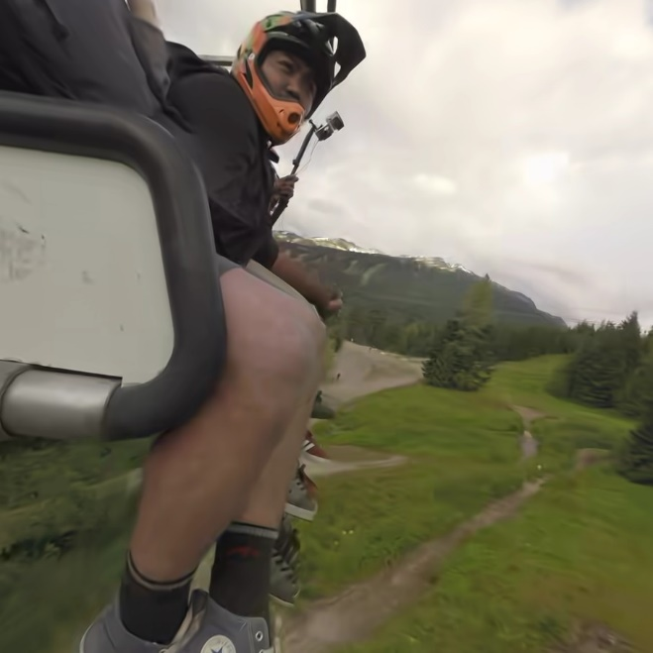 | 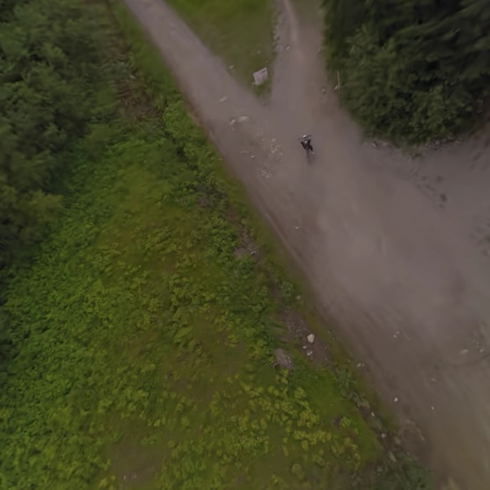
KiteFlite | 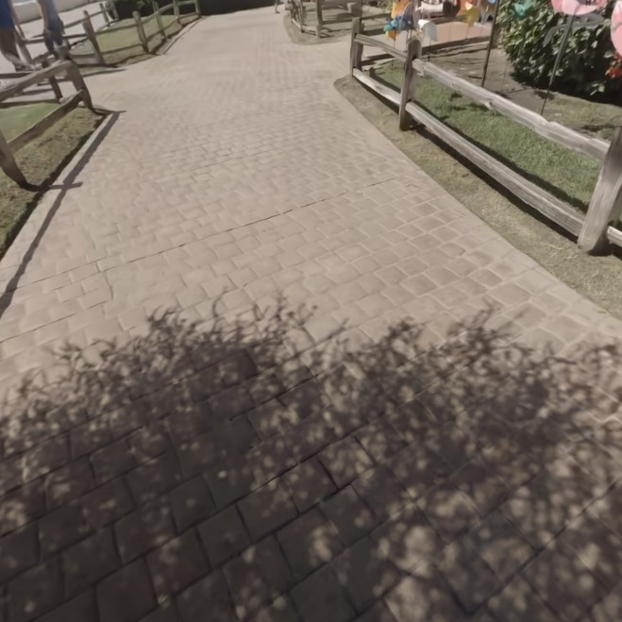 | 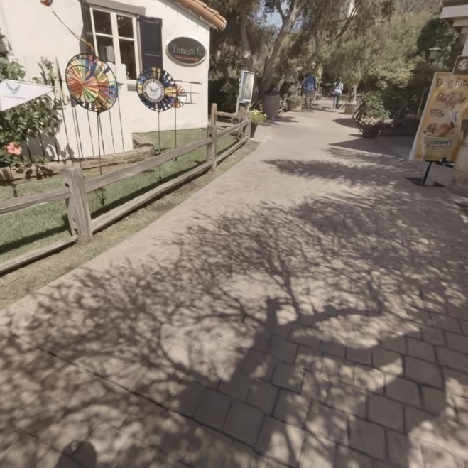
Harbor |  | 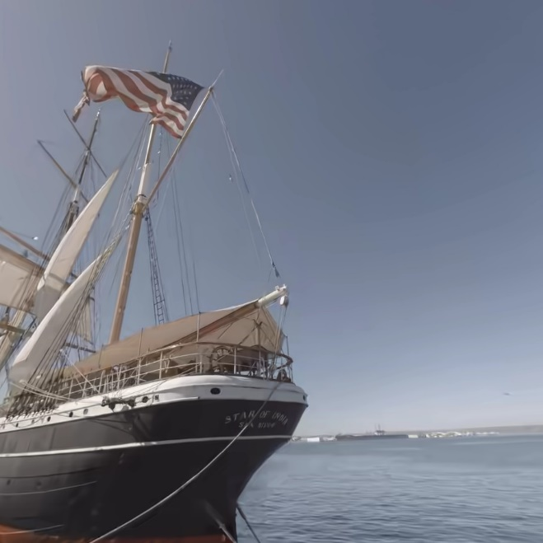
PoleVault | 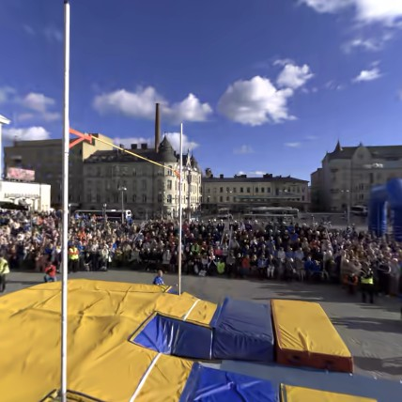 | 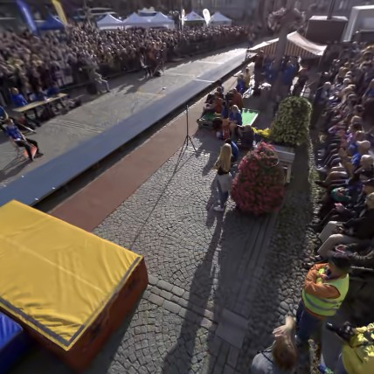
AerialCity |  | 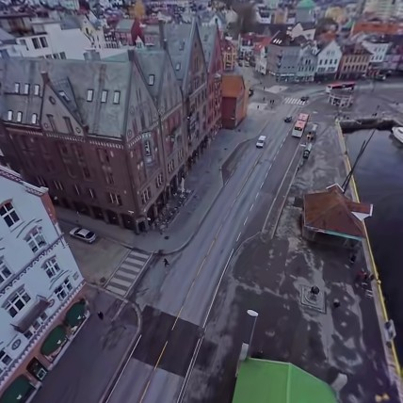
DrivingInCity | 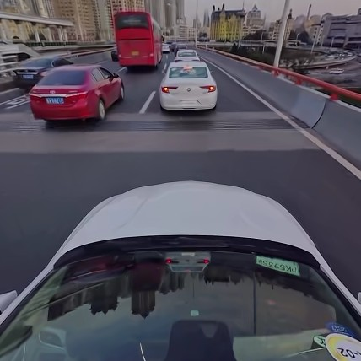 | 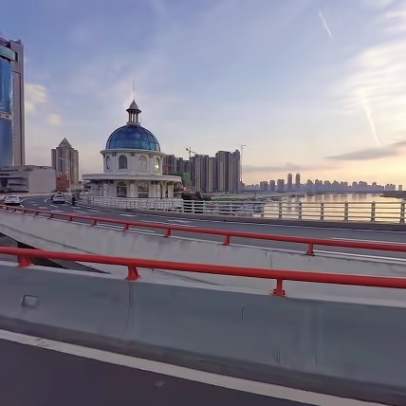
DrivingInCountry | 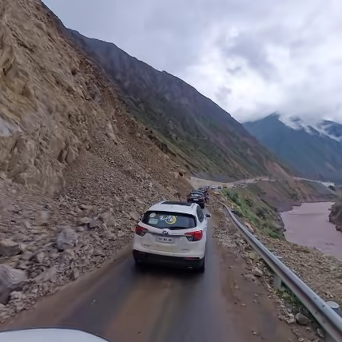 | 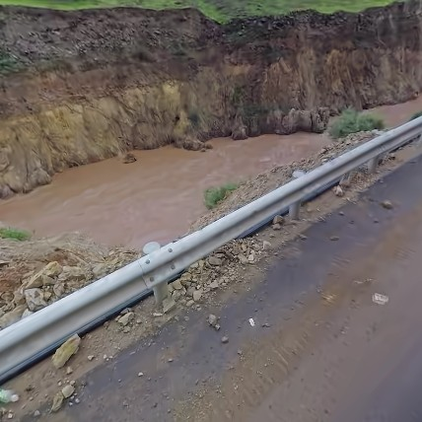

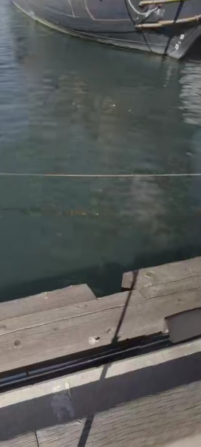 | 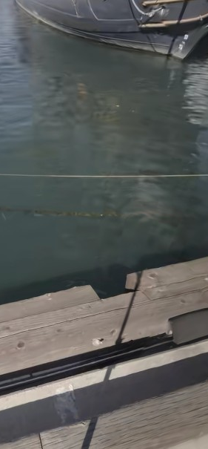
(a) HM | (b) JEM
Figure 2. Harbor – VP1: comparison between HM (a) and JEM (b) at QP=37.

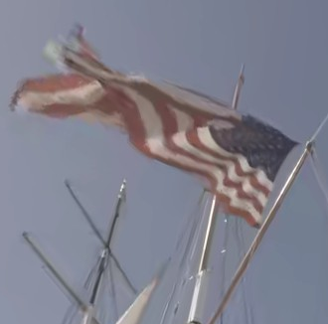 | 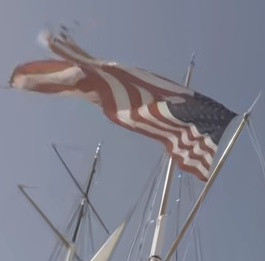
(a) HM | (b) JEM
Figure 3. Harbor – VP2: comparison between HM (a) and JEM (b) at QP=37.

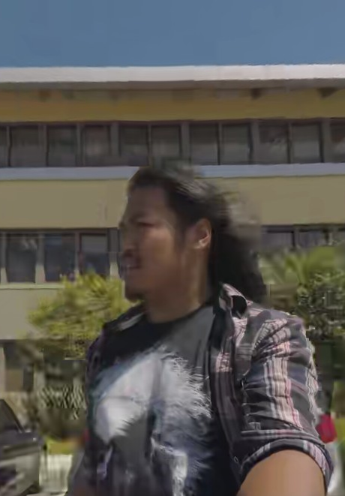 | 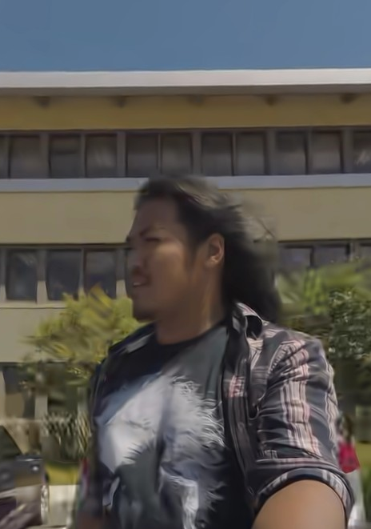
(a) HM | (b) JEM
Figure 4. SkateboardInLot – VP1: comparison between HM (a) and JEM (b) at QP=37.

Regarding the results from the second subjective experiment comparing JEM at QP=37 and HM at matching bit rate (see Figure 1), most MOSs demonstrate slightly better advantage for JEM over HM. The major exception is KiteFlite VP2, which was rated lower in the second experiment, but there is not sufficient statistical evidence to indicate a difference between the two sets of subjective scores based on one-way analysis of variance (ANOVA) test. For the Train sequence, results are similar between the two experiments as visual artefacts are difficult to assess because of the fast motion. For AerialCity VP1, DrivingInCity VP2, and DrivingInCountry VP1, the MOS results of the second experiment are statistically (p ≤ 0.05) significantly better than those of the first experiment, based on one-way ANOVA. In particular, for DrivingInCity VP2, blocking artefacts are visible on the concrete guardrails on the side of the road the car is driving on. In general, the visual artefacts are more severe for HM at matching bit rate when compared to HM at QP=37 and, thus, the relative difference between JEM and HM is more visible.

Discussion
In general, the stitching artefacts, e.g., geometric distortions and color differences, observed in some VPs can be disturbing, especially for non-expert viewers or viewers not familiar with the content, as similar artifacts can also result from compression, which may influence the viewers’ judgement. Based on this observation, we recommend trying to select VP parameters such that stitching artefacts are minimized in the rendered VPs. When selecting a test methodology, it is also important to take this aspect into account such that the influence of stitching artefacts can be minimized. This can be achieved by avoiding to rate a sequence independently from any reference or other sequence to compare to, i.e., avoiding single stimulus test methods.
The rendered VPs with horizontal and vertical FOV set to 75 degrees appear a little blurred in the corners as the content is further from the sphere center. It is suggested that when using rectilinear projection, such as currently supported by 360Lib, FOV values larger than 75 degrees should not be used in order to avoid over-blurring in the corners.
For rather static contents, dynamic viewports may be a good alternative to static viewports to explore a larger portion of the 360-degree video content. However, for sequences having relatively large amount of motion, dynamic viewports might introduce some visual discomfort or create simulator sickness if not selected carefully. For example, we should avoid placing fast-moving dynamic viewports in sequences with large motion, especially avoiding fast-moving viewports along the latitude direction. Instead, we may consider placing dynamic viewports along the horizontal direction to mimic more natural viewer behavior. Dynamic viewports can also change the relative motion of the content. For example, in the Train sequence, if a dynamic viewport is defined by changing the yaw linearly and keeping the pitch constant, the relative motion of the train may appear either slower or faster depending on the direction of the camera pan. As a results, considering motion masking, the visibility of video compression artefacts might be affected by the change in relative motion. Based on this observation, for sequences containing fast moving objects, dynamic viewports should be moving in a similar direction as the main object, rather than against it.
While watching the test material, we have observed that, for sequences with fast motion such as Train or SkateboardInLot, compression artefacts and improvements from JEM over HM were more visible on still frames than during playback due to motion masking. Based on this observation, we propose to consider an alternative to static and dynamic viewports: a dynamic viewport defined at a fixed time instance. The resulting effect is similar to the ‘bullet time’ visual effect used in movies such as “The Matrix”, thus we refer to this type of viewports as bullet time viewport. Bullet time viewports mimic the user behavior of exploring the 360-degree content while the video is paused, which corresponds to a real life application of 360-degree video. As part of this contribution, we provide a patch for the 360Lib to enable bullet time viewport rendering using a new parameter, named ViewPortType, and the existing ViewPortFile parameter with the same syntax as for dynamic viewports. Examples of bullet time viewports are attached for the Train and SkateboardInLot sequences. We will bring different dynamic and bullet time viewports for these two sequences at the meeting for better visual comparison. For this purpose, we would like to request a viewing session.
A similar approach to bullet time viewports has been proposed in [6] for quality assessment of free-viewpoint video sequences, which is a particular application of 3DTV that allows the user to interact with the content and change his/her viewpoint. In [6], the authors used a free-viewpoint video sequence corresponding to a smooth camera motion during a time freeze, which was generated from fifty intermediate views in-between the left and right views of the original content. Several free-viewpoint video sequences were generated through depth-image-based rendering (DIBR) from 3D content represented in the multiview video plus depth (MVD) format. The authors used this protocol in a subjective quality evaluation to assess the performance of several depth maps compression algorithms. Though only image quality was rated in this study, the analysis of the results showed that the proposed protocol was considered as a reliable quality assessment methodology for the evaluation of depth map compression and view synthesis algorithms. In [7], two possible approaches to crowdsourcing-based quality assessment of MVD content on 2D displays were investigated: by using a virtual view and by using a free-viewpoint video generated following the method proposed in [6]. The authors conducted the crowdsourcing experiments using seven MVD sequences encoded at different bit rates with the 3D-AVC video coding standard. The results demonstrated high correlation with subjective evaluations performed using a stereoscopic monitor in a controlled laboratory environment. The analysis showed no statistically significant difference between the two approaches.
The advantage of freezing time is that visual artefacts that might be concealed because of motion masking, especially when rendering dynamic viewports for high motion content, can be better evaluated with bullet time viewports. The drawback is that only one particular time instance is assessed for each rendered viewport. Therefore, the time coverage of bullet time viewport is rather small. As for dynamic viewports, a proper trajectory has to be selected for the bullet time viewport. But unlike dynamic viewports, similar trajectory parameters, e.g., yaw/pitch speed, should most likely be sufficient for different contents. Unlike dynamic viewports where the duration and framerate are linked to those of the source 360-degree video sequences, the duration and framerate of bullet time viewports can be set independently to achieve a smooth and pleasant rendering of the resulting video sequence.
Table 4 reports a comparison of the different viewport types in terms of space and time coverage, as well as visual comfort. With static viewports, the selected viewport location might influence the results. With dynamic viewports, there is a tradeoff between the area that one wants to cover and the visual comfort of the resulting video sequence. For bullet time viewports, the selected time instance might influence the results.
Assessing the whole 360-degree video, i.e., covering each portion of the sphere during each time instance, requires many viewports. However, for subjective evaluations, it is necessary to select fewer viewports to have a reasonable number of test points and to keep the test length within a comfortable range. As the viewport selection might impact the results of the subjective evaluation, we suggest to consider different viewport types, including static, dynamic, and bullet time viewports, with different characteristics for each content.
Table 4. Viewports comparison.
Viewport type | Space coverage | Time coverage | Visual comfort | Comment
Static | Poor | Good | Good | Suitable for any type of content
Dynamic | Average – Good | Good | Poor – Good | Not recommended for sequences with fast motion  Visual comfort is somewhat inversely proportional to space coverage
Bullet time | Good | Poor | Good | Suitable for any type of content

References
- J. Boyce, E. Alshina, A. Abbas, Y. Ye, “JVET common test conditions and evaluation procedures for 360° video”, Joint Video Exploration Team of ITU-T SG16 WP3 and ISO/IEC JTC1/SC29/WG11, JVET-D1030, 4th Meeting, Oct. 2016.
- K. Suehring, X. Li, “JVET common test conditions and software reference configurations”, Joint Video Exploration Team of ITU-T SG16 WP3 and ISO/IEC JTC1/SC29/WG11, JVET-B1010, 2nd Meeting, Feb. 2016.
- ITU-R BT.2022, “General viewing conditions for subjective assessment of quality of SDTV and HDTV television pictures on flat panel displays.” International Telecommunication Union, Aug. 2012.
- ITU-R BT.500-13, “Methodology for the subjective assessment of the quality of television pictures.” International Telecommunication Union, Jan. 2012.

- 360Lib-1.0, https://jvet.hhi.fraunhofer.de/svn/svn_360Lib/tags/360Lib-1.0
- E. Bosc, P. Hanhart, P. Le Callet, T. Ebrahimi, “A quality assessment protocol for Free-viewpoint video sequences synthesized from decompressed depth data”, 5th International Workshop on Quality of Multimedia Experience, July 2013.
- P. Hanhart, P. Korshunov, T. Ebrahimi, “Crowd-based quality assessment of multiview video plus depth coding”, IEEE International Conference on Image Processing, Oct. 2014.

Patent rights declaration(s)
InterDigital Communications Inc. does not have any current or pending patent rights relating to the technology described in this contribution.

