    Joint Video Exploration Team (JVET)  of ITU-T SG 16 WP 3 and ISO/IEC JTC 1/SC 29/WG 11  5th Meeting: Geneva, CH, 12–20 January 2017 | Document: JVET-E0058

Title: | AHG 8: A viewport-based pyramid projection for VR360 video streaming
Status: | Input Document to JVET
Purpose: | Proposal
Author(s) or  Contact(s): | Peng Wang, Hung-Chih Lin, Chia-Ying Li, Ya-Hsuan Lee, Jian-Liang Lin, Shen-Kai Chang  No. 1, Dusing Rd. 1, Hsinchu Science Park, Hsinchu, Taiwan 30078 | Tel:  Email: | Hung-Chih Lin  +886-3-5670766 ext. 24349  {ben.wang, hungchih.lin, erica.li, louise.lee, jl.lin, shenkai.chang} @mediatek.com
Source: | MediaTek Inc.
_____________________________

Abstract
This contribution proposes a viewport-based pyramid projection format for VR360 video streaming. The compression efficiency among the ERP, TSP, and proposed projections is examined. In terms of the window-sized S-PSNR metrics (S-PSNR-NN and S-PSNR-I), the experimental results reportedly demonstrate that the BD-rate reduction provided by the proposed layout is considerably improved as compared to the ERP format when FOV is less than 140º, and that the proposed layout is superior to the TSP layout until FOV is 160º.

Introduction
One of the challenges of the 360VR streaming application is to provide excellent immersive experience with limited network bandwidth and/or decoding capability of device. The viewport switching scheme is thus used to overcome the above limitations with a viewport-based projection format [1]. Moreover, a viewport-based projection format is composed of two regions: primary region and secondary region. The primary area preserves high-fidelity viewing region specified by a pre-defined FOV while the secondary area represents the down-sampled version of the region outside the primary area. That is, the resolution of the viewport-based projection format can be significantly reduced for streaming application. The preparation of the viewport switching scheme produces tens of viewport videos. These primary areas of these viewport videos comprise the entire 360ºx180º region. Usually, the center of the primary area of each viewport video is indicated by the yaw and pitch angles. Thus, according to the user’s viewing angle, the user can receive the corresponding viewport video that encompasses the viewing area.

Proposed Compact Pyramid Layout
An efficient compact layout of the pyramid projection format for the viewport switching scheme is proposed in this contribution. In Fig. 1 (a), the 360VR video content on the sphere is projected on an inscribed pyramid. The pyramid consists of five faces as shown in Fig. 1 (b). One of these five faces is the primary viewport face, denoted as V, which contains a 90ºx90º region. The secondary region is represented by the other four isosceles triangle faces, denoted as Left (L), Top (T), Right (R), and Bottom (B). As illustrated in Fig. 1 (c), these triangle faces with shrunk height are rearranged to form the proposed compact layout. In addition, there is no discontinuous egde between any two connected faces in the proposed layout.
When packing the five faces into the proposed layout, the height of the four triangle faces are shunk from $H$ to $h$. That is, these triangle faces are down-sampled vertically. We introduce a non-uniform mapping curve to perform the down-sampling process for these four faces. As illustrated in Fig. 2, the non-uniform mapping curve is defined as
$\frac{y}{h}=1-{\left(1-\frac{x}{H}\right)}^{n}$,
where $n>1$. The proposed non-uniformly down-sampling process can achieve that the degradation of the image quality of the projection area close to the primary region is slower than that of the area far from the primary region. Moreover, Fig. 3 depicts an example of the viewport image of the proposed layout with (yaw, pitch) = (0, 0) and $n=2.5$.
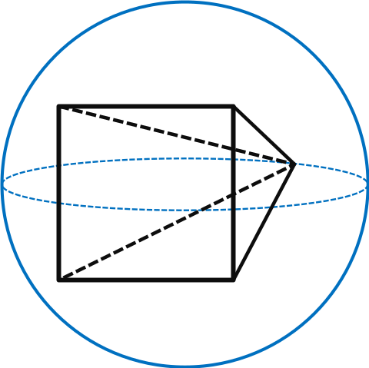 | 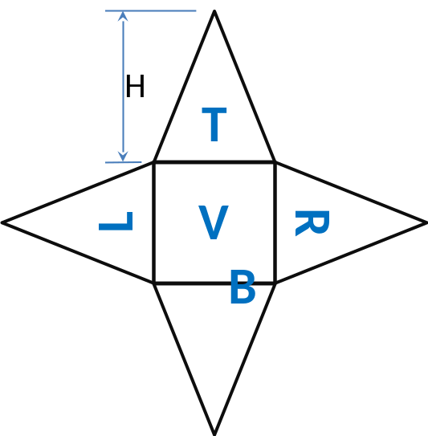
(a) | (b)
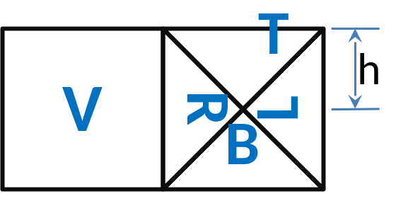
(c)
Fig. 1 (a) Sphere with inscribed pyramid; (b) Pyramid net; (c) Proposed compact layout.
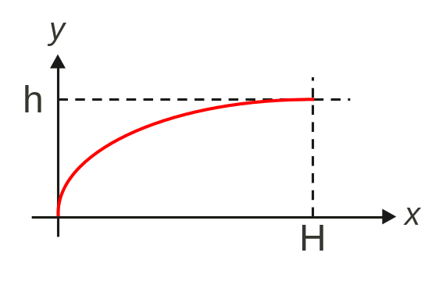
Fig. 2 Non-uniform mapping function.

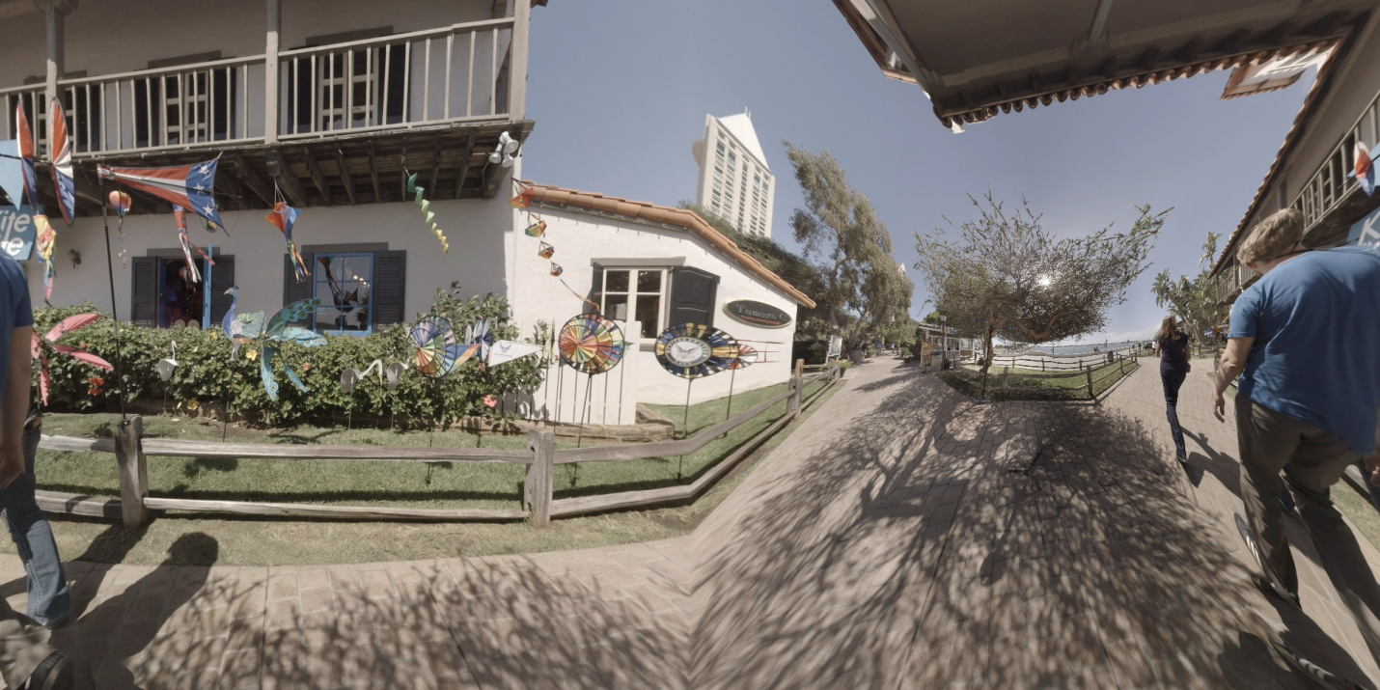
Fig 3. An example image of the proposed layout with (yaw, pitch) = (0, 0) and $n=2.5$.

Experimental Results
The simulations on the ERP, TSP, and the proposed projections are conducted based on the test procedure [2]. Also, the encoder setting is followed by the common test conditions [3]. Moreover, the resolution of the proposed layout is the same as that of the TSP layout.
We use the window-sized S-PSNR to evaluate the encoding quality for these three projections. As mentioned before, the center of the primary area of a viewport is indicated by the orientation angles, yaw (longitude) $ψ$ and pitch (latitude) $Θ$. The size of the window around the center of a viewport can be defined by two FOV parameters, horizontal FOV (hFOV) and vertical FOV (vFOV). Thus, the coding error $e$ of the sphere points $Ω$ in window-sized S-PSNR calculation would be accumulated if the sphere points are in the region $Λ=\left[ψ-\frac{hFOV}{2},ψ+\frac{hFOV}{2}\right]×\left[Θ-\frac{vFOV}{2},Θ+\frac{vFOV}{2}\right]$, defined as
$$e=\sum_{s∈Ω if s in Λ}{{\left(p_{s}-{\hat{p}}_{s}\right)}^{2}}$$
where $p_{s}$ and ${\hat{p}}_{s}$ represent the (interpolated) pixel value located at the sphere point $s$ of the original and reconstructed frame, respectively.
We select six viewports to demonstrate the coding efficiency among these three projections. The (yaw, pitch) orientations of these six viewports are (0, 0), (90, 0), (180, 0), (270, 0), (0, 90), and (0, -90). As listed in Table I and Table II, the BD-rate results are obtained by the averaged coding bit-rates and window-sized S-PSNR values of the six viewports.
Table I. BD-rate performance (Window-sized S-PSNR-NN)
hFOV = vFOV | ERP vs. TSP |  |  | ERP vs. Proposed |  |  | TSP vs. Proposed
hFOV = vFOV | Y | U | V | Y | U | V | Y | U | V
70º | -44.6% | -44.9% | -45.7% | -51.2% | -51.4% | -52.1% | -11.8% | -11.7% | -11.8%
80º | -47.0% | -47.8% | -48.5% | -54.8% | -54.5% | -55.0% | -14.7% | -12.9% | -12.5%
90º | -44.4% | -46.3% | -47.8% | -57.5% | -56.9% | -57.2% | -23.5% | -19.6% | -17.9%
100º | -32.9% | -39.7% | -42.2% | -57.5% | -57.0% | -57.4% | -36.8% | -29.0% | -26.5%
110º | -22.3% | -34.4% | -37.3% | -53.6% | -54.4% | -54.9% | -40.7% | -30.4% | -28.1%
120º | -10.0% | -28.6% | -32.1% | -46.2% | -49.5% | -50.5% | -41.1% | -29.3% | -27.2%
130º | 3.4% | -23.0% | -26.8% | -35.0% | -43.3% | -44.8% | -38.6% | -26.4% | -24.6%
140º | 21.4% | -17.3% | -21.3% | -17.6% | -36.0% | -37.8% | -33.6% | -22.6% | -21.0%
150º | 42.2% | -11.7% | -15.9% | 6.9% | -27.8% | -30.0% | -25.5% | -18.1% | -16.8%
160º | 65.4% | -6.7% | -11.0% | 44.9% | -18.9% | -21.7% | -11.8% | -12.8% | -11.9%
170º | 94.2% | -2.4% | -6.4% | N/A | N/A | N/A | 7.5% | -7.5% | -6.6%
180º | 137.5% | 1.2% | -2.6% | N/A | N/A | N/A | 29.6% | -2.0% | -0.9%
Note:
1. A vs. B represents that A is anchor projection and B is tested projection.
2. Several fields are N/A because the BD-rate performance cannot be calculated.

Table II. BD-rate performance (Window-sized S-PSNR-I)
hFOV = vFOV | ERP vs. TSP |  |  | ERP vs. Proposed |  |  | TSP vs. Proposed
hFOV = vFOV | Y | U | V | Y | U | V | Y | U | V
70º | -44.6% | -44.9% | -45.6% | -51.2% | -51.4% | -52.1% | -11.8% | -11.7% | -11.8%
80º | -47.2% | -47.8% | -48.5% | -54.8% | -54.6% | -55.0% | -14.3% | -13.0% | -12.6%
90º | -44.4% | -46.9% | -48.2% | -57.5% | -56.9% | -57.2% | -23.6% | -19.0% | -17.4%
100º | -33.2% | -40.5% | -42.8% | -57.5% | -57.2% | -57.5% | -36.7% | -28.2% | -26.0%
110º | -22.7% | -35.1% | -37.8% | -53.7% | -54.5% | -55.0% | -40.6% | -29.9% | -27.8%
120º | -10.4% | -29.4% | -32.6% | -46.3% | -49.7% | -50.7% | -41.1% | -28.8% | -26.9%
130º | 3.1% | -23.7% | -27.2% | -35.1% | -43.5% | -44.9% | -38.6% | -26.0% | -24.4%
140º | 21.0% | -17.9% | -21.7% | -17.6% | -36.1% | -37.9% | -33.6% | -22.1% | -20.8%
150º | 41.8% | -12.3% | -16.3% | 6.8% | -27.8% | -30.1% | -25.5% | -17.6% | -16.5%
160º | 65.0% | -7.3% | -11.4% | 44.7% | -18.9% | -21.8% | -11.8% | -12.4% | -11.7%
170º | 93.5% | -2.9% | -6.8% | N/A | N/A | N/A | 7.6% | -7.1% | -6.3%
180º | 136.4% | 0.7% | -3.0% | N/A | N/A | N/A | 29.8% | -1.5% | -0.6%
Note:
1. A vs. B represents that A is anchor projection and B is tested projection.
2. Several fields are N/A because the BD-rate performance cannot be calculated.

Conclusion
In this contribution, a viewport-based compact layout for pyramid projection format is proposed. This viewport-based pyramid projection contains a primary viewing region and has no discontinuous edge inside the layout. The experimental data show that the compression efficiency of the proposed layout is noticeably superior to that of the ERP and TSP projections over a wide range of FOV values.

References
- G. Van der Auwera, M. Coban, Hendry, and M. Karczewicz, “AHG8: Truncated Square Pyramid Projection (TSP) For 360 Video,” Joint Video Exploration Team of ITU-T SG16 WP3 and ISO/IEC JTC1/SC29/WG11, JVET-D0071, Oct. 2016
- E. Alshina, J. Boyce, A. Abbas, and Y. Ye, “JVET common test conditions and evaluation procedures for 360° video,” Joint Video Exploration Team of ITU-T SG16 WP3 and ISO/IEC JTC1/SC29/WG11, JVET-D1030, Oct. 2016
- K. Suehring and X. Li, “JVET common test conditions and software reference configurations”, Joint Video Exploration Team of ITU-T SG16 WP3 and ISO/IEC JTC1/SC29/WG11, JVET-B1010, Feb. 2016.

Patent rights declaration(s)
MediaTek Inc. may have current or pending patent rights relating to the technology described in this contribution and, conditioned on reciprocity, is prepared to grant licenses under reasonable and non-discriminatory terms as necessary for implementation of the resulting ITU-T Recommendation | ISO/IEC International Standard (per box 2 of the ITU-T/ITU-R/ISO/IEC patent statement and licensing declaration form).

