    Joint Video Exploration Team (JVET)  of ITU-T SG 16 WP 3 and ISO/IEC JTC 1/SC 29/WG 11  4th Meeting: Chengdu, CN, 15–21 October 2016 | Document: JVET-D0165

Title: | Cross-check of JVET-D0098 Decoupling decoder-side intra mode derivation from entropy decoding
Status: | Input Document
Purpose: | Information
Author(s) or  Contact(s): | Alexey Filippov  Vasily Rufitskiy  Haitao Yang  Altufevskoe shosse Building 1/7,  127106 Moscow, Russia | Tel:  Email: | +79250082308  alexey.filippov@huawei.com  vasily.rufitskiy@huawei.com  haitao.yang@huawei.com
Source: | Huawei Technologies
_____________________________

Abstract
This contribution reports an evaluation of JVET-D0098 (EE8-related: Decoupling decoder-side intra mode derivation from entropy decoding). The performance of the proposal is assessed in terms of runtime and BD-rate. In addition, the source code is analyzed to highlight the proposed changes. The evaluation results presented in this contribution are reported to match those of the proponent.

Introduction
Contribution JVET-D0098 proposes an intra-prediction mode propagation technique to address the issue of parsing dependency caused by the DIMD design initially described in JVET-C0061 and considered in EE8 (decoder-side intra mode derivation). This DIMD-related technique reportedly uses the intra-prediction modes of normal intra blocks (i.e., being explicitly signaled) to generate the intra-prediction modes of DIMD blocks at the parsing stage. Thus, the intra-prediction modes of DIMD-coded blocks are not required to be derived during entropy decoding.

Software analysis
The software provided by the proponent has modification in 14 files in comparison with HM-16.6-JEM-3.0-EE8-DIMD revision 291.
The software is consistent with the content of the proposal. If DIMD_PARSING_FIX macro is set on, deriveNeighborIntraDirs function is not called during entropy decoding process. Entropy decoding part of the software does not contain other calls to pixel reconstruction functions if DIMD_PARSING_FIX is in effect.
Macro DIMD_ENC_ADD_MPM_RD is used in a single function of the encoder and its value is used as an increment to the size of the list of the modes for which full RD-cost estimation should be performed (uiRdModeList). There are no other modifications in test 3b as compared to tests 3a.

Test results
All the tests results provided further are for the reduced length (“-f 30” argument is passed to the encoder command line). Full-length tests results will be provided as soon as available.

Test 3a: DIMD + intra mode propagation
The software was provided by the proponent.
Test is activated (modifications in TypedDef.h) by setting EE8_TEST_IDX to 3 and providing additional macros DIMD_PARSING_FIX equal to 1 and DIMD_ENC_ADD_MPM_RD equal to 0.

Short-length test results are summarized in the Table below for AI configuration
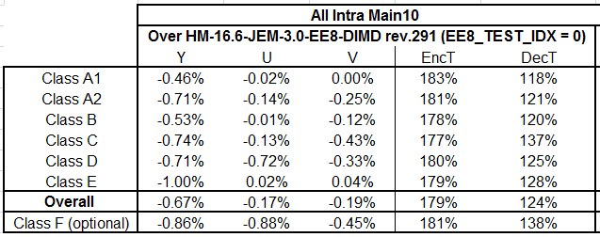
Coding performance results match the results provided by the proponent, however encoding and decoding times are greater by ~16% for the encoding time and by ~12% for the decoding time.
Full-length test results are summarized in the Table below for AI configuration
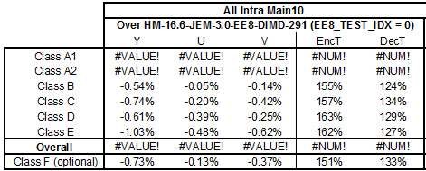
Results for full length tests for AI and RA configuration will be provided later as soon as they are available. Coding performance results match the results provided by the proponent, however average decoding time for classes B, C, D, and E is greater by appr. 14%. For higher resolutions (class B and class E) encoding time differs with the one reported by the proponent negligibly. For smaller resolutions (Class C and Class D) encoding time is greater by 5% and by 9% respectively.
Encoding time for the full length simulation is lesser more than by 10% as compared to the encoding time of the short length simulation. However, decoding time for the full-length simulation differ from short-length simulation no more than by 5%.

Test 3b: DIMD + intra mode propagation + encoder change
The software was provided by the proponent.
Test is activated (modifications in TypedDef.h) by setting EE8_TEST_IDX to 3 and providing additional macros DIMD_PARSING_FIX equal to 1 and DIMD_ENC_ADD_MPM_RD equal to 2.
Test results are summarized in the Table below for AI configuration (results for RA will be provided as soon as available).
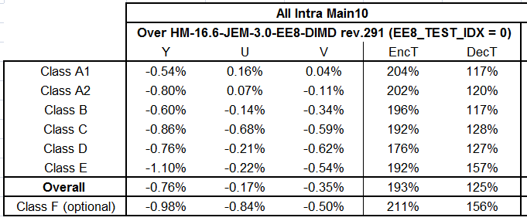
Coding performance results match the results provided by the proponent, however encoding and decoding times are greater by ~30% for the encoding time and by ~17% for the decoding time.
Full-length test results are summarized in the Table below for AI configuration
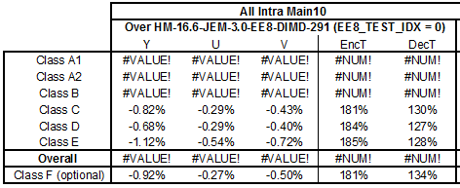
Results for full length tests for AI and RA configuration will be provided later as soon as they are available. Coding performance results match the results provided by the proponent, however average decoding time for classes C, D and E is greater by ~14%. For classes C, D and E encoding time is greater by 21%, 22% and by 13% respectively.

Comments
According to the obtained results, the encoding / decoding time is greater for Test 3a and Test 3b than the running time provided by the proponent. For the short-length tests, the encoding and decoding time increases are shown in the table below.
Test number | Encoding time increase | Decoding time increase
Test 3a | 16% | 12%
Test 3b | 30% | 17%
Probably, this difference is caused by the fact that short length tests were performed.
For the full-length tests, the encoding and decoding time increases are shown in the table below.
Test number | Encoding time increase | Decoding time increase
Test 3a (classes B, C, D, E) | <4% | 14%
Test 3b (classes C, D, E) | 17% | 14%

Conclusion
In this contribution, the proposal described in JVET-D0098 is analyzed and evaluated according to the common test conditions. For the short length tests, the average compression performance matches the results provided by the proponent. However, the running time (especially, at the decoder side) is higher (appr. 14%) than reported in JVET-D0098.
The source code is consistent with the description in JVET-D0098.

Patent rights declaration(s)
Huawei Technologies may have current or pending patent rights relating to the technology described in this contribution and, conditioned on reciprocity, is prepared to grant licenses under reasonable and non-discriminatory terms as necessary for implementation of the resulting ITU-T Recommendation | ISO/IEC International Standard (per box 2 of the ITU-T/ITU-R/ISO/IEC patent statement and licensing declaration form).

