    Joint Video Exploration Team (JVET)  of ITU-T SG 16 WP 3 and ISO/IEC JTC 1/SC 29/WG 11  4th Meeting: Chengdu, CN, 15–21 October 2016 | Document: JVET-D0074

Title: | AHG8: Suggested test methodology for evaluating projection formats for 360 video coding
Status: | Input Document to JVET
Purpose: | Proposal
Author(s) or  Contact(s): | Bharath Vishwanath ,Yuwen He, Xiaoyu Xiu, Yan Ye  9710 Scranton Rd, #250  San Diego, CA 92121, USA | Tel:  Email: | Yuwen.He@interdigital.com  Xiaoyu.Xiu@interdigital.com  Yan.Ye@interdigital.com
Source: | InterDigital Communications Inc.
_____________________________

Abstract
At the 3rd JVET meeting, AHG8 on 360 video test conditions was established. One of AHG8’s mandates is to “study the effect on compression when different warping methods are applied to the input 360 video before compression.” A main challenge for the test is that the input video is always in Equirectangular Projection (ERP). This gives ERP an obvious edge over the other projection formats. In this document, we propose a test methodology to compare different projection formats and their impact on 360 video coding aimed at reducing/removing the bias towards ERP, the geometry in which all currently available original spherical content is represented. We further propose to also study the impact on rendered video quality within a given viewport using different projection formats in future JVET tests, as we believe consuming 360 video content on conventional 2D displays will continue.

Introduction
360 video allows user to view the content on the entire sphere. Spherical content can be represented in different projection formats on a 2D plane, for example, using equirectangular projection (ERP) [1], cubemap projection (CMP) [2], equal-area projection (EAP) [3], octahedron projection (OHP) [4], icosahedron (ISP), etc. Implementations of these projection formats are available in the PCT360 software tool described in JVET-D0021 [5]. Currently, most of the 360 video content capture systems only support outputting the original content in ERP format. This naturally gives a bias towards ERP in any evaluation tests related to 360 video. Extending and generalizing this problem further, the native format in which the original content is represented will always have an unfair advantage when compared to other projection formats. However, the evaluation should be made independent of this bias. In other words, the test should evaluate how well we represent the content on the sphere rather than the content in a given geometry format. Thus, ideally, in order to understand the impact on 360 video coding when different projection formats are used, the test should follow the flow depicted in Figure 1, where the ground truth signal and reconstructed signal are both represented in spherical format, and the quality evaluation is conducted in the spherical format as well. This workflow can focus on the impact due to projection format (referred to as “coding geometry” in Figure 1) used at the coding stage. However, this is not achievable in practice, as the ground truth signal is always represented in a starting projection format (native projection format), and not in the spherical format.

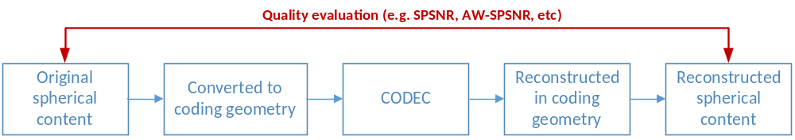
Figure 1. Testing flow for 360 video with ground truth signal in spherical format

Proposed test methodology for evaluating projection formats for 360 video coding
We propose two work flows to evaluate “the impact on coding of 360 video when different warping methods are applied to the input 360 video before compression.” The first method evaluates the quality of the entire 360 video signal but reduces the bias toward ERP, a common native projection format in which content is represented. The second method evaluates the quality of a given viewport in the 360 video.

Evaluating the entire 360 video signal
It is evident that we need to have a good representation of the spherical content. However, the main drawback is that different projection formats have different sampling densities depending on the sampling location, and thus might poorly represent different parts of the original spherical content. In order to overcome this difficulty, we suggest to have a ground truth in a very high resolution (at least 8K for 360 video) as a good representation of original sphere. It is to be noted that whereas the currently available test sequences are all in ERP geometry format, the ground truth can be in other commonly used geometry formats as long as at that high resolution they can provide a good representation of the spherical content. We then move to different geometries at lower resolutions before compression is applied. Given a fixed number of samples, different geometries spend different number of samples to represent different parts of the sphere. Thus, going from a high resolution ground truth to a lower resolution geometry representation brings out the difference among different geometries in terms of their sampling patterns and impact on coding, and thus effectively removes the bias towards the starting geometry in which the ground truth is represented. With this analysis, we suggest the pipeline depicted in Figure 2 for evaluating geometries and compression algorithms. For simplicity of the explanation, we take the case where ground truth is available in ERP 8K (which actually is the best resolution currently available for original spherical content) [6]. The ERP 8K ground truth is converted into a coding geometry of choice in lower resolution, sent through coding and decoding, converted back into ERP 8K domain, and a quality metric suitable for spherical content is applied between the original ERP 8K and the reconstructed ERP 8K. The coding geometry in Figure 2 to be evaluated could be ERP (in lower resolution), EAP, CMP, OHP, etc.; and the quality evaluation metric could be any or all of WS-PSNR [7], SPSNR [8], and AW-SPSNR [9].
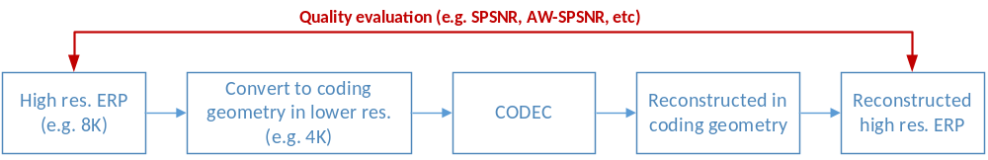
Figure 2. Suggested workflow for 360 video with ground truth signal in high resolution

Evaluating a given viewport
Today, apps on the phone, tablet, a computer, etc., can render a viewport from an input 360 video, and display it as a conventional 2D video. The user can move the phone/tablet around or use a mouse to drag the window in order to view different portions of the 360 video, and also zoom in/out content by changing the size of the field of view (FOV). As more 360 video content becomes available, we believe such ways of consuming 360 video content on conventional 2D displays will continue, and will co-exist with Head Mounted Device (HMD) based 360 video viewing in the future. Therefore, we propose to also study if there is any impact on the rendered video quality within a given viewport when different projection formats are used as the coding geometry, and quantify such impact, if any. Figure 3 shows the suggested workflow for evaluating the impact on the 2D viewport quality when different projection formats are used as the coding geometry. The bottom part of the workflow in Figure 3 is the same as Figure 2. The additional steps include 1) given a viewport, rendering the original 2D viewport video and the reconstructed 2D viewport video, based on the original ERP 8K and reconstructed ERP 8K, respectively, and 2) calculating a quality metric score between the original viewport video and the reconstructed viewport video.
It is worth noting that although Figure 3 depicts three steps after CODEC on the reconstruction side, the “reconstructed high res. ERP” step is only conceptual can be bypassed in practice. The PCT360 software (which we used to collect the simulation results in 4.2) can generate a viewport video in the high resolution ERP domain directly from the lower resolution coding geometry.
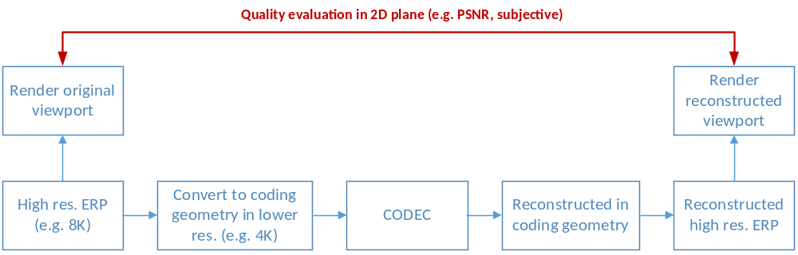
Figure 3. Suggested testing flow for a viewport on 360 video

Other test methodologies
In the light of the above suggestion, next we briefly discuss two other test methodologies that have been suggested during between-meeting discussions.

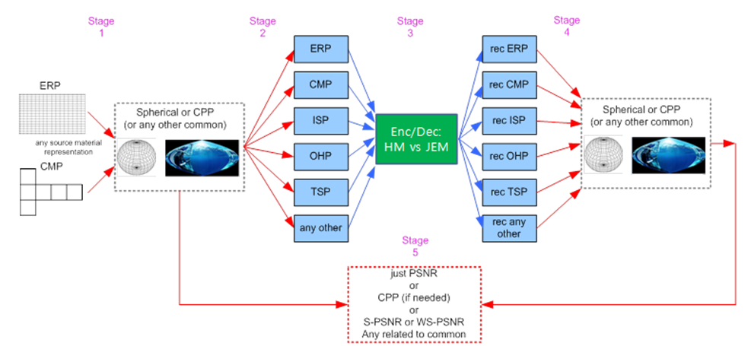
Figure 4. Test methodology A
The testing workflow A shown in Figure 4tries to remove the bias towards ERP by first converting the ground truth signal in ERP format into another projection format, which inFigure 4is the Castor Parabolic Projection (CPP), available in the 360tools software package provided by Samsung, at https://github.com/Samsung/360tools. In stage 2 of the workflow, the signal in CPP is then converted to the coding projection format, or the coding geometry. The coding projection format could be any of ERP, CMP, ISP, OHP, TSP, etc. After encoding and decoding (stage 3 of the work flow), the reconstructed signal in the coding projection format will be converted back to CPP at stage 4. Finally, a 360 video quality metric such as PSNR, S-PSNR, WS-PSNR, AW-SPSNR, etc, is used to compute the end-to-end distortion in CPP format.
In our view, this workflow has following disadvantages:
- Since quality is compared in CPP, this workflow tells us how best we preserved the content in CPP rather than evaluating how best we preserved the content on the sphere.
- This work requires a stage 1 conversion from ERP to CPP, which already introduces a conversion loss that may be non-negligible for some content.
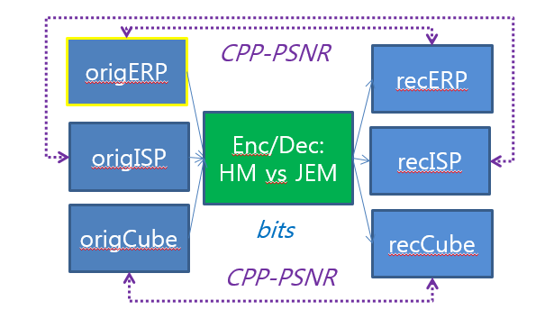
Figure 5. Test methodology B
Figure 5 shows a second test methodology, test methodology B, which uses the CPP-PSNR to measure the distortion between the “original” signal and the reconstructed signal in different projection formats, for example, ERP, ISP, CMP, in a common domain (i.e., CPP domain).In our view, test methodology B has the following disadvantages:
- Given that original content is always in ERP, the “original” ISP and the “original” CMP signals have gone through conversion (and therefore suffer from some conversion loss), whereas the original ERP has not. Therefore, test methodology B does not reduce the bias toward ERP.
- Another shortcoming of test methodology B is that, the comparison is between, origISP and recISP, and origCube and recCube. In this comparison, note that the ground truth signal, origERP, is totally ignored.

Experimental Results
Simulation results were collected following the proposed test methodologies in Figure 2 and Figure 3. The PCT360 software tool was used to generate all conversion only and conversion + coding results. The PCT360 software tool is available for both HM16.12 and JEM3.0. The conversion + coding results were collected using the HM16.12-PCT360 tool. Currently, a total of eight test sequences in 8K resolution are available to the JVET, including six sequences from GoPro [6] and two sequences from ETRI. All of these eight available sequences were used; all frames were converted and coded. For interpolation filters, we choose Lanczos-3 for luma and Lanczos-2 for chroma, based on the observation documented in our contribution JVET-D0xxx that studies the performance impact of interpolation filters [10]. The Random Access configuration was used in coding.

Evaluating the entire 360 video

Geometry conversion without coding
For conversion-only tests, the CODEC and reconstruction blocks in Figure 2 are bypassed. The ground truth 8K ERP signal is converted to respective coding geometry in lower resolution (4K or 4K equivalent), which is then converted back and compared to the original 8K ERP. This test examines the “conversion loss” due to impact of using different coding geometries.
Table 1, Table 2, Table 3, and Table 4 show the S-PSNR and AW-SPSNR metrics when the coding geometry in lower resolution in Figure 2 is set to ERP, CMP, EAP, and OHP, respectively. Clearly, under the proposed workflow, the ERP projection is not the highest performing projection format any more. On average, OHP provides the highest quality in conversion only tests, followed by CMP, ERP, and EAP, in that order.
However, we note two observations: 1) the best projection format is highly content dependent; 2) the quality variation among different projection formats can be very significant (for example, for the sequence “Basketball”, ERP underperforms OHP by 6 dB luma SPSNR/AW-SPSNR). To better understand the performance data, in Table 5 we list the best and worst projection formats for each individual sequence (in terms of luma SPSNR/AW-SPSNR). As shown, OHP is not only the best format on average, but also the best format for the majority of the sequences (5 out of 8). The best format for the remaining 3 sequences are EAP, which is the worst format on average. On the other hand, ERP is the worst format for 6 out of 8 sequences, with EAP being the worst for the remaining 2 sequences. CMP does not show up as the worst or the best in Table 5, and achieves a relatively “stable” performance.

Table 1. ERP 8K (8192x4096) → ERP 4K (4096x2048) → ERP 8K (8192x4096)
Sequences | SPSNR |  |  | AW-SPSNR
Sequences | Y | Cb | Cr | Y | Cb | Cr
Basketball | 45.58 | 63.95 | 61.77 | 45.59 | 63.98 | 61.79
Chairlift | 47.42 | 58.59 | 58.76 | 47.40 | 58.60 | 58.77
Jam Session | 51.45 | 58.74 | 58.24 | 51.45 | 58.75 | 58.25
Skate in lot | 46.48 | 60.02 | 59.90 | 46.50 | 60.05 | 59.92
Skate Trick | 44.83 | 58.36 | 58.80 | 44.80 | 58.36 | 58.81
Train | 45.64 | 58.22 | 58.48 | 45.65 | 58.23 | 58.49
Dancing | 47.62 | 53.72 | 52.81 | 47.63 | 53.71 | 52.79
Driving | 48.36 | 54.50 | 54.49 | 48.35 | 54.50 | 54.49
Average | 47.17 | 58.26 | 57.91 | 47.17 | 58.27 | 57.91
Table 2. ERP 8K (8192x4096) → CMP 4K equivalent (3552x2368) → ERP 8K (8192x4096)
Sequences | SPSNR |  |  | AW-SPSNR
Sequences | Y | Cb | Cr | Y | Cb | Cr
Basketball | 46.24 | 64.43 | 62.23 | 46.22 | 64.43 | 62.23
Chairlift | 48.06 | 58.95 | 59.18 | 48.05 | 58.95 | 59.17
Jam Session | 51.74 | 59.35 | 58.83 | 51.76 | 59.34 | 58.84
Skate in lot | 47.05 | 60.71 | 60.39 | 47.05 | 60.71 | 60.37
Skate Trick | 45.09 | 58.92 | 59.33 | 45.11 | 58.91 | 59.33
Train | 46.01 | 58.75 | 59.00 | 46.06 | 58.76 | 59.01
Dancing | 48.09 | 54.17 | 53.33 | 48.10 | 54.15 | 53.29
Driving | 49.03 | 55.11 | 55.07 | 48.98 | 55.10 | 55.05
Average | 47.66 | 58.80 | 58.42 | 47.67 | 58.79 | 58.41

Table 3. ERP 8K (8192x4096) → EAP 4K (4096x2048) → ERP 8K (8192x4096)
Sequences | SPSNR |  |  | AW-SPSNR
Sequences | Y | Cb | Cr | Y | Cb | Cr
Basketball | 41.23 | 64.21 | 61.79 | 41.23 | 64.24 | 61.81
Chairlift | 44.51 | 56.73 | 58.42 | 44.42 | 56.75 | 58.43
Jam Session | 52.66 | 59.48 | 59.01 | 52.64 | 59.50 | 59.04
Skate in lot | 47.40 | 60.58 | 60.11 | 47.39 | 60.61 | 60.12
Skate Trick | 46.07 | 59.15 | 59.47 | 46.05 | 59.15 | 59.49
Train | 46.65 | 58.92 | 59.15 | 46.66 | 58.94 | 59.17
Dancing | 47.80 | 54.25 | 53.35 | 47.81 | 54.23 | 53.33
Driving | 49.95 | 55.28 | 55.11 | 49.89 | 55.28 | 55.12
Average | 47.03 | 58.58 | 58.30 | 47.01 | 58.59 | 58.31
Table 4. ERP 8K (8192x4096) → OHP 4K equivalent (6208x2688) → ERP 8K (8192x4096)
Sequences | SPSNR |  |  | AW-SPSNR
Sequences | Y | Cb | Cr | Y | Cb | Cr
Basketball | 47.22 | 65.05 | 62.67 | 47.26 | 65.07 | 62.69
Chairlift | 48.67 | 59.14 | 59.51 | 48.71 | 59.16 | 59.52
Jam Session | 52.12 | 59.39 | 58.78 | 52.15 | 59.41 | 58.81
Skate in lot | 50.02 | 61.33 | 60.97 | 50.07 | 61.37 | 60.99
Skate Trick | 45.53 | 58.88 | 59.26 | 45.53 | 58.89 | 59.27
Train | 46.11 | 58.63 | 58.84 | 46.12 | 58.65 | 58.86
Dancing | 48.40 | 54.21 | 53.40 | 48.38 | 54.21 | 53.39
Driving | 51.13 | 55.42 | 55.29 | 51.12 | 55.41 | 55.29
Average | 48.65 | 59.01 | 58.59 | 48.67 | 59.02 | 58.60

Table 5. Best and worst geometry for each individual sequence (considering luma only)
 | Best | Worst
Basketball | OHP | EAP
Chairlift | OHP | EAP
Jam Session | EAP | ERP
Skate in lot | OHP | ERP
Skate Trick | EAP | ERP
Train | EAP | ERP
Dancing | OHP | ERP
Driving | OHP | ERP

Geometry conversion with coding
Since codec is an essential part of the 360 video delivery workflow, we need to examine the impact of different projection formats on coding. Conversion + coding results when different coding geometries are used are provided in this section. We set the anchor to using ERP as the lower-resolution coding geometry, and calculate the BD rate performance for CMP, ERP, OHP against the ERP anchor, as shown in Table 5, Table 6, and Table 7, respectively. For coding we use the Random Access configuration. For projection formats with multiple faces, we use the compact face packing arrangement: for CMP, packing arrangement of CMP3x2 is applied; and for OHP, the compact packing shown in [5] is applied. All RD plots are given in Figure 7.
The results show that the optimal projection format is sequence/content dependent. CMP is the best format for “basketball” and “chairlift”, EAP is the best format for “lot”, “trick” and “driving”, ERP is the best format for “train” and “dancing”, and EAP and ERP are effectively tied for “jam”. The proposed test methodology is therefore asserted to be effective in overcoming the bias toward ERP, and distinguishing the optimal projection format from others. Analysis to be added once COHP is available.
Table 6. Entire 360 video, CMP3x2 vs ERP
 | S-PSNR |  |  | AW-PSNR
 | Y | U | V | Y | U | V
Basketball | -5.6% | -11.0% | -10.7% | -5.5% | -10.7% | -10.4%
Chairlift | -16.8% | -13.0% | -14.7% | -17.0% | -13.3% | -15.0%
Skate in lot | -6.5% | -10.3% | -11.5% | -6.2% | -10.1% | -11.4%
Jam session | 3.5% | 0.3% | 0.0% | 3.1% | 0.4% | 0.1%
Train | 11.6% | 12.2% | 11.1% | 11.5% | 12.1% | 10.8%
Skate trick | 10.5% | 9.2% | 8.5% | 10.2% | 9.0% | 8.5%
Dancing | 1.3% | 0.8% | 1.9% | 1.3% | 0.5% | 1.9%
Driving | 14.2% | 16.3% | 18.8% | 14.6% | 16.5% | 18.8%
Overall | 1.5% | 0.6% | 0.4% | 1.5% | 0.6% | 0.4%
Table 7. Entire 360 video, EAP vs ERP
 | S-PSNR |  |  | AW-PSNR
 | Y | U | V | Y | U | V
Basketball | 32.8% | -17.2% | -12.4% | 32.8% | -17.1% | -12.3%
Chairlift | 9.5% | 1.3% | -2.8% | 10.1% | 1.3% | -2.9%
Skate in lot | -14.1% | -21.3% | -19.1% | -14.0% | -21.2% | -19.0%
Jam session | 0.1% | -0.6% | -0.5% | 0.1% | -0.7% | -0.6%
Train | 1.3% | 1.0% | 2.3% | 1.3% | 1.0% | 2.3%
Skate trick | -2.8% | -3.7% | -2.5% | -2.9% | -3.7% | -2.5%
Dancing | 6.4% | 2.6% | 4.4% | 6.3% | 2.9% | 4.3%
Driving | -7.9% | 1.5% | 0.3% | -7.7% | 1.4% | 0.2%
Overall | 3.2% | -4.5% | -3.8% | 3.3% | -4.5% | -3.8%
Table 8. Entire 360 video, COHP vs ERP

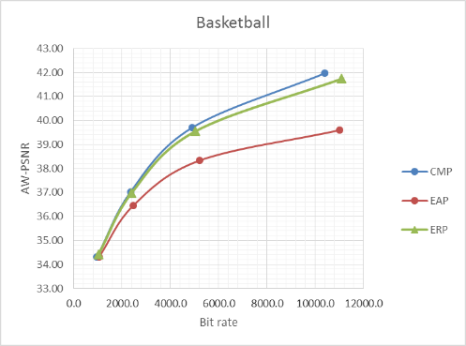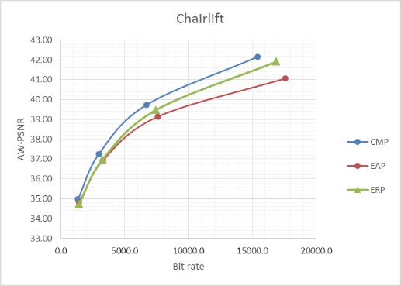

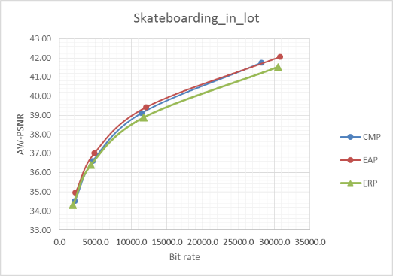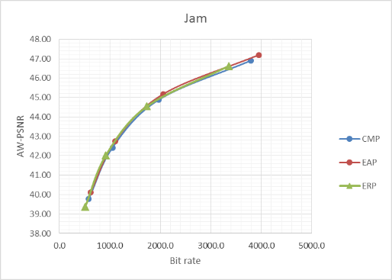

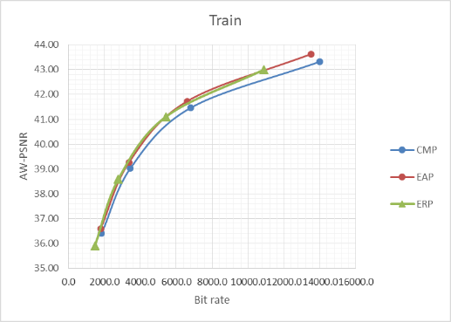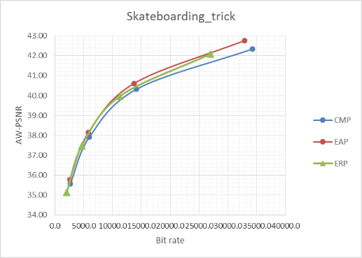

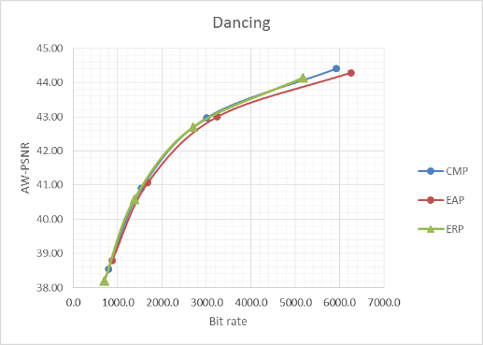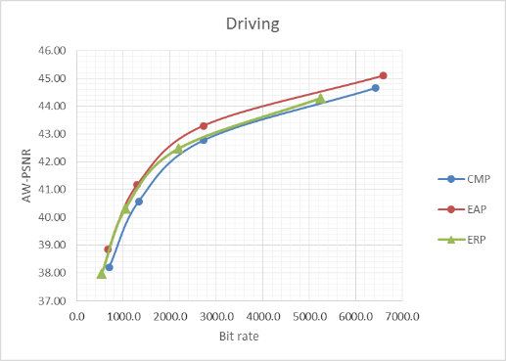
Figure 7. Entire 360 video, RD-plots
To study the impact of frame packing on coding efficiency, we compare the CMP4x3 frame packing, which is a non-compact frame packing arrangement with six valid faces and six “null” faces in the frame packed 2D pictures, to CMP3x2 frame packing arrangement, which is a compact frame packing arrangement with only six valid faces. Table 9 shows the BD-rate results comparing CMP4x3 with CMP3x2 (anchor). These results confirm that a compact packing arrangement is slightly better than a non-compact packing arrangement in terms of coding efficiency.
Table 9. Entire 360 video, CMP4x3 vs CMP3x2
 | S-PSNR |  |  | AW-PSNR
 | Y | U | V | Y | U | V
Basketball | 0.3% | 2.2% | 3.5% | 0.3% | 2.3% | 3.6%
Chairlift | 0.5% | 0.8% | 1.0% | 0.5% | 0.8% | 1.0%
Skate in lot | -0.6% | -0.2% | 0.7% | -0.6% | -0.2% | 0.9%
Jam session | 1.4% | 1.0% | 1.5% | 1.5% | 0.9% | 1.4%
Train | -0.3% | 0.6% | -0.5% | -0.3% | 0.6% | -0.4%
Skate trick | 1.2% | 1.4% | 1.7% | 1.2% | 1.4% | 1.6%
Dancing | 1.1% | 1.9% | 2.4% | 1.2% | 2.0% | 2.5%
Driving | 0.0% | 4.6% | -5.3% | 0.0% | 4.8% | -5.2%
Overall | 0.4% | 1.5% | 0.6% | 0.5% | 1.6% | 0.7%

Evaluating a viewport
According to the suggested viewport evaluation workflow in Figure 3, we use the PCT360 software to perform projection format conversion and viewport generation. To limit the number of tests, we use a fixed viewport in our simulation. Whereas fixed viewport is not completely aligned with the typical viewing habit of 360 video, it can serve as a proof of concept, which can help the JVET figure out a “common test condition” for viewport quality evaluation. We choose a 60⁰x60⁰ front viewport centered at (0⁰, 0⁰) for all test sequences except the “Train” sequence. For the “Train” sequence, we use a 60⁰x60⁰ viewport centered at (45⁰, 0⁰) (that is, the viewport is along the equator but toward the right part of picture instead of front facing). We make this special arrangement for the “Train” sequence in order to capture the moving train inside the viewport video. We set the resolution of the viewport to 1440x1440, which roughly corresponds to a 60⁰x60⁰ area of 8K ERP.
Table 10, Table 11, Table 12 show the BD rate results for the viewport video using CMP3x2, EAP, and OHP as the coding geometry in Figure 3. The anchor uses ERP as coding geometry. The results included here indicate a clear “win” for EAP. This is more due to the viewport selected in the simulation, than due to any intrinsic advantage of EAP over other projection formats. The EAP projection format applies denser vertical sampling toward the equator and sparser vertical sampling toward the poles, in order to keep the spherical area covered by each sample on the 2D plane equal. As the selected viewport represents an area that can benefit the most from such sampling behavior, EAP becomes the “winner” for this viewport.
Thus, we suggest to use this data set as a starting point for our discussion, and try to answer the following open questions:
1) Should viewport evaluation be included in future testing of 360 video and projection formats?
2) If so, how should we do it? How many viewports should we evaluate and where should we set them?
Table 10. Viewport, CMP3x2 vs ERP
 | Y | U | V
Basketball | -0.3% | -1.7% | -0.4%
Chairlift | -8.7% | -8.7% | -10.8%
Skate in lot | 3.2% | -1.7% | 0.2%
Jam session | 14.7% | 9.7% | 9.7%
Train | 4.9% | -0.1% | 1.1%
Skate trick | 28.8% | 27.3% | 27.9%
Dancing | 8.5% | 8.9% | 4.8%
Driving | 29.5% | 21.4% | 26.1%
Overall | 10.1% | 6.9% | 7.3%
Table 11. Viewport, EAP vs ERP
 | Y | U | V
Basketball | -24.6% | -22.2% | -20.2%
Chairlift | -23.6% | -24.2% | -24.7%
Skate in lot | -23.7% | -24.7% | -23.2%
Jam session | -4.6% | -7.2% | -8.4%
Train | -1.9% | -5.4% | -7.4%
Skate trick | -8.3% | -8.8% | -9.5%
Dancing | -3.5% | -5.3% | -4.5%
Driving | -6.7% | -7.3% | -3.9%
Overall | -12.1% | -13.1% | -12.7%

Table 12. Viewport, COHP vs ERP
 | Y | U | V
Basketball | -14.6% | -12.8% | -9.0%
Chairlift | -9.7% | -11.7% | -7.8%
Skate in lot | -2.9% | 0.2% | 2.6%
Jam session | 10.3% | 9.6% | 10.1%
Train | 9.2% | 4.7% | 5.3%
Skate trick | -4.3% | -2.1% | -2.2%
Dancing | 8.8% | 9.0% | 7.9%
Driving | 56.9% | 55.8% | 60.2%
Overall | 6.7% | 6.6% | 8.4%

References
- Equirectangular projection, https://en.wikipedia.org/wiki/Equirectangular_projection
- Cubemap, https://en.wikipedia.org/wiki/Cube_mapping
- Lambert cylindrical equal-area projection, https://en.wikipedia.org/wiki/Lambert_cylindrical_equal-area_projection
- Octahedron, https://en.wikipedia.org/wiki/Octahedron
- Y. He, B. Vishwanath, X. Xiu, Y. Ye, “AHG8: InterDigital's projection format conversion tool”, JVET-D0021, Oct. 2016, Chengdu, China.
- A. Abbas, B. Adsumilli, “New GoPro Test Sequences for Virtual Reality Video Coding”, JVET-D0026, Oct. 2016, Chengdu, China.
- Y. Sun, A. Lu, L. Yu, “[FTV-AHG] WS-PSNR for 360 video quality evaluation”, MPEG document no m38551, June 2016, Geneva, Switzerland.
- M. Yu, H. Lakshman, B. Girod, “A Framework to Evaluate Omnidirectional Video Coding Schemes”, IEEE International Symposium on Mixed and Augmented Reality, 2015.
- B. Vishwanath, Y. He, Y. Ye, “AHG8: Area Weighted Spherical PSNR for 360 video quality evaluation”, JVET-D0072, Oct. 2016, Chengdu, China.
- Y. He, Y. Ye, B. Vishwanath, “AHG8: Interpolation filters for 360 video geometry conversion and coding”, JVET-D0073, Oct. 2016, Chengdu, China.

Patent rights declaration(s)
InterDigital Communications Inc. may have current or pending patent rights relating to the technology described in this contribution and, conditioned on reciprocity, is prepared to grant licenses under reasonable and non-discriminatory terms as necessary for implementation of the resulting ITU-T Recommendation | ISO/IEC International Standard (per box 2 of the ITU-T/ITU-R/ISO/IEC patent statement and licensing declaration form).

