    Joint Video Exploration Team (JVET)  of ITU-T SG 16 WP 3 and ISO/IEC JTC 1/SC 29/WG 11  3rd Meeting: Geneva, CH, 26 May – 1 June 2016 | Document: JVET-C1001_v3

Title: | Algorithm Description of Joint Exploration Test Model 3
Status: | Output Document to JVET
Purpose: | Algorithm Description of Joint Exploration Test Model 3
Author(s) or  Contact(s): | Jianle Chen  Qualcomm Inc.  Elena Alshina  Samsung Electronics  Gary J. Sullivan  Microsoft Corp.  Jens-Rainer Ohm  RWTH Aachen University  Jill Boyce  Intel | Email: | cjianle@qti.qualcomm.com  elena_a.alshina@samsung.com  garysull@microsoft.com  ohm@ient.rwth-aachen.de  jill.boyce@intel.com
Source: | Editors
_____________________________
List of changes to JVET-B1001

Release 1
Integration of adoptions
#1 JVET-C0024, QTBT replaces quadtree in main branch of JEM3
#2 JVET-C0025, Simplification/unification of MC filters for affine prediction
#3 JVET-C0027, Simplification/improvement of BIO
#4 JVET-C0035, ATMVP simplification
#5 JVET-C0038, Modifications of ALF: Diagonal classification, geometric transformations of filters, prediction of coefficients from fixed set, alignment of luma and chroma filter shapes, removal of context-coded bins for filter coefficient signaling
#6 JVET-C0042/JVET-C0053, Unified binarization of NSST index
#7 JVET-C0055, Simplified derivation of MPM in intra prediction
#8 NSST & TS, Disable NSST and do not code NSST index if all components in a block use TS; otherwise, if NSST is on, it shall not be used for a block of a component that uses TS.
Other changes:
#9 Review_JC0: AMT description improvement and other review modification.
#10 Review_Lena0: BIO description improvement

Release 2
#11 JVET-C0046, Enabling TS with 64x64 transform blocks
#12 Review_JC1: Cross-component linear model (CCLM) prediction description improvement and other minor changes.

Abstract
ITU-T VCEG (Q6/16) and ISO/IEC MPEG (JTC 1/SC 29/WG 11) are studying the potential need for standardization of future video coding technology with a compression capability that significantly exceeds that of the current HEVC standard (including its current extensions and near-term extensions for screen content coding and high-dynamic-range coding). The groups are working together on this exploration activity in a joint collaboration effort known as the Joint Video Exploration Team (JVET) to evaluate compression technology designs proposed by their experts in this area.
This document is the Joint Exploration Model 3 (JEM 3) algorithm description. It describes the coding features that are under coordinated test model study by the Joint Video Exploration Team (JVET) of ITU-T VCEG and ISO/IEC MPEG as potential enhanced video coding technology beyond the capabilities of HEVC. The description of encoding strategies used in experiments for the study of the new technology in JEM is also provided.
Contents
1. Introduction 1
2. Description of new coding features and encoding methods 1
2.1. Quadtree plus binary tree (QTBT) block structure 1
2.1.1. QTBT block partitioning structure 1
2.1.2. Encoder implementation 4
2.2. Intra prediction improvement 6
2.2.1. Intra mode coding with 67 intra prediction modes 6
2.2.2. Four-tap intra interpolation filter 8
2.2.3. Boundary prediction filters 8
2.2.4. Cross-component linear model prediction 8
2.2.5. Position dependent intra prediction combination (PDPC) 9
2.2.6. Adaptive reference sample smoothing 10
2.3. Inter prediction improvement 12
2.3.1. Sub-CU based motion vector prediction 12
2.3.2. Adaptive motion vector difference resolution 13
2.3.3. Higher motion vector storage accuracy 14
2.3.4. Overlapped block motion compensation 14
2.3.5. Local illumination compensation 15
2.3.6. Affine motion compensation prediction 16
2.3.7. Pattern matched motion vector derivation 18
2.3.8. Bi-directional optical flow 19
2.4. Transform improvement 22
2.4.1. Adaptive multiple Core transform 22
2.4.2. Secondary transforms 24
2.4.3. Signal dependent transform (SDT) 25
2.5. In loop filter 26
2.5.1. Adaptive loop filter 26
2.5.2. SAO and deblocking 30
2.6. Enhanced context adaptive binary arithmetic coding (CABAC) 30
2.6.1. Context modeling for transform coefficients 31
2.6.2. Multi-hypothesis probability estimation 31
2.6.3. Initialization for context models 32
3. Software and common test conditions 32
3.1. Reference software 32
3.2. Common test condition 33
4. References 33

Introduction
The Joint Exploration Test Model (JEM) is build up on top of HEVC test model[1][2][16][17]. The basic encoding and decoding flowchart of HEVC is kept unchanged in JEM, however, the design elements of most important modules, including the modules of block structure, intra and inter prediction, residue transform, loop filter and entropy coding, are somewhat modified and new coding tools are added. The following new coding features are included in JEM3.
- Block structure
  - Quadtree plus binary tree (QTBT) block structure [5]
- Intra prediction improvements
  - 65 intra prediction directions [4][6][7][8]
  - 4-tap interpolation filter for intra prediction [4][6]
  - Boundary filter applied to other directions in addition to horizontal and vertical ones [4][6]
  - Cross-component linear model (CCLM) prediction [3][4]
  - Position dependent intra prediction combination (PDPC) [9]
  - Adaptive reference sample smoothing [10]
- Inter prediction improvements
  - Sub-PU level motion vector prediction [3][4][11]
  - Locally adaptive motion vector resolution (AMVR) [3][4]
  - 1/16 pel motion vector storage accuracy
  - Overlapped block motion compensation (OBMC) [3][4]
  - Local illumination compensation (LIC) [4][12]
  - Affine motion prediction [13]
  - Pattern matched motion vector derivation [4][6][5]
  - Bi-directional optical flow (BIO) [7][8]
- Transform
  - Explicit multiple core transform [3][4]
  - Mode dependent non-separable secondary transforms [4][14]
  - Signal dependent transform (SDT) [15]
- Adaptive loop filter (ALF) [3][4]
- Enhanced CABAC design [4][6]
  - Context model selection for transform coefficient levels
  - Multi-hypothesis probability estimation
  - Initialization for context models
All the methods listed above have been integrated into the main software branch of JEM. In the software implementation of JEM3, signal dependent transform (SDT) is turned off by default.

Description of new coding features and encoding methods
Technical detail of each new coding method is described in the following sub-sections. The description of encoding strategies is also provided. JEM Encoder reuses all basic encoding methods in HM encoder [16]. In this document, the additions needed for the new coding features are included.

Quadtree plus binary tree (QTBT) block structure

QTBT block partitioning structure
In HEVC, a CTU is split into CUs by using a quadtree structure denoted as coding tree to adapt to various local characteristics. The decision whether to code a picture area using inter-picture (temporal) or intra-picture (spatial) prediction is made at the CU level. Each CU can be further split into one, two or four PUs according to the PU splitting type. Inside one PU, the same prediction process is applied and the relevant information is transmitted to the decoder on a PU basis. After obtaining the residual block by applying the prediction process based on the PU splitting type, a CU can be partitioned into transform units (TUs) according to another quadtree structure similar to the coding tree for the CU. One of key feature of HEVC structure is that it has the multiple partition conceptions including CU, PU, and TU.
The QTBT structure removes the concepts of multiple partition type, i.e. removes the separation of CU, PU and TU conception, and support more flexibility for CU partition shape to better match the local characteristics of video data. In QTBT block structure, CU can have either square or rectangle shape. As show in Figure 1, a Coding Tree Unit (CTU) is firstly partitioned by a quadtree structure. The quadtree leaf nodes are further partitioned by a binary tree structure. There are two splitting types, symmetric horizontal splitting and symmetric vertical splitting, in the binary tree splitting. The binary tree leaf node is named as Coding Units (CUs), which is used for prediction and transform without any further partitioning. That means the CU, PU and TU have the same block size in the new coding block structure. In JEM, a CU consists of Coding Blocks (CBs) of different color components, e.g. one CU contains one luma CB and two chroma CBs for YUV420 chroma format.
The following parameters are defined to have efficient signalling of a QTBT true.
– CTU size: the root node size of a quadtree, same concept as in HEVC
– MinQTSize: the minimum allowed quadtree leaf node size
– MaxBTSize: the maximum allowed binary tree root node size
– MaxBTDepth: the maximum allowed binary tree depth
– MinBTSize: the minimum allowed binary tree leaf node size
In one example of the QTBT partitioning structure, the CTU size is set as 128x128 (luma samples and two corresponding 64x64 chroma samples), the MinQTSize is set as 16x16, the MaxBTSize is set as 64x64, the MinBTSize (for both width and height) is set as 4, and the MaxBTDepth is set as 4. The quadtree partitioning is applied to the CTU first to generate quadtree leaf nodes. The quadtree leaf nodes may have a size from 16x16 (i.e., the MinQTSize) to 128x128 (i.e., the CTU size). If the leaf quadtree node is 128x128, it will not be further split by the binary tree since the size exceeds the MaxBTSize (i.e., 64x64). Otherwise, the leaf quadtree node could be further partitioned by the binary tree. Therefore the quadtree leaf node is also the root node for the binary tree and it has the binary tree depth as 0. When the binary tree depth reaches MaxBTDepth (i.e., 4), it implies that no further splitting. When the binary tree node has width equal to MinBTSize (i.e., 4), it implies no further horizontal splitting. Similarly, when the binary tree node has height equal to MinBTSize, it implies no further vertical splitting. The leaf nodes of the binary tree are namely CUs further processed by prediction and transform without any further partitioning.
Figure 1 (left) illustrates an example of block partitioning by using QTBT, and Figure 1 (right) illustrates the corresponding tree representation. The solid lines indicate quadtree splitting and dotted lines indicate binary tree splitting. In each splitting (i.e., non-leaf) node of the binary tree, one flag is signalled to indicate which splitting type (i.e., horizontal or vertical) is used, where 0 indicates horizontal splitting and 1 indicates vertical splitting. For the quadtree splitting, there is no need to indicate the splitting type since it always split a block horizontally and vertically into 4 sub-blocks with an equal size.
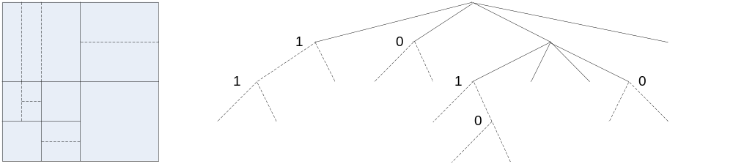
Figure 1: Illustration of a QTBT structure
In addition, the QTBT block structure supports the feature that luma and chroma have the separate QTBT structure. Currently, for P and B slice the luma and chroma CTUs in one CTU share the same QTBT structure. For I slice the luma CTU is partitioned into CUs by a QTBT structure, and chroma CTU are partitioned into chroma CUs by another QTBT structure. This means that a CU in I slice consists of a coding block of luma component or coding blocks of two chroma component, and a CU in P and B slice a CU consists of coding blocks of all three color component.
In HEVC, inter prediction for small block are restricted to reduce memory access of motion compensation, i.e. the bi-directional prediction for 4x8 and 8x4 block is not allowed, and also 4x4 inter prediction is disabled. In QTBT, such restriction is removed.
In JEM, large transform, up to 128x128, is enabled to improve coding efficiency especially for higher resolution video, e.g., 1080p and 4K sequences. High frequency transform coefficients zero-out are applied when a large block when transform is applied. Only the lower-frequency coefficients are maintained (the higher-frequency coefficients are zeroed out) for the transform block with size (width or height, or both width and height) larger than or equal to 64. For example, for an MxN transform block, with M as block width and N as block height, when M is larger than or equal to 64, only the left M/2 columns of transform coefficients are kept. Similarly when N is larger than or equal to 64, only the top N/2 rows of transform coefficients are kept. When transform skip mode is used for a large block, transform coefficients zero-out is not applied.

Encoder implementation
The encoder rate-distortion optimization (RDO) process of the QTBT structure used to determine the best block partitioning shape is illustrated by the pseudo code shown in Figure 2.
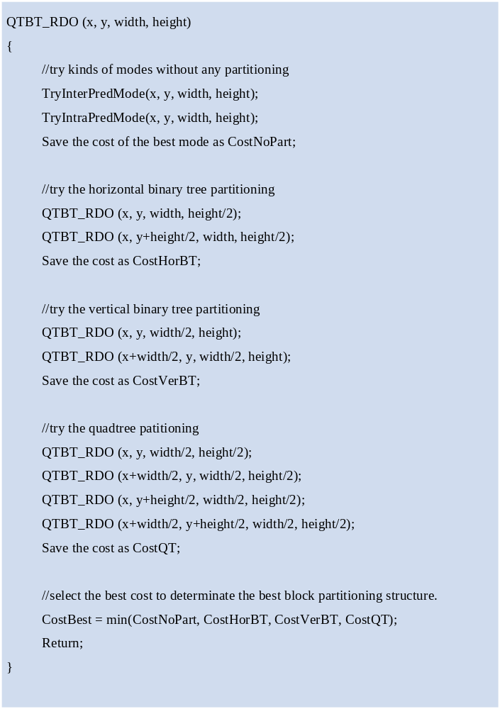
Figure 2: Pseudo code of the QTBT RDO process
As shown in Figure 2, the function QTBT_RDO() is used for encoder to determine the best partition for an input block which is specified by the four input parameters x, y, width, and height indicating respectively the x-coordinate and y-coordinate of the top-left position, width, and height of the block. Firstly, the input block is treated as a leaf node (i.e., CU or CB) of the coding tree to try all kinds of modes without any further partitioning for prediction and transform, and then the RD cost of the best mode is stored as CostNoPart. Secondly, if the condition of the horizontal binary tree split is met, the input block is split into two sub-blocks horizontally. Each of them has the same width but half height of the input block. The top one has its top-left position equal to the current input block and the bottom one has its y-coordinate increased by half height. Each sub-block calls the function QTBT_RDO() recursively to determine their own best partitions. The cost of this horizontal binary tree split of current input block is stored as CostHorBT. Similarly, the cost of the vertical binary tree split and quadtree split of current input block can be derived as CostVerBT and CostQT respectively. After comparing the CostNoPart, CostHorBT, CostVerBT, and CostQT, the best block partition shape which has the minimum RD cost can be derived.
For I slice, the QTBT_RDO() for a luma CTB is processed before the QTBT_RDO() for the two corresponding chroma CTBs since the chroma CBs may reuse the collocated luma intra prediction mode as the same concept in HEVC.
The recursive calling of the function QTBT_RDO() within the quadtree and the binary tree together is very time-consuming. Several fast encoding schemes have been implemented to speed up the RDO process in the released software.
If one block has its CostNoPart smaller than CostHorBT and CostVerBT when the binary tree with deep depth is tried, then the CostQT is very likely also to be larger than CostNoPart, so the RD check of quadtree split can be skipped.
The quadtree split of one node can be represented by some combinations of horizontal binary tree split and vertical binary tree split. The same partition shape can also be generated by applying the horizontal and vertical binary tree split in different orders. Even if the signalled flags representing the tree structure and the processing order of the generated CUs may different, the RD performance is supposedly to be similar since the block partition shape is the same. Therefore, the binary tree split is constrained to avoid some redundant cases.
In the QTBT_RDO() process, one block may be accessed more than once. In Figure 3(left) the block is firstly vertically split and the right sub-block is further horizontally split. In Figure 3 (right) the block is firstly horizontally split and the top sub-block is further vertically split. Therefore, the sub-block in the top-right position will be accessed twice. The whole block itself may also be accessed many times. Since the best mode information of a same block is likely to be unchanged during the multiple RDO accessing, the best mode information is stored during the first RDO check stage and will be reused during the later RDO accessing to save encoding time.
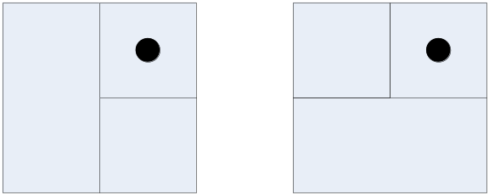
Figure 3: Illustration of one block accessed twice
If the best mode of current block is skip mode and current block depth is deep enough, then it usually has no need to try further split RDO for both quadtree and binary tree.
The maxBTSize and minQTSize (for both luma and chroma in I slice) are two critical factors for the RD performance and the encoding time. In JEM3.0 software, these two parameters of the currently slice are set adaptively larger when the average CU size of the previous coded picture in the same temple layer is larger, and vice versa. This picture level adaptive setting is only used for P and B slices. In JEM3.0 software, the default values of the two parameter as well as maxBTDepth and minBTSize are given in Table 1.
Table 1: Derivation QTBT high level parameters setting and experimental results
QTBT high level parameters | I slice | P and B slice
CTU size | 128x128 | 128x128
minQTLumaSize | 8x8 | 8x8 (init)
minQTChromaSize | 4x4 | n/a
maxBTSize | 32x32 | 128x128 (init)
maxBTDepthLuma | 3 | 3
maxBTDepthChorma | 3 | n/a
minBTSize | 4 | 4

Intra prediction improvement

Intra mode coding with 67 intra prediction modes
To capture finer edge directions presented in natural videos, the directional intra modes is extended from 33, as defined in HEVC, to 65. The new directional modes are depicted as red dotted arrows in Figure 4, and the Planar and DC modes remain the same. These denser directional intra prediction modes apply for all block sizes and both luma and chroma intra predictions.
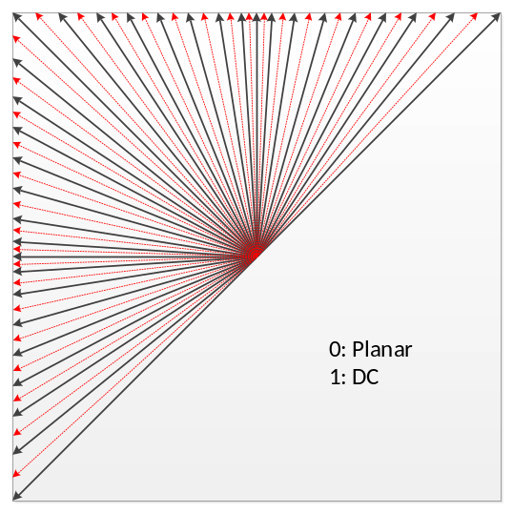
Figure 4: Proposed 67 intra prediction modes
To accommodate the increased number of directional Intra modes, an Intra mode coding method with 6 Most Probable Modes (MPMs) is used. Two major technical aspects are involved: 1) the derivation of 6 MPMs, and 2) entropy coding of 6 MPMs and non-MPM modes.
In JEM, the modes included into the MPM lists are classified into three groups:
- Neighbor intra modes
- Derived intra modes
- Default intra modes
Five neighboring intra prediction modes are used to form MPM list. Those locations of the 5 neighboring blocks are the same as those used in the merge mode, i.e., left (L), above (A), below left (BL), above right (AR), and above left (AL) as shown in Figure 5. An initial MPM list is formed by insert 5 neighbour intra modes, planar, and DC modes into the MPM list. A pruning process is used to remove the duplicated mode so that only unique modes can be included into the MPM list. The order in which the initial modes are included is left, above, planar, DC, below left, above right, and above left.

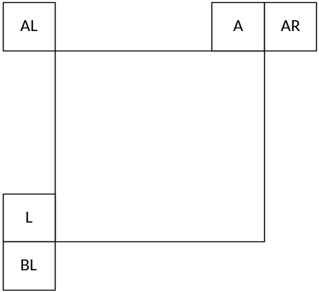
Figure 5: Neighbouring blocks for MPM derivation
If MPM list is not full (i.e. less than 6 MPM candidates in the list), derived modes are added, those intra modes are obtained by adding -1 or +1 to the angular modes which are already included into MPM list. Derivation is not applied to non-angular modes (DC or planar).
Finally, if the MPM list is still not complete, the default modes are added in the order of: vertical, horizontal, mode 2, and diagonal mode. As a result of this process, a unique list of 6 MPM modes is generated.
For entropy coding of 6 MPMs, a truncated unary binarization of the MPMs is used. The first three bins are coded with contexts which depend on the MPM mode related to the bin currently being signaled. The MPM mode is classified into one of three categories: (a) whether the mode belongs to horizontal (MPM mode is less than or equal to diagonal direction), (b) vertical (MPM mode greater than the diagonal direction), or (c) non-angular (DC and planar) class. Accordingly, three contexts are used to signal MPM index.
The coding of the remaining 61 non-MPMs is done as follows. The 61 non-MPMs are firstly divided into two sets: selected modes set and non-selected modes set. Selected modes set contains 16 modes and the rest (45 modes) are assigned to non-selected modes set. The mode set that the current mode belongs to is indicated in the bit-stream with a flag. Then, the mode from selected set is signaled with a 4-bit fixed length code, and the mode from non-selected set is coded with a truncated binary code. The selected modes set is generated by sub-sampling the total 61 non-MPM mode with index as follows:
Selected modes set = {0, 4, 8, 12, 16, 20 … 60}
Non-selected modes set = {1, 2, 3, 5, 6, 7, 9, 10 … 59}
At the encoder side, the similar two-stage Intra mode decision process of HM is used. In the first stage, i.e., the Intra mode pre-selection stage, a lower complexity Sum of Absolute Transform Difference (SATD) cost is used to pre-select the best N Intra prediction modes from all the available Intra modes. In the second stage, a higher complexity R-D cost selection is further applied to decide the best one Intra prediction mode from the N candidates. However, when 67 Intra prediction modes is applied, since the total number of available modes is roughly doubled, the complexity of the Intra mode pre-selection stage will also be increased if the same encoder mode decision process of HM is directly used. To minimize the encoder complexity increase, a two-step Intra mode pre-selection process is performed. At the first step, the best N (N depends on Intra prediction block size) modes from the original 35 Intra prediction modes (indicated by black solid arrows in Figure 4) are first decided based on the cost of Sum of Absolute Transform Difference (SATD); At the second step, the direct neighbors (new Intra prediction directions as indicated by red dotted arrows in Figure 4) of the selected N modes are further examined by SATD, and the list of selected N modes are updated. Finally, the first M MPMs are added to the N modes if not already included, and the final list of candidate Intra prediction modes is generated for the second stage R-D cost examination, which is done in the same way as HM. The value of M is increased by one based on the original setting in HM, and N is slightly decreased to optimize the performance of 67 prediction modes, as illustrated below Figure 3.
Table 2: Number of best mode candidates at the Intra mode pre-selection step
Intra prediction block size | 4x4 | 8x8 | 16x16 | 32x32 | 64x64 | >64x64
HM | 8 | 8 | 3 | 3 | 3 | 3
HM with 67 Intra prediction modes | 7 | 7 | 2 | 2 | 2 | 2

Four-tap intra interpolation filter
Four-tap intra interpolation filters are utilized to improve the directional intra prediction accuracy. In HEVC, a two-tap linear interpolation filter has been used to generate the intra prediction block in the directional prediction modes (i.e., excluding Planar and DC predictors). In JEM, two types of four-tap interpolation filters are used: Cubic interpolation filters for block with size smaller than or equal to 64 samples, and Gaussian interpolation filters for block with size larger than 64 samples. The parameters of the filters are fixed according to block size, and the same filter is used for all predicted pixels, in all directional modes.

Boundary prediction filters
In HEVC, after the intra prediction block has been generated for VER and HOR intra modes, the left-most column and top-most row of the prediction samples are further adjusted, respectively. Here this method is further extended to several diagonal intra modes, and boundary samples up to four columns or rows are further adjusted using a two-tap (for intra mode 2 & 34) or a three-tap filter (for intra mode 3-6 & 30-33). Examples of the boundary prediction filters for intra mode 34 and 30~33 are shown in Figure 6, and the boundary prediction filters for intra mode 2 and 3~6 are similar.
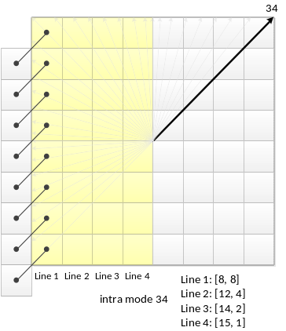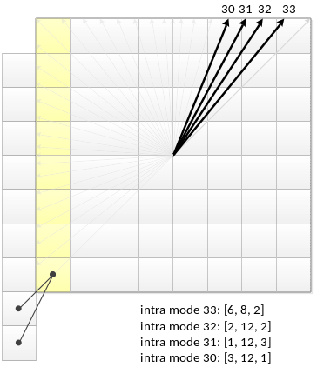
Figure 6: Examples of boundary prediction filters for intra mode 30 – 34

Cross-component linear model prediction
It was known that coding performance can be improved by utilizing the cross component correlation existing even in YUV 4:2:0 video sequences. To reduce the cross component redundancy, in cross-component linear model (CCLM) prediction mode, the chroma samples are predicted based on the reconstructed luma samples of the same block by using a linear model as follows:
${pred}_{C}\left(i, j\right)=α·{rec}_{L}\left(i, j\right)+ β$ (1)
where ${pred}_{C}\left(i, j\right)$ represents the prediction of chroma samples in a block and ${rec}_{L}\left(i, j\right)$ represents the downsampled reconstructed luma samples of the same block. Parameters $α$ and $β$ are derived by minimizing regression error between the neighbouring reconstructed luma and chroma samples around the current block as follows:
$α= \frac{N·∑\left(L\left(n\right)·C\left(n\right)\right)-∑L\left(n\right)·∑C\left(n\right)}{N·∑\left(L\left(n\right)·L\left(n\right)\right)-∑L\left(n\right)·∑L\left(n\right)}$ (2)
$β= \frac{∑C\left(n\right)-α·∑L\left(n\right)}{N}$ (3)
where $L\left(n\right)$ represents the down-sampled top and left neighboring reconstructed luma samples, $C\left(n\right)$ represents the top and left neighboring reconstructed chroma samples, and value of $N$is equal to twice of the minimum of width and height of the current chroma coding block. For a coding block with sequare shape, the above two equations are applied directly. For a non-sequare coding block, the neighboring samples of the longer bourndary are first subsampled to have the same amount of samples to the shorter boundary.
In JEM, CCLM prediction mode is extended to the prediction between two chroma components, i.e. Cr component is predicted from Cb component. Instead of using the reconstructed sample signal, the CCLM Cb-to-Cr prediction is applied in residual domain. This is implemented by adding a weighted reconstructed Cb residual to the original Cr intra prediction to form the final Cr prediction:
${pred}_{Cr}^{*}\left(i, j\right)={pred}_{Cr}\left(i, j\right)+ {α·resi}_{Cb}'\left(i, j\right)$ (4)
The scaling factor$α$ is derived in a similar way as in CCLM luma-to-chroma mode. The only difference is an addition of a regression cost relative to a default $α$ value in the error function so that derived scaling factor is biased towards the default value (-0.5) as follows:
$α= \frac{N·∑\left(Cb\left(n\right)·Cr\left(n\right)\right)-∑Cb\left(n\right)·∑Cr\left(n\right)+λ·(-0.5)}{N·∑\left(Cb\left(n\right)·Cb\left(n\right)\right)-∑Cb\left(n\right)·∑Cb\left(n\right)+λ}$ (5)
where $Cb\left(n\right)$ represents the neighboring reconstructed Cb samples and $Cr\left(n\right)$ represents the neighboring reconstructed Cr samples, and $λ$ is equal to $∑\left(Cb\left(n\right)·Cb\left(n\right)\right)≫9$.
In JEM, CCLM luma-to-chroma prediction mode is added as one additional chroma intra prediction mode. At encoder side, one more RD cost check for chroma components is added for selecting the optimal chroma intra prediction mode. When the intra prediction modes other than CCLM luma-to-chroma prediction mode is used for chroma components of a CU, CCLM Cb-to-Cr prediction is used to enhance the Cr component prediction

Position dependent intra prediction combination (PDPC)
PDPC is a post-processing for Intra prediction which invokes combination of HEVC Intra prediction with un-filtered boundary reference samples:

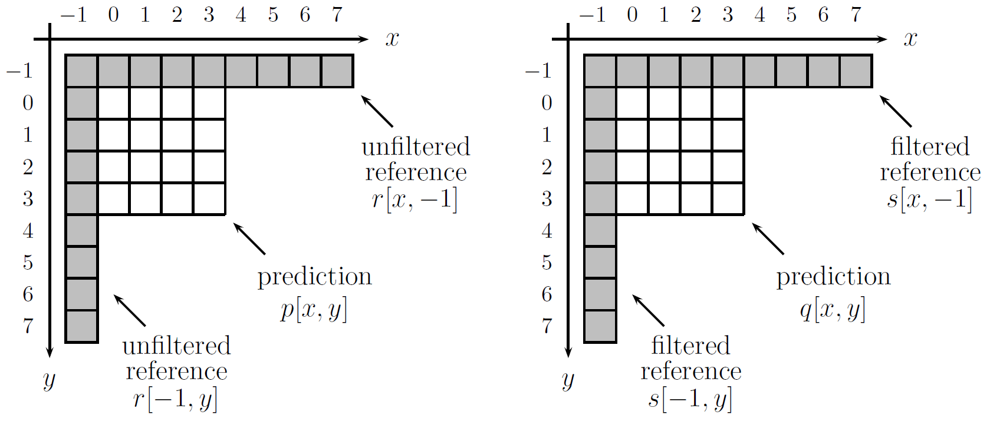
Figure 7: Example of intra prediction in 4×4 blocks, with notation for unfiltered and filtered reference samples.
The notation used to define PDPC is shown in Figure 7. r and s represents the boundary samples with filtered and unfiltered references, respectively. $q[x,y]$ is the intra prediction based on filtered reference s, and computed as defined in HEVC. $x$ and $y$ are the horizontal and vertical distance from the block boundary.
The new prediction $p[x,y]$ combines weighted values of boundary elements with $q[x,y]$ as following
$p\left[x,y\right]=\left\{\left(c_{1}^{(v)}≫\left\lfloor y/d_{y}\right\rfloor \right)r\left[x,-1\right]-\left(c_{2}^{(v)}≫\left\lfloor y/d_{y}\right\rfloor \right)r\left[-1,-1\right]+ \left(c_{1}^{(h)}≫\left\lfloor x/d_{x}\right\rfloor \right)r\left[-1,y\right]-\left(c_{2}^{(h)}≫\left\lfloor x/d_{x}\right\rfloor \right)r\left[-1,-1\right]+b\left[x,y\right]q\left[x,y\right]+64\right\}≫7$ (6)
where $c_{1}^{v}, c_{2}^{v}, c_{1}^{h}, c_{2}^{h}$ are stored prediction parameters, $d_{x}=1$for blocks with width smaller than or equal to 16 and$d_{x}=2$ for blocks with width larger than 16, $d_{y}=1$for blocks with height smaller than or equal to 16 and $d_{y}=2$ for blocks with height larger than 16. b[x, y] is a normalization factor derived as follow:
$b\left[x,y\right]=128-\left(c_{1}^{\left(v\right)}≫\left\lfloor y/{d_{y}}\right\rfloor \right)+\left(c_{2}^{\left(v\right)}≫\left\lfloor y/{d_{y}}\right\rfloor \right)-\left(c_{1}^{(h)}≫\left\lfloor x/d_{x}\right\rfloor \right)+\left(c_{2}^{(h)}≫\left\lfloor x/d_{x}\right\rfloor \right)$ (7)
A few 7-tap low pass filter is used to smooth the boundary samples. Defining h_{k} as the impulse response of a filter k, an additional stored parameter a for computing the filtered reference as in equation (6).
$s=a r+(1-a)(h_{k}*r)$ (8)
where “*” represents convolution.
One set of prediction parameters ($c_{1}^{v}, c_{2}^{v}, c_{1}^{h}, c_{2}^{h}$, a and filter index k) is defined per intra prediction mode (neighbouring prediction directions are grouped) and block size. A CU level flag in signalled to indicate whether PDPC is applied or not. Value 0 indicates that the existing HEVC intra prediction (with HEVC reference sample smoothing filter disabled) is used, and values 1 indicates the PDPC is applied. When PDPC flag value is equal to 0, the mode dependent reference smoothing of HEVC is disabled to generate intra prediction.
At encoder side, the PDPC flag for an intra-coded CU is determined at CU level. When intra mode RD cost check is needed for a CU, one additional CU level RD check is added to select the optimal PDPC flag between the value of 0 and 1 for an intra-coded CU.

Adaptive reference sample smoothing
In HEVC, mode-dependent reference sample smoothing is applied. In JEM, a new reference sample filtering mechanism is introduced. As presented in Figure 8 two low pass filters (LPF) are used to process reference samples:
- 3-tap LPF with the coefficients of [1, 2, 1] / 4
- 5-tap LPF with the coefficients of [2, 3, 6, 3, 2] / 16

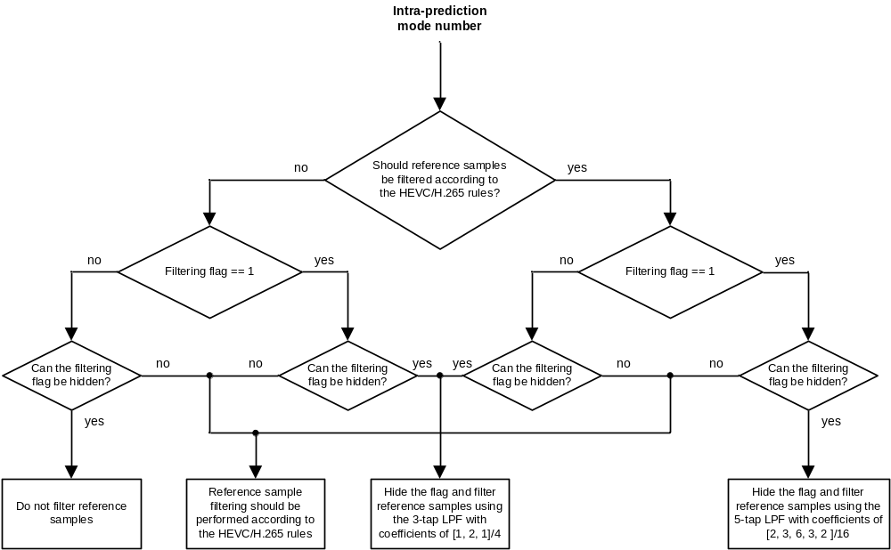
Figure 8: Reference sample adaptive filtering
To signal what option is selected, data hiding is used instead of signaling the flag in the bitstream. In HEVC, the sign of the last coefficient of a coefficients group (CG) is hidden in the sum of the absolute values of the CG’s coefficients. In JEM, a similar technique is used to hide the filtering flag that indicates what of the two filters related to the same filter set and selected in accordance with block size and intra prediction mode. The transform coefficients of a given coding block that are located at an odd position are used to hide the value of the filtering flag.
Adaptive reference samples smoothing (ARSS) is applied only for the luma component, in case that CU size is smaller than or equal to 1024 luma samples and larger than or equal to 64 luma samples, at least one coefficient sub-group in the Luma coding block has a sign bit hidden and the intra prediction mode is not DC mode. The condition of reference samples smoothing has been modified for luminance component compared to HEVC: the threshold of angle between intra mode and the closest horizontal or vertical axis has been reduced by 2. The selection rules for 4-taps Intra interpolation filer has been also modified for the luma component: cubic intra-interpolation is used for coding block with all sizes.
In JEM, when PDPC flag is equal to 1 for a CU, adaptive reference samples smoothing is disabled in this CU.
To select optimal ARSS flag value for a coding block, two rounds of RD cost checks are needed at encoder-side: one with ARSS flag set equal to zero and the other with it set equal to one. In JEM software, the following fast encoder mechanism is used to simplify the ARSS computational complexity at the encoder side.
- When CBF equal to 0 for default reference sample smoothing (i.e. ARSS flag is zero), the RD-cost check is skipped for the case of ARSS flag equal to one.
ARSS flag hiding is combined with sign hiding at the encoder side. It is noteworthy that coefficients adjustment for sign hiding and for ARSS flag hiding is not a separate step. Both bits hiding are performed jointly within a single step (“hiding procedure”). Encoder selects coefficients to modify with respect to both sign hiding and ARSS flag hiding checksum values. Coefficients at both odd positions or at even positions are adjusted. Hence, it makes possible to provide the desired combination of sign hiding and ARSS flag hiding checksum values.

Inter prediction improvement

Sub-CU based motion vector prediction
In JEM with QTBT, each CU can have at most one set of motion for each prediction direction. Two sub-CU level motion vector prediction methods are studied by splitting a large CU into sub-CUs and deriving motion information for all the sub-CUs of the large CU. Advanced temporal motion vector prediction (ATMVP) method allows each CU to fetch multiple sets of motion information from multiple blocks smaller than the current CU in the collocated reference picture. In spatial-temporal motion vector prediction (STMVP) method motion vectors of the sub-CUs are derived recursively by using the temporal motion vector predictor and spatial neighbouring motion vector.
To preserve more accurate motion field for sub-CU motion prediction, the motion compression for the reference frames is currently disabled.
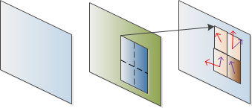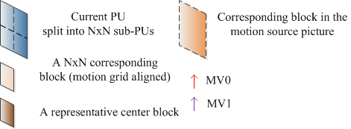
Figure 9: ATMVP motion prediction for a CU

Advanced temporal motion vector prediction
In the advanced temporal motion vector prediction (ATMVP) method, the motion vectors temporal motion vector prediction (TMVP) is improved by allowing each CU to fetch multiple sets of motion information (including motion vectors and reference indices) from multiple blocks smaller than the current CU. As shown in Figure 2, the sub-CUs are square NxN blocks (N is set to 4 by default).
The ATMVP predicts the motion vectors of the sub-CUs within a CU in two steps. The first step is to identify the corresponding block in a reference picture with a so-called temporal vector. The reference picture is called the motion source picture. The second step is to split the current CU into sub-CUs and obtain the motion vectors as well as the reference indices of each sub-CU from the block corresponding to each sub-CU, as shown in Figure 9.
In the first step, a reference picture and the corresponding block is simply determined by the motion information of the spatial neighbouring blocks of the current CU. To avoid the repetitive scanning process of neighboring blocks, the first merge candidate in the merge candidate list of the current CU is used. The first available motion vector as well as its associated reference index are set to be the temporal vector and the index to the motion source picture. This way, in ATMVP, the corresponding block may be more accurately identified, compared with TMVP, wherein the corresponding block (sometimes called co-located block) is always in a bottom-right or center position relative to the current CU.
In the second step, a corresponding block of the sub-CU is identified by the temporal vector in the motion source picture, by adding to the coordinate of the current CU the temporal vector. For each sub-CU, the motion information of its corresponding block (the smallest motion grid that covers the center pixel) is used to derive the motion information for the sub-CU. After the motion information of a corresponding NxN block is identified, it is converted to the motion vectors and reference indices of the current sub-CU, in the same way as TMVP, wherein motion scaling and other procedures apply. For example, the decoder checks whether the low-delay condition is fulfilled and possibly uses motion vector MV_{x} (the motion vector corresponding to reference picture list X) to predict motion vector MV_{y} (with X being equal to 0 or 1 and Y being equal to 1-X) for each sub-CU. This is done in the same way as for temporal motion vector prediction.

Spatial-temporal motion vector prediction (STMVP)
In this method, the motion vectors of the sub-CUs are derived recursively, following raster scan order. Figure 10 illustrates this concept. Let us consider an 8x8 CU which contains four 4x4 sub-CUs A, B, C, and D. The neighbouring NxN blocks in the current frame are labeled as a, b, c, and d.
The motion derivation for sub-CU A starts by identifying its two spatial neighbours. The first neighbour is NxN block above sub-CU A (block c). If this block c is not available or is intra coded the other NxN blocks above sub-CU A are checked (from left to right, starting at block c). The second neighbour is a block to the left of the sub-CU A (block b). If block b is not available or is intra coded other blocks to the left of sub-CU A are checked (from top to bottom, staring at block b). The motion information obtained from the neighbouring blocks for each list is scaled to the first reference frame for a given list. Next, temporal motion vector predictor (TMVP) of sub-block A is derived by following the same procedure of TMVP derivation as specified in HEVC. The motion information of the co-located block at location D is fetched and scaled accordingly. At last, after retrieving and scaling the motion information, all available motion vectors (up to 3) are averaged separately for each reference list. The averaged motion vector is assigned as the motion vector of the current sub-CU.
A
B
C
D
c
d
b
a

Figure 10: Example of one CU with four sub-blocks (A-D) and its neighbouring blocks (a-d).

Sub-CU motion prediction mode signaling
The sub-CU modes are enabled as additional merge candidates and there is no additional syntax element required to signal the modes. Two additional merge candidates are added to merge candidates list of each CU to represent the ATMVP mode and STMVP mode. Up to seven merge candidates are used, if the sequence parameter set indicates that ATMVP and STMVP are enabled. At encoding logic of the additional merge candidates is same as the merge candidates in HM, which means, for each CU in P or B slice, two more RD checks is needed for the two additional merge candidates.
To improve the merge index coding, in JEM, all bins of Merge index is context coded by CABAC. While in HEVC, only the first bin is context coded and the remaining bins are context by-pass coded.

Adaptive motion vector difference resolution
In Advanced Motion Vector Resolution (AMVR) mode, Motion Vector Difference (MVD) (between the motion vector and predicted motion vector of a CU) can be coded with either quarter-pel resolution or integer-pel resolution. The MVD resolution is controlled at coding unit (CU) level and an integer MVD resolution flag is conditionally signalled for each CU that has at least one non-zero MVD components.
When integer MVD resolution flag of a CU is zero, or not coded for a CU, the default quarter-pel MV resolution is used for the CU; Otherwise (when integer MVD resolution flag is true for a CU), the CU use integer MVD resolution. When a CU uses integer MV resolution, the AMVP candidate list is filled with integer MV by rounding MV predictors to integer-pel MVs.
At encoder side, CU level RD checks are used to determine whether integer-pel MVD resolution is used or not for a CU. That is, the CU level RD check is performed twice, firstly for quarter-pel MVD resolution and then for integer-pel MVD resolution. To accelerate encoder speed, the following encoding schemes are applied in JEM.
- During RD check of a CU with normal quarter-pel MVD resolution, the motion information of the current CU is stored, and the stored motion information (after rounding) is reused during the RD check for the same partition type with integer-pel MVD resolution so that the time-consuming motion estimation process is not duplicated.

Higher motion vector storage accuracy
In HEVC, motion vector accuracy is one-quarter pel (one-quarter luma sample and one-eighth chroma sample for YUV420 video). In JEM, the accuracy for the internal motion vector storage and the merge candidate increases to 1/16 pel. The higher motion vector accuracy (1/16 pel) is used in motion compensation inter prediction for the CU coded with Skip/Merge mode. For the CU coded with normal AMVP mode, either the integer-pel or quarter-pel motion is used, as described in section 2.3.2.
SHVC upsampling interpolation filters, which have same filter length and normalization factor as HEVC motion compensation interpolation filters, are used as motion compensation interpolation filters for the additional fractional pel positions. The chroma component motion vector accuracy is 1/32 sample in JEM, the additional interpolation filters of 1/32 pel fractional positions are derived by using the average of the filters of the two neighboring 1/16 pel fractional positions.

Overlapped block motion compensation
The Overlapped Block Motion Compensation (OBMC) has been used for early generations of video standards, e.g., as in H.263. In JEM, the OBMC is performed for all Motion Compensated (MC) block boundaries except the right and bottom boundaries of a CU. Moreover, it is applied for both luma and chroma components. In JEM, a MC block is corresponding to a coding block. When a CU is coded with sub-CU mode (includes sub-CU merge, Affine and FRUC mode), each sub-block of the CU is a MC block. To process CU boundaries in a uniform fashion, OBMC is performed at sub-block level for all MC block boundaries, where sub-block size is set equal to 4x4, as illustrated in Figure 11.
When OBMC applies to the current sub-block, besides current motion vectors, motion vectors of four connected neighbouring sub-blocks, if available and are not identical to the current motion vector, are also used to derive prediction block for the current sub-block. These multiple prediction blocks based on multiple motion vectors are combined to generate the final prediction signal of the current sub-block.
Prediction block based on motion vectors of a neighbouring sub-block is denoted as P_{N}, with N indicating an index for the neighbouring above, below, left and right sub-blocks and prediction block based on motion vectors of the current sub-block is denoted as P_{C}. When P_{N} is based on the motion information of a neighbouring sub-block that contains the same motion information to the current sub-block, the OBMC is not performed from P_{N}. Otherwise, every pixel of P_{N} is added to the same pixel in P_{C}, i.e., four rows/columns of P_{N} are added to P_{C}. The weighting factors {1/4, 1/8, 1/16, 1/32} are used for P_{N} and the weighting factors {3/4, 7/8, 15/16, 31/32} are used for P_{C}. The exception are small MC blocks, (i.e., when height or width of the coding block is equal to 4 or a CU is coded with sub-CU mode), for which only two rows/columns of P_{N} are added to P_{C}. In this case weighting factors {1/4, 1/8} are used for P_{N} and weighting factors {3/4, 7/8} are used for P_{C}. For P_{N} generated based on motion vectors of vertically (horizontally) neighbouring sub-block, pixels in the same row (column) of P_{N} are added to P_{C} with a same weighting factor.
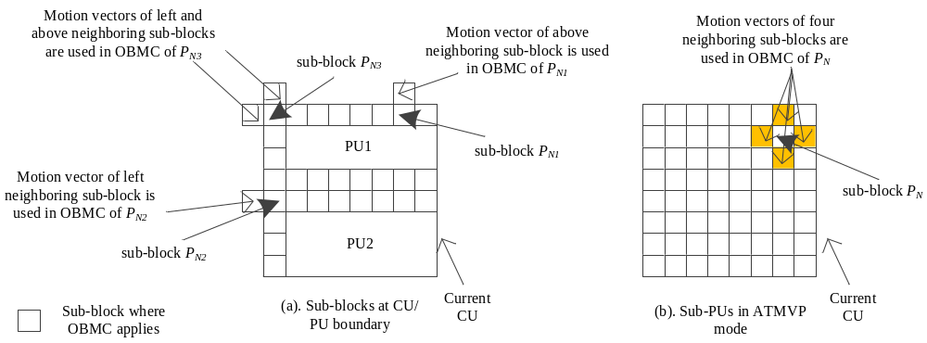
Figure 11: Illustration of sub-blocks where OBMC applies
In JEM, for a CU with size less than or equal to 256 luma samples, a CU level flag is signalled to indicate whether OBMC is applied or not for the current CU. For the CUs with size larger than 256 luma samples or not coded with AMVP mode, OBMC is applied by default. At encoder, when OBMC is applied for a CU, its impact is taken into account during motion estimation stage. The prediction signal by using motion information of the top neighboring block and the left neighboring block is used to compensate the top and left boundaries of the original signal of the current CU, and then the normal motion estimation process is applied.

Local illumination compensation
Local Illumination Compensation (LIC) is based on a linear model for illumination changes, using a scaling factor a and an offset b. And it is enabled or disabled adaptively for each inter-mode coded coding unit (CU).
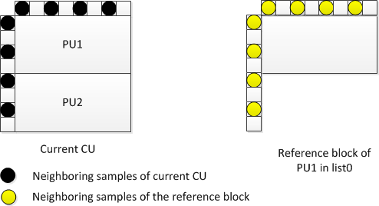
Figure 12: Neighbouring samples used for deriving IC parameters
When LIC applies for a CU, a least square error method is employed to derive the parameters a and b by using the neighbouring samples of the current CU and their corresponding reference samples. More specifically, as illustrated in Figure 12, the subsampled (2:1 subsampling) neighbouring samples of the CU and the corresponding pixels (identified by motion information of the current CU or sub-CU) in the reference picture are used. The IC parameters are derived and applied for each prediction direction separately.
When a CU is coded with 2Nx2N merge mode, the LIC flag is copied from neighbouring blocks, in a way similar to motion information copy in merge mode; otherwise, an LIC flag is signalled for the CU to indicate whether LIC applies or not.
When LIC is enabled for a pciture, addtional CU level RD check is needed to determine whether LIC is applied or not for a CU. When LIC is enabled for a CU, mean-removed sum of absolute diffefference (MR-SAD) and mean-removed sum of absolute Hadamard-transformed difference (MR-SATD) are used, instead of SAD and SATD, for integer pel motion search and fractional pel motion search, respectively.
To reduce the encoding complexity, the following encoding scheme is applied in JEM.
- LIC is disabled for the entire picture when there is no obvious illumination change between a current picture and its reference pictures. To identify this situation, histograms of a current picture and every reference picture of the current picture are calculated at the encoder. If the histogram difference between the current picture and every reference picture of the current picture is smaller than a given threshold, LIC is disabled for the current picture; otherwise, LIC is enabled for the current picture.

Affine motion compensation prediction
In HEVC, only translation motion model is applied for motion compensation prediction (MCP). While in the real world, there’re many kinds of motions, e.g. zoom in/out, rotation, perspective motions and the other irregular motions. In JEM, a simplified affine transform motion compensation prediction is applied to improve the coding efficiency. As shown Figure 13, the affine motion field of the block is described by two control point motion vectors.
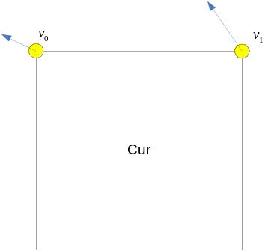
Figure 13: Simplified affine motion model
The motion vector field (MVF) of a block is described by the following equation:
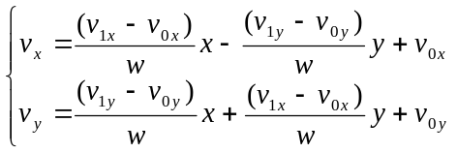 (9)
Where (v_{0x}, v_{0y}) is motion vector of the top-left corner control point, and (v_{1x}, v_{1y}) is motion vector of the top-right corner control point.
In order to further simplify the motion compensation prediction, block based affine transform prediction is applied. To derive motion vector of each 4x4 sub-block, the motion vector of the center sample of each sub-block, as shown in Figure 14, is calculated according to equation (7), and rounded to 1/16 fraction accuracy. Then the motion compensation interpolation filters mentioned in sub-section 2.3.3 are applied to generate the prediction of each sub-block with derived motion vector.
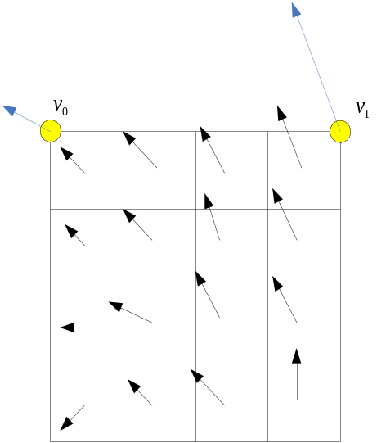
Figure 14: Affine MVF per sub-block
After MCP, the high accuracy motion vector of each sub-block is rounded and saved as the same accuracy as the normal motion vector.
In JEM, there are two affine motion modes: AF_INTER mode and AF_MERGE mode. For CUs with both width and height larger than 8, AF_INTER mode can be applied. An affine flag in CU level is signalled in the bitstream to indicate whether AF_INTER mode is used. In this mode, a candidate list with motion vector pair $\left\{\left(v_{0},v_{1}\right)|v_{0}=\{v_{A},v_{B},v_{c}\},v_{1}=\{v_{D, }v_{E}\}\right\}$ is constructed using the neighbour blocks. As shown in Figure 15, $v_{0}$ is selected from the motion vectors of the block A, B or C. The motion vector from the neighbour block is scaled according to the reference list and the relationship among the POC of the reference for the neighbour block, the POC of the reference for the current CU and the POC of the current CU. And the approach to select $v_{1}$ from the neighbour block D and E is similar. If the number of candidate list is smaller than 2, the list is padded by the motion vector pair composed by duplicating each of the AMVP candidates. When the candidate list is larger than 2, the candidates are firstly sorted according to the consistency of the neighbouring motion vectors (similarity of the two motion vectors in a pair candidate) and only the first two candidates are kept. RD cost check is used to determine which motion vector pair candidate is selected as the control point motion vector prediction (CPMVP) of the current CU. And an index indicating the position of the CPMVP in the candidate list is signalled in the bit stream. After the CPMVP of the current affine CU is determined, affine motion estimation is applied and the control point motion vector (CPMV) is found. Then the difference of the CPMV and the CPMVP is signalled in the bit stream.
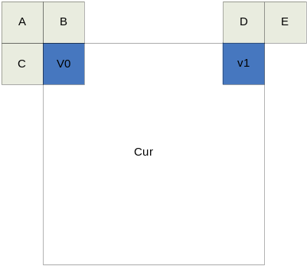
Figure 15: MVP for AF_INTER
When a CU is applied in AF_MERGE mode, it gets the first block coded with affine mode from the valid neighbour reconstructed blocks. And the selection order for the candidate block is from left, above, above right, left bottom to above left as shown in Figure 16.a. If the neighbour left bottom block A is coded in affine mode as shown in Figure 16.b, the motion vectors$v_{2}$ , $v_{3}$ and $v_{4}$ of the top left corner, above right corner and left bottom corner of the CU which contains the block A are derived. And the motion vector $v_{0}$of the top left corner on the current CU is calculated according to $v_{2}$ , $v_{3}$ and $v_{4}$. Secondly, the motion vector $v_{1 }$of the above right of the current CU is calculated
After the CPMV of the current CU $v_{0}$ and $v_{1 }$are derived, according to the simplified affine motion model equation (7), the MVF of the current CU is generated. In order to identify whether the current CU is coded with AF_MERGE mode, an affine flag is signalled in the bit stream when there is at least one neighbour block is coded in affine mode.

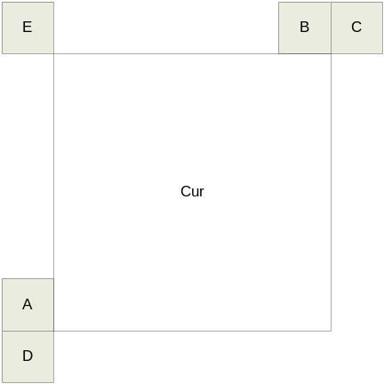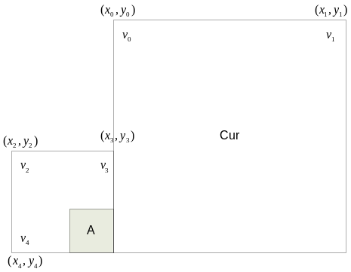
(a) (b)
Figure 16: Candidates for AF_MERGE

Pattern matched motion vector derivation
Pattern matched motion vector derivation (PMMVD) mode is a special merge mode based on Frame-Rate Up Conversion (FRUC) techniques. With this mode, motion information of a block is not signaled but derived at decoder side.
A FRUC flag is signalled for a CU when its merge flag is true. When the FRUC flag is false, a merge index is signalled and the regular merge mode is used. When the FRUC flag is true, an additional FRUC mode flag is signalled to indicate which method (bilateral matching or template matching) is to be used to derive motion information for the block.
During the motion derivation process, an initial motion vector is first derived for the whole CU based on bilateral matching or template matching. First, the merge list of the CU is checked and the candidate which leads to the minimum matching cost is selected as the starting point. Then a local search based on bilateral matching or template matching around the starting point is performed and the MV results in the minimum matching cost is taken as the MV for the whole CU. Subsequently, the motion information is further refined at sub-block level with the derived CU motion vectors as the starting points.
As shown in the Figure 17, the bilateral matching is used to derive motion information of the current block by finding the best match between two blocks along the motion trajectory of the current block in two different reference pictures. Under the assumption of continuous motion trajectory, the motion vectors MV0 and MV1 pointing to the two reference blocks shall be proportional to the temporal distances, i.e., TD0 and TD1, between the current picture and the two reference pictures. As a special case, when the current picture is temporally between the two reference pictures and the temporal distance from the current picture to the two reference pictures is the same, the bilateral matching becomes mirror based bi-directional MV.
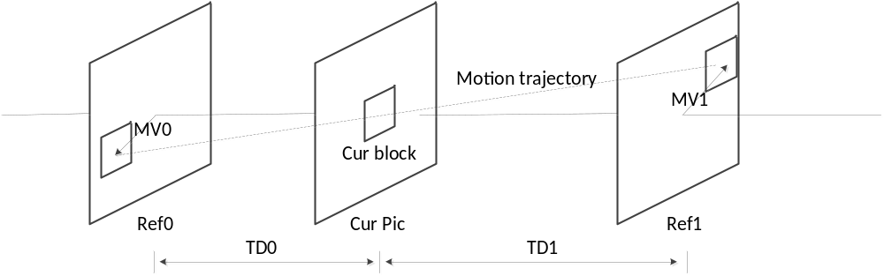
Figure 17: Bilateral matching
As shown in Figure 18, template matching is used to derive motion information of the current block by finding the best match between a template (top and/or left neighbouring blocks of the current block) in the current picture and a block (same size to the template) in a reference picture.
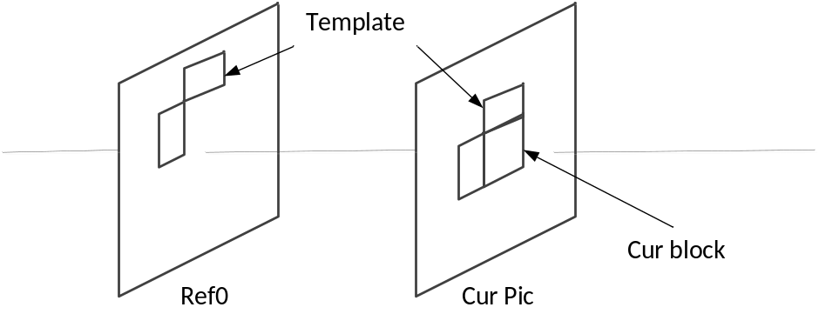
Figure 18: Template matching
At encoder side, the decision on whether using FRUC merge mode for a CU is based on RD cost selection as done for normal merge candidate. That is the two matching modes (bilateral matching and template matching) are both checked for a CU by using RD cost selection. The one leading to the minimal cost is further compared to other CU modes. If a FRUC matching mode is the most efficient one, FRUC flag is set to true for the CU and the related matching mode is used.

Bi-directional optical flow
Bi-directional Optical flow (BIO) is pixel-wise motion refinement which is performed on top of block-wise motion compensation in a case of bi-prediction. Since it compensates the fine motion can inside the block enabling BIO results in enlarging block size for motion compensation. Sample-level motion refinement doesn’t require exhaustive search or signaling since there is explicit equation which gives fine motion vector for each sample.
τ₀
τ₁
Ref₀
Ref₁
B-picture
−v_{y}τ₁
v_{y}τ₀

v_{x}τ₀
−v_{x}τ₁
A
B
t
(MVx_{1;} MVy₁)
(MVx_{0;} MVy₀)
Figure 19: Optical flow trajectory.
Let 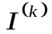 be luminance value from reference k (k=0, 1) after compensation block motion, and 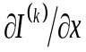, 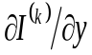are horizontal and vertical components of the gradient respectively. Assuming the optical flow is valid, the motion vector field 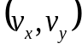 is given by an equation
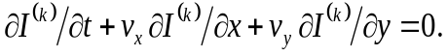 (10)
Combining optical flow equation with Hermite interpolation for motion trajectory of each sample one gets a unique polynomial of third order which matches both function values and derivatives , at the ends. The value of this polynomial at t=0 is BIO prediction:
(11)
Here 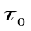 and 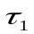 denote the distance to reference frames as shown on a Figure 18. Distances and are calculated based on POC for Ref0 and Ref1: τ₀=POC(current)−POC(Ref0), τ₁= POC(Ref1)− POC(current). If both predictions come from the same time direction (both from the past or both from the future) then signs are different 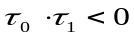. In this case BIO is applied only if prediction come not from the same time moment (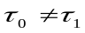), both referenced regions have non-zero motion () and block motion vectors are proportional to the time distance ().
The motion vector field is determined by minimizing the difference $∆$between values in points A and B (intersection of motion trajectory and reference frame planes on Fig. 9). Model uses only first linear term of local Taylor expansion for $∆$:
(12)
All values in (10) depend on sample location $\left(i^{'},j' \right)$, which was omitted so far. Assuming the motion is consistent in local surrounding we minimize $∆$ inside (2M+1)×(2M+1) square window $Ω$ centered in currently predicted point $\left(i,j\right)$:
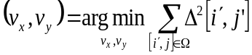 (13)
For this optimization problem we use simplified solution making first minimization in vertical and then in horizontal directions. It results in
$v_{x}=\left(s_{1}+r\right)>m?clip3\left(-thBIO,thBIO,-\frac{s_{3}}{\left(s_{1}+r\right)}\right):0$ (14)
$v_{y}=\left(s_{5}+r\right)>m?clip3\left(-thBIO,thBIO,-\frac{s_{6}-v_{x}{s_{2}}/2}{\left(s_{5}+r\right)}\right):0$ (15)
where,
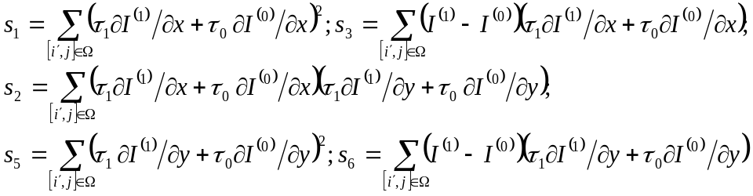 (16)
In order to avoid division by zero or very small value, regularization parameters r and m are introduced in equations (11), (12).
$r=500∙4^{d-8}$ (17)
$m=700∙4^{d-8}$ (18)
Here $d$ is internal bit-depth of the input video.
In some cases, MV regiment of BIO might be unreliable due to noise or irregular motion. Therefore, in BIO, the magnitude of MV regiment is clipped to the certain threshold thBIO. The threshold value is determined based on whether all the reference pictures of the current picture are all from one direction. If all the reference pictures of the current pictures of the current picture are from one direction, the value of the threshold is set to ${12×2}^{14-d}$, otherwise, it is set to ${12×2}^{13-d}$.
Gradients for BIO are calculated at the same time with motion compensation interpolation using operations consistent with HEVC motion compensation process (2D separable FIR). The input for this 2D separable FIR is the same reference frame sample as for motion compensation process and fractional position (fracX, fracY) according to the fractional part of block motion vector. In case of horizontal gradient ${∂I}/{∂x}$ signal first interpolated vertically using BIOfilterS corresponding to the fractional position fracY with de-scaling shift d-8, then gradient filter BIOfilterG is applied in horizontal direction corresponding to the fractional position fracX with de-scaling shift by 18-d. In case of vertical gradient ${∂I}/{∂y}$ first gradient filter is applied vertically using BIOfilterG corresponding to the fractional position fracY with de-scaling shift d-8, then signal displacement is performed using BIOfilterS in horizontal direction corresponding to the fractional position fracX with de-scaling shift by 18-d. The length of interpolation filter for gradients calculation BIOfilterG and signal displacement BIOfilterF is shorter (6-tap) in order to maintain reasonable complexity. Table 3 shows the filters used for gradients calculation for different fractional positions of block motion vector in BIO. Table 4 shows the interpolation filters used for prediction signal generation in BIO.
Table 3: Filters for gradients calculation in BIO
Fractional pel position | Interpolation filter for gradient(BIOfilterG)
0 | { 8, -39, -3, 46, -17, 5}
1/16 | { 8, -32, -13, 50, -18, 5}
1/8 | { 7, -27, -20, 54, -19, 5}
3/16 | { 6, -21, -29, 57, -18, 5}
¼ | { 4, -17, -36, 60, -15, 4}
5/16 | { 3, -9, -44, 61, -15, 4}
3/8 | { 1, -4, -48, 61, -13, 3}
7/16 | { 0, 1, -54, 60, -9, 2}
1/2 | { -1, 4, -57, 57, -4, 1}
Table 4: Interpolation filters for prediction signal generation in BIO
Fractional pel position | Interpolation filter for prediction signal(BIOfilterS)
0 | { 0, 0, 64, 0, 0, 0}
1/16 | { 1, -3, 64, 4, -2, 0}
1/8 | { 1, -6, 62, 9, -3, 1}
3/16 | { 2, -8, 60, 14, -5, 1}
1/4 | { 2, -9, 57, 19, -7, 2}
5/16 | { 3, -10, 53, 24, -8, 2}
3/8 | { 3, -11, 50, 29, -9, 2}
7/16 | { 3, -11, 44, 35, -10, 3}
1/2 | { 3, -10, 35, 44, -11, 3}
In JEM, BIO is applied to all bi-directional predicted blocks when the two predictions are from different reference pictures. When LIC is enabled for a CU, BIO is disabled.

Transform improvement

Adaptive multiple Core transform
In addition to DCT-II and 4x4 DST-VII which have been employed in HEVC, an Adaptive Multiple Transform (AMT) scheme is used for residual coding for both inter and intra coded blocks. It utilizes multiple selected transforms from the DCT/DST families other than the current transforms in HEVC. The newly introduced transform matrices are DST-VII, DCT-VIII, DST-I and DCT-V. The following table shows the basis functions of the selected DST/DCT.
Table 5: Transform basis functions of DCT-II/V/VIII and DST-I/VII for N-point input
Transform Type | Basis function T_{i}(j), i, j=0, 1,…, N-1
DCT-II | $T_{i}(j)=ω_{0}∙\sqrt{\frac{2}{N}}∙\cos\left(\frac{π∙i∙\left(2j+1\right)}{2N}\right)$  where $ω_{0}=\left\{\begin{matrix}\sqrt{\frac{2}{N}} & i=0 \\ 1 & i≠0\end{matrix}\right.$
DCT-V | $T_{i}(j)=ω_{0}∙ω_{1}∙\sqrt{\frac{2}{2N-1}}∙\cos\left(\frac{2π∙i∙j}{2N-1}\right)$,  where $ω_{0}=\left\{\begin{matrix}\sqrt{\frac{2}{N}} & i=0 \\ 1 & i≠0\end{matrix}\right.$,$ω_{1}=\left\{\begin{matrix}\sqrt{\frac{2}{N}} & j=0 \\ 1 & j≠0\end{matrix}\right.$
DCT-VIII | $$T_{i}(j)=\sqrt{\frac{4}{2N+1}}∙\cos\left(\frac{π∙(2i+1)∙(2j+1)}{4N+2}\right)$$
DST-I | $$T_{i}(j)=\sqrt{\frac{2}{N+1}}∙\sin\left(\frac{π∙(i+1)∙(j+1)}{N+1}\right)$$
DST-VII | $$T_{i}(j)=\sqrt{\frac{4}{2N+1}}∙\sin\left(\frac{π∙(2i+1)∙(j+1)}{2N+1}\right)$$
In order to keep the orthogonality of the transform matrix, the transform matrixes are quantized more accurately than the transform matrixes in HEVC. To keep the intermediate values of the transformed coefficients within the range of 16-bit, after horizontal and after vertical transform, all the coefficients are right shifted by 2 more bits, comparing to the right shift used in the current HEVC transforms.
The AMT applies to the CUs with both width and height smaller than for equal to 64, and whether AMT applies or not is controlled by a CU level flag. When the CU level flag is equal to 0, DCT-II is applied in the CU to encode the residue. For luma coding block within an AMT enabled CU, two additional flags are signaled to identify the horizontal and vertical transform to be used.
For intra residue coding, due to the different residual statistics of different intra prediction modes, a mode-dependent transform candidate selection process is used. Three transform sub-sets have been defined as shown in Table 6, and the transform subset is selected based on the intra prediction mode, as specified in Table 7.
Table 6: Three pre-defined transform candidate sets
Transform Set | Transform Candidates
0 | DST-VII, DCT-VIII
1 | DST-VII, DST-I
2 | DST-VII, DCT-VIII
With the sub-set conception, a transform subset is first identified based on Table 6 using the Intra prediction mode of a CU with the CU-level AMT flag is equal to 1. After that, for each of the horizontal and vertical transform, one of the two transform candidates in the identified transform subset, according to in Table 7, is selected based on explicitly signaled with lag.
Table 7: Selected (H)orizontal and (V)ertical transform sets for each Intra prediction mode
Intra Mode | 0 | 1 | 2 | 3 | 4 | 5 | 6 | 7 | 8 | 9 | 10 | 11 | 12 | 13 | 14 | 15 | 16 | 17
H | 2 | 1 | 0 | 1 | 0 | 1 | 0 | 1 | 0 | 0 | 0 | 0 | 0 | 1 | 0 | 1 | 0 | 1
V | 2 | 1 | 0 | 1 | 0 | 1 | 0 | 1 | 2 | 2 | 2 | 2 | 2 | 1 | 0 | 1 | 0 | 1
Intra Mode | 18 | 19 | 20 | 21 | 22 | 23 | 24 | 25 | 26 | 27 | 28 | 29 | 30 | 31 | 32 | 33 | 34
H | 0 | 1 | 0 | 1 | 0 | 1 | 2 | 2 | 2 | 2 | 2 | 1 | 0 | 1 | 0 | 1 | 0
V | 0 | 1 | 0 | 1 | 0 | 1 | 0 | 0 | 0 | 0 | 0 | 1 | 0 | 1 | 0 | 1 | 0
For inter prediction residual, however, only one transform set, which consists of DST-VII and DCT-VIII, is used for all inter modes and for both horizontal and vertical transforms.
The complexity of AMT would be relatively high at the encoder side, since totally five (DCT-II and four multiple transform candidates) different transform candidates need to be evaluated with rate-distortion cost for each residual block when brutal-force search is used. To alleviate this complexity issue at the encoder, several optimization methods are designed for algorithm acceleration in JEM.
At the encoder, for each CU-level coding mode, two-pass coding is applied. As shown in Fig. 2(left), the first pass examines the R-D cost of applying only DCT-II for the CU (CU level flag is 0), while the second pass further examines the R-D cost of applying multiple transforms for the CU (CU level flag is 1). In addition, it is observed that the CU-level coding mode is relatively consistent no matter which pass is actually applied. Therefore, when checking the multi-transform pass for the CU, the statistics of applying only DCT-II is collected and are utilized to skip unnecessary R-D calculations in the second multi-transform pass. As shown in Figure 20 (right), when the R-D cost of a certain CU coding mode with AMT CU-level flag 0 exceeds the minimum R-D cost of a certain threshold, as indicated by the condition highlighted in red in Figure 20, the second pass, i.e., encode the CU with the current CU coding mode with AMT CU-level flag 1, is skipped.
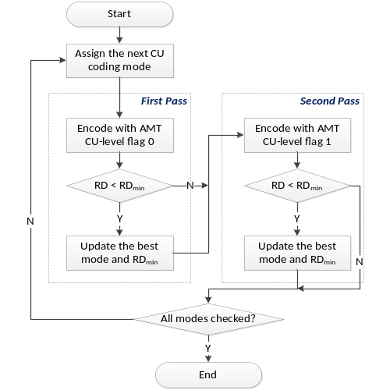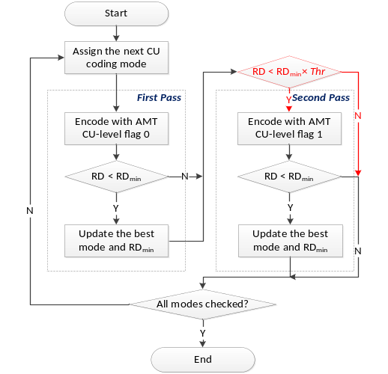
Figure 20: Flow-chart of the CU encoding process using AMT w/o(left) and w/(right) the fast algorithms.

Mode dependent non-separable secondary transforms
In JEM, a mode dependent non-separable secondary transform (MDNSST) is applied between forward core transform and quantization (at encoder) and between de-quantization and inverse core transform (at decoder side). As shown in Figure 21, MDNSST is performed independently for each 4×4 sub-group of transform coefficients within an intra-coded CU. And is applied only in Intra CU.
Application of a non-separable transform is described as follows using input as an example. To apply the non-separable transform, the 4x4 input block X
$X=\left[\begin{matrix}\begin{matrix}X_{00} & X_{01} \\ X_{10} & X_{11}\end{matrix} & \begin{matrix}X_{02} & X_{03} \\ X_{12} & X_{13}\end{matrix} \\ \begin{matrix}X_{20} & X_{21} \\ X_{30} & X_{31}\end{matrix} & \begin{matrix}X_{22} & X_{23} \\ X_{32} & X_{33}\end{matrix}\end{matrix}\right]$ (19)
is represented as a vector $\overset{⃑}{X}$:
$\overset{⃑}{X}={\left[\begin{matrix}\begin{matrix}\begin{matrix}\begin{matrix}X_{00} & X_{01}\end{matrix} & \begin{matrix}X_{02} & X_{03}\end{matrix}\end{matrix} & \begin{matrix}\begin{matrix}X_{10} & X_{11}\end{matrix} & \begin{matrix}X_{12} & X_{13}\end{matrix}\end{matrix}\end{matrix} & \begin{matrix}\begin{matrix}\begin{matrix}X_{20} & X_{21}\end{matrix} & \begin{matrix}X_{22} & X_{23}\end{matrix}\end{matrix} & \begin{matrix}\begin{matrix}X_{30} & X_{31}\end{matrix} & \begin{matrix}X_{32} & X_{33}\end{matrix}\end{matrix}\end{matrix}\end{matrix}\right]}^{T}$ (20)
The non-separable transform is calculated as $\overset{⃑}{F}=T∙\overset{⃑}{X}$, where $\overset{⃑}{F}$ indicates the transform coefficient vector, and T is a 16x16 transform matrix. The 16x1 coefficient vector $\overset{⃑}{F}$ is subsequently re-organized as 4x4 block using the scanning order for that block (horizontal, vertical or diagonal). The coefficients with smaller index will be placed with the smaller scanning index in the 4x4 coefficient block.
There are totally 11×3(for directional modes)6 + 1×2(for non-directional modes) non-separable transform matrices, where 11 is the number of transform sets for the directional intra prediction mode and each transform set includes 3 transform matrices. While for non-directional modes, i.e., Planar, DC and LM, only one transform set is applied which includes 2 transform matrices. The mapping from the intra prediction mode to the transform set is defined in Table 8. The transform set applied to luma/chroma transform coefficients is specified by the corresponding luma/chroma intra prediction modes, according to Table 8.
For each transform set, the selected non-separable secondary transform candidate is further specified by the explicitly signalled CU-level MDNSST index. The index is signalled in a bit-stream once per Intra CU after transform coefficients and truncated unary banalization is used. The truncated value is 2 in case of planar or DC mode, and 3 for angular intra prediction mode. This MDNSST index is signalled only when there is more than one non-zero coefficient in a CU. The default value is zero when it’s not signalled. Zero value of this syntax element indicates secondary transform is not applied to the current CU, values 1-3 indicates which secondary transform from the set should be applied.
In JEM, MDNSST is not applied for a block coded with transform skip mode. when MDNSST index is signalled for a CU and not equal to zero, MDNSST shall not be used for a block of a component that is coded with transform skip mode in the CU. When a CU with blocks of all components coded in transform skip mode, MDNSST index is not signalled for the CU.
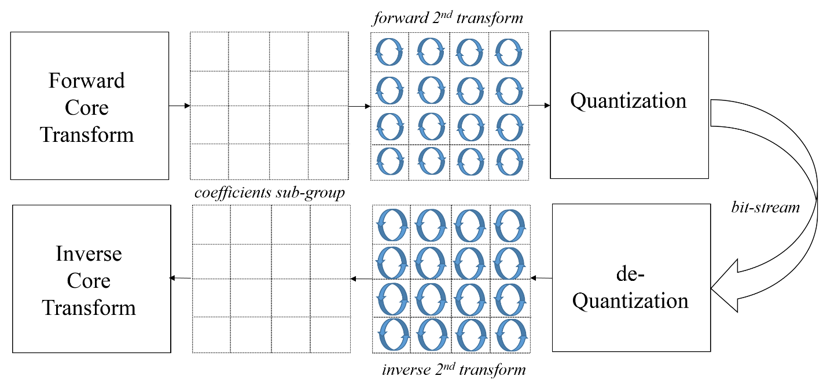
Figure 21: Secondary transform
Table 8: Mapping from intra prediction mode to transform set index
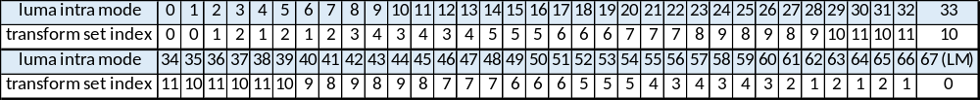
At encoder side, CU level RD checks are used to select the NSST index for a CU. That is, for an intra-coded CU, the CU level RD check is looped four time by using NSST index value as loop index. To accelerate encoder speed, early stop of the loop is applied. The RD check for a NSST index with larger value is skipped when there is no non-zero transformed coefficients in the current CU for a NSST index with smaller value.

Signal dependent transform (SDT)
Considering that there are many similar patches within a frame and across frames, signal dependent transform explores such correlations can enhance coding performance by means of KLT. This trained KLT plays the role of transform which intends to compact the energy more efficiently.

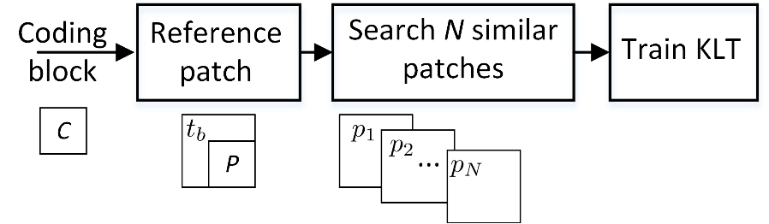
Figure 22: Flowchart of KLT exploring the non-local correlations
The flowchart in Figure 22 describes this idea. For the current coding block indicated by C, at first, a reference patch R which consists of the reconstructed left-up template $t_{b}$ and the prediction block p of the coding block is obtained. Then, this reference patch is used to search for N most similar patches over the reconstructed regions. Finally, one-dimensional KLT based on these blocks and prediction block is calculated.The coding block is unknown at the decoder for the collection of similar candidate blocks. The prediction block and the reconstructed template are used to guide the searching of similar blocks instead of using the original block. This tool is used for various block sizes 4x4, 8x8, 16x16 and 32x32.
It is known that Karhunen-Loéve transform (KLT) is the optimal transform from the energy compaction efficiency. By searching over the reconstructed regions, N blocks $x_{i}$, i = 1, 2, …, N, which are most similar to the reference patch are obtained. Here, $x_{i}$ = ${(x_{i1}, x_{i2}, …, x_{iD})}^{T}$ and D indicates the vector dimension which is the transform block size. For an example, for 4x4 coding block, N is 16. The prediction p from those blocks is subtracted and obtain the residual blocks as $u_{i}$, i = 1, 2, …, N, where $u_{i}$ = ($x_{i}$ – p)/$\sqrt{N}$. The, these residual blocks are used as the training samples with zero mean for the KLT derivation. These N training samples can be represented by U = ($u_{1}$,$u_{2}$,…,$u_{N}$), which is an D$×$N matrix. Let‘s indicate the covariance matrix $Σ$ as
$Σ=UU^{T}$ (21)
where the dimension of this covariance matrix is D$×$D. KLT bases are then the eigenvectors of this covariance matrix. For natural image/video contents, we find the selection of the candidate number N as 100 is enough for the good performance
The computation complexity for the eigenvalue decomposition is $O(D^{3})$. For 4x4 block with D being 16, the complexity is $O({16}^{3})$, which is acceptable. For a large block, the complexity will be very high. For 32x32 block with D being 1024, the time complexity will be 262144 times slower than that for 4x4 block, being intolerable in the coding framework.
In considering this, a fast algorithm is utilyzed to make the large block size KLT feasible. The dimension of $Σ$ is D$×$D. However, $U^{T}U$ has a much lower dimension as N$×N$. We calculate the eigenvectors $ϕ$of $Σ^{'}=U^{T}U$, which satisfy the equation as
$U^{T}Uϕ=ϕΛ$ (22)
$ϕ$ indicates the eigenvector matrix while $Λ$ denotes the diagonal matrix with the eigenvalues being the diagonal elements. Let‘s multiply both sides of equation (2) by $U$ to get
$UU^{T}Uϕ=UϕΛ$ (23)
Add brackets to this equation and obtain
$(UU^{T})(Uϕ)=(Uϕ)Λ$ (24)
The column vectors of $Uϕ$ are the eigenvectors of $UU^{T}$ with their corresponding eigenvalues being the diagonal elements of matrixes $Λ$. Let $φ=Uϕ$. This indicates the eigenvectors of the high dimensional covariance matrix $U^{T}U$ can be obtained by multiplying $U$ with the eigenvectors $ϕ$ which are obtained from the low dimensional covariance matrix $U^{T}U$. The dimensions of $φ$ and $Λ$ are both D$×$N. All the other (D$-$N) eigenvectors of $UU^{T}$ have zero eigenvectors. We can use Schmidt orthogonalization to fill these (D$-$N) eigenvectors to get D$×$D eigenvector matrix.
To reduce the complexity for matrix multiplication, one can use the obtained N eigenvectors to perform KLT transform, leaving the remaining (D$-$N) transform coefficients as zeros. This will not attenuate the performance since the first N projections can cover the most of the signal energy while the bases are trained from samples being highly correlated with the coding block.
The described KLT is implemented at the block level on the coding block in JEM. To have high adaptability to the image/video contents, the proposed scheme supports the proposed KLT on 4x4, 8x8, 16x16 and 32x32 coding blocks. At JEM encoder side, rate-distortion optimization is utilized to determine the best transform mode among the SDT and the advanced multiple transform (AMT).

In loop filter

Adaptive loop filter
In JEM, adaptive loop filter (ALF) with block based filter adaption is applied. For the luma component, one among 25 filters is selected for each 2x2 block based on direction and activity of local gradients.

Filter shape
In JEM, up to three circular symmetric filter shapes (as shown in Figure 23) are supported for Luma component. An index is signalled at picture level to indicate the filter shape used for the luma component of a picture.
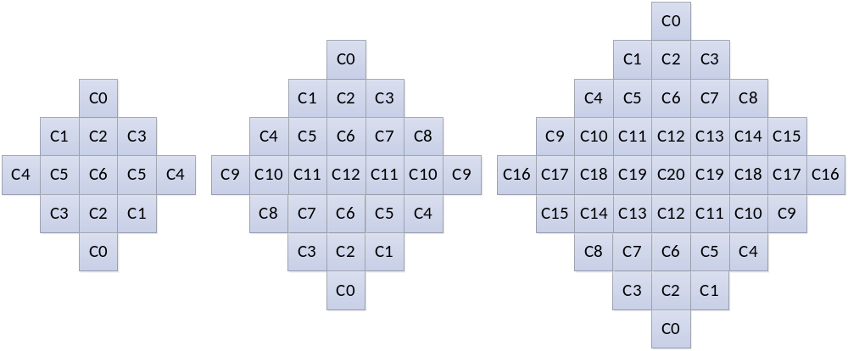
Figure 23: ALF filter shapes (left: 5x5 diamond, middle: 7x7 diamond, right: 9x9 diamond)
For chroma components in a picture, the 5x5 diamond shape filter is always used.

Block classification
Each $2×2$ block is categorized into one out of 25 classes. The classification index C is derived based on its directionality $D$ and quantized value of activity $\hat{A}$, as follows:
 | $C=5D+\hat{A}$. | (25)
To calculate $D$ and $\hat{A}$, gradients of the horizontal, vertical and two diagonal direction are first calculated using 1-D Laplacian:
 | $$g_{v}=\sum_{k=i-2}^{i+3}{\sum_{l=j-2}^{j+3}{V_{k,l}}, V_{k,l}=\left|2R\left(k,l\right)-R\left(k,l-1\right)-R\left(k,l+1\right)\right|,}$$ | (26)
 | $$g_{h}=\sum_{k=i-2}^{i+3}{\sum_{l=j-2}^{j+3}{H_{k,l}}, H_{k,l}=\left|2R\left(k,l\right)-R\left(k-1,l\right)-R\left(k+1,l\right)\right|, }$$ | (27)
 | $$g_{d1}=\sum_{k=i-2}^{i+3}{\sum_{l=j-3}^{j+3}{{D1}_{k,l}}, {D1}_{k,l}=\left|2R\left(k,l\right)-R\left(k-1,l-1\right)-R\left(k+1,l+1\right)\right|}$$ | (28)
 | $$g_{d2}=\sum_{k=i-2}^{i+3}{\sum_{j=j-2}^{j+3}{{D2}_{k,l}},} {D2}_{k,l}=\left|2R\left(k,l\right)-R\left(k-1,l+1\right)-R\left(k+1,l-1\right)\right|$$ | (29)
Indices $i$ and $j$ refer to the coordinates of the upper left pixel in the $2×2$ block and $R(i,j)$ indicates a reconstructed pixel at coordinate $(i,j)$.
Then $D$maximum and minimum values of the gradients of horizontal and vertical directions are set as:
 | $g_{h,v}^{max}=max\left(g_{h},g_{v}\right)$, $g_{h,v}^{min}=min\left(g_{h},g_{v}\right)$, | (30)
and the maximum and minimum values of the gradient of two diagonal directions are set as :
 | $g_{d0,d1}^{max}=max\left(g_{d0},g_{d1}\right)$, $g_{d0,d1}^{min}=min\left(g_{d0},g_{d1}\right)$, | (31)
To derive value of directionality $D$, those values are compared against each other and with set of thresholds $t_{1}$ and $t_{2}$:
Step 1. If both $g_{h,v}^{max}≤t_{1}∙g_{h,v}^{min}$ and $g_{d0,d1}^{max}≤t_{1}∙ g_{d0,d1}^{min}$ are true, $D$ is set to $0$.
Step 2. If ${g_{h,v}^{max}}/{g_{h,v}^{min}}>{g_{d0,d1}^{max}}/{g_{d0,d1}^{min}}$, continue from Step 3, otherwise continue from Step 4.
Step 3. If $g_{h,v}^{max}>t_{2}∙g_{h,v}^{min}$, $D$ is set to $2$, otherwise $D$ is set to $1$.
Step 4. If $g_{d0,d1}^{max}>t_{2}∙g_{d0,d1}^{min}$, $D$ is set to $4$, otherwise $D$ is set to $3$.
The activity value $A$ is calculated as:
 | $$A=\sum_{k=i-2}^{i+3}{\sum_{l=j-2}^{j+3}{\left(V_{k,l}+H_{k,l}\right).}}$$ | (32)
$A$ is further quantized to the range of 0 to 4 inclusively, and the quantized value is denoted as $\hat{A}$.
For both chroma components in a picture, no classification method is applied, i.e. a single set of ALF coefficients is applied for each chroma component.

Geometric transformations of filter coefficients
Before filtering each 2×2 block, geometric transformations such as rotation or diagonal and vertical flip are applied to the filter coefficients $f(k, l)$ depending on gradient values calculated for that block. This is equivalent to applying these transformations to the pixels in the filter support region. The idea is to make different blocks to which ALF is applied more similar by aligning their directionality.
Three geometric transformations, including diagonal, vertical flip and rotation are introduced:
Diagonal: $f_{D}\left(k,l\right)=f\left(l,k\right),$  Vertical flip: $f_{V}\left(k,l\right)=f\left(k,K-l-1\right)$,  Rotation: $f_{R}\left(k,l\right)=f\left(K-l-1,k\right).$ | (33)
where $K$ is the size of the filter and $0≤k,l≤K-1$ are coefficients coordinates, such that location $\left(0,0\right)$ is at the upper left corner and location $\left(K-1,K-1\right)$ is at the lower right corner. The transformations are applied to the filter coefficients f (k, l) depending on gradient values calculated for that block. The relationship between the transformation and the four gradients of the four directions are summarized in the following table.
Table 9: Mapping of the gradient calculated for one block and the transformations.
Gradient values | Transformation
g_{d2} < g_{d1} and g_{h} < g_{v} | No transformation
g_{d2} < g_{d1} and g_{v} < g_{h} | Diagonal
g_{d1} < g_{d2} and g_{h} < g_{v} | Vertical flip
g_{d1} < g_{d2} and g_{v} < g_{h} | Rotation

Filter parameters signalling
In JEM, ALF filter parameters are signaled in the slice header. Up to 25 sets of luma filter coefficients could be signalled. To reduce bits overhead, filter coefficients of different classification can be merged. Also the ALF coefficients of reference pictures are stored and allowed to be reused as ALF coefficients of a current picture. The current picture may choose to use ALF coefficients stored for the reference pictures, and bypass the ALF coefficients signalling. In this case, only an index to one of the reference pictures is signalled, and the stored ALF coefficients of the indicated reference picture are simply inherited for the current picture.
The temporal prediction of ALF coefficients improves coding efficiency for inter coded frames. To improve coding efficiency when temporal prediction is not available (intra frames), a set of 16 fixed filters is assigned to each class. To indicate the usage of the fixed filter, a flag for each class is signaled and if required, the index of the chosen fixed filter. Even when the fixed filter is selected for a given class, the coefficients of the adaptive filter $f(k,l)$ can still be sent for this class in which case the coefficients of the filter which will be applied to the reconstructed image are sum of both sets of coefficients.
The filtering process of luma component can controlled at CU level. A flag is signalled to indicate whether ALF is applied to the luma component of a CU. For chroma component, whether ALF is applied or not is indicated at picture level only.

Filtering process
At decoder side, when ALF is enabled for a CU, each pixel sample $R(i,j)$within the CU is filtered, resulting in pixel value $R'(i,j)$ as shown in equation (25), where L denotes filter length, $f_{m,n}$ represents filter coefficient, and $f(k, l)$ denotes the decoded filter coefficients.
$R'(i,j)=\sum_{k=-L/2}^{L/2}{\sum_{l=-L/2}^{L/2}{f(k, l)×R(i+k,j+l)}}$ (34)

Encoding side filter parameters determination process
Overall encoder decision process for ALF is illustrated in Figure 24. For luma samples of each CU, the encoder makes a decision on whether or not the ALF is applied and the appropriate signaling flag is included in the slice header. For chroma samples, the decision to apply the filter is done based on the picture-level rather than CU-level. Furthermore, chroma ALF for a picture is checked only when Luma ALF is enabled for the picture.
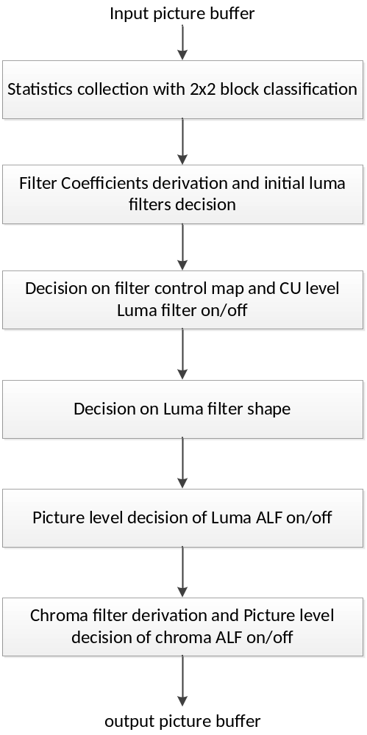
Figure 24: Flow-graph of encoder decision for ALF

SAO and deblocking
In JEM, SAO and deblocking filtering process is same to those in HEVC. However, in the experiment of JEM, the de-blocking filter configuration is modified when ALF is enabled. The parameter of de-blocking strength (LoopFilterTcOffset) is set as -2, instead of 0.

Enhanced context adaptive binary arithmetic coding (CABAC)
In JEM, the CABAC contains the following three major changes compared to the design in HEVC:
- Modified context modeling for transform coefficients
- Multi-hypothesis probability estimation with context-dependent updating speed
- Adaptive initialization for context models

Context modeling for transform coefficients
In HEVC, transform coefficients of a coding block are coded using non-overlapped coefficient groups (CGs), and each CG contains the coefficients of a 4x4 block of a coding block. The CGs inside a coding block, and the transform coefficients within a CG, are coded according to pre-defined scan orders. The coding of transform coefficient levels of a CG with at least one non-zero transform coefficient may be separated into multiple scan passes. In the first pass, the first bin (denoted by bin0, also referred as significant_coeff_flag, which indicates the magnitude of the coefficient is larger than 0) is coded. Next, two scan passes for context coding the second/third bins (denoted by bin1 and bin2, respectively, also referred as coeff_abs_greater1_flag and coeff_abs_greater2_flag) may be applied. Finally, two more scan passes for coding the sign information and the remaining values (also referred as coeff_abs_level_remaining) of coefficient levels are invoked, if necessary. Note that only bins in the first three scan passes are coded in a regular mode and those bins are termed regular bins in the following descriptions.
In JEM, the context modeling for regular bins is changed. When coding bini in the i-th scan pass (i being 0, 1, 2), the context index is dependent on the values of the i-th bins of previously coded coefficients in the neighbourhood covered by a local template. More specifically, the context index is determined based on the sum of the i-th bins of neighbouring coefficients. As depicted in Figure 25, the local template contains up to five spatial neighboring transform coefficients wherein x indicates the position of current transform coefficient and xi (i being 0 to 4) indicates its five neighbors. To capture the characteristics of transform coefficients at different frequencies, one coding block may be split into up to three regions and the splitting method is fixed regardless of the coding block sizes. For example, when coding bin0 of luma transform coefficients, as depicted in Figure 25, one coding block is split into three regions marked with different colours, and the context index assigned to each region is listed. Luma and chroma components are treated in a similar way but with separate sets of context models. Moreover, the context model selection for bin0 (i.e., significant flags) of the luma component is further dependent on transform size. For the coding of the remaining values of coefficient levels, please refer to reference [4] or [6].
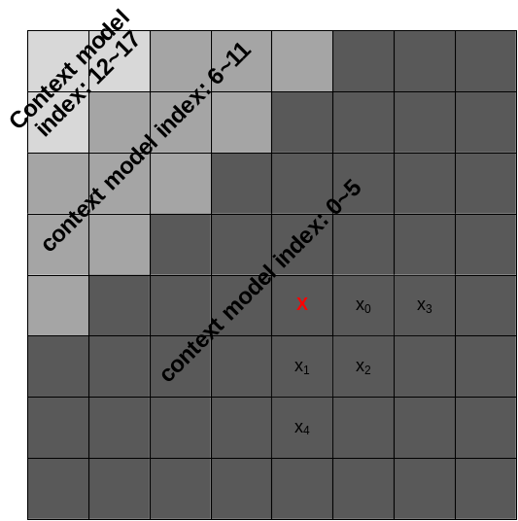
Figure 25: Definition of template used in transform coefficient context modeling

Multi-hypothesis probability estimation
The binary arithmetic coder with the multi-hypothesis probability update model is applied. Two probabilities P₀ and P₁ are associated with each context model. They are updated independently:
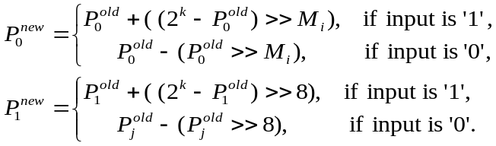 (35)
Where 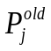 and 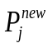 (j=0, 1) represent the probabilities before and after decoding a bin, respectively. The variable M_{i} (being 4, 5, 6, 7) is a parameter which controls the probability updating speed for a context model with index equal to i; and k represents the precision of probabilities (here it is equal to 15). Probability P used for interval sub-division is binary arithmetic coder is combination of 2 hypothesis
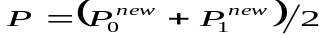 (36)
In JEM, a method that assigns different values of parameter M_{i} used in equation (26) for changing the probability updating speed for each context model is used.
At the encoder side, the coded bins associated with each context model are recorded. After one slice is coded, for each context model with index equal to i, the rate costs of using different values of M_{i} (being 4, 5, 6, 7) are calculated and the one that provides the minimum rate cost is selected. Note that for simplicity, only when a new slice type and a new slice quantization parameter happen, the aforementioned process is invoked. The selected values of M_{i} may be signalled in the slice header.
The value of M_{i} ranges from 4 to 7, and a 2-bit variable is used to indicate the probability updating speed for a specific context model. This variable is signalled in slice header if 1 bit flag signalled for each context model i indicates that M_{i} is different from default value 4.

Initialization for context models
Instead of using fixed tables for context model initialization in HEVC, the initial probability states of context models for inter-coded slices can be initialized by copying states from previously coded pictures. More specifically, after coding a centrally-located CTU of each picture, the probability state of all context models are stored and optionally used as the initial state of each corresponding context model on later pictures. In the JEM, the set of initial states for each inter-coded slice is copied from the stored states of a previously coded picture that has the same slice type, and the same slice level QP as the current slice.

Software and common test conditions

Reference software
The main software branch of JEM is developed on top of HEVC standard reference software HM16.6 [17]. The reference software for JEM can be downloaded from the SVN link shown in [18].
The related codes for each new added tool are marked with a dedicated macro. The macro name for the tools in the main software branch are provided in Table 10.
Table 10: Macro for the tools in JEM1
Macro name | Tool
JVET_C0024_QTBT | Quadtree plus binary tree (QTBT) block structure
VCEG_AZ07_INTRA_65ANG_MODES | 65 intra prediction directions
VCEG_AZ07_INTRA_4TAP_FILTER | 4-tap interpolation filter for intra prediction
VCEG_AZ07_INTRA_BOUNDARY_FILTER | Additional boundary filter or intra prediction
COM16_C806_LMCHROMA | Cross-component linear model (CCLM) prediction
COM16_C1046_PDPC_INTRA | Position dependent intra prediction combination
COM16_C983_RSAF | Adaptive reference sample smoothing
COM16_C806_VCEG_AZ10_SUB_PU_TMVP | Sub-CU level motion vector prediction
JVET_B058_HIGH_PRECISION_MOTION_VECTOR_MC | 1/16 pel motion vector storage accuracy
VCEG_AZ07_IMV | Locally adaptive motion vector resolution (AMVR)
COM16_C806_OBMC | Overlapped block motion compensation (OBMC)
VCEG_AZ06_IC | Local illumination compensation (LIC)
COM16_C1016_AFFINE | Affine motion prediction
VCEG_AZ07_FRUC_MERGE | Pattern matched motion vector derivation
VCEG_AZ05_BIO | Bi-directional optical flow (BIO)
COM16_C806_EMT | Explicit multiple core transform
COM16_C1044_NSST | Mode dependent non-separable secondary transforms
INTRA_KLT & INTER_KLT | Signal dependent transform (SDT)
ALF_HM3_REFACTOR | Adaptive loop filter (ALF)
VCEG_AZ07_CTX_RESIDUALCODING | Context modeling for transform coefficient levels
VCEG_AZ07_BAC_ADAPT_WDOW | Multi-hypothesis probability estimation
VCEG_AZ07_INIT_PREVFRAME | Initialization for context models

Common test condition
Common test conditions (including test materials) for JEM coding efficiency experiments can be found in [19].

References
- High Efficiency Video Coding (HEVC), Rec. ITU-T H.265 and ISO/IEC 23008-2, Jan. 2013.
- G. J. Sullivan, J.-R. Ohm, W.-J. Han, and T. Wiegand, “Overview of the High Efficiency Video Coding (HEVC) Standard”, IEEE Trans. Circuits and Systems for Video Technology, Vol. 22, No. 12, pp. 1649‒1668, Dec. 2012.
- J. Chen, Y. Chen, M. Karczewicz, X. Li, H. Liu, L. Zhang, X. Zhao, “Coding tools investigation for next generation video coding”, ITU-T SG16 Doc. COM16–C806, Feb. 2015.
- M. Karczewicz, J. Chen, W.-J. Chien, X. Li, A. Said, L. Zhang, X. Zhao, “Study of coding efficiency improvements beyond HEVC”, MPEG doc. m37102, Oct. 2015.
- J. An, Y.-W. Chen, K. Zhang, H. Huang, Y.-W. Huang, S. Lei, “Block partitioning structure for next generation video coding”, MPEG doc. m37524 and ITU-T SG16 Doc. COM16–C966, Oct. 2015.
- J. Chen, W.-J. Chien, M. Karczewicz, X. Li, H. Liu, A. Said, L. Zhang, X. Zhao, “Further improvements to HMKTA-1.0”, ITU-T SG16/Q6 Doc. VCEG-AZ07, Jun. 2015.
- E. Alshina, A. Alshin, J.-H. Min, K. Choi, A. Saxena, M. Budagavi, “Known tools performance investigation for next generation video coding”, ITU-T SG16/Q6 Doc. VCEG-AZ05, Jun. 2015.
- Kiho Choi, E. Alshina, A. Alshin, C. Kim, “Information on coding efficiency improvements over HEVC for 4K content”, MPEG doc. m37043, Oct. 2015.
- A. Said, X. Zhao, J. Chen, M. Karczewicz, W.-J. Chien, F. Zhou, “Position dependent intra prediction combination”, MPEG doc. m37502 and ITU-T SG16 Doc. COM16–C1016, Oct. 2015.
- A. Filippov, V. Rufitskiy, “Reference sample adaptive filtering for intra coding”, MPEG doc. m37526 and ITU-T SG16 Doc. COM16–C983, Oct. 2015.
- W.-J. Chien, M. Karczewicz, “Extension of Advanced Temporal Motion Vector Predictor”, ITU-T SG16/Q6 Doc. VCEG-AZ10, Jun. 2015.
- H. Liu, Y. Chen, J. Chen, L. Zhang, M. Karczewicz, “Local Illumination Compensation”, ITU-T SG16/Q6 Doc. VCEG-AZ06, Jun. 2015.
- S. Lin, H. Chen, H. Zhang, S. Maxim, H. Yang, J. Zhou, “Affine transform prediction for next generation video coding”, MPEG doc. m37525 and ITU-T SG16 Doc. COM16–C1016, Oct. 2015.
- X. Zhao, J. Chen, M. Karczewicz, “Mode-dependent non-separable secondary transform”, ITU-T SG16/Q6 Doc. COM16–C1044, Oct. 2015.
- C. Lan, J. Xu and F. Wu, “Enhancement of HEVC using Signal Dependent Transform (SDT)”, MPEG doc. m37503, Oct. 2015 and ITU-T SG16/Q6 Doc. VCEG-AZ08, Jun. 2015.
- C. Rosewarne, B. Bross, M. Naccari, K. Sharman, G. J. Sullivan, “High Efficiency Video Coding (HEVC) Test Model 16 (HM 16) Update 4 of Encoder Description”, Joint Collaborative Team of ITU-T SG16 WP3 and ISO/IEC JTC1/SC29/WG11 on Video Coding, JCTVC-V1002, 22nd Meeting, Oct. 2015.
- HEVC reference software, https://hevc.hhi.fraunhofer.de/svn/svn_HEVCSoftware/tags/HM-16.6/.
- JEM reference software, https://jvet.hhi.fraunhofer.de/svn/svn_HMJEMSoftware/.
- K. Suehring, X. Li, “JVET common test conditions and software reference configurations”, Joint Video Exploration Team of ITU-T SG16 WP3 and ISO/IEC JTC1/SC29/WG11, JVET-B1010, 2nd Meeting, Feb. 2016.

