    Joint Video Exploration Team (JVET)  of ITU-T SG 16 WP 3 and ISO/IEC JTC 1/SC 29/WG 11  3rd Meeting: Geneva, CH, 26 May – 1 June 2016 | Document: JVET-C0061

Title: | Decoder-side intra mode derivation
Status: | Input Document to JVET
Purpose: | Proposal
Author(s) or  Contact(s): | Xiaoyu Xiu, Yuwen He, Yan Ye  9710 Scranton Rd, #250  San Diego, CA 92121, USA | Tel:  Email: | + 1-858-210-4830  Xiaoyu.Xiu@InterDigital.com  Yuwen.He@InterDigital.com  Yan.Ye@InterDigital.com
Source: | InterDigital Communications Inc.
_____________________________

Abstract
In this contribution, a decoder-side intra mode derivation (DIMD) approach is proposed based on JEM. The DIMD approach derives the intra prediction mode and reduces the overhead of intra mode signaling. Further, because no mode signaling is needed in DIMD, intra prediction can be performed at higher granularity than in JEM. For the intra CU with 2Nx2N partition, one DIMD flag is signaled. When the flag is true, the intra mode of the CU is derived with a template based method at both encoder and decoder. Additionally, when the DIMD mode is selected, another control flag is signaled to indicate if the intra mode is derived at PU-level or TU-level. For the intra CU with NxN partition, the intra modes derived by DIMD is used to replace one exiting MPM candidate for the intra mode coding of four PUs in this CU. It is reported that compared to JEM-2.0 anchor, the proposed method achieves on average 0.81%, 0.47%, 0.21% and 0.23% luma BD-rate reductions for AI, RA, LDB and LDP configurations, respectively; when compared to the anchor by disabling all JEM tools, the corresponding average BD-rate reductions reach 1.37%, 0.72%, 0.27% and 0.40%.

Introduction
In JEM-2.0 [1] intra modes are extended to 67 from 35 modes in HEVC, and they are derived at encoder and explicitly signaled to decoder. A significant amount of overhead is spent on intra mode coding in JEM-2.0.For example, the intra mode signaling overhead may be up to 5~10% of overall bitrate in all intra coding configuration. This contribution proposes the decoder-side intra mode derivation approach to reduce the intra mode coding overhead while keeping prediction accuracy.

Proposed method
To reduce the overhead of intra mode signaling, this contribution presents a decoder-side intra mode derivation (DIMD) approach. In the proposed approach, instead of signaling intra mode explicitly, the information is derived at both encoder and decoder from the neighboring reconstructed samples of current block. The intra mode derived by DIMD is used in two ways:
1) For 2Nx2N CUs, the DIMD mode is used as the intra mode for intra prediction when the corresponding CU-level DIMD flag is turned on;
2) For NxN CUs, the DIMD mode is used to replace one candidate of the existing MPM list to improve the efficiency of intra mode coding.

Templated based intra mode derivation
As illustrated in Figure 1, the target denotes the current block (of block size N) for which intra prediction mode is to be estimated. The template (indicated by the patterned region in Figure 1) specifies a set of already reconstructed samples, which are used to derive the intra mode. The template size is denoted as the number of samples within the template that extends to the above and the left of the target block, i.e., L. In the current implementation, a template size of 2 (i.e.,$L=2$) is used for 4x4 and 8x8 blocks and a template size of 4 (i.e.,$L=4$) is used for 16x16 and larger blocks. The reference of template (indicated by the dotted region in Figure 1) refers to a set of neighboring samples from above and left of the template, as defined by JEM-2.0 [1]. Unlike the template samples which are always from reconstructed region, the reference samples of template may not be reconstructed yet when encoding/decoding the target block. In this case, the existing reference samples substitution algorithm of JEM-2.0 [1] is utilized to substitute the unavailable reference samples with the available reference samples.
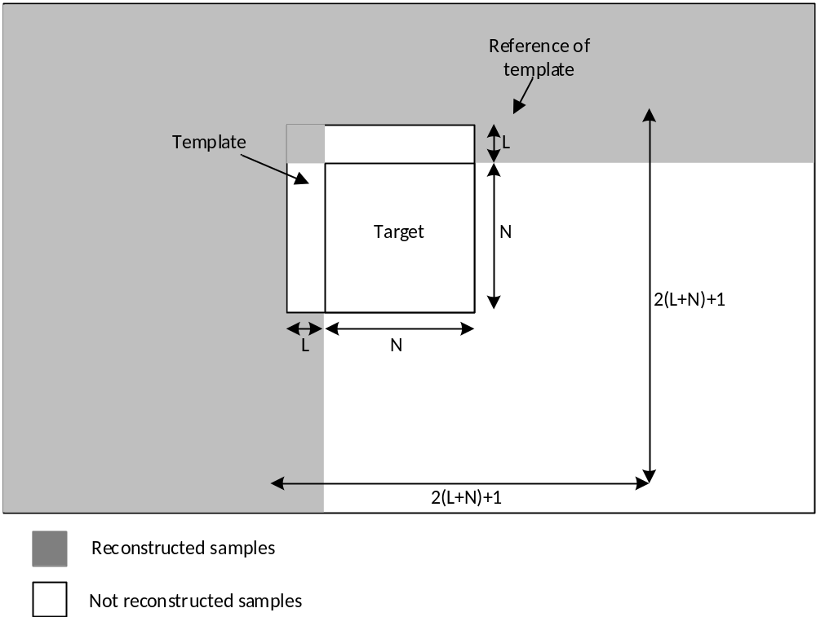
Figure 1 Target samples, template samples and the reference samples of template used in the DIMD.
For each intra prediction mode, the DIMD calculates the absolute difference (SAD) between the reconstructed template samples and its prediction samples obtained from the reference samples of the template. The intra prediction mode that yields the minimum SAD is selected as the final intra prediction mode of the target block.

DIMD for intra 2Nx2N CUs
For intra 2Nx2N CUs, the DIMD is used as one additional intra mode, which is adaptively selected by comparing the DIMD intra mode with the optimal normal intra mode (i.e, being explicitly signaled). One flag is signaled for each intra 2Nx2N CU to indicate the usage of the DIMD. If the flag is one, then the CU is predicted using the intra mode derived by DIMD; otherwise, the DIMD is not applied and the CU is predicted using the intra mode explicitly signaled in the bit-stream. When the DIMD is enabled, chroma components always reuse the same intra mode as that derived for luma component, i.e., DM mode.
Additionally, for each DIMD-coded CU, the blocks in the CU can adaptively select to derive their intra modes at either PU-level or TU-level. Specifically, when the DIMD flag is one, another CU-level DIMD control flag is signaled to indicate the level at which the DIMD is performed. If this flag is zero, it means that the DIMD is performed at the PU level and all the TUs in the PU use the same derived intra mode for their intra prediction; otherwise (i.e., the DIMD control flag is one), it means that the DIMD is performed at the TU level and each TU in the PU derives its own intra mode.
Further, when the DIMD is enabled, the number of angular directions increases to 129, and the DC and planar modes still remain the same. To accommodate the increased granularity of angular intra modes, the precision of intra interpolation filtering for DIMD-coded CUs increases from 1/32-pel to 1/64-pel. Additionally, in order to use the derived intra mode of a DIMD coded CU as MPM candidate for neighboring intra blocks, those 129 directions of the DIMD-coded CUs are converted to “normal” intra modes (i.e., 65 angular intra directions) before they are used as MPM.

DIMD for intra NxN CUs
In the proposed method, intra modes of intra NxN CUs are always signaled. However, to improve the efficiency of intra mode coding, the intra modes derived from DIMD are used as MPM candidates for predicting the intra modes of four PUs in the CU. In order to not increase the overhead of MPM index signaling, the DIMD candidate is always placed at the first place in the MPM list and the last existing MPM candidate is removed. Also, pruning operation is performed such that the DIMD candidate will not be added to the MPM list if it is redundant.

Intra mode search algorithm of DIMD
In order to reduce encoding/decoding complexity, one straightforward fast intra mode search algorithm is used for DIMD. Firstly, one initial estimation process is performed to provide a good starting point for intra mode search. Specifically, an initial candidate list is created by selecting N fixed modes from the allowed intra modes. Then, the SAD is calculated for all the candidate intra modes and the one that minimizes the SAD is selected as the starting intra mode. To achieve a good complexity/performance trade-off, the initial candidate list consists of 11 intra modes, including DC, planar and every 4-th mode of the 33 angular intra directions as defined in HEVC [2], i.e., intra modes 0, 1, 2, 6, 10… 30, 34.
If the starting intra mode is either DC or planar, it is used as the DIMD mode. Otherwise, based on the starting intra mode, one refinement process is then applied where the optimal intra mode is identified through one iterative search. It works by comparing at each iteration the SAD values for three intra modes separated by a given search interval and maintain the intra mode that minimize the SAD. The search interval is then reduced to half, and the selected intra mode from the last iteration will serve as the center intra mode for the current iteration. For the current DIMD implementation with129 angular intra directions, up to 4 iterations are used in the refinement process to find the optimal DIMD intra mode.

Simulation results
The proposed method is implemented on top of JEM-2.0 and simulated under the JVET common test conditions (CTCs) [3]. In addition to JEM-2.0 anchor, the DIMD method is also tested following the “tool-ON” test condition [4][5][6] which disables all the existing new tools in JEM-2.0 (i.e., pure HEVC) and only enables the DIMD.
Table I. BD-rate performance of the DIMD, compared to the JEM-2.0 anchor.
 | All Intra Main10 Over HM-16.6-JEM-2 (parallel)
 | Y | U | V | EncT | DecT
Class A1 | -0.55% | -0.23% | -0.26% | 151% | 123%
Class A2 | -1.03% | -1.19% | -1.31% | 155% | 132%
Class B | -0.69% | -0.62% | -0.76% | 150% | 138%
Class C | -0.80% | -0.63% | -0.62% | 144% | 158%
Class D | -0.58% | -0.19% | -0.36% | 141% | 169%
Class E | -1.40% | -1.72% | -1.50% | 154% | 141%
Overall | -0.81% | -0.72% | -0.77% | 149% | 143%
 | Random Access Main10 Over HM-16.6-JEM-2 (parallel)
 | Y | U | V | EncT | DecT
Class A1 | -0.37% | 0.04% | -0.18% | 113% | 105%
Class A2 | -0.74% | -0.85% | -0.91% | 108% | 103%
Class B | -0.42% | -0.08% | -0.32% | 112% | 104%
Class C | -0.52% | -0.32% | -0.49% | 115% | 104%
Class D | -0.34% | -0.08% | -0.36% | 115% | 103%
Class E
Overall (Ref) | -0.47% | -0.25% | -0.44% | 113% | 104%

 | Low delay B Main10 Over HM-16.6-JEM-2 (parallel)
 | Y | U | V | EncT | DecT
Class A1
Class A2
Class B | -0.17% | -0.15% | -0.15% | 120% | 107%
Class C | -0.28% | -0.20% | -0.39% | 121% | 109%
Class D | -0.11% | -0.24% | -0.55% | 121% | 107%
Class E | -0.30% | -0.88% | -0.68% | 113% | 100%
Overall (Ref) | -0.21% | -0.32% | -0.41% | 119% | 106%

 | Low delay P Main19 Over HM-16.6-JEM-2 (parallel)
 | Y | U | V | EncT | DecT
Class A1
Class A2
Class B | -0.24% | -0.24% | -0.36% | 125% | 112%
Class C | -0.30% | -0.22% | -0.25% | 129% | 114%
Class D | -0.18% | 0.14% | 0.25% | 133% | 110%
Class E | -0.21% | -0.24% | -0.23% | 117% | 109%
Overall (Ref) | -0.23% | -0.14% | -0.15% | 127% | 112%

Table II. BD-rate performance of the DIMD, compared to the “tool-ON” anchor.
 | All Intra Main10 Over HM-16.6 (parallel)
 | Y | U | V | EncT | DecT
Class A1 | -0.90% | -1.09% | -1.28% | 148% | 127%
Class A2 | -2.03% | -2.66% | -2.52% | 150% | 138%
Class B | -1.16% | -1.49% | -1.49% | 148% | 142%
Class C | -1.31% | -1.61% | -1.74% | 147% | 160%
Class D | -0.78% | -1.03% | -1.14% | 146% | 167%
Class E | -2.31% | -3.49% | -2.97% | 146% | 135%
Overall | -1.37% | -1.81% | -1.80% | 148% | 144%

 | Random Access Main10 Over HM-16.6 (parallel)
 | Y | U | V | EncT | DecT
Class A1 | -0.61% | -0.46% | -0.90% | 102% | 123%
Class A2 | -1.26% | -1.73% | -1.66% | 100% | 120%
Class B | -0.64% | -0.68% | -0.89% | 103% | 123%
Class C | -0.67% | -0.80% | -1.04% | 104% | 127%
Class D | -0.40% | -0.70% | -0.39% | 103% | 129%
Class E
Overall (Ref) | -0.71% | -0.86% | -0.97% | 102% | 124%

 | Low delay B Main10 Over HM-16.6 (parallel)
 | Y | U | V | EncT | DecT
Class A1
Class A2
Class B | -0.27% | -0.38% | -0.60% | 100% | 126%
Class C | -0.38% | -0.75% | -0.42% | 101% | 120%
Class D | -0.21% | -0.31% | -0.11% | 103% | 119%
Class E | -0.26% | -0.37% | -0.87% | 96% | 102%
Overall (Ref) | -0.28% | -0.45% | -0.48% | 100% | 118%

 | Low delay P Main10 Over HM-16.6 (parallel)
 | Y | U | V | EncT | DecT
Class A1
Class A2
Class B | -0.43% | -0.76% | -0.84% | 100% | 129%
Class C | -0.47% | -0.75% | -0.59% | 102% | 119%
Class D | -0.28% | -0.10% | -1.04% | 104% | 122%
Class E | -0.47% | -0.37% | -0.64% | 98% | 106%
Overall (Ref) | -0.41% | -0.52% | -0.79% | 101% | 120%

References
- J. Chen, E. Alshina, G.-J. Sullivan, J.-R. Ohm, J, Boyce, “Algorithm description of joint exploration test mode 2,” JVET-B1001, San Diego, USA, Feb. 2016.
- High Efficiency Video Coding, Rec. ITU-T H.265 and ISO/IEC 23008-2, Jan. 2013.
- K. Suehring, X. Li, “JVET common test conditions and software reference configurations,” JVET-B1010, San Diego, USA, Feb. 2016.
- E. Alshina, A. Alshin, K. Choi, M. Park, “Performance of JEM 1 tools analysis,” JVET-B0022, San Diego, USA, Feb. 2016.
- H. Schwarz, C. Rudat, M. Siekmann, B. Bross, D. Marpe, T. Wiegand, “Coding efficiency/complexity analysis of JEM 1.0 coding tools for the random access configuration,” JVET-B0044, San Diego, USA, Feb. 2016.
- J. Chen, X. Li, F. Zou, M. Karczewicz, W.-J. Chien, T. Hsieh, “Performance evaluation of JEM 1 tools by Qualcomm,” JVET-B0045, San Diego, USA, Feb. 2016.

Patent rights declaration(s)
InterDigital Communications Inc. may have current or pending patent rights relating to the technology described in this contribution and, conditioned on reciprocity, is prepared to grant licenses under reasonable and non-discriminatory terms as necessary for implementation of the resulting ITU-T Recommendation | ISO/IEC International Standard (per box 2 of the ITU-T/ITU-R/ISO/IEC patent statement and licensing declaration form).

