Joint Video Exploration Team (JVET)  of ITU-T SG 16 WP 3 and ISO/IEC JTC 1/SC 29/WG 11  2nd Meeting: San Diego, USA, 20–26 February 2016 | Document: JVET-B0054

Title: | De-quantization and scaling for next generation containers
Status: | Input Document to JVET
Purpose: | Proposal
Author(s) or  Contact(s): | Jie Zhao, Andrew Segall, Seung-Hwan Kim and Kiran Misra  5750 NW Pacific Rim Blvd,  Camas, WA 98607  USA | Tel:  Emails: | +1 360 817 8487  jzhao@sharplabs.com  asegall@sharplabs.com  kimse@sharplabs.com  misrak@sharplabs.com
Source: | SHARP
_____________________________

Abstract
This contribution proposes a change in the de-quantization and scaling process in JEM 1.0. For background, the change is motivated by recent work in MPEG, where it has been shown that next generation containers, such as ST-2084, re-shape quantization noise as a function of brightness. For current standards, this requires encoders to compensate by spatially varying the QP in an inverse manner. Here, it is proposed that a next generation standards decoder could infer the needed compensation without significant QP signaling. This is accomplished by adapting the scaling of AC coefficients based on the DC coefficient and reconstructed prediction mean. Experiments performed using sequences under study in MPEG (and now JCT-VC) show a gain of 2.0% for both AI and RA configuration when the QP granularity is 16x16.

Introduction
We believe that a key application for any next generation video coding standard will be the efficient compression of next generation video formats. These formats include wider color gamut, higher frame rate, and higher dynamic range and have been under significant study recently throughout the standards eco-system. As a result, new standards have been created to support this type of content. For example, ITU-R Recommendation BT-2020 defines a format that includes color primaries outside of the currently deployed BT-709 gamut. Additionally, SMPTE ST-2084 defines an electro-optical transfer function intended to support a luminance range of approximately 0.01cd/m2 to 10,000 cd/m2, which is a significantly larger than the approximately 0.1cd/m2 to 100 cd/m2 range supported by widely deployed ITU-R Recommendation BT.1886-like systems.
From a video coding perspective, the introduction and use of new containers can result in an altering of the statistics and properties of the pixel values that are provided to an encoder. Evidence of this can be found in the work now considered in the JCT-VC on high dynamic range coding. There, systems are being considered that “re-shape” the pixel values before coding, and then invert the “re-shaping” operation after de-coding. We assert that this process allows one to modify the pixel values in the new containers to better fit the properties expected by current codecs and encoders, such as HEVC and the HM, respectively.
Instead of “re-shaping” the pixel values before coding, an alternative approach to handle the new containers is to re-shape the quantization noise. This is also being considered in the JCT-VC activity. A first example of the work is re-allocating (or re-shaping) bits between the luma and chroma channels. This is motivated by the change in color primaries from BT-709 to BT-2020, and it can be accomplished by applying an offset to the chroma QP parameters [3]. A second example of the work is re-allocating bits between the darker and lighter regions of the image. This work is motivated by the study reported in [4]. There it was shown that when converting content from a BT.1886 container to a ST-2084 container and preserving luminance values (e.g., 100 nits mapping to 100 nits), it is necessary for an encoder to adjust the QP parameter based on the local luma value to maintain the fidelity between the two containers. Please note that both the chroma re-allocation and luma re-allocation methods have been shown to improve the performance of the HM after expert visual evaluation and confirmation, and both have been incorporated into the JCT-VC HDR anchors.
Given the above, it appears important to support a variety of quantization noise and allocation strategies for next generation containers.

Proposed System
To describe the proposed system, we first provide a brief description of the luma QP control considered in the JCT-VC (formerly MPEG) HDR anchors. There, the encoder determines the QP for a CTU by calculating the mean of the CTU and then determining the QP adjustment using a LUT and the mean value. Currently, the QP adjustment is a linear relationship between the mean and QP adjustment. It is in the range of [3,-6], and the LUT is shown in Table 1 below. For intuition, a QP adjustment value of 3 is assigned to the darkest regions, so that fewer bits are allocated; a QP adjustment value of -6 is assigned to the brightest regions, so that more bits are allocated. Of course, other functions and adjustment ranges could be considered. The current settings are somewhat influenced from the study of storing BT.1886 content in a ST-2084 container.

luma intL range | dQP
intL < 301 | 3
301 ≤ intL < 367 | 2
367 ≤ intL < 434 | 1
434 ≤ intL < 501 | 0
501 ≤ intL < 567 | -1
567 ≤ intL < 634 | -2
634 <= intL < 701 | -3
701 <= intL < 767 | -4
767 <= intL < 834 | -5
intL >= 834 | -6
Table 1 Look-up table of the dQP value from the average of the luma value.

So, basically, the encoder varies QP as a function of the mean of the block.
Here, we propose to support the same functionality. However, instead of having the encoder derive the QP and signal to the decoder, we have the encoder send the LUT and the decoder infer and apply the adjustment directly. To perform the adjustment, the decoder estimates the mean of the reconstructed block, and so the adjustment is applied after prediction and de-quantization of the DC coefficient. This is shown in Figure 1.
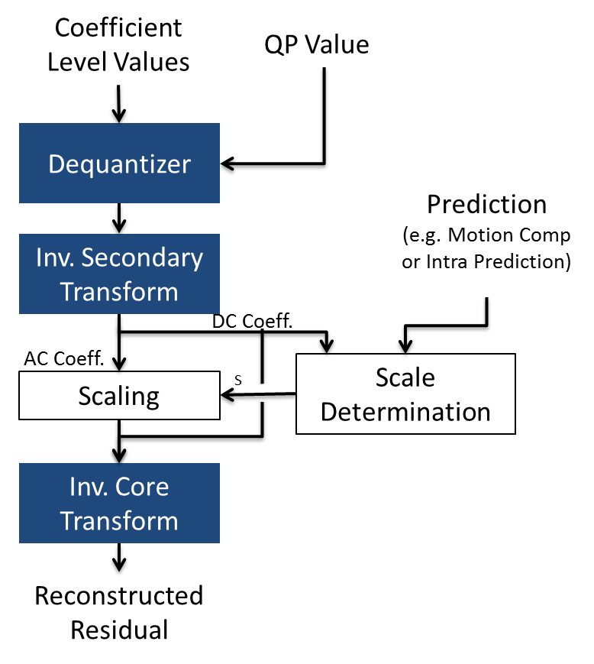
Figure 1 – Proposed System

As can be seen from the Figure, we introduce two additional functions to the de-quantizer and inverse transform pipeline. The first is a scale determination block that computes the QP scale adjustment for the current TU. The scale determination block takes the DC coefficient value and predicted pixel values for the CU as input and generates and scale adjustment according to
S = LUT[ Mean(Prediction) + f(DC Coefficient) ],
where LUT is a lookup table sent from the encoder to the decoder and f() denotes scaling from the DC coefficient value to a DC value. The second additional function is a scaling block. Using the output of the scale determination block, we then scale the AC coefficients prior to the core transform. The inverse core transform then proceeds as normal.
For chroma blocks, we apply the same process. However, the block uses the same scaling parameter for luma and so is applied to both the AC and DC coefficients. Finally, following reconstruction, we determine the average QP adjustment for the CU and use the adjusted value for de-blocking.
The benefit of the approach is two-fold:
First, determining the adjustment at the decoder reduces the bit-rate overhead of signaling a spatially varying QP
Second, the adjustment is performed on a TU basis, and so provides a method to do QP adjustment with fine granularity. This provides further picture quality improvement.

Experimental results
To evaluate the performance of the proposal, we implemented the method in the JEM 1.0 [1]. Additionally, we integrated the adaptive luma QP approach that is part of the JCT-VC HDR anchor into JEM 1.0 as well. We used this JCT-VC HDR anchor configuration as our anchor, and then processed the HDR sequences considered in the JCT-VC activity.
For the tests reported here, we wanted to ensure that the pixel output of the proposed method and anchor configuration were similar. This is done to ensure that the gains measured were from the coding efficiency improvement of not sending delta QP information in the bit-stream. To achieve this, we configured both systems to operate with a 16x16 CTU. Furthermore, we restricted the encoder to use a 16x16 CU, PU and TU. Again, this was done to ensure that the decoded output was substantially the same and coding gains are due to the QP signaling. Besides those changes, the JEM 1.0 common conditions were used.
Results are summarized in Table 2 and Table 3. As can be seen from the Tables, the proposed method provided BD-rate gains of 2.0% for both AI and RA configurations. Moreover, we also report the PSNR difference between anchor and the proposal to confirm that the decoded output was substantially similar in both cases.
Table 2 – All Intra Results Proposed vs JEM (with Delta QP)
 | All Intra | Y | U | V
class A | FireEaterClip4000r1 | -3.1% | -7.0% | 0.4%
 | Market3Clip4000r2 | -1.0% | -1.1% | -1.4%
 | SunRise | -2.4% | 1.0% | -2.8%
class B | BikeSparklers cut 1 | -2.1% | -1.0% | -1.9%
 | BikeSparklers cut 2 | -2.4% | -1.6% | 0.1%
 | GarageExit | -3.3% | -3.0% | -3.0%
class C | ShowGirl2Teaser | -2.7% | -1.6% | -2.6%
class D | StEM_MagicHour cut 1 | -2.4% | -1.3% | -1.9%
 | StEM_MagicHour cut 2 | -1.9% | -0.8% | -0.5%
 | StEM_MagicHour cut 3 | -2.1% | -1.1% | -1.5%
 | StEM_WarmNight cut 1 | -1.3% | -0.6% | -0.4%
 | StEM_WarmNight cut 2 | -1.8% | -0.1% | -1.9%
class G | BalloonFestival | -1.4% | -1.6% | -1.1%
class H | EBU_04_Start | -1.5% | -2.1% | -2.3%
 | EBU_06_Hurdles | -1.3% | -1.3% | -1.4%
Average BD rate |  | -2.0% | -1.6% | -1.5%
Average PSNR Difference |  | -0.02 | -0.01 | -0.01

Table 3 – Random Access Results Proposed vs JEM (with Delta QP)
 | RA | Y | U | V
class A | FireEaterClip4000r1 | -3.0% | -1.3% | -2.6%
 | Market3Clip4000r2 | -1.3% | -1.4% | -1.2%
 | SunRise | -1.4% | -1.2% | -5.0%
class B | BikeSparklers cut 1 | -2.0% | -0.4% | 0.0%
 | BikeSparklers cut 2 | -2.2% | -1.3% | -2.5%
 | GarageExit | -3.1% | -2.2% | -2.0%
class C | ShowGirl2Teaser | -2.3% | -1.0% | -2.8%
class D | StEM_MagicHour cut 1 | -1.8% | -0.4% | -1.4%
 | StEM_MagicHour cut 2 | -2.1% | -1.0% | -1.4%
 | StEM_MagicHour cut 3 | -2.0% | -1.1% | -0.2%
 | StEM_WarmNight cut 1 | -1.5% | 0.9% | 1.7%
 | StEM_WarmNight cut 2 | -1.8% | -0.3% | -2.2%
class G | BalloonFestival | -1.7% | -1.9% | -0.9%
class H | EBU_04_Start | -2.2% | -1.9% | -1.8%
 | EBU_06_Hurdles | -1.4% | -0.7% | -1.2%
Average BD rate |  | -2.0% | -1.0% | -1.6%
Average PSNR Difference |  | 0.01 | 0.01 | 0.00

Conclusion
This contribution proposes to scale the AC coefficient values after the secondary transform as a function of the prediction and DC coefficient. This is motivated by properties of next generation containers, such as ST-2084, where it is desirable to represent darker areas with less fidelity than brighter areas. Using a configuration similar to the JCT-VC HDR anchor as an anchor, it is reported that the proposal provides a BD rate gain of -2.0% for both AI and RA configurations. It is proposed to adopt the approach into the JEM model.

Patent rights declaration(s)
SHARP may have current or pending patent rights relating to the technology described in this contribution and, conditioned on reciprocity, is prepared to grant licenses under reasonable and non-discriminatory terms as necessary for implementation of the resulting ITU-T Recommendation | ISO/IEC International Standard (per box 2 of the ITU-T/ITU-R/ISO/IEC patent statement and licensing declaration form).

References

JEM1.0, https://vceg.hhi.fraunhofer.de/svn/svn_HMJEMSoftware/tags/HM-16.6-JEM-1.0, Dec. 2015.

[2] Video/JVET, “Algorithm Description of Joint Exploration Test Model 1 (JEM 1)”, ISO/IEC JTC1/SC29/WG11/N15790, Oct. 2015.
[3] K. Andersson, P. Hermansson, J. Samuelsson, J. Ström, M. Pettersson, "Report for CE1.a (Chroma QP)", m37179, Geneva, October 2015.
[4] J. Zhao, S.-H. Kim, A. Segall, K. Misra, “Performance Investigation of High Dynamic Range and Wider Color Gamut Video Coding Techniques”, ITU-T T13-SG16-C-1030, Meeting of Study Group 16, Geneva, CH, October 12-23, 2015. (Note: A slightly edited version of this document is also available as MPEG m37439.)
[5] A. Segall, J. Zhao, J. Ström, K. Andersson, M. Pettersson, " AHG on HDR and WCG: Average Luma Controlled Adaptive dQP ", JCTVC-W0054, San Diego, February 2016.

