    Joint Video Experts Team (JVET)  of ITU-T SG 16 WP 3 and ISO/IEC JTC 1/SC 29/WG 11  42nd Meeting, Santa Eulària, ES, 24 April – 1 May 2026 | Document: JVET-AP0186-v1

Title: | AHG17/AHG4: A Generic Full-Reference Objective Quality Assessment Method for Compressed Video
Status: | Input document to JVET
Purpose: | Proposal
Author(s) or  Contact(s): | Jiayi Wang  Xiaoqi Zhuang  Jiaqi Zhang  Lu Yu | Email: | blindwang@zju.edu.cn  zhuangxiaoqi@zju.edu.cn  jiaqi.zhang@zju.edu.cn  yul@zju.edu.cn
Source: | Zhejiang University
_____________________________

Abstract
Recent advances in block-based hybrid video codecs and neural network-based codecs for next-generation compression, alongside the widespread adoption of high dynamic range (HDR) and wide color gamut (WCG) video content, pose significant challenges for existing objective quality metrics. These metrics often fail to maintain consistent correlation with human perception across different codec types, distortion patterns, and HDR/WCG content characteristics.
In this contribution, we propose FDIM, a generic full-reference objective quality assessment method with high correlation to human perception, strong generalization across traditional and learning-based codecs, and high robustness across SDR and HDR/WCG content, to support the objective assessment of next-generation video coding technologies.
It is recommended to consider FDIM as a candidate quality metric beyond PSNR, e.g., for studying perceptual coding algorithms, evaluating CfP proposals, etc.
The source code for FDIM has been released at https://github.com/MCL-ZJU/FDIM.

Introduction
With the continuous enrichment of coding technologies and application scenarios, the types of compression artifacts have become increasingly diverse, bringing new challenges to the accurate evaluation of video perceptual quality. In practice, the most reliable way to measure perceptual quality is subjective testing, but it is costly and time-consuming for iterative codec development. Therefore, robust, perceptually aligned objective quality assessment metrics have become the core foundation for codec optimization, performance comparison, and standardized evaluation in JVET.
However, existing mainstream objective quality metrics are not sufficiently reliable to meet this demand. Traditional metrics such as PSNR have long been criticized for their poor alignment with human visual perception, while widely used metrics including VMAF show insufficient robustness and correlation with subjective results when facing novel distortions introduced by learning-based codecs, such as over-smoothing, synthetic texture artifacts and temporal incoherence. Meanwhile, these metrics also fail to accurately model the perceptually significant distortions specific to HDR/WCG content.
In this context, we propose a generic full-reference video quality assessment method with high correlation to human perception, strong generalization across traditional and learning-based codecs, and high robustness across SDR and HDR/WCG content. We evaluate the behavior of the proposed method on the CVQM [1] dataset established by MPEG AG5 and other SDR/HDR public benchmarks across various distortion types and content categories, aiming to assess its applicability and consistency in the task of compressed video quality assessment.

Proposed Method
Detailed description of the FDIM algorithm is provided in the MPEG AG5 contribution [2]. For simplicity, only a high-level overview is provided in this contribution.
FDIM is a hybrid full-reference video quality assessment metric, which combines a handcrafted perceptual feature-based branch and a deep learning-based branch to leverage their complementary advantages, as illustrated in Figure 1. The handcrafted branch uses VMAF v3.0.0 to provide a stable baseline for classical compression artifacts, while the deep learning-based branch is optimized for novel artifacts from learning-based codecs, with a local content-adaptive feature comparison module and multi-scale fusion mechanism to capture perceptually salient distortions, as depicted in Figure 2.
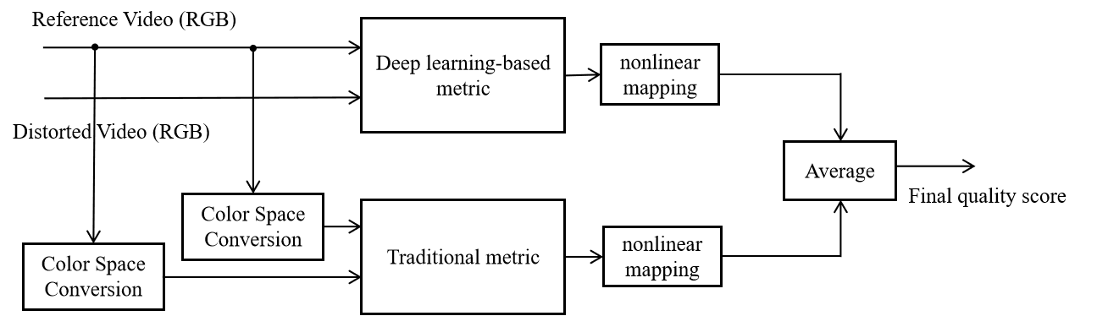
Figure 1. The framework of the proposed method.
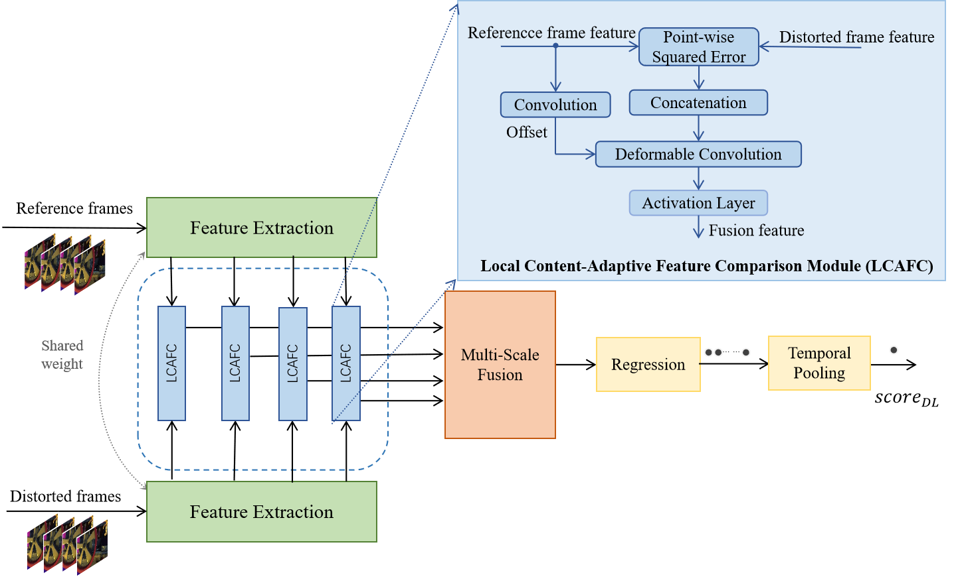
Figure 2. The overall architecture of the deep learning-based metric.
The outputs of the two branches are individually mapped to a unified numerical range via four-parameter nonlinear functions, and the final video-level quality score is calculated as the average of the two mapped outputs. A ranking-based learning framework aligned with human subjective evaluation logic is used for model training, as fully detailed in [2]. A low-complexity implementation of FDIM is also provided, which downsamples UHD video to 1080p resolution to reduce computational complexity for high resolution videos while maintaining perceptual correlation.

Experiments

Datasets
We evaluate FDIM on the AG5 CVQM datasets and five widely used public SDR/HDR datasets [3-7] for compressed video quality assessment:
- CVQM HD includes 8 pristine 1080p source videos compressed by six different encoders (four traditional and two learning-based) at four distortion levels. Subjective scores were collected in a controlled laboratory environment using the double-stimulus methodology with an 11-point scale.
- CVQM UHD includes 25 pristine 2160p source videos compressed by seven different encoders (four traditional and three learning-based) at four distortion levels. Subjective scores were collected in a controlled laboratory environment using the double-stimulus methodology with an 11-point scale.
- MCML 4K UHD includes 10 pristine 4K source videos compressed by three different encoders (HEVC, AVC, VP9) across two resolutions (1080p, 2160p) and four distortion levels, totaling distorted 240 videos. Subjective scores were collected in a controlled laboratory environment using the 11-point Absolute Category Rating with Hidden Reference (ACR-HR) methodology.
- AVT-VQDB-UHD-1 includes 17 pristine 4K source videos compressed by three different encoders (HEVC, AVC, VP9) across six resolutions (360p, 480p, 720p, 1080p, 1440p, 2160p) and four frame rates (15, 24, 30, 60 fps). The database is divided into four test subsets (Test1–Test4), and we selected a subset covering Test1–Test3 only, excluding, within Test1–Test3, those original videos and their corresponding distorted versions that were not publicly released. This results in 5 reference videos and 218 distorted videos. Subjective scores were collected in a controlled laboratory environment using the Absolute Category Rating (ACR) methodology with a 5-point scale.
- WaterlooIVC 4K contains 20 source sequences covering diverse content types. Each source was encoded by five codecs (H.264/AVC, H.265/HEVC, VP9, AV1, and AVS2) at three spatial resolutions and four quality levels, producing 1,200 distorted sequences. Subjective quality scores were obtained following ACR methodology on a 4K display with a 0-100 continuous scale.
- BVI HD includes 32 source sequences and 384 distorted sequences generated by HEVC and HEVC-SYNTH (synthesis-based texture replacement). Subjective experiments were conducted in a controlled lab environment with double-stimulus continuous quality scale (DSCQS) ratings on a 0-100 scale.
- LIVE-HDR contains 31 4K HDR reference sequences and 310 distorted sequences generated by HEVC compression and spatial scaling. Subjective scores were collected in a controlled laboratory using an ACR-HR protocol with a 0-100 continuous scale under different ambient illumination conditions (dark/bright).

Evaluation Metrics
To evaluate the performance of the proposed method, we employ two widely used correlation-based metrics: the Spearman Rank Order Correlation Coefficient (SROCC), and the Pearson Linear Correlation Coefficient (PLCC). For the proposed hybrid metric, correlation coefficients are computed directly between the predicted quality scores and the corresponding subjective scores, without applying any post-processing.
Two evaluation settings are used for all evaluation metrics:
- Per-sequence evaluation, where metrics are computed for each original video across all its corresponding distorted versions, and the final results are obtained by averaging the metrics over all source videos; and
- All-sequence evaluation, where metrics are computed across all distorted sequences regardless of content.

Results
We compare FDIM with four widely used objective quality metrics: VMAF, XPSNR, PSNR, and MS-SSIM. PSNR and MS-SSIM were computed using HDRTools v0.24 across the three components of the YUV color space, and the component-wise scores were subsequently fused into a single prediction through a weighted average with a ratio of 6:1:1 for Y:U:V. XPSNR was computed using FFmpeg 7.1.1 on the three components and similarly aggregated following the same weighting scheme. VMAF (version 2.3.1) was evaluated solely on the luminance (Y) component. We used VMAF 4K model (vmaf_4k_v0.6.1) for the three 4K UHD datasets (MCML 4K, AVT-VQDB-UHD-1, WaterlooIVC 4K) and the default model for the two HD datasets (CVQM HD and BVI-HD).
Table 1 reports all-sequence correlation results on the CVQM HD and UHD datasets, which include sequences encoded by traditional and NN-based codecs. For both datasets, FDIM demonstrates the strongest correlation with MOS among all evaluated metrics. On the HD dataset, FDIM achieves the highest Pearson and Spearman correlation, followed by VMAF and XPSNR. A similar trend is observed on the UHD dataset, where FDIM maintains the highest correlation, while VMAF ranks second. FDIM exhibits strong generalization capability for both conventional compression artifacts from traditional hybrid codecs and generative distortions introduced by NN-based codecs.

Table 1 All-sequence correlation of MOS and objective quality metrics for CVQM HD and UHD dataset.
 | CVQM HD |  | CVQM UHD
 | PLCC | SROCC | PLCC | SROCC
FDIM | 0.955 | 0.956 | 0.881 | 0.904
VMAF | 0.943 | 0.941 | 0.828 | 0.843
PSNR(AVG) | 0.735 | 0.756 | 0.499 | 0.536
XPSNR(AVG) | 0.895 | 0.918 | 0.756 | 0.808
MS-SSIM(AVG) | 0.720 | 0.733 | 0.629 | 0.647

Table 2 shows the per-sequence correlation on the CVQM HD and UHD datasets. For the HD dataset, all metrics show high per-sequence correlation, with average PLCC above 0.94. VMAF ranks slightly higher than FDIM, while the differences between metrics remain relatively small. For the UHD dataset, FDIM achieves the highest average per-sequence correlation in both Pearson and Spearman measures, followed by VMAF. The ranking of the metrics is largely consistent between Pearson and Spearman correlation.
The results presented in Table 1 and Table 2 are consistent with those reported in m76136 [8].

Table 2 Average per-sequence correlation of MOS and objective quality metrics for the CVQM HD and UHD dataset.
 | CVQM HD |  | CVQM UHD
 | PLCC | SROCC | PLCC | SROCC
FDIM | 0.971 | 0.961 | 0.926 | 0.948
VMAF | 0.973 | 0.964 | 0.920 | 0.938
PSNR(AVG) | 0.948 | 0.964 | 0.888 | 0.929
XPSNR(AVG) | 0.948 | 0.964 | 0.887 | 0.922
MS-SSIM(AVG) | 0.959 | 0.966 | 0.892 | 0.924

Table 3 summarizes the all-sequence correlation results on four public SDR datasets, namely MCML 4K UHD, AVT-VQDB-UHD-1, WaterlooIVC 4K, and BVI HD. Across all datasets, FDIM achieves substantial performance gains over all comparative metrics, exhibiting strong discriminative capability for compressed sequences. Since these datasets involve a wider range of codecs than the others, the results further demonstrate the strong cross-codec generalization capability of FDIM.

Table 3 All-sequence correlation of MOS and objective quality metrics for four SDR public datasets.
 | MCML 4K UHD |  | AVT-VQDB-UHD-1 |  | WaterlooIVC 4K |  | BVI-HD
 | PLCC | SROCC | PLCC | SROCC | PLCC | SROCC | PLCC | SROCC
FDIM | 0.972 | 0.961 | 0.856 | 0.879 | 0.805 | 0.840 | 0.814 | 0.799
VMAF | 0.952 | 0.916 | 0.753 | 0.798 | 0.703 | 0.711 | 0.772 | 0.772
PSNR(AVG) | 0.818 | 0.850 | 0.594 | 0.666 | 0.482 | 0.471 | 0.554 | 0.573
XPSNR(AVG) | 0.928 | 0.932 | 0.683 | 0.738 | 0.747 | 0.781 | 0.719 | 0.757
MS-SSIM(AVG) | 0.672 | 0.870 | 0.568 | 0.643 | 0.435 | 0.520 | 0.546 | 0.662

Table 4 shows the average per-sequence correlation on the four public SDR datasets. On MCML 4K UHD, FDIM and other metrics exhibit identical and excellent per-sequence correlation, with both PLCC and SROCC reaching the same high level. On AVT-VQDB-UHD-1, VMAF ranks slightly higher than FDIM on PLCC, while the performance gap between the two metrics is very small. On WaterlooIVC 4K, MS-SSIM achieves higher average per-sequence PLCC and SROCC than VMAF, PSNR, XPSNR, and FDIM. On BVI HD, all metrics show comparable and high per-sequence performance. Overall, FDIM yields competitive and stable per-sequence quality prediction across all tested datasets, demonstrating reliable generalization to diverse content characteristics and compression distortion patterns.
The results presented in Table 3 and Table 4 are consistent with those reported in m74357 [9] and m75750 [10], where m75750 serves as a revised version of m74357 with updated XPSNR results.

Table 4 Average per-sequence correlation of MOS and objective quality metrics for four SDR public datasets.
 | MCML 4K UHD |  | AVT-VQDB-UHD-1 |  | WaterlooIVC 4K |  | BVI-HD
 | PLCC | SROCC | PLCC | SROCC | PLCC | SROCC | PLCC | SROCC
FDIM | 0.976 | 0.965 | 0.953 | 0.956 | 0.865 | 0.898 | 0.842 | 0.842
VMAF | 0.976 | 0.965 | 0.961 | 0.953 | 0.787 | 0.802 | 0.839 | 0.844
PSNR(AVG) | 0.954 | 0.974 | 0.857 | 0.778 | 0.878 | 0.913 | 0.831 | 0.838
XPSNR(AVG) | 0.960 | 0.974 | 0.899 | 0.844 | 0.896 | 0.924 | 0.833 | 0.843
MS-SSIM(AVG) | 0.952 | 0.964 | 0.895 | 0.864 | 0.902 | 0.917 | 0.830 | 0.837
We further evaluate FDIM on the LIVE-HDR dataset against three HDR objective quality metrics used in JVET CTC: wPSNR, DeltaE100, and PSNRL100, all computed using HDRTools v0.24. For HDR video quality assessment, PU21 perceptual uniform encoding [11] is used as a preprocessing module for the deep feature component of FDIM. The input HDR RGB signals are first converted to absolute linear luminance considering display parameters and ambient illumination. Then the PU21 transform is applied to achieve a perceptually uniform mapping, followed by normalization to the range [0,1] before being fed into the network. FDIM and FDIM+PU21 outperform all other metrics, demonstrating its superior performance on HDR content, under both bright and dark viewing conditions.

Table 5 All-sequence correlation of MOS and objective quality metrics for LIVE-HDR dataset. The symbol * indicates that the predictions were computed at a temporal sampling rate of 1 frames per second.
 | LIVE-HDR (bright) |  | LIVE-HDR (dark)
 | PLCC | SROCC | PLCC | SROCC
FDIM | 0.874 | 0.922 | 0.845 | 0.882
FDIM+PU21* | 0.885 | 0.933 | 0.865 | 0.900
wPSNR | 0.636 | 0.689 | 0.562 | 0.621
DeltaE100 | 0.650 | 0.698 | 0.600 | 0.648
PSNRL100 | 0.724 | 0.729 | 0.681 | 0.678

Table 6 Average per-sequence correlation of MOS and objective quality metrics for LIVE-HDR dataset. The symbol * indicates that the predictions were computed at a temporal sampling rate of 1 frames per second.
 | LIVE-HDR (bright) |  | LIVE-HDR (dark)
 | PLCC | SROCC | PLCC | SROCC
FDIM | 0.977 | 0.977 | 0.973 | 0.977
FDIM+PU21* | 0.975 | 0.975 | 0.973 | 0.973
wPSNR | 0.946 | 0.960 | 0.941 | 0.960
DeltaE100 | 0.943 | 0.949 | 0.920 | 0.937
PSNRL100 | 0.962 | 0.965 | 0.948 | 0.959
We evaluate the computational complexity of the deep component of FDIM in terms of GFLOPs and runtime on CPU and GPU. The deep component of FDIM has 12M parameters. Tests are carried out on a 150‑frame video sequence at three common spatial resolutions. The computational complexity of FDIM is evaluated on a platform equipped with an Intel Xeon Gold 6530 CPU and an NVIDIA RTX 5880 Ada GPU.

Table 7 FLOPs and runtime (GPU and CPU) for a 150-frame video at different spatial resolutions.
 | CPU |  | GPU
 | GFLOPs | FPS | GFLOPs | FPS
1280x720 | 94.2 | 0.171 | 94.2 | 24.144
1920x1080 | 211.6 | 0.063 | 211.6 | 10.877
3840x2160 | 844.9 | 0.018 | 844.9 | 2.509
We also evaluate total runtime of FDIM on CPU and GPU, as shown in Table 8.

Table 8 Total runtime (GPU and CPU) of FDIM at different spatial resolutions.
 | GPU |  | CPU
 | Runtime (s) | FPS | Runtime (s) | FPS
1280x720 | 0.068 | 14.779 | 5.047 | 0.198
1920x1080 | 0.107 | 9.330 | 11.064 | 0.090
3840x2160 | 0.383 | 2.613 | 42.807 | 0.023

Table 9 summarizes the performance of the full-resolution FDIM and the 4K downsampling implementation on the CVQM UHD dataset, where input 4K (2160p) video sequences are downsampled spatially to 1080p resolution before being fed into the network. As shown in Table 9, the 4K downsampling implementation not only reduces complexity but also slightly improves PLCC and SROCC on the CVQM UHD dataset, demonstrating stable and reliable quality assessment for 4K content with high efficiency.

Table 9 Comparison of full-resolution FDIM and the 4K downsampling implementation on the CVQM UHD dataset.
 | CVQM UHD (all-sequence) |  | CVQM UHD (per-sequence)
 | PLCC | SROCC | PLCC | SROCC
FDIM | 0.881 | 0.881 | 0.926 | 0.948
FDIM (4K downsampling) | 0.896 | 0.907 | 0.938 | 0.949

The FDIM values for each sequence from CVQM HD and UHD dataset, and the correlations between FDIM and MOS reported in m76136 are cross-checked in m76934 [12]. The cross-checked results match the results in m76136.

Conclusion
This contribution presents a generic full-reference objective quality assessment metric, FDIM. FDIM achieves consistently high correlation with human subjective perception across traditional and learning-based codecs, SDR and HDR/WCG content, and diverse resolutions, outperforming mainstream metrics including PSNR, XPSNR, MS-SSIM and VMAF. It is recommended to consider FDIM as a candidate quality metric beyond PSNR, e.g., for studying perceptual coding algorithms, evaluating CfP proposals, etc.

References
- Report on CVQM - Dataset of compressed video for study of quality metrics (v3), MPEG doc. No. AG05N00190
- X. Zhuang, J. Zhang, L. Yu, “[AHG CVQM] A Full-Reference Objective Quality Assessment Method for Compressed Video,” MPEG doc. No. m73451, Jun. 2025.
- Cheon M, Lee J S. Subjective and objective quality assessment of compressed 4K UHD videos for immersive experience[J]. IEEE Transactions on Circuits and Systems for Video Technology, 2017, 28(7): 1467-1480.
- Rao R R R, Göring S, Robitza W, et al. AVT-VQDB-UHD-1: A large scale video quality database for UHD-1[C]//2019 IEEE International Symposium on Multimedia (ISM). IEEE, 2019: 17-177.
- Li Z, Duanmu Z, Liu W, et al. AVC, HEVC, VP9, AVS2 or AV1?—A comparative study of state-of-the-art video encoders on 4K videos[C]//International Conference on Image Analysis and Recognition. Cham: Springer International Publishing, 2019: 162-173.
- Zhang F, Moss F M, Baddeley R, et al. BVI-HD: A video quality database for HEVC compressed and texture synthesized content[J]. IEEE Transactions on Multimedia, 2018, 20(10): 2620-2630.
- Z. Shang, J. P. Ebenezer, A. K. Venkataramanan, Y. Wu, H. Wei, S. Sethuraman, and A. C. Bovik, “A study of subjective and objective quality assessment of HDR videos,” IEEE Trans. Image Process., vol. 33, pp. 42–57, 2024.
- J. Wang, X. Zhuang, J. Zhang, and L. Yu, “[AHG CVQM] Correlation Analysis for FDIM on CVQM HD and UHD sequences,” ISO/IEC JTC 1/SC 29/AG 5, doc. No. m76136, Apr. 2026.
- X. Zhuang, J. Zhang, C. Hu, and L. Yu, “[AHG CVQM] Public Datasets and Metrics Performance,” MPEG input doc. No. m74357, Oct. 2025.
- C. Lehmann, X. Zhuang, C. Helmrich, J. Zhang, A. Wieckowski, C. Hu, B. Bross, and L. Yu, “[CVQM] Corrigendum for Metrics Provided in m74357,” ISO/IEC JTC 1/SC 29/AG 5, doc. No. m75750, Jan. 2026.
- R. K. Mantiuk and M. Azimi, “Pu21: A novel perceptually uniform encoding for adapting existing quality metrics for hdr,” in 2021 Picture Coding Symposium (PCS), 2021, pp. 1–5.
- J. Liu and Z. Chen, “[AHG CVQM] Crosscheck of m76136,” ISO/IEC JTC 1/SC 29/AG 5, doc. No. m76934, Apr. 2026.

Patent rights declaration(s)
Zhejiang University may have current or pending patent rights relating to the technology described in this contribution and, conditioned on reciprocity, is prepared to grant licenses under reasonable and non-discriminatory terms as necessary for implementation of the resulting ITU-T Recommendation | ISO/IEC International Standard (per box 2 of the ITU-T/ITU-R/ISO/IEC patent statement and licensing declaration form).

