    Joint Video Experts Team (JVET)  of ITU-T SG21 WP3/21 and ISO/IEC JTC 1/SC 29  42nd Meeting, Santa Eulària, ES, 24 April – 1 May 2026 | Document: JVET-AP0171-v2

Title: | AHG9: On indication of intermediate data application in EOI, SPO and NNPFC SEI messages
Status: | Input document to JVET
Purpose: | Proposal
Author(s) or  Contact(s): | Xiaozhong Xu  Stephan Wenger  Shan Liu  Tencent Binhai Building,  No. 33, Haitian Second Road,  Nanshan District, Shenzhen. 518054  China | Tel:  Email: | xiaozhongxu@tencent.com
Source: | Tencent
_____________________________

Abstract
In this contribution, addition of a syntax element in the TuC document is suggested, to extend the usage of video content, beyond the existing human viewing and machine analysis coverage. Such a change will impact the current EOI, NNPFC and SOP SEI messages.

Introduction / Problem Statement
In the most updated VSEI VSEI v4 specification [1], the semantics of syntax elements for video content description have constraints such that a video content cannot be unsuitable for human viewing nor for machine analysis at the same time. Instances for such a statement can be found in SPO SEI message, EOI SEI message and NNPFC SEI messages.
Using SOP SEI as an example, the specific descriptions of po_for_human_viewing_idc and po_for_machine_analysis_idc are listed and highlighted in green as follows:

po_for_human_viewing_idc equal to 3 specifies that the intended optimal usage of the video resulting from the processing chain specified by this SPO SEI message includes for human viewing. po_for_human_viewing_idc equal to 2 specifies that that the video resulting from the processing chain specified by this SPO SEI message is suitable but not specifically optimized for human viewing. po_for_human_viewing_idc equal to 1 specifies that the video resulting from the processing chain specified by this SPO SEI message is unsuitable for human viewing. po_for_human_viewing_idc equal to 0 specifies that it is unknown if the video resulting from the processing chain specified by this SPO SEI message is suitable for human viewing.
po_for_machine_analysis_idc equal to 3 specifies that the intended optimal usage of the video resulting from the processing chain specified by this SPO SEI message includes machine analysis. po_for_machine_analysis_idc equal to 2 specifies that the video resulting from the processing chain specified by this SPO SEI message is suitable but not specifically optimized for machine analysis. po_for_machine_analysis_idc equal to 1 specifies that the video resulting from the processing chain specified by this SPO SEI message is unsuitable for machine analysis. po_for_machine_analysis_idc equal to 0 specifies that it is unknown if the video resulting from the processing chain specified by this SPO SEI message is suitable for machine analysis.
It is a requirement of bitstream conformance that the value of po_for_human_viewing_idc and po_for_machine_analysis_idc shall not be both equal to 1.
NOTE 4 – The values of po_for_human_viewing_idc and po_for_machine_analysis_idc are in force for the output of a processing chain.
It is a requirement of bitstream conformance that when an NNPFA SEI message is associated with an SEI message type that has the greatest value of po_sei_processing_order[ i ] among the SEI message types having a payload type included in SpoProcessSeiList and indicated by an SPO SEI message and the nnpfc_for_human_viewing_idc and nnpfc_for_machine_analysis_idc syntax elements are present in the NNPFC SEI message associated with the NNPFA SEI message, the values of po_for_human_viewing_idc and po_for_machine_analysis_idc shall be equal to the values of nnpfc_for_human_viewing_idc and nnpfc_for_machine_analysis_idc, respectively, of the associated NNPFC SEI message.
It is a requirement of bitstream conformance that when an annotated regions SEI message with the value of ar_not_optimized_for_viewing_flag, when present, equal to 1 is associated with an SEI message type that has the greatest value of po_sei_processing_order[ i ] among the SEI message types indicated by an SPO SEI message, the value of po_for_human_viewing_idc shall not be equal to 3.

Problem statement

The highlighted sentence in the bitstream conformance requirement lies in the assumption that a coded video content should be at least serving for the purpose of human viewing or machine analysis tasks. However, in multiple applications, video codecs are used a general-purpose static 2D data compressor or time-varying 2D data compressor. In that regard, the content represented by the bitstream may be not suitable for human vision nor for machine analysis. This is typically true for 3D volumetric video data, where 3D models are converted into 2D “videos” so that video coding standards can be used to compress these 2D data efficiently. In Fig.1, an example of V-PCC encoder framework is shown, where 3 video data streams are needed to support such a system.

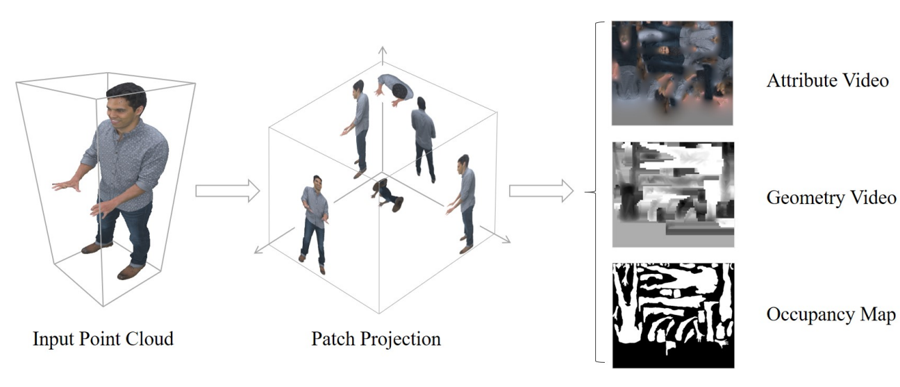
Fig.1: A typical point cloud model and texture (attribute) image, geometry image and occupancy map using V-PCC [2]

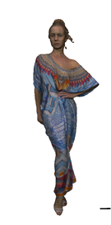 | 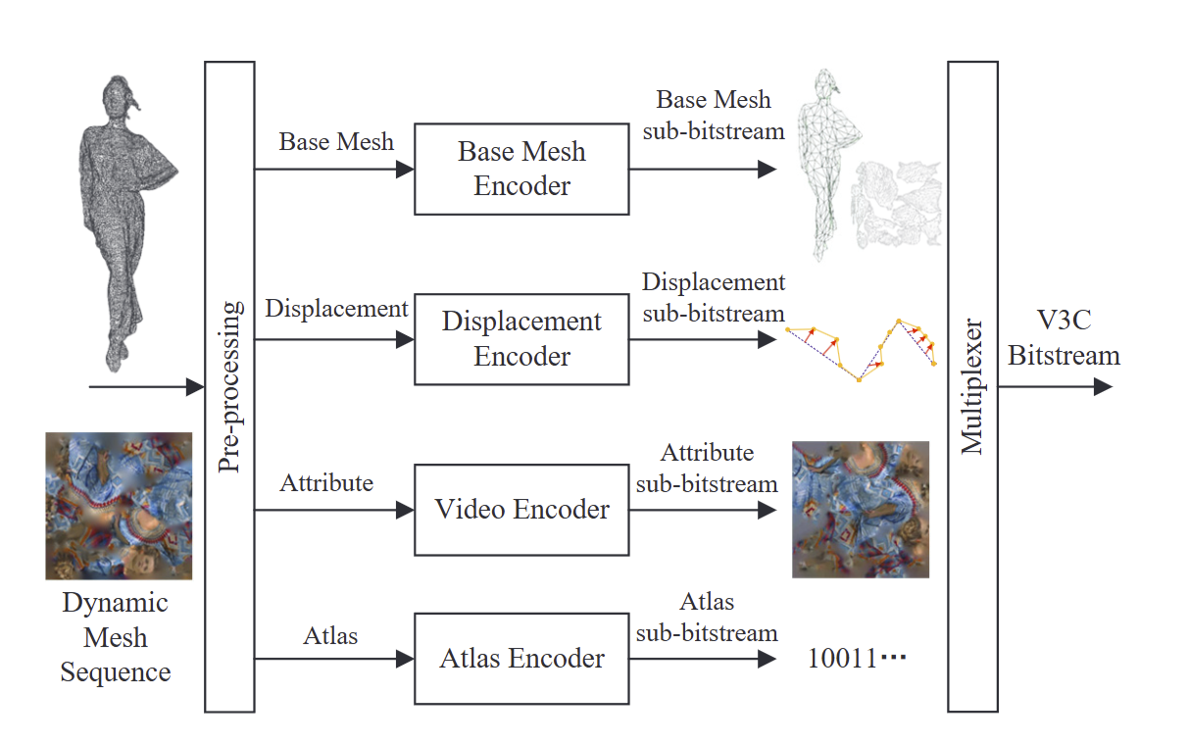
Fig.2: A typical 3D mesh model and the texture (attribute) image using V-DMC [3]

In Fig.2, another example of V-DMC encoder framework is shown, where 1 video data stream for attribute data is needed to support such a system.

In the above two examples, the intermediate sub-bitstreams contain contents that are clearly not for human viewing nor for machine analysis. Rather, they are considered as general data formats for intermediate processing. Eventually the data can be used for human viewing, but only after going through post processing/format conversion after decoding.
The existing syntax element combinations may not be able to provide enough clarity in this situation. Having both xxx_for_human_viewing_idc and xxx_for_machine_analysis_idc being 0 can only suggest an unknown status of such a content. To process the decoded content appropriately, an indication of the intended general intermediate data usage in the SEI message can be helpful.

Suggested solutions
In the most updated TuC document JVET-AO2032 [4], the following modifications are made (highlighted in yellow).

In SPO SEI message:

sei_processing_order( payloadSize ) { | Descriptor
po_id | u(8)
po_for_human_viewing_idc | u(2)
po_for_machine_analysis_idc | u(2)
po_reserved_zero_4bits | u(4)
…
if( more_data_in_payload( ) )
if(payload_extension_present( )) {
SeiExtensionBitsPresentFlag = 1
if( po_for_human_viewing_idc == 0 && po_for_machine_analysis_idc == 0 )
po_for_general_data_idc | u(8)
…

po_for_general_data_idc indicates the intended usage of the video resulting from the processing chain, with values as listed in Table XX. Values of po_for_general_data_idc in the range of 8 and 15, inclusive, in Table XX are reserved for future use by ITU-T | ISO/IEC and shall not appear in payload data conforming to this version of the specification. Decoders shall ignore PO SEI messages that contain reserved values of po_for_general_data_idc.

Table XX – Interpretation of po_for_general_data_idc
po_for_general_data_idc | Interpretation
0 | Unspecified
1 | Intermediate data
2…7 | User-defined
8…255 | Reserved

In EOI SEI message:

encoder_optimization_info(payloadSize ) { | Descriptor
eoi_cancel_flag | u(1)
if( !eoi_cancel_flag ) {
eoi_persistence_flag | u(1)
eoi_for_human_viewing_idc | u(2)
eoi_for_machine_analysis_idc | u(2)
eoi_reserved_zero_2bits | u(2)
……
…
if( more_data_in_payload( ) && payload_extension_present( ) ) {
SeiExtensionBitsPresentFlag = 1
if( eoi_for_human_viewing_idc == 0 && eoi_for_machine_analysis_idc == 0 )
eoi_for_general_data_idc | u(8)
}
…

eoi_for_general_data_idc indicates the intended usage of the video resulting from the encoding system, with values as listed in Table XX. Values of eoi_for_general_data_idc in the range of 8 and 15, inclusive, in Table XX are reserved for future use by ITU-T | ISO/IEC and shall not appear in payload data conforming to this version of the specification. Decoders shall ignore EOI SEI messages that contain reserved values of eoi_for_general_data_idc.

Table XX – Interpretation of eoi_for_general_data_idc
eoi_for_general_data_idc | Interpretation
0 | Unspecified
1 | Intermediate data
2…7 | User-defined
8…255 | Reserved

In NNPFC SEI message:

nn_post_filter_characteristics( payloadSize ) { | Descriptor
…
if( nnpfc_for_human_viewing_idc == 0 && nnpfc_for_machine_analysis_idc == 0 )
nnpfc_for_general_data_idc | u(8)
if( TemporalExtrapolationFlag ) {
…

nnpfc_for_general_data_idc indicates the intended usage of the video resulting from the NNPF process, with values as listed in Table XX. Values of nnpfc_for_general_data_idc in the range of 8 and 15, inclusive, in Table XX are reserved for future use by ITU-T | ISO/IEC and shall not appear in payload data conforming to this version of the specification. Decoders shall ignore NNPF SEI messages that contain reserved values of nnpfc_for_general_data_idc.

Table XX – Interpretation of nnpfc_for_general_data_idc
nnpfc_for_general_data_idc | Interpretation
0 | Unspecified
1 | Intermediate data
2…7 | User-defined
8…255 | Reserved

Reference
- S. McCarthy, J. Boyce, J. Chen, S. Deshpande, M. M. Hannuksela, H. Tan, Y.-K. Wang, Technologies under consideration for future extensions of VSEI (version 11), JVET-AO2032, Jan. 2026
- S. Schwarz, M. M. Hannuksela, [AHG4] Occupancy-only PSNR calculations for V3C V-PCC coding evaluation, JVET-AC0044, Jan. 2023
- W. Zou, S. Zhang, F. Yang, M. Preda, Standardization Status of MPEG Video-based Dynamic Mesh Coding (V-DMC), 2025 IEEE International Conference on Acoustics, Speech and Signal Processing (ICASSP), Apr. 2025

Patent rights declaration(s)
Tencent may have current or pending patent rights relating to the technology described in this contribution and conditioned on reciprocity, is prepared to grant licenses under reasonable and non-discriminatory terms as necessary for implementation of the resulting ITU-T Recommendation | ISO/IEC International Standard (per box 2 of the ITU-T/ITU-R/ISO/IEC patent statement and licensing declaration form).

