    Joint Video Experts Team (JVET)  of ITU-T SG21 WP3/21 and ISO/IEC JTC 1/SC 29  42nd Meeting, Santa Eulària, ES, 24 April – 1 May 2026 | Document: JVET-AP0146-v3

Title: | AHG9: Software implementation of the Green SEI message and demonstration of the use of attenuation map information metadata for display adaptation
Status: | Input document to JVET
Purpose: | Information
Author(s) or  Contact(s): | Claire-Hélène Demarty,  Nicolas Caramelli,  Franck Aumont | Email: | 1stname.lastname@interdigital.com
Source: | InterDigital
_____________________________

Abstract
This contribution informs of the implementation of the carriage of the display attenuation maps as auxiliary pictures in the bitstream, and of their usage at the decoder side for display adaptation, with the goal of reducing the energy consumption of the display.
This contribution also proposes a demonstration of the encoding/decoding of a green MPEG bitstream and its rendering result on a TV.
In v2 version, the number of a related contribution was added.
In v3, some typos were corrected and a slide deck was added.

Introduction
In the amendment 2 of the 23001-11 Energy-Efficient Media Consumption (Green Metadata) edition 3 specification [1], new display attenuation map information metadata for the reduction of the power consumption at the display side is specified. This new metadata is inserted in the Green Metadata SEI message as a new metadata type.
In contribution m73186 of MPEG #154 meeting, an updated implementation of the Green Metadata SEI message including this new type in the VTM software was presented, which proposes a writing and parsing of the updated Green Metadata SEI message.

This contribution further informs of the implementation of the carriage of the display attenuation maps as auxiliary pictures in the bitstream, and of their usage at the decoder side for display adaptation, with the goal of reducing the energy consumption of the display. This contribution also proposes a demonstration of the encoding/decoding of a green MPEG bitstream and its rendering result on a TV.

The carriage of green metadata in DASH and ISOBMFF is specified in the 23001-19 Carriage of Green Metadata specification.
The proposed demonstration and an accompanying demonstration of the carriage of the display attenuation maps in DASH (see contribution m76441) will be jointly showcased during this meeting.

Usage of attenuation maps and attenuation map information metadata
A presentation subsystem may use the attenuation map information metadata to reduce power consumption at the display side by modifying the content based on the attenuation maps. Examples of attenuation maps are shown in the below figure.


Figure 1: Example attenuation map. From left to right: Original content, Luma component, attenuation map
An example use of pre-computed attenuation maps is given in the below figure. The attenuation map is computed on the luma component of the original figure by for example an energy-aware algorithm provided in [2]. The attenuation map may be transmitted in the bitstream for example in a rescaled and downsampled version. At the receiver side the attenuation map is applied on the decoded content, after rescaling and upscaling, for example through subtraction of its values to the sample values of the original image.

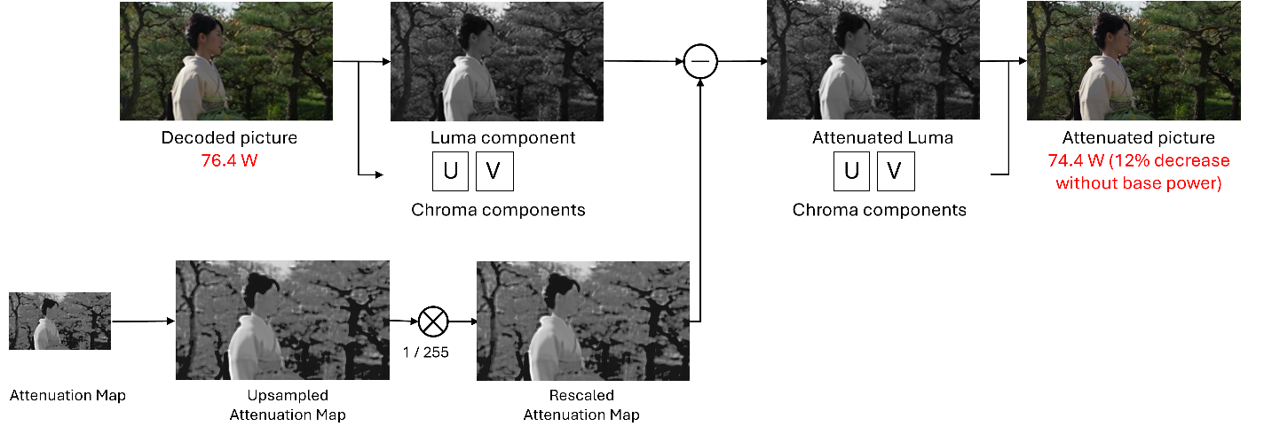
Figure 2: Example of use of attenuation maps to reduce the energy consumption while displaying a content.
The attenuation map information metadata corresponds to a new value (equal to 2) of the green_metadata_type in the green metadata SEI message.
The attenuation maps are carried as auxiliary pictures of type ALPHA_MAP in the bitstream.

The software implementation of the green metadata SEI message in VTM has been updated to allow the carriage of the attenuation maps as auxiliary pictures and to enable their application to the decoded pictures, according to the attenuation map information in the green metadata SEI message.

Software description
The updated software is proposed in branch WG03-N01464-GreenSEI-ApplyAttenuationMaps in the VVCSoftware_VTM repository. The corresponding merge request is denoted:

WG03_N01464: Implementation of carriage and application of attenuation maps (green_metadata_type==2)
It allows to:
- (Encoder) Encode a multi-layer bitstream with original pictures (first layer) and attenuation maps as auxiliary pictures (second layer).
- (Encoder) Read a config file with the attenuation map information metadata
- (Encoder) Insert the green metadata SEI message with the new information into the bitstream
- (Decoder) Parse the green metadata SEI message with the new information from the bitstream
- (Decoder) Decode and apply the attenuation maps according to the attenuation map information metadata to the decoded pictures.

The applied changes in the source code can be retrieved by searching for the macro: GREEN_METADATA_SEI_AMI_ENABLED_WG03_N01464.
This macro is defined within the namespace of the already existing macro GREEN_METADATA_SEI_ENABLED.
The application of the attenuation maps using the new attenuation map information metadata can therefore be activated or deactivated by setting the above macros to 1 or 0 in file TypeDef.h.
The contribution also proposes to rename some of the syntax element variables in the informative text messages in the existing implementation, to match the specification, by replacing the green_metadata_ami_ prefix with an ami_ prefix.

Example configuration files
Two example configuration files were already existing from contribution m73186:
- cfg/sei_vui/greenMetadataAttMapSEI.cfg
- cfg/sei_vui/greenMetadataAttMapSEI_global.cfg
It is first proposed to rename these files to follow the naming rules in the VTM software and to move them to a dedicated subfolder green_metadata in subfolder cfg/sei_vui:
- cfg/sei_vui/green_metadata/green_metadata_ami.cfg
- cfg/sei_vui/green_metadata/green_metadata_ami_global.cfg
An additional configuration file (stored as green_metadata_attenuationmaps_with_auxiliary_pictures.cfg) is proposed, which describes a simple scenario of usage of attenuation maps:
- one single attenuation map (SEIGreenMetadataAMIMapNumber = 1) is transmitted in the bitstream;
- the attenuation map is carried in layer #1 (SEIGreenMetadataAMILayerId = 1);
- when applied, this attenuation map is responsible for an energy reduction rate of 10% (SEIGreenMetadataAMIEnergyReductionRate = 10) at the display side;
- this attenuation map shall be used through subtraction (SEIGreenMetadataAMIAttenuationUseIdc = 0) of its sample values to the luma sample values (SEIGreenMetadataAMIAttenuationCompIdc = 0) of the decoded picture;
- no preprocessing through rescaling or downsampling/upsampling is required (bit #3 equal to 0 in SEIGreenMetadataAMIFlags).

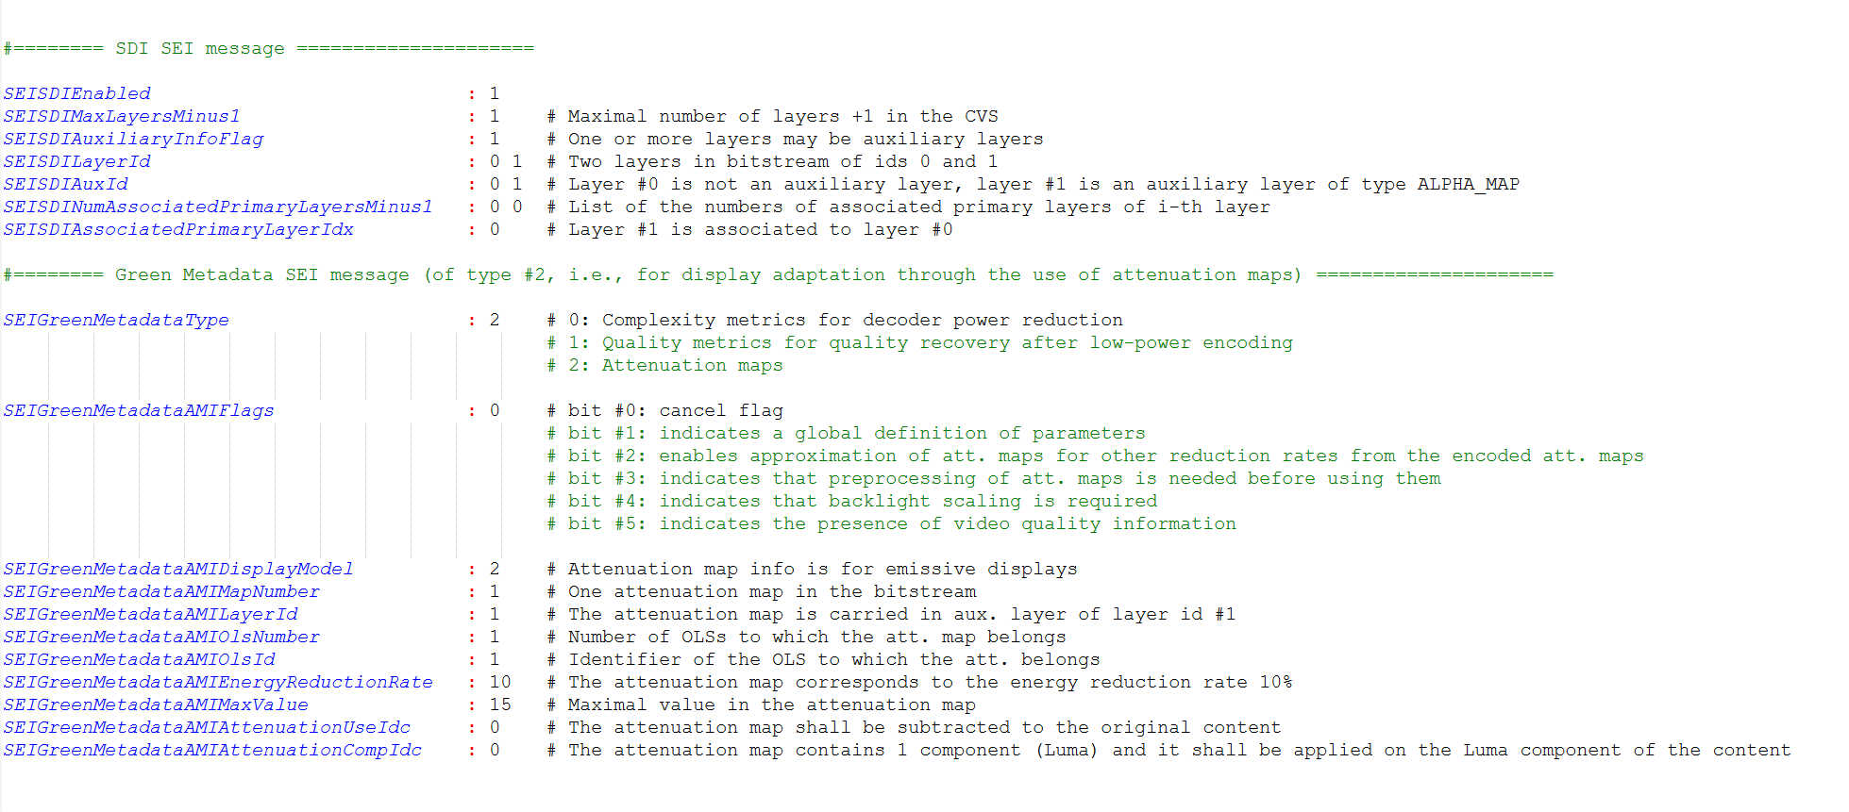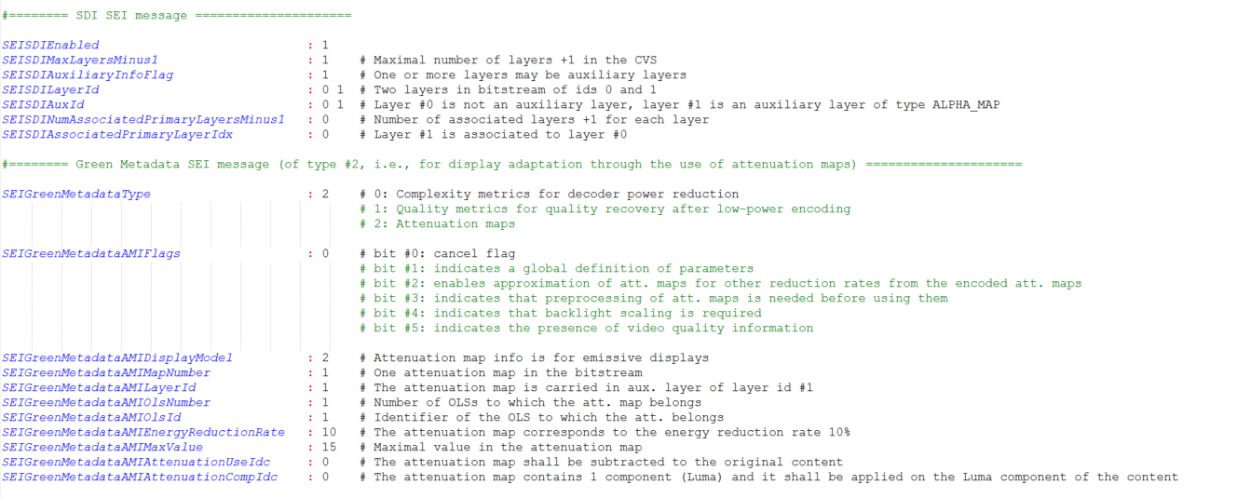
Figure 3: Example configuration file for one single attenuation map applied through simple subtraction on the decoded picture.
A helper configuration file (stored as green_metadata_attenuationmaps_twolayers.cfg) is proposed for the configuration of the multilayer bitstream.

Example command lines
At the encoder side, the green metadata SEI message with support for attenuation maps can be enabled by using the following example command line:
EncoderApp -c cfg/encoder_randomaccess_vtm.cfg
-l0 -c cfg/sei_vui/green_metadata/ green_metadata_attenuationmaps_with_auxiliary_pictures.cfg
-l0 -c cfg/per_sequence/BQMall.cfg -l0 --Level=5.1
-l1 -c cfg/per_sequence/BQMall.cfg -l1 -i BQMall_attenuation_maps_0.1.yuv --Level=5.1
-c cfg/sei_vui/green_metadata/ green_metadata_attenuationmaps_two_layers.cfg
-b bitstream.bin
At the decoder side, the attenuation maps present in the bitstream can be applied to the decoded pictures, according to the information in the green metadata SEI message, using the following command line, through the definition of a dedicated output file name:
DecoderApp -b bitstream.bin --SEIGreenMetadataAttenuatedFilename=BQMall_with_attenuation_0_1.yuv

Demonstration
A demonstration of the implementation of the Green SEI message together with the carriage of the attenuation map samples in auxiliary pictures of type ALPHA_MAP, and their application to the encoded content is proposed.
The global workflow used for the demonstration is illustrated in Figure 4.
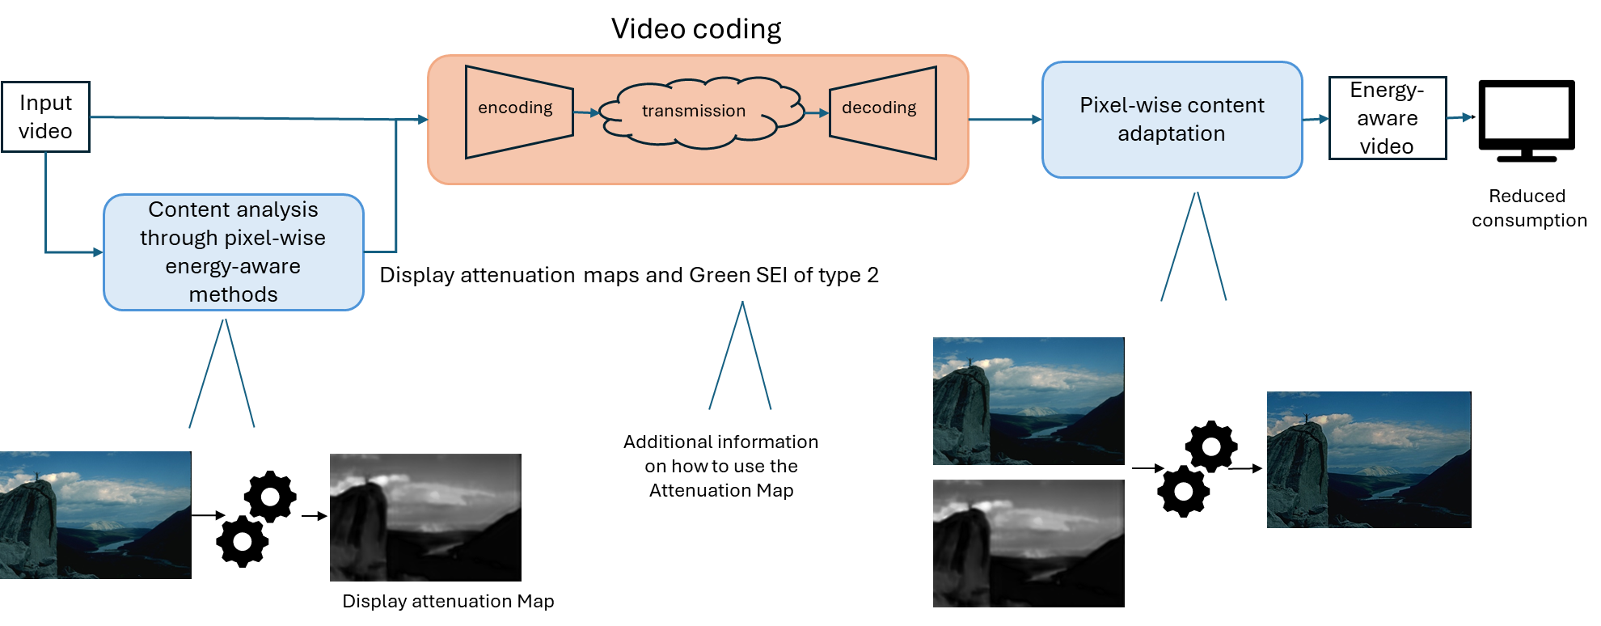
Figure 4: Global workflow of the demonstration: multi-layer encoding, decoding, and application of attenuation maps on a content.
Through analysis of some input video, the attenuation maps are prepared (not demonstrated) at the encoder side via some pixel-wise energy-aware method [3]. Both the input video and the attenuation map(s) are encoded in the bitstream, together with a Green SEI message of green_metadata_type corresponding to attenuation map information.
At the decoder side, both contents are decoded and the Green SEI message is retrieved. The attenuation map is then applied on the content according to the information carried in the Green SEI message, to produce an energy reduced content.
Figure 5 gives more details of the different steps conducted at the encoder and at the decoder, as demonstrated. 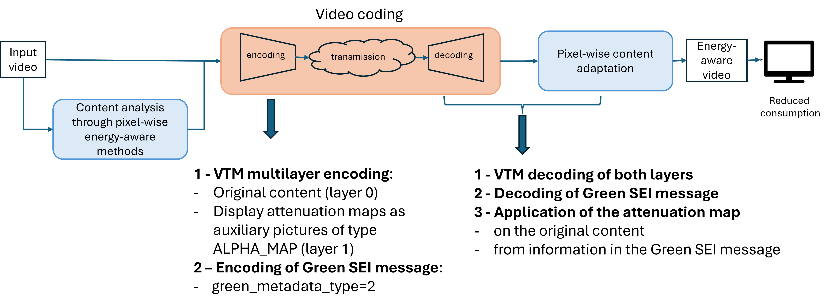
Figure 5: Steps at the encoder and at the decoder in the proposed demonstration
A simple scenario consisting in transmitting one 8-bit Luma attenuation map for a given reduction ratio (10%, 30%) together with the corresponding original content is proposed. Both streams are encapsulated in a multilayer scheme with the attenuation map being carried as an auxiliary layer of type ALPHA MAP. A Green SEI message of green_metadata_type equal to 2, accompanies the bitstream (encapsulated in the base layer) that describes how the attenuation map samples shall be used at the decoder side.
At the decoder side, both streams are decoded from the bitstream. The Green SEI message is also decoded and parsed. According to the information of how to use the attenuation map it contains, the attenuation map is applied on the content. In this case, a simple subtraction of the attenuation map samples to the content samples is used.

For more information on the method used to build the attenuation maps, its performances in terms of quality and power reduction, refer to [3, 4].

References
[1] WG03N01464, Text of ISO/IEC 23001-11 FDAM 2 Energy-efficient media consumption for new display power reduction metadata, MPEG #149, January 2025.
[2] K. A. Nugroho and S.-J. Ruan, "R-ACE Network for OLED Image Power Saving," in IEEE 4th Global Conference on Life Sciences and Technologies, 2022.
[3] O. Le Meur et al, “Deep-learning-based Energy Aware Images”, IEEE ICIP, 2023.
[4] E. Sampaio et al, “How to make images less power-hungry: An objective benchmark
Study”. ACMGMSys 2024.

Patent rights declaration(s)
InterDigital may have current or pending patent rights relating to the technology described in this contribution and, conditioned on reciprocity, is prepared to grant licenses under reasonable and non-discriminatory terms as necessary for implementation of the resulting ITU-T Recommendation | ISO/IEC International Standard (per box 2 of the ITU-T/ITU-R/ISO/IEC patent statement and licensing declaration form).

